Batch: B3 Roll No.: 16010122158

Experiment / Assignment / Tutorial No. 6

Grade: AA / AB / BB / BC / CC / CD /DD

Signature of the Staff In-charge with date

Title: Queries based Views and Triggers

Objective: To be able to use SQL view and triggers.

Expected Outcome of Experiment:

CO 2 | Develop relational database design using the designed Entity-Relationship model.
CO 3 | Use SQL for Relational database creation, maintenance and query processing

Books/ Journals/ Websites referred:

1. Dr. P.S. Deshpande, SQL and PL/SQL for Oracle 10g.Black book, Dreamtech Press
2. www.db-book.com
3. Korth, Slberchatz, Sudarshan : “Database Systems Concept”, 5th Edition , McGraw
Hill
4. Elmasri and Navathe,”Fundamentals of database Systems”, 4th Edition,PEARSON
Education.

Resources used: Postgresql

Theory

Views are pseudo-tables. That is, they are not real tables; nevertheless appear as ordinary tables to SELECT. A view can represent a subset of a real table, selecting certain columns or certain rows from an ordinary table. A view can even represent joined tables. Because views are assigned separate permissions, you can use them to restrict table access so that the users see only specific rows or columns of a table.

A view can contain all rows of a table or selected rows from one or more tables. A view can be created from one or many tables, which depends on the written PostgreSQL query to create a view.
Views, which are kind of virtual tables, allow users to do the following −
- Structure data in a way that users or classes of users find natural or intuitive.
- Restrict access to the data such that a user can only see limited data instead of complete table.
- Summarize data from various tables, which can be used to generate reports.

Since views are not ordinary tables, you may not be able to execute a DELETE, INSERT, or UPDATE statement on a view. However, you can create a RULE to correct this problem of using DELETE, INSERT or UPDATE on a view.
Syntax
CREATE [TEMP | TEMPORARY] VIEW view_name AS
SELECT column1, column2.....
FROM table_name
WHERE [condition];
Ex:
CREATE VIEW COMPAN-VIEW AS
SELECT ID, NAME, AGE
FROM COMPANY;

select * from Company-View
Insert into Company-View values (123,’alpha’, 10)
select * from Company

Dropping Views
Syntax: DROP VIEW view_name;

Triggers
The basic syntax of creating a trigger is as follows −
CREATE TRIGGER trigger_name [BEFORE|AFTER|INSTEAD OF] event_name
ON table_name
[
-- Trigger logic goes here....
];
event_name could be INSERT, DELETE, UPDATE, and TRUNCATE database operation on the mentioned table table_name. You can optionally specify FOR EACH ROW after table name.

The following is the syntax of creating a trigger on an UPDATE operation on one or more specified columns of a table as follows −
CREATE TRIGGER trigger_name [BEFORE|AFTER] UPDATE OF column_name
ON table_name
[
-- Trigger logic goes here....
];

Example :
creates a log table and a trigger that inserts a row in the log table after any UPDATE statement affects the SALARY column of the EMPLOYEES table, and then pdates EMPLOYEES.SALARY and shows the log table.
CREATE TABLE Emp_log ( Emp_id NUMBER, Log_date DATE, New_salary NUMBER, Action VARCHAR2(20));
- Create trigger that inserts row in log table after EMPLOYEES.SALARY is update
CREATE OR REPLACE TRIGGER log_salary_increase
AFTER UPDATE OF salary ON employees
FOR EACH ROW BEGIN INSERT INTO Emp_log (Emp_id, Log_date, New_salary, Action) VALUES (:NEW.employee_id, SYSDATE, :NEW.salary, 'New Salary');
END;
Update EMPLOYEES.SALARY:
UPDATE employees SET salary = salary + 1000.0 WHERE Department_id = 20;

Result:
2 rows updated. Show log table:
SELECT * FROM Emp_log;
Result:
EMP_ID LOG_DATE NEW_SALARY ACTION
201 28-APR-10 15049.13 New Salary
202 28-APR-10 6945.75 New Salary
2 rows selected.

Implementation Screenshots (Problem Statement, Query and Screenshots of Results):

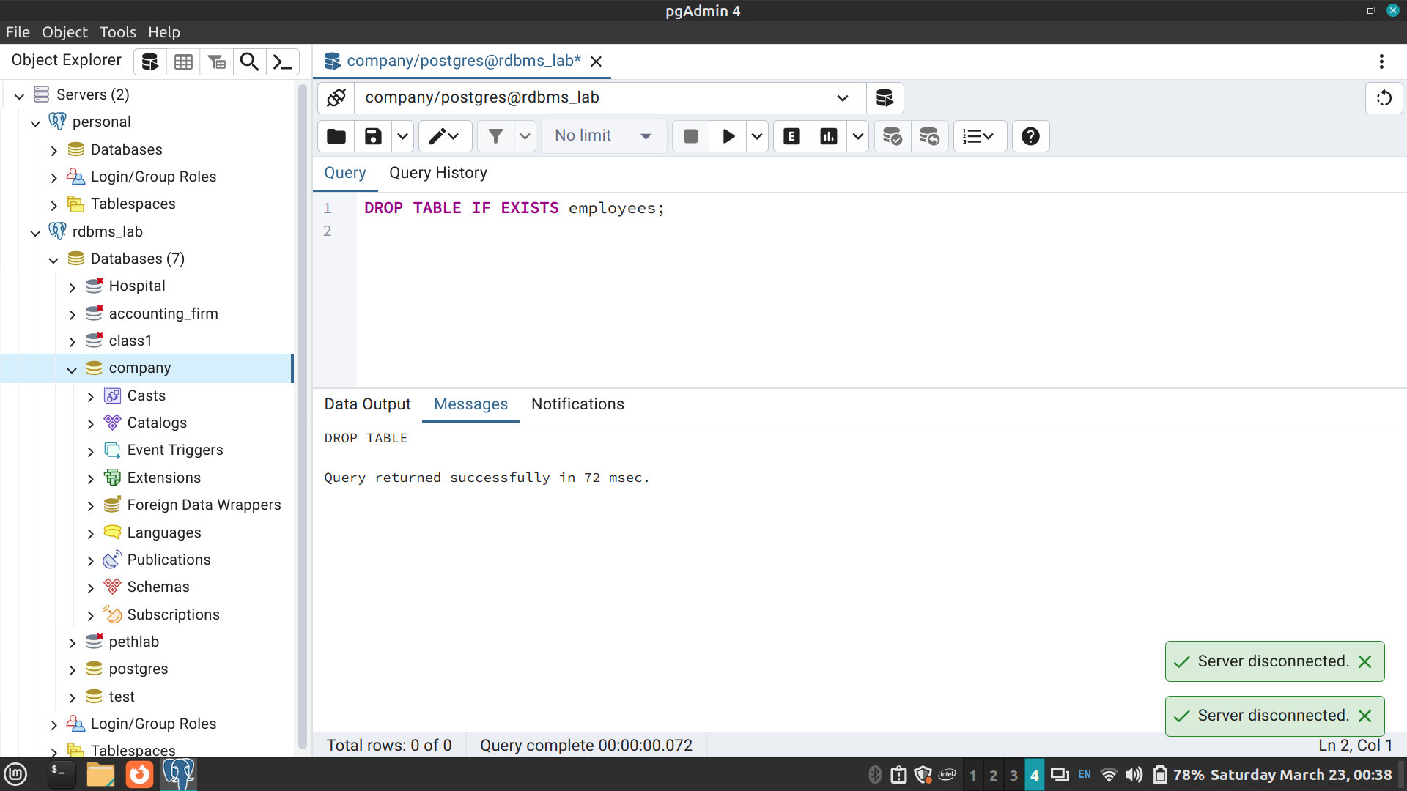
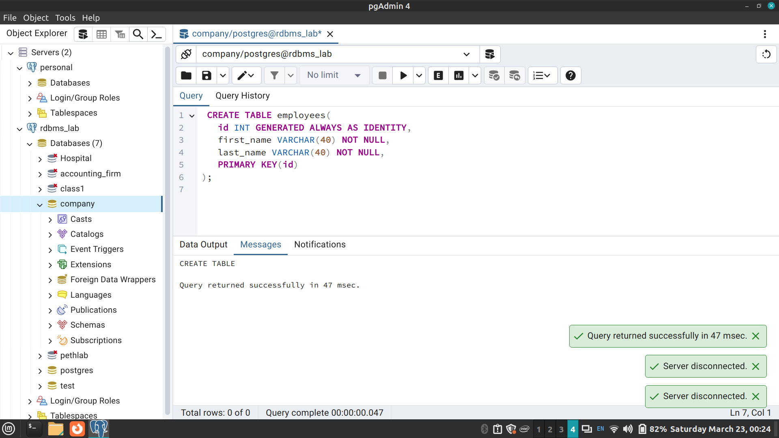
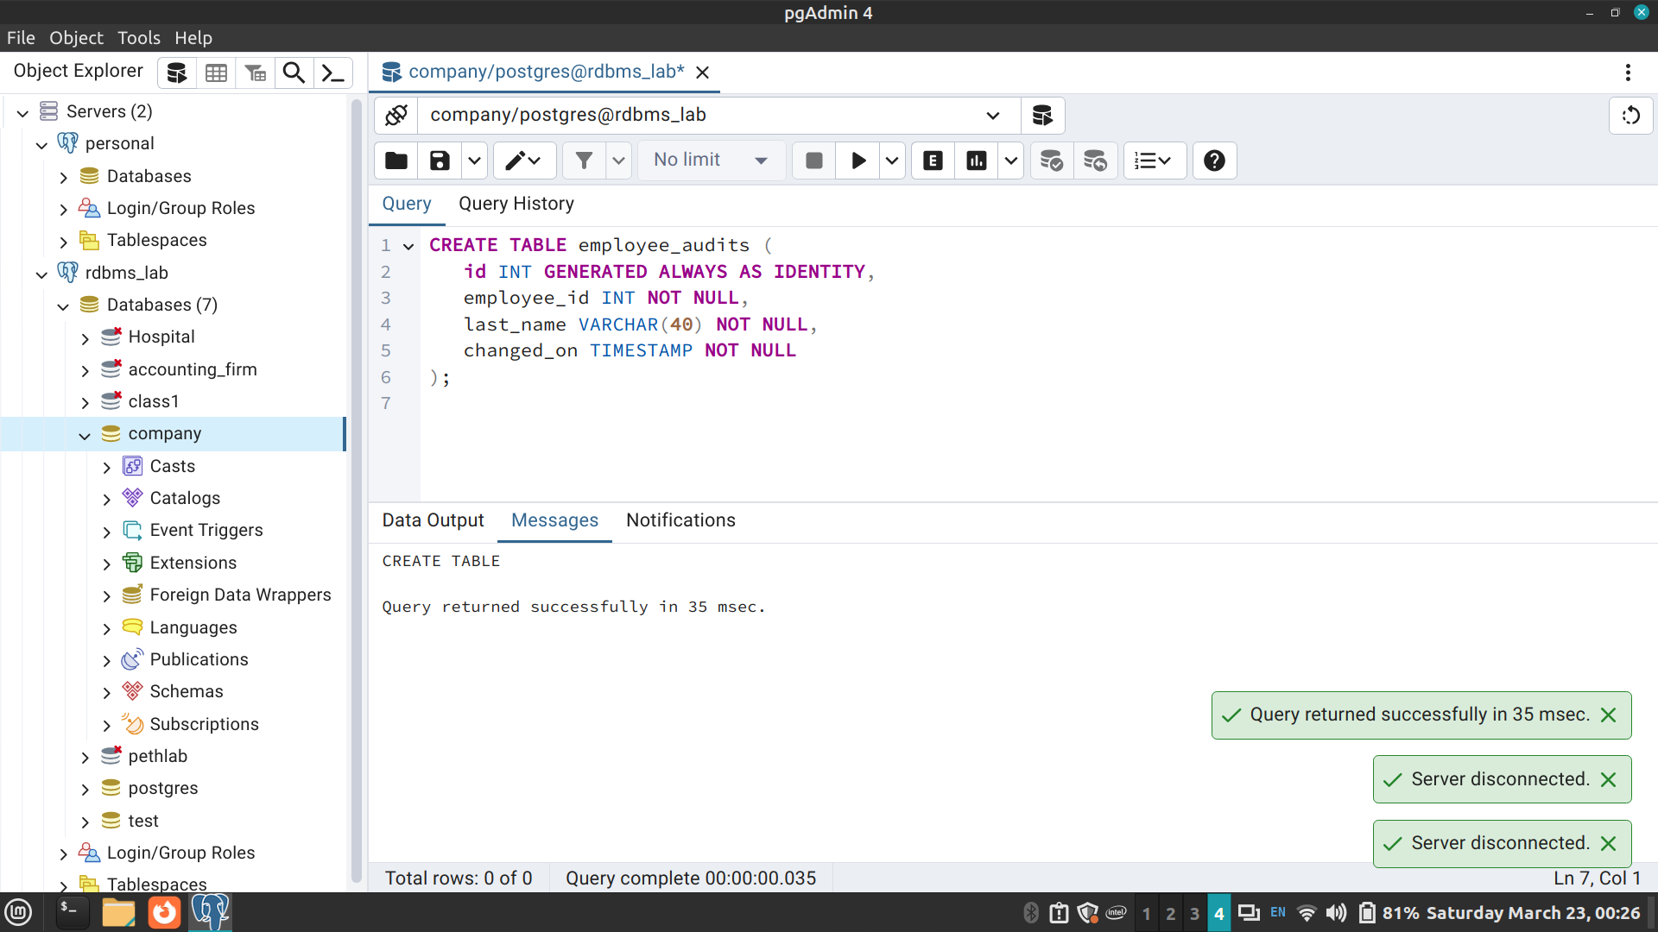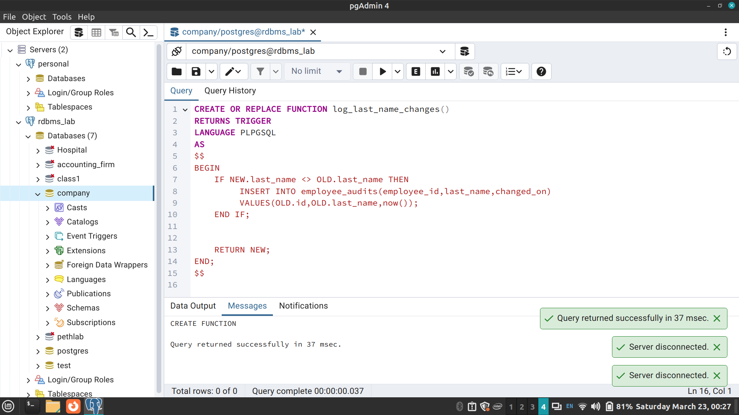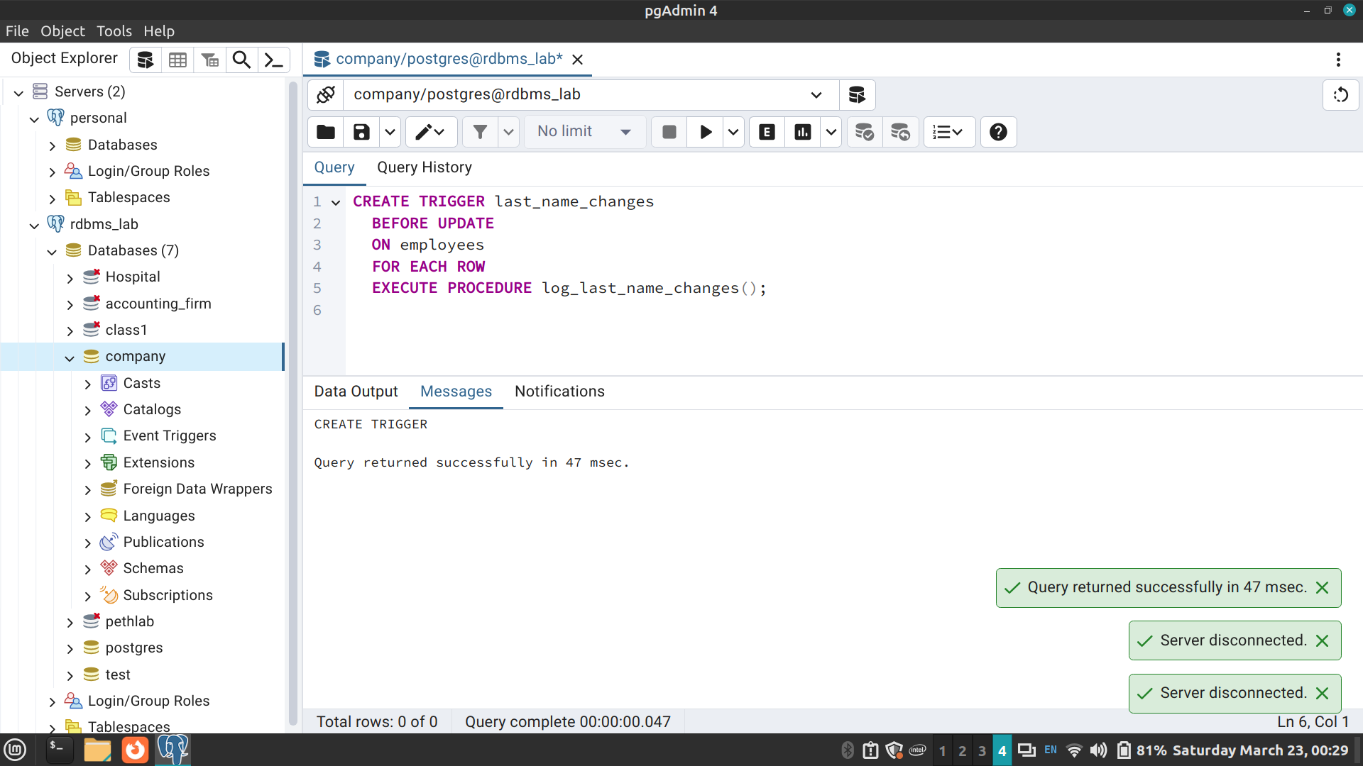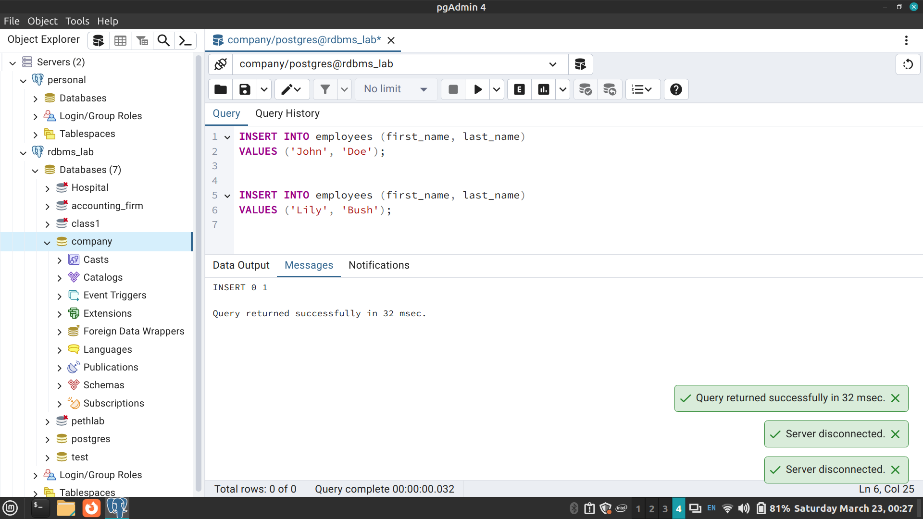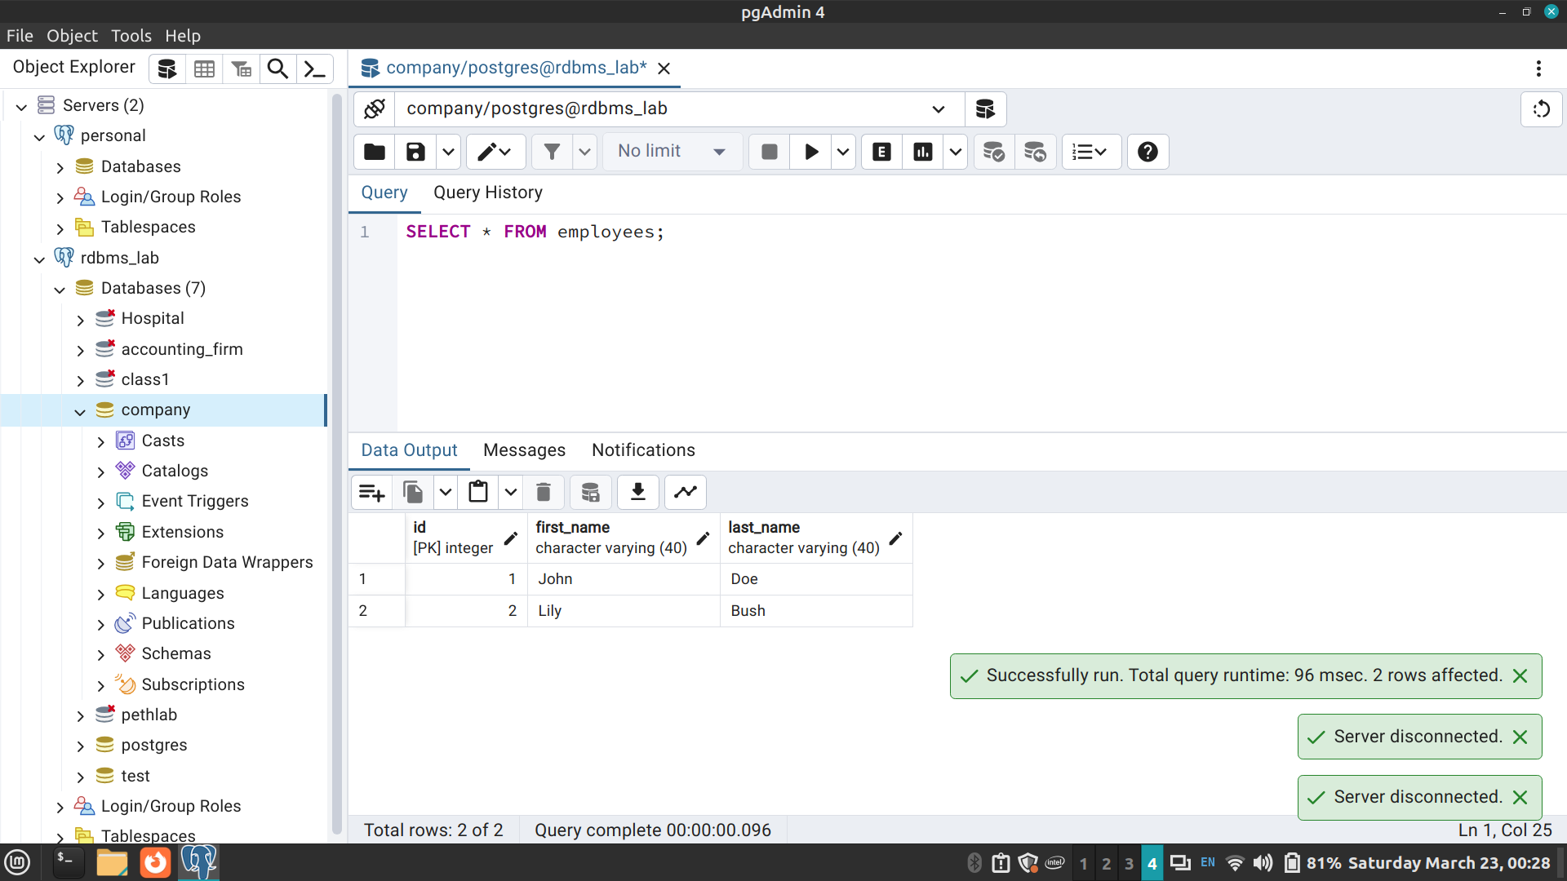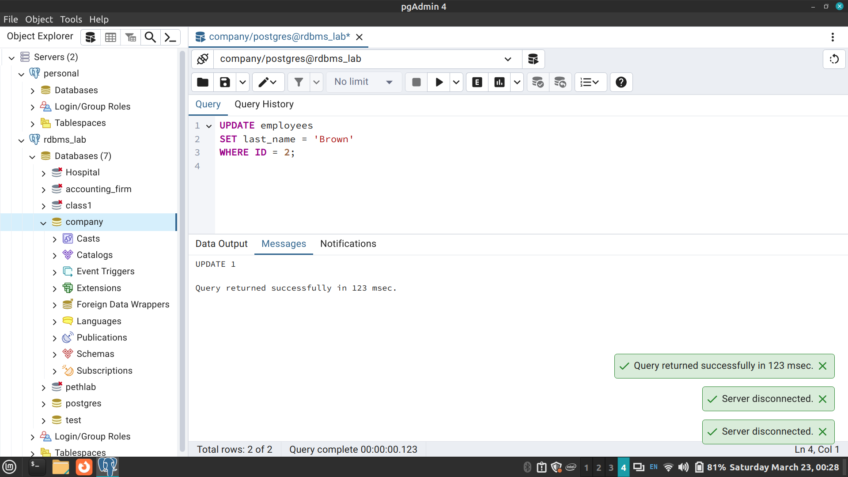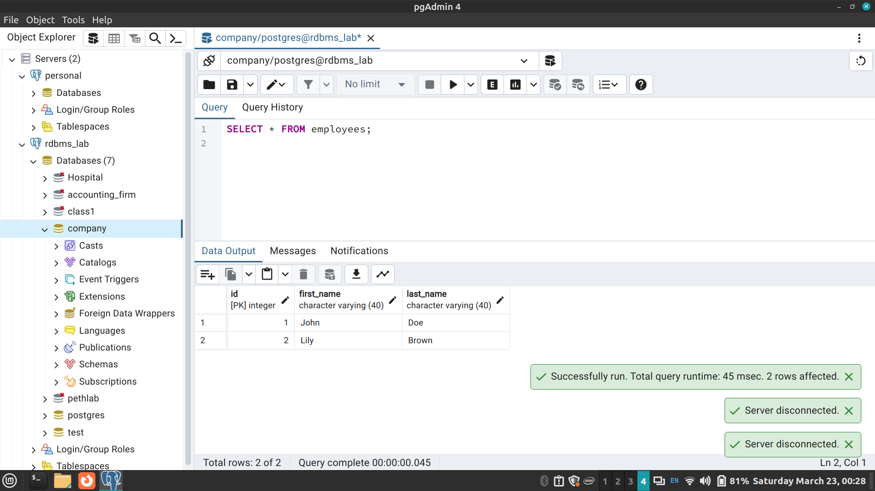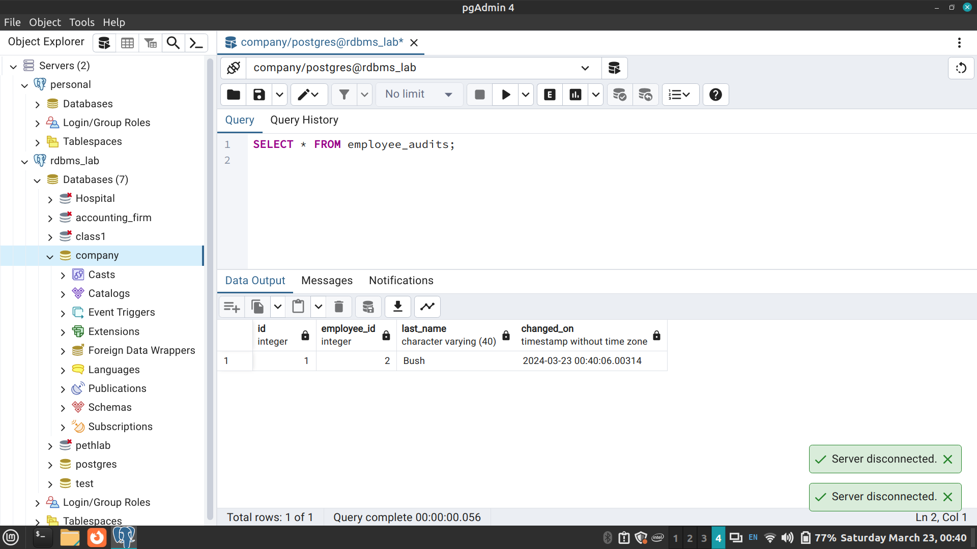

TRIGGERS ON SELECTED DATABASE

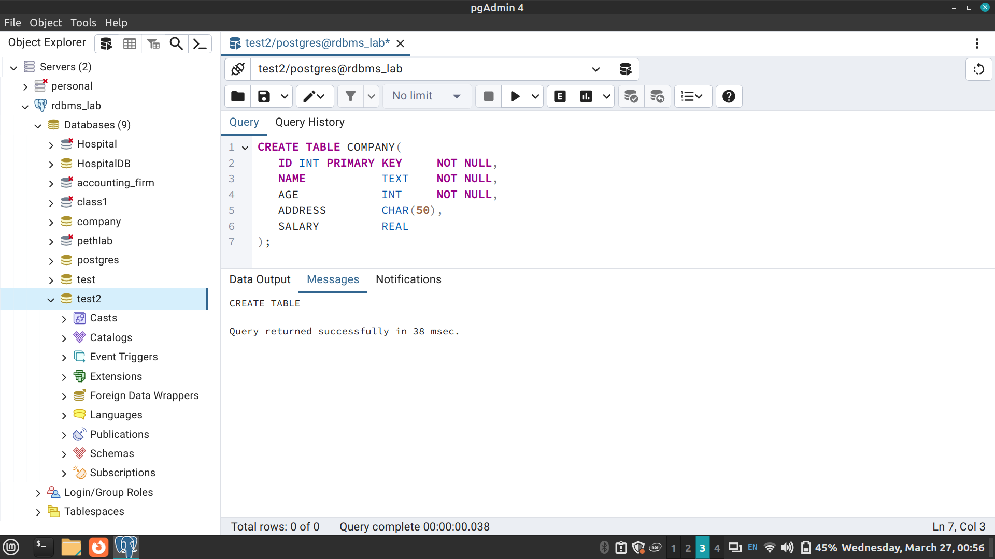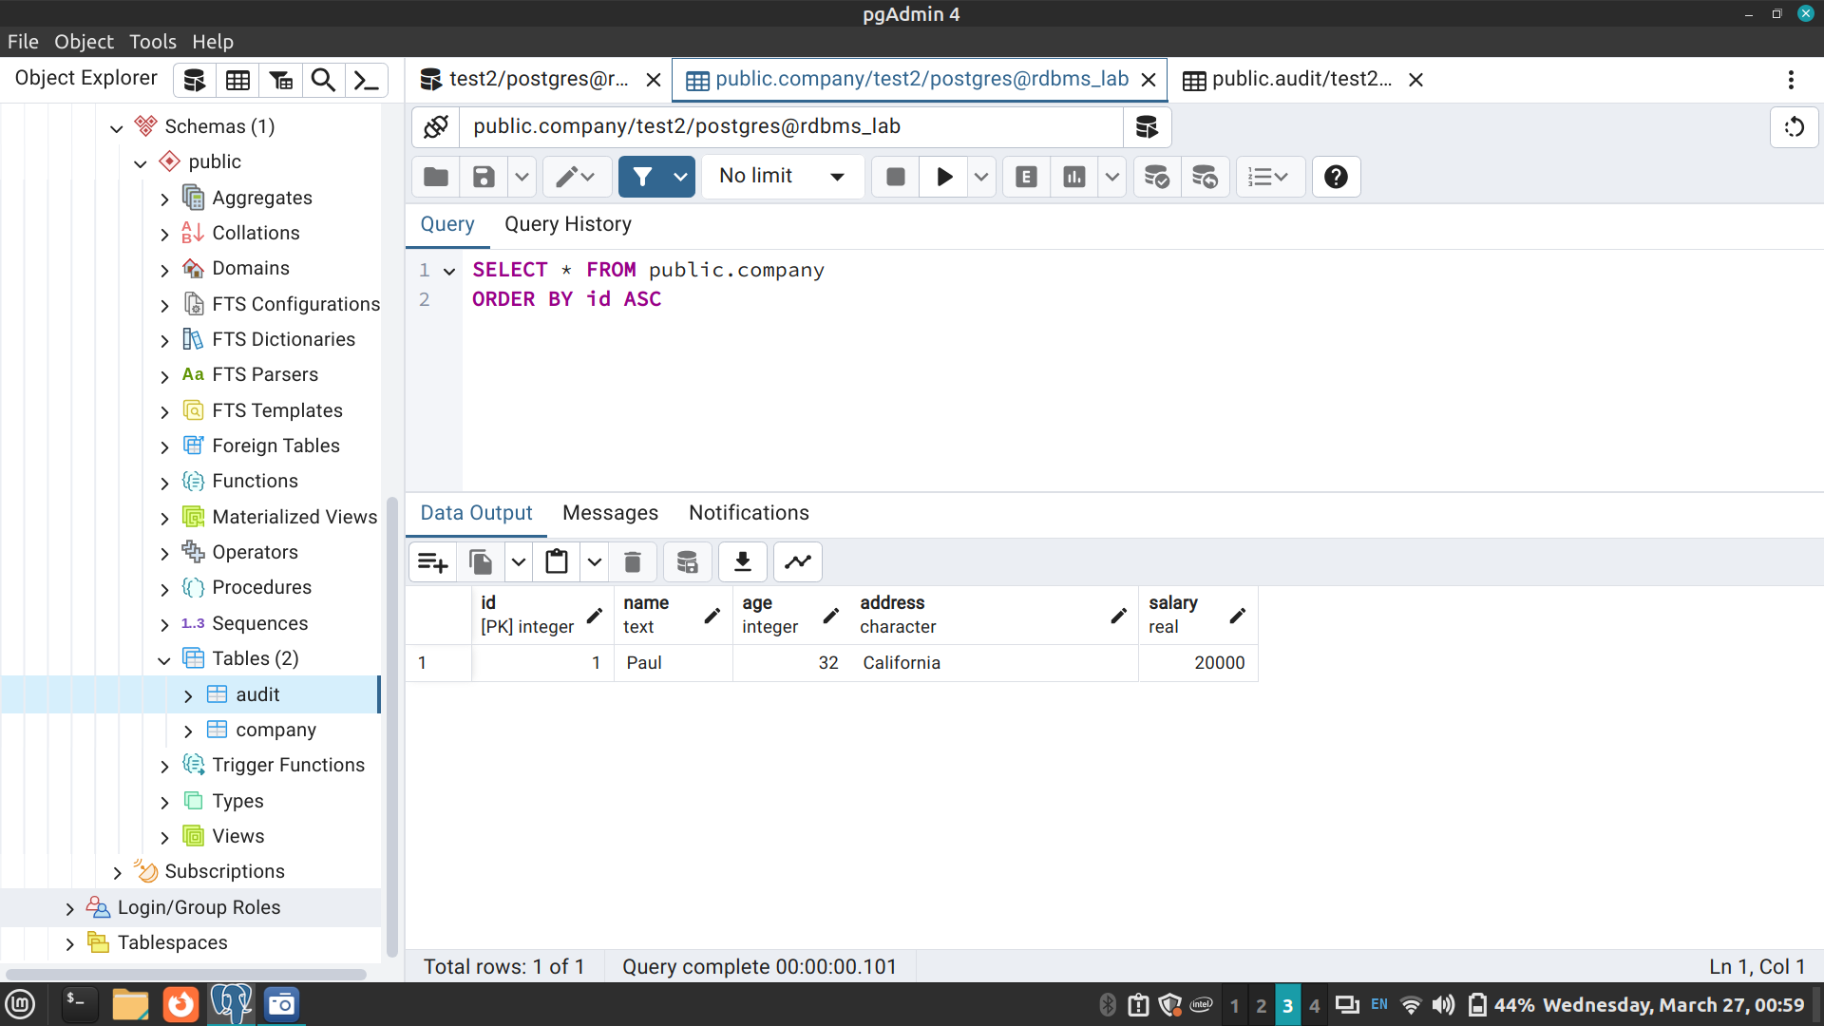
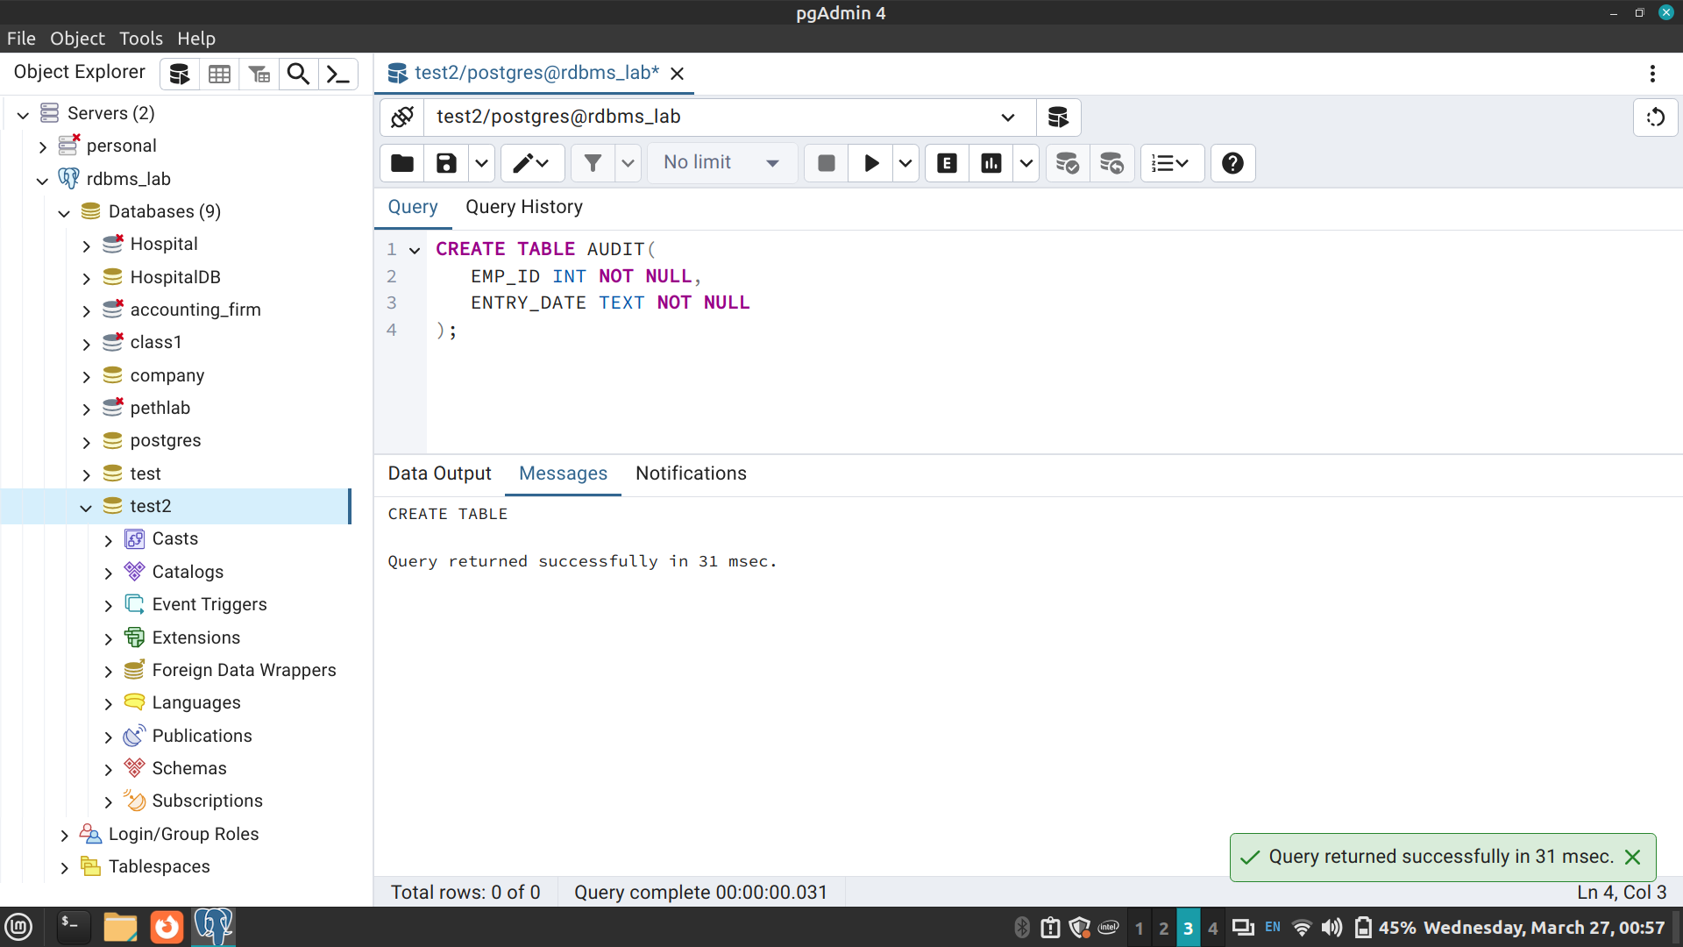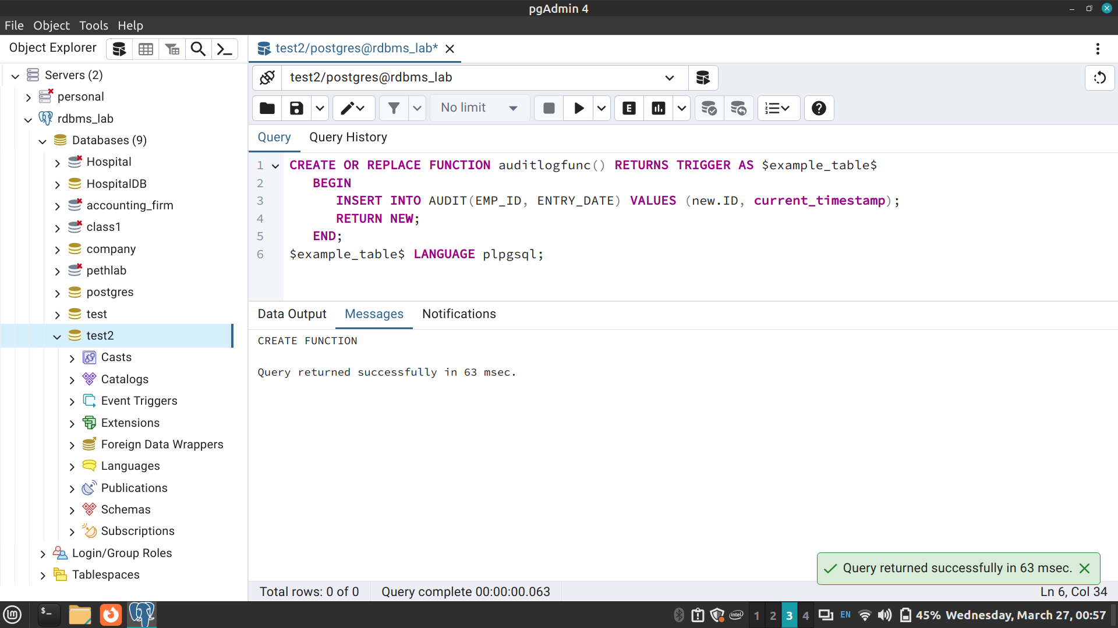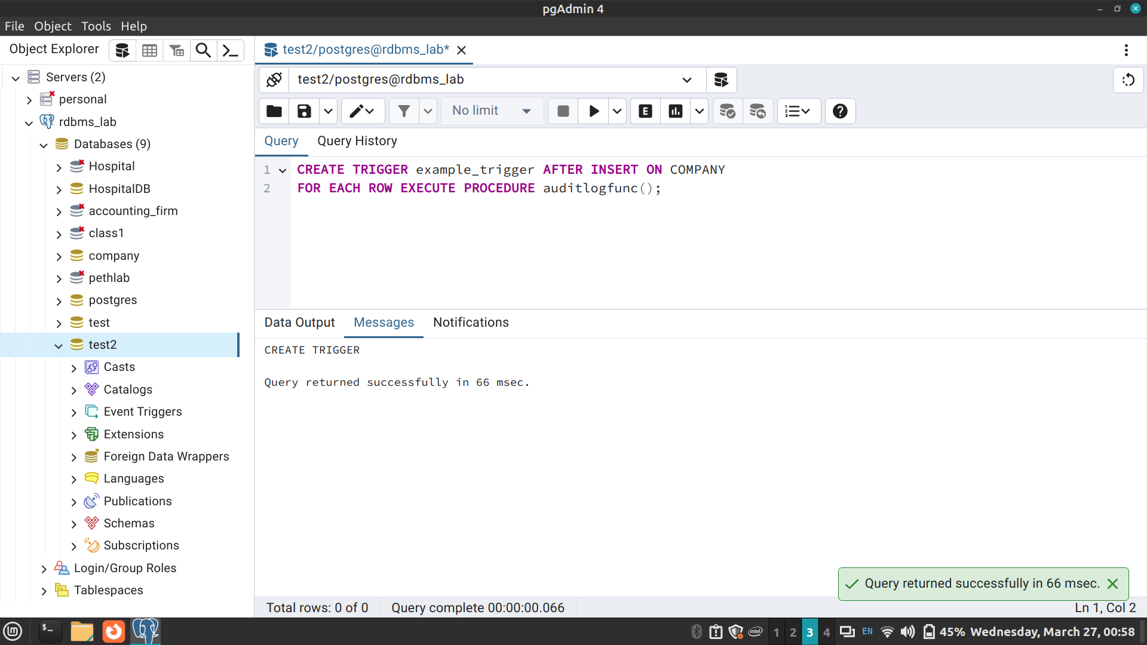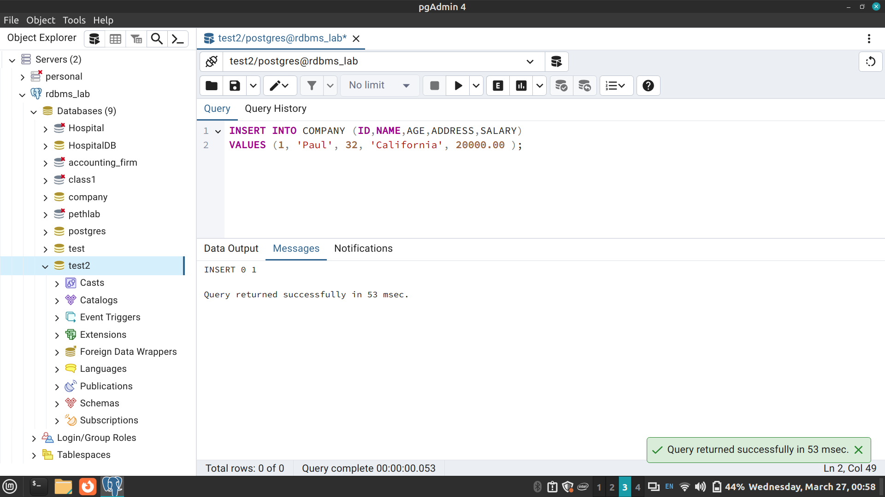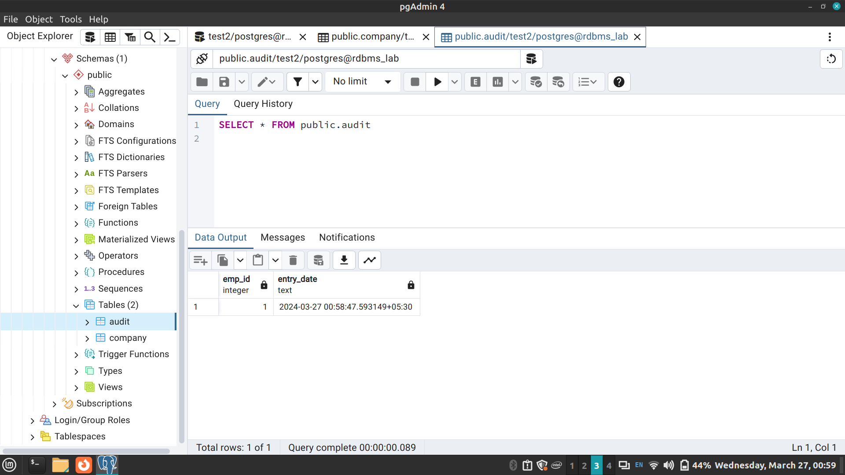

Conclusion:
In conclusion, SQL views and triggers provide essential functionalities for managing relational databases effectively. Views offer flexible data presentation and access control, while triggers enable automatic actions in response to database events. Despite considerations such as server load and complexity, when used judiciously, views and triggers contribute to a robust database management system.

Post Lab Questions:

What is a view?

a) A view is a special stored procedure executed when certain event occurs

b) A view is a virtual table which results of executing a pre-compiled query

c) A view is a database diagram

d) None of the Mentioned

Answer: (b) A view is a virtual table which results of executing a pre-compiled query

List Advantages and disadvantages of triggers

Advantages of triggers

Triggers are useful for enforcing referential integrity, which preserves the defined relationships between tables when you add, update or delete the rows in those tables.

Make sure that a column is filled with default information.

After finding that the new information is inconsistent with the database, raise an error that will cause the entire transaction to roll back.

Disadvantages of triggers
- Invisible from client applications − Basically MySQL triggers are invoked and executed invisible from the client applications hence it is very much difficult to figure out what happens in the database layer.
- Impose load on server − Triggers can impose a high load on the database server.
- Not recommended for high velocity of data − Triggers are not beneficial for use with high-velocity data i.e. the data when a number of events per second are high. It is because in case of high-velocity data the triggers get triggered all the time.

