Batch: A2 Roll No.: 16010122034

Experiment / Assignment / Tutorial No. 8

Grade: AA / AB / BB / BC / CC / CD /DD

Signature of the Staff In-charge with date

Title: Implementing TCL/DCL

Objective: To be able to Implement TCL and DCL.

Expected Outcome of Experiment:
CO 2: Convert entity-relationship diagrams into relational tables, populate a relational
database and formulate SQL queries on the data Use SQL for creation and query the database.

CO 4: Demonstrate the concept of transaction, concurrency control and recovery techniques.

Books/ Journals/ Websites referred:

1. Dr. P.S. Deshpande, SQL and PL/SQL for Oracle 10g.Black book, Dreamtech Press
2. www.db-book.com
3. Korth, Slberchatz, Sudarshan : “Database Systems Concept”, 5th Edition , McGraw
Hill
4. Elmasri and Navathe,”Fundamentals of database Systems”, 4th Edition,PEARSON
Education.
5. https://onecompiler.com/tutorials/postgresql/commands/dcl-commands

Resources used: PostgreSQL

Theory

DCL stands for Data Control Language.
DCL is used to control user access in a database.
This command is related to the security issues.
Using DCL command, it allows or restricts the user from accessing data in database schema.
DCL commands are as follows,
GRANT
REVOKE
It is used to grant or revoke access permissions from any database user.

GRANT command gives user's access privileges to the database.
This command allows specified users to perform specific tasks.
Syntax:
GRANT { { SELECT | INSERT | UPDATE | DELETE | TRUNCATE | REFERENCES | TRIGGER }
[, ...] | ALL [ PRIVILEGES ] }
ON { [ TABLE ] table_name [, ...]
| ALL TABLES IN SCHEMA schema_name [, ...] }
TO { [ GROUP ] role_name | PUBLIC } [, ...] [ WITH GRANT OPTION ]

GRANT { { SELECT | INSERT | UPDATE | REFERENCES } ( column_name [, ...] )
[, ...] | ALL [ PRIVILEGES ] ( column_name [, ...] ) }
ON [ TABLE ] table_name [, ...]
TO { [ GROUP ] role_name | PUBLIC } [, ...] [ WITH GRANT OPTION ]

Example
GRANT INSERT ON films TO PUBLIC;
GRANT ALL PRIVILEGES ON kinds TO ram;
GRANT admins TO krishna;

REVOKE command is used to cancel previously granted or denied permissions.
This command withdraw access privileges given with the GRANT command.
It takes back permissions from user.
Syntax:
REVOKE [ GRANT OPTION FOR ]
{ { SELECT | INSERT | UPDATE | DELETE | TRUNCATE | REFERENCES | TRIGGER }
[, ...] | ALL [ PRIVILEGES ] }
ON { [ TABLE ] table_name [, ...]
| ALL TABLES IN SCHEMA schema_name [, ...] }
FROM { [ GROUP ] role_name | PUBLIC } [, ...]
[ CASCADE | RESTRICT ]

REVOKE [ GRANT OPTION FOR ]
{ { SELECT | INSERT | UPDATE | REFERENCES } ( column_name [, ...] )
[, ...] | ALL [ PRIVILEGES ] ( column_name [, ...] ) }
ON [ TABLE ] table_name [, ...]
FROM { [ GROUP ] role_name | PUBLIC } [, ...]
[ CASCADE | RESTRICT ]

REVOKE [ GRANT OPTION FOR ]
{ { USAGE | SELECT | UPDATE }
[, ...] | ALL [ PRIVILEGES ] }
ON { SEQUENCE sequence_name [, ...]
| ALL SEQUENCES IN SCHEMA schema_name [, ...] }
FROM { [ GROUP ] role_name | PUBLIC } [, ...]
[ CASCADE | RESTRICT ]

Example
REVOKE INSERT ON films FROM PUBLIC;
REVOKE ALL PRIVILEGES ON kinds FROM Madhav;
REVOKE admins FROM Keshav;

TCL stands for Transaction Control Language.
This command is used to manage the changes made by DML statements.
TCL allows the statements to be grouped together into logical transactions.
TCL commands are as follows:
1. COMMIT
2. SAVEPOINT
3. ROLLBACK
4. SET TRANSACTION

COMMIT command saves all the work done. It ends the current transaction and makes permanent changes during the transaction
Syntax:
commit;

SAVEPOINT command is used for saving all the current point in the processing of a transaction. It marks and saves the current point in the processing of a transaction. It is used to temporarily save a transaction, so that you can rollback to that point whenever necessary.
Syntax
SAVEPOINT savepoint_name

ROLLBACK command restores database to original since the last COMMIT. It is used to restores the database to last committed state.
Syntax:
ROLLBACK [ WORK | TRANSACTION ] TO [ SAVEPOINT ] savepoint_name

Example
BEGIN;
INSERT INTO table1 VALUES (1);
SAVEPOINT my_savepoint;
INSERT INTO table1 VALUES (2);
ROLLBACK TO SAVEPOINT my_savepoint;
INSERT INTO table1 VALUES (3);
COMMIT;
The above transaction will insert the values 1 and 3, but not 2.

SET TRANSACTION is used for placing a name on a transaction. You can specify a transaction to be read only or read write. This command is used to initiate a database transaction.

Syntax:
SET TRANSACTION [Read Write | Read Only];
The SET TRANSACTION command sets the characteristics of the current transaction. It has no effect on any subsequent transactions. SET SESSION CHARACTERISTICS sets the default transaction characteristics for subsequent transactions of a session. These defaults can be overridden by SET TRANSACTION for an individual transaction.
The available transaction characteristics are the transaction isolation level, the transaction access mode (read/write or read-only), and the deferrable mode. In addition, a snapshot can be selected, though only for the current transaction, not as a session default.
The isolation level of a transaction determines what data the transaction can see when other transactions are running concurrently:

READ COMMITTED
A statement can only see rows committed before it began. This is the default.

REPEATABLE READ
All statements of the current transaction can only see rows committed before the first query or data-modification statement was executed in this transaction.

SERIALIZABLE
All statements of the current transaction can only see rows committed before the first query or data-modification statement was executed in this transaction. If a pattern of reads and writes among concurrent serializable transactions would create a situation which could not have occurred for any serial (one-at-a-time) execution of those transactions, one of them will be rolled back with a serialization_failure error.
Examples
With the default read committed isolation level.

process A: BEGIN; -- the default is READ COMMITED

process A: SELECT sum(value) FROM purchases;
--- process A sees that the sum is 1600

process B: INSERT INTO purchases (value) VALUES (400)
--- process B inserts a new row into the table while
--- process A's transaction is in progress

process A: SELECT sum(value) FROM purchases;
--- process A sees that the sum is 2000

process A: COMMIT;

If we want to avoid the changing sum value in process A during the lifespan of the transaction, we can use the repeatable read transaction mode.
process A: BEGIN TRANSACTION ISOLATION LEVEL REPEATABLE READ;
process A: SELECT sum(value) FROM purchases;
--- process A sees that the sum is 1600

process B: INSERT INTO purchases (value) VALUES (400)
--- process B inserts a new row into the table while
--- process A's transaction is in progress

process A: SELECT sum(value) FROM purchases;
--- process A still sees that the sum is 1600

process A: COMMIT;

The transaction in process A freeze its snapshot of the data and offers consistent values during the life of the transaction.
Repeatable reads are not more expensive than the default read commit transaction. There is no need to worry about performance penalties. However, applications must be prepared to retry transactions due to serialization failures.
Let’s observe an issue that can occur while using the repeatable read isolation level — the could not serialize access due to concurrent update error.
process A: BEGIN TRANSACTION ISOLATION LEVEL REPEATABLE READ;
process B: BEGIN;
process B: UPDATE purchases SET value = 500 WHERE id = 1;
process A: UPDATE purchases SET value = 600 WHERE id = 1;
-- process A wants to update the value while process B is changing it
-- process A is blocked until process B commits

process B: COMMIT;
process A: ERROR: could not serialize access due to concurrent update
-- process A immidiatly errors out when process B commits
If process B would rolls back, then its changes are negated and repeatable read can proceed without issues. However, if process B commits the changes then the repeatable read transaction will be rolled back with the error message because it can not modify or lock the rows changed by other processes after the repeatable read transaction has began.
Demonstrate the differences between the two isolation modes.
process A: BEGIN TRANSACTION ISOLATION LEVEL REPEATABLE READ;
process A: SELECT sum(value) FROM purchases;
process A: INSERT INTO purchases (value) VALUES (100);
process B: BEGIN TRANSACTION ISOLATION LEVEL REPEATABLE READ;
process B: SELECT sum(value) FROM purchases;
process B: INSERT INTO purchases (id, value);
process B: COMMIT;
process A: COMMIT;
With Repeatable Reads everything works, but if we run the same thing with a Serializable isolation mode, process A will error out.
process A: BEGIN TRANSACTION ISOLATION LEVEL SERIALIZABLE;
process A: SELECT sum(value) FROM purchases;
process A: INSERT INTO purchases (value) VALUES (100);
process B: BEGIN TRANSACTION ISOLATION LEVEL SERIALIZABLE;
process B: SELECT sum(value) FROM purchases;
process B: INSERT INTO purchases (id, value);
process B: COMMIT;
process A: COMMIT;
ERROR: could not serialize access due to read/write
dependencies among transactions
DETAIL: Reason code: Canceled on identification as
a pivot, during commit attempt.
HINT: The transaction might succeed if retried.

Both transactions have modified what the other transaction would have read in the select statements. If both would allow to commit this would violate the Serializable behaviour, because if they were run one at a time, one of the transactions would have seen the new record inserted by the other transaction.

Implementation Screenshots (Problem Statement, Query and Screenshots of Results):
Demonstrate DCL and TCL language commands on your database.
TCL

CREATE TABLE Product (
Product_id INT PRIMARY KEY,
Product_name VARCHAR(40),
Price INT,
Quantity INT );
INSERT INTO Product VALUES(111, 'Mobile', 10000, 10),
(112, 'Laptop', 20000, 15),
(113, 'Mouse', 300, 20),
(114, 'Hard Disk', 4000, 25),
(115, 'Speaker', 3000, 20);

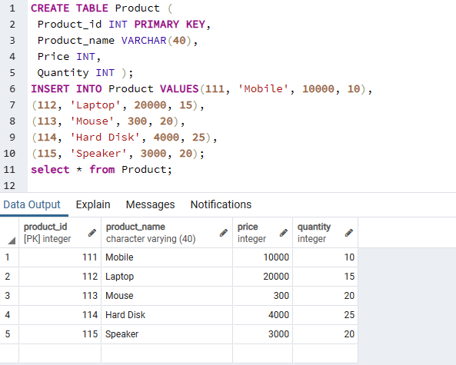

-- Start a new transaction
BEGIN TRANSACTION
-- SQL Statements
INSERT INTO Product VALUES(116, 'Headphone', 2000, 30)
UPDATE Product SET Price = 450 WHERE Product_id = 113
-- Commit changes
COMMIT TRANSACTION

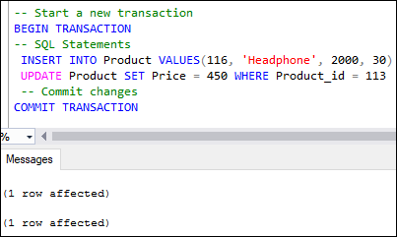
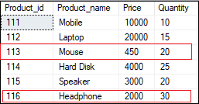

-- Start a new transaction
BEGIN TRANSACTION
-- SQL Statements
UPDATE Product SET Price = 5000 WHERE Product_id = 114
DELETE FROM Product WHERE Product_id = 116
--Undo Changes
ROLLBACK TRANSACTION

Savepoint in Transactions
The savepoint inserts a special mark into a transaction that allows us to rollbacks all changes executed after savepoint. It is also used to roll back any specific portion of the transaction rather than the entire transaction. We can define it by using the SAVE TRANSACTION sp_name statement. The following example will explain the use of savepoint in transactions that commits the insert statement and rollbacks the delete statement.
BEGIN TRANSACTION
INSERT INTO Product VALUES (117, 'USB Drive', 1500, 10)
SAVEPOINT TRANSACTION
DELETE FROM Product WHERE Product_id = 116
SELECT * FROM Product
ROLLBACK TRANSACTION
COMMIT
SELECT * FROM Product;

See the below result where we can see the product id 116 is deleted, and 117 is inserted in the first output. However, in the second output, the deletion operation is rolled back because of the savepoint.

SCREENSHOTS:
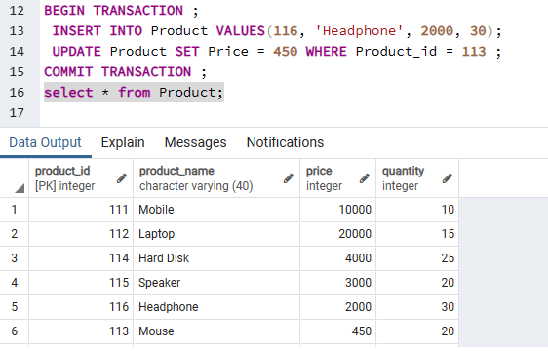
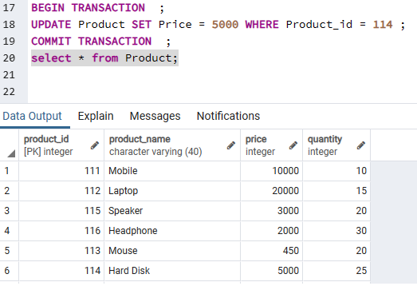
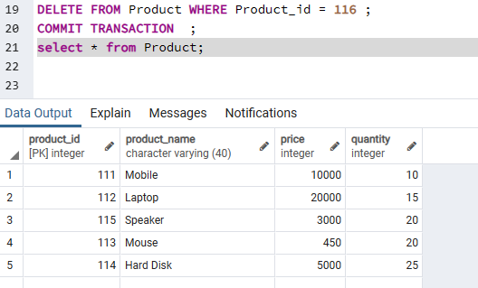
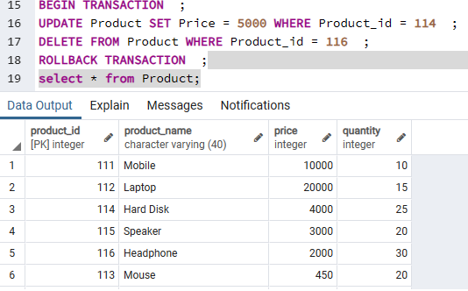
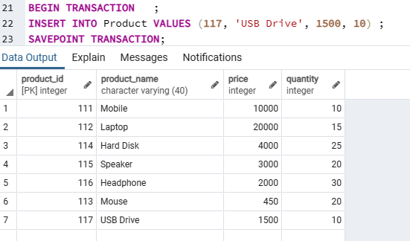
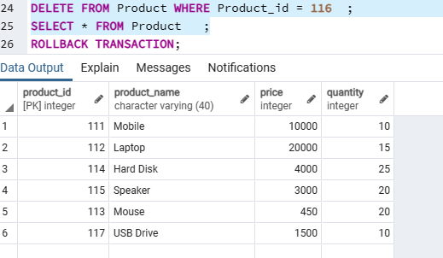
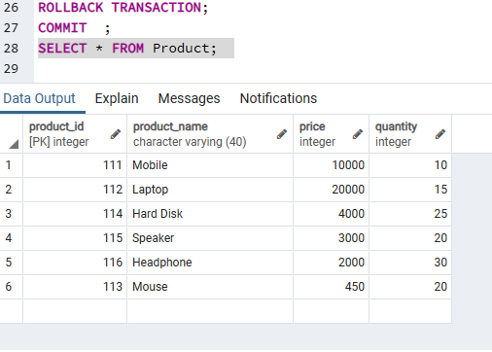
DCL

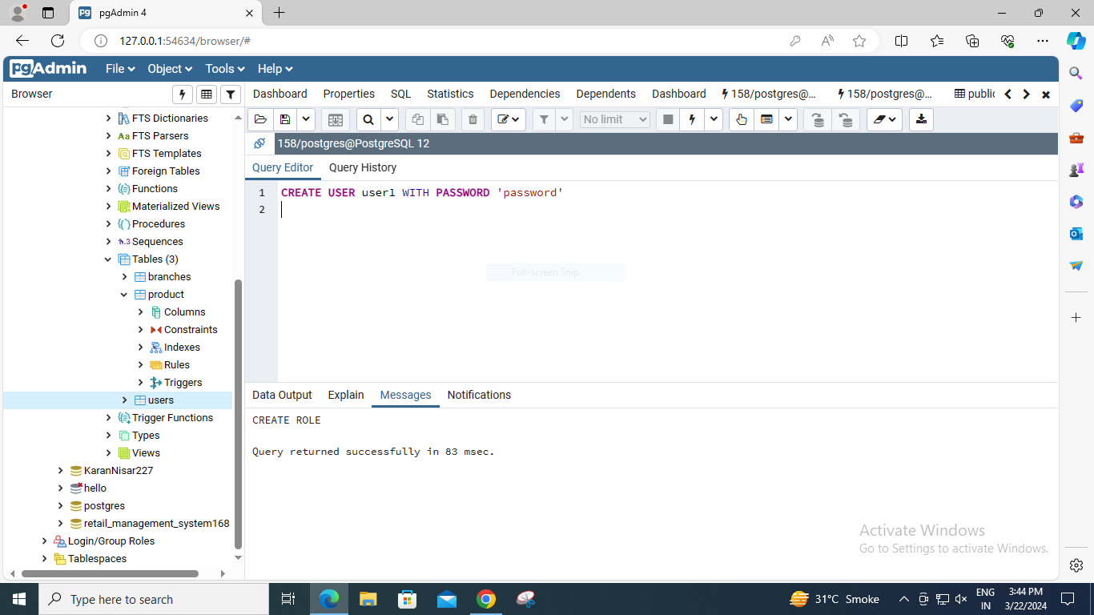

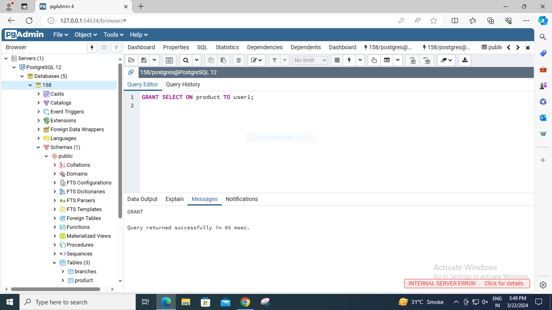
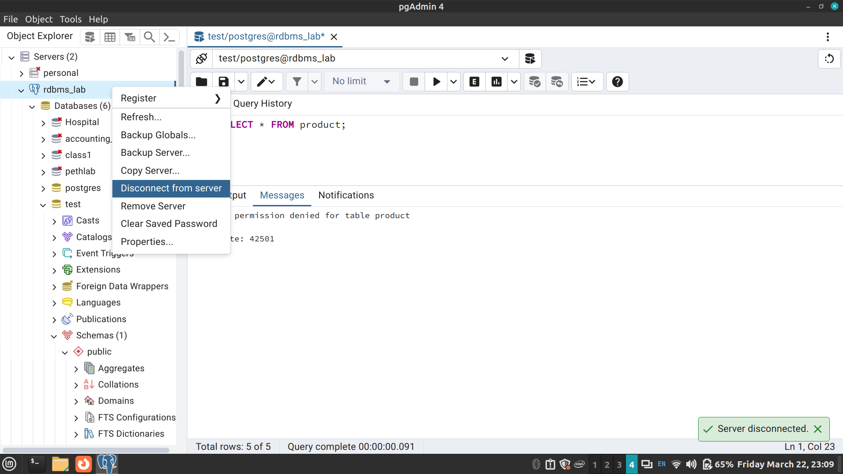
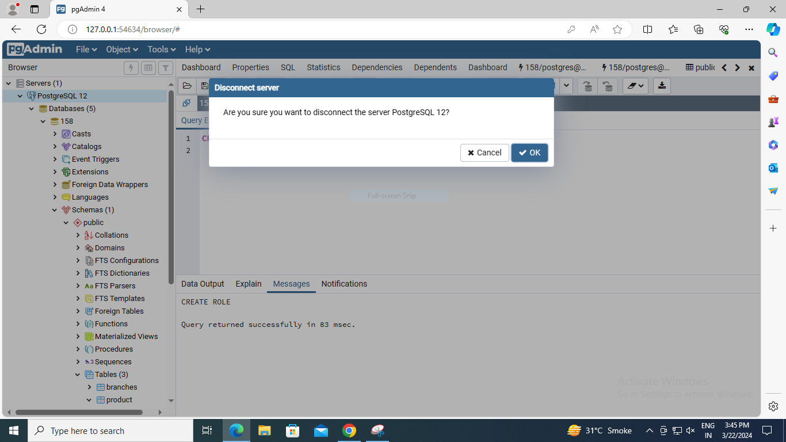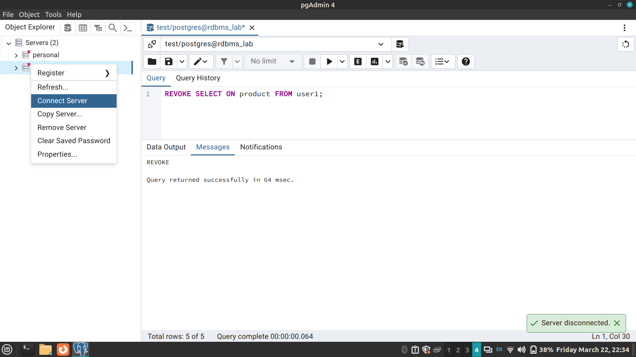
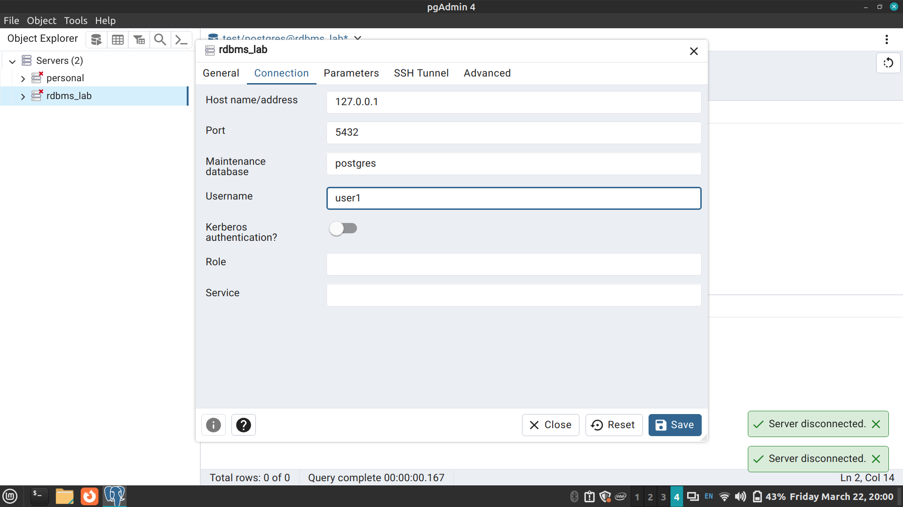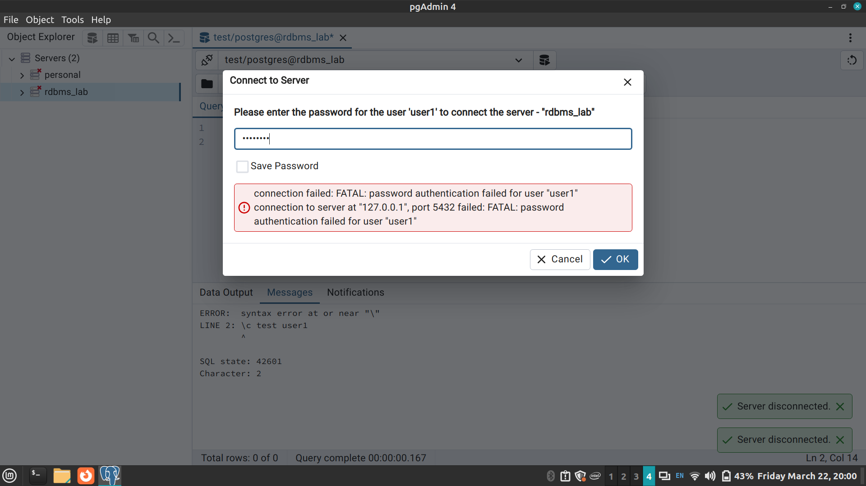
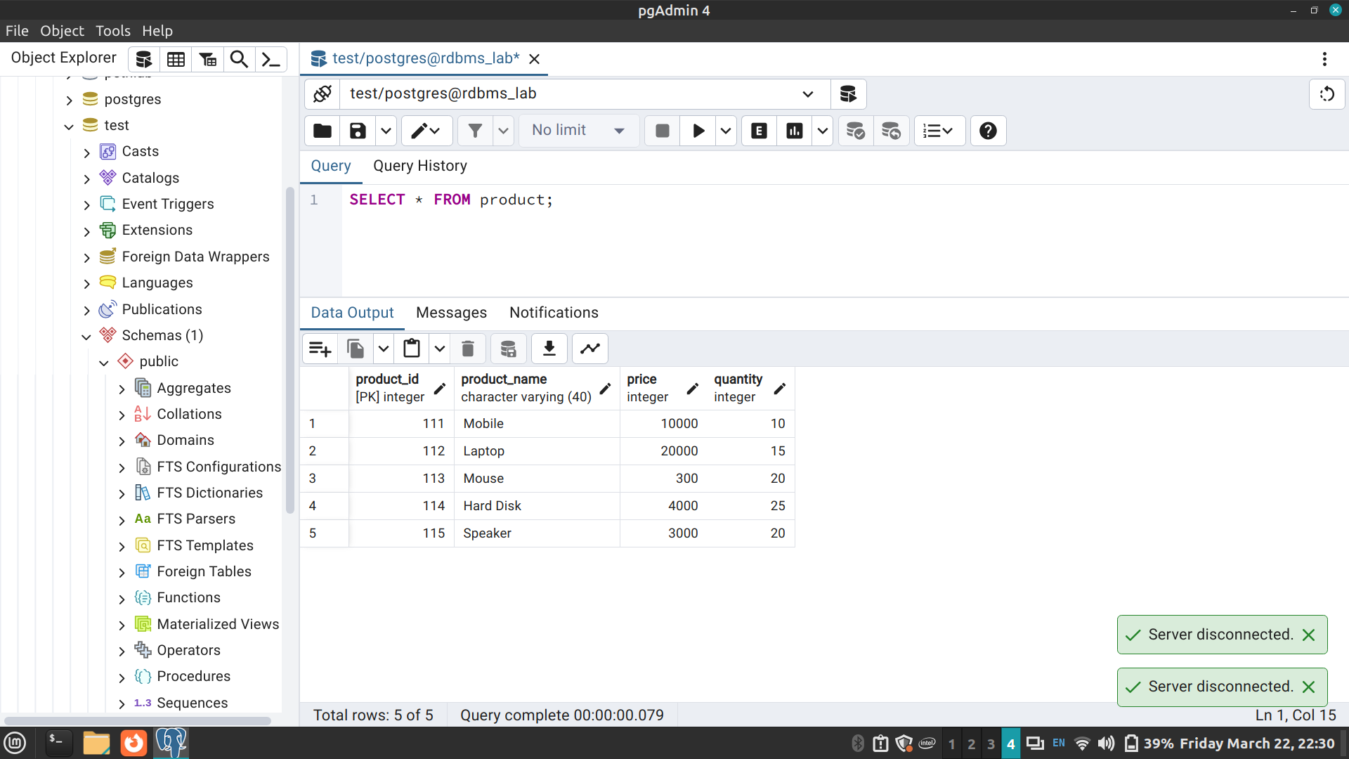

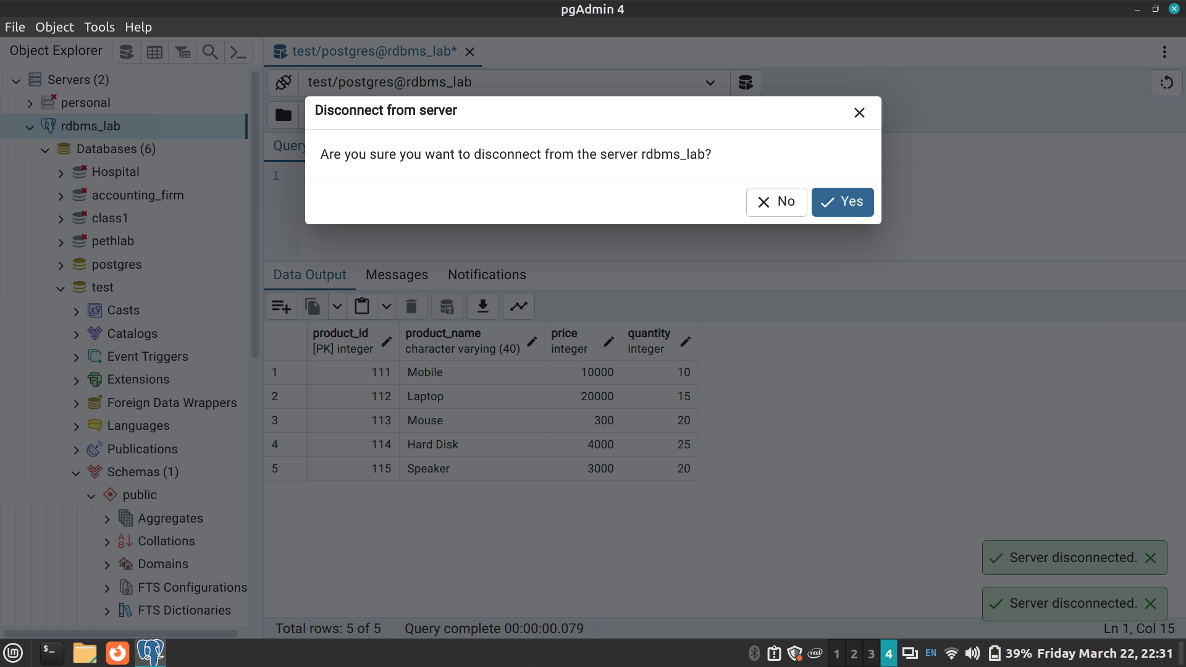

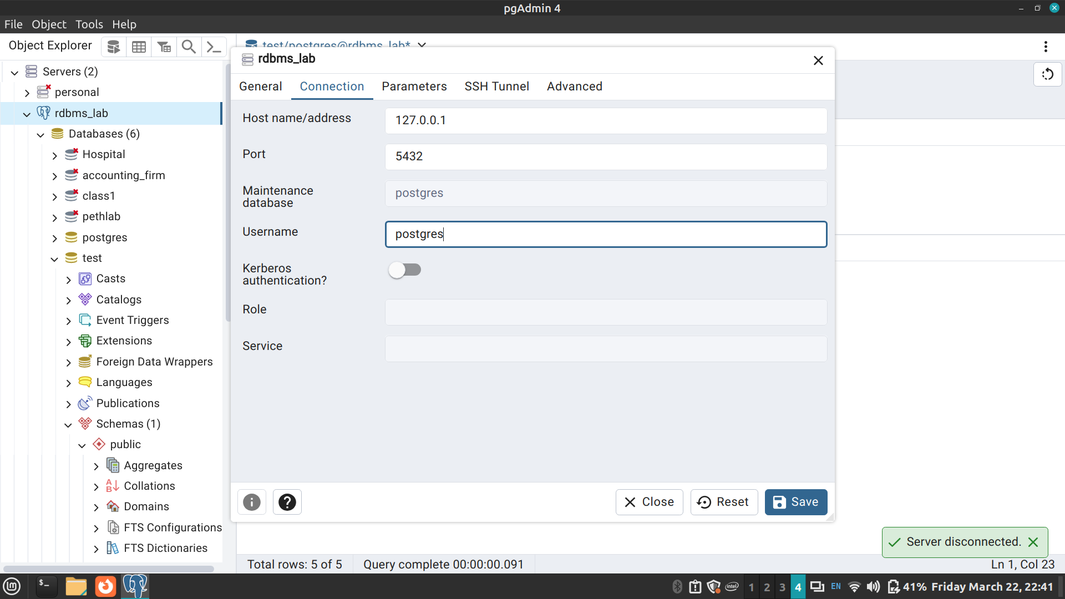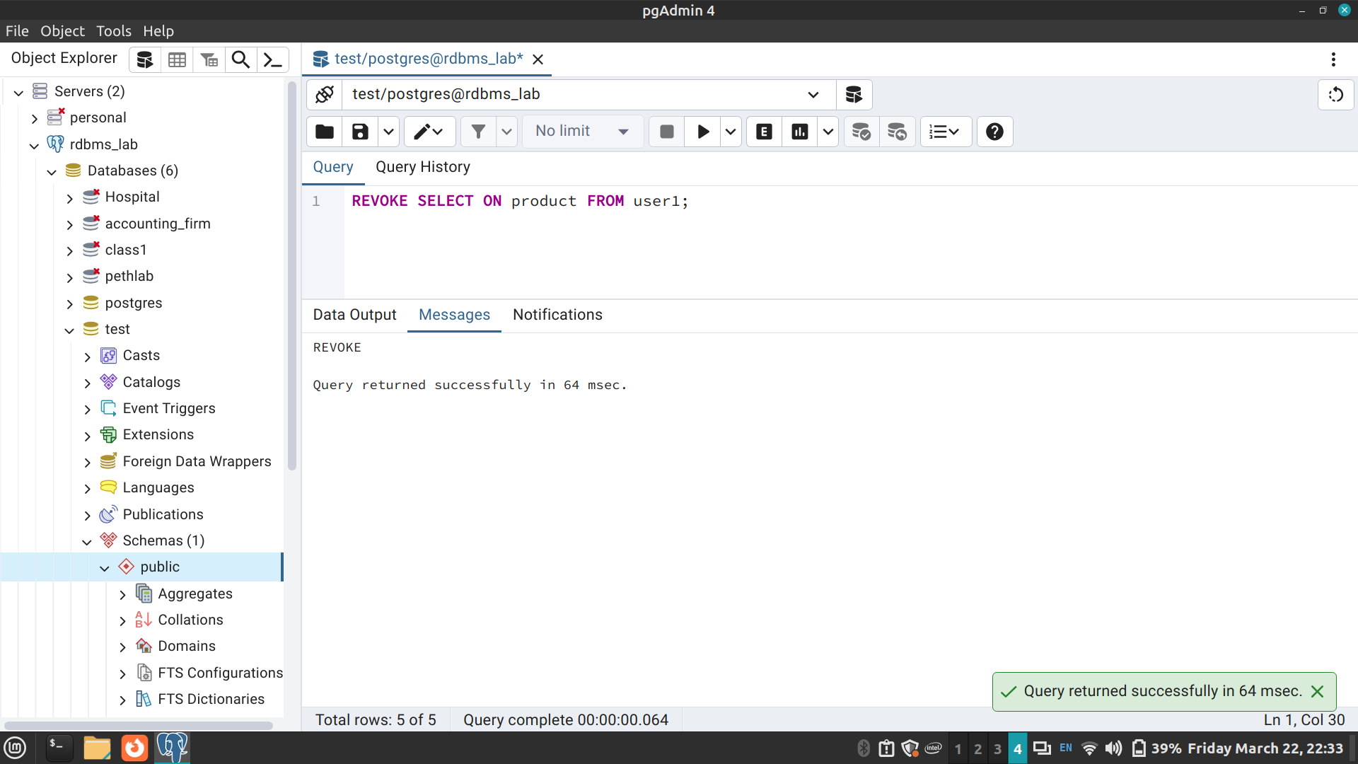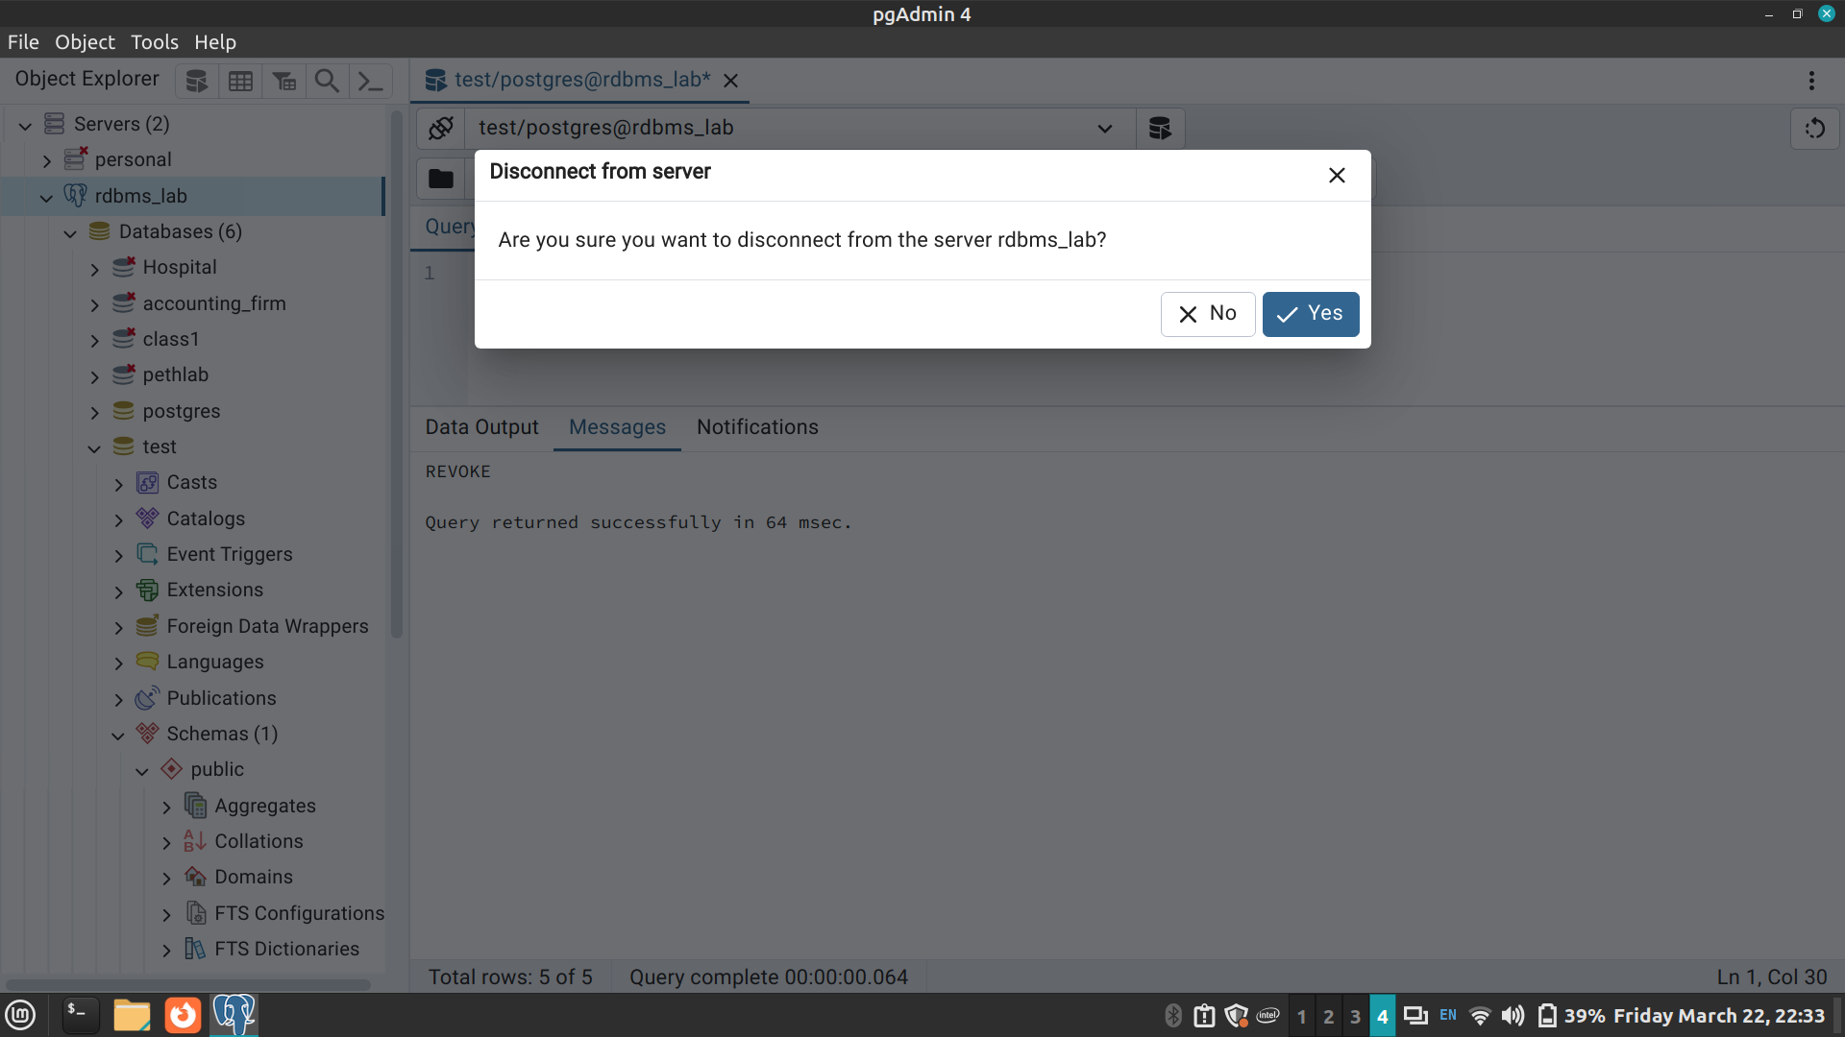

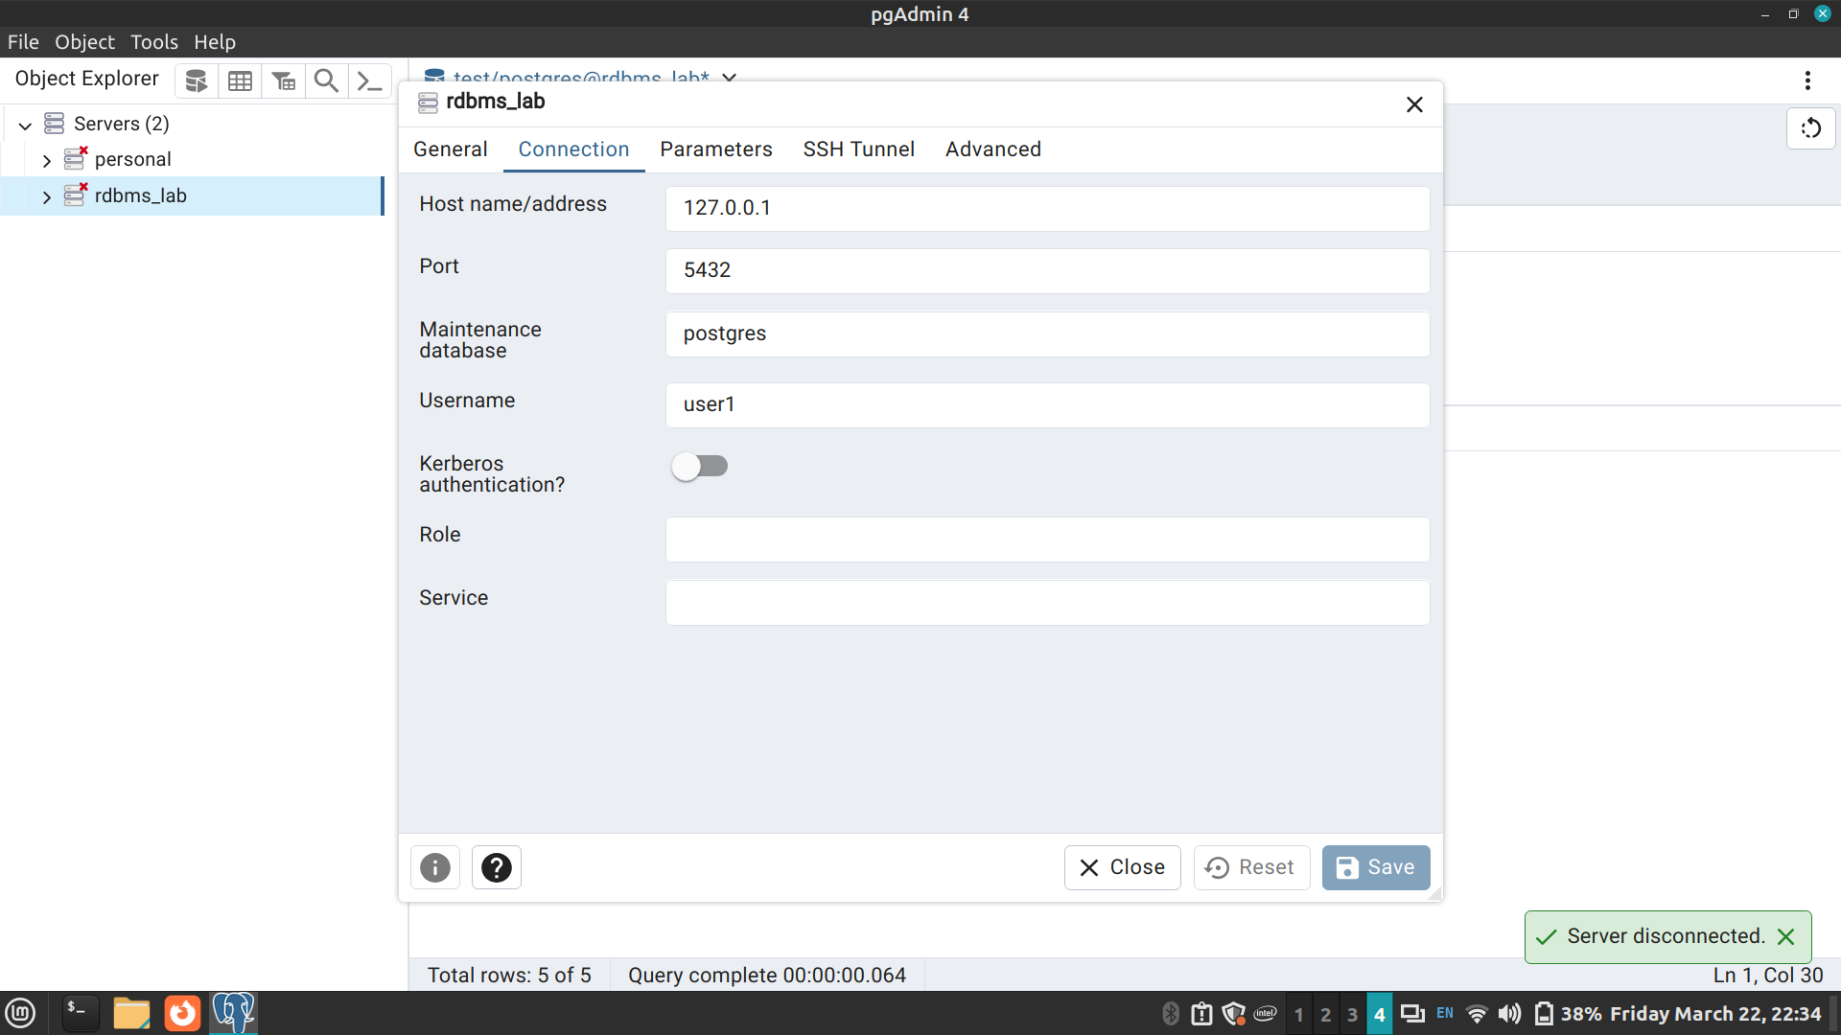

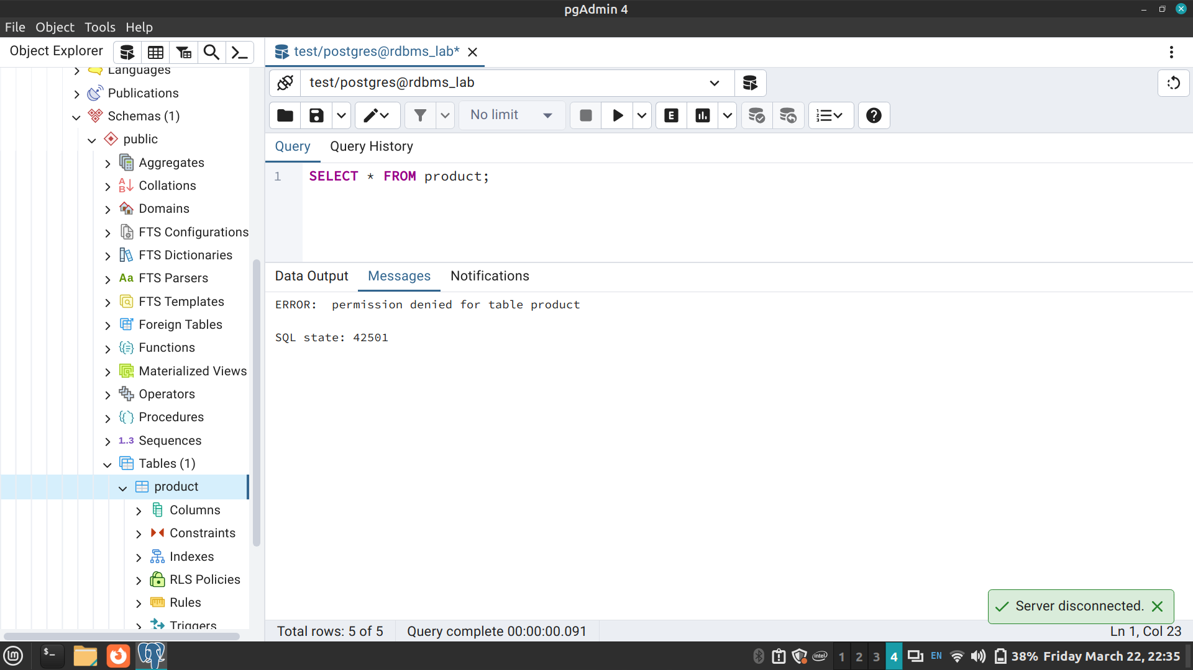

Conclusion:
Successfully implemented TCL and DCL commands in PostgreSQL
Post Lab Questions:
- Discuss ACID properties of transaction with suitable example
ACID properties are the four key characteristics that ensure the reliability and consistency of database transactions. These properties stand for Atomicity, Consistency, Isolation, and Durability.
Atomicity: This property ensures that either all operations within a transaction are successfully completed and committed, or none of them are. In other words, a transaction is indivisible and all-or-nothing. If any part of the transaction fails, the entire transaction is rolled back to its initial state.
Consistency: This property ensures that the database remains in a consistent state before and after the transaction. It means that any transaction should bring the database from one valid state to another, maintaining all integrity constraints, domain constraints, and business rules.
Isolation: Isolation ensures that the concurrent execution of transactions produces the same results as if the transactions were executed serially. It prevents interference between transactions that are executing concurrently by ensuring that each transaction is unaware of other transactions executing concurrently.
Durability: This property ensures that once a transaction is committed, its effects persist even in the event of system failures. The changes made by committed transactions are permanent and will not be lost, even if the system crashes.

- What is the purpose of the SAVEPOINT command in SQL?
The SAVEPOINT command is used within a transaction to mark a point to which you can later roll back. It allows you to create a point within a transaction to which you can later rollback if necessary. This is particularly useful when you want to divide a large transaction into smaller parts and rollback to a specific part without undoing the entire transaction.
For example, consider a scenario where you are updating multiple rows in a table within a single transaction. You might want to create a savepoint before each update operation so that if one of the updates fails, you can rollback to the corresponding savepoint without reverting changes made by previous updates. This helps in granular control over transaction rollback and ensures that only necessary changes are undone.

