TCL Commands for commit, Rollback & savepoint

CREATE TABLE Product (
Product_id INT PRIMARY KEY,
Product_name VARCHAR(40),
Price INT,
Quantity INT );
INSERT INTO Product VALUES(111, 'Mobile', 10000, 10),
(112, 'Laptop', 20000, 15),
(113, 'Mouse', 300, 20),
(114, 'Hard Disk', 4000, 25),
(115, 'Speaker', 3000, 20);

-- Start a new transaction
BEGIN TRANSACTION
-- SQL Statements
INSERT INTO Product VALUES(116, 'Headphone', 2000, 30)
UPDATE Product SET Price = 450 WHERE Product_id = 113
-- Commit changes
COMMIT TRANSACTION

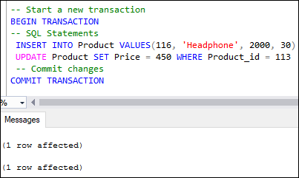
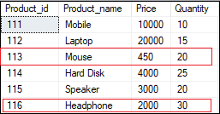

-- Start a new transaction
BEGIN TRANSACTION
-- SQL Statements
UPDATE Product SET Price = 5000 WHERE Product_id = 114
DELETE FROM Product WHERE Product_id = 116
--Undo Changes
ROLLBACK TRANSACTION

Savepoint in Transactions
The savepoint inserts a special mark into a transaction that allows us to rollbacks all changes executed after savepoint. It is also used to roll back any specific portion of the transaction rather than the entire transaction. We can define it by using the SAVE TRANSACTION sp_name statement. The following example will explain the use of savepoint in transactions that commits the insert statement and rollbacks the delete statement.
BEGIN TRANSACTION
INSERT INTO Product VALUES (117, 'USB Drive', 1500, 10)
SAVEPOINT TRANSACTION
DELETE FROM Product WHERE Product_id = 116
SELECT * FROM Product
ROLLBACK TRANSACTION
COMMIT
SELECT * FROM Product;
See the below result where we can see the product id 116 is deleted, and 117 is inserted in the first output. However, in the second output, the deletion operation is rolled back because of the savepoint.
