Batch: A2 Roll No.: 16010122034

Experiment / Assignment / Tutorial No. 7

Title: Implementing indexing and query processing

Objective: To understand Query Processing and implement indexing to improve query execution plans

Expected Outcome of Experiment:
CO 3: Use SQL for relational database creation , maintenance and query processing

Books/ Journals/ Websites referred:

1. Dr. P.S. Deshpande, SQL and PL/SQL for Oracle 10g.Black book, Dreamtech Press
2. www.db-book.com
3. Korth, Slberchatz, Sudarshan : “Database Systems Concept”, 5th Edition , McGraw
Hill
4. Elmasri and Navathe,”Fundamentals of database Systems”, 4th Edition,PEARSON
Education.

Resources used: PostgreSQL/MySQL

Theory:

A database index is a data structure that improves the speed of operations in a table. Indexes can be created using one or more columns, providing the basis for both rapid random lookups and efficient ordering of access to records.

While creating index, it should be taken into consideration which all columns will be used to make SQL queries and create one or more indexes on those columns.
To add an index for a column or a set of columns, you use the CREATE INDEX statement as follows:
CREATE INDEX index_name ON table_name (column_list)

Query life cycle

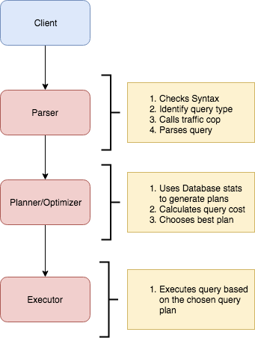

Planner and Executor:
The planner receives a query tree from the rewriter and generates a (query) plan tree that can be processed by the executor most effectively.
The planner in Database is based on pure cost-based optimization -

EXPLAIN command:
This command displays the execution plan that the PostgreSQL/MySQL planner generates for the supplied statement. The execution plan shows how the table(s) referenced by the statement will be scanned — by plain sequential scan, index scan, etc. — and if multiple tables are referenced, what join algorithms will be used to bring together the required rows from each input table.
As in the other RDBMS, the EXPLAIN command in Database displays the plan tree itself. A specific example is shown below:-

Database: testdb=#
- EXPLAIN SELECT * FROM tbl_a WHERE id < 300 ORDER BY data;
- QUERY PLAN
- ---------------------------------------------------------------
- Sort (cost=182.34..183.09 rows=300 width=8)
- Sort Key: data
- -> Seq Scan on tbl_a (cost=0.00..170.00 rows=300 width=8)
- Filter: (id < 300)
- (4 rows)

A simple plan tree and the relationship between the plan tree and the result of the EXPLAIN command in PostgreSQL.
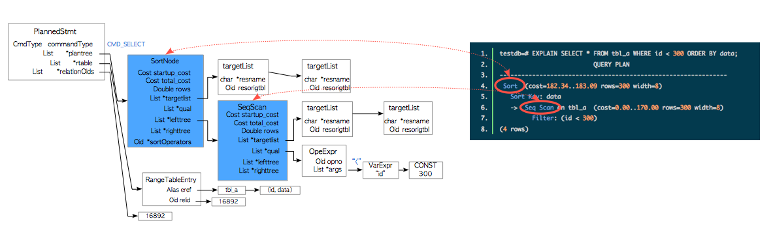

Nodes
The first thing to understand is that each indented block with a preceeding “->” (along with the top line) is called a node. A node is a logical unit of work (a “step” if you will) with an associated cost and execution time. The costs and times presented at each node are cumulative and roll up all child nodes.

Cost:
It is not the time but a concept designed to estimate the cost of an operation. The first number is start-up cost (cost to retrieve first record) and the second number is the cost incurred to process entire node (total cost from start to finish).
Cost is a combination of 5 work components used to estimate the work required: sequential fetch, non-sequential (random) fetch, processing of row, processing operator (function), and processing index entry.

Rows are the approximate number of rows returned when a specified operation is performed.
(In the case of select with where clause rows returned is
Rows = cardinality of relation * selectivity )
Width is an average size of one row in bytes.

Explain Analyze command:
The EXPLAIN ANALYZE option causes the statement to be actually executed, not only planned. Then actual run time statistics are added to the display, including the total elapsed time expended within each plan node (in milliseconds) and the total number of rows it actually returned. This is useful for seeing whether the planner's estimates are close to reality.
Ex: EXPLAIN (ANALYZE) SELECT * FROM foo;
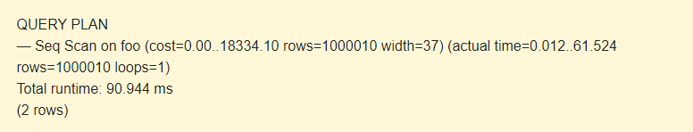
The command displays the following additional parameters:
- actual time is the actual time in milliseconds spent to get the first row and all rows, respectively.
- rows is the actual number of rows received with Seq Scan.
- loops is the number of times the Seq Scan operation had to be performed.
- Total runtime is the total time of query execution.
Query plans for select with where clause can be sequential scan, Index Scan, Index only Scan, Bitmap Index Scan etc.
Query plans for joins are Nested loop join, Hash join, Merge join etc.
Implementation Screenshots :
Comprehend how indexes improves the performance of query applied for your database . Demonstrate for the following types of query on your database
  - Simple select query
  - Select query with where clause
  - Select query with order by query
  - Select query with JOIN
  - Select query with aggregation
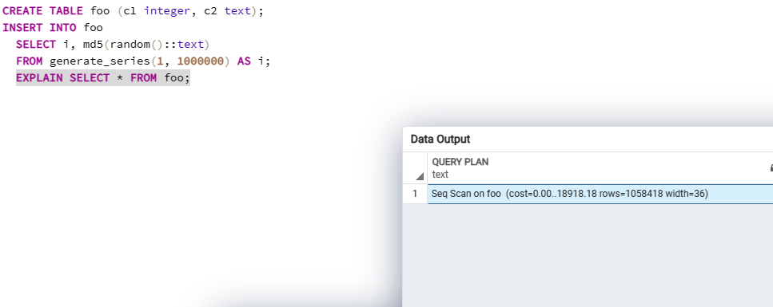
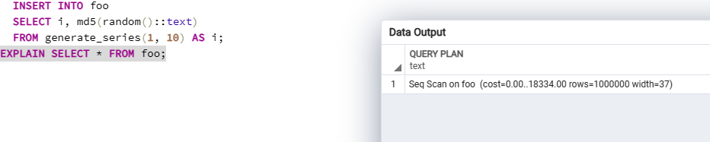
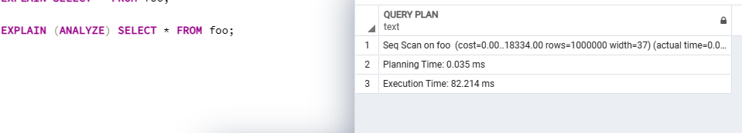
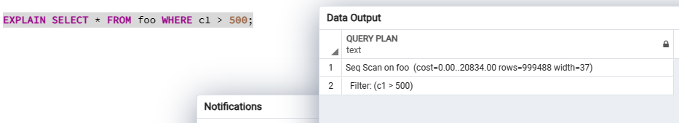
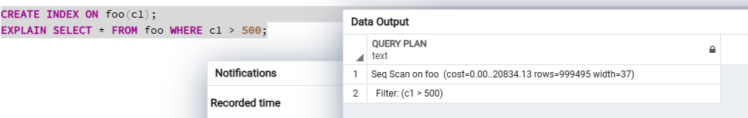
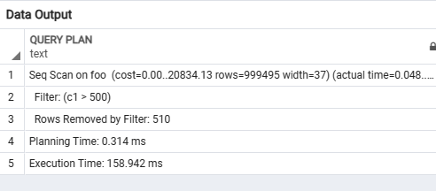

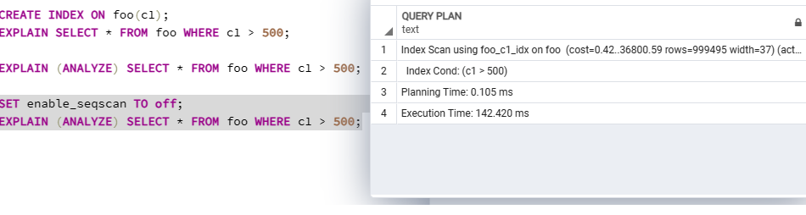
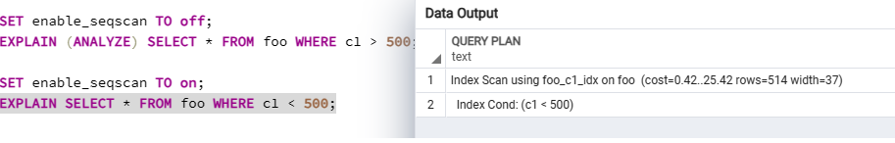
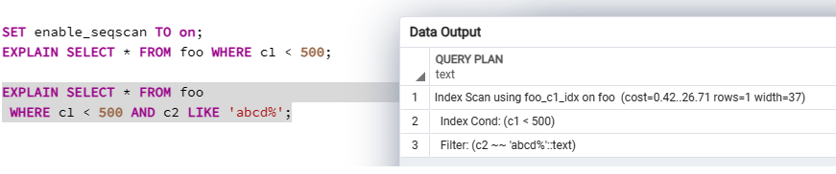
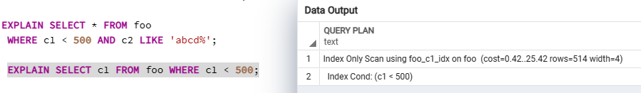
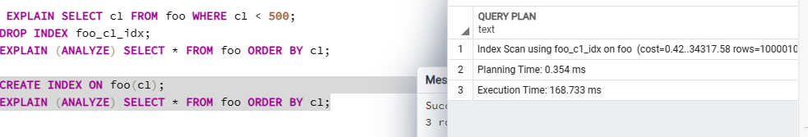
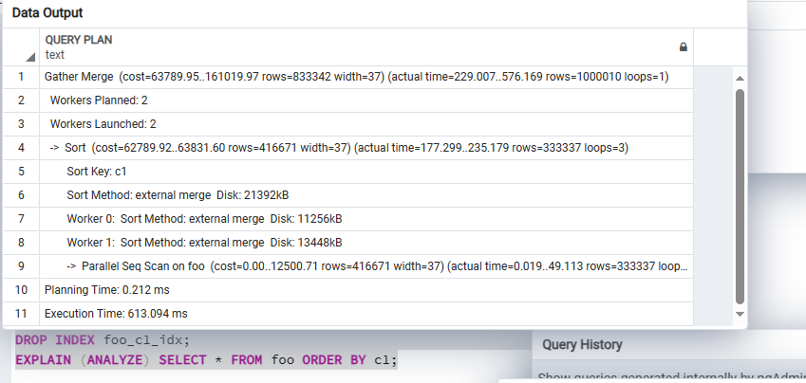
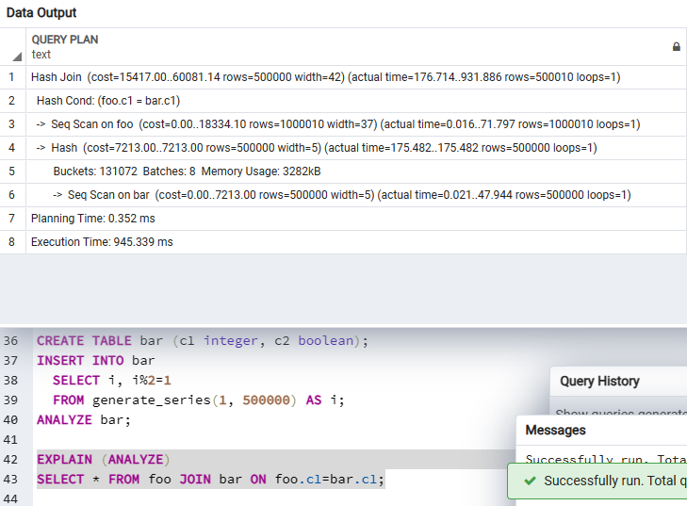
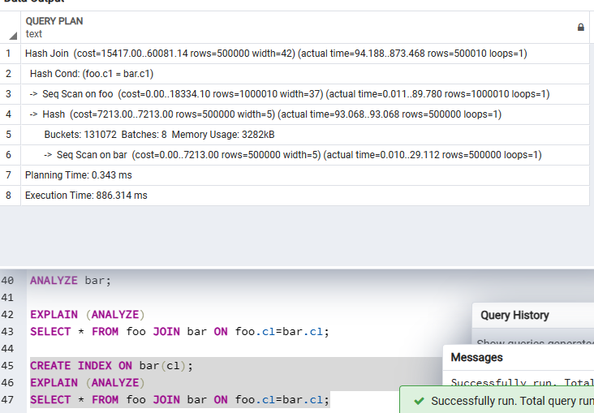
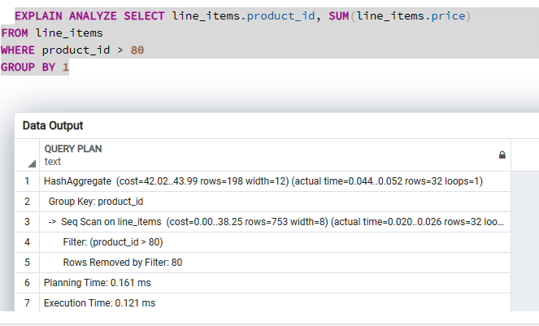
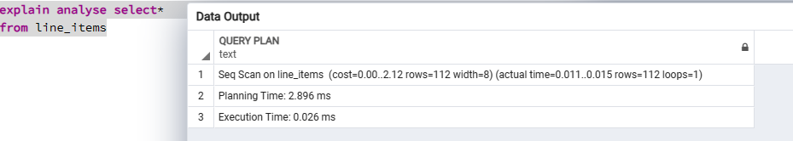

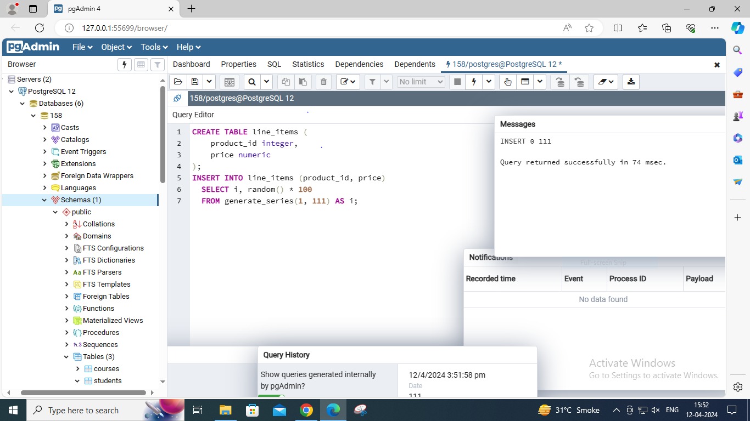
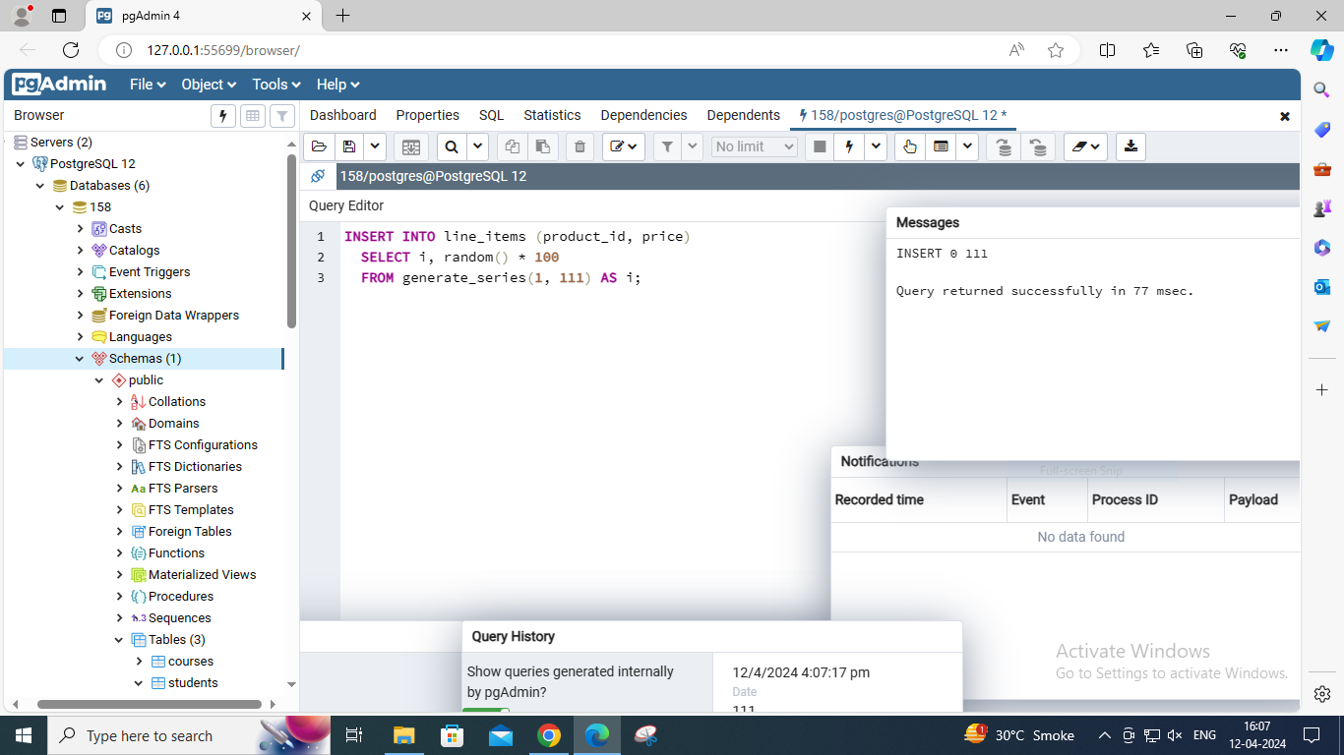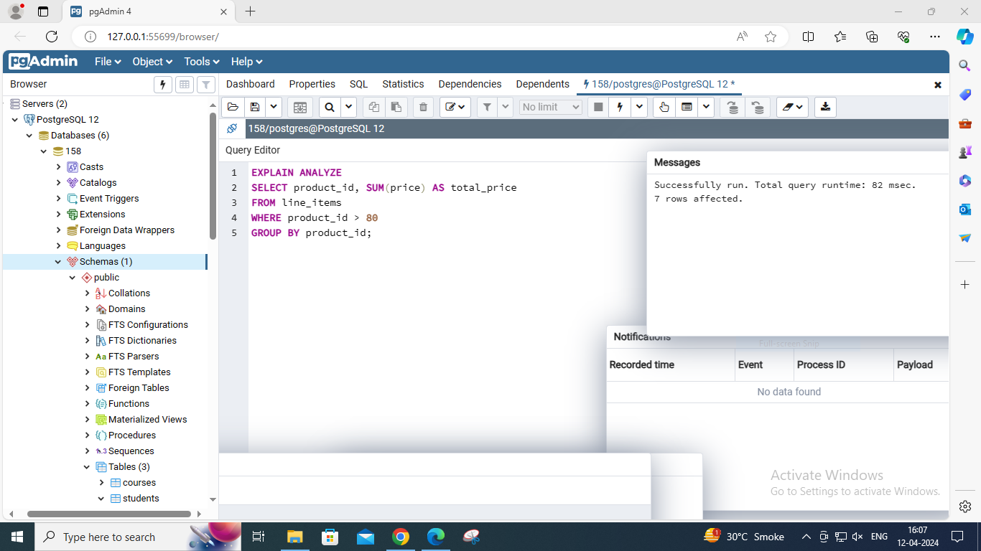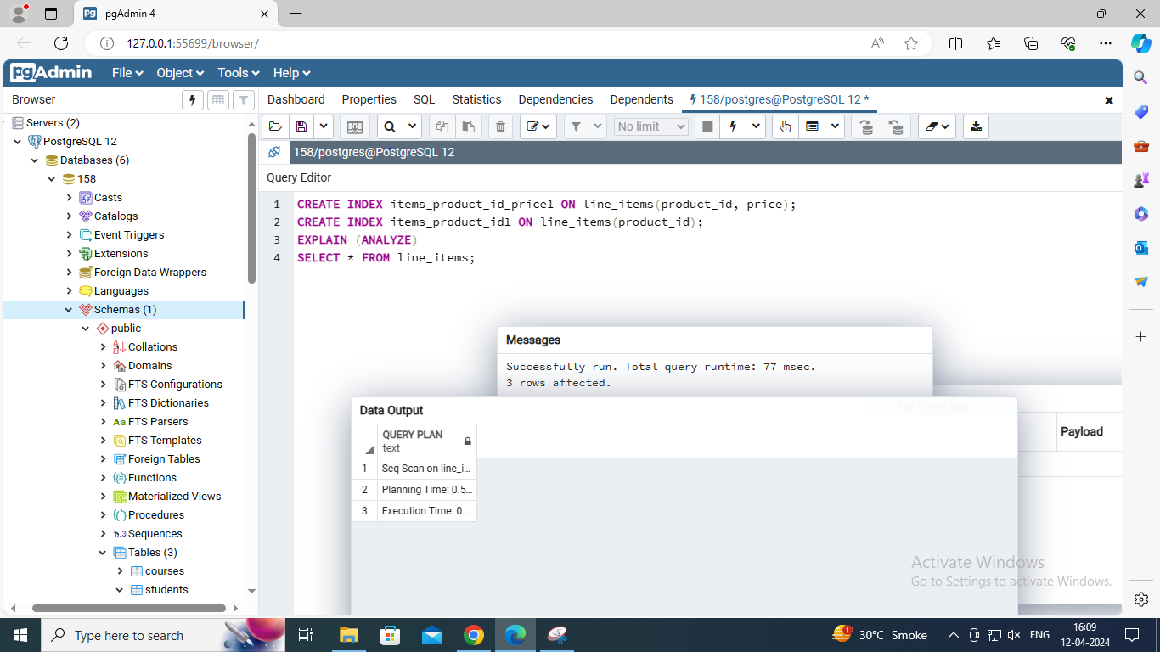
The runtime decreased.
Post Lab Question:
- Illustrate with an example Heuristic based query optimization with suitable example
Answer:
Heuristic-based query optimization is a strategy employed by database management
systems (DBMS) to enhance the efficiency of query execution. Unlike exhaustive
search methods, which consider all possible query execution plans, heuristic
optimization relies on predefined rules or heuristics to make informed decisions.
For example, consider a scenario where a query involves multiple tables. One
heuristic might prioritize joining smaller tables first, assuming that filtering them
down early will reduce the overall dataset size and improve performance.
Additionally, the optimizer might consider selecting appropriate indexes to expedite
data retrieval, leveraging factors such as index selectivity and table sizes.
Another heuristic involves predicate pushdown, where the filtering conditions
specified in the WHERE clause are pushed down to lower levels of execution, such
as index scans or table scans, to minimize the number of rows fetched and
processed. Moreover, cost-based estimation, although not strictly heuristic-based, is
often utilized alongside heuristics. This approach estimates the cost of different
execution plans based on factors such as resource utilization and then selects the
plan with the lowest estimated cost.
In summary, heuristic-based query optimization aims to find an efficient execution
plan by leveraging predefined rules and heuristics, thus improving query
performance without exhaustive exploration of all possible combinations.

Conclusion:
In conclusion, implementing indexing and optimizing query processing significantly
improves database performance. These techniques expedite data retrieval and
streamline query execution, reducing latency and resource consumption. This
integration is essential for enhancing scalability and responsiveness in data-driven
environments.

