Batch: B3 Roll No.: 16010122158

Experiment No. 09

TITLE: Demonstrate deployment of Web Application on Web Hosting Platforms.

AIM: Deployment of Web Application on one of various Dynamic Web Hosting Sites.

_____________________________________________________________________
Expected OUTCOME of Experiment:

CO5: Apply database operations by integrating SQL queries and session variables.
_____________________________________________________________________
Books/ Journals/ Websites referred:

1. Head First HTML5 Programming published by Shroff/O'Reilly in 2011.

2. HTML, XHTML, and CSS Bible, 5th Edition By Steven Schafe.
3. https://developer.mozilla.org/en-US/docs/Web/Guide/HTML/HTML5
4. https://www.w3schools.com/php/php_mysql_connect.asp

Pre Lab/ Prior Concepts:

- Web servers: A web server is a software program that serves web pages to users over the internet. Understanding how web servers work is essential to understand how to deploy web applications.

- HTTP protocol: The Hypertext Transfer Protocol (HTTP) is the foundation of data communication on the World Wide Web. It governs how web servers and clients communicate with each other. Understanding the basics of HTTP is crucial to understanding how web applications work.

- DNS: The Domain Name System (DNS) is a hierarchical naming system that translates human-readable domain names into IP addresses. Understanding how DNS works is important to ensure that your website is accessible on the internet.

- Web application architecture: A web application typically consists of two parts: the client-side and server-side. Understanding the architecture of web applications is crucial to deploying them correctly.

- Deployment methods: There are various methods to deploy web applications, including FTP, SSH, and Git. Understanding how to use these methods is essential to deploy web applications to web servers.

- Web hosting: Web hosting is a service that allows individuals and organizations to publish their website or web application on the internet. Understanding the different types of web hosting services and their features is essential to choose the right web hosting provider for your web application.

- Security: Deploying a web application also involves ensuring its security. Understanding basic security concepts such as authentication, authorization, encryption, and firewalls is essential to secure your web application.
Implementation Details-

In this section students need to specify steps of deployment of Web application on given Dynamic Web hosting sites like Heroku, 000WebHost , Infinityfree etc.

- Screen Shots:

- We signed up on 000WebHost and verified my email


- Created a project and named it as estatescentral.



- Uploaded all my website files from htdocs to public_html on 000webhost.

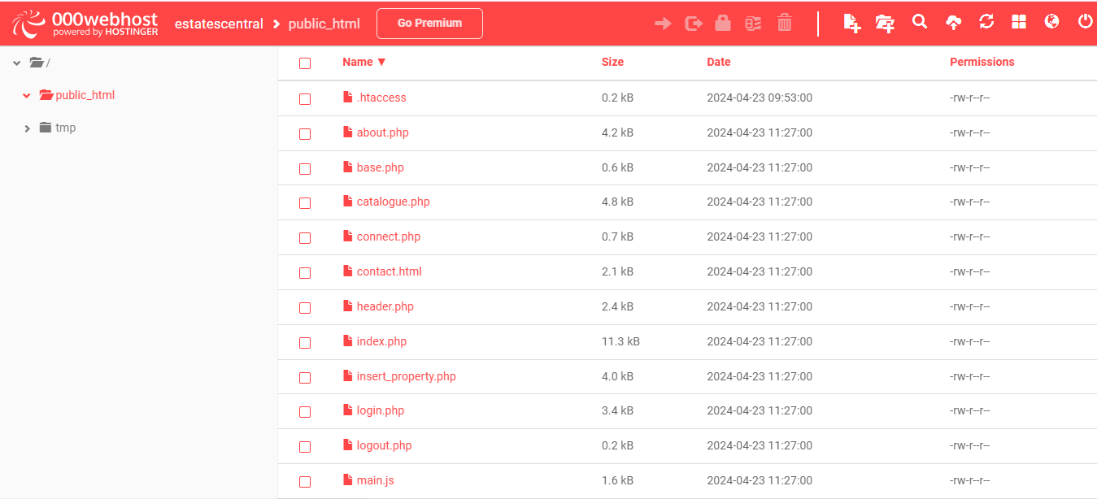

- Viewed my website estatescentral on 000webhostapp.



- Created a new database on webhost related to our website

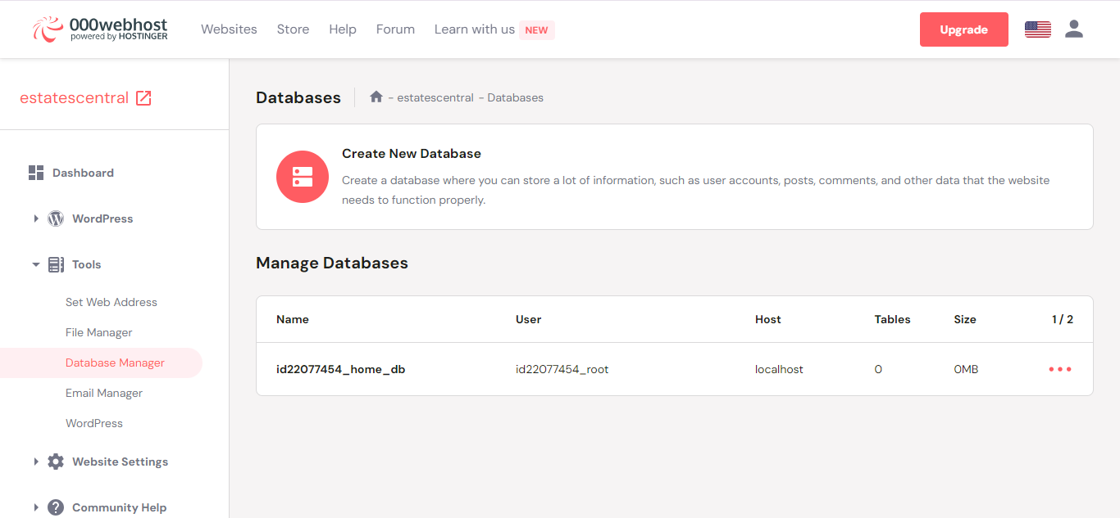

- Imported the tables and values from our previous database on phpMyAdmin.

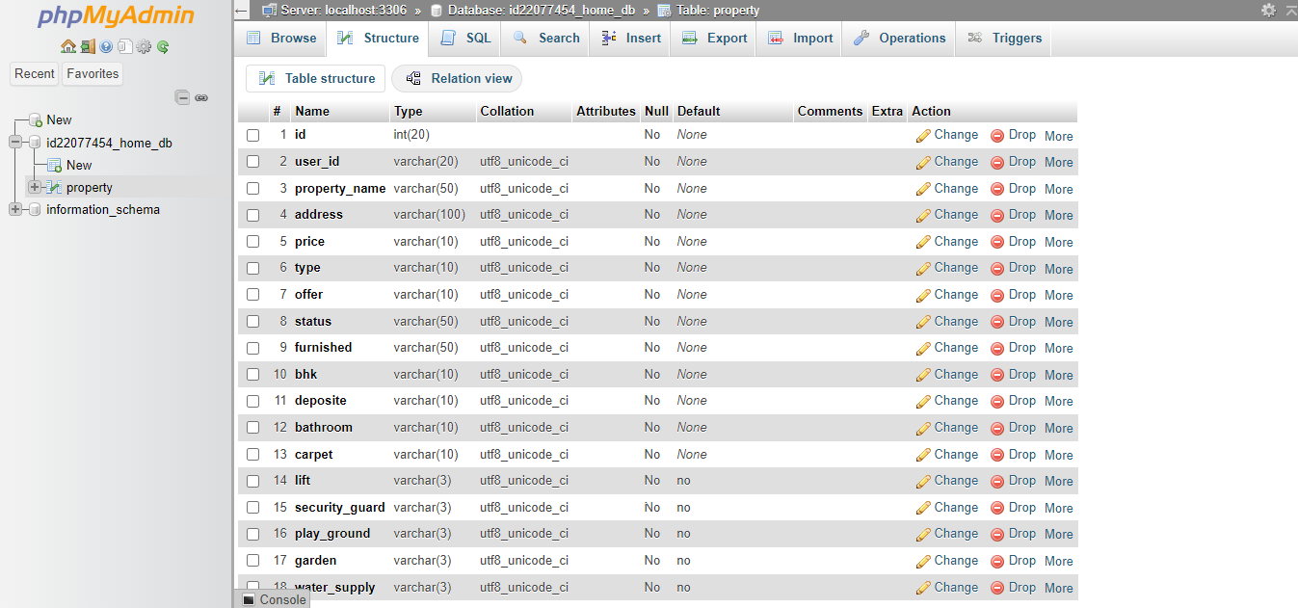

- Link of your Project (Uploaded online) :
https://estatescentral.000webhostapp.com/

Conclusion:
000webhost uses shared hosting technology to deploy applications and websites. This means multiple users share server resources like CPU, memory, and storage, enabling cost-effective hosting for smaller projects or those just starting out. It typically offers an easy-to-use interface, basic website-building tools, and limited support for common technologies like PHP, MySQL, and WordPress. Due to its shared nature, it's best suited for smaller websites, experiments, or beginners rather than high-traffic or resource-intensive applications.

