Batch: B1 Roll No.: 16010122158

Experiment / Assignment / Tutorial No. 5

Grade: AA / AB / BB / BC / CC / CD / DD

Signature of the Staff In-charge with date

Experiment No.:5

TITLE: Flow control Mechanism: Selective Repeat ARQ Sliding Window Protocol using Socket programming
________________________________________________________________
AIM: Implementation of Flow Control Mechanism: Stop and Wait ARQ / Go-Back- N
/ Selective Repeat Sliding Window Protocol ARQ using sockets.

Expected Outcome of Experiment:
CO2: Demonstrate Data Link Layer, MAC layer technologies & protocols and implement
the functionalities like error control, flow control.
________________________________________________________________
Books/ Journals/ Websites referred:
- A. S. Tanenbaum, “Computer Networks”, Pearson Education, Fourth Edition
- B. A. Forouzan, “Data Communications and Networking”, TMH, Fourth Edition
________________________________________________________________

Pre-Lab/ Prior Concepts:
Java Socket Programming, Flow Control, Go-Back-Stop and Wait
________________________________________________________________

New Concepts to be learned: Window Flow Control ________________________________________________________________

Design of Go-Back-N ARQ

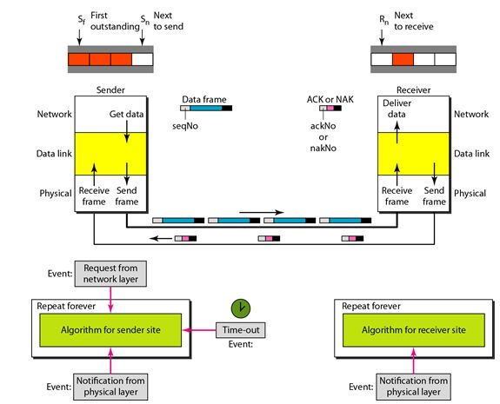

- Take data from user about how many bit windows is case of go back n and selective repeat.

- Generate frames randomly and show the transmission

- Generate the random number for the frame to be lost.

- For Go – Back – N transmit all the frames after that number till max number

- For Selective repeat transmit the selected frame which is not received by the receiver.

IMPLEMENTATION:

Sender.py

import socket
import time
import random

# Create a socket
server_socket = socket.socket(socket.AF_INET, socket.SOCK_STREAM)

# Set the host and port
host = "localhost" # Use "localhost" or "127.0.0.1" for the same machine
port = 12345 # Choose a port number that is not being used

# Bind the socket to the address
server_socket.bind((host, port))

# Listen for incoming connections
server_socket.listen(1) # One connection for simplicity
print("Waiting for a connection...")

# Accept the connection from the client
conn, addr = server_socket.accept()
print("Connection established with", addr)

# Sender's data preparation (Simulated message)
message = "HELLO THIS IS A TEST MESSAGE" # This can be a user input message
message_length = len(message)

# Window size and other settings
window_size = 4 # Example sliding window size
acked = [False] * message_length # To keep track of acknowledged frames
next_frame_to_send = 0
base = 0

# Send window size to receiver
conn.send(str(window_size).encode())

while base < message_length:
# Send frames in the current window
while next_frame_to_send < base + window_size and next_frame_to_send < message_length:
frame = message[next_frame_to_send]
print(f"Sending frame {next_frame_to_send}: {frame}")
conn.send(frame.encode()) # Send frame
next_frame_to_send += 1

# Receive ACKs from the receiver
try:
ack = int(conn.recv(1024).decode())
print(f"ACK received for frame: {ack}")
acked[ack] = True

# Move the window base forward if the base frame is acknowledged
while base < message_length and acked[base]:
base += 1
except socket.error:
print("Error in receiving ACKs.")

print("All frames sent successfully.")
conn.close()
server_socket.close()

Receiver.py

import socket
import random
import time

# Create a socket
client_socket = socket.socket(socket.AF_INET, socket.SOCK_STREAM)

# Set the host and port (Make sure these match the server)
host = "localhost" # Use "localhost" or "127.0.0.1" for the same machine
port = 12345 # Same port number as in the sender

# Connect to the sender (server)
print("\nTrying to connect to the sender...")
client_socket.connect((host, port))
print("Connected to the sender.")

# Receive the window size from the sender
window_size = int(client_socket.recv(1024).decode())
print(f"Window size: {window_size}")

# Receiver's settings
message = []
next_frame_expected = 0
received_frames = {}

# Simulating selective repeat ARQ
while True:
try:
# Receive a frame from the sender
frame = client_socket.recv(1024).decode()
if not frame:
break

frame_id = next_frame_expected

# Simulate frame loss
if random.random() < 0.1: # 10% chance to simulate frame loss
print(f"Frame {frame_id} lost.")
continue

print(f"Frame {frame_id} received: {frame}")

# Store the received frame
if frame_id not in received_frames:
received_frames[frame_id] = frame

# Send an ACK for the received frame
print(f"Sending ACK for frame: {frame_id}")
client_socket.send(str(frame_id).encode())

# If the received frame is in order, move to the next expected frame
next_frame_expected += 1

except socket.error:
print("Error in receiving frames.")

# End when all frames are received (assuming known message length)
if next_frame_expected >= 20: # You can change this based on actual message length
break

# Print the received message
received_message = ''.join([received_frames[i] for i in sorted(received_frames.keys())])
print(f"The complete message received is: {received_message}")

client_socket.close()

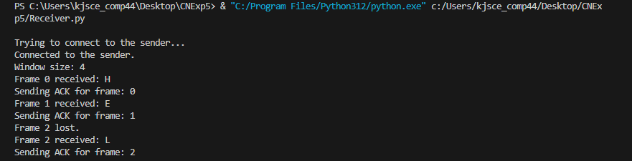
CONCLUSION: Learned and implemented Selective Repeat ARQ with sliding window using socket programming.

- Compare Go-Back-N and Stop and Wait.
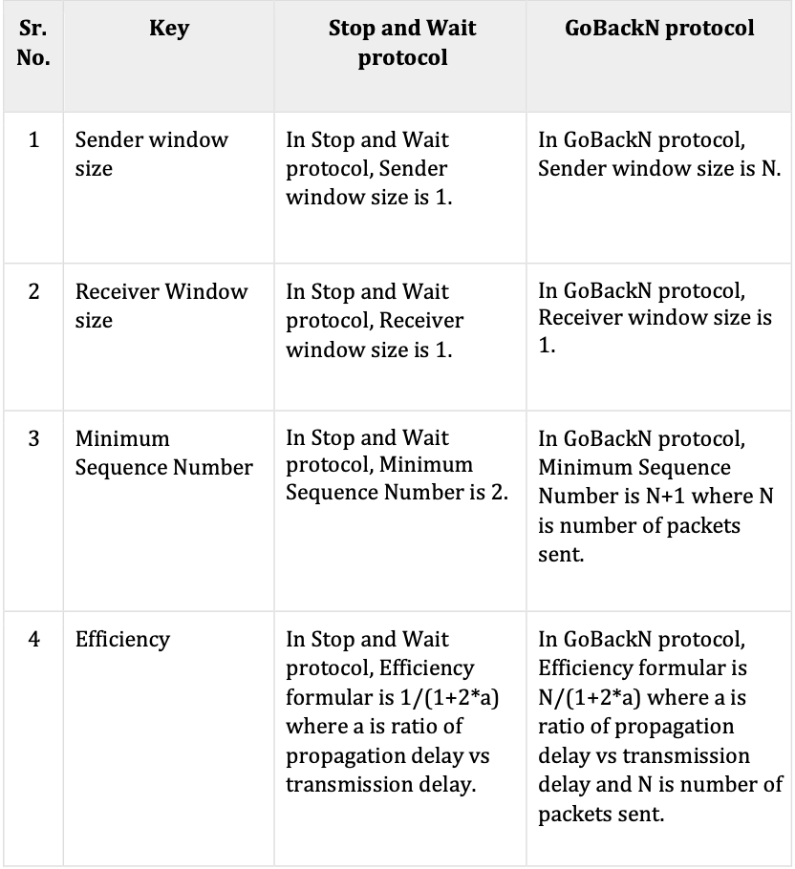

- What is Flow Control and why is it necessary?

Flow control is a design issue at Data Link Layer. It is a technique that generally observes proper flow of data from sender to receiver. It is very essential because it is possible for the sender to transmit data or information at a very fast rate and hence the receiver can receive this information and process it. This can happen only if the receiver has a very high load of traffic as compared to the sender, or if the receiver has less processing power as compared to sender.
Flow control is basically a technique that gives permission to two stations that are working and processing at different speeds to just communicate with one another. Flow control in Data Link Layer simply restricts and coordinates the number of frames or amount of data the sender can send just before it waits for an acknowledgment from the receiver. Flow control is actually a set of procedures that explains to the sender how much data or frames it can transfer or transmit before data overwhelms the receiver.
The receiving device also contains only a limited amount of speed and memory to store data. This is why the receiving device should be able to tell or inform the sender about stopping the transmission or transferring of data on a temporary basis before it reaches the limit. It also needs a buffer, a large block of memory for just storing data or frames until they are processed.

- The maximum window size for data transmission using the selective reject protocol with n-bit frame sequence numbers is
a) 2n b) 2n-1 c) 2n-1 d)2n-2

Date: 23/ 10/ 24 Signature of Faculty In-charge

