Batch: B1 Roll No.: 16010122158

Experiment No. 09

Grade: AA / AB / BB / BC / CC / CD / DD

Signature of the Staff In-charge with date

Experiment No.:9

TITLE: Study and configure DHCP & DNS protocol using Cisco Packet tracer

AIM: To study and configure DHCP/DNS protocol using Cisco Packet tracer
______________________________________________________________________
Expected Outcome of Experiment:
CO3: Demonstrate various network layer protocols and network design using IP addressing, forwarding, routing concepts.

CO5: Describe various features and operations of application layer protocols such as Telnet, HTTP, DNS, SMTP.
______________________________________________________________________
Books/ Journals/ Websites referred:
- A. S. Tanenbaum, “Computer Networks”, Pearson Education, Fourth Edition
- B. A. Forouzan, “Data Communications and Networking”, TMH, Fourth Edition

______________________________________________________________________
Pre Lab/ Prior Concepts:
IPv4 Addressing, Subnetting, Link State Protocol, Router configuration Commands

______________________________________________________________________
New Concepts to be learned: DHCP/DNS Protocol and its configuration.
______________________________________________________________________

THEORY:
DHCP:

DHCP stands for Dynamic Host Configuration Protocol, a network management protocol that automatically assigns IP addresses and other communication parameters to devices on a network:
- What it does
- DHCP assigns IP addresses, subnet masks, default gateways, and Domain Name System (DNS) addresses to devices on a network. This allows devices to communicate with each other and the internet. DHCP also automatically assigns new IP addresses when devices move to new locations on the network.
- How it works
- DHCP uses a client–server architecture to assign IP addresses and other communication parameters. A DHCP server provides a client with an IP address, subnet mask, and default gateway.
- How it's used
- DHCP is used in homes and to connect devices, often without the user realizing it. It can connect any device to any IP network, including local area networks (LANs) and wide area networks (WANs).
DNS:

The Domain Name System (DNS) is the phonebook of the Internet. Humans access information online through domain names, like nytimes.com or espn.com. Web browsers interact through Internet Protocol (IP) addresses. DNS translates domain names to IP addresses so browsers can load Internet resources.

IMPLEMENTATION:

Network Topology:
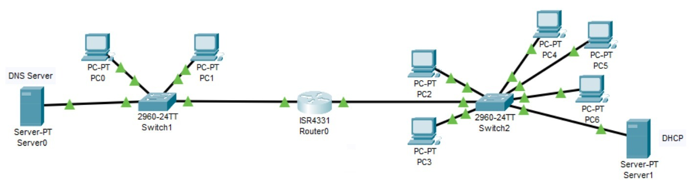
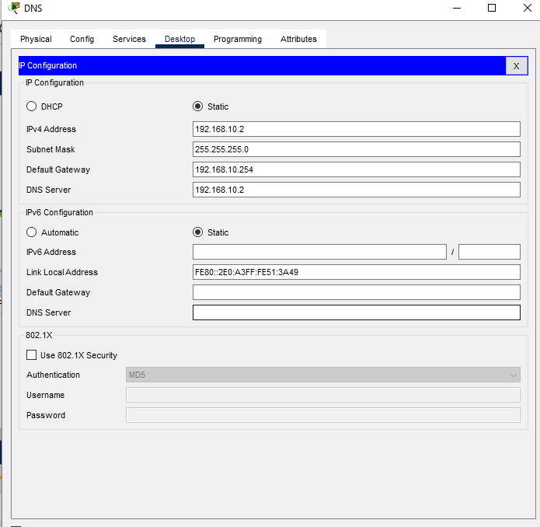

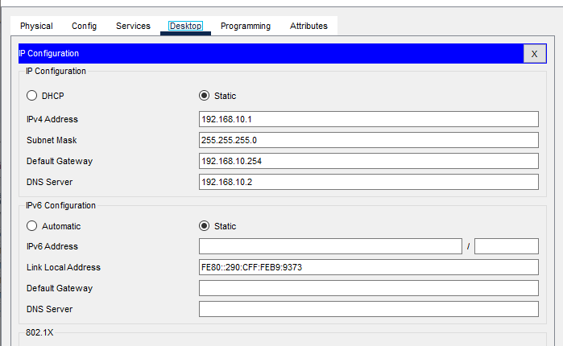
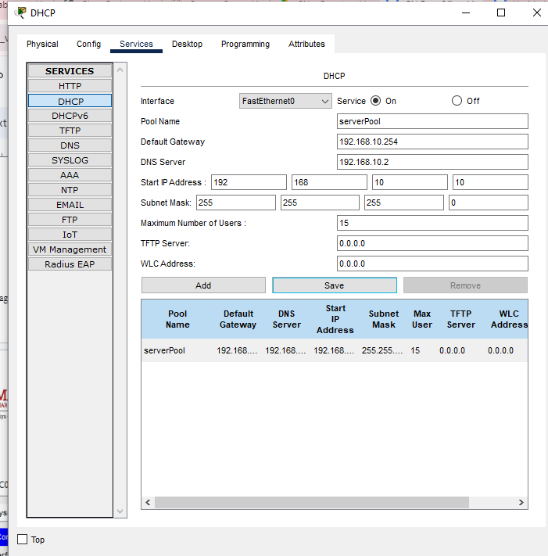

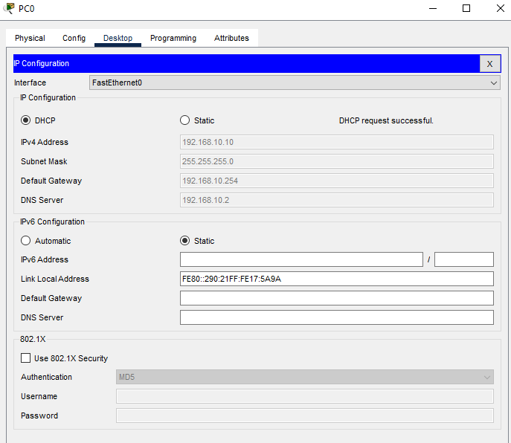
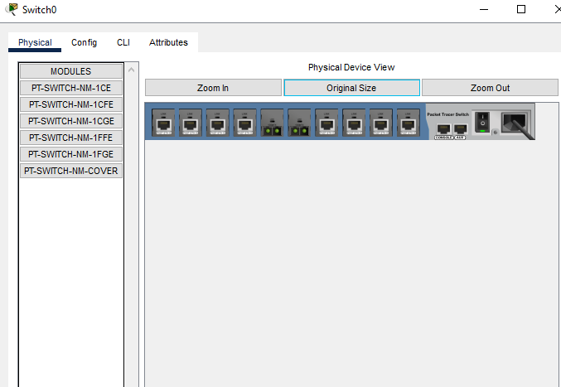
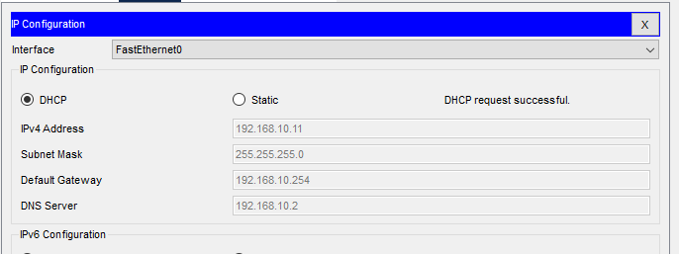
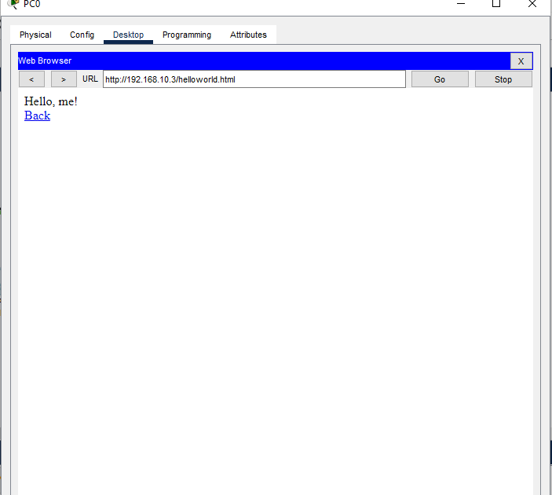
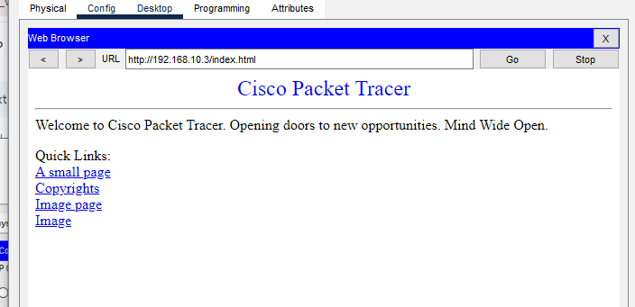
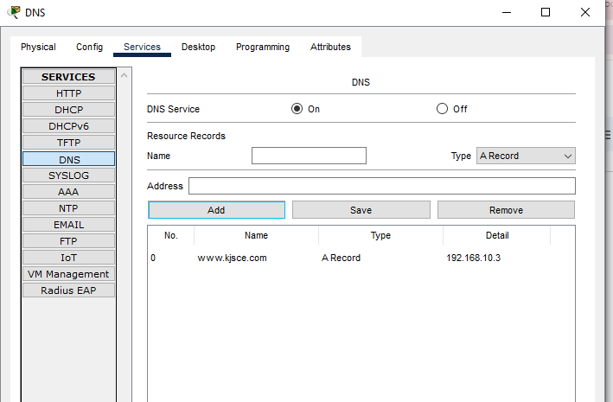

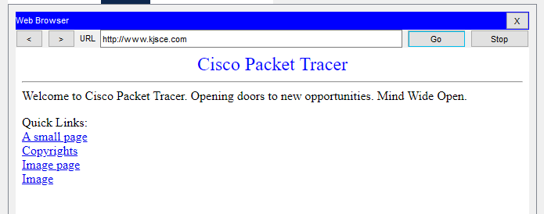

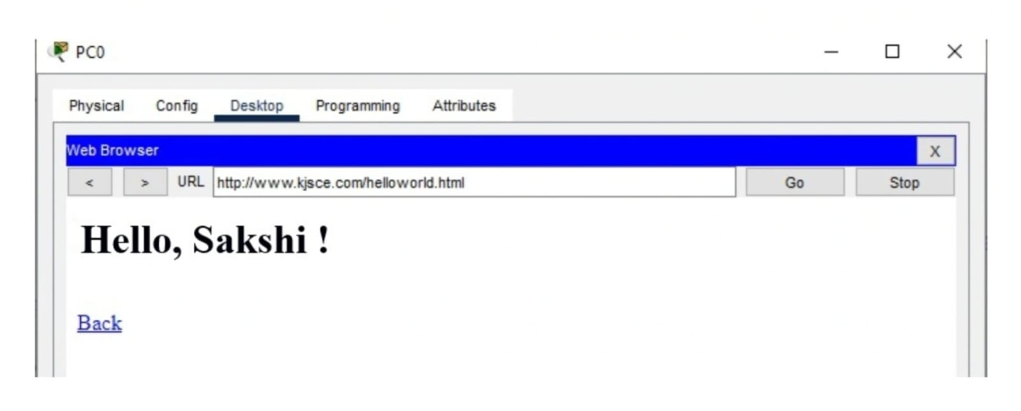

CONCLUSION:

This Experiment - using Cisco Packet Tracer - teaches us how to set up and utilise DNS and DHCP servers.

Date: 6th November, 2024 Signature of faculty in-charge

