Batch: B1 Roll No.: 16010122158

Experiment / Assignment / Tutorial No. 7

Grade: AA / AB / BB / BC / CC / CD / DD

Signature of the Staff In-charge with date

Experiment No.:7

TITLE: Building and configuring simple topology using Network tool - CISCO PACKET TRACER.
______________________________________________________________________
AIM: To build and configure VLAN (Virtual LAN) using CISCO Packet Tracer.

Packet Tracer is a network simulation program that allows students to experiment with network behaviour and ask “what if” questions. Packet Tracer provides simulation, visualization, and authoring, assessment, and collaboration capabilities and facilitates the teaching and learning of complex technology concepts.
______________________________________________________________________
Expected Outcome of Experiment:

CO1: Explain the fundamentals of the data communication networks, reference models,
topologies, physical media, devices, simulators and identify their use in day-to-day networks.

CO3: Demonstrate various network layer protocols and network design using IP addressing
concepts.
_______________________________________________________________
Books/ Journals/ Websites referred:
- http://www.google.com
- A. S. Tanenbaum, “Computer Networks”, Pearson Education, Fourth Edition
- B. A. Forouzan, “Data Communications and Networking”, TMH, Fourth Edition
- CISCO PACKET TRACER 6.0.1 and Higher version (free download)

Pre-Lab/ Prior Concepts: Virtual LAN

A virtual local area network (VLAN) is a LAN which is not configured by physical wiring but it is configured by software. A VLAN is logical group of network devices that appear to be on same LAN despite their geographical distribution. A VLAN is implemented so that network administrators can connect a group of host in the same domain inspite of their physical location to achieve scalability and improve security features.

To subdivide a network into virtual LANs, one configures a network switch or router. Simpler network devices can partition only per physical port (if at all) , in which case each VLAN is connected with a dedicated network cable ( and VLAN connectivity is limited by the number of hardware ports available) More sophisticated devices can mark packets through tagging, so that a single interconnect ( trunk) may be used to transport data for multiple VLANs. VLAN can greatly simplify network design and deployment, because VLAN membership can be configured through software.
______________________________________________________________________
New Concepts to be learned: Purpose of this lab is to become familiar with building Virtual Network in Packet Tracer. ______________________________________________________________________

Stepwise-Procedure:

- Creating a simple LAN network using packet tracer:
Step 1: Select 12 PCs from the end devices and one fast ethernet switch (2950/24 ports)

Step 2: Connect PCs and switch via copper cable from the panel. Connection can be verified by appearance of all green dots on the links.

Step 3: For PCs to communicate click on PC0.
- Dialog box for PC0 appears
- Click on desktop applications by packet tracer.
- Go to IP configuration.
- Enter IP address to identify host i.e. PC0 (for example: 192.168.1.1)
- Subnet mask-by default already set one can change it as per his/her specification.

Step 4: Repeat step 3 for PC1

Step 5: Ping the PCs and check their working status.

Step 6: Simple PDU (Protocol Data Unit) to simulate network traffic by sending ICMP PDU to assess the network traffic. View simulation in simulation mode

Step 7: . Configure two VLAN in a switch in 6 verticals.

Step 8. As per design, assign membership of VLAN to port using following command
# switch port access vlan2 or vlan3
Step 9. Check status of VLAN.

IMPLEMENTATION:

Screen shots

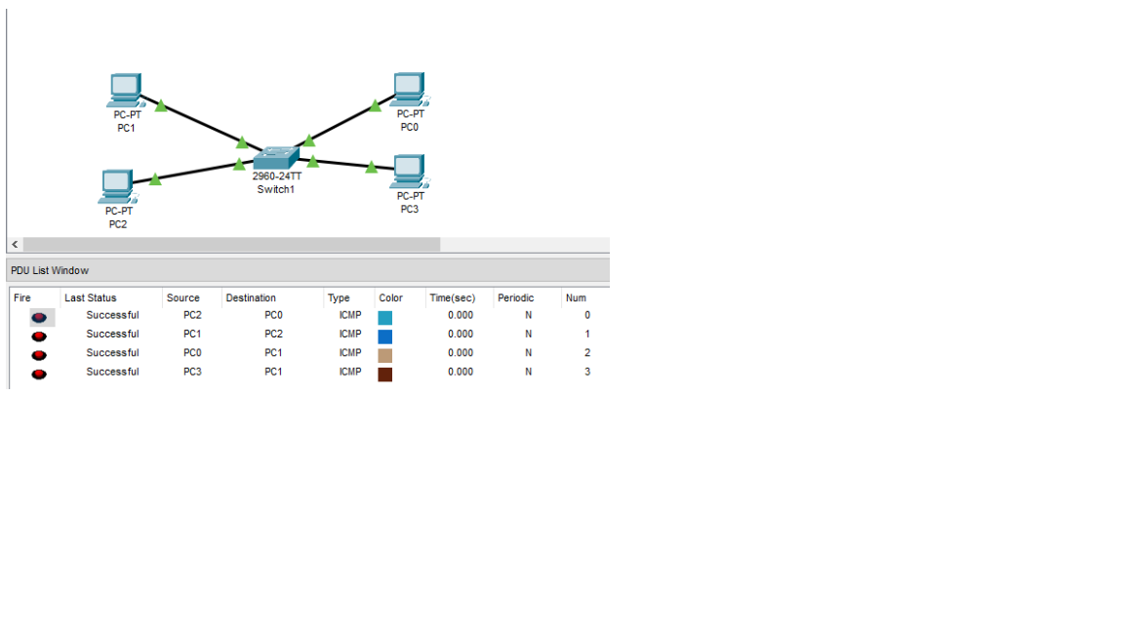
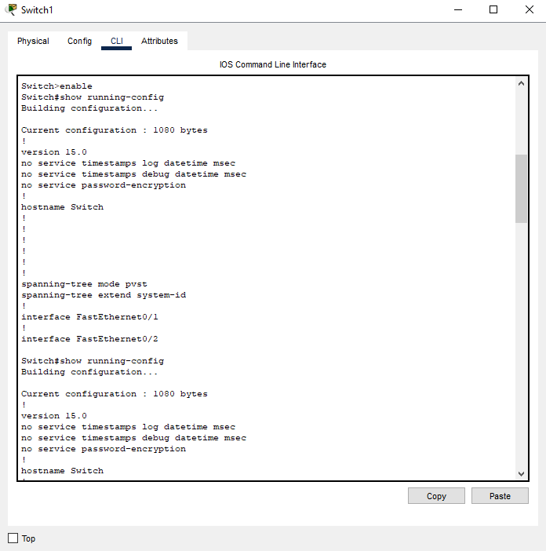

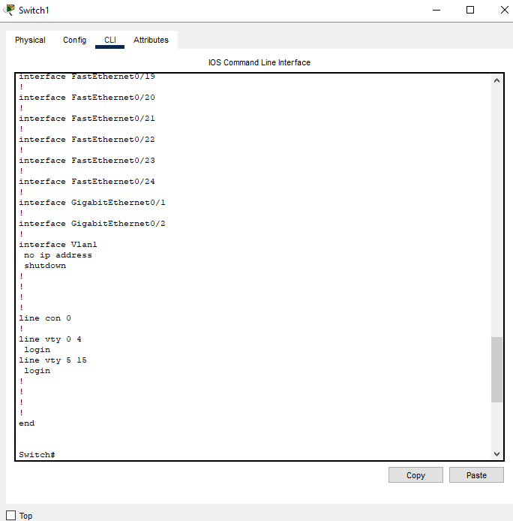
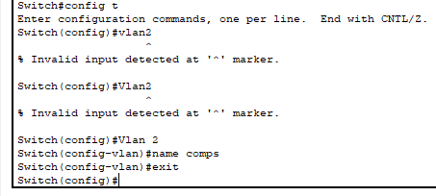

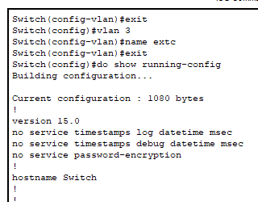

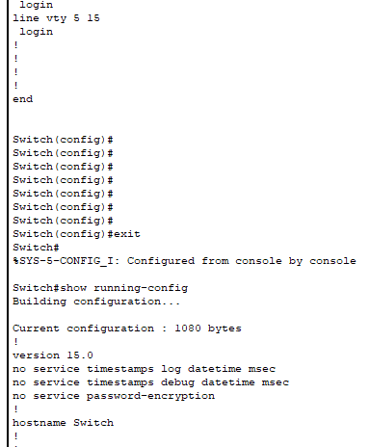
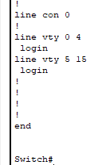

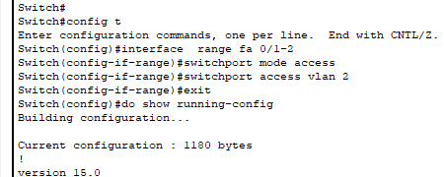
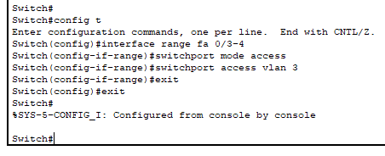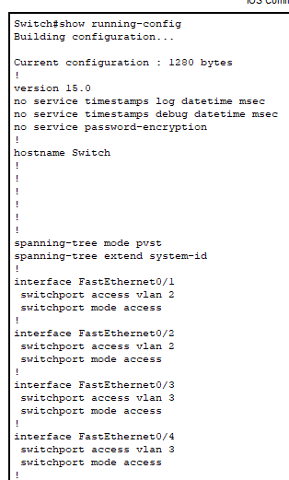

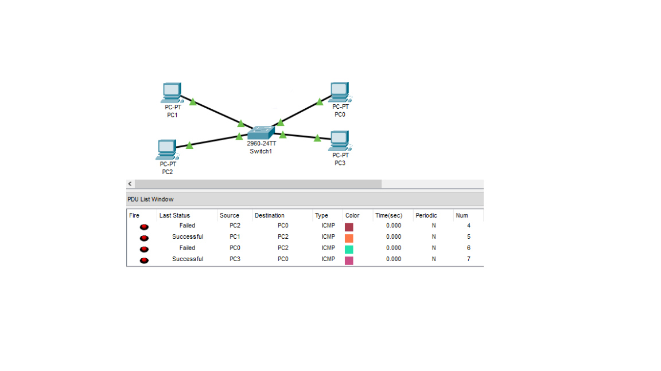

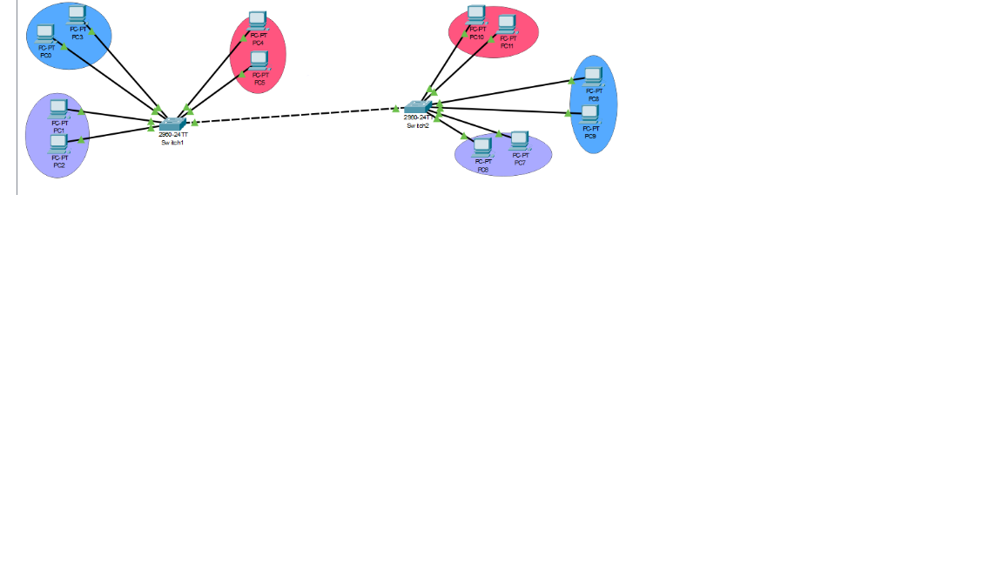

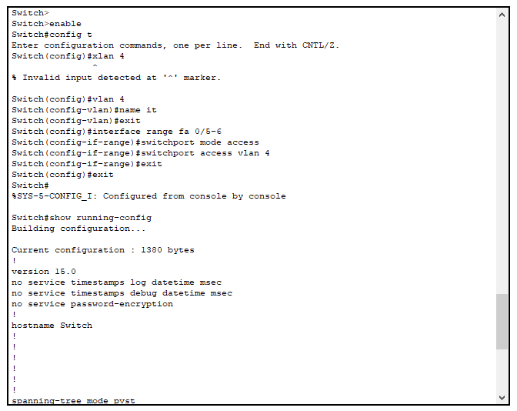

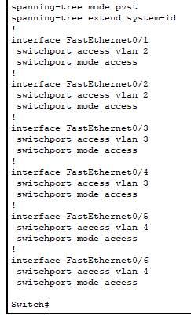

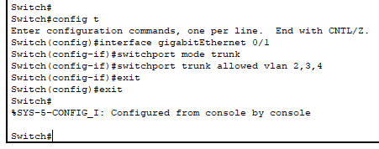

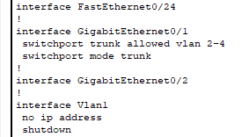

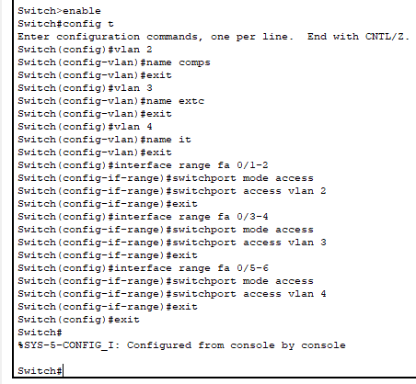

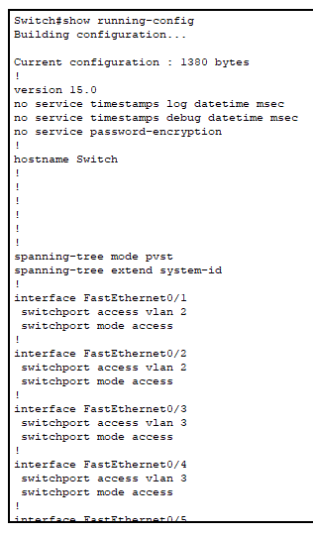
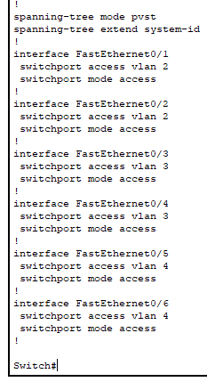
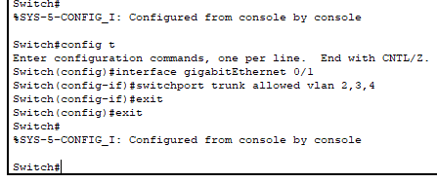
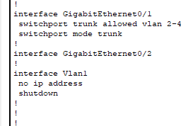
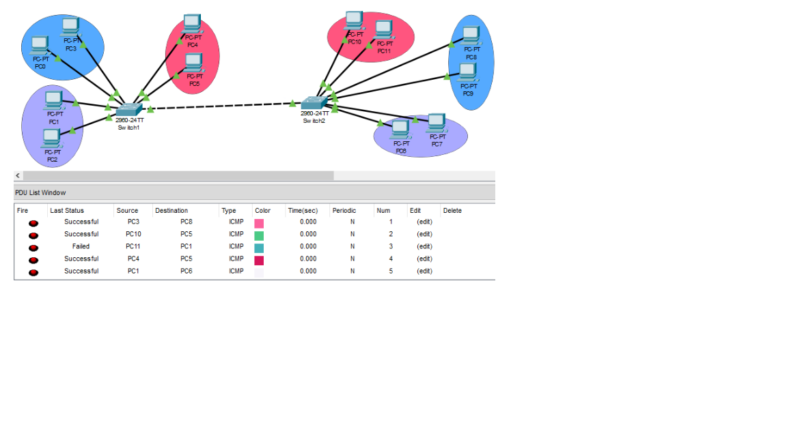

Post Lab Subjective/Objective type Questions

1. Describe the concept of Virtual LAN.

A Virtual Local Area Network (VLAN) is a network configuration that allows multiple distinct networks to coexist on a single physical network infrastructure. By logically segmenting devices within a larger network, VLANs enable different groups to communicate as if they are on their own separate networks, regardless of their physical locations. This is accomplished through tagging Ethernet frames, which helps network switches recognize which VLAN a particular frame belongs to. VLANs enhance network management, improve performance, and enhance security by limiting broadcast traffic and isolating sensitive data.

2. Compare LAN with VLAN.

LAN (Local Area Network) | VLAN (Virtual Local Area Network)
A physical network connecting devices in a limited area. | A logical grouping of devices across multiple locations.
Bound by physical infrastructure (cables, switches). | Defined by software configuration, independent of physical layout.
Single broadcast domain for all devices. | Multiple broadcast domains can be created within the same physical network.
Less secure; all devices share the same network. | Improved security through segmentation and isolation.
More challenging to manage, especially as it scales. | Easier management and reconfiguration without physical changes.

3. State the benefits of implementing VLAN.

- Improved Network Security: VLANs isolate sensitive data and critical systems from general users, enhancing overall security.

- Enhanced Performance: By segmenting traffic, VLANs reduce broadcast domains, minimizing unnecessary traffic and improving network efficiency.

- Simplified Management: VLANs enable easier troubleshooting and better management of network resources.

- Regulatory Compliance: They help organizations meet regulatory requirements through effective data segregation.

- Flexibility and Adaptability: VLANs allow for quick adjustments to network configurations without extensive physical rewiring.

- Organized Networking Environment: Overall, VLANs contribute to a more structured and efficient network setup.

CONCLUSION:

Learnt about basics of Routing with the help of Cisco Packet Tracer

Date: 24/ 10/ 2024 Signature of faculty in-charge

