Batch: B1 Roll No.: 16010122158

Experiment / Assignment / Tutorial No. 10

Grade: AA / AB / BB / BC / CC / CD /DD

Signature of the Staff In-charge with date

Experiment No.:10

TITLE: Study of Packet Analyzer tool: Wireshark

AIM: To study and analyse various Protocols using Packet Analyzer tool: Wireshark
______________________________________________________________________
Expected Outcome of Experiment:
CO5: Describe various features and operations of application layer protocols such as Telnet, HTTP, DNS, SMTP.
______________________________________________________________________

Books/ Journals/ Websites referred:
- A. S. Tanenbaum, “Computer Networks”, Pearson Education, Fourth Edition
- B. A. Forouzan, “Data Communications and Networking”, TMH, Fourth Edition
______________________________________________________________________

Pre Lab/ Prior Concepts:
IPv4 Addressing, Subnetting, Link State Protocol, Router configuration Commands
______________________________________________________________________

New Concepts to be learned: Packet Analyzer tool: Wireshark.

THEORY:

A packet analyzer, also known as a network analyzer or protocol analyzer, is a tool used to capture, monitor, and analyze network traffic. Wireshark is one of the most widely used packet analyzers, providing in-depth insights into network protocols and their operations. Originally called Ethereal, Wireshark allows network administrators, developers, and students to troubleshoot, optimize, and understand network behavior by observing real-time packet data.

Key Features of Wireshark:
- Real-time Packet Capture: Wireshark captures packets directly from the network interface, allowing users to observe network traffic in real time.
- Protocol Analysis: Wireshark can decode over 2,000 protocols, including HTTP, DNS, Telnet, and SMTP. This makes it an ideal tool to study application layer protocols and their behaviors.
- Filtering and Search Capabilities: Users can apply filters to isolate specific types of packets or protocols, making it easier to study individual components of network traffic.
- Detailed Packet Information: Wireshark provides both high-level overviews and detailed views of each packet, including headers, payloads, and protocol-specific fields.
- Export and Sharing: Packet data captured in Wireshark can be saved and shared, which is useful for collaborative troubleshooting and documentation.

IMPLEMENTATION:

- Starting a Capture: Select the appropriate network interface and start capturing packets.

- Applying Filters: Use filters to narrow down packets of interest, such as filtering by protocol (http, dns) or IP address.

- Analyzing Packets: Explore the packet details pane to examine each layer of the packet (Ethernet, IP, TCP, etc.) and observe the fields specific to each protocol.

- Stopping and Saving: Once enough data is captured, stop the capture and save the session for further analysis.

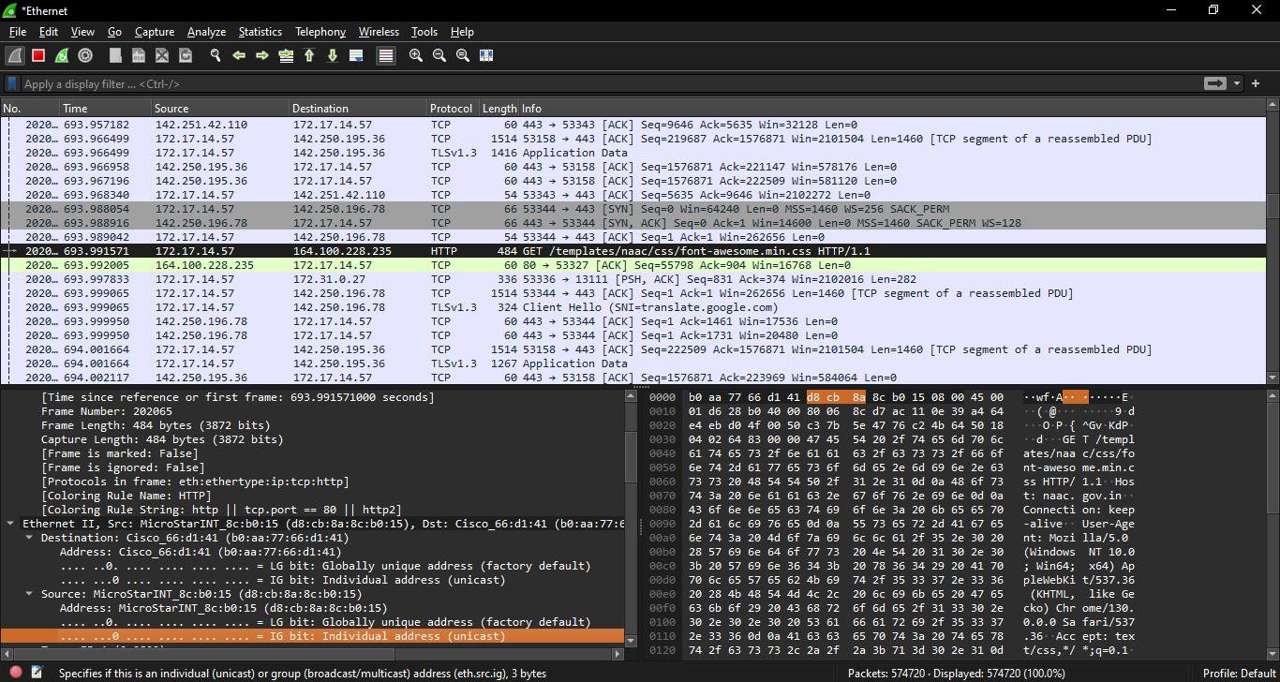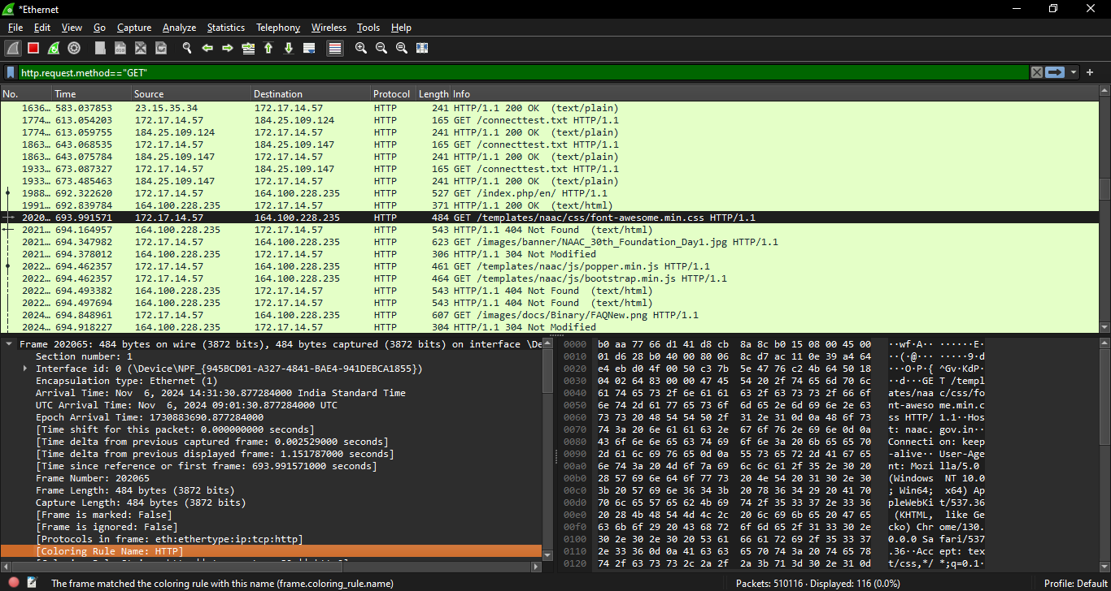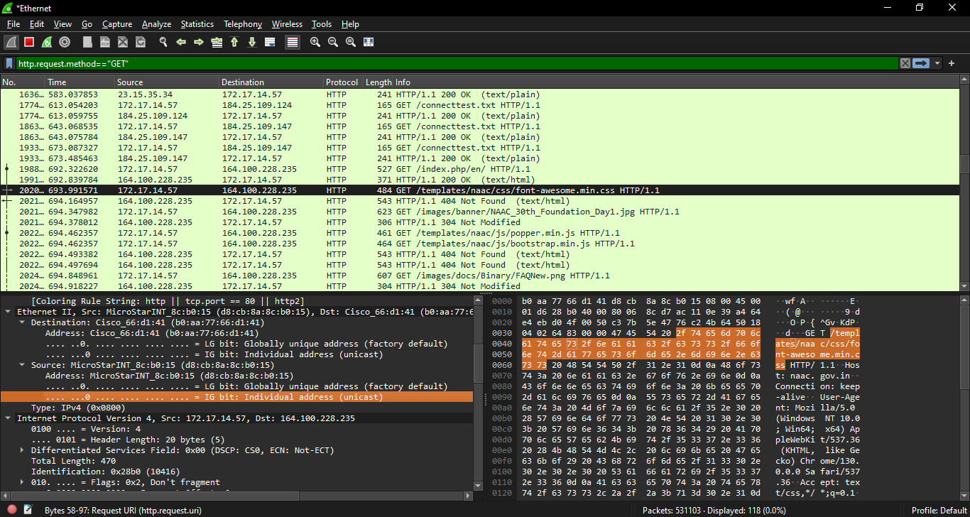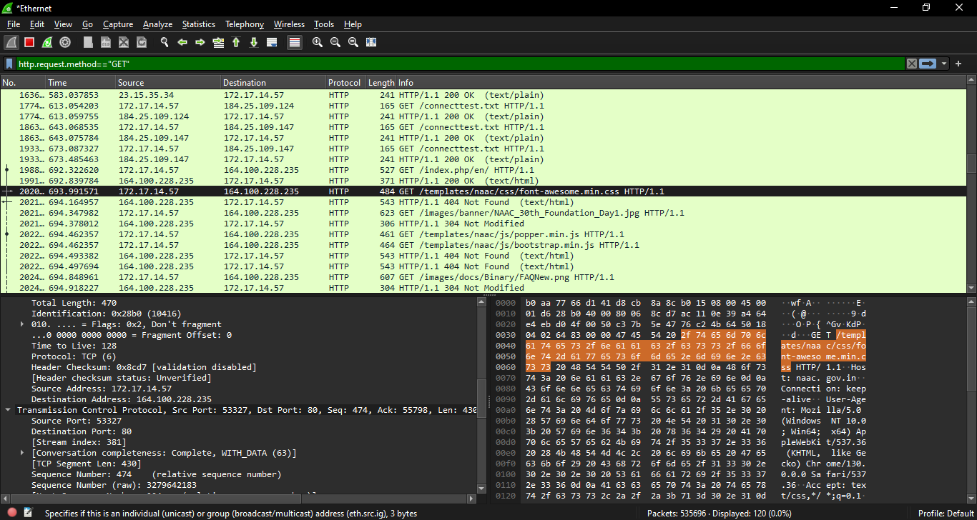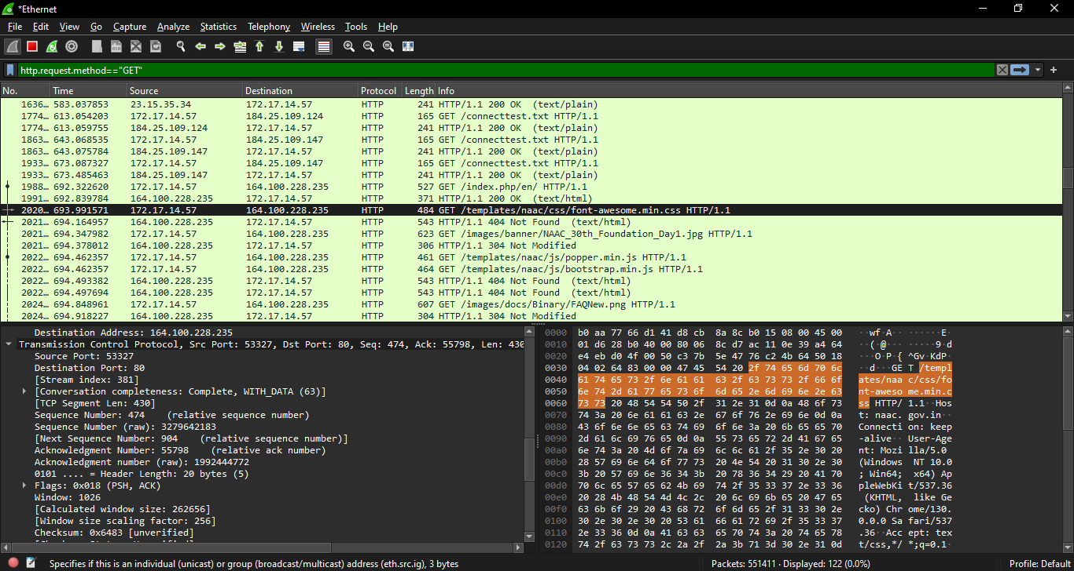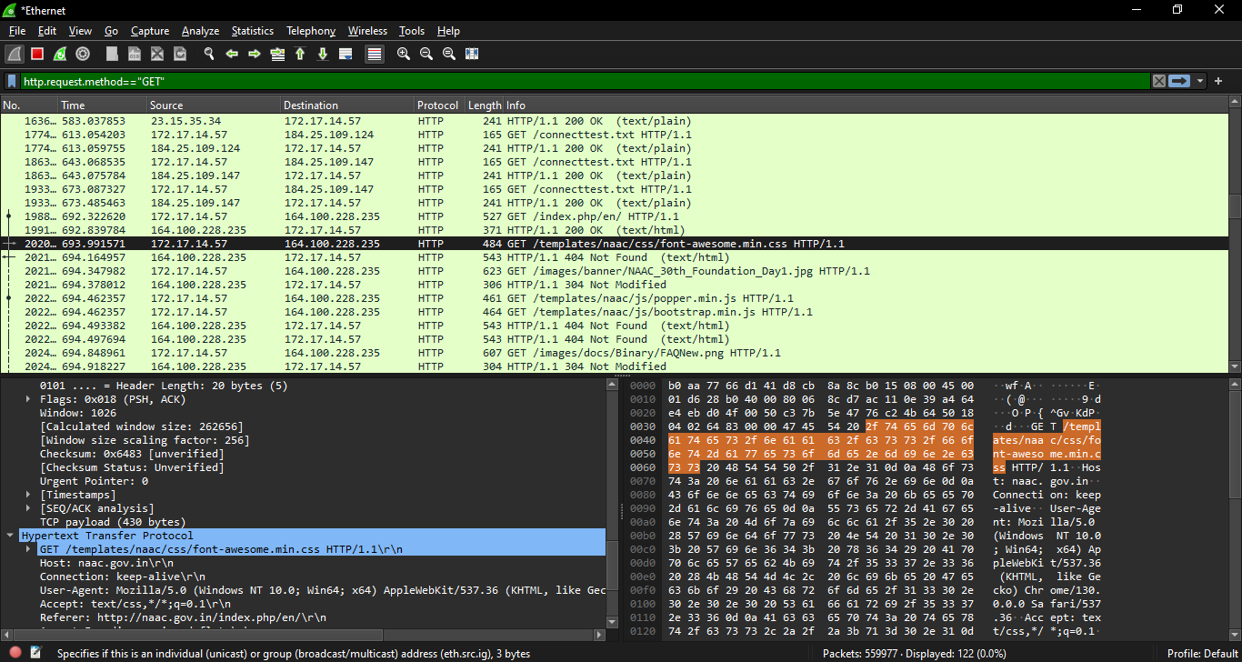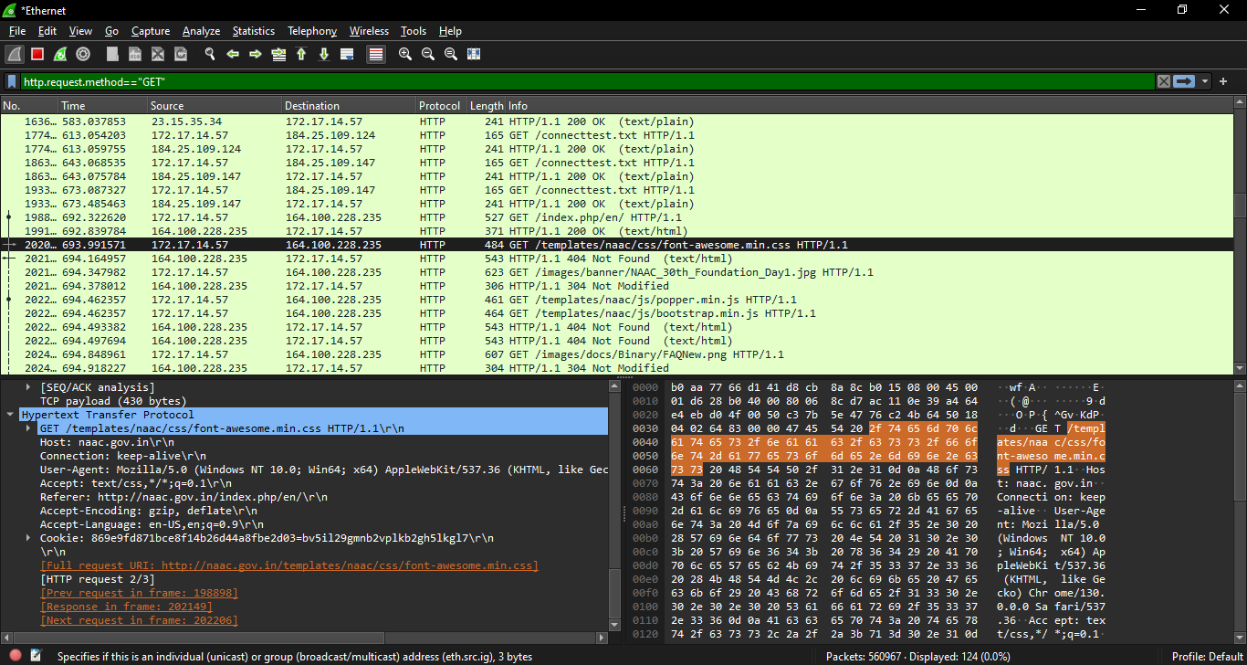

CONCLUSION:

This experiment used Wireshark to analyze protocols. By capturing and filtering network traffic, we gained insights into protocol operations and the importance of packet analysis in network troubleshooting and security.

Date: 6th November 2024 Signature of faculty in-charge

