Batch: A2 Roll No.: 16010122034

Experiment No. 8

TITLE : To perform NLP on clinical data

AIM: Named Entity Recognition on Healthcare Data
Expected OUTCOME of Experiment:
CO5: Apply data analytics in the field of Health care.
_____________________________________________________________________
Books/ Journals/ Websites referred:

Students have to list.
_____________________________________________________________________
Pre Lab/ Prior Concepts:

Students should have a basic understanding of natural language processing concepts like named entity recognition.

Procedure:
Data set Used: Pretrained spaCy model
Step1: Installed required library
!pip install spacy
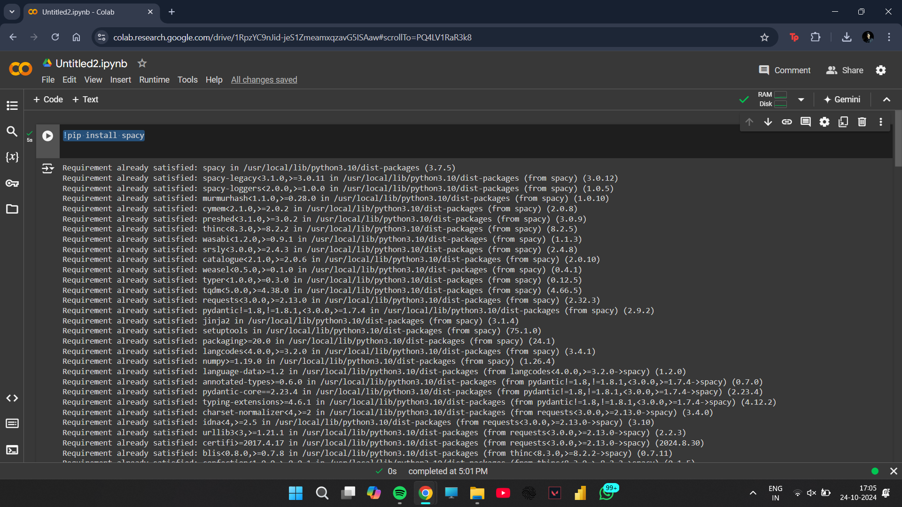

Step2: Load pretrained spaCy model
import spacy
nlp = spacy.load("en_core_web_sm")

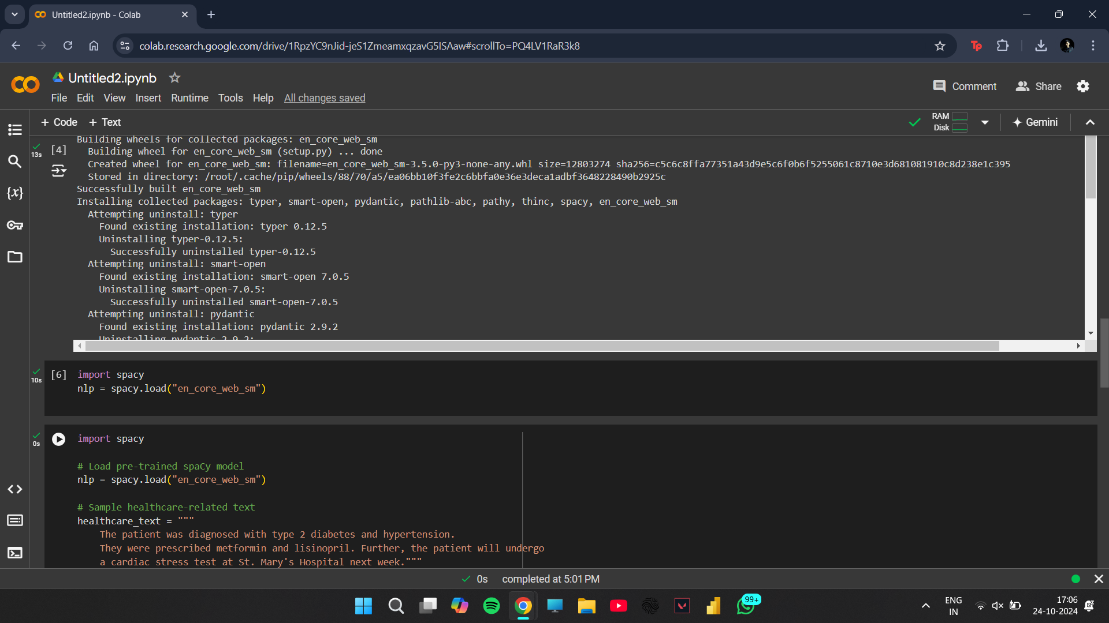

Step 3: Add Sample healthcare-related text
import spacy

# Load pre-trained spaCy model
nlp = spacy.load("en_core_web_sm")

# Sample healthcare-related text
healthcare_text = """
The patient was diagnosed with type 2 diabetes and hypertension.
They were prescribed metformin and lisinopril. Further, the patient will undergo
a cardiac stress test at St. Mary's Hospital next week."""

# Process the text
doc = nlp(healthcare_text)

# Print named entities
print("Entities in the text:")
for ent in doc.ents:
print(f"{ent.text} - {ent.label_}")

# Print explanations of entity labels
print("\nEntity Label Explanations:")
for ent in doc.ents:
print(f"{ent.text}: {spacy.explain(ent.label_)}")
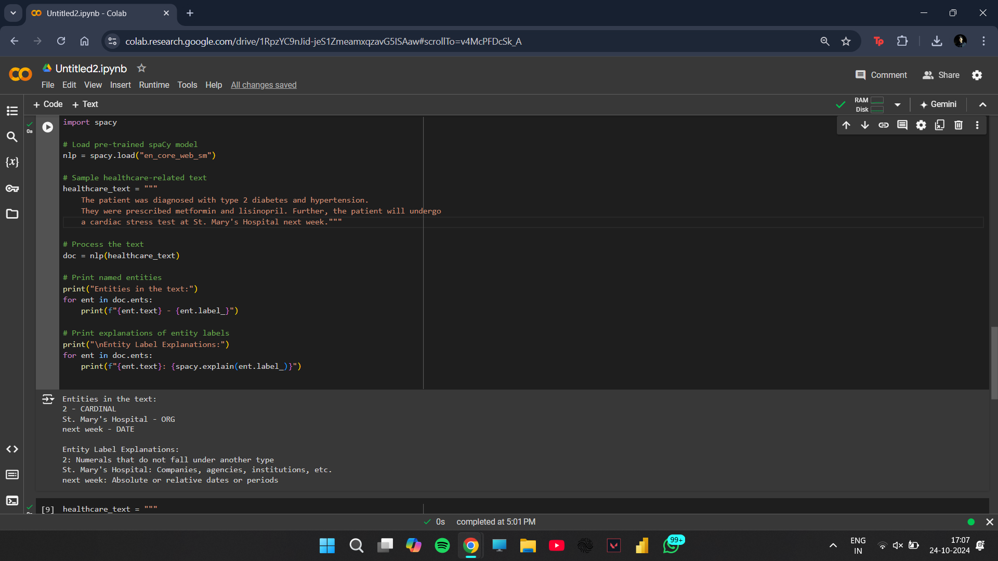
Step4: Process Text
healthcare_text = """
The patient was diagnosed with type 2 diabetes and hypertension.
They were prescribed metformin and lisinopril. Further, the patient will undergo
a cardiac stress test at St. Mary's Hospital next week."""

# Process the text#
doc = nlp(healthcare_text)

# Define custom entity labels for diseases and drugs
disease_labels = ["type 2 diabetes", "hypertension"] # Add more disease terms as needed
drug_labels = ["metformin", "lisinopril"] # Add more drug names as needed

# Iterate through the text and identify entities based on the custom labels
entities = []
for label in disease_labels:
if label in healthcare_text:
entities.append((label, "DISEASE"))
for label in drug_labels:
if label in healthcare_text:
entities.append((label, "DRUG"))

# Print the identified entities
print("Entities in the text:")
for entity, label in entities:
print(f"{entity} - {label}")

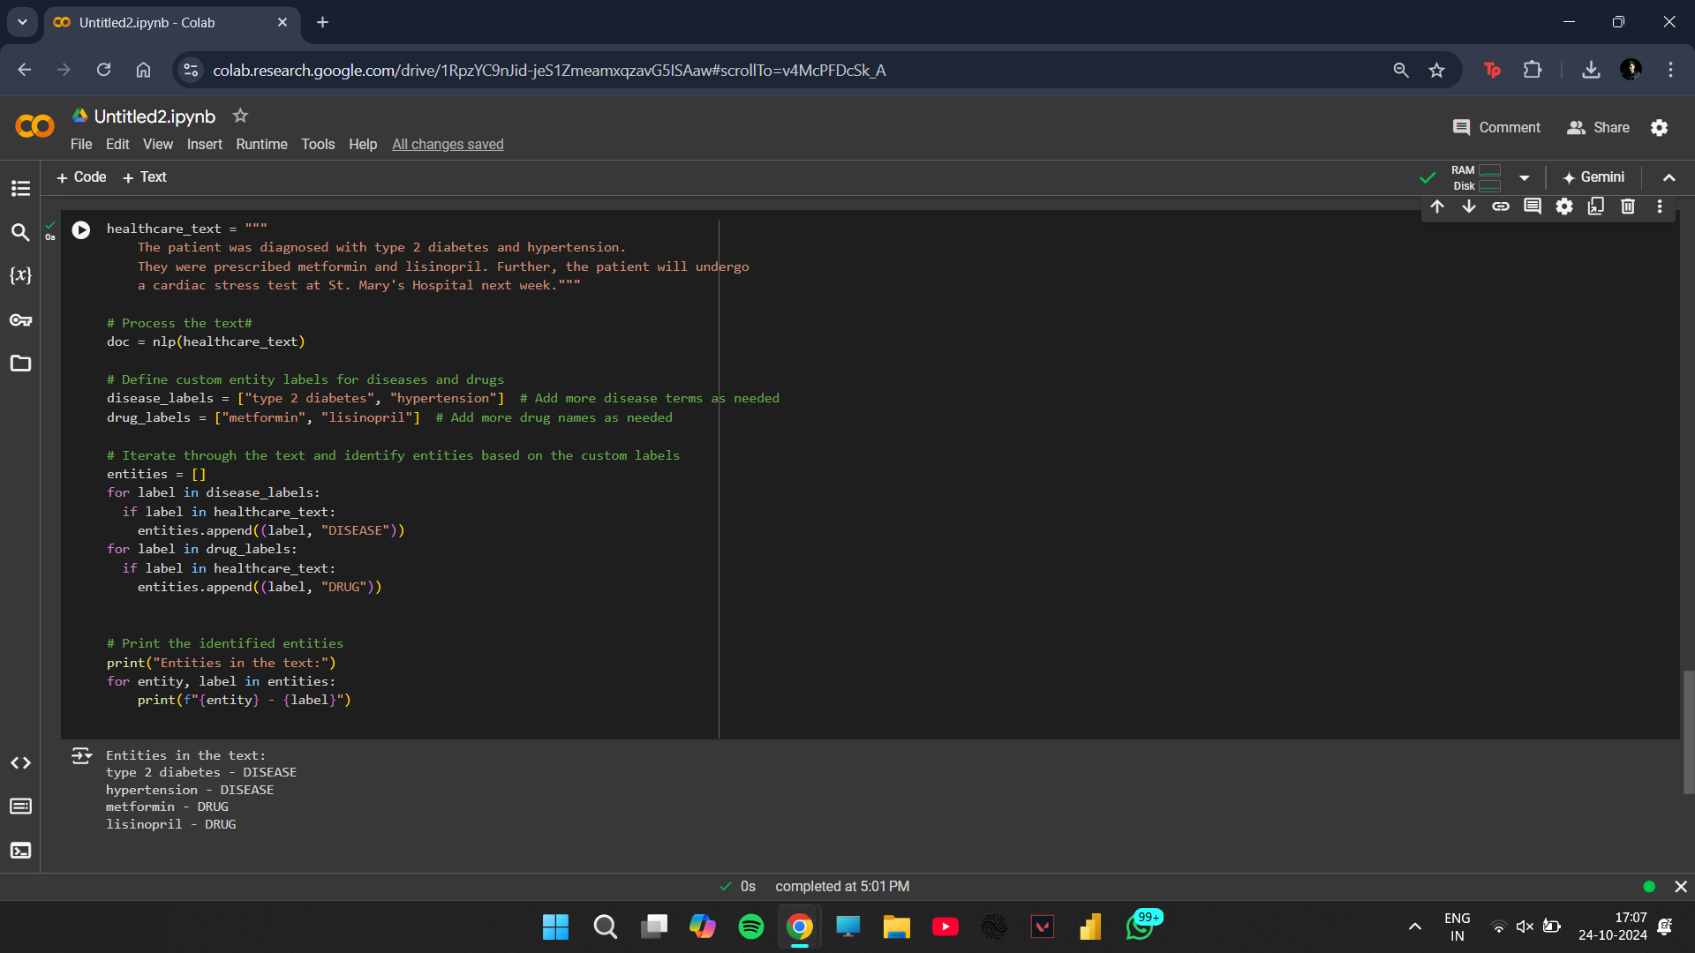

Step 5: Print named entities

# Print the identified entities
print("Entities in the text:")
for entity, label in entities:
print(f"{entity} - {label}")



Implementation details:
1.12 types of entities
import spacy

# Load pre-trained spaCy model
nlp = spacy.load("en_core_web_sm")

# Sample healthcare-related text
b_text = """
In 2023, Apple Inc. announced the launch of the MacBook Pro 16-inch, a cutting-edge product, during a grand event in San Francisco. The product is expected to generate over $100 million in sales within the first month. John Doe, the CEO of Apple, stated that the new features of the MacBook Pro will enhance user experience and set a new standard in the technology industry.
On October 15, the company also revealed plans to invest 20% of its profits into renewable energy projects, aiming to reduce its carbon footprint. This initiative is part of a broader commitment to sustainability, which includes partnerships with organizations such as Greenpeace and WWF.
Additionally, a cardinal number of 100 engineers are working on the project, and the launch event was streamed live, attracting thousands of viewers worldwide. The English language is the primary medium for the presentation, although translations were provided in Spanish and Mandarin.
In a surprising twist, a locally sourced product was showcased, representing the California craft culture. The excitement surrounding the event led to a significant increase in social media mentions, contributing to a record-breaking viral marketing campaign.
Events like this are crucial for keeping Apple's competitive edge in the market, showcasing not just products but a vision for the future. Moreover, the announcement aligns with the upcoming 2024 Summer Olympics, where Apple plans to feature its latest innovations, further solidifying its presence in global markets.
Furthermore, a notable work of art titled "Innovation Unleashed" will be unveiled at the launch, representing the fusion of technology and creativity. The California Environmental Quality Act was cited as a framework for their sustainability goals, and the Apple Park facility in Cupertino was highlighted as a model of eco-friendly design."""
# Process the text
doc = nlp(b_text)

# Print named entities
print("Entities in the text:")
for ent in doc.ents:
print(f"{ent.text} - {ent.label_}")

# Print explanations of entity labels
print("\nEntity Label Explanations:")
for ent in doc.ents:
print(f"{ent.text}: {spacy.explain(ent.label_)}")

Output:
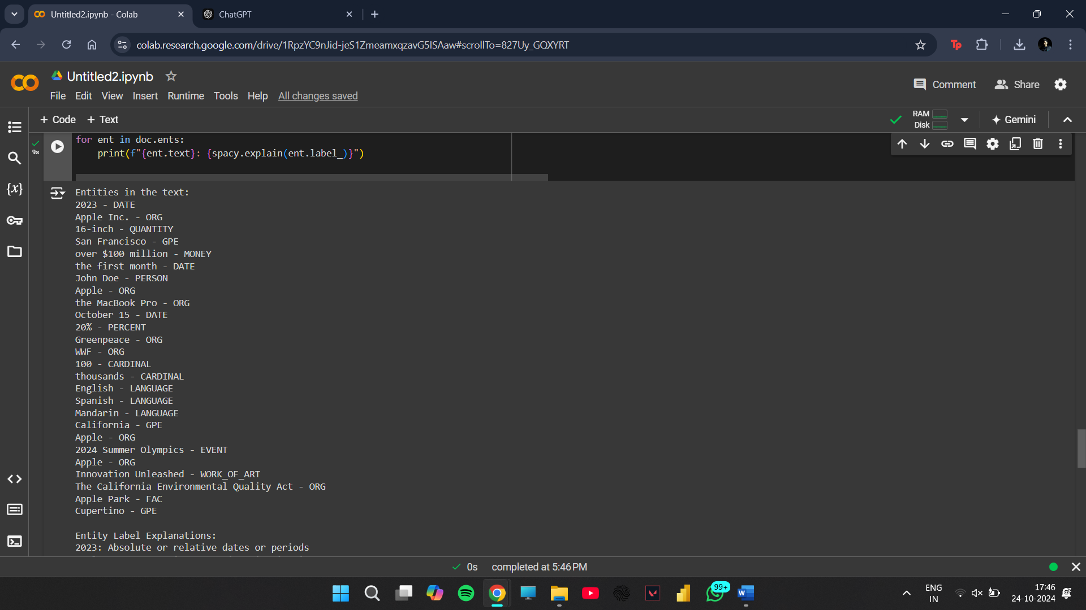

2. 6 Entities related to healthcare data
import spacy

# Load pre-trained spaCy model
nlp = spacy.load("en_core_web_sm")

# Sample healthcare-related text
b_text = """
In March 2023, Dr. John Smith, a renowned cardiologist at Mayo Clinic, successfully performed a heart transplant on a 45-year-old male patient diagnosed with end-stage heart failure. The procedure, which lasted 6 hours, involved the use of advanced robotic-assisted surgery techniques. The patient's post-operative recovery is being closely monitored, and he is expected to be discharged in two weeks. The hospital billed the procedure at a cost of $150,000."""
# Process the text
doc = nlp(b_text)

# Print named entities
print("Entities in the text:")
for ent in doc.ents:
print(f"{ent.text} - {ent.label_}")

# Print explanations of entity labels
print("\nEntity Label Explanations:")
for ent in doc.ents:
print(f"{ent.text}: {spacy.explain(ent.label_)}")

Output:
Entities in the text:
March 2023 - DATE
John Smith - PERSON
Mayo Clinic - ORG
45-year-old - DATE
6 hours - TIME
two weeks - DATE
150,000 - MONEY

Entity Label Explanations:
March 2023: Absolute or relative dates or periods
John Smith: People, including fictional
Mayo Clinic: Companies, agencies, institutions, etc.
45-year-old: Absolute or relative dates or periods
6 hours: Times smaller than a day
two weeks: Absolute or relative dates or periods
150,000: Monetary values, including unit

3.Add 6 different entities with spacy library
# Sample healthcare-related text
healthcare_text = """
The patient was diagnosed with type 2 diabetes and hypertension.
They were prescribed metformin and lisinopril.
The patient reported experiencing frequent headaches and fatigue.
Further, the patient will undergo a cardiac stress test at St. Mary's Hospital next week.
A blood glucose monitor was recommended for home use.
The physician also suggested physical therapy sessions as part of the treatment plan."""

# Process the text
doc = nlp(healthcare_text)

# Define custom entity labels for diseases, drugs, procedures, symptoms, medical devices, and healthcare facilities
disease_labels = ["type 2 diabetes", "hypertension"]
drug_labels = ["metformin", "lisinopril"]
procedure_labels = ["cardiac stress test", "physical therapy sessions"]
symptom_labels = ["frequent headaches", "fatigue"]
device_labels = ["blood glucose monitor"]
facility_labels = ["St. Mary's Hospital"]

# Iterate through the text and identify entities based on the custom labels
entities = []
for label in disease_labels:
if label in healthcare_text:
entities.append((label, "DISEASE"))
for label in drug_labels:
if label in healthcare_text:
entities.append((label, "DRUG"))
for label in procedure_labels:
if label in healthcare_text:
entities.append((label, "PROCEDURE"))
for label in symptom_labels:
if label in healthcare_text:
entities.append((label, "SYMPTOM"))
for label in device_labels:
if label in healthcare_text:
entities.append((label, "MEDICAL_DEVICE"))
for label in facility_labels:
if label in healthcare_text:
entities.append((label, "HEALTHCARE_FACILITY"))

# Print the identified entities
print("Entities in the text:")
for entity, label in entities:
print(f"{entity} - {label}")

4 Display these entities from the test data
Entities in the text:
type 2 diabetes - DISEASE
hypertension - DISEASE
metformin - DRUG
lisinopril - DRUG
cardiac stress test - PROCEDURE
physical therapy sessions - PROCEDURE
frequent headaches - SYMPTOM
fatigue - SYMPTOM
blood glucose monitor - MEDICAL_DEVICE
St. Mary's Hospital - HEALTHCARE_FACILITY

Date: _____________ Signature of faculty in-charge

Post Lab Descriptive Questions:

Q.1 What is Natural Language Processing (NLP) and how is it applied to healthcare data?
Natural Language Processing (NLP) is a subfield of artificial intelligence (AI) focused on the interaction between computers and humans through natural language. The goal of NLP is to enable computers to understand, interpret, and generate human language in a valuable way.
Applications of NLP in Healthcare:
- Clinical Documentation: NLP can automate the process of converting physician notes and dictations into structured electronic health records (EHRs), reducing the administrative burden on healthcare providers.
- Information Extraction: NLP techniques can extract relevant information from unstructured clinical texts, such as patient histories, lab results, and treatment plans.
- Patient Interaction: Chatbots and virtual assistants powered by NLP can handle patient inquiries, schedule appointments, and provide medical information.
- Predictive Analytics: By analyzing patient notes and historical data, NLP can help predict patient outcomes and identify risk factors.
- Clinical Research: NLP helps researchers analyze vast amounts of medical literature and clinical trial data, identifying trends and outcomes relevant to their studies.

Q.2 What are named entities in the context of healthcare NLP, and how can Named Entity Recognition (NER) be useful in medical texts?
Named Entities refer to real-world objects or concepts that are identified in a text, such as names of people, organizations, locations, dates, and specialized terms (e.g., medical conditions, medications). In the context of healthcare NLP, named entities often include:
- Patient names (PERSON)
- Medical conditions (DISEASE)
- Drugs and treatments (PRODUCT)
- Healthcare facilities (ORG)
- Dates (DATE)
- Medical procedures (PROCEDURE)
Named Entity Recognition (NER) is a process within NLP that identifies and classifies these entities in text. NER is useful in medical texts for several reasons:
- Data Structuring: It helps convert unstructured clinical narratives into structured data that can be analyzed, stored, and retrieved easily.
- Information Retrieval: NER can improve the efficiency of searching medical records by tagging and categorizing relevant information.
- Clinical Decision Support: By identifying critical entities in clinical notes, NER can assist in clinical decision-making, alerting providers to potential issues like allergies or medication interactions.
- Research and Reporting: NER aids in extracting relevant information for research studies, systematic reviews, and reporting by automatically identifying and categorizing key information.

Q.3 What are some common applications of NLP in healthcare, such as clinical decision support, medical coding, or patient sentiment analysis?
Clinical Decision Support:

Automated Alerts: NLP systems can analyze patient records to provide alerts for potential drug interactions, allergies, or deviations from clinical guidelines.
Guideline Adherence: NLP can help ensure that clinical documentation aligns with evidence-based guidelines by flagging incomplete or inaccurate entries.
Medical Coding:

Automated Coding Systems: NLP can assist in medical coding by extracting diagnosis and procedure codes from clinical texts, significantly speeding up the coding process and reducing errors.
Coding Audits: NLP can analyze coded data for discrepancies, ensuring accurate billing and compliance with regulations.
Patient Sentiment Analysis:

Feedback Analysis: NLP techniques can analyze patient feedback from surveys, reviews, and social media to gauge patient sentiment towards healthcare services.
Patient Engagement: By understanding sentiment, healthcare providers can improve patient engagement strategies and address areas of dissatisfaction.
Clinical Trial Matching:

Participant Identification: NLP can help identify potential participants for clinical trials by analyzing patient records for relevant medical history and conditions.
Population Health Management:

Risk Stratification: NLP can analyze clinical data to identify high-risk patient populations, enabling targeted interventions and improved outcomes.
Healthcare Chatbots:

Virtual Health Assistants: NLP-powered chatbots can provide patients with information, answer questions, and guide them through health-related issues, improving access to care.

