Forward Fill (FFill)
Definition: The missing values are replaced with the most recent non-missing value found before the gap.
Day | Temperature
-----|-------------
1 | 20°C
2 | 22°C
3 | 22°C <-- Filled with Day 2's value
4 | 22°C <-- Filled with Day 2's value
5 | 25°C

Backward Fill (BFill)
Definition: The missing values are replaced with the next available non-missing value found after the gap.
Day | Temperature
-----|-------------
1 | 20°C
2 | 22°C
3 | 25°C <-- Filled with Day 5's value
4 | 25°C <-- Filled with Day 5's value
5 | 25°C

Moving Average Imputation
Definition: The missing values are replaced with the average of a defined window of neighboring values. This method smooths the data and works well with time series data.
Day | Temperature
-----|-------------
1 | 20°C
2 | 22°C
3 | 23.5°C <-- Average of Day 2 (22°C) and Day 5 (25°C)
4 | 23.75°C <-- Average of Days 2, 3, 5 (22, 23.5, 25°C)
5 | 25°C

Smoothing Data:
Smoothing is a technique used to remove noise and fluctuations from data, making trends and patterns more visible.
- Feature Generation: Reduces noise, creating clearer features (e.g., moving averages in stock prices).
- Visualization: Helps highlight trends by smoothing out short-term fluctuations (e.g., smoothing sales data to show overall patterns).
- Prediction: Improves model accuracy by reducing noise, allowing focus on trends (e.g., smoothing web traffic for better trend prediction).

Addressing Seasonality:
- Seasonality refers to recurring patterns in data (e.g., monthly sales spikes). Ignoring it can lead to poor predictions.
- Techniques: SARIMA.
- Example: Retail sales prediction improves by modeling holiday season patterns.

Preventing Unintentional Lookaheads:
- Lookahead bias occurs when future data is mistakenly used for predictions, leading to false model performance.
- Prevention: Split data chronologically, use lagged features (only past data to predict future), and time-based cross-validation (e.g., TimeSeriesSplit).

Upsampling and Downsampling
Related time series data from different sources will not have the same sampling frequency.
Increasing or decreasing the timestamp frequency.

When to Downsample:
- Original Resolution Isn't Sensible:
  - When data is collected too frequently and doesn't add much value.
  - Example: Measuring air temperature every second when minute-level data would suffice.
  - Solution: Select every nth element (e.g., every 10th second).
- Focus on a Portion of a Seasonal Cycle:
  - To focus on specific seasonal trends, downsample the data to represent a particular season.
  - Example: Create a time series for only January from a yearly dataset.
- Match Data at a Lower Frequency:
  - When you want to align data with another dataset that has a lower frequency.
  - Solution: Aggregate or downsample data using mean, sum, or weighted mean.
  - Example: Summing donations over a week or averaging economic data over a year.

When to Upsample:
- Irregular Time Series:
  - When the data is irregularly sampled and needs to be converted to a regular frequency.
  - Solution: Increase the frequency by interpolating between data points.
- Match Data at a Higher Frequency:
  - When low-frequency data needs to be aligned with higher-frequency data for modeling.
  - Solution: Upsample the low-frequency data and carry it forward.
  - Example: Using monthly unemployment data for daily analysis.
- Interpolation:
  - When there's an understanding of the system's behavior over time.
  - Solution: Treat upsampling as a missing data problem and use interpolation.
  - Example: Assuming the unemployment rate stays steady throughout the month and using it for daily analysis.

Finding and Wrangling Time Series Data
- Finding Time Series Data: This involves locating datasets that are recorded over time, often from sources like sensors, stock markets, or databases.
- Wrangling Time Series Data: This is the process of cleaning, organizing, and preparing the data for analysis, ensuring it is in the correct format and free of errors.

Main Challenges in Finding Time Series Data
- Availability: High-quality time series datasets may not always be readily accessible for specific problems or domains.
  - Example: Limited public datasets for niche industries like energy grid data.
- Inconsistent Formats: Data might be stored across various platforms or formats, making integration difficult.
  - Example: Some data may be in Excel, others in JSON or APIs.
- Missing Data: Missing time points in the data series can create gaps and affect analysis.
  - Example: A weather station may skip readings during power outages.
- Granularity Mismatch: Different datasets may have varying time intervals (e.g., daily vs. hourly).
  - Example: Combining hourly temperature readings with monthly rainfall data.

Main Challenges in Wrangling Time Series Data
- Handling Missing Data: Interpolating, imputing, or filling missing values without distorting patterns.
  - Example: Using linear interpolation to fill gaps in daily stock prices.
- Dealing with Noise: Removing random fluctuations that can obscure trends or patterns.
  - Example: Applying smoothing techniques to noisy sensor data.
- Time Zone and Synchronization Issues: Aligning datasets from different time zones or with inconsistent timestamps.
  - Example: Synchronizing flight data from multiple airports in different time zones.
- Non-Stationarity: Addressing changing statistical properties over time (e.g., mean, variance).
  - Example: Transforming a sales dataset to make it stationary for ARIMA modeling.
- High Dimensionality: Managing large datasets with multiple variables.
  - Example: Processing millions of timestamped IoT sensor readings efficiently.
What are the key considerations when simulating time series data, and why is simulation important?
- Data Distribution and Structure:
  - Stationarity: Ensure that the time series is either stationary or explicitly model non-stationary behavior (e.g., trends or seasonality).
  - Autocorrelation: Time series data often exhibit autocorrelation, meaning past values influence future ones. Incorporating this correlation is essential.
  - Seasonality: If the data exhibits periodic patterns (e.g., monthly, quarterly), these should be reflected in the simulation.
  - Trends: Some time series have underlying trends, either linear or nonlinear. Ensure the simulation accounts for such trends if necessary.
  - Noise: Add random noise (e.g., white noise) to simulate real-world data variability.
- Choice of Model:
  - ARIMA (AutoRegressive Integrated Moving Average), GARCH (Generalized Autoregressive Conditional Heteroskedasticity), or State Space Models (e.g., Kalman filters) can be used to simulate realistic time series.
  - Machine Learning models such as recurrent neural networks (RNN) and LSTM (Long Short-Term Memory) networks can also be trained to simulate time series if the patterns are complex.
- Evaluation Metrics:
  - When simulating, it's essential to evaluate how well the synthetic data matches real-world patterns using metrics like Mean Squared Error (MSE), Autocorrelation of residuals, and forecast accuracy.
- Temporal Resolution and Granularity:
  - Time series data may be recorded at different granularities (e.g., daily, hourly, monthly). Simulation should respect the resolution of the original data.
- Outliers and Structural Breaks:
  - Time series data can sometimes contain outliers or exhibit structural breaks (changes in the underlying data-generating process). It's important to decide whether to simulate these features or ignore them.

Importance of Simulation:
- Scenario Testing:
  - Simulated time series data allows testing various models under different scenarios without the risk of overfitting to a specific dataset.
- Data Augmentation:
  - If real-world data is sparse or expensive to obtain, simulation can generate additional data for model training or testing purposes.
- Model Robustness:
  - Simulation helps assess how a model performs under a range of conditions (e.g., with different levels of noise or trends), improving robustness before deploying it on real data.
- Stress Testing:
  - In fields like finance or economics, simulated time series can be used to stress-test models and assess performance under extreme, yet plausible, conditions.

Challenges in Simulating Time Series Data:
- Overfitting:
  - If the model used for simulation is too complex, it might overfit the real-world data patterns, leading to unrealistic synthetic datasets that don’t generalize well.
- Computational Cost:
  - Some advanced models, especially those based on machine learning (like LSTM networks), can be computationally expensive to train and simulate, particularly for long time series.
- Generating Realistic Outliers and Shocks:
  - Incorporating rare events (e.g., stock market crashes, extreme weather events) in simulations can be challenging, as these events are inherently unpredictable and may not be well-represented by traditional models.
- Model Validation:
  - Evaluating the accuracy of simulated data is inherently difficult. It's hard to determine if the synthetic data truly reflects the underlying processes of the real-world data, especially when real data is limited.

What is EDA (Exploratory Data Analysis)?
Exploratory Data Analysis (EDA) is the process of analyzing and summarizing a dataset to better understand its structure, patterns, and relationships before applying statistical models. In the context of time series data, EDA helps uncover trends, seasonal variations, and other underlying patterns.

Common EDA Techniques for Time Series Data
- Box Plot
  - Purpose: Helps identify the distribution and spread of data, and detect outliers.
  - Description: A box plot visually shows the median, quartiles, and outliers of a dataset. It’s useful for checking the symmetry and spread of the data at different time intervals.
    - Key Insights: Outliers, variation across time periods, central tendency.
  - Example: Plotting monthly sales data to identify seasonal extremes or anomalies.
- Decomposition
  - Purpose: Breaks down a time series into its components: trend, seasonality, and residuals.
  - Description: Decomposition methods like STL (Seasonal-Trend decomposition using Loess) help separate the time series into different components to understand underlying patterns more clearly.
    - Key Insights: Trend, seasonality, and noise.
  - Example: Decomposing monthly sales data to separate seasonal effects from long-term trends.
- Moving Averages
  - Purpose: Smoothing out fluctuations to reveal trends.
  - Description: A moving average is used to smooth a time series by averaging data points in a rolling window. It helps reveal trends by reducing the effect of short-term fluctuations.
    - Key Insights: Trends and noise reduction.
  - Example: Applying a 7-day moving average to daily stock prices to spot longer-term trends.
- Histograms
  - Purpose: Shows the distribution of data.
  - Description: A histogram displays the frequency distribution of data values over specified bins. It helps in understanding the distribution of data values and checking for skewness.
    - Key Insights: Skewness, outliers, and data distribution.
  - Example: Plotting the histogram of daily sales to observe whether sales are normally distributed or skewed.
- Plotting
  - Purpose: Visualizing data over time.
  - Description: Time series data is often plotted as a line chart to show changes over time, revealing trends, seasonality, and anomalies.
    - Key Insights: Trends, seasonal fluctuations, abrupt changes.
  - Example: Plotting monthly revenue to identify upward or downward trends.

Advantages of EDA
- Identifying Patterns and Trends:
  - EDA helps identify long-term trends, seasonal variations, and potential outliers that could influence future forecasting.
- Better Data Understanding:
  - Through graphical visualizations and statistical summaries, EDA allows a deeper understanding of the dataset's structure, distribution, and anomalies.

Disadvantages of EDA
- Time-Consuming:
  - EDA can be time-consuming, especially with large datasets, as it requires generating and interpreting multiple plots and summaries.
- Subjectivity in Interpretation:
  - The interpretation of EDA results can be subjective, and different analysts may draw different conclusions from the same visualizations.

Barriers to Doing EDA
- Data Quality Issues:
  - Missing data, outliers, or noisy data can make it difficult to interpret time series patterns accurately during EDA.
- High Dimensionality:
  - Working with datasets that have many variables or high-frequency data can make EDA challenging due to the complexity of managing and visualizing the data effectively.

The Random Walk Model is a foundational concept in time series analysis, often used to describe and forecast processes where future values depend only on the present value plus a random component. It is widely used in finance, economics, and other fields to model stochastic or unpredictable processes. Here is an overview of the model:

Definition
The Random Walk Model can be expressed mathematically as:
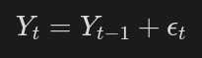
where:
- yty_t: Value of the time series at time tt
- yt−1y_{t-1}: Value of the time series at time t−1t-1 (previous time step)
- ϵt\epsilon_t: A random shock (white noise) at time tt, typically assumed to be independently and identically distributed (i.i.d) with ϵt∼N(0,σ2)\epsilon_t \sim N(0, \sigma^2)

Key Characteristics
- No Mean Reversion: In a random walk, deviations from the mean are not corrected over time. Instead, the series tends to wander indefinitely.
- Non-Stationarity: A random walk is inherently non-stationary because its mean, variance, and autocovariance change over time.
- Memory: Each value depends directly on the previous value. Therefore, the series exhibits a form of persistence—shocks to the system have a lasting impact.
- Variance Grows Over Time: The variance of the random walk increases with tt, making predictions less certain over longer horizons.

Variants
- Random Walk with Drift:
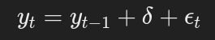
where δ\delta is a constant drift term, indicating a trend in the series.
- Geometric Random Walk (common in financial modeling):
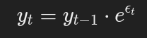
Used to model prices of assets where percentage changes (rather than absolute changes) are important.

Applications
- Financial Markets: The Efficient Market Hypothesis (EMH) suggests that stock prices follow a random walk because all available information is already priced in, and future changes are unpredictable.
- Economics: Exchange rates, interest rates, and other macroeconomic indicators can often be approximated using random walk models.
- Benchmarking: Serves as a null hypothesis to evaluate the predictability of time series data. If a model does not outperform a random walk in forecasting, its predictive power is questionable.

Limitations
- Over-Simplicity: It assumes no underlying structure, which may not be realistic for many real-world time series with seasonality or trends.
- Non-Stationarity: Makes statistical inference and parameter estimation more challenging.
- No Short-Term Predictability: It assumes future values are entirely driven by random shocks, limiting its practical usefulness in short-term forecasting.

Visualization
A simple random walk typically shows an erratic pattern with no clear direction or periodicity, emphasizing the randomness and dependence on prior values.
By understanding the random walk model, analysts can determine whether a series requires transformation (e.g., differencing) to achieve stationarity or whether more complex models like ARIMA or state-space methods are needed for forecasting.

State Space Models in Time Series Analysis
State Space Models (SSMs) represent time series data using two components: the state (hidden process) and the observation (measured data).
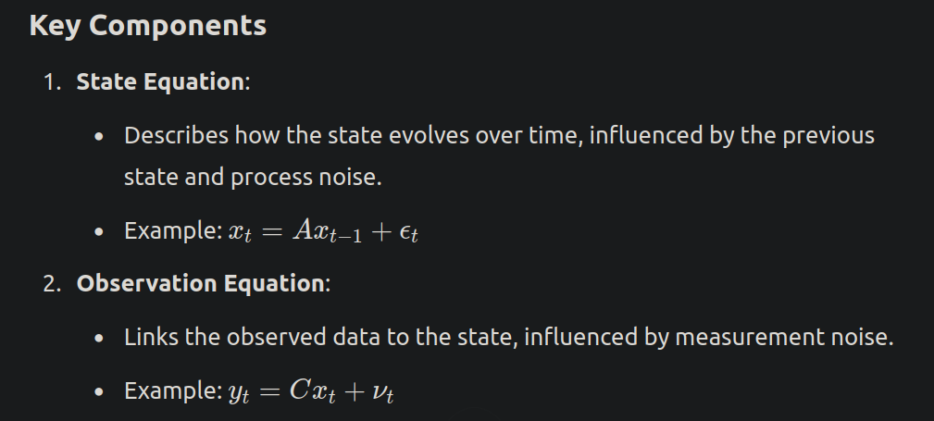

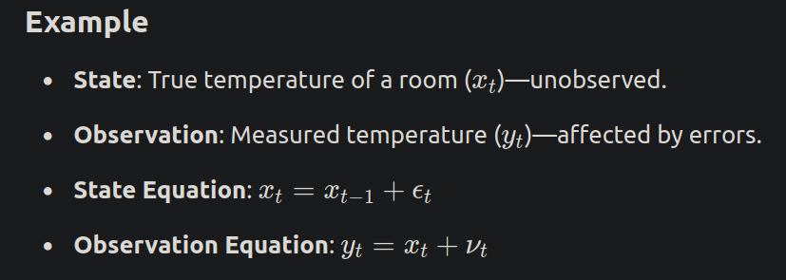

Advantages
- Flexible: Handles complex dynamics, missing data, and unobserved variables.
- Forecasting: Good for predicting future values.

Disadvantages
- Complex: Requires careful modeling and computation (e.g., Kalman filter).
- Hard to Interpret: The hidden state might be difficult to understand.

