Batch: H1-2 Roll No.: 16010122034
Experiment 01

Title: Data pre-processing using python on real world dataset

Objective:

To learn how to prepare the dataset

To learn various steps in Data –Preprocessing

Perform the Descriptive analytics (obtain measure of central tendency, dispersion, skewness, Kurtosis, and graphical representation of the given dataset)

Perform Exploratory Data Analysis over dataset

Course Outcome:

CO1: Understand basic concepts of data analytics to solve real-world problems

CO2: Experiment using advanced software techniques and tools to conduct thorough and insightful analysis

Books/ Journals/ Websites referred:
- Data Mining Concepts and Techniques Jiawei Han, Michelin Kamber, Jian Pie, 3rd edition

Resources used:
1. Kaggle datasets
2. Google Colaboratory
______________________________________________________________________

Theory (About Data Preprocessing):
Data preprocessing involves transforming raw data to well-formed data sets so that data mining analytics can be applied. Raw data is often incomplete and has inconsistent formatting. The adequacy or inadequacy of data preparation has a direct correlation with the success of any project that involve data analytics.
Preprocessing involves both data validation and data imputation. The goal of data validation is to assess whether the data in question is both complete and accurate. The goal of data imputation is to correct errors and input missing values – either manually or automatically through business process automation (BPA) programming.
Source of the dataset (URL):
https://www.kaggle.com/datasets/jessemostipak/hotel-booking-demand
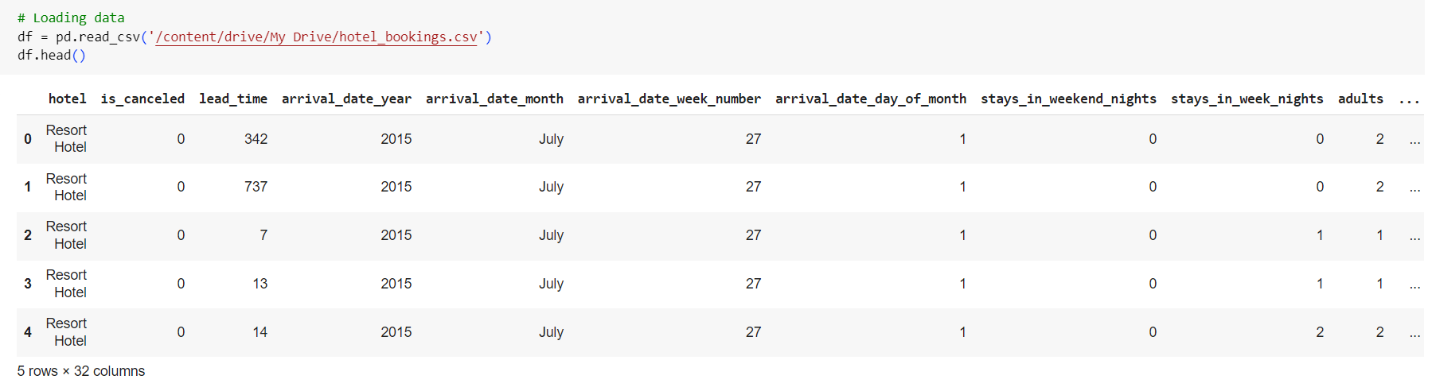

Platform used by the student: Google Colaboratory (Python)

Following points should be written by students

Different steps in Data Preprocessing:

Finding missing, null values

Replacing missing, null values with statistical parameters

Encoding categorical data if needed (Write user defined function)

Normalization (Write user defined function)

Discretization (Write user defined function)
Working (Paste the code and Output for each Data Preprocessing task):

Data Preprocessing:

Finding missing/null values:

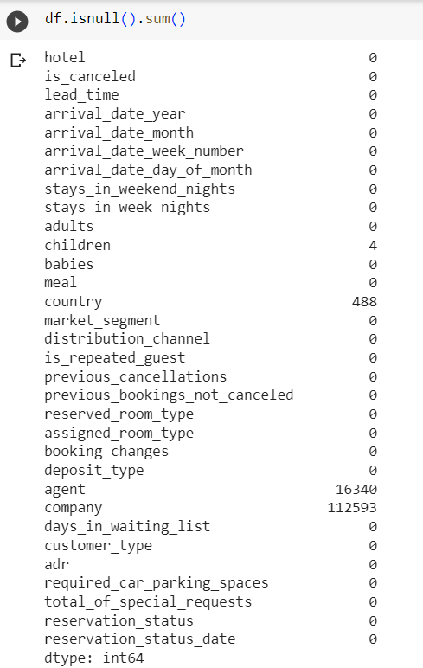

Replacing missing/null values with statistical parameters:

The ‘children’, ‘country’, ‘agent’ and ‘company’ columns contain missing/null values.

Dropping ‘agent’ and ‘company’ columns as they have too many missing values.

Replacing missing values in the ‘country’ column with the most frequent country.

Missing values in ‘children’ column are replaced with 0.

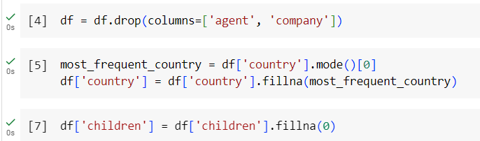

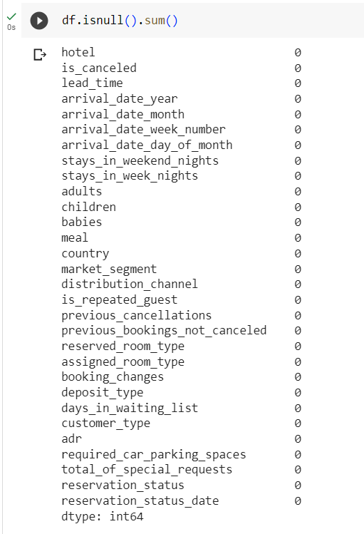

All missing/null values are dealt with.

Encoding categorical data:

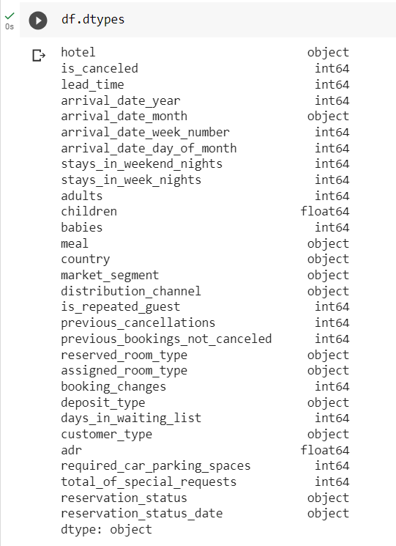

The ‘arrival_date_month’ is one of the columns containing categorical data.

Replacing month names by respective numbers 1-12.

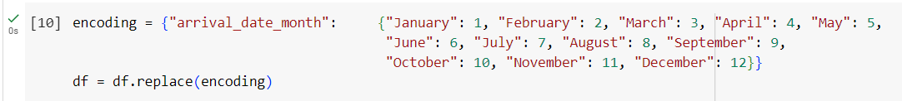

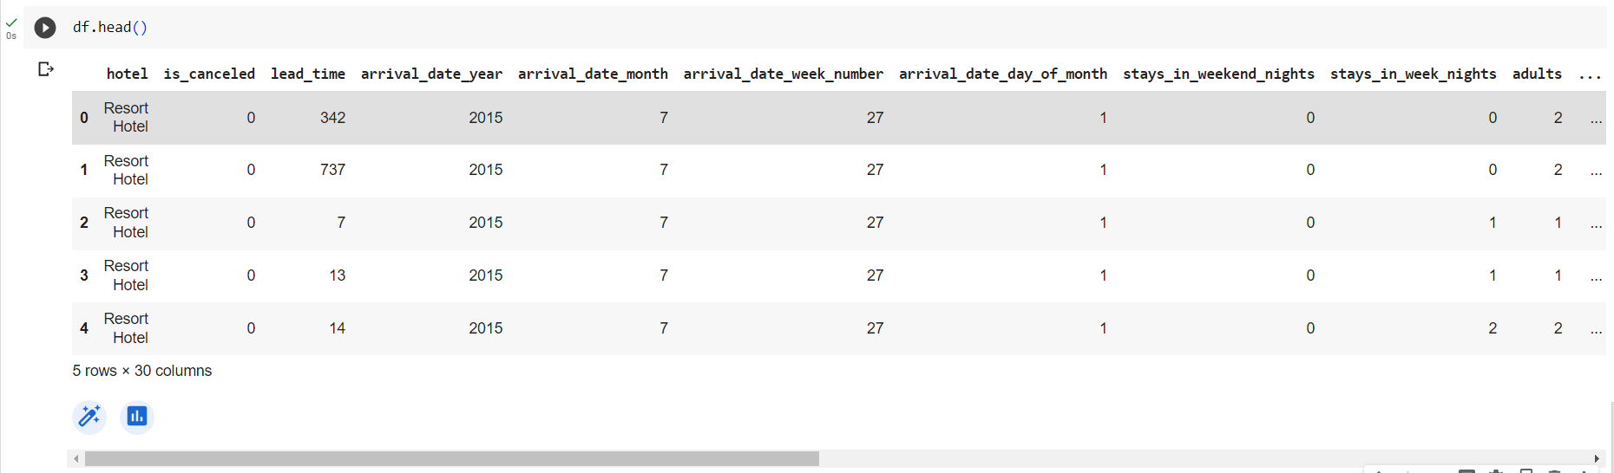

Removing incorrect data:

Removing any 0 values from adults column as bookings need to have at least one adult.

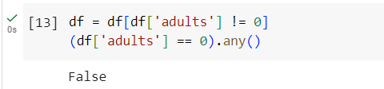

Discretization:

Making a seasons column and mapping arrival month to the season.

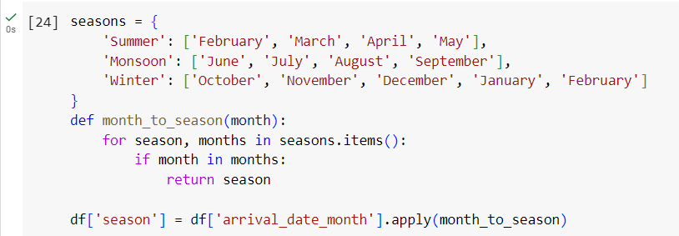

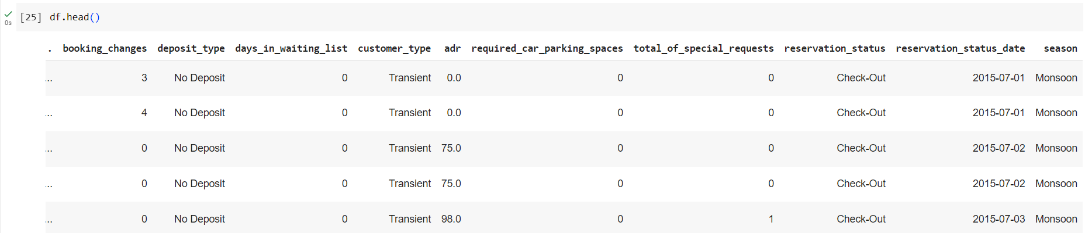

Removing outliers:

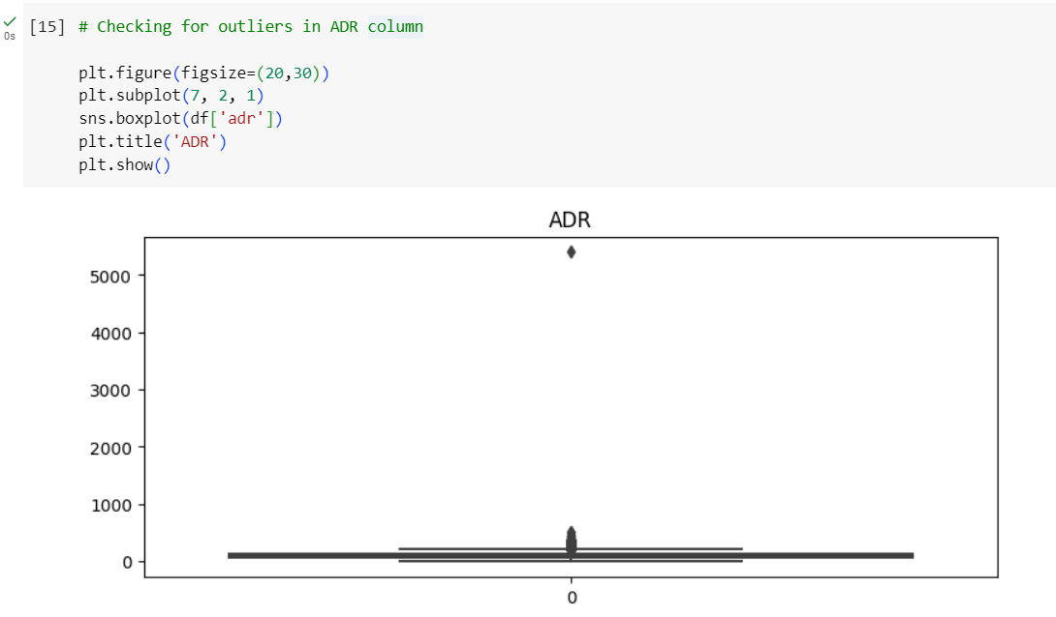

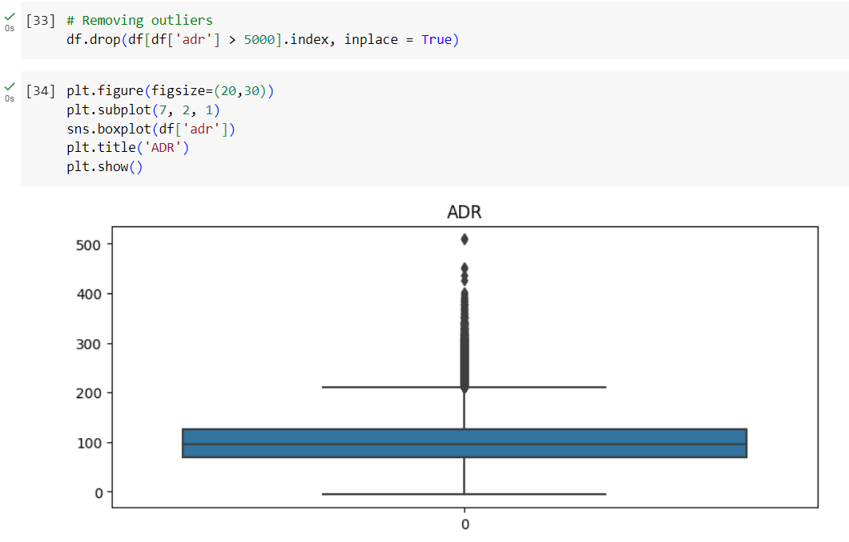

Conclusion (Students should write in their own words):

Prepared the dataset and pre-processed it using python. Handled missing/null values, incorrect data, duplicate data, encoded categorical variables and removed outliers.

Performed descriptive analysis on the dataset and drew some conclusions using exploratory data analysis.

Post lab questions:

Q.1 What are some common challenges encountered during data cleaning? How did you handle missing values in the provided dataset?
Challenges in Data Cleaning:
Missing Values: One of the most common issues, missing data can occur due to various reasons, such as human error, equipment malfunction, or data corruption. Handling missing values is crucial to ensure the quality of the analysis.
- Duplicate Entries: Duplicate records can skew the results and need to be identified and removed.
- Incorrect Data: Erroneous data, such as outliers or inconsistent values, can affect the analysis and need to be corrected or removed.
- Inconsistent Data Formats: Data coming from different sources may have inconsistent formats (e.g., date formats), requiring standardization.
- Categorical Data: Converting categorical variables into numerical formats suitable for machine learning models can be challenging.
Handling Missing Values: In the provided dataset, missing values were handled by first identifying rows containing 'null' values. These rows were then removed to ensure that the dataset only contained complete entries. Specifically, I applied a lambda function that checks each row for the presence of 'null' and filtered out any row where 'null' was detected. This method ensured that the remaining dataset was free of missing values, which is essential for accurate analysis.
Q.2 Explain the importance of data normalization in the context of machine learning models. How does normalizing benefit the analysis?
Importance of Data Normalization: Data normalization is the process of scaling numerical data to a standard range, usually between 0 and 1 or -1 and 1. It’s particularly important in machine learning for several reasons:
- Improved Model Performance: Many machine learning algorithms, such as gradient descent-based models, perform better when the input features are on a similar scale. Normalization ensures that no single feature dominates due to its scale.
- Faster Convergence: Algorithms converge faster during training when the data is normalized, reducing the time and computational resources required.
- Reduced Sensitivity to Outliers: Normalization can help reduce the impact of outliers, making the model more robust.
- Consistency in Analysis: Normalized data ensures that features contribute proportionately to the analysis, leading to more reliable and interpretable results.
Benefits to the Analysis: Normalizing the data makes the machine learning models more stable and reliable, reducing the risk of biases toward certain features due to their scale. It also ensures that the distance-based algorithms, such as k-NN and SVM, work efficiently since they rely on feature distances, which should be comparable.
Q.3 Discuss why it's essential to convert categorical variables like 'gender' into numerical representations.
Importance of Converting Categorical Variables: Categorical variables like 'gender' represent qualitative data that machine learning algorithms cannot process directly. Most algorithms require numerical inputs to perform mathematical computations. Therefore, converting categorical variables into numerical representations is essential for several reasons:
- Compatibility with Algorithms: Algorithms like linear regression, SVM, and neural networks require numerical inputs to perform calculations. Categorical data needs to be encoded into numbers to be used in these models.
- Preserving Information: Proper encoding techniques, like one-hot encoding, ensure that the categorical data is represented in a way that preserves its inherent information without introducing any ordinal relationships unless they are meaningful.
- Improved Model Interpretability: Converting categorical variables into numbers helps in analyzing feature importance and understanding how different categories contribute to the predictions.
Common Methods of Conversion:
- Label Encoding: Assigns a unique number to each category. It’s simple but can introduce ordinal relationships where they don’t exist.
- One-Hot Encoding: Creates binary columns for each category, ensuring no ordinal relationship is introduced. This method is preferred when there is no inherent order in the categories.
By converting categorical variables into numerical forms, we ensure that the machine learning models can utilize all available information effectively, leading to better predictions and more accurate analyses.

