Batch: H1-2 Roll No.: 16010122034

Experiment No. 6

TITLE : To perform time series analysis on health care

AIM: To perform forecasting using time series analysis
Expected OUTCOME of Experiment:
CO4: Perform Time series Analytics and forecasting
_____________________________________________________________________
Books/ Journals/ Websites referred:

_____________________________________________________________________
Pre Lab/ Prior Concepts:

Students should have a basic understanding of: Time series Analytics and forecasting

Procedure:

Data set Used: Hospital_patients_datasets

Step1: Select and Load the dataset

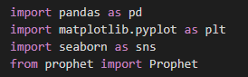

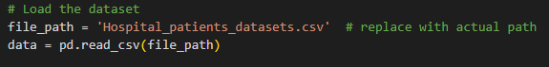

Step2: Convert 'ScheduledDay' and 'AppointmentDay' to datetime format

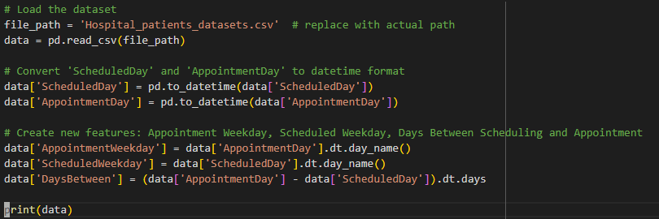\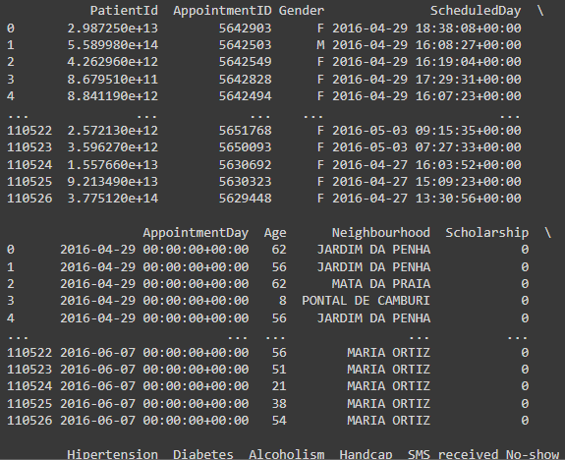
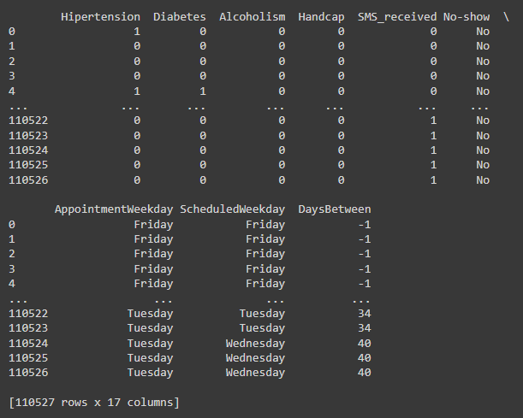

Step 3: Initialize Prophet model for forecasting

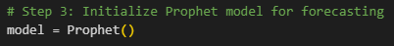

Step 4: Fit the model

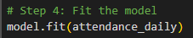

Step 5: Create future dates for prediction

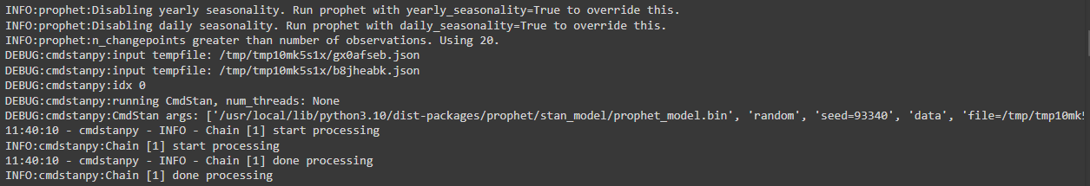

Step 6: Predict future attendance

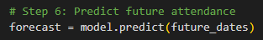

Step 7: Plot the forecast

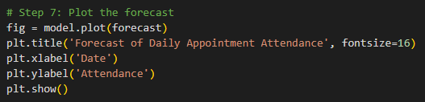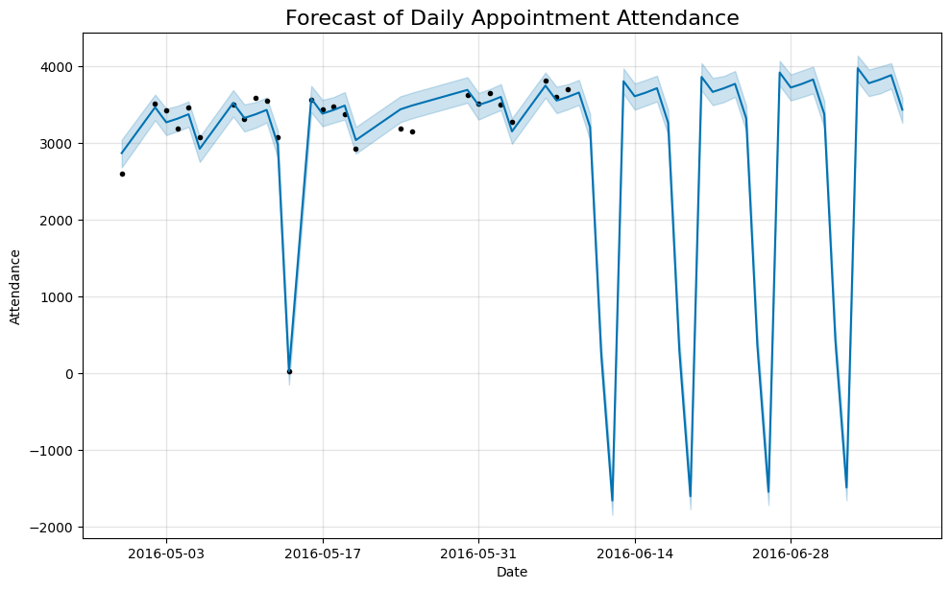

Step 8: Exploratory Data Analysis Functions and Running the analysis functions

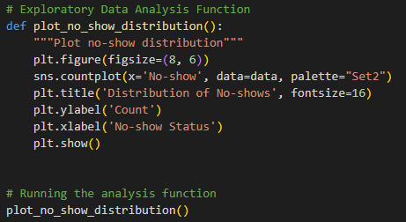

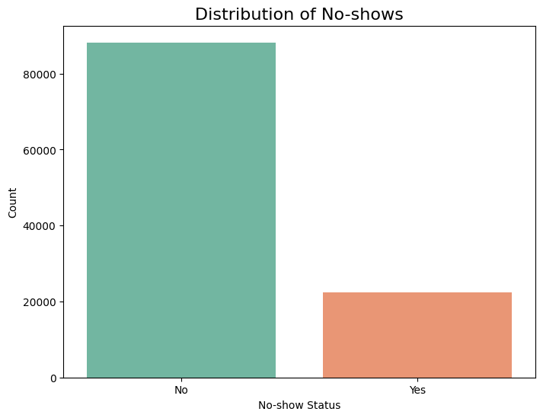

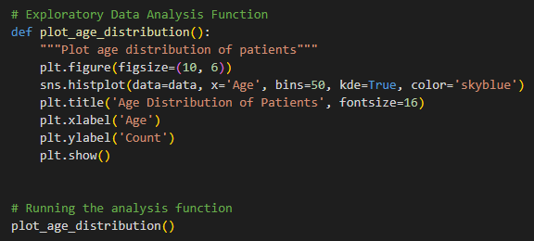

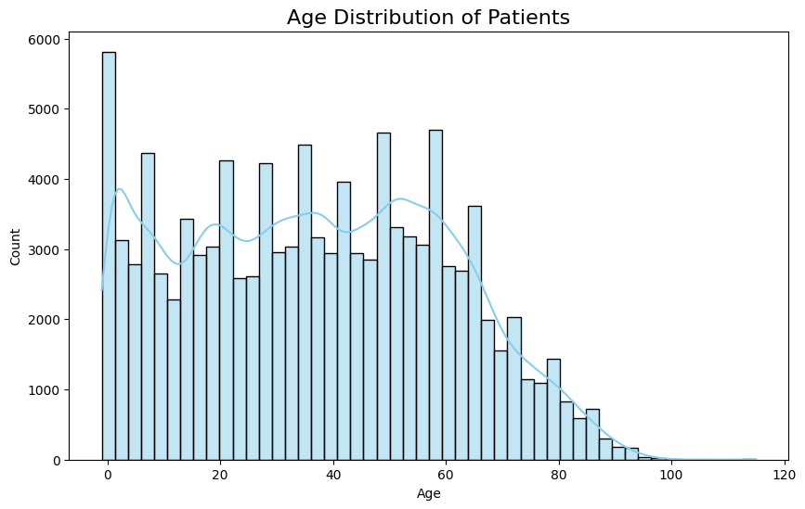

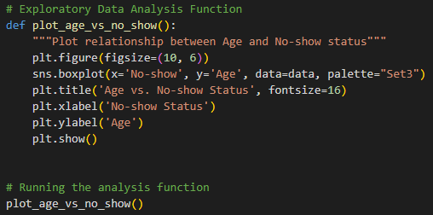
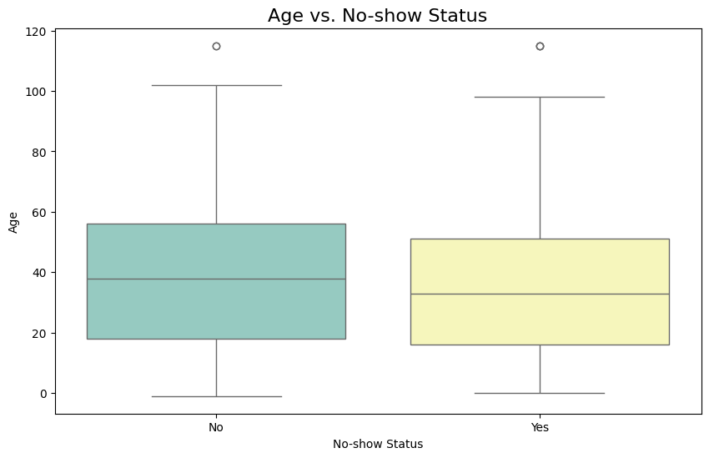

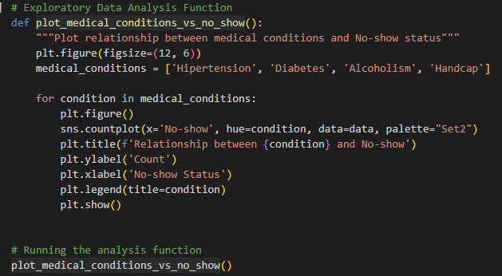

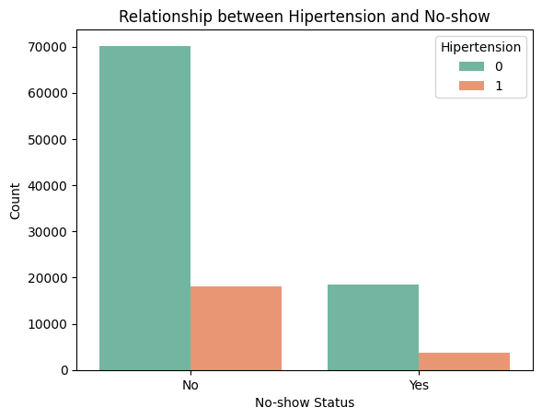
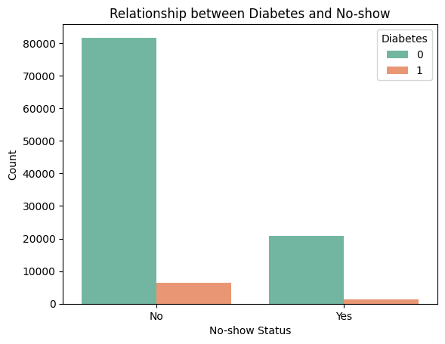
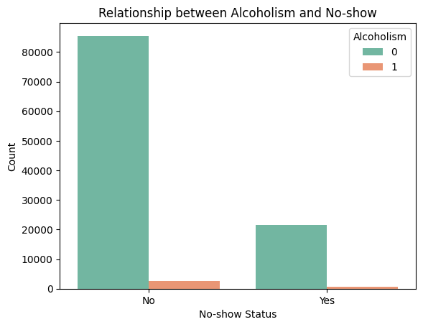
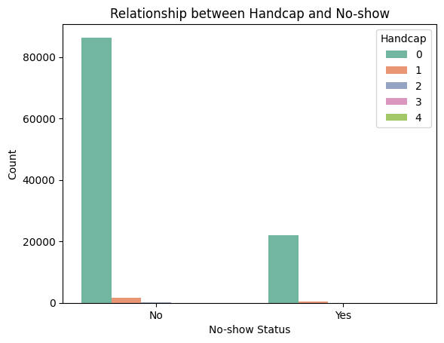

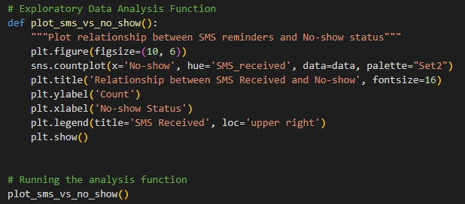
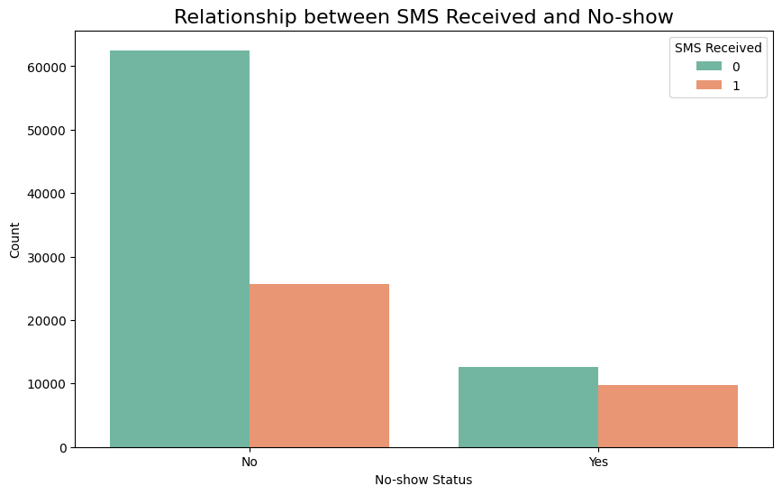

Students have to perform all the tasks illustrated above by choosing any other time series related dataset.

Implementation details:

Output:

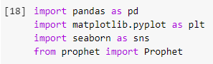

# Load the dataset
file_path = 'airquality.csv' # replace with your actual file path
air_quality_data = pd.read_csv(file_path)
air_quality_data.head()

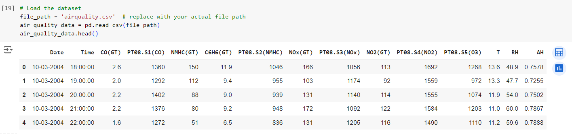

# Convert 'Date' and 'Time' to datetime format
air_quality_data['DateTime'] = pd.to_datetime(air_quality_data['Date'] + ' ' + air_quality_data['Time'], format='%d-%m-%Y %H:%M:%S')
air_quality_data.head()

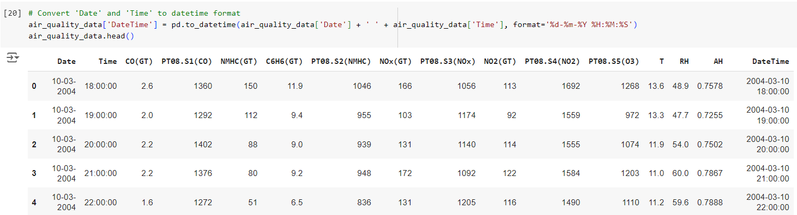

# Create new features: Year, Month, Day, Hour, Weekday
air_quality_data['Year'] = air_quality_data['DateTime'].dt.year
air_quality_data['Month'] = air_quality_data['DateTime'].dt.month
air_quality_data['Day'] = air_quality_data['DateTime'].dt.day
air_quality_data['Hour'] = air_quality_data['DateTime'].dt.hour
air_quality_data['Weekday'] = air_quality_data['DateTime'].dt.day_name()
air_quality_data.head()

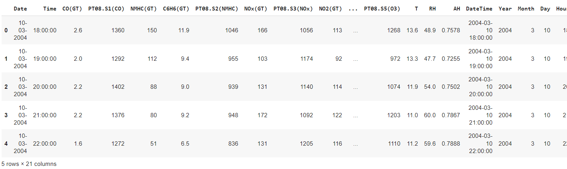

# Forecasting CO(GT) concentrations using Prophet
# Step 1: Preprocess the data to aggregate daily CO concentrations
air_quality_daily = air_quality_data.groupby(air_quality_data['DateTime'].dt.date)['CO(GT)'].mean().reset_index()
air_quality_daily.columns = ['ds', 'y']

# Ensure the 'ds' column is in datetime format and without timezone
air_quality_daily['ds'] = pd.to_datetime(air_quality_daily['ds']).dt.tz_localize(None)

# Ensure 'y' (CO levels) is numeric
air_quality_daily['y'] = pd.to_numeric(air_quality_daily['y'], errors='coerce')

# Drop any rows with missing values (NaNs)
air_quality_daily = air_quality_daily.dropna()

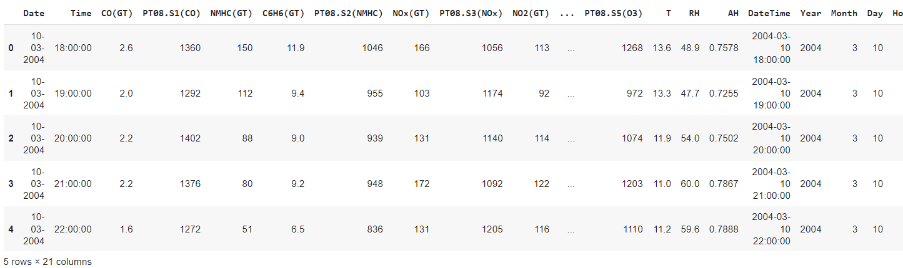
# Step 2: Initialize Prophet model for forecasting
model = Prophet()

# Step 3: Fit the model
model.fit(air_quality_daily)

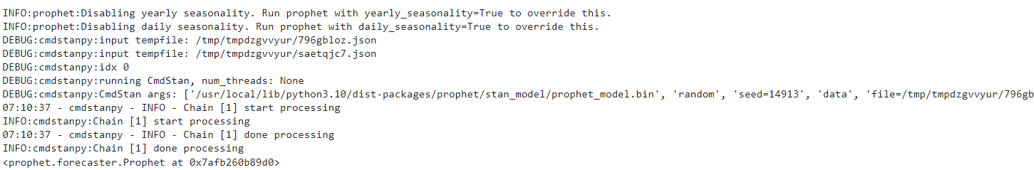

# Step 4: Create future dates for prediction (e.g., next 30 days)
future_dates = model.make_future_dataframe(periods=30)

# Step 5: Predict future CO concentrations
forecast = model.predict(future_dates)

# Step 6: Plot the forecast
fig = model.plot(forecast)
plt.title('Forecast of Daily CO Concentrations', fontsize=16)
plt.xlabel('Date')
plt.ylabel('CO(GT) Concentration')
plt.show()
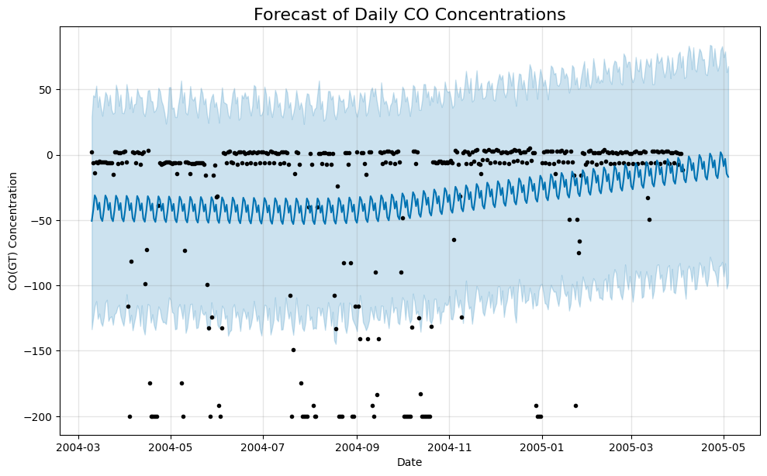

# Exploratory Data Analysis (EDA)

def plot_co_distribution():
"""Plot distribution of CO concentrations"""
plt.figure(figsize=(8, 6))
sns.histplot(air_quality_data['CO(GT)'], bins=30, kde=True, color='lightcoral')
plt.title('Distribution of CO(GT) Concentrations', fontsize=16)
plt.xlabel('CO(GT) Concentration')
plt.ylabel('Count')
plt.show()

def plot_temperature_vs_co():
"""Plot relationship between Temperature and CO(GT) Concentration"""
plt.figure(figsize=(10, 6))
sns.scatterplot(x='T', y='CO(GT)', data=air_quality_data, color='skyblue')
plt.title('Temperature vs. CO(GT) Concentration', fontsize=16)
plt.xlabel('Temperature (°C)')
plt.ylabel('CO(GT) Concentration')
plt.show()

def plot_weekday_vs_co():
"""Plot average CO(GT) Concentration by Weekday"""
plt.figure(figsize=(10, 6))
sns.barplot(x='Weekday', y='CO(GT)', data=air_quality_data, estimator=lambda x: x.mean(), palette="Set2")
plt.title('Average CO(GT) Concentration by Weekday', fontsize=16)
plt.ylabel('CO(GT) Concentration')
plt.xticks(rotation=45)
plt.show()

# Running the EDA functions
plot_co_distribution()
plot_temperature_vs_co()
plot_weekday_vs_co()

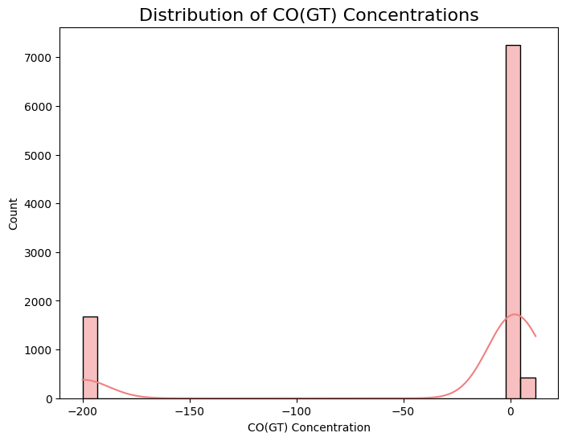
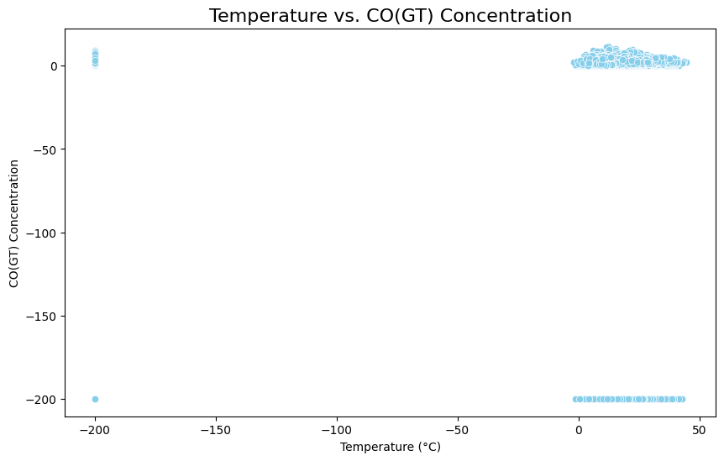

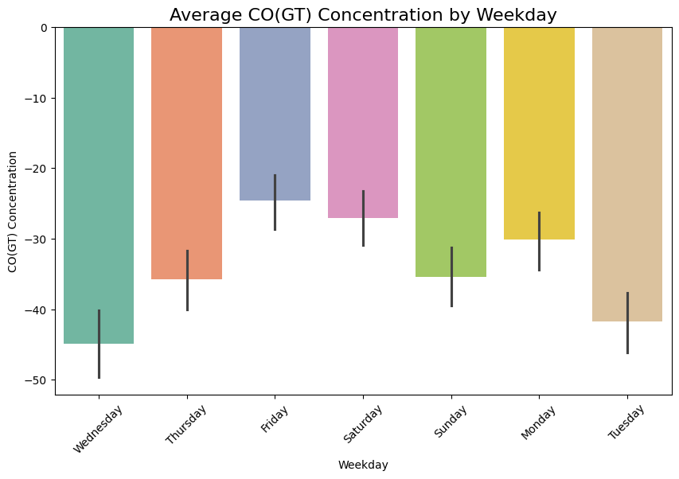
Date: 24 October 2024 Signature of faculty in-charge

Post Lab Descriptive Questions:

- Explain the components of time series?
Time series data typically consists of several key components that help in understanding its underlying patterns and trends. Here are the main components:
- Trend: This represents the long-term movement or direction in the data over time. Trends can be upward, downward, or stable.
- Seasonality: This refers to regular, predictable patterns that occur at specific intervals, such as daily, monthly, or yearly. Seasonality often correlates with calendar events or seasons.
- Cyclic Patterns: Unlike seasonality, cyclic patterns are long-term fluctuations that occur over irregular intervals, often linked to economic or business cycles.
- Irregular or Random Component: This represents random noise or unpredictable events that do not follow a discernible pattern. These fluctuations can be due to unexpected occurrences, such as natural disasters or sudden market changes.
- Level: The average value around which the time series fluctuates. It can be thought of as the baseline or central tendency of the data.

- How do you handle seasonality in time series data? What methods or transformations can you apply?
Following are several methods and transformations you can apply:
- Seasonal Decomposition:
  - Additive Decomposition: Decomposes the time series into trend, seasonal, and irregular components, assuming the seasonal component is constant over time.
  - Multiplicative Decomposition: Similar to additive, but assumes that the seasonal effect varies with the level of the series.
- Differencing:
  - Seasonal Differencing: Subtracting the value from the same season in the previous cycle (e.g., the same month last year) to remove seasonality.
- Seasonal Adjustment:
  - Use methods like X-12-ARIMA or STL (Seasonal-Trend decomposition using LOESS) to adjust the data for seasonality.
- Fourier Transforms:
  - Apply Fourier transforms to capture seasonal patterns by adding sine and cosine terms corresponding to the seasonal frequencies.
- Dummy Variables:
  - Create dummy variables for seasonal periods (e.g., months or quarters) and include them in regression models to account for seasonal effects.
- Moving Averages:
  - Apply moving averages to smooth out seasonal fluctuations, which can help in identifying trends.
- Exponential Smoothing:
  - Methods like Holt-Winters seasonal smoothing explicitly account for seasonality, trend, and level in the forecasts.
- Machine Learning Models:
  - Use models like seasonal ARIMA, SARIMA, or advanced machine learning techniques that can naturally capture seasonal patterns.

3. What are some common metrics for evaluating forecasting models (e.g., MAE, RMSE, MAPE)?
- Mean Absolute Error (MAE):
  - Measures the average absolute difference between forecasted and actual values.
  - Formula: MAE=1n∑t=1n∣yt−y^t∣\text{MAE} = \frac{1}{n} \sum_{t=1}^{n} |y_t - \hat{y}_t|MAE=n1​t=1∑n​∣yt​−y^​t​∣
  - Advantages: Easy to interpret; treats all errors equally.
- Root Mean Squared Error (RMSE):
  - Calculates the square root of the average squared differences between forecasted and actual values.
  - Formula: RMSE=1n∑t=1n(yt−y^t)2\text{RMSE} = \sqrt{\frac{1}{n} \sum_{t=1}^{n} (y_t - \hat{y}_t)^2}RMSE=n1​t=1∑n​(yt​−y^​t​)2​
  - Advantages: Penalizes larger errors more heavily; sensitive to outliers.
- Mean Absolute Percentage Error (MAPE):
  - Measures the average absolute percentage error between forecasted and actual values.
  - Formula: MAPE=100n∑t=1n∣yt−y^tyt∣\text{MAPE} = \frac{100}{n} \sum_{t=1}^{n} \left|\frac{y_t - \hat{y}_t}{y_t}\right|MAPE=n100​t=1∑n​​yt​yt​−y^​t​​​
  - Advantages: Scale-independent; expressed as a percentage, making it easy to interpret.
- Mean Squared Error (MSE):
  - Similar to RMSE but without taking the square root, measuring the average of the squared differences.
  - Formula: MSE=1n∑t=1n(yt−y^t)2\text{MSE} = \frac{1}{n} \sum_{t=1}^{n} (y_t - \hat{y}_t)^2MSE=n1​t=1∑n​(yt​−y^​t​)2
  - Advantages: Useful for highlighting the magnitude of errors.
- Theil's U Statistic:
  - Compares the accuracy of the forecasting model to a naïve benchmark.
  - Values less than 1 indicate that the model is more accurate than the naïve approach.
- R-squared (Coefficient of Determination):
  - Measures the proportion of variance in the dependent variable explained by the model.
  - Useful in regression-based forecasts.
- Tracking Signal:
  - Helps detect bias in forecasts by calculating the cumulative forecast error relative to the average error.

