Batch: H5 Roll No.: 16010122158

Experiment No. 8

TITLE : To perform NLP on clinical data

AIM: Named Entity Recognition on Healthcare Data
Expected OUTCOME of Experiment:
CO5: Apply data analytics in the field of Health care.
_____________________________________________________________________
Books/ Journals/ Websites referred:

_____________________________________________________________________
Pre Lab/ Prior Concepts:

Natural Language Processing (NLP) Basics

Definition: NLP is a field that combines linguistics, computer science, and AI to process and analyze human language (text and speech).
Goal: Convert unstructured language data (like text) into structured, analyzable formats.
Common Tasks:
- Tokenization: Breaking text into words or sub-phrases (tokens).
- Lemmatization: Reducing words to their base form (e.g., "running" to "run").
- POS (Part of Speech) Tagging: Identifying the role of each word in a sentence (e.g., noun, verb, adjective).

Named Entity Recognition (NER)
- Definition: A technique that identifies and categorizes key information or "entities" in text, such as names, locations, dates, and specific terms.
- How It Works:
  - NER models analyze text and label entities based on pre-defined categories.
  - Example: In a sentence like "John took ibuprofen for his headache," NER might tag "John" (Person), "ibuprofen" (Medication), and "headache" (Symptom).
- Importance in Healthcare:
  - Helps automate information extraction from medical records.
  - Useful for identifying medications, symptoms, and diagnoses to streamline clinical processes.
Procedure:

!pip install spacy
!pip install https://github.com/explosion/spacy-models/releases/download/en_core_web_sm-3.5.0/en_core_web_sm-3.5.0.tar.gz
import spacy
nlp = spacy.load("en_core_web_sm")

# Sample healthcare-related text
healthcare_text = """
The patient was diagnosed with type 2 diabetes and hypertension.
They were prescribed metformin and lisinopril. Further, the patient will undergo
a cardiac stress test at St. Mary's Hospital next week."""

# Process the text
doc = nlp(healthcare_text)

# Print named entities
print("Entities in the text:")
for ent in doc.ents:
print(f"{ent.text} - {ent.label_}")

# Print explanations of entity labels
print("\nEntity Label Explanations:")
for ent in doc.ents:
print(f"{ent.text}: {spacy.explain(ent.label_)}")

# Sample healthcare-related text
healthcare_text = """
The patient was diagnosed with type 2 diabetes and hypertension.
They were prescribed metformin and lisinopril. Further, the patient will undergo
a cardiac stress test at St. Mary's Hospital next week."""

# Process the text
doc = nlp(healthcare_text)

# Define custom entity labels for diseases and drugs
disease_labels = ["type 2 diabetes", "hypertension"] # Add more disease terms as needed
drug_labels = ["metformin", "lisinopril"] # Add more drug names as needed

# Iterate through the text and identify entities based on the custom labels
entities = []
for label in disease_labels:
if label in healthcare_text:
entities.append((label, "DISEASE"))
for label in drug_labels:
if label in healthcare_text:
entities.append((label, "DRUG"))

# Print the identified entities
print("Entities in the text:")
for entity, label in entities:
print(f"{entity} - {label}")

Data set Used: Pretrained spaCy model

Step1: Installed required library
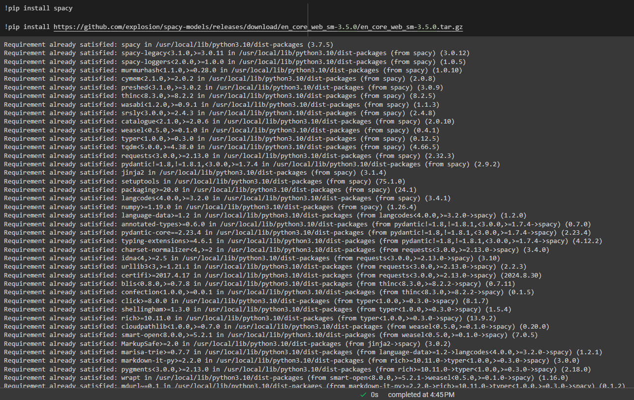

Step2: Load pretrained spaCy model

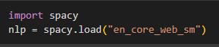
Step 3: Add Sample healthcare-related text

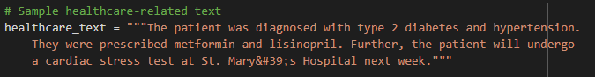
Step4: Process Text
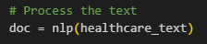
Step 5: Print named entities
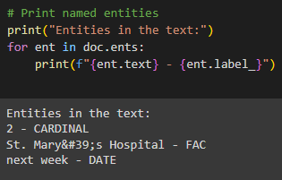
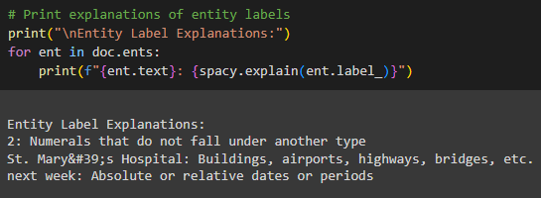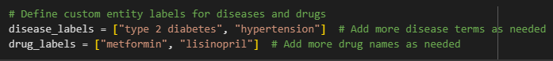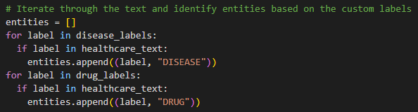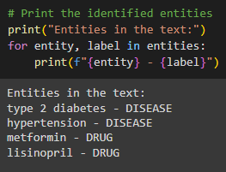

Breakdown of the Code:
Loading the Model: We use en_core_web_sm, which is a small English language model from spaCy, to process the text.
Processing Text: The healthcare data (e.g., medical conditions, treatments) is fed into the NLP model.
Extracting Named Entities: The program identifies entities like diseases, drugs, organizations (hospitals), and dates, and outputs them with their corresponding labels.
Explaining Entities: The function spacy.explain() gives a brief explanation of each entity label (e.g., DISEASE or DRUG).

Date: 8th November, 2024 Signature of faculty in-charge

Post Lab Descriptive Questions:

Q.1 What is Natural Language Processing (NLP) and how is it applied to healthcare data?

- NLP Definition: NLP is a field of AI focused on processing and analyzing human language to make sense of text and spoken words.
- Healthcare Applications:
  - Electronic Health Records (EHR): Extracts and structures information from free-text notes, making patient histories more accessible.
  - Clinical Documentation: Reduces manual data entry by automatically transcribing and organizing physician notes.
  - Drug Discovery: Identifies potential drug candidates by analyzing medical literature and existing drug descriptions.
  - Patient Monitoring: Analyzes patient feedback and communications to detect urgent health issues or monitor chronic diseases.
Q.2 What are named entities in the context of healthcare NLP, and how can Named Entity Recognition (NER) be useful in medical texts?

- Named Entities in Healthcare: Specific terms that relate to medical information, such as diseases, medications, body parts, procedures, and patient attributes (e.g., age, gender).
- Named Entity Recognition (NER) Utility:
  - Information Extraction: NER identifies and categorizes critical terms, like "diabetes" (disease) or "aspirin" (drug), from unstructured medical notes.
  - Diagnosis Support: Helps in identifying symptoms and conditions in clinical documents, which can aid in patient diagnosis.
  - Data Structuring: Organizes medical records by recognizing key entities, making the data ready for further analysis, such as machine learning.
Q.3 What are some common applications of NLP in healthcare, such as clinical decision support, medical coding, or patient sentiment analysis?

- Clinical Decision Support: Assists healthcare providers by analyzing patient records and suggesting possible diagnoses or treatment plans.
- Medical Coding: Automates the coding of diagnoses and procedures, ensuring accuracy in billing and insurance claims.
- Patient Sentiment Analysis: Analyzes feedback and patient communications to measure satisfaction, detect issues, or improve healthcare services.
Examples:
- IBM Watson Health for diagnostics and clinical insights.
- Google’s DeepMind for analyzing EHR data to predict patient deterioration.
- Mayo Clinic uses NLP to improve EHR searchability and summarize patient histories.

