Batch: B1 Roll No.: 16010122158

Experiment No. 2

Title: Implement vector data styling and raster data styling in QGIS

Course Outcome:

CO2 Apply the data analytics in the field of geospatial system

Books/ Journals/ Websites referred:

QGIS Installation Link: https://www.qgis.org/download/ Version 3.38

Resources used:
https://qgis.org/en/site/forusers/download.html
______________________________________________________________________

Algorithm: Vector data styling

Open QGIS and Load Vector Data:

Step 1: Start QGIS and load your vector data (e.g., shapefile, GeoJSON, etc.). Go to Layer-> Add Layer -> Add Vector Layer -> Upload the code file

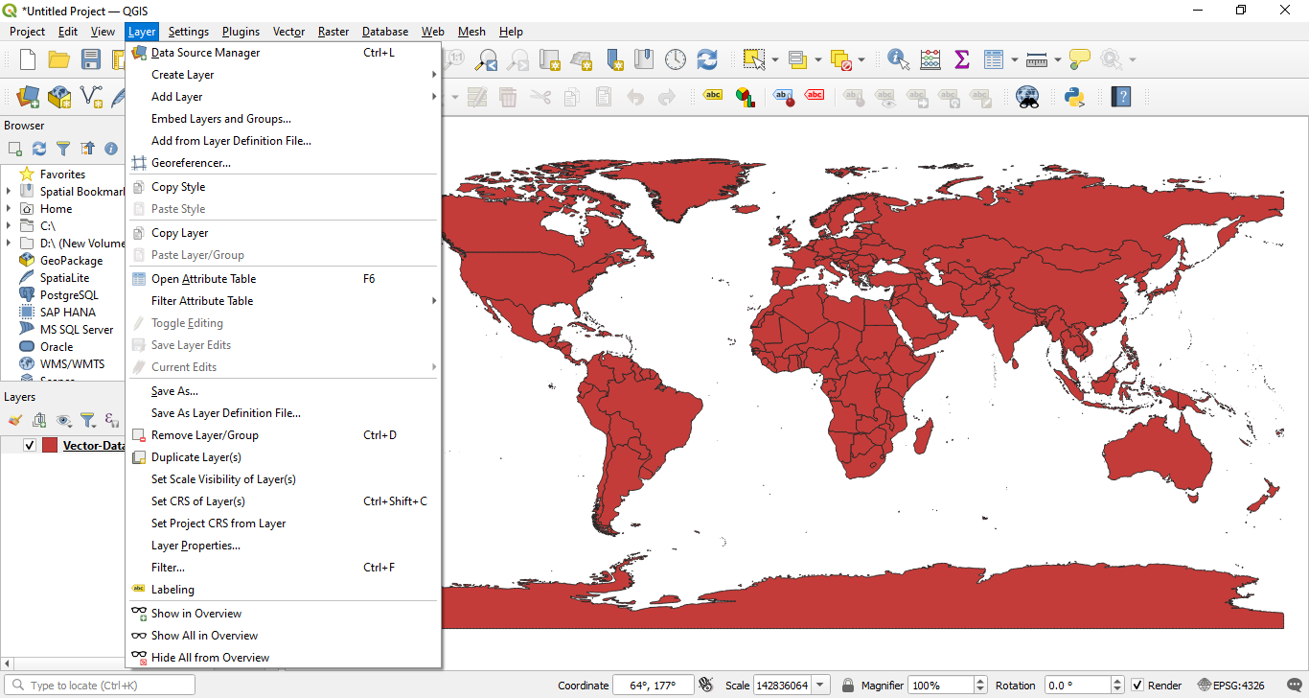

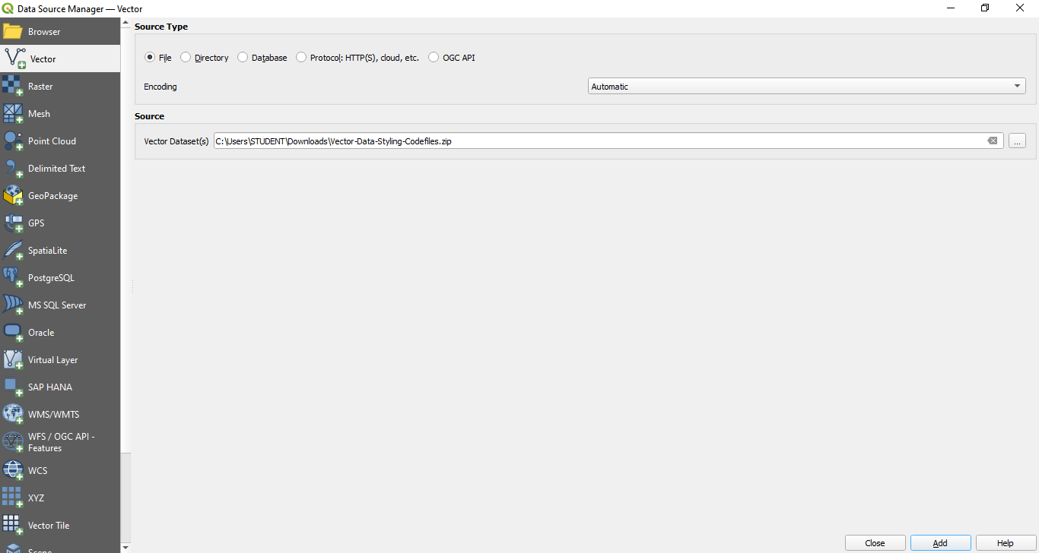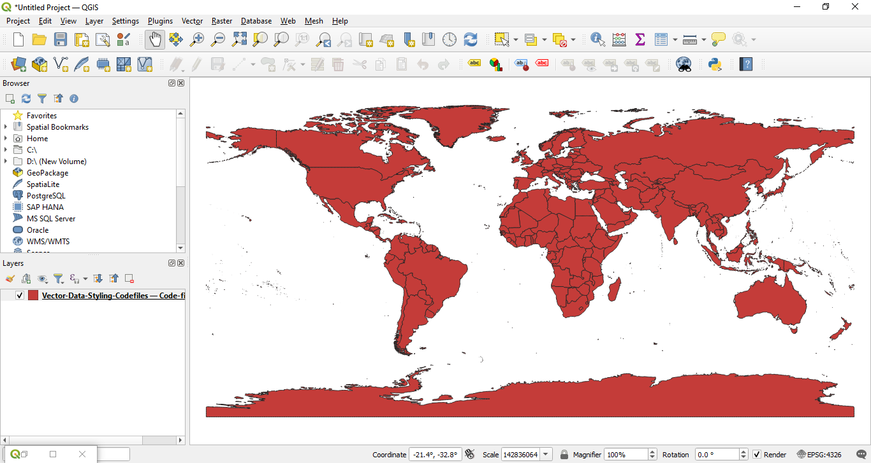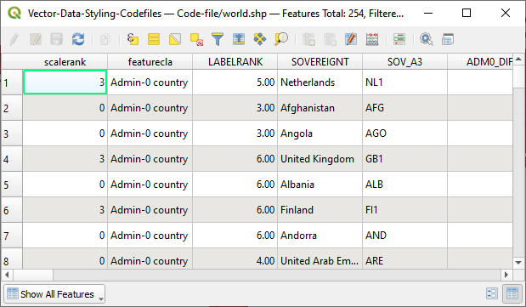

Step 2: Open the Layer Styling Panel
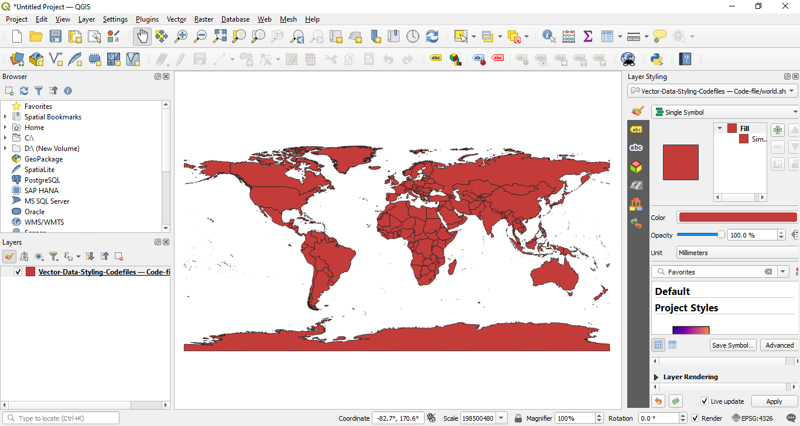

Step 3: Select your vector layer in the Layers panel.
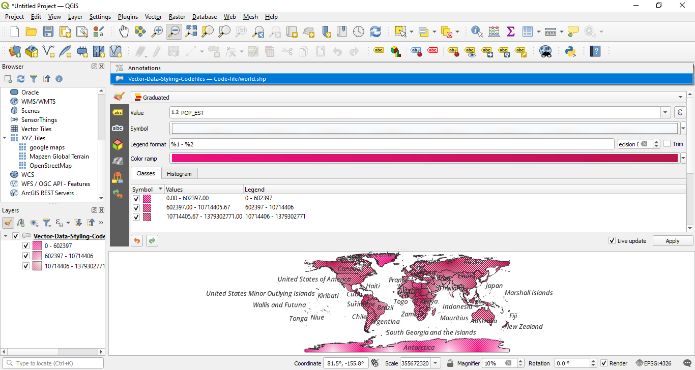

Step 4: Right-click the layer and choose "Properties" or click on the "Layer Styling" panel on the right.
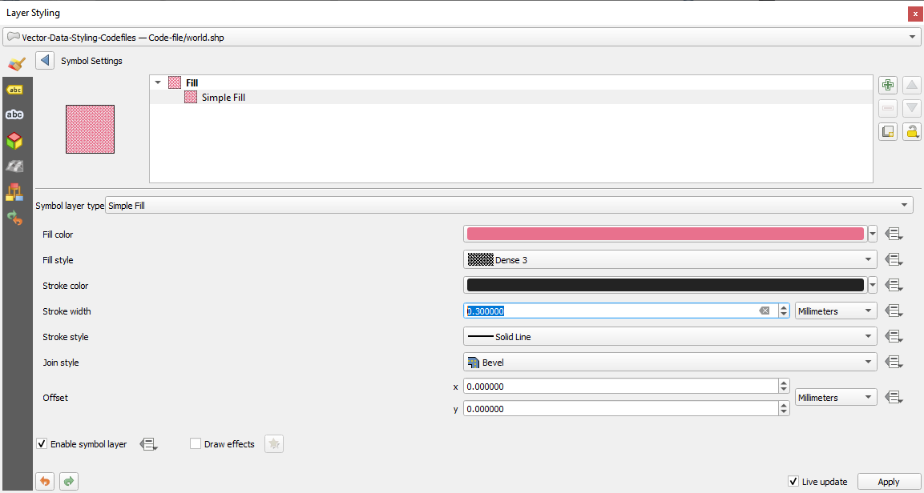

Step 5: Select a Symbology Type: In the Layer Properties window, go to the "Symbology" tab. Choose a symbology type (e.g., Single Symbol, Categorized, Graduated).
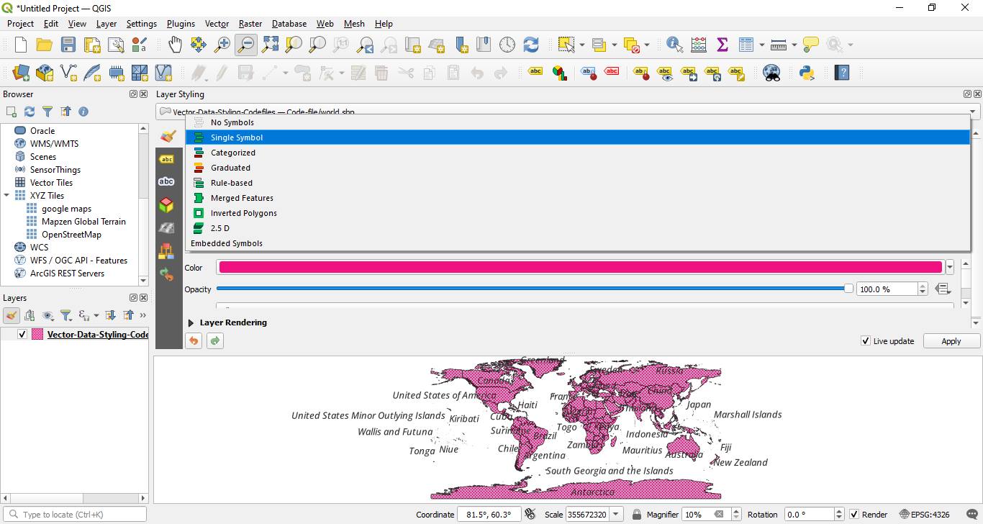

Step 6: Single Symbol Styling: For simple styling, choose "Single Symbol." Select the symbol and click on the symbol to open the Symbol Selector. Customize the symbol's color.
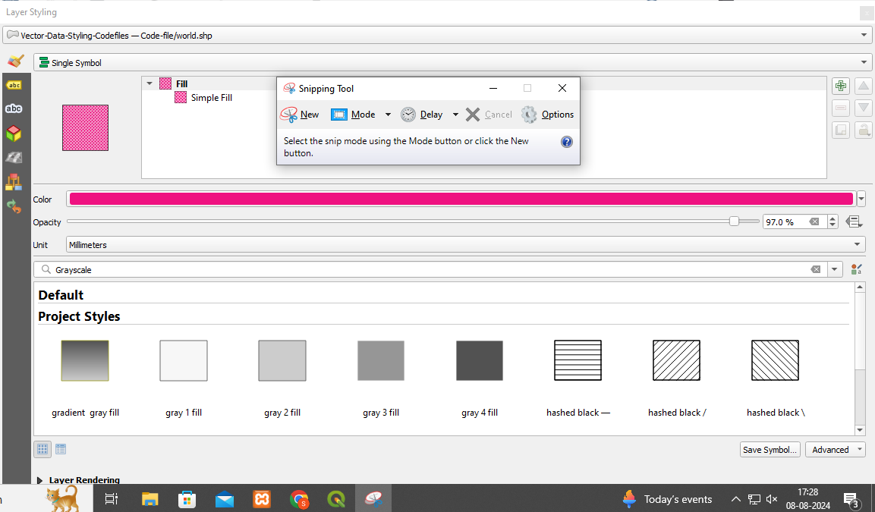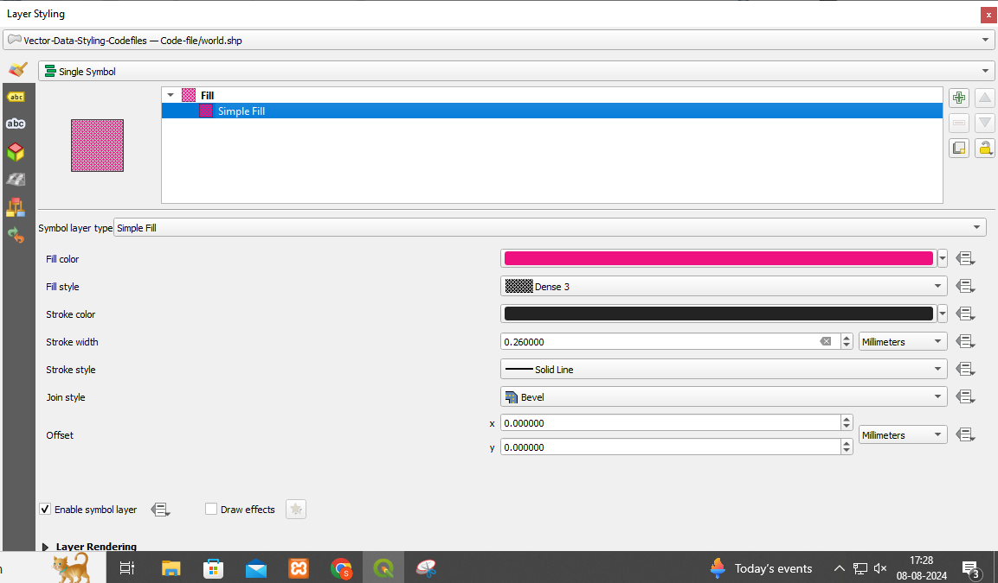

Step 6: Categorized Styling: Choose "Categorized" to style the layer based on a categorical attribute. Select the attribute column and click "Classify" to generate unique symbols for each category. Customize each category's symbol by clicking on the symbol next to each category.
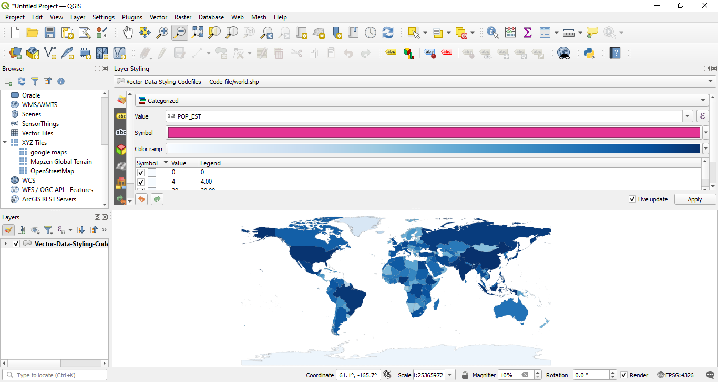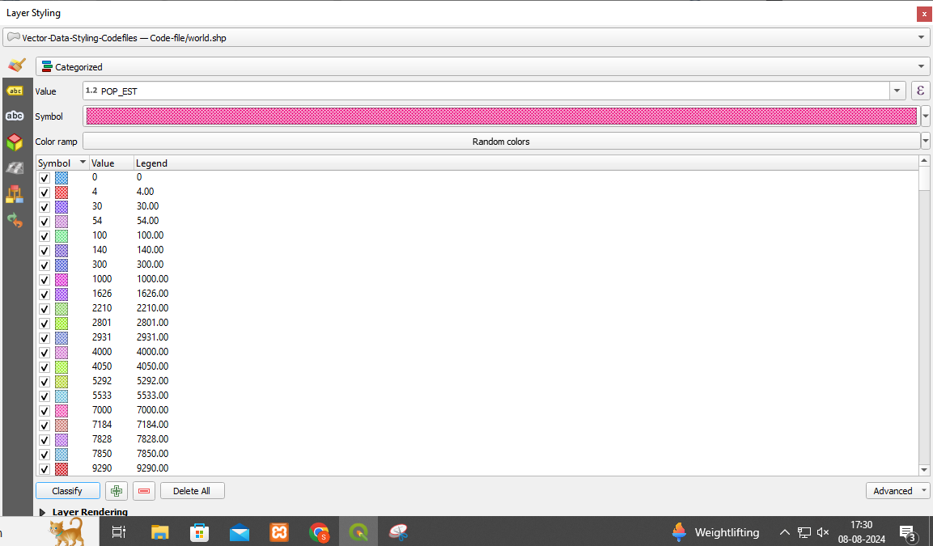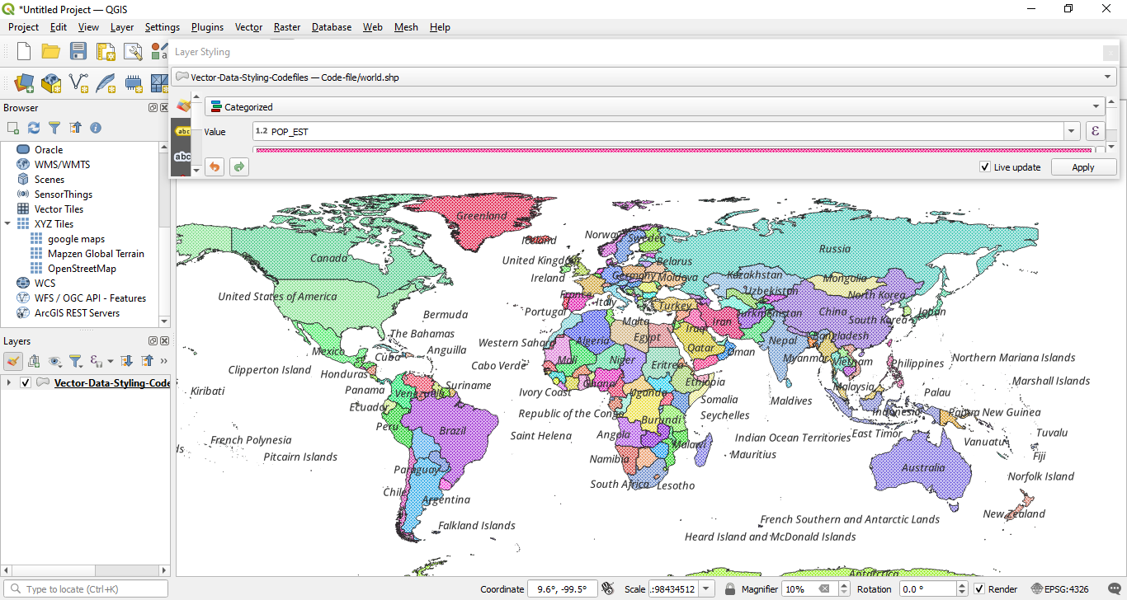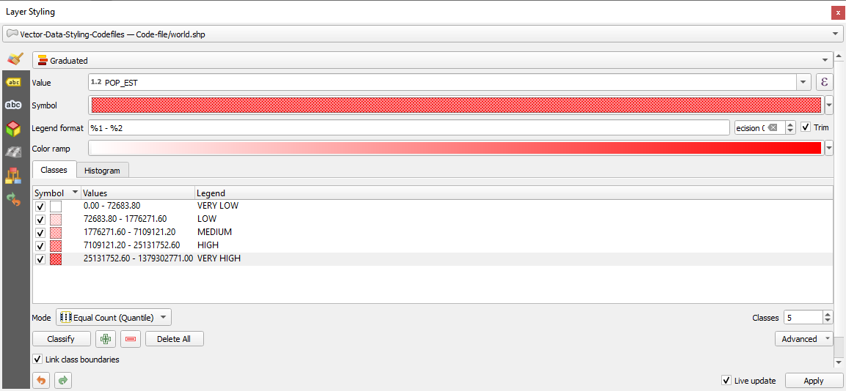
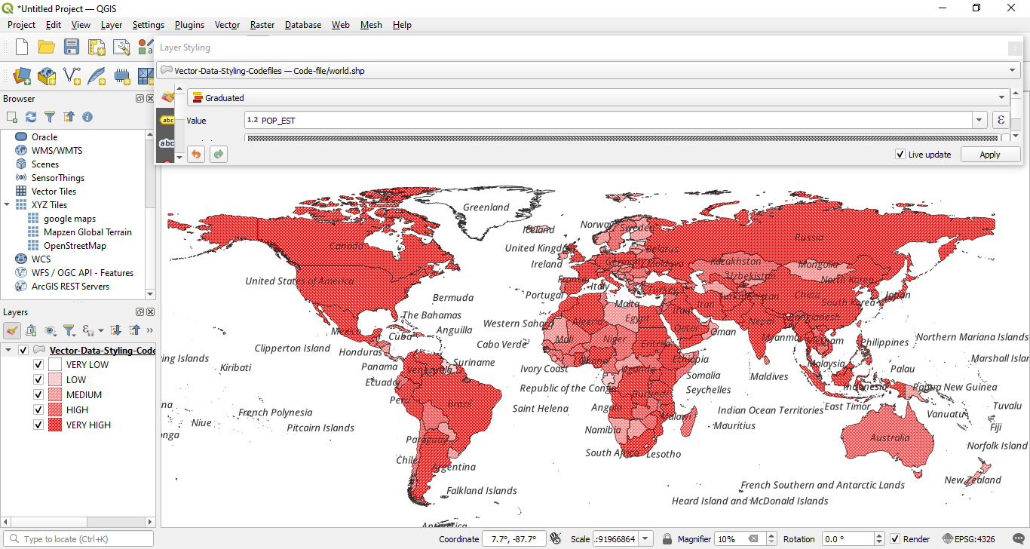

Step 7: Graduated Styling: Choose "Graduated" to style the layer based on a numeric attribute. Select the attribute column and the classification mode (e.g., Equal Interval, Quantile). Click "Classify" to generate ranges and corresponding symbols. Customize each range's symbol by clicking on the symbol next to each range.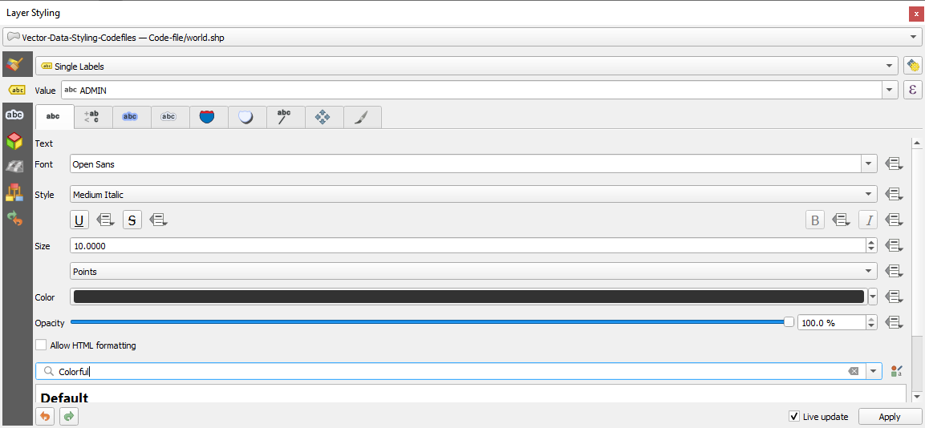
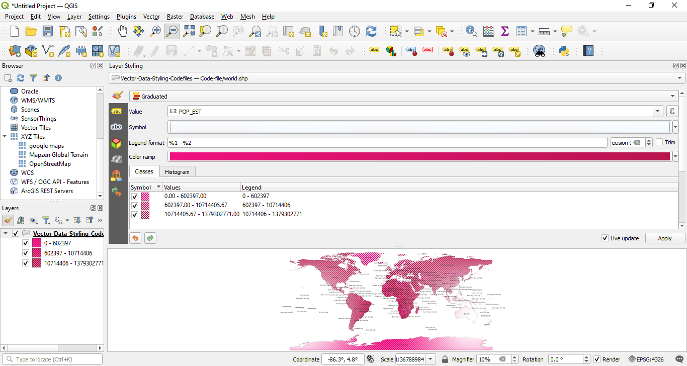

Algorithm: Raster data styling

Step 1 : Start QGIS and load your raster data (e.g., GeoTIFF, JPEG, etc.).
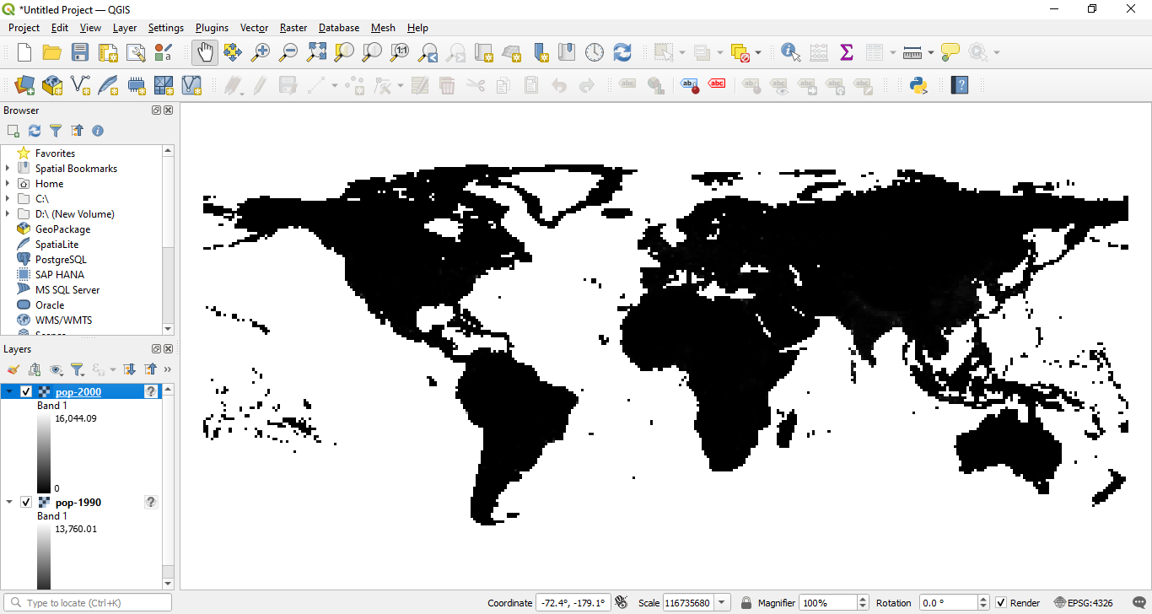

Step 2 : Open the Layer Styling Panel:
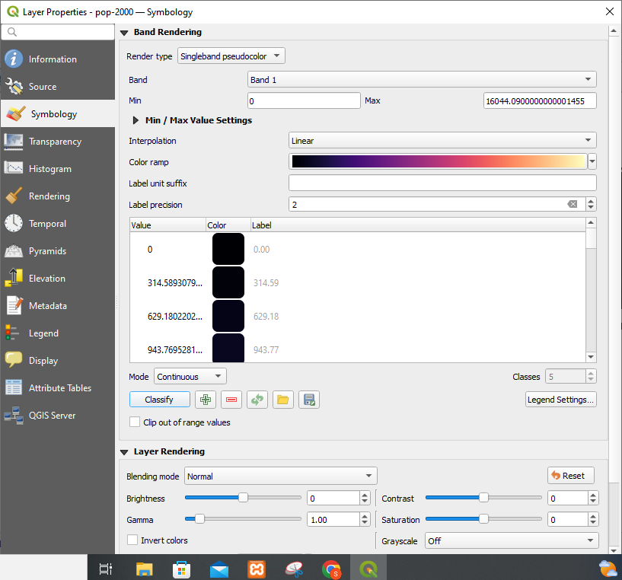

Step 3 : Select your raster layer in the Layers panel. Right-click the layer and choose "Properties" or click on the "Layer Styling" panel on the right.
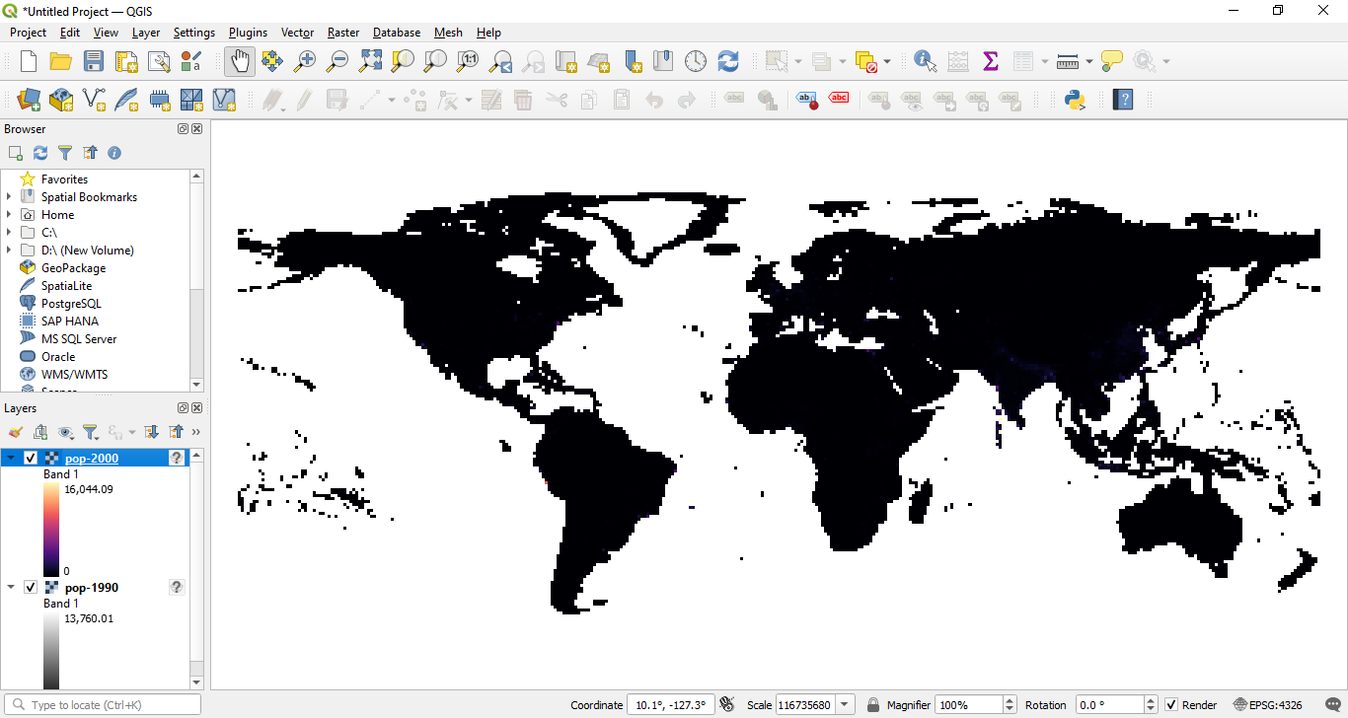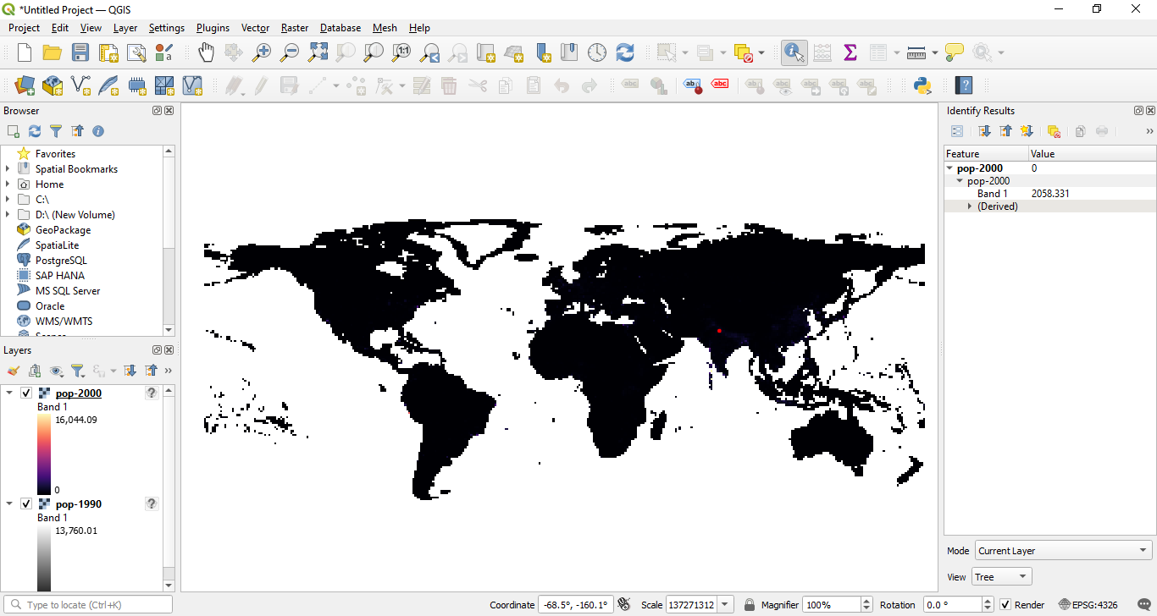

Step 4 : Select a Render Type: In the Layer Properties window, go to the "Symbology" tab.
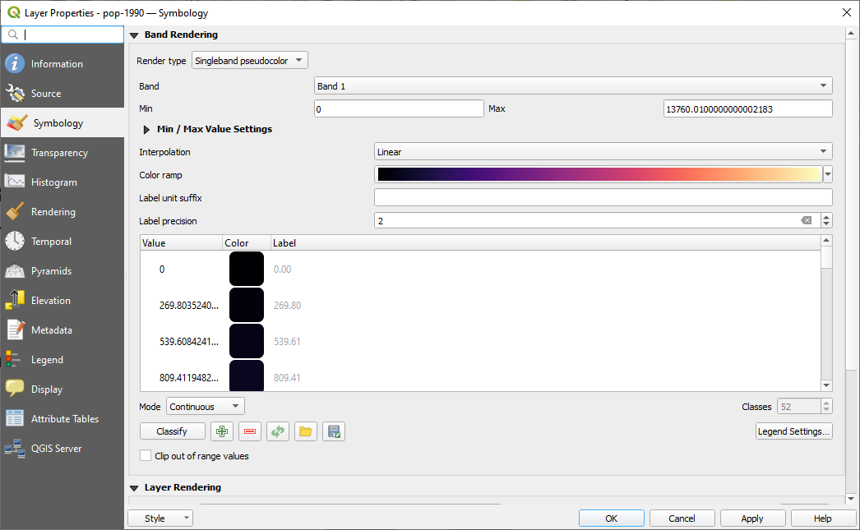

Step 5: Choose a render type (e.g., Singleband gray, Singleband pseudocolor). 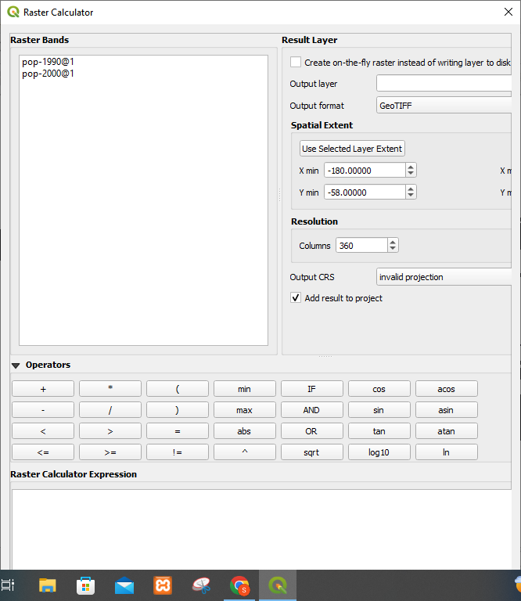
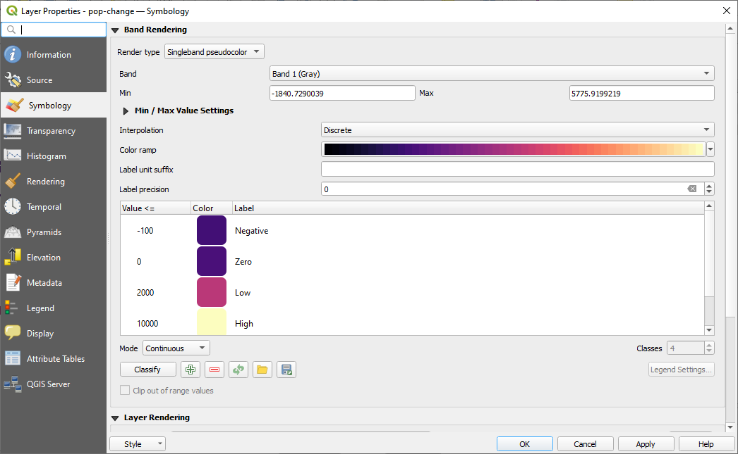

Step 6 : Singleband Pseudocolor: For continuous data, choose "Singleband pseudocolor." Select a color ramp and adjust the Min and Max values. Click "Classify" to generate a color map based on the selected color ramp.
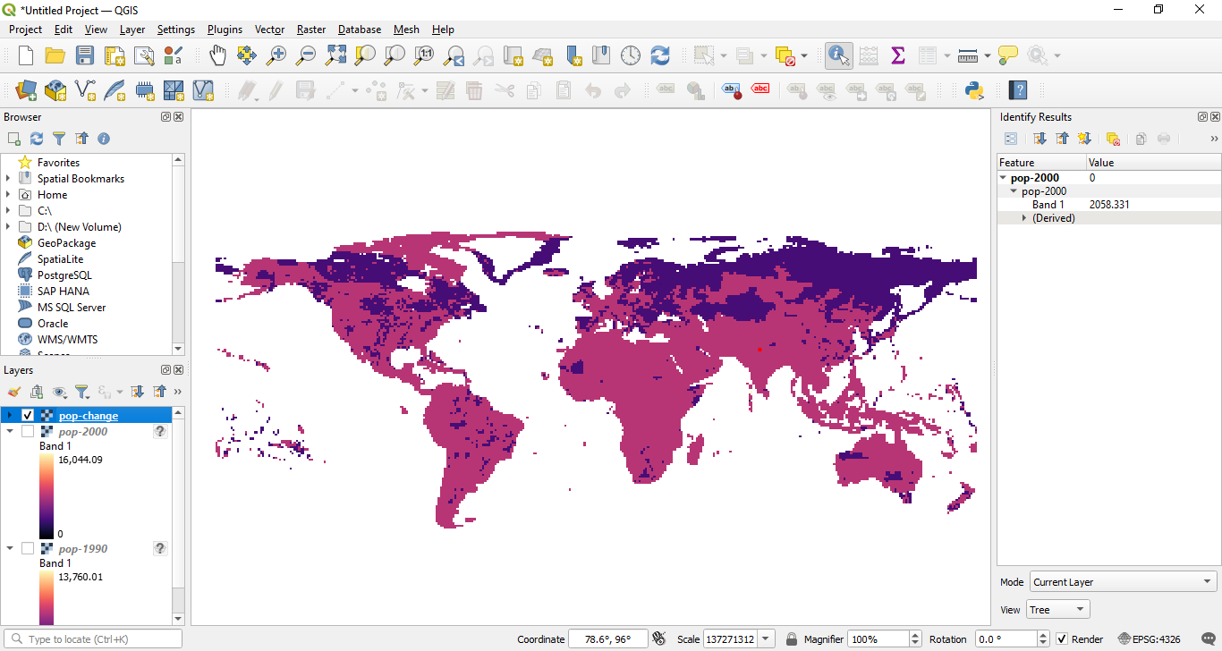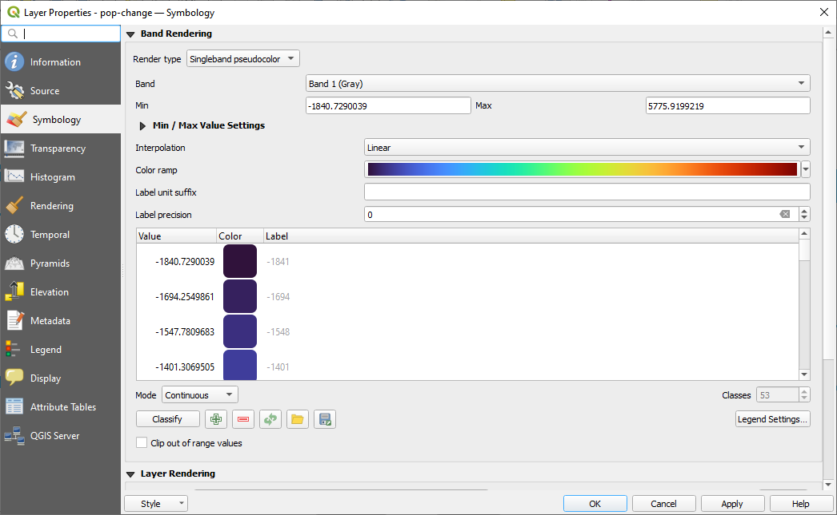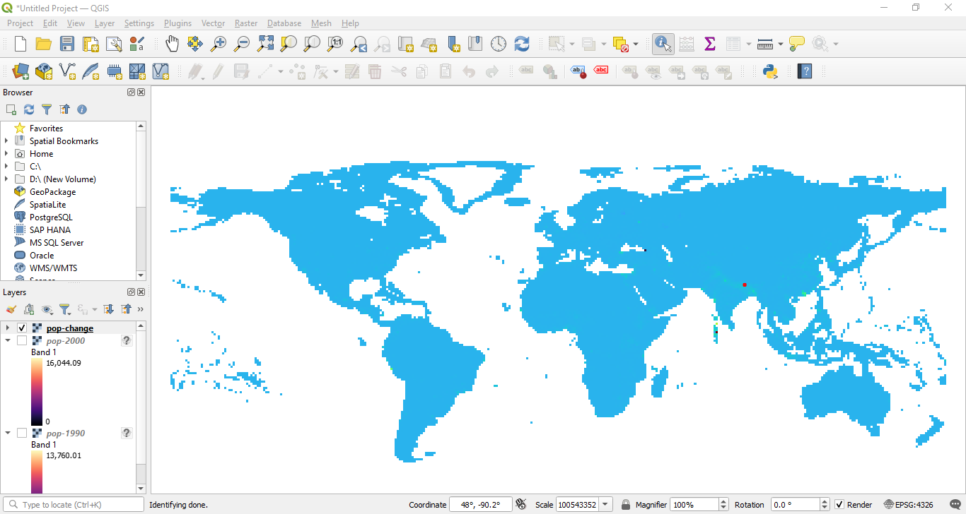

Task: Install QGIS Software version 3.38. Select different features and perform the vector data and raster data styling. Insert the output images for the respective task.

Platform used by the student: QGIS 3.38

Conclusion (Students should write in their own words):
In this experiment, vector and raster data styling techniques in QGIS were explored to effectively visualize and interpret spatial data. By applying various symbology methods, we enhanced the clarity and usability of geospatial information for better analysis and decision-making.
Post Lab Questions

Q.1 How do different symbolization methods (e.g., simple symbols, graduated symbols, categorized symbols) impact the interpretation of vector data?
Different symbolization methods in vector data styling help to visualize and interpret spatial information effectively by presenting data in varied formats:
- Simple Symbols: Using simple symbols (e.g., circles, squares) for vector data provides a uniform appearance across the entire layer. This is useful for displaying data where differentiation between features is not necessary or where each feature represents a similar type of information. Simple symbols are straightforward but lack detail in conveying variations within the data.

- Categorized Symbols: Categorized symbols allow users to distinguish different categories or classes within the data by applying unique symbols to each category. For instance, in a land use map, different land use types (e.g., residential, commercial, industrial) can be represented by different colors or icons. This method facilitates the comparison of distinct categories and helps in understanding the distribution and diversity of the data.

- Graduated Symbols: Graduated symbols vary in size or color intensity based on a numeric attribute, such as population size or income levels. This method is particularly useful for visualizing quantitative data and understanding patterns or trends within the dataset. For example, cities with larger populations can be represented with larger symbols, making it easier to grasp the relative magnitude of the data.

Overall, the choice of symbolization method affects how quickly and accurately users can interpret the data, identify patterns, and make decisions based on spatial information.

Q.2 How can attribute data be used to style vector layers effectively (e.g., using different colors for different categories or sizes based on numerical values)?
Attribute data is critical for effective vector layer styling because it provides the necessary information for applying meaningful visual distinctions:
- Categorical Attributes: When using categorical attributes (e.g., land use type, political affiliation), different colors or symbols can be assigned to each category. This helps in distinguishing between various classes visually. For instance, different colors can represent different types of land use (e.g., green for parks, yellow for commercial areas), making it easier to analyze the spatial distribution of these categories.

- Numerical Attributes: For numerical attributes (e.g., population density, elevation), graduated symbols or color ramps can be used to represent different ranges of values. For instance, varying the size of symbols based on population figures or using a gradient color scheme to show different elevation levels allows users to quickly assess and compare numerical data across the map.

- Labeling: Attribute data can also be used for labeling features on the map. Labels can be customized based on the attribute values to provide additional context and make the map more informative. For example, displaying city names with population numbers can provide immediate insight into both the location and the size of each city.

By leveraging attribute data for styling, maps become more informative and easier to understand, enabling users to visualize complex datasets and derive insights from spatial patterns.

Q.3 Discuss in detail vector data styling and raster data styling.

Vector Data Styling:

Vector data represents geographic features such as points, lines, and polygons. Vector data styling in QGIS involves applying various symbology techniques to visualize these features effectively:
- Single Symbol: This method uses a uniform symbol for all features in the layer. It is suitable for datasets where individual feature characteristics are not critical, such as plotting locations on a map.
- Categorized Symbology: Features are styled based on categorical attributes, with each category receiving a distinct symbol or color. This technique is useful for differentiating between classes of data, such as types of land use or types of transportation networks.
- Graduated Symbology: Features are styled based on a numeric attribute, with symbol size or color representing different value ranges. This method helps in visualizing quantitative data, such as population density or economic activity.

Raster Data Styling:
Raster data represents continuous phenomena and is often used for displaying images or data grids (e.g., elevation models, temperature maps). Raster data styling in QGIS focuses on rendering these continuous values in a way that highlights patterns and variations:
- Singleband Gray: For grayscale raster images, this method adjusts the contrast and brightness to enhance visibility. Users can modify the min and max values to control the range of grayscale intensities.
- Singleband Pseudocolor: This method assigns colors to different value ranges in continuous raster data. A color ramp is used to represent variations in data values, making it easier to interpret gradients and patterns in data such as temperature or elevation.

Both vector and raster data styling are essential for creating clear, informative maps that convey complex information effectively. While vector styling is useful for discrete features and categorical distinctions, raster styling is suited for continuous data and visualizing gradients and patterns.

