Batch: B1 Roll No.: 16010122158

Experiment No. 3

Title: Implement spatial data analysis in QGIS

Course Outcome:

CO2 Apply the data analytics in the field of geospatial system

Books/ Journals/ Websites referred:

QGIS Version 3.38-Vector Data Code File-World.shp

Resources used:
https://www.qgis.org/
______________________________________________________________________

Algorithm: Spatial Data Analysis

Spatial Data type: Vector Data

Step 1: Load Your Vector Data

Open QGIS.

Add your vector layer: Go to Layer > Add Layer > Add Vector Layer... and browse to your shapefile or other vector data.

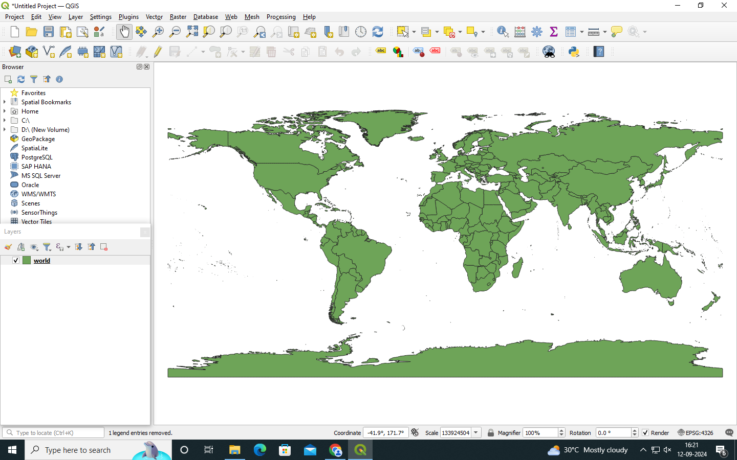

Step 2: Open the Attribute Table

Right-click on the layer in the Layers panel.

Select Open Attribute Table.

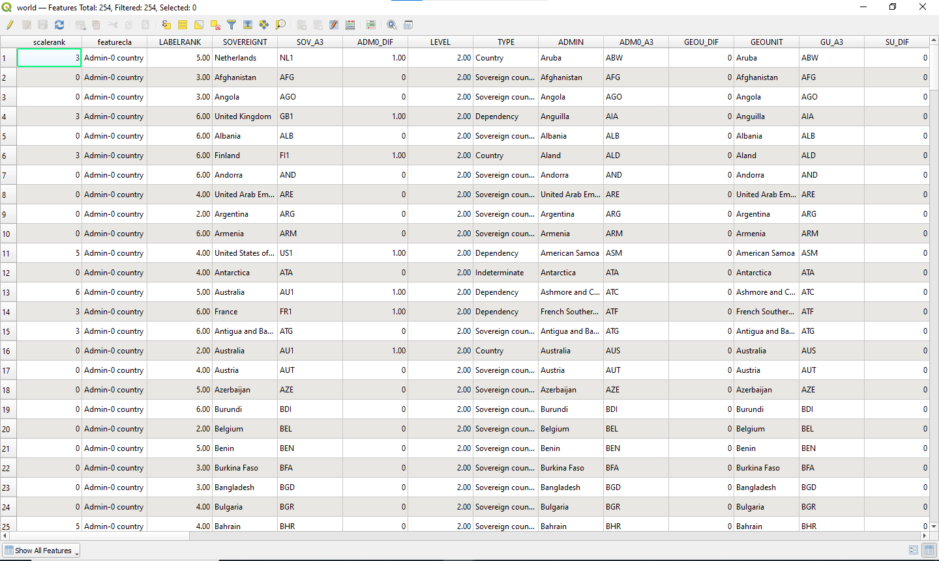

Step 3: Add a New Field for Calculations

In the attribute table, click on the Field Calculator icon (it looks like an abacus).

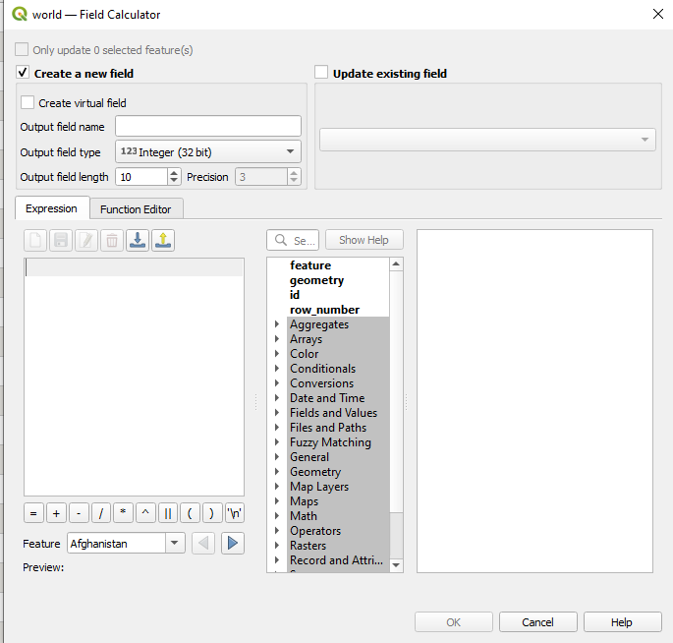

Step 4: Calculate Area

In the Field Calculator dialog:

Check the option Create a new field.

Enter a name for the new field (e.g., "Area").

Set the output field type to Decimal number (real).

In the Expression field, enter the following expression to calculate the area in square meters:

$area

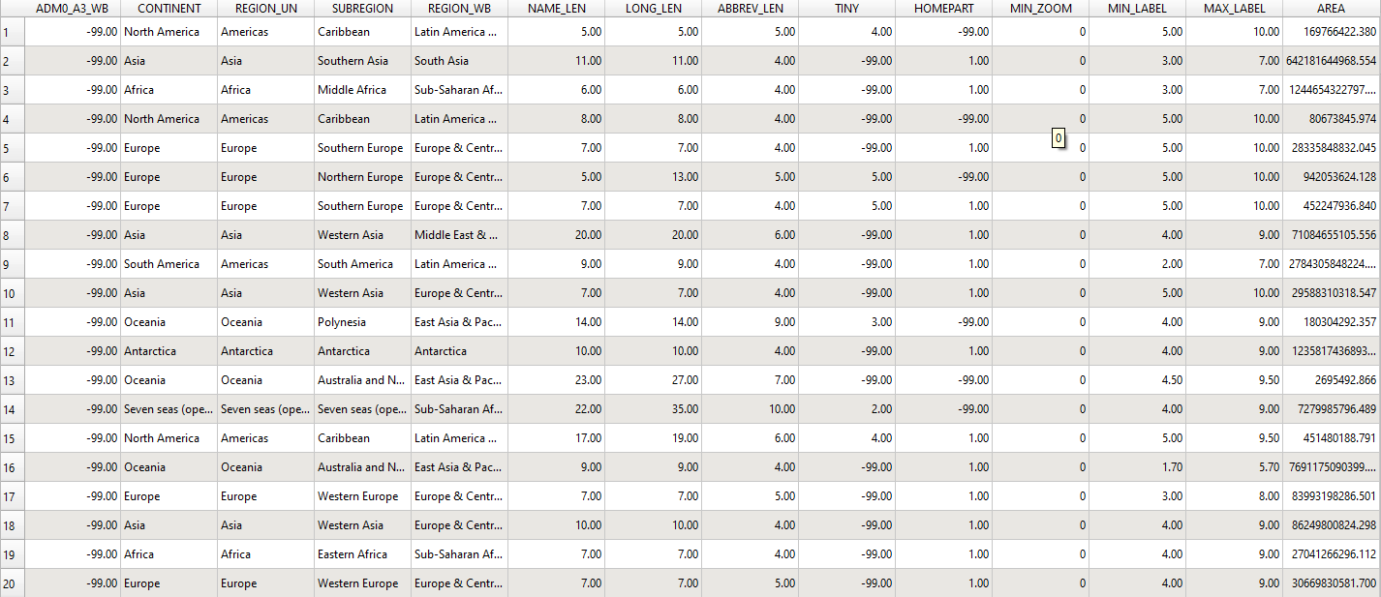
To get the area in hectares:
$area / 10000
Click OK to create the new field and calculate the areas.
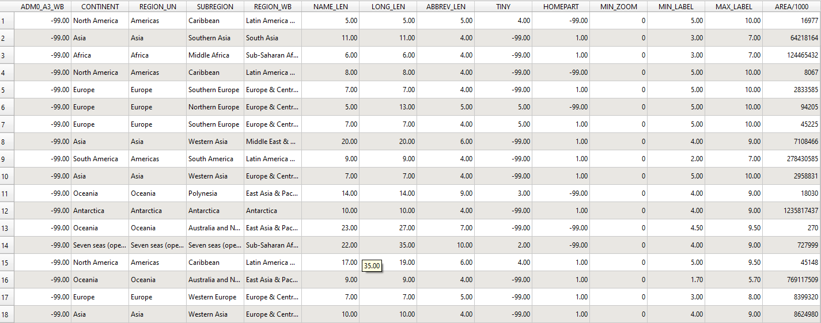
Step : Calculate Perimeter (for polygons):
perimeter($geometry)
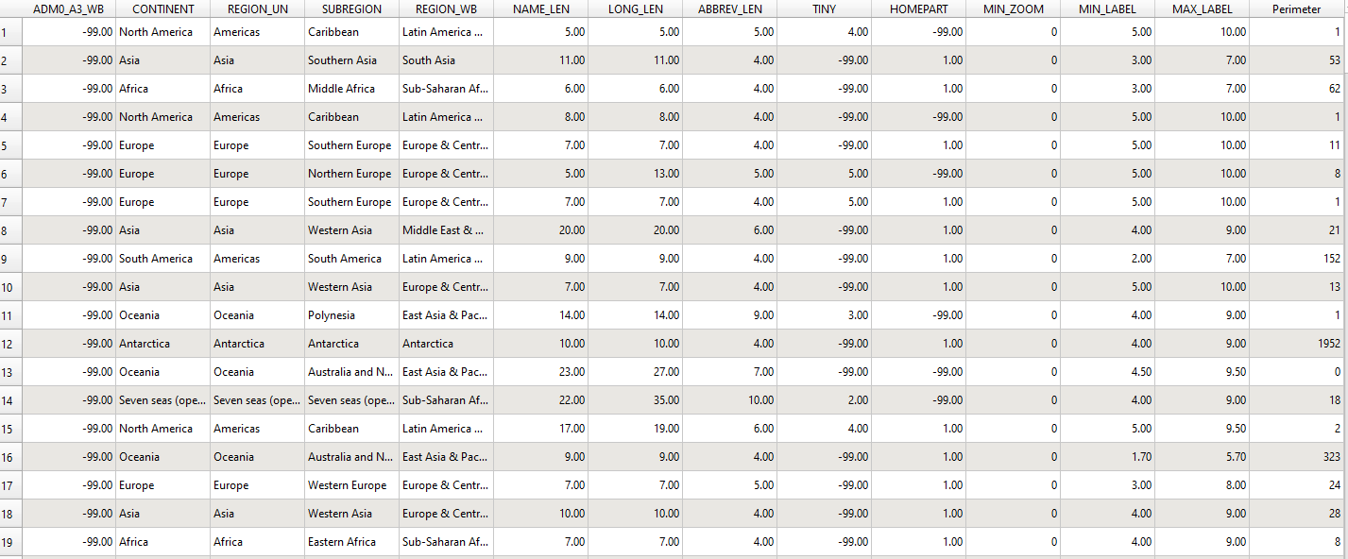

Step: length of all countries
Task: To work on other geometric properties like centroid using different expressions in the Field Calculator.

Centroid_x:
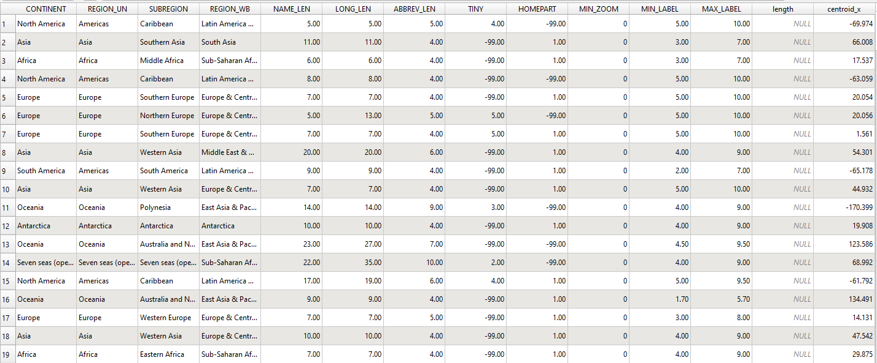

Centroid_y
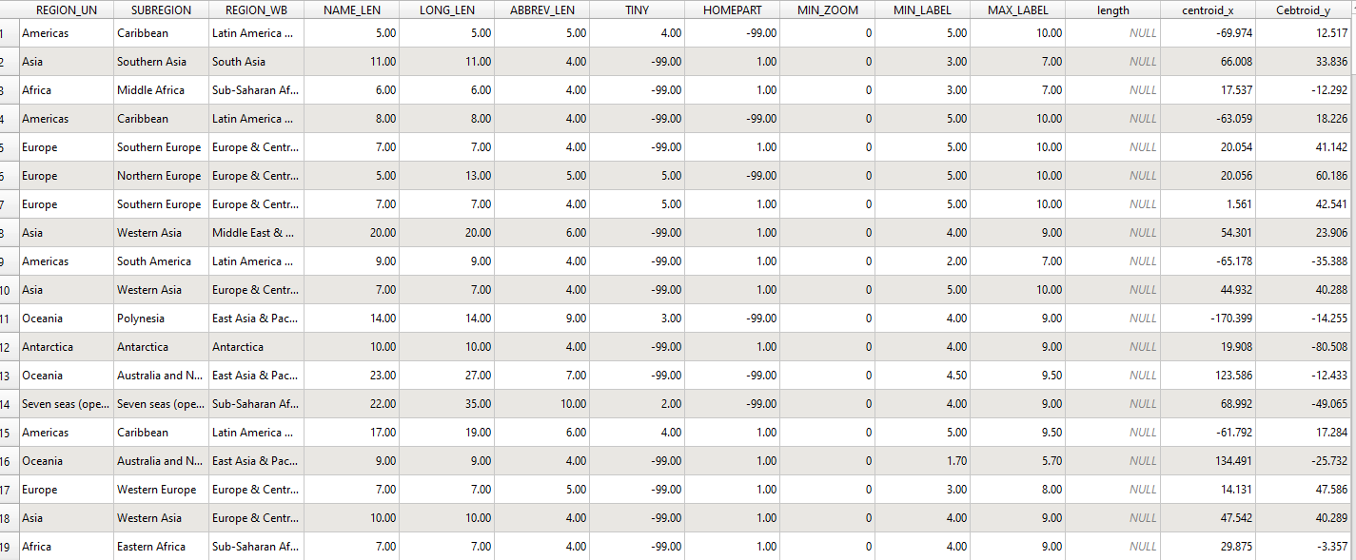

Centroid Distance
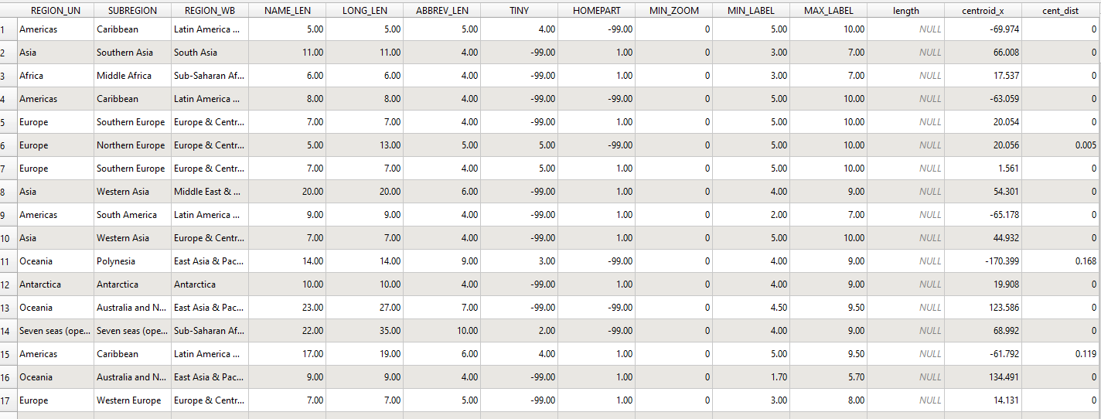

Intersecting Areas
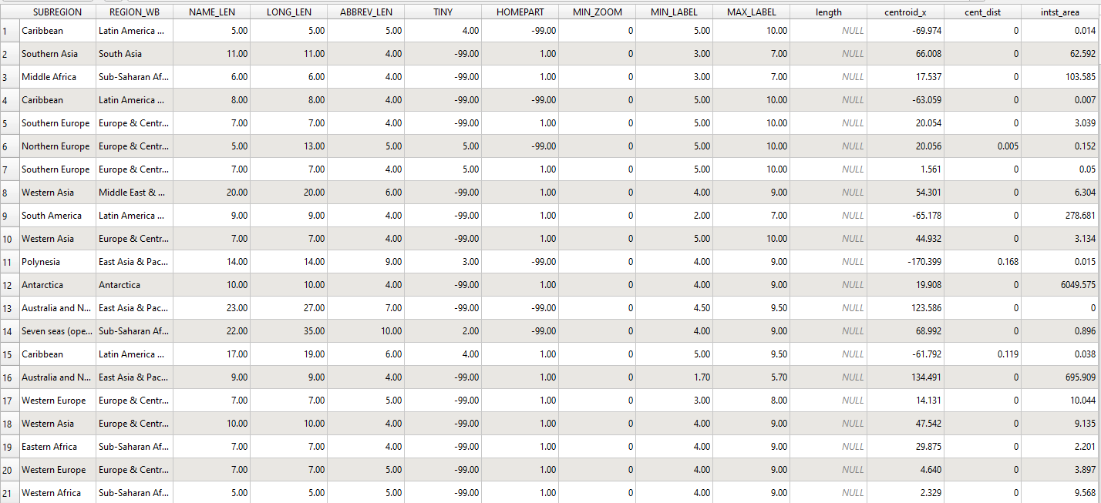

Following points should be written by students
Different Geometric Properties used in spatial data analysis.
Geometric properties in spatial data analysis refer to the measurable attributes of vector data, such as points, lines, and polygons, that help define spatial features. Key properties include area, which measures the surface covered by a polygon, and perimeter, which calculates the boundary length of a polygon. For linear features, the length property is used to determine the total distance covered by lines or boundaries. Additionally, centroid coordinates (Centroid_x and Centroid_y) help identify the geometric center of a feature, aiding in the spatial alignment or distribution of objects.

Another important aspect is the calculation of distances between centroids, which helps in understanding spatial relationships between different features. In some cases, intersecting areas can be determined to analyze where two or more features overlap. These properties are critical for tasks like land use planning, environmental monitoring, and infrastructure development, making spatial data analysis an essential tool in fields like urban development, agriculture, and resource management.
Conclusion:
We used QGIS to calculate geometric properties like area, perimeter, and centroid coordinates on vector data. This demonstrated the software's ability to perform spatial operations efficiently, laying the groundwork for more advanced geospatial analysis.
Post lab questions:
Q.1 What are different geometric properties used in spatial data analysis on vector data with expression?
Area: $area
Perimeter: perimeter($geometry)
Length: length($geometry)
Centroid (X-coordinate): x(centroid($geometry))
Centroid (Y-coordinate): y(centroid($geometry))
Distance between centroids: distance(centroid($geometry), centroid($other_geometry))
Intersecting areas: intersects($geometry, $other_geometry)

Q.2 What are different geometric properties used in spatial data analysis on raster data with expression?
Pixel value: Represents the value of the phenomenon the raster captures, such as elevation, temperature, or intensity.
Slope: slope() (calculated from elevation data).
Aspect: aspect() (the direction of the slope).
Raster statistics: Calculations like mean, sum, or standard deviation of pixel values over a specified area.

Q.3 What is spatial data analysis and its advantages
Spatial data analysis refers to the process of examining the locations, attributes, and relationships of features in spatial data through the use of statistical and geographic techniques. It helps in identifying patterns, relationships, and trends within the data.
Advantages:
- Helps in decision-making by analyzing the spatial distribution of phenomena.
- Improves resource management (e.g., land use planning, urban development).
- Enhances environmental monitoring (e.g., deforestation, pollution).
- Facilitates real-time data tracking and analysis (e.g., for disaster management, infrastructure development).

