Batch: HDA-5 Roll No.: 16010122158

Experiment No. 4

TITLE : Performing Graph Analytics

AIM: To analyze the structural properties of a real-world social network by constructing a graph representation, identifying key players and influential individuals through centrality measures, and detecting communities within the network using appropriate algorithms.
_________________________________________________________________
Expected OUTCOME of Experiment:
CO3: Perform the social data analytics
_____________________________________________________________________
Books/ Journals/ Websites referred:

Students have to list.
_____________________________________________________________________
Pre Lab/ Prior Concepts:

Students should have a basic understanding of:

Graph theory: Nodes, edges, directed and undirected graphs, weighted graphs.
Data structures: Lists, dictionaries.
Python programming: Basic syntax, data manipulation, libraries like NetworkX.
Statistical concepts: Mean, standard deviation, correlation.
Visualization techniques: Basic plotting using libraries like Matplotlib.

Procedure:

Building a Social Network Graph with NetworkX
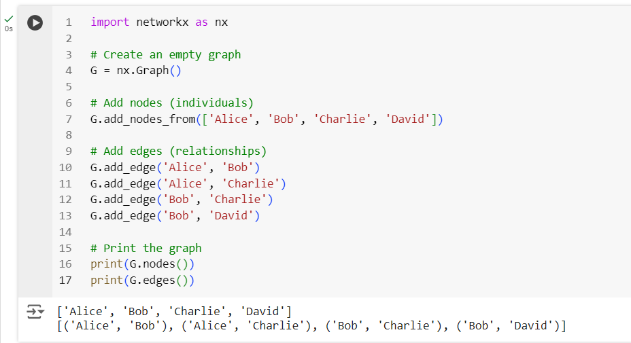

Visualizing the Graph
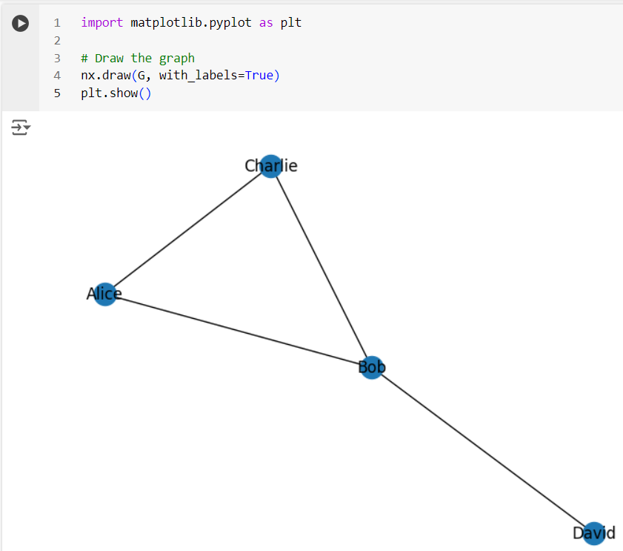
Exporting a NetworkX Graph to CSV
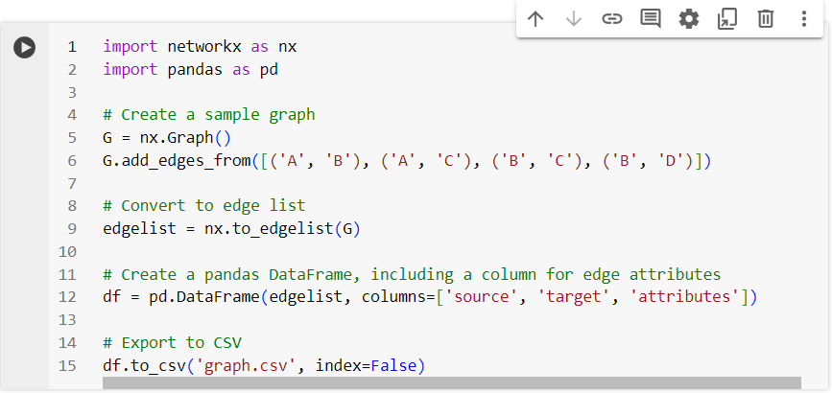
The csv file gets created

Contents of the csv file
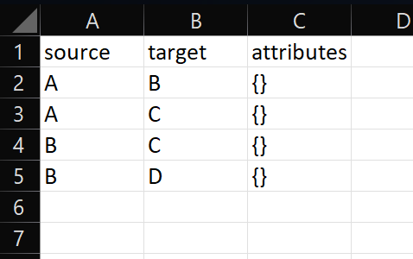

Creating and exporting a NetworkX Graph with edge attributes and node attributes to a csv file
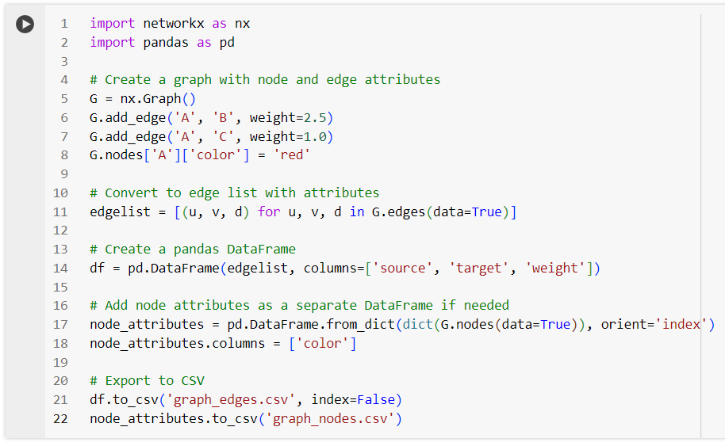

csv files get created
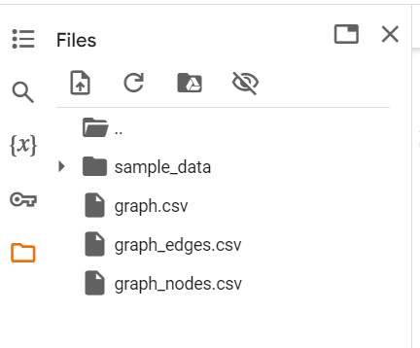
Contents of graph_edges.csv
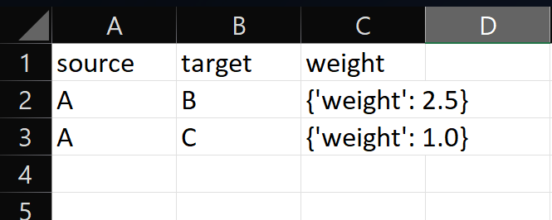

Contents of graph_nodes.csv
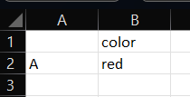
Importing a graph from a csv file
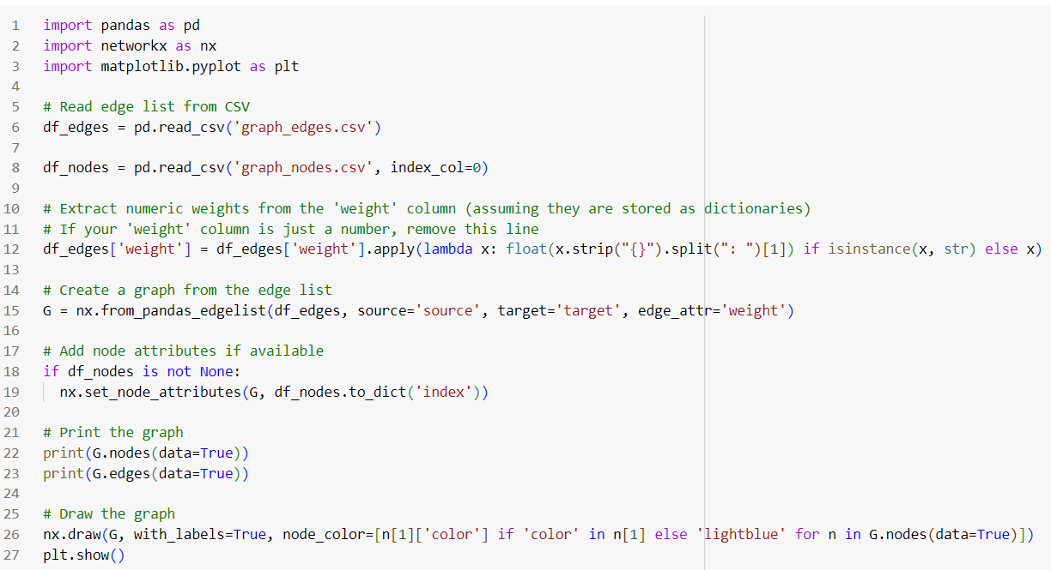

Output (List of nodes and edges, and visualizing the imported graph)
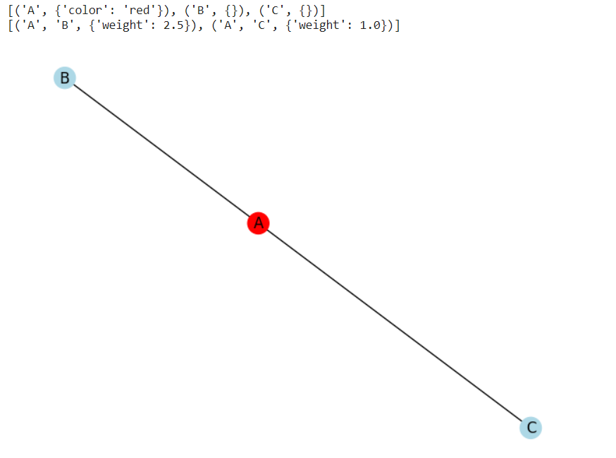
Graph Analytics

- Degree centrality : The degree centrality for a node v is the fraction of nodes it is connected to. The degree centrality values are normalized by dividing by the maximum possible degree in a simple graph n-1 where n is the number of nodes in G.
- Betweenness centrality : Betweenness centrality of a node v is the sum of the fraction of all-pairs shortest paths that pass through v. The betweenness centrality is normalized by dividing by the total number of shortest paths.
- Edge betweenness centrality : Betweenness centrality of a node e is the sum of the fraction of all-pairs shortest paths that pass through e. The betweenness centrality is normalized by dividing by the maximum possible number of edges in a graph G.
- Communities can be identified using the Girvan Newman algorithm, by successively deleting the edges with the highest betweenness centrality values.

Importing a graph from csv file and performing graph analytics

The graph in csv file:

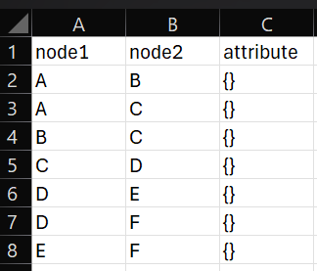

Importing the graph, printing its edge list and visualizing it:

import pandas as pd
import networkx as nx
import matplotlib.pyplot as plt

# Read edge list from CSV
df_edges = pd.read_csv('new_graph_edges.csv')

# Create a graph from the edge list
G = nx.from_pandas_edgelist(df_edges,source='node1', target='node2')

# Print the graph
print(G.nodes(data=True))
print(G.edges(data=True))

# Draw the graph
nx.draw(G, with_labels=True)
plt.show()

Output (graph details and visualization):
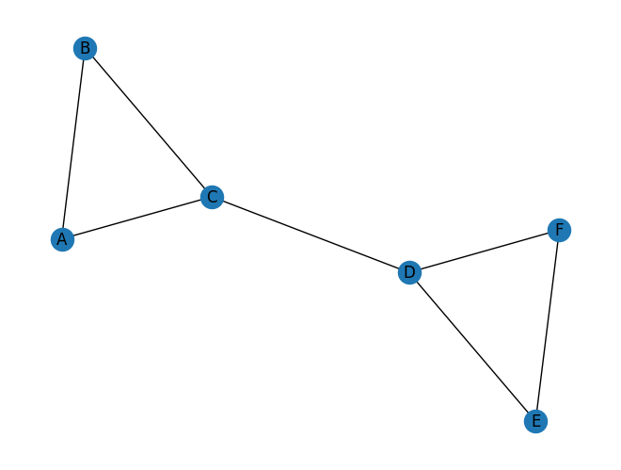
Performing analytics on this graph:

# Basic graph properties
print("Number of nodes:", G.number_of_nodes())
print("Number of edges:", G.number_of_edges())

# Degree centrality
degrees = dict(G.degree())
print("\nDegree Centrality:", degrees)

# Betweenness centrality
betweenness = nx.betweenness_centrality(G, normalized=False)
print("\nBetweenness Centrality:", betweenness)
betweenness = nx.betweenness_centrality(G)
print("Normalized Betweenness Centrality:", betweenness)

# Closeness centrality
e_betwenness = nx.edge_betweenness_centrality(G,normalized=False)
print("\nEdge Betweenness Centrality:", e_betwenness)
e_betwenness = nx.edge_betweenness_centrality(G)
print("Normalized Edge Betweenness Centrality:", e_betwenness)

# Community detection (Girvan-Newman)
communities = nx.algorithms.community.girvan_newman(G)
try:
top_level_communities = next(communities)
print("\nCommunities after 1 step:", top_level_communities)

top_level_communities = next(communities)
print("\nCommunities after 2 steps:", top_level_communities)

top_level_communities = next(communities)
print("\nCommunities after 3 steps:", top_level_communities)

top_level_communities = next(communities)
print("\nCommunities after 4 steps:", top_level_communities)

top_level_communities = next(communities)
print("\nCommunities after 5 steps:", top_level_communities)

except StopIteration:
print("\nNo more splits are possible.")

Output:
Number of nodes: 6
Number of edges: 7

Degree Centrality: {'A': 2, 'B': 2, 'C': 3, 'D': 3, 'E': 2, 'F': 2}

Betweenness Centrality: {'A': 0.0, 'B': 0.0, 'C': 6.0, 'D': 6.0, 'E': 0.0, 'F': 0.0}
Normalized Betweenness Centrality: {'A': 0.0, 'B': 0.0, 'C': 0.6000000000000001, 'D': 0.6000000000000001, 'E': 0.0, 'F': 0.0}

Edge Betweenness Centrality: {('A', 'B'): 1.0, ('A', 'C'): 4.0, ('B', 'C'): 4.0, ('C', 'D'): 9.0, ('D', 'E'): 4.0, ('D', 'F'): 4.0, ('E', 'F'): 1.0}
Normalized Edge Betweenness Centrality: {('A', 'B'): 0.06666666666666667, ('A', 'C'): 0.26666666666666666, ('B', 'C'): 0.26666666666666666, ('C', 'D'): 0.6, ('D', 'E'): 0.26666666666666666, ('D', 'F'): 0.26666666666666666, ('E', 'F'): 0.06666666666666667}

Communities after 1 step: ({'A', 'C', 'B'}, {'E', 'F', 'D'})

Communities after 2 steps: ({'A'}, {'C', 'B'}, {'E', 'F', 'D'})

Communities after 3 steps: ({'A'}, {'B'}, {'C'}, {'E', 'F', 'D'})

Communities after 4 steps: ({'A'}, {'B'}, {'C'}, {'D'}, {'E', 'F'})

Communities after 5 steps: ({'A'}, {'B'}, {'C'}, {'D'}, {'E'}, {'F'})

Students have to perform all the tasks illustrated above by creating a social network graph with nodes labelled with their own names and their friends’ names. The graph should have at least 10 nodes.
Students have to paste their code and screenshots of output and csv file below.

Implementation details:

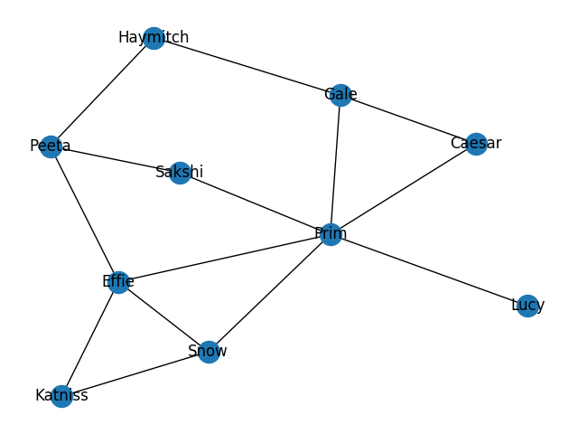
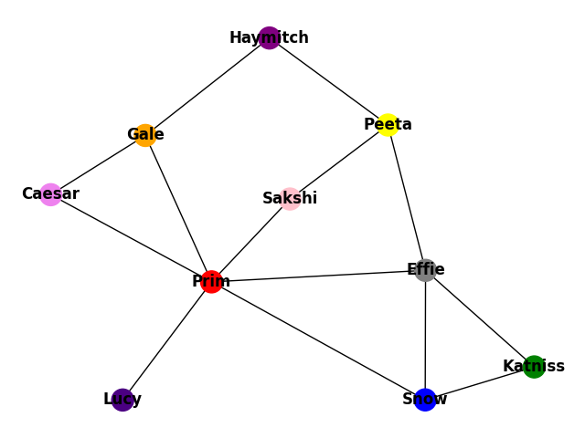

Edge list and node attributes exported to CSV.

[('Sakshi', {'color': 'pink'}), ('Prim', {'color': 'red'}), ('Katniss', {'color': 'green'}), ('Gale', {'color': 'orange'}), ('Haymitch', {'color': 'purple'}), ('Lucy', {'color': 'indigo'}), ('Peeta', {'color': 'yellow'}), ('Caesar', {'color': 'violet'}), ('Snow', {'color': 'blue'}), ('Effie', {'color': 'grey'})]

[('Sakshi', 'Prim', {'weight': 3.0226877535990413}), ('Sakshi', 'Peeta', {'weight': 4.4983396511560905}), ('Prim', 'Effie', {'weight': 4.150127964265766}), ('Prim', 'Snow', {'weight': 1.120907671661008}), ('Prim', 'Lucy', {'weight': 4.685303704904885}), ('Prim', 'Gale', {'weight': 3.456893683355261}), ('Prim', 'Caesar', {'weight': 4.936059464704805}), ('Katniss', 'Snow', {'weight': 4.928907738481952}), ('Katniss', 'Effie', {'weight': 3.190104643296904}), ('Gale', 'Haymitch', {'weight': 2.5244106970918856}), ('Gale', 'Caesar', {'weight': 1.828424847225023}), ('Haymitch', 'Peeta', {'weight': 4.707886871935422}), ('Peeta', 'Effie', {'weight': 3.474121032023563}), ('Snow', 'Effie', {'weight': 1.3736947184270134})]

Number of nodes: 10
Number of edges: 14

[('Sakshi', {}), ('Prim', {}), ('Peeta', {}), ('Effie', {}), ('Snow', {}), ('Lucy', {}), ('Gale', {}), ('Caesar', {}), ('Katniss', {}), ('Haymitch', {})]

[('Sakshi', 'Prim', {}), ('Sakshi', 'Peeta', {}), ('Prim', 'Effie', {}), ('Prim', 'Snow', {}), ('Prim', 'Lucy', {}), ('Prim', 'Gale', {}), ('Prim', 'Caesar', {}), ('Peeta', 'Haymitch', {}), ('Peeta', 'Effie', {}), ('Effie', 'Katniss', {}), ('Effie', 'Snow', {}), ('Snow', 'Katniss', {}), ('Gale', 'Haymitch', {}), ('Gale', 'Caesar', {})]



[('Sakshi', {'color': 'pink'}), ('Prim', {'color': 'red'}), ('Katniss', {'color': 'green'}), ('Gale', {'color': 'orange'}), ('Haymitch', {'color': 'purple'}), ('Lucy', {'color': 'indigo'}), ('Peeta', {'color': 'yellow'}), ('Caesar', {'color': 'violet'}), ('Snow', {'color': 'blue'}), ('Effie', {'color': 'grey'})]

[('Sakshi', 'Prim', {'weight': 2.6962280723875787}), ('Sakshi', 'Peeta', {'weight': 1.9386672230656115}), ('Prim', 'Effie', {'weight': 1.2070108561861619}), ('Prim', 'Snow', {'weight': 1.5225606264590983}), ('Prim', 'Lucy', {'weight': 2.706470954529101}), ('Prim', 'Gale', {'weight': 1.0490699257294973}), ('Prim', 'Caesar', {'weight': 1.2659587830508712}), ('Katniss', 'Snow', {'weight': 2.134163240976767}), ('Katniss', 'Effie', {'weight': 1.1206689510597356}), ('Gale', 'Haymitch', {'weight': 3.2259333762638716}), ('Gale', 'Caesar', {'weight': 2.0816564913446065}), ('Haymitch', 'Peeta', {'weight': 4.710904755582943}), ('Peeta', 'Effie', {'weight': 3.509908889670192}), ('Snow', 'Effie', {'weight': 1.7202124262992804})]

Number of nodes: 10
Number of edges: 14

Degree Centrality: {'Sakshi': 2, 'Prim': 6, 'Katniss': 2, 'Gale': 3, 'Haymitch': 2, 'Lucy': 1, 'Peeta': 3, 'Caesar': 2, 'Snow': 3, 'Effie': 4}

Betweenness Centrality: {'Sakshi': 1.3333333333333333, 'Prim': 19.333333333333332, 'Katniss': 0.0, 'Gale': 3.833333333333333, 'Haymitch': 1.3333333333333333, 'Lucy': 0.0, 'Peeta': 4.333333333333333, 'Caesar': 0.0, 'Snow': 2.333333333333333, 'Effie': 7.499999999999999}

Normalized Betweenness Centrality: {'Sakshi': 0.037037037037037035, 'Prim': 0.537037037037037, 'Katniss': 0.0, 'Gale': 0.10648148148148147, 'Haymitch': 0.037037037037037035, 'Lucy': 0.0, 'Peeta': 0.12037037037037035, 'Caesar': 0.0, 'Snow': 0.0648148148148148, 'Effie': 0.2083333333333333}

Edge Betweenness Centrality: {('Sakshi', 'Prim'): 7.5, ('Sakshi', 'Peeta'): 4.166666666666666, ('Prim', 'Effie'): 8.166666666666668, ('Prim', 'Snow'): 7.833333333333333, ('Prim', 'Lucy'): 9.0, ('Prim', 'Gale'): 8.5, ('Prim', 'Caesar'): 6.666666666666666, ('Katniss', 'Snow'): 3.333333333333333, ('Katniss', 'Effie'): 5.666666666666666, ('Gale', 'Haymitch'): 5.833333333333334, ('Gale', 'Caesar'): 2.333333333333333, ('Haymitch', 'Peeta'): 5.833333333333333, ('Peeta', 'Effie'): 7.666666666666667, ('Snow', 'Effie'): 2.5}

Normalized Edge Betweenness Centrality: {('Sakshi', 'Prim'): 0.16666666666666669, ('Sakshi', 'Peeta'): 0.09259259259259259, ('Prim', 'Effie'): 0.18148148148148152, ('Prim', 'Snow'): 0.17407407407407408, ('Prim', 'Lucy'): 0.2, ('Prim', 'Gale'): 0.18888888888888888, ('Prim', 'Caesar'): 0.14814814814814814, ('Katniss', 'Snow'): 0.07407407407407407, ('Katniss', 'Effie'): 0.1259259259259259, ('Gale', 'Haymitch'): 0.12962962962962965, ('Gale', 'Caesar'): 0.05185185185185185, ('Haymitch', 'Peeta'): 0.12962962962962962, ('Peeta', 'Effie'): 0.1703703703703704, ('Snow', 'Effie'): 0.05555555555555556}

Communities after 1 step: ({'Prim', 'Effie', 'Gale', 'Haymitch', 'Katniss', 'Sakshi', 'Caesar', 'Peeta', 'Snow'}, {'Lucy'})

Communities after 2 steps: ({'Haymitch', 'Peeta', 'Sakshi'}, {'Prim', 'Effie', 'Gale', 'Katniss', 'Caesar', 'Snow'}, {'Lucy'})

Communities after 3 steps: ({'Haymitch', 'Peeta', 'Sakshi'}, {'Caesar', 'Gale', 'Prim'}, {'Effie', 'Katniss', 'Snow'}, {'Lucy'})

Communities after 4 steps: ({'Sakshi'}, {'Caesar', 'Gale', 'Prim'}, {'Effie', 'Katniss', 'Snow'}, {'Haymitch', 'Peeta'}, {'Lucy'})

Communities after 5 steps: ({'Sakshi'}, {'Prim'}, {'Effie', 'Katniss', 'Snow'}, {'Caesar', 'Gale'}, {'Haymitch', 'Peeta'}, {'Lucy'})

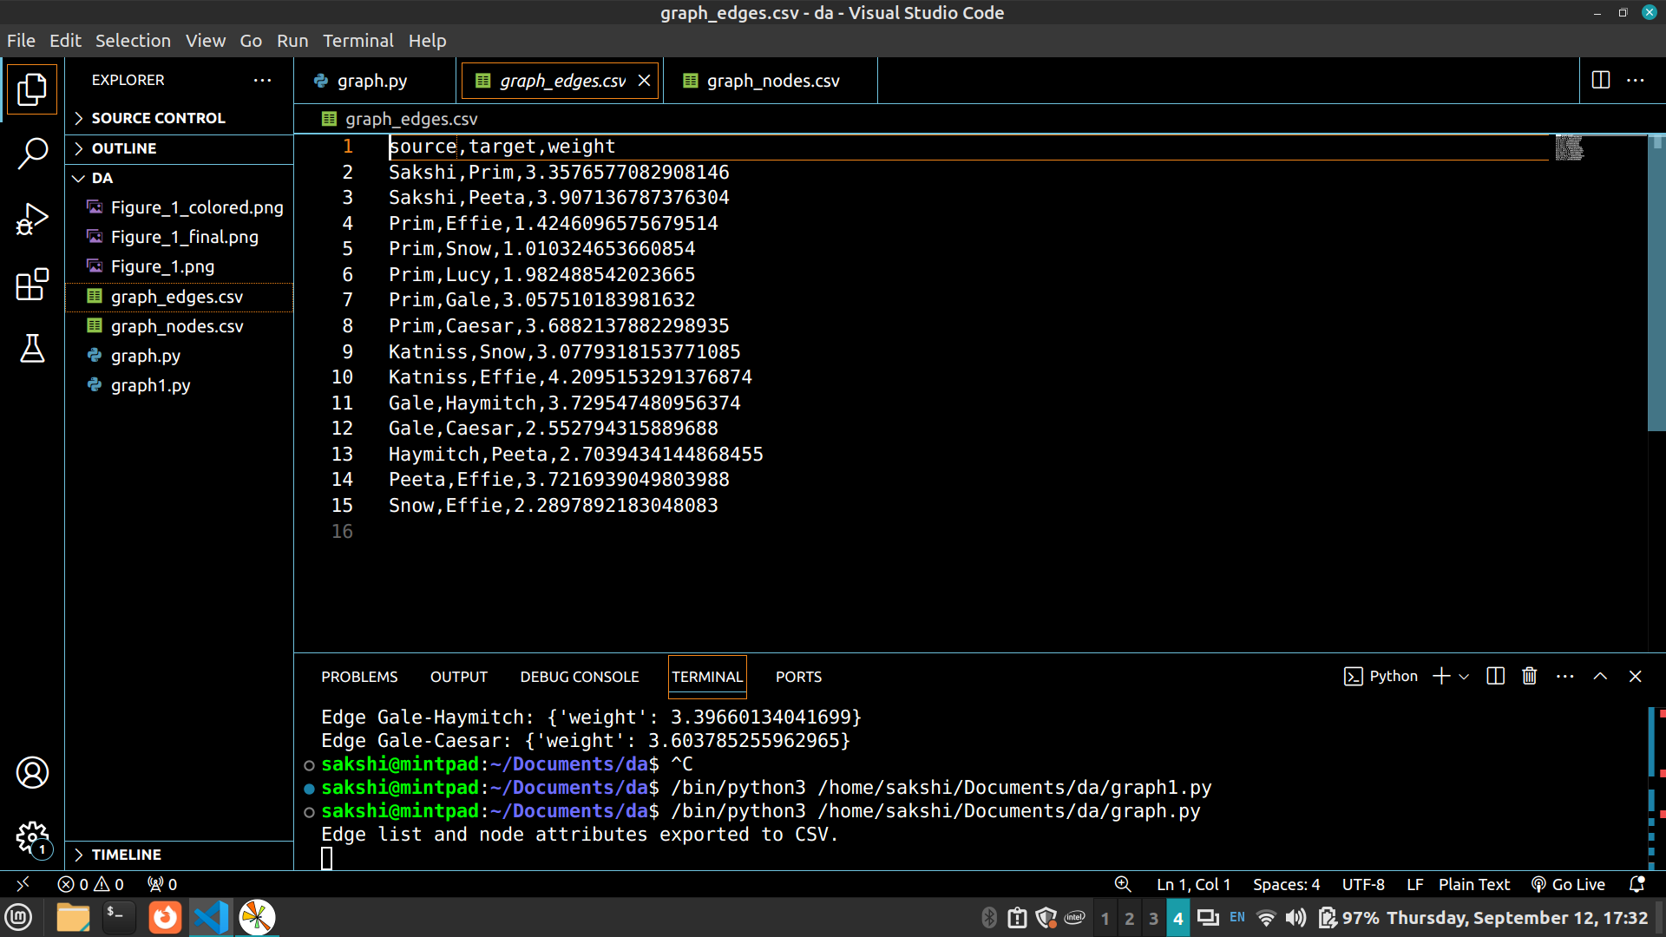

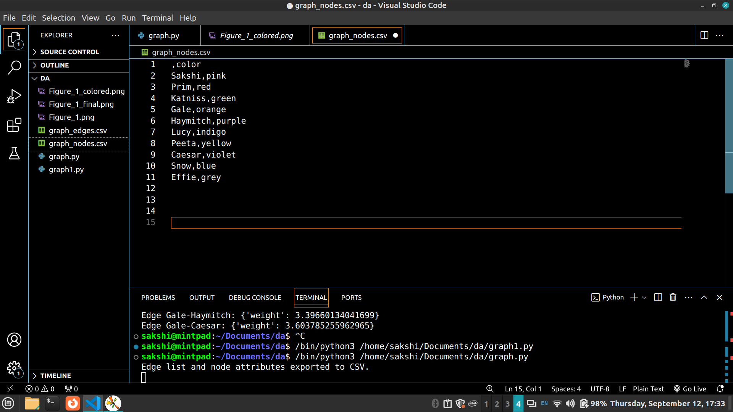

Date: 3/ 10/ 2024 Signature of faculty in-charge

Post Lab Descriptive Questions:

- Analyze the centrality measures you calculated. Which nodes were identified as the most influential? What does this mean in the context of the social network?
Answer:
In this experiment, we calculated several centrality measures to identify influential nodes in the social network:
- Degree Centrality: The degree centrality values indicate the number of direct connections each node has. For example, Prim has the highest degree centrality with 6 connections, making it a central figure in the network. Other nodes, like Gale and Effie, also have significant connections (3 and 4, respectively).
- Betweenness Centrality: This measure reveals nodes that serve as bridges within the network. Prim again stands out with a high betweenness centrality score (19.33), indicating it plays a critical role in connecting disparate parts of the network. Other notable nodes include Effie and Peeta, which also show substantial betweenness.
- Closeness Centrality: Not explicitly calculated in your output, this measure can be useful to identify how quickly a node can access others in the network.
Contextual Meaning: In the context of a social network, nodes like Prim are likely influential in spreading information or coordinating activities, as they are well-connected and serve as conduits between groups.

- Describe the communities identified using the Girvan-Newman algorithm. What are the characteristics of these communities? How do they relate to the social network's structure?
Answer:
The Girvan-Newman algorithm revealed several communities as edges with the highest betweenness centrality were removed:
- First Split: The first division identified a large community containing most nodes, including Prim, Gale, Effie, and others, alongside a smaller community with Lucy.
- Subsequent Splits: As the algorithm progressed, it became evident that smaller, cohesive groups formed. For instance, after several splits, communities were identified where Haymitch and Peeta clustered together, while Effie, Katniss, and Snow formed another group.
Characteristics of Communities:
- Cohesion: Communities are characterized by tight interconnections, suggesting shared interests or mutual influences.
- Isolated Nodes: Lucy often stands alone, indicating weaker ties to the rest of the network.
Relation to Network Structure: The structure reflects social dynamics where certain groups may have shared interests or activities, while others may be more isolated. The community structure can inform the flow of information and potential collaborations.

- Discuss the implications of identifying influential nodes in the network. How can this information be used?
Answer:
Identifying influential nodes has several practical implications:
- Targeted Communication: Knowledge of influential individuals can aid in designing communication strategies. For instance, messages or campaigns can be directed at nodes like Prim to maximize outreach.
- Resource Allocation: In organizational settings, focusing on high-betweenness nodes for leadership roles can help bridge gaps between departments or teams.
- Intervention Strategies: In public health or marketing, leveraging influential individuals can help in disseminating information quickly and effectively.
- Network Resilience: Understanding which nodes are pivotal for connectivity allows for strategic planning in case of disruptions. If an influential node is removed, alternative connections can be reinforced to maintain network functionality.

