Batch: B1 Roll No.: 16010122158

Experiment No. 5

TITLE : To perform forecasting using time series analysis

AIM: To perform forecasting using time series analysis

Expected OUTCOME of Experiment:
CO4: Perform Time series Analytics and forecasting
_____________________________________________________________________
Books/ Journals/ Websites referred:

Students have to list.
_____________________________________________________________________
Pre Lab/ Prior Concepts:

Students should have a basic understanding of: Time series Analytics and forecasting

Procedure:
Data set Used: Air Quality
Step1: Select and Load the dataset
(Students should write the code and output)
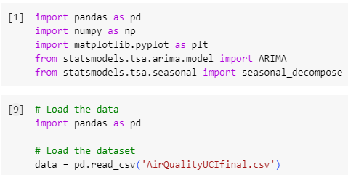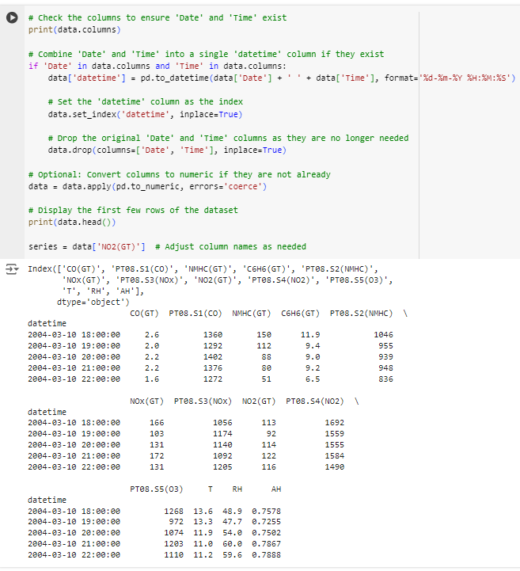
Step2: Visualize the data
(Students should write the code and output)

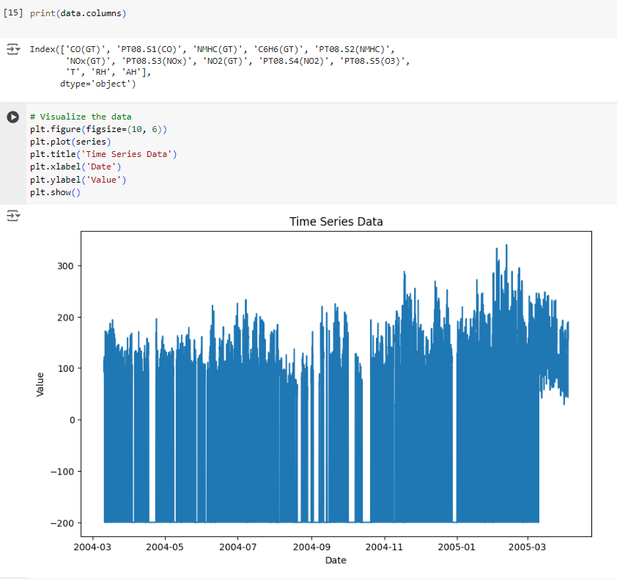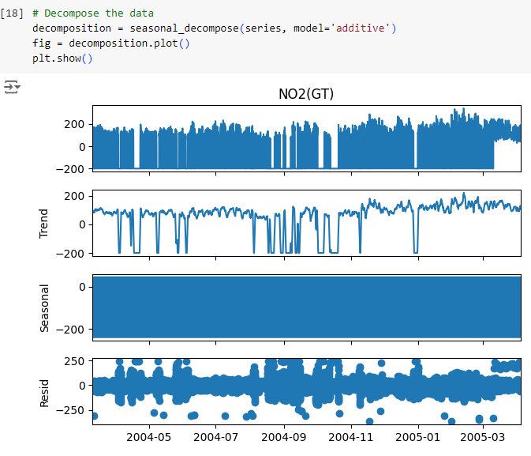Step 3: Fit the model (ARIMA Model is Used)
(Students should write the code and output)
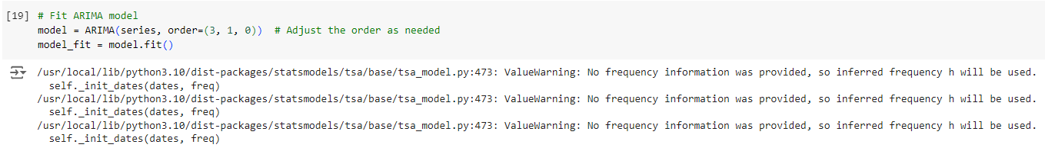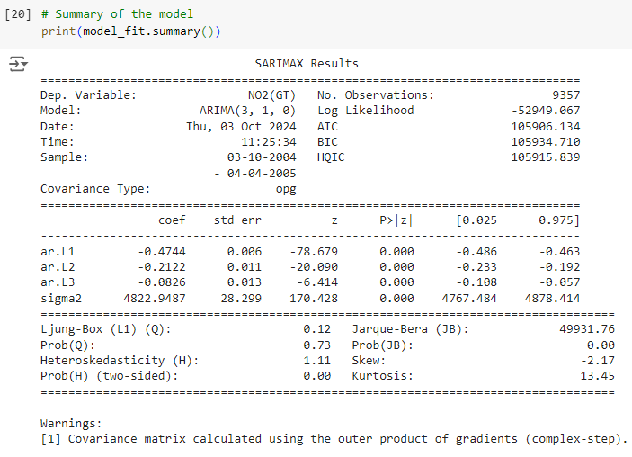
Step4: Forecast future values
(Students should write the code and output)
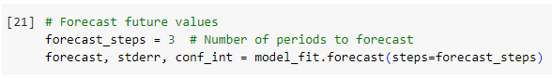
Step 5: Create a DataFrame for the forecast
(Students should write the code and output)
Step 6: Plot the results
(Students should write the code and output)
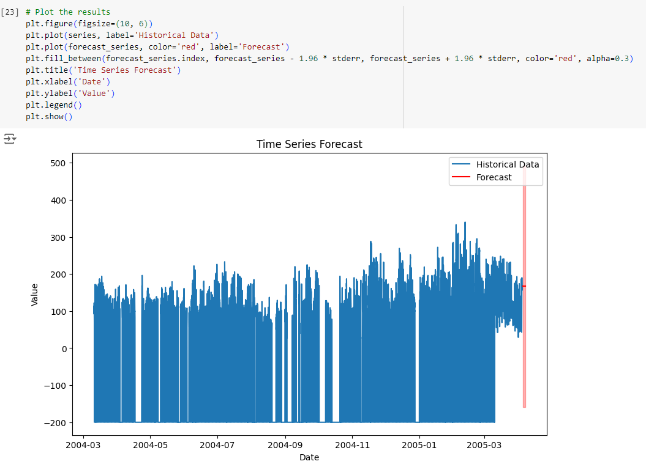

Students have to perform all the tasks illustrated above by choosing any other time series related dataset.

Implementation details:
Step 1)

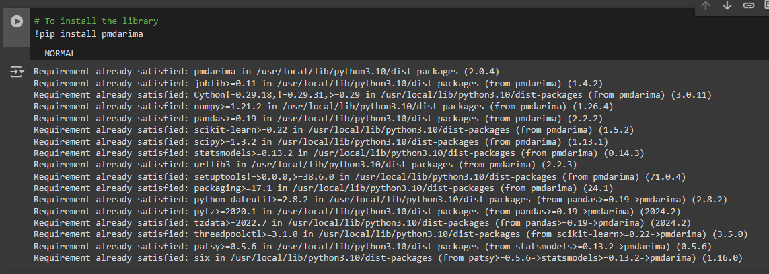

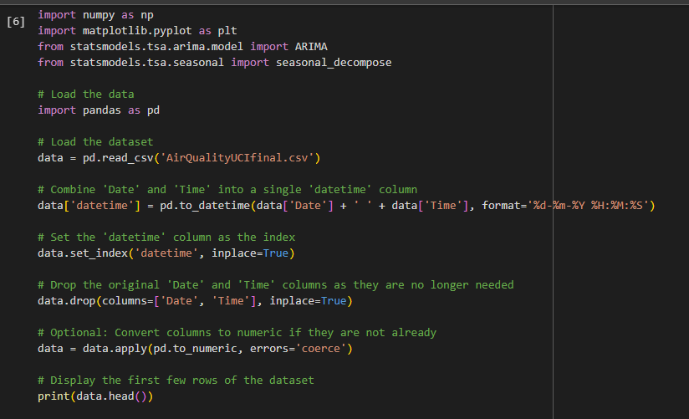
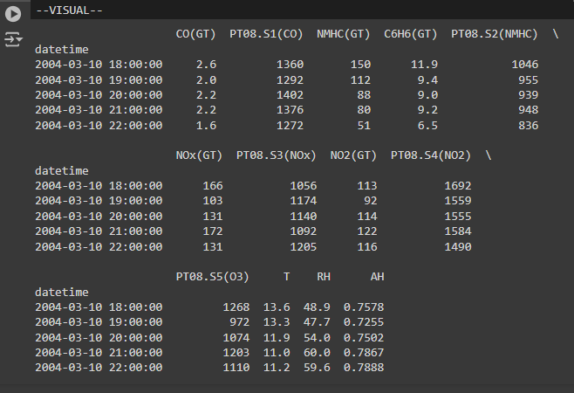

Step 2)

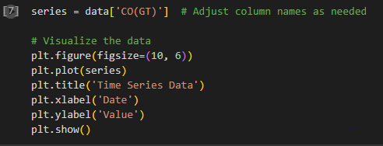

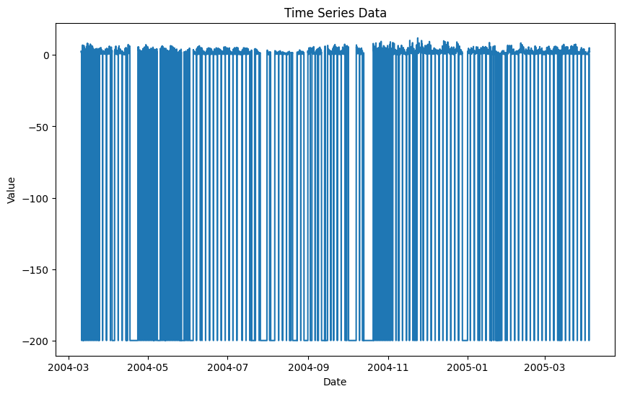

Step 3)

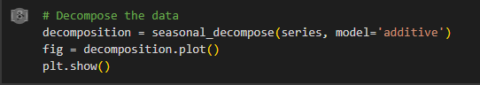

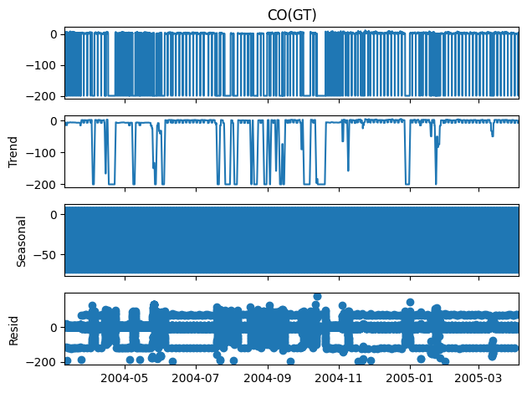

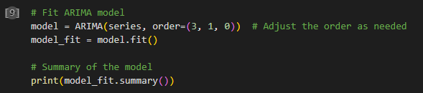

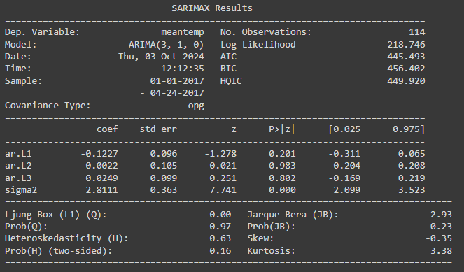

Step 4)

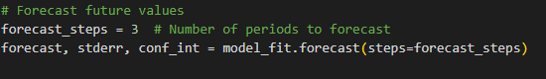

Step 5)

Step 6)

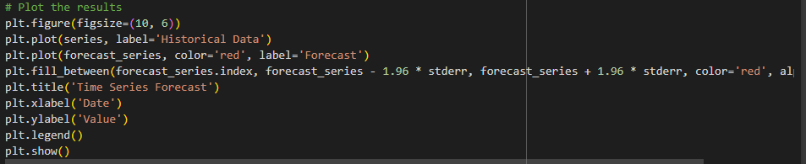

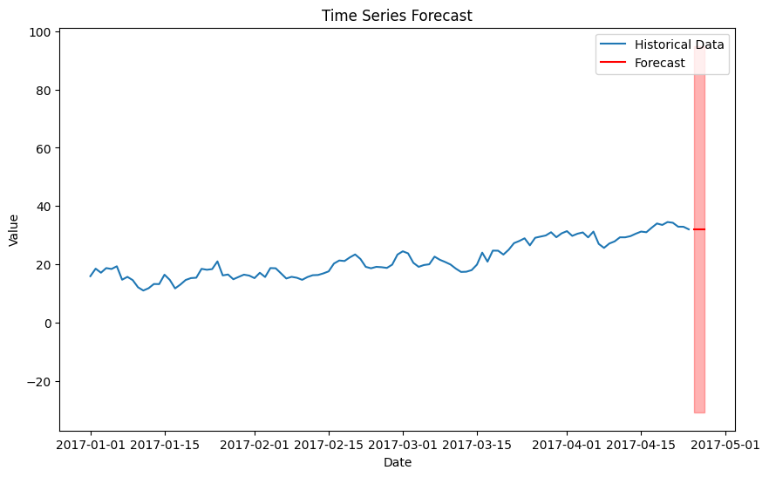

Date: 17/ 10/ 2024 Signature of faculty in-charge

Post Lab Descriptive Questions:

- What are the key components of a time series, and how do they affect the analysis?
A time series is typically composed of four key components:
- Trend: This represents the long-term progression of the series, showing an overall increase or decrease over time. Trends can be linear or non-linear.
- Seasonality: These are regular patterns or fluctuations that occur at specific intervals, such as daily, monthly, or yearly. Seasonality reflects periodic influences on the data.
- Cyclical: These are long-term fluctuations that occur at irregular intervals, often tied to economic or business cycles, and are not strictly periodic like seasonality.
- Residual (or Irregular): This component captures random noise or irregularities that cannot be explained by the trend, seasonality, or cyclical patterns.
Impact on Analysis: Understanding these components helps in modeling and forecasting. For instance, separating these components allows analysts to identify patterns and make predictions more accurately by focusing on relevant factors without the interference of noise.

- What is the purpose of decomposing a time series into trend, seasonal, and residual components?
Decomposing a time series into its components (trend, seasonal, and residual) serves several purposes:
Simplification: It simplifies the analysis by isolating patterns, making it easier to understand underlying behaviors.
Forecasting: By modeling each component separately, analysts can improve forecasting accuracy. For example, forecasting seasonal patterns can enhance overall predictions.
Understanding Relationships: It helps in understanding how different components interact. For example, one might analyze how trends are influenced by seasonal patterns.
Anomaly Detection: By examining residuals, analysts can identify outliers or anomalies in the data that may require further investigation.

- Explain how the ARIMA model works and what the terms (p, d, q) represent.
ARIMA (AutoRegressive Integrated Moving Average) is a popular time series forecasting model that combines autoregressive and moving average components with differencing to make the data stationary.
- p (AutoRegressive part): This parameter indicates the number of lagged observations (previous time points) included in the model. It captures the relationship between an observation and a number of lagged observations.
- d (Differencing): This parameter denotes the number of times the data needs to be differenced to achieve stationarity (i.e., the mean and variance remain constant over time). Differencing is a technique used to remove trends or seasonality from the data.
- q (Moving Average part): This parameter specifies the number of lagged forecast errors in the prediction equation. It captures the relationship between an observation and a residual error from a moving average model.
In summary, ARIMA models leverage the relationships between past values and past errors to generate forecasts, making them versatile for various types of time series data.

