Batch: HDA2 Roll No.: 16010122050

Experiment No. 7

TITLE : To perform VLab on NLP

AIM: Vlab on NLP
Expected OUTCOME of Experiment:
CO5: Apply data analytics in the field of Health care.
_____________________________________________________________________
Books/ Journals/ Websites referred:
https://nlp-iiith.vlabs.ac.in
_____________________________________________________________________
Pre Lab/ Prior Concepts:

Students should have a basic understanding of word analysis.

Procedure:
Vlab Name: Computer Science and Engineering -Natural Language Processing- Word Generation
Vlab Link: https://nlp-iiith.vlabs.ac.in/exp/morphology/

Implementation details:

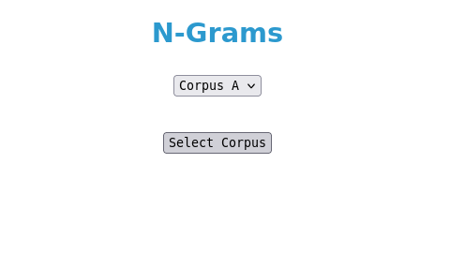
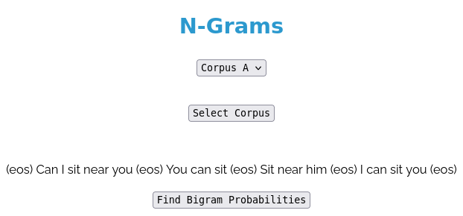
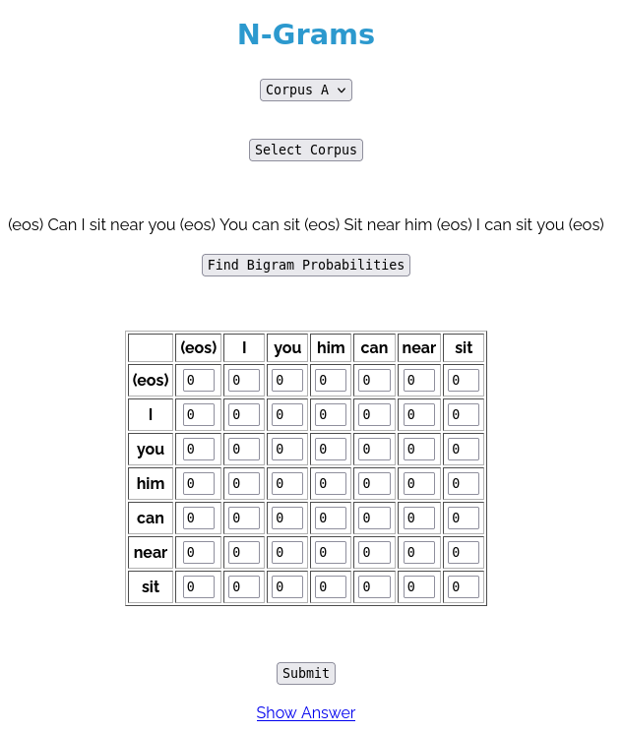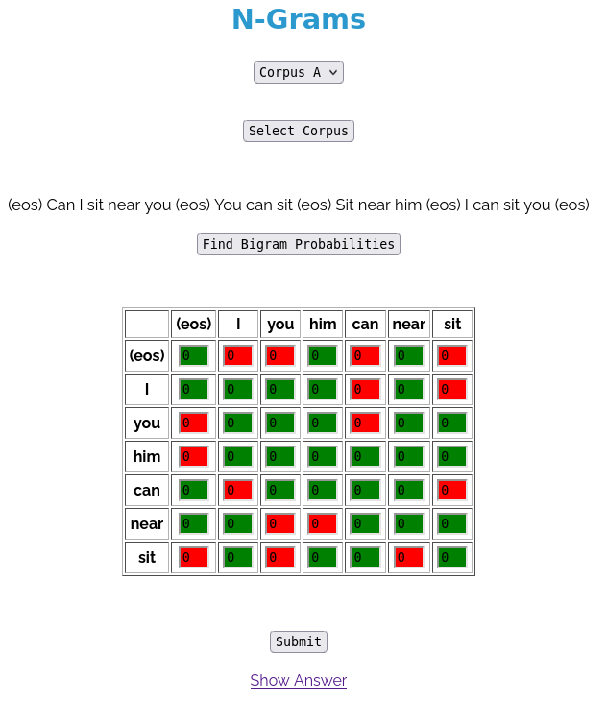

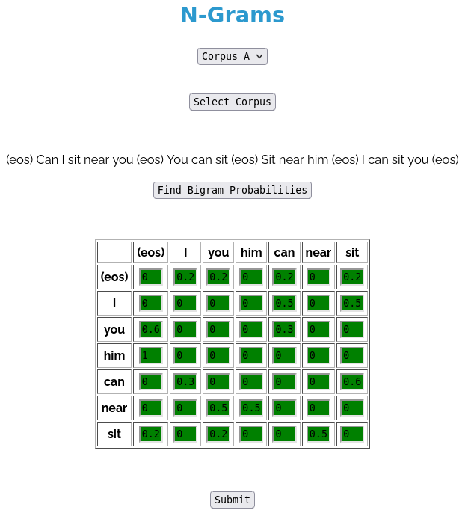

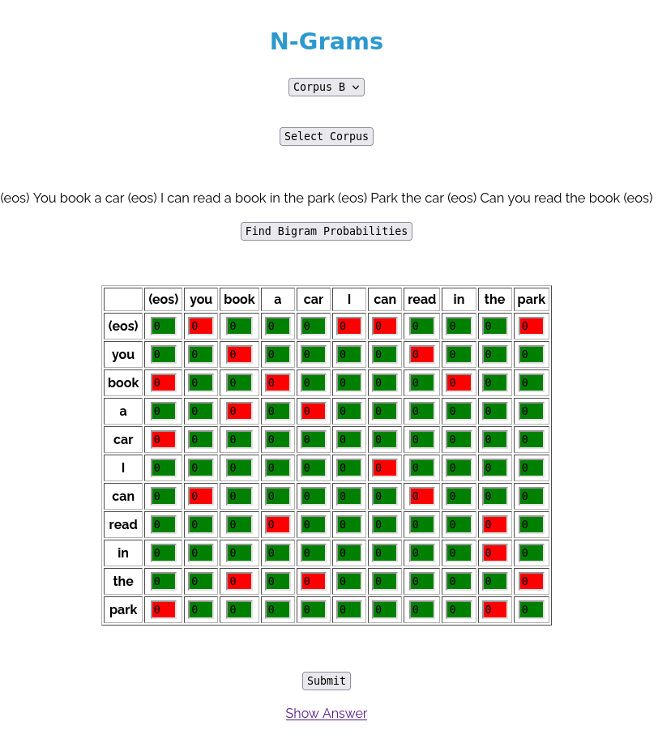

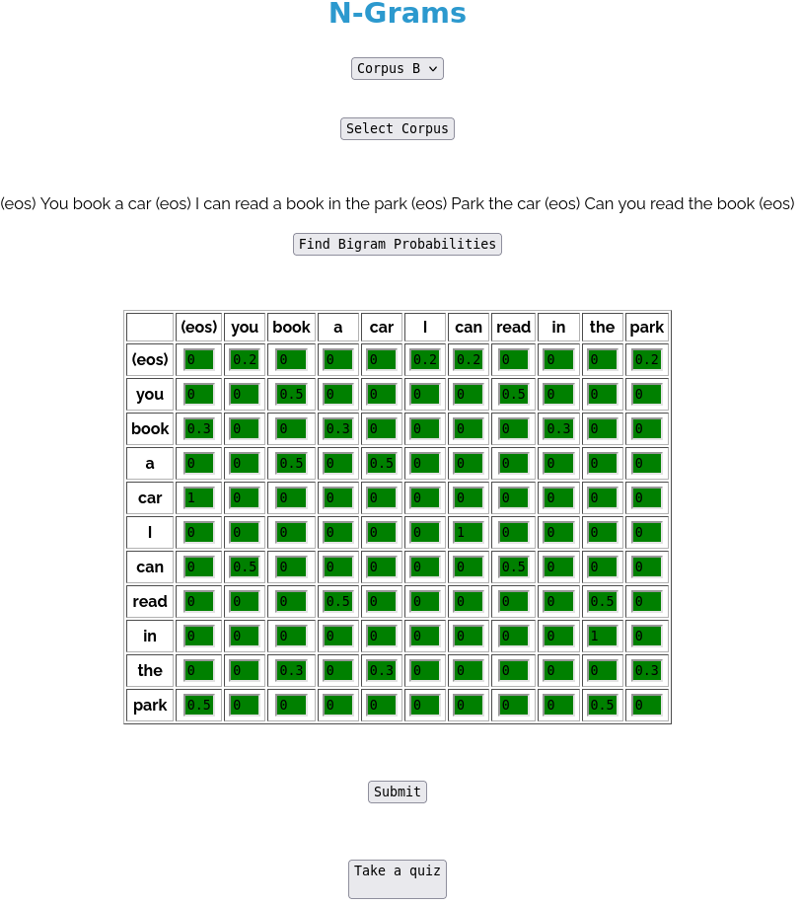
Date: 17 Oct 2024 Signature of faculty in-charge

Post Lab Descriptive Questions:

Q.1 Explain various applications of NLP.

Natural Language Processing (NLP) has a wide range of applications across different fields. Here are some key applications:
- Chatbots and Virtual Assistants: NLP powers chatbots and virtual assistants like Siri, Alexa, and Google Assistant, enabling them to understand and respond to user queries in natural language.
- Sentiment Analysis: Businesses use NLP to analyze customer feedback and social media posts to gauge public sentiment about products, brands, or services. This helps in improving customer relations and marketing strategies.
- Text Classification: NLP is used to categorize text into predefined groups, such as spam detection in emails or tagging articles in news aggregators.
- Machine Translation: Services like Google Translate rely on NLP to convert text from one language to another, facilitating communication across language barriers.
- Information Retrieval: Search engines use NLP to understand user queries and retrieve relevant documents, improving the search experience.
- Summarization: NLP can automatically generate summaries of long documents or articles, making it easier for users to get the main points quickly.
- Speech Recognition: NLP techniques are used to convert spoken language into text, enabling voice-to-text applications and transcription services.
- Content Recommendation: NLP analyzes user preferences and behaviors to recommend articles, products, or media tailored to individual tastes.
- Text Generation: Advanced models can generate coherent and contextually relevant text, used in creative writing, marketing, and content creation.
- Sentiment and Emotion Recognition: Beyond basic sentiment, NLP can analyze text for deeper emotional insights, which can be valuable in mental health applications and customer service.
- Healthcare Applications: NLP helps in processing and analyzing medical texts, such as patient notes, to extract relevant information and assist in diagnosis.
- Legal Document Analysis: NLP is used to review contracts and legal documents, helping lawyers quickly find relevant clauses and insights.
- Education Technology: NLP tools can assess student writing, provide feedback, and facilitate language learning through interactive applications.
- Social Media Monitoring: Organizations use NLP to monitor conversations and trends on social media, helping them respond to crises or engage with customers more effectively.

Q.2 What is the significance of Natural Language Processing (NLP) in modern technology, and how does it impact various industries?

Natural Language Processing (NLP) plays a crucial role in modern technology, significantly impacting various industries in multiple ways:

Significance of NLP
- Enhanced Human-Computer Interaction: NLP enables computers to understand and respond to human language, making interactions more intuitive and accessible. This enhances user experience across applications, from voice assistants to customer service chatbots.
- Data Analysis and Insights: NLP allows for the analysis of vast amounts of unstructured text data, providing valuable insights into trends, sentiments, and consumer behavior. This capability is essential for businesses looking to make data-driven decisions.
- Automation and Efficiency: By automating tasks such as data entry, summarization, and customer inquiries, NLP reduces the need for human intervention, saving time and resources.
- Personalization: NLP helps tailor experiences and recommendations based on individual user preferences, enhancing customer satisfaction and engagement.
- Language Accessibility: NLP facilitates communication across different languages and dialects, breaking down language barriers and making technology more inclusive.

Impact on Various Industries
- Healthcare: NLP aids in processing medical records, extracting critical information for diagnosis and treatment, and enhancing patient interactions through chatbots. It also supports research by analyzing medical literature and clinical trial data.
- Finance: In finance, NLP is used for sentiment analysis of market trends, risk assessment through analysis of news articles, and automating customer service tasks. It helps firms make informed investment decisions.
- E-commerce: NLP enhances product search and recommendation systems, analyzes customer reviews for insights, and automates customer support. This leads to improved customer experiences and increased sales.
- Education: NLP applications in education include automated grading, personalized learning experiences, and language translation tools. These technologies help educators assess student performance and cater to diverse learning needs.
- Marketing and Advertising: NLP enables targeted marketing strategies through audience analysis and sentiment tracking. It helps brands understand consumer perceptions and tailor their messaging accordingly.
- Legal: NLP is used to review contracts and legal documents, identifying relevant clauses and streamlining the research process. This increases efficiency and reduces the workload for legal professionals.
- Media and Entertainment: In media, NLP powers content recommendation systems, sentiment analysis of viewer feedback, and automated content generation, enhancing audience engagement and retention.
- Social Media: Companies leverage NLP to monitor brand reputation and analyze trends. It helps in understanding audience sentiment and improving engagement strategies.

