Batch: B1 Roll No.: 16010122146

Experiment / Assignment / Tutorial No. 0

Grade: AA / AB / BB / BC / CC / CD /DD

Signature of the Staff In-charge with date

Title: Implementation of Advanced JavaScript Concept

AIM: To Implement the Concept of Advanced JavaScript

Problem Definition:

-Demonstrate the Concept of Advanced JavaScript With the help of Example.

Resources used:
https://developer.mozilla.org/en-US/
_____________________________________________________________________
Expected OUTCOME of Experiment:

CO 1:.Build full stack applications in JavaScript using the MERN technologies.
___________________________________________________________________
Books/ Journals/ Websites referred:
1. Shelly Powers Learning Node O’ Reilly 2 nd Edition, 2016.

Pre Lab/ Prior Concepts:

- Basic understanding of JavaScript syntax and functions.
- Familiarity with arrays and objects in JavaScript.
- Understanding of asynchronous programming and promises in JavaScript.

Methodology:

Filter Unique Array Members:
- Define an array with duplicate elements.
- Implement the unique function to filter out duplicate elements.
- Use Set to ensure unique elements or alternative methods for uniqueness.
Filter Anagrams:
- Create a function to identify anagrams by sorting and comparing the characters of words.
- Test the function with multiple examples to ensure accuracy.
Iterable Keys:
- Create a Map object with key-value pairs.
- Retrieve the keys using map.keys() and convert the iterator to an array.
- Apply array-specific methods to the keys.
Fetch Users from GitHub:
- Implement the getUsers async function.
- Use the fetch API to retrieve user information from GitHub based on provided usernames.
- Handle errors and edge cases, ensuring the function returns an array of user objects.

Implementation Details:

1)
Filter unique array members
Let arr be an array.
Create a function unique(arr) that should return an array with unique items of arr
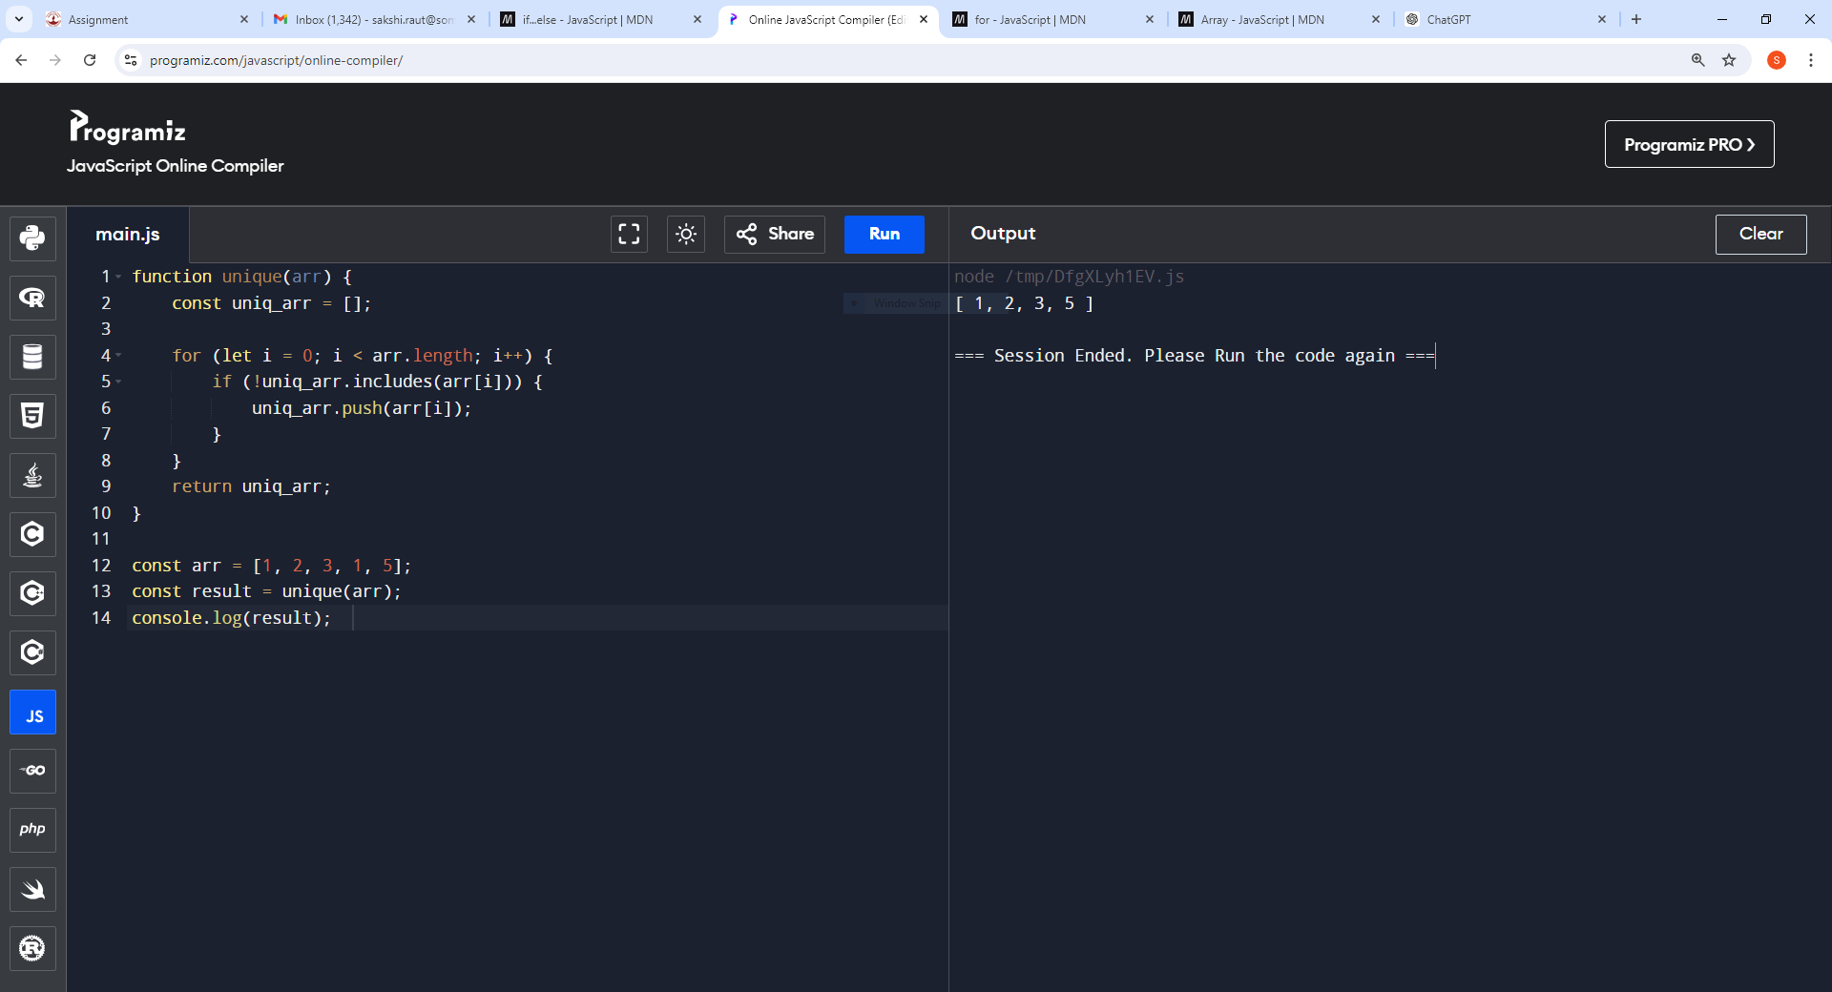


2) Filter anagrams
Anagrams are words that have the same number of same letters but in different order. e.g. car=arc, right=thing
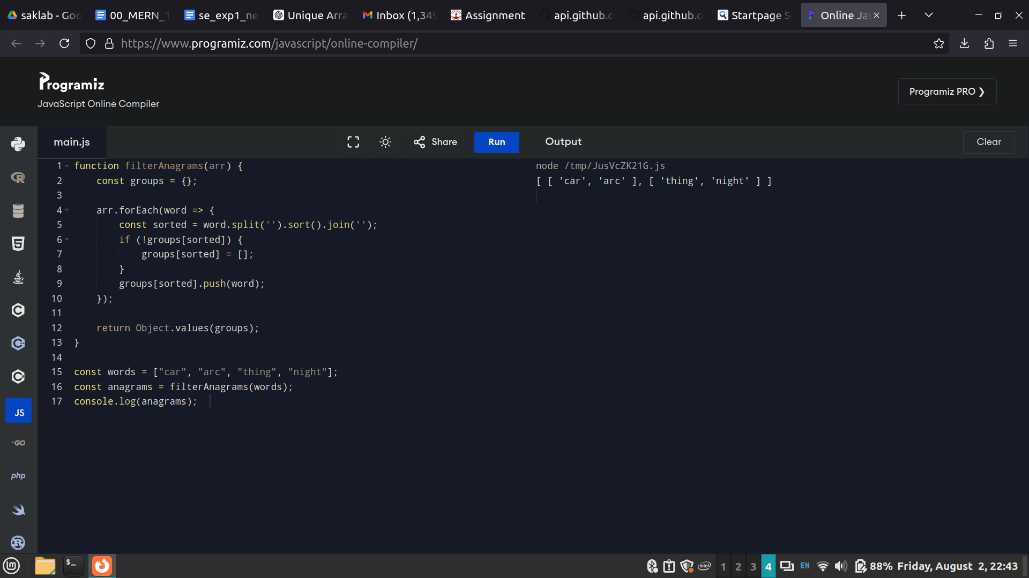


3) Iterable keys
We’d like to get an array of map.keys() in a variable and then apply array-specific methods to it, e.g. .push.

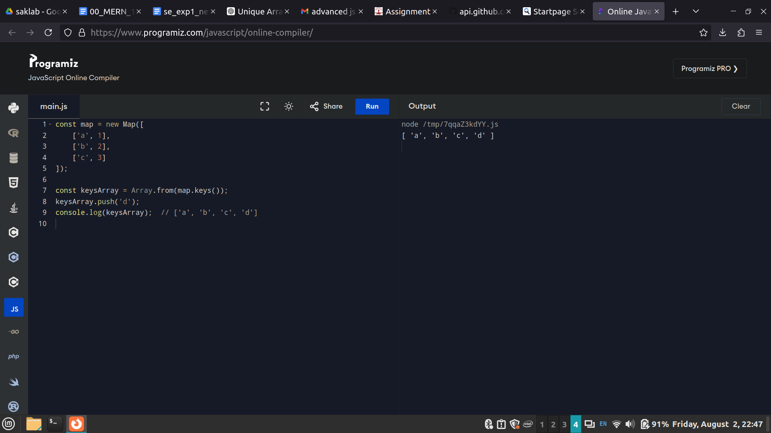

4) Fetch users from GitHub
Create an async function getUsers(names), that gets an array of GitHub logins, fetches the users from GitHub and returns an array of GitHub users.
The GitHub url with user information for the given USERNAME is: https://api.github.com/users/USERNAME.
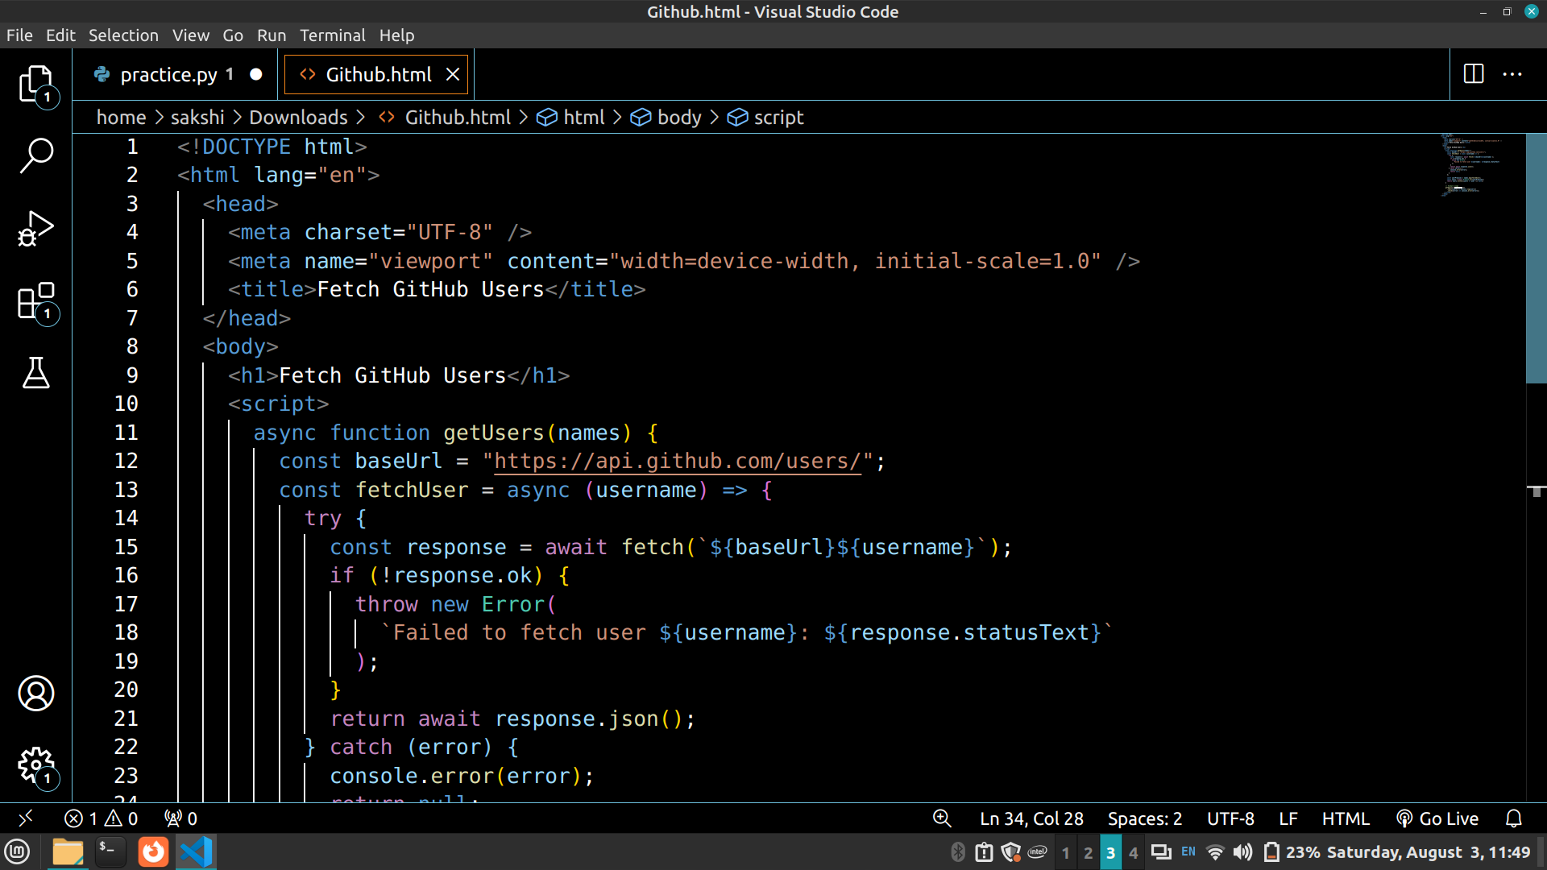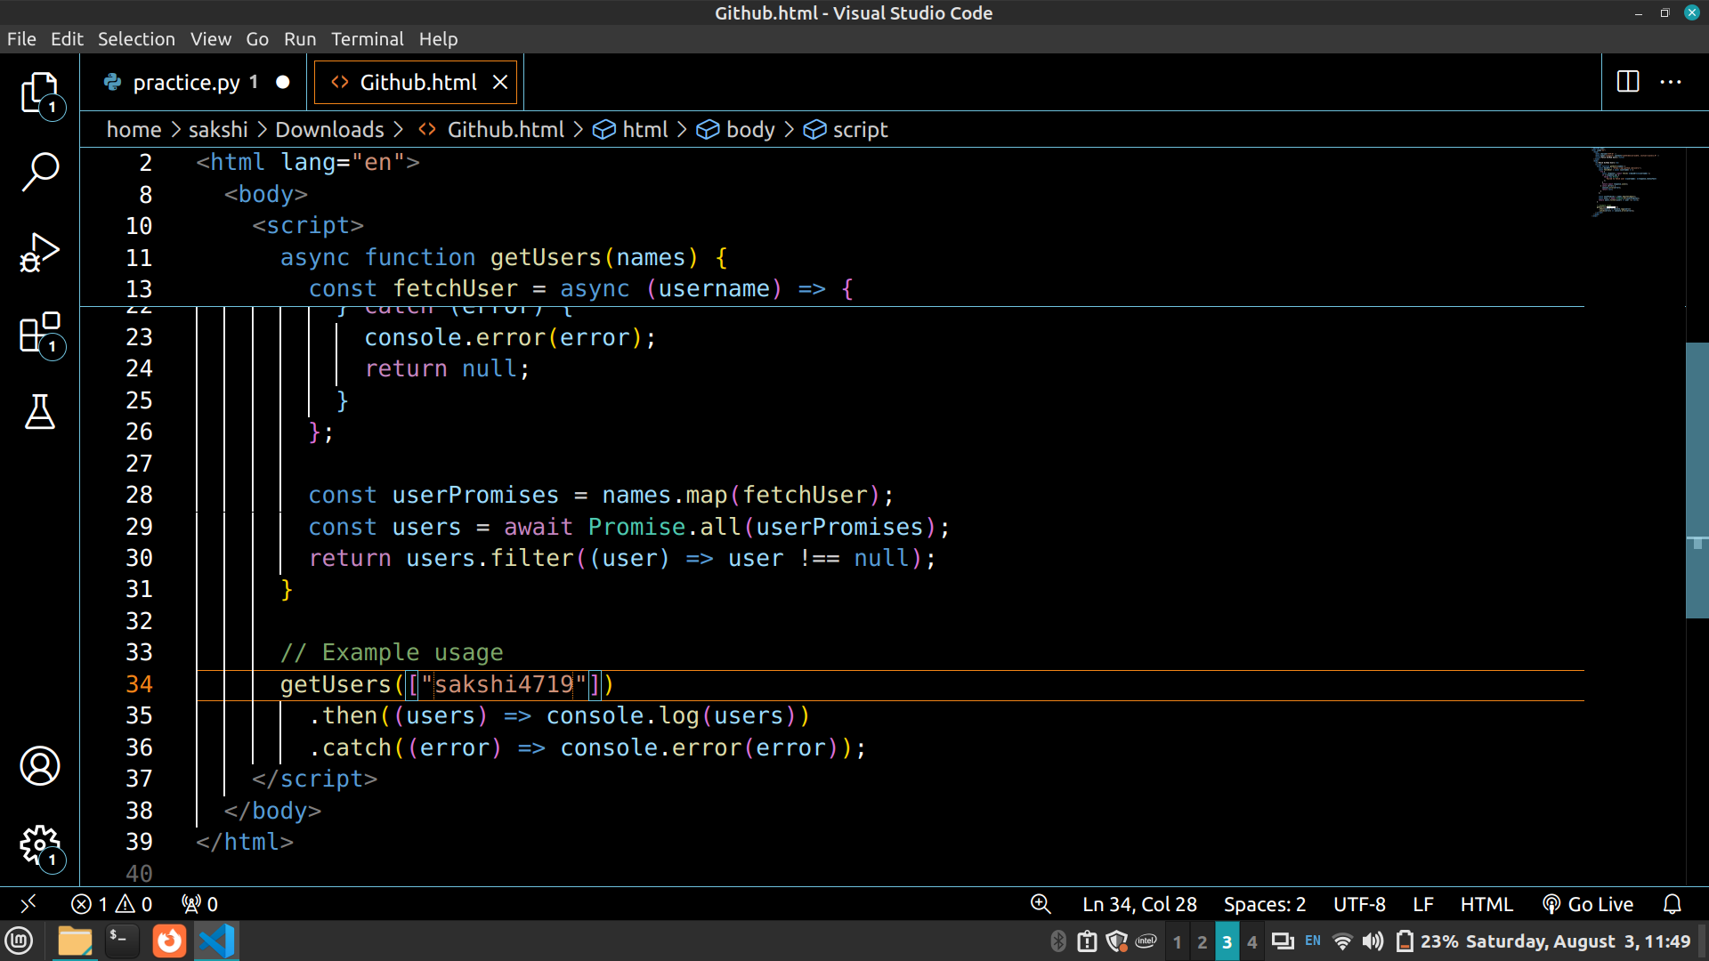
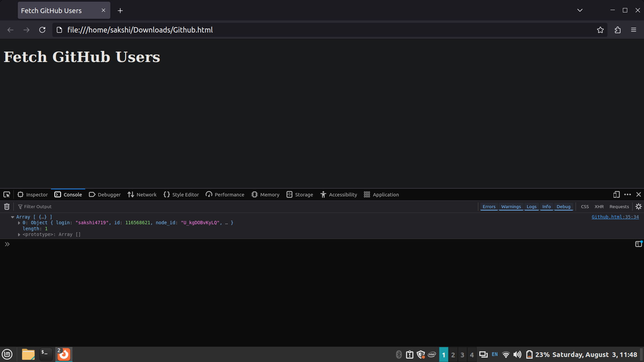

Conclusion:

In this experiment, successfully implemented and demonstrated several advanced JavaScript concepts. Created functions to filter unique array members, identify anagrams, handle iterable keys, and fetch user data from GitHub asynchronously. By mastering these techniques, we are better equipped to build robust full-stack applications using the MERN stack.

