Batch: A2 Roll No.: 16010122034

Experiment / Assignment / Tutorial No. 09

Grade: AA / AB / BB / BC / CC / CD / DD

Signature of the Staff In-charge with date

Title: Create a RESTful API server in Express and Node.js. Implementation + Testing application using postman/Thurderclient

AIM: Create a RESTful API server in Express and Node.js. Implementation + Testing application using postman/Thurderclient
Problem Definition:
Develop a RESTful API server in Node.js using Express to handle CRUD operations. The server will allow clients to retrieve, create, update, and delete resources via HTTP requests. Testing will be conducted using Postman or Thunder Client to verify endpoint functionality.

Resources used:

- Node.js and Express Documentation: For server setup and routing.
- Postman Documentation: For testing API endpoints.
- Thunder Client: An optional in-editor API testing tool for VS Code.
- Shelly Powers, Learning Node, O'Reilly, 2nd Edition, 2016: Reference for Node.js and Express basics.

_____________________________________________________________________
Expected OUTCOME of Experiment:

CO 3: Test the concepts and components of various front-end, back-end web app development technologies & frameworks using web development tools.
___________________________________________________________________

Books/ Journals/ Websites referred:
1. Shelly Powers Learning Node O’ Reilly 2 nd Edition, 2016.

Pre Lab/ Prior Concepts:

Write details about the following content

- Testing in POSTMAN
Testing in Postman involves creating and sending HTTP requests to an API to verify its functionality. Here’s a quick guide:
- Install and Open Postman: Download Postman and open it.
- Create a New Request: Click New > Request and select the HTTP method (e.g., GET, POST).
- Enter API Endpoint: Type the API’s URL (e.g., http://localhost:5000/api/items).
- Set Headers and Body:
  - For POST requests, go to the Body tab, select raw and JSON, then enter your JSON data (e.g., {"name": "Item1", "quantity": 10}).
- Send Request: Click Send to execute the request.
- Check Response: View the server’s response in the Response section to confirm the API behavior.
Postman helps you test endpoints, debug responses, and validate the functionality of each API route.

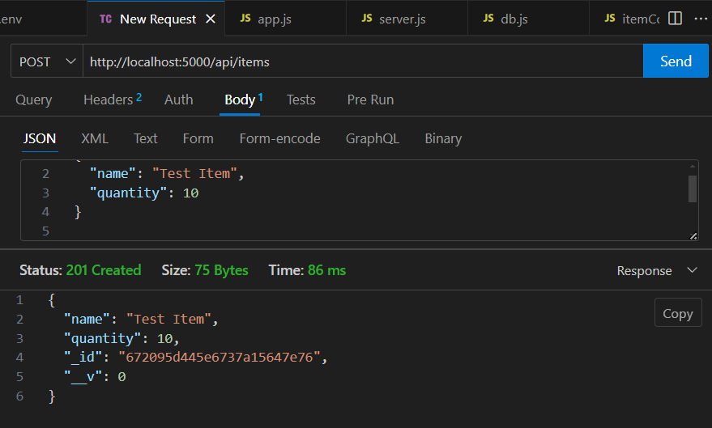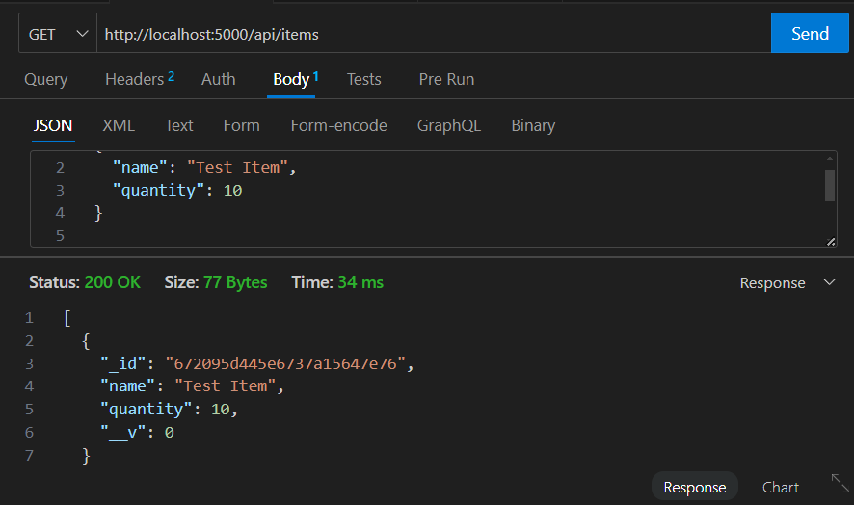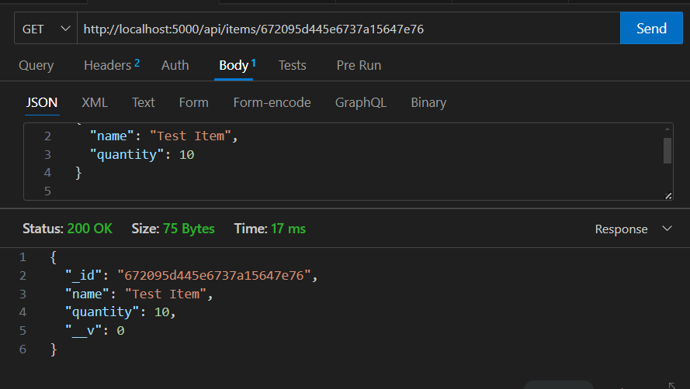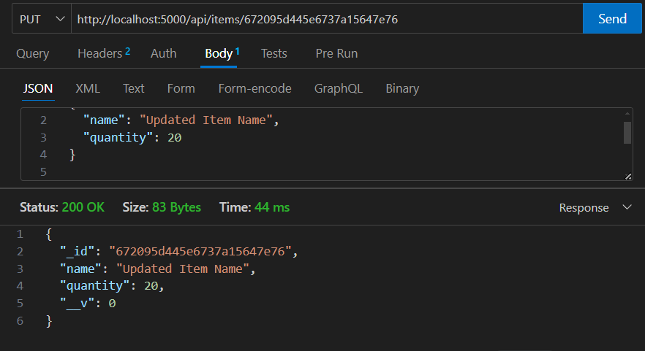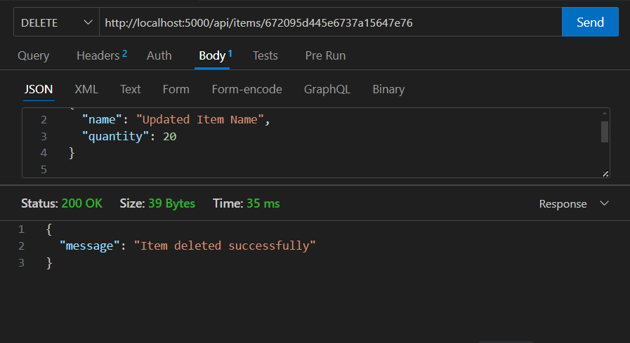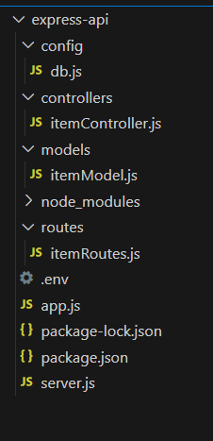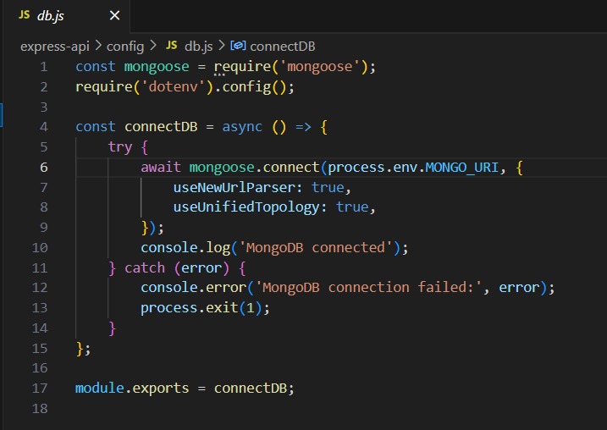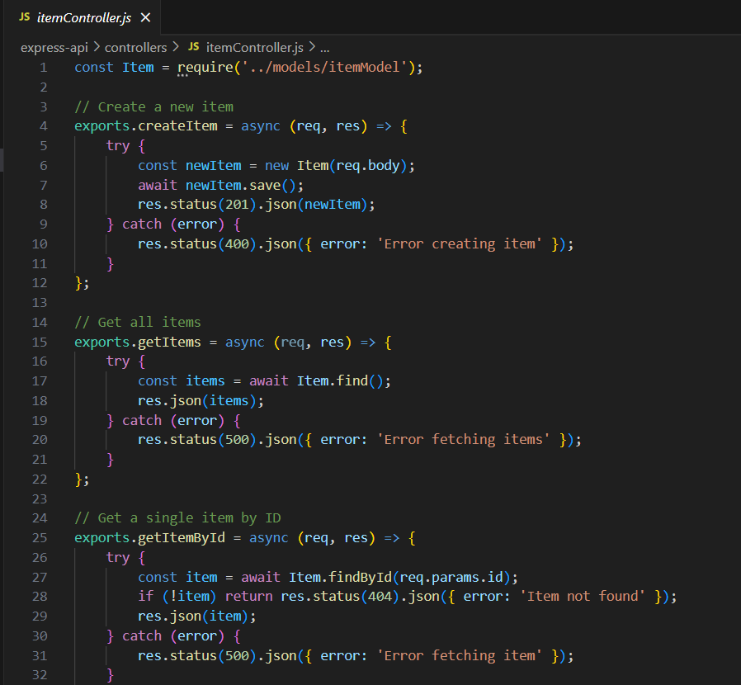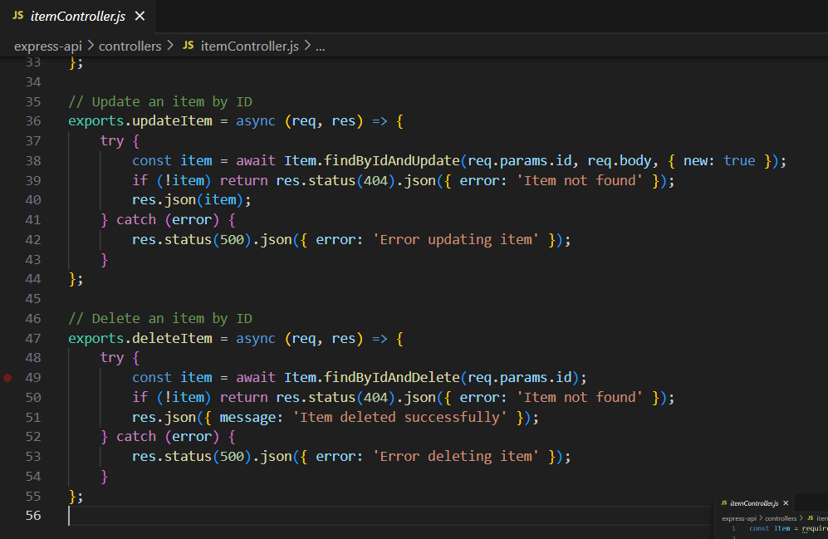
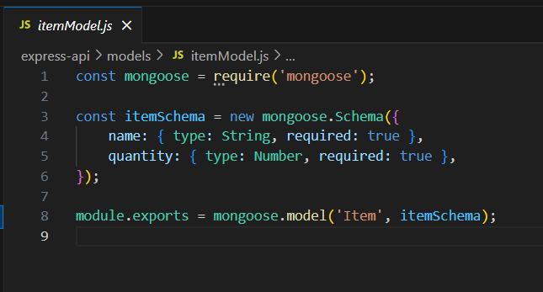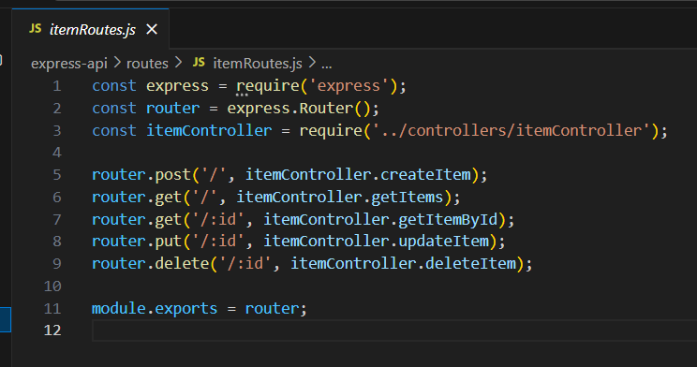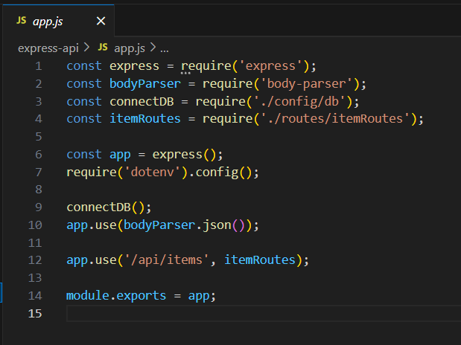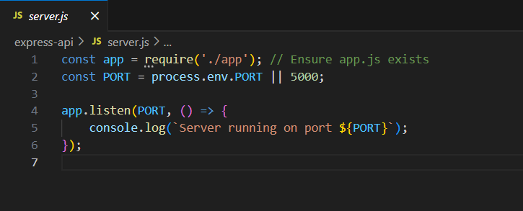

Conclusion:

In conclusion, testing APIs with tools like Postman enables efficient validation of endpoint functionality, ensuring the API behaves as expected. This process is essential for identifying and fixing potential issues, contributing to a reliable and well-functioning backend system.

