Batch: B1 Roll No.: 16010122158

Experiment / Assignment / Tutorial No. 1

Grade: AA / AB / BB / BC / CC / CD / DD

Signature of the Staff In-charge with date

Title: Implementation of React Fundamentals.

AIM: To Implement the Basic operations of React js
Problem Definition:
-Demonstrate the
- React Fundamentals
- Function Component
- Styling/ Bootstrap
- React JSX
- Expressions in JSX
- React Props
- React state
- React Component Lifecycle
- React Events
- Event Binding

*(Students have to perform the task assigned within group and demonstrate the same).
Resources used:

_____________________________________________________________________
Expected OUTCOME of Experiment:

CO 1:.Build full stack applications in JavaScript using the MERN technologies.
___________________________________________________________________
Books/ Journals/ Websites referred:
1. Shelly Powers Learning Node O’ Reilly 2 nd Edition, 2016.

Pre Lab/ Prior Concepts:

1. Creating Environment and First Project Setup:

First, ensure you have Node.js and npm (Node Package Manager) installed on your computer.
Open your terminal and run the following command to create a new React application using Create React App:

npx create-react-app my-react-app
Navigate to the project directory:

cd my-react-app
Start the development server:

npm start
This sets up a basic React application.

2. Use of JSX:

React uses JSX (JavaScript XML) to describe the UI components. JSX allows you to write HTML-like code within your JavaScript.

// Example JSX in a React component
function App() {
return (
<div>
<h1>Hello, React!</h1>
<p>This is a JSX example.</p>
</div>
);
}

3. Class and Function Components:

You can create React components as classes or functions. Here's an example of both:

// Class Component
class Greeting extends React.Component {
render() {
return <h2>Hello, {this.props.name}!</h2>;
}
}

// Function Component
function Greeting(props) {
return <h2>Hello, {props.name}!</h2>;
}

4. Props:

Props (short for properties) allow you to pass data from parent to child components.

// Using props in a component
function Welcome(props) {
return <h1>Welcome, {props.name}</h1>;
}

// Rendering the component with props
ReactDOM.render(<Welcome name="John" />, document.getElementById('root'));

5. State:

State allows you to manage data that can change over time in your component.

// Using state in a class component
class Counter extends React.Component {
constructor() {
super();
this.state = { count: 0 };
}

render() {
return (
<div>
<p>Count: {this.state.count}</p>
<button onClick={() => this.setState({ count: this.state.count + 1 })}>Increment</button>
</div>
);
}
}

6. Event Handling:

React components can handle events using event handlers.

// Handling events in a React component
function ButtonExample() {
function handleClick() {
alert('Button clicked!');
}

return <button onClick={handleClick}>Click me</button>;
}

7. Building a Basic Form:

You can create forms in React by using form elements and handling form submissions.

// Building a basic form in React
class BasicForm extends React.Component {
constructor() {
super();
this.state = { inputText: '' };
}

handleChange(event) {
this.setState({ inputText: event.target.value });
}

handleSubmit(event) {
event.preventDefault();
alert('Submitted: ' + this.state.inputText);
}

render() {
return (
<form onSubmit={(e) => this.handleSubmit(e)}>
<input
type="text"
value={this.state.inputText}
onChange={(e) => this.handleChange(e)}
/>
<button type="submit">Submit</button>
</form>
);
}
}
This example demonstrates key React concepts, from project setup to building a basic form. You can expand upon this foundation to create more complex and interactive applications.

Methodology:

Setup React Environment:
- Install Node.js and npm.
- Create a React application using Create React App.
Understand React Basics:
- Learn about components, JSX, props, and state.
- Implement examples for each concept.
Explore Advanced React Concepts:
- Study the component lifecycle.
- Handle events and event binding.
Implementation Details:

1]Function Component

import './App.css';
import React from 'react';

// Define the Welcome component
function Welcome(props) {
return <h1>Hello, {props.name}</h1>;
}
function App() {
const name = "Student";
const element = <Welcome name={name} />;

return (
<div>
{element}
</div>
);
}

export default App;
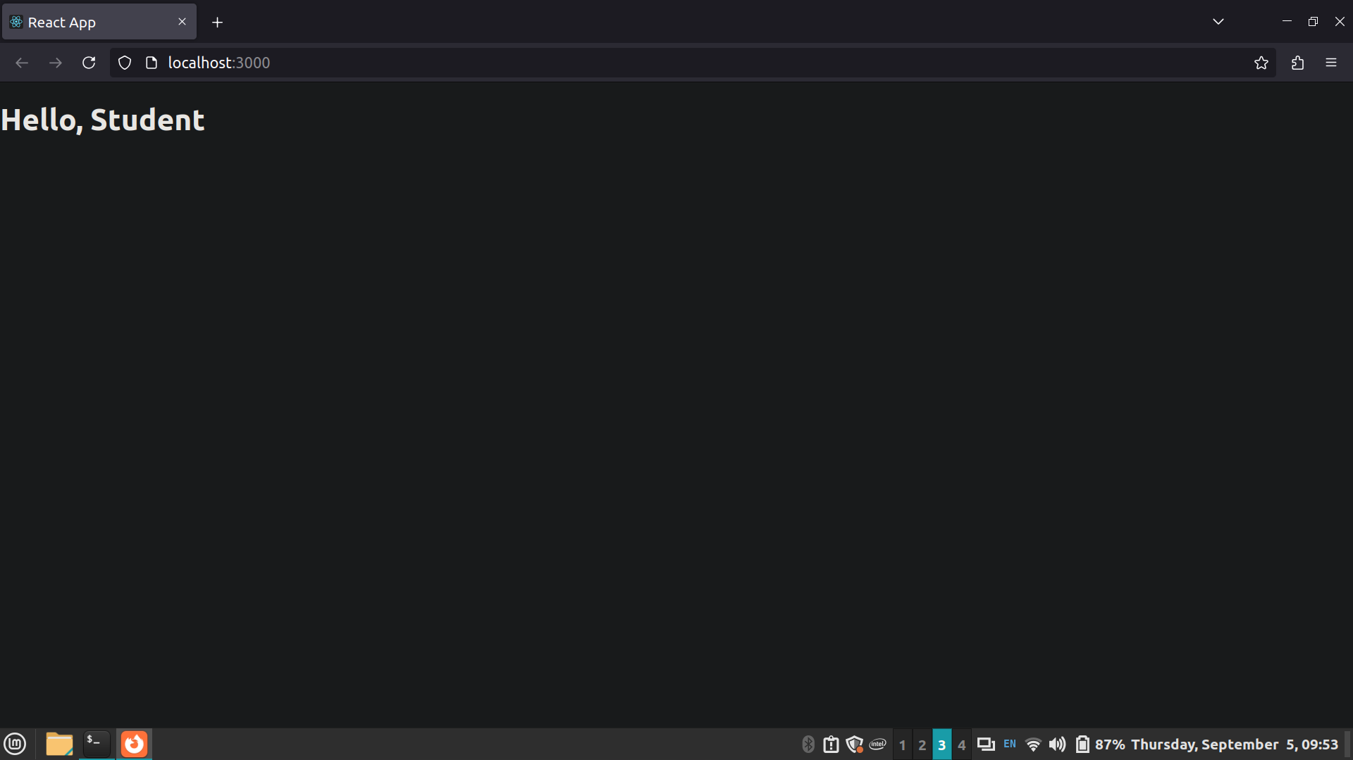

2] React Bootstrap

import './App.css';
import React from 'react';
import Button from 'react-bootstrap/Button';
import Stack from 'react-bootstrap/Stack'; // Import Stack component

function App() {
const name = "student"; // Define the variable outside of the return statement

return (
<Stack direction="horizontal" gap={2}>
<Button as="button" variant="large">
Button as link
</Button>
</Stack>
);
}
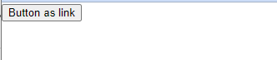
3]Expressions in jsx
import React from 'react';

function App() {
// Variables
const name = 'Vedant';
const number = 5;
const isLoggedIn = true;
const user = { firstName: 'Vedant', lastName: 'Shah' };

// Function to format name
function formatName(user) {
return `${user.firstName} ${user.lastName}`;
}

return (
<div>
{/* Embedding Variables */}
<h1>Hello, {name}!</h1>

{/* Inline Expressions */}
<p>The number is {number * 2}.</p>

{/* Conditional Rendering */}
<div>
{isLoggedIn ? <p>Welcome back!</p> : <p>Please log in.</p>}
</div>

{/* Function Calls */}
<p>{`Full name: ${formatName(user)}`}</p>
</div>
);
}

export default App;
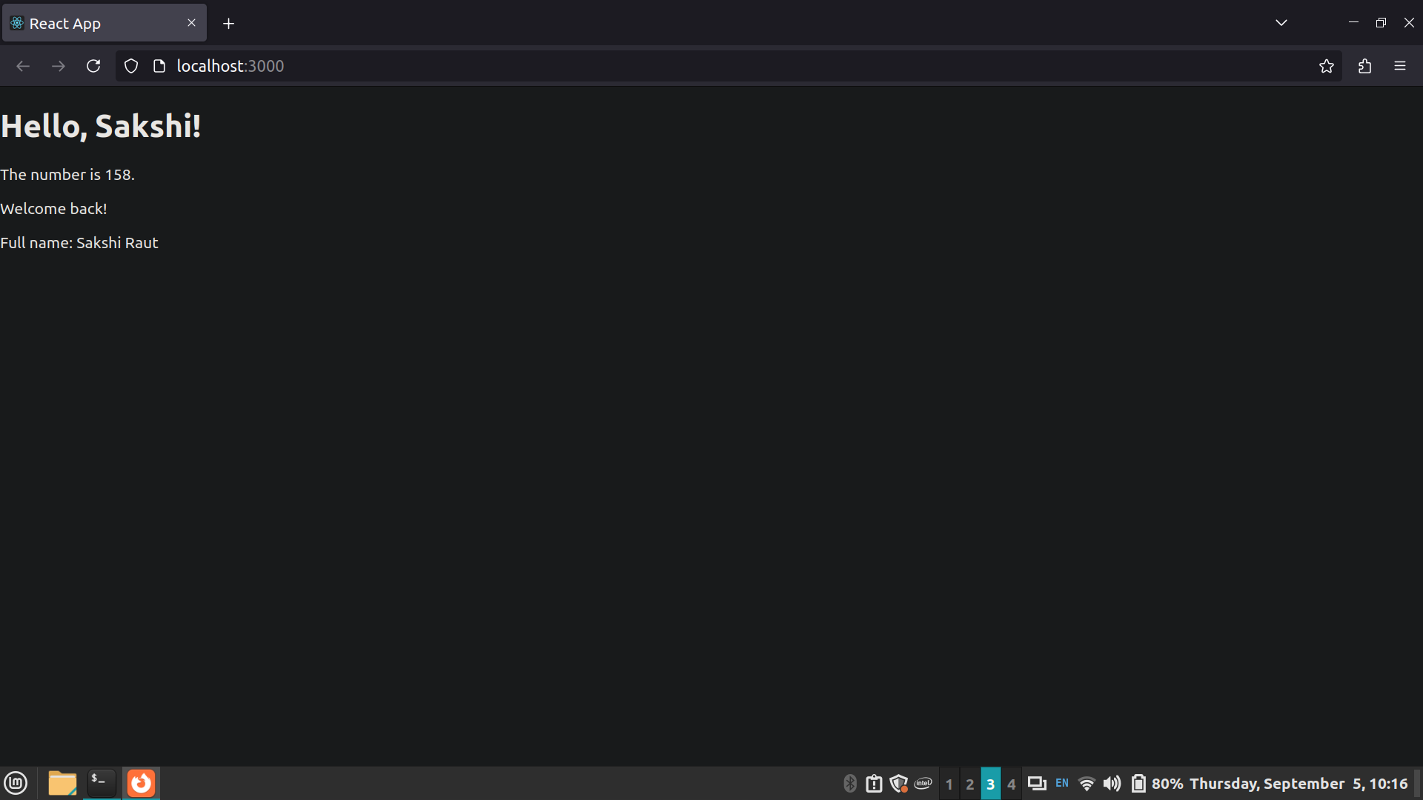
4]React jsx
import './App.css';
import React from 'react';
function App() {
const name = "student"; return (
<h1>
Hello,
Welcome to {name}.
</h1>
);
}

export default App;
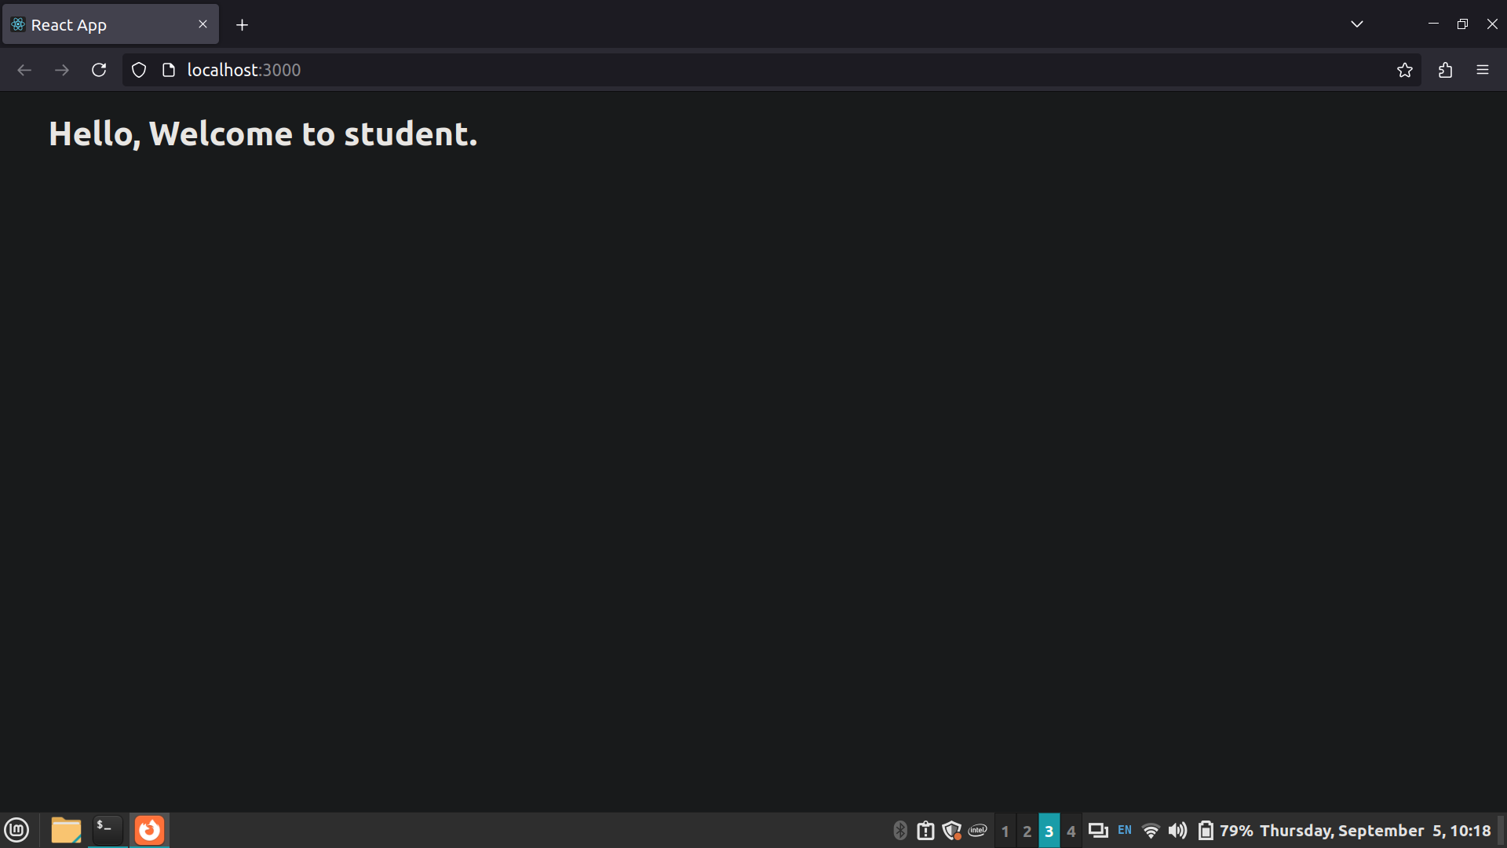
5] React Props

import './App.css';

function App() {
return (
<div className="App">
<Lab name='Web development' />
</div>
);
}

export default App;

function Lab(props) {
return (
<h1>Welcome to {props.name} lab </h1>
)
}



6} React State

import './App.css';
import { useState } from 'react';

function App() {
let [count, setCount] = useState(0)
return (
<div className="App">
<button onClick={() => setCount(count + 1)}>Clicked {count} times</button>
</div>
);
}

export default App;

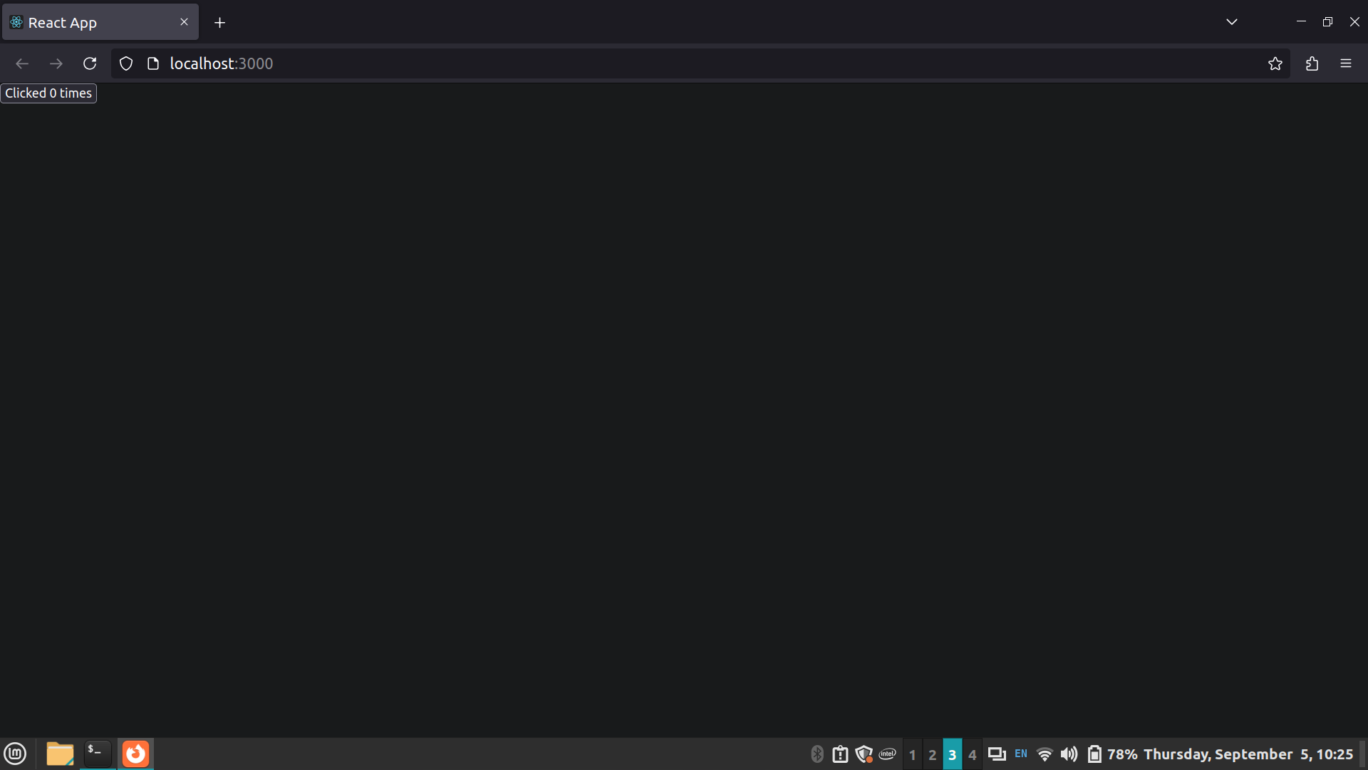
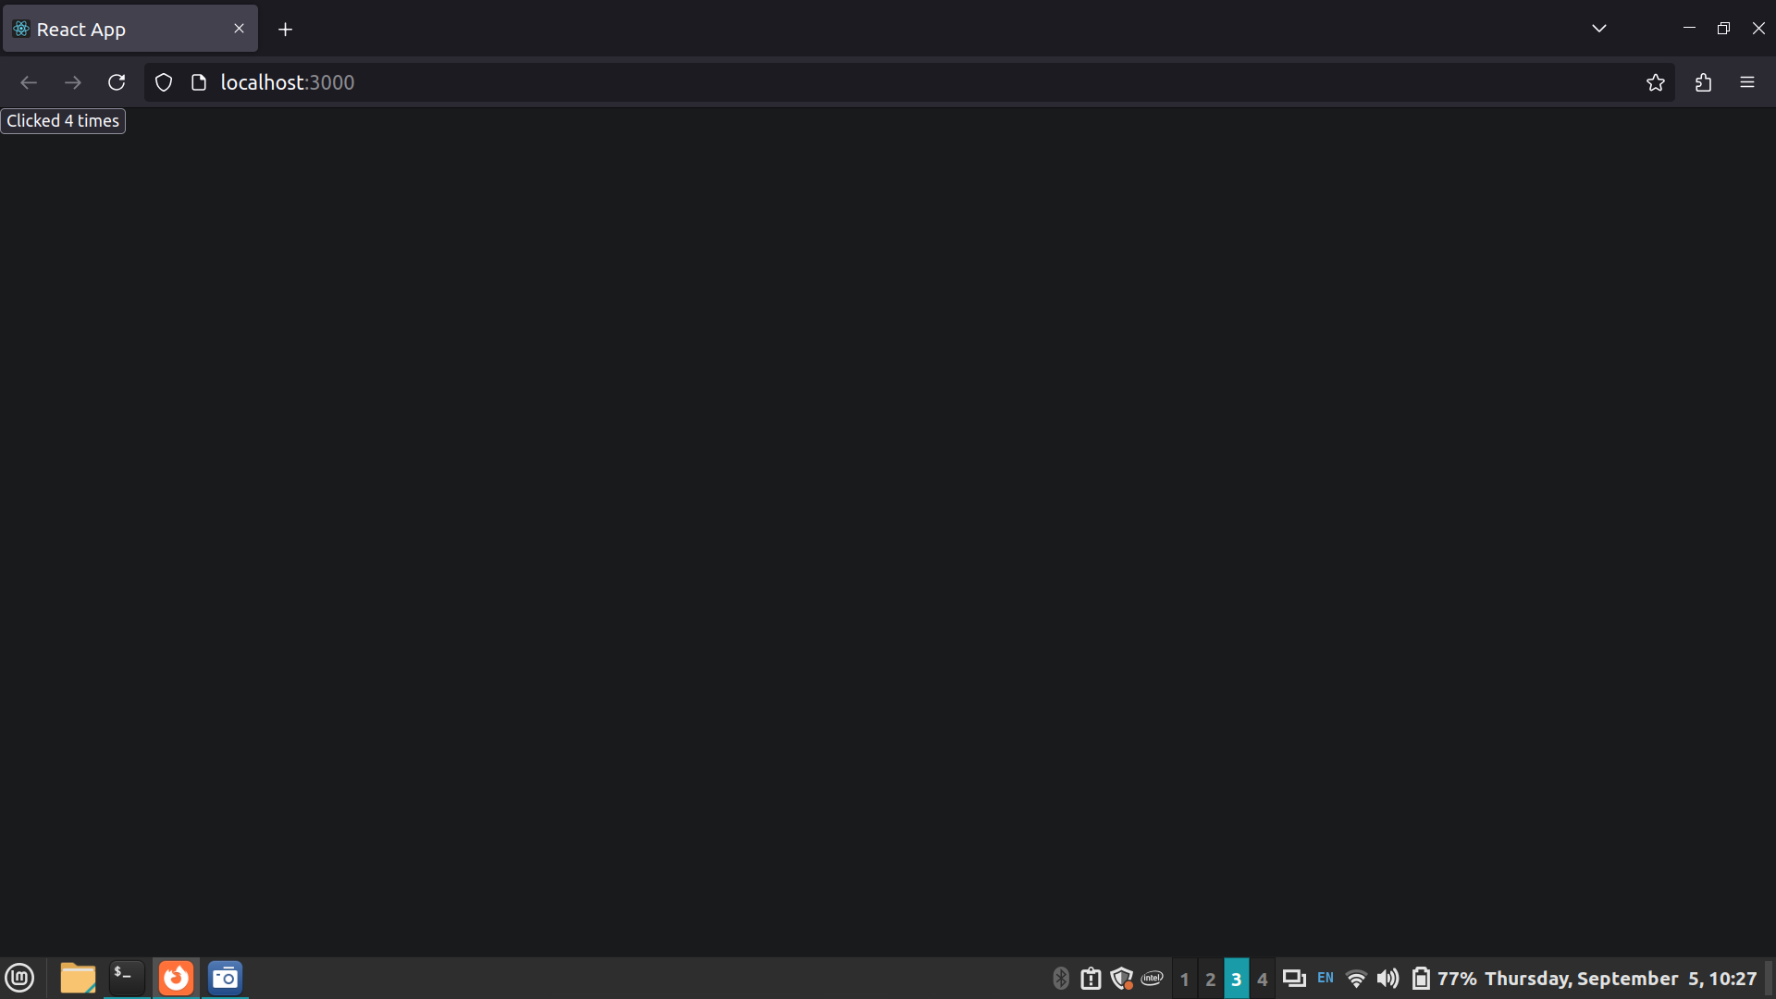

7] React component lifecycle

import React from 'react';

class Clock extends React.Component {
constructor(props) {
super(props);
this.state = { date: new Date() };
this.tick = this.tick.bind(this);
}

componentDidMount() {
this.timerID = setInterval(
() => this.tick(),
1000
);
}

componentWillUnmount() {
clearInterval(this.timerID);
}

tick() {
this.setState({
date: new Date()
});
}

render() {
return (
<div>
<h1>Hello, world!</h1>
<h2>It is {this.state.date.toLocaleTimeString()}.</h2>
</div>
);
}
}

export default Clock;

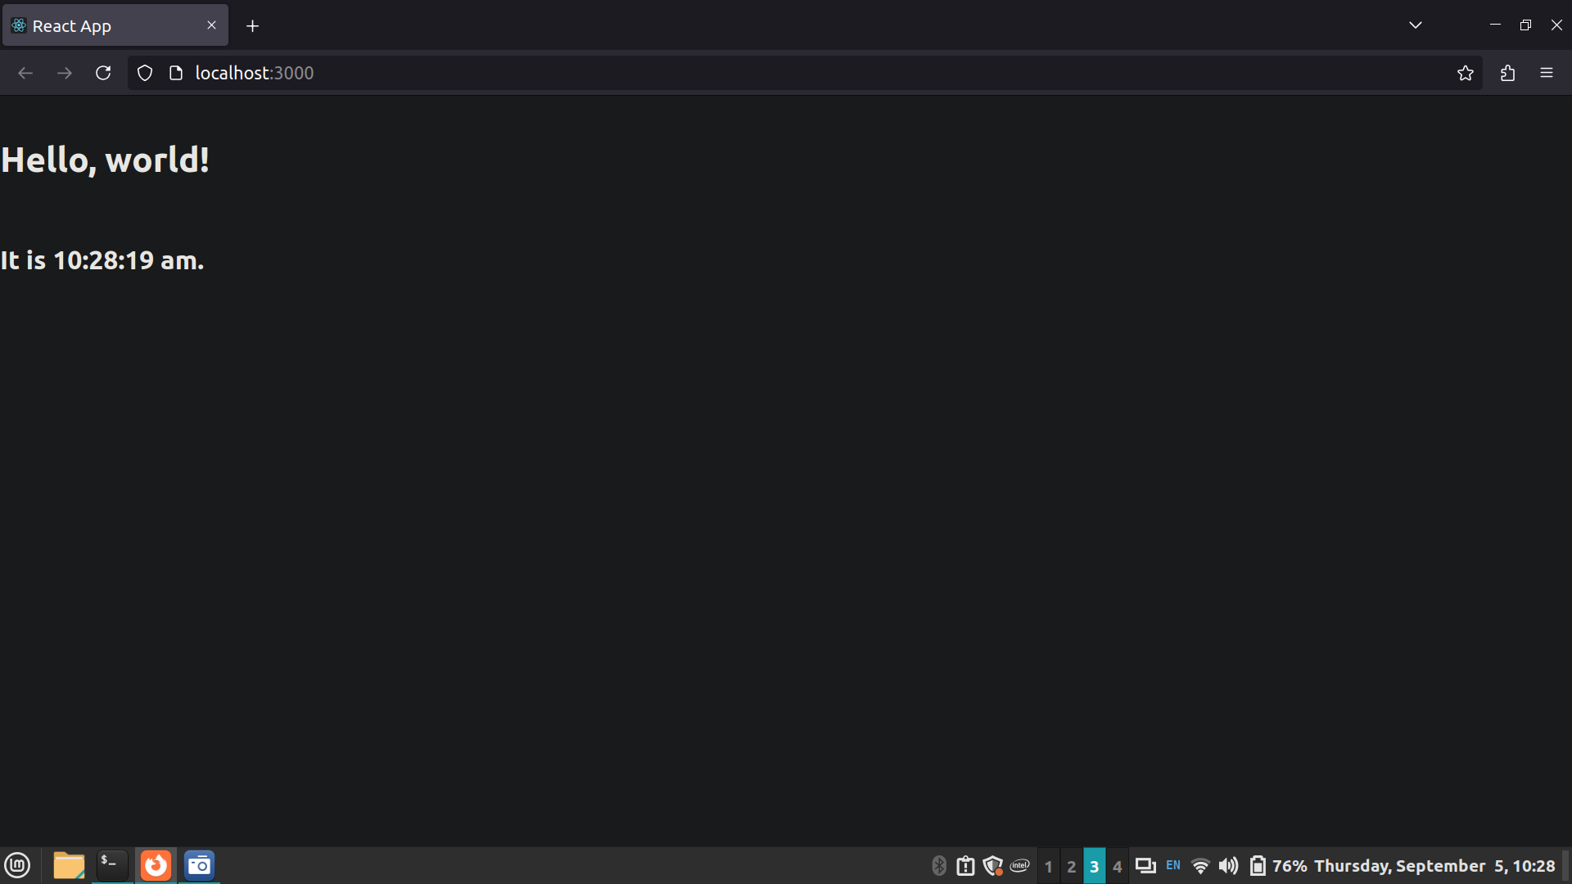
8] React Events

import './App.css';
import { useState } from 'react';

function App() {
let [count, setCount] = useState(0)
return (
<div className="App">
<button onClick={() => setCount(count + 1)}>Clicked {count} times</button>
</div>
);
}

export default App;

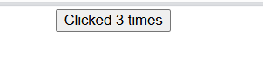

9] Event Binding

import './App.css';
import { useState } from 'react';

function App() {
let [count, setCount] = useState(0)
return (
<button onClick={handleClick}>Click Me</button>
);
}

export default App;

function Lab(props) {
return (
<h1>Welcome to {props.name} lab </h1>
)
}
function handleClick() {
alert('Button clicked!');
}
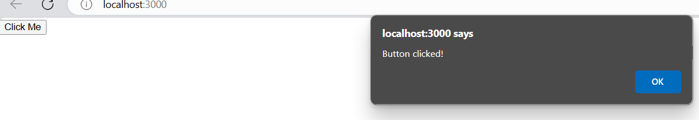

Steps for execution:
Set up the environment:
- Install Node.js and Create React App.
- Initialize a new React project.
Create Components:
- Develop function components for different UI elements.
Styling:
- Apply Bootstrap styling to components.
JSX:
- Use JSX for creating elements and embedding expressions.
Props and State:
- Pass data using props and manage internal state.
Lifecycle Methods:
- Implement lifecycle methods for different stages of a component.
Events:
- Handle events and ensure proper binding of event handlers.
Conclusion:
The tasks demonstrated the fundamentals of React, including component creation, JSX syntax, props, state management, component lifecycle, and event handling. These concepts are essential for building dynamic and interactive user interfaces in modern web applications.

Post Lab questions:

- Explain the Concept of SPA.
Ans- SPA (Single Page Application):
An SPA is a web application that loads a single HTML page and dynamically updates content as the user interacts with the app, without refreshing the entire page. It provides a smoother, faster user experience by only loading the necessary data, often using AJAX. Popular SPA frameworks/libraries include React, Angular, and Vue.js.

- What is Component Lifecycle?
Ans- Component Lifecycle in React:
The component lifecycle in React consists of methods that are invoked at different stages of a component's existence. These stages are:
- Mounting: When the component is created and added to the DOM (e.g., componentDidMount).
- Updating: When the component is re-rendered due to changes in props or state (e.g., componentDidUpdate).
- Unmounting: When the component is removed from the DOM (e.g., componentWillUnmount).
These lifecycle methods allow developers to perform specific actions at each stage, such as initializing state, making AJAX requests, or cleaning up resources.

