Batch: B1 Roll No.: 16010122158

Experiment / assignment / tutorial No. 3

Grade: AA / AB / BB / BC / CC / CD / DD

Signature of the Staff In-charge with date

Title: Implementation of React Hooks.

AIM: To Implement the React Hooks
Problem Definition:
To demonstrate the working of react hooks based on the following points and Apply this on assigned programming task
- useState
- useEffect
- useContext
- useReducer:
- useCallback
- useMemo

Resources used:

https://www.geeksforgeeks.org/react-tutorial/
https://legacy.reactjs.org/docs/getting-started.html
_____________________________________________________________________
Expected OUTCOME of Experiment:

CO 1:.Build full stack applications in JavaScript using the MERN technologies.
___________________________________________________________________
Books/ Journals/ Websites referred:
1. Shelly Powers Learning Node O’ Reilly 2 nd Edition, 2016.

Pre Lab/ Prior Concepts:

- useState
- useEffect
- useContext
- useReducer:
- useCallback
- useMemo

1. useState:
- Purpose: useState is a hook that lets you add state to functional components. It returns a state variable and a function to update that variable.
- Usage:
const [count, setCount] = useState(0);

- count is the state variable, and setCount is the function used to update it.
- The initial state is set to 0.

2. useEffect:
- Purpose: useEffect allows you to perform side effects in functional components. It can be used for tasks like data fetching, subscriptions, or manually changing the DOM.
- Usage:
useEffect(() => {
// Code to run on component mount or update
return () => {
// Cleanup code (optional)
};
}, [dependencies]);

- The function passed to useEffect runs after the component renders.
- The dependencies array determines when the effect runs; it runs whenever a dependency changes.

3. useContext:
- Purpose: useContext allows you to consume context in functional components, making it easier to share state or functions between components without prop drilling.
- Usage:
const value = useContext(MyContext);

- MyContext is the context object created using React.createContext().
- value is the current context value.

4. useReducer:
- Purpose: useReducer is a hook for managing complex state logic in a component. It’s an alternative to useState when state logic becomes complex or when the next state depends on the previous one.
- Usage:
const [state, dispatch] = useReducer(reducer, initialState);

- reducer is a function that takes the current state and an action, and returns the new state.
- state is the current state, and dispatch is a function to send actions to the reducer.

5. useCallback:
- Purpose: useCallback returns a memoized version of a callback function that only changes if one of the dependencies changes. It’s useful to avoid unnecessary re-renders when passing callbacks to child components.
- Usage:
const memoizedCallback = useCallback(() => {
// Function logic
}, [dependencies]);

- The memoizedCallback will only change if one of the dependencies changes.

6. useMemo:
- Purpose: useMemo returns a memoized value, recomputing it only when its dependencies change. It’s used to optimize performance by avoiding costly calculations on every render.
- Usage:
const memoizedValue = useMemo(() => computeExpensiveValue(a, b), [a, b]);

- memoizedValue is only recalculated when a or b changes.

These hooks are fundamental to building functional components in React, allowing for state management, side effects, and performance optimizations.

Methodology:

Understanding React Hooks:
• Begin by understanding the core React Hooks: useState, useEffect, useContext, useReducer,
useCallback, and useMemo.
• Review the React documentation to understand how these hooks manage state, side effects,
context, and performance optimizations.

Task Implementation:
• User Profile Editor: Implement a form with hooks to manage user input, toggle form visibility,
and reset the form.
• Task Manager: Build a task manager with hooks to handle task addition, completion, visibility
toggling, and list resetting.
• User Profile Manager: Create a form that initializes with fetched data and allows updates,
logging changes to the console.

Component Design:
• Design each component to use appropriate hooks for state management and side effects.
• Ensure clear separation of concerns by using functional components and hooks.

Testing and Validation:
• Test each component to ensure functionality, including form handling, task management, and
data fetching/updating.
• Validate that the hooks are working as expected and handling state and side effects properly.

Implementation Details:

Task: User Profile Editor

// App.js

import React from 'react';
import UserProfile from './UserProfile';
const App = () => {
return (
<div>
<UserProfile />
</div>
);
};
export default App;

// UserProfile.js

import React, { useState } from 'react';
import './UserProfile.css'; // Import the CSS file
const UserProfile = () => {
const [formData, setFormData] = useState({
name: '',
age: '',
email: ''
});
const [isFormVisible, setFormVisible] = useState(true);
const handleChange = (e) => {
const { name, value } = e.target;
setFormData({
...formData,
[name]: value
});
};
const handleReset = () => {
setFormData({
name: '',
age: '',
email: ''
});
};
const toggleFormVisibility = () => {
setFormVisible(!isFormVisible);
};
return (
<div className="container">
<button onClick={toggleFormVisibility}>{isFormVisible ? 'Hide Form' : 'Show Form'}
</button>
{isFormVisible && (
<div>
<form>
<div>
<label>Name:</label>
<input
type="text"
name="name"
value={formData.name}
onChange={handleChange}
/>
</div>
<div>
<label>Age:</label>
<input
type="number"
name="age"
value={formData.age}
onChange={handleChange}
/>
</div>
<div>
<label>Email:</label>
<input
type="email"
name="email"
value={formData.email}
onChange={handleChange}
/>
</div>
<button type="button" onClick={handleReset} className="reset-
button">
Reset
</button>
</form>
<div>
<h2>Entered Information:</h2>
<p><strong>Name:</strong> {formData.name}</p>
<p><strong>Age:</strong> {formData.age}</p><p><strong>Email:</strong> {formData.email}</p>
</div>
</div>
)}
</div>
);
};
export default UserProfile;

/* UserProfile.css */

.container {
width: 300px;
margin: 20px auto;
padding: 20px;
border: 2px solid #ccc;
border-radius: 8px;
background-color: #f9f9f9;
box-shadow: 0 4px 8px rgba(0, 0, 0, 0.1);
}

button {
display: block;
width: 100%;
padding: 10px;
margin-bottom: 20px;
background-color: #4CAF50;
color: white;
border: none;
border-radius: 4px;
cursor: pointer;
}

button:hover {
background-color: #45a049;
}

form div {
margin-bottom: 15px;
}

label {
display: block;
font-weight: bold;
margin-bottom: 5px;
}

input {
width: 100%;
padding: 8px;
box-sizing: border-box;
border: 1px solid #ccc;
border-radius: 4px;
}

.reset-button {
background-color: #f44336;
color: white;
border: none;
padding: 10px;
cursor: pointer;
border-radius: 4px;
width: 100%;
}

.reset-button:hover {
background-color: #e53935;
}

h2 {
margin-top: 20px;
color: #333;
}

p {
font-size: 16px;
margin: 5px 0;
}

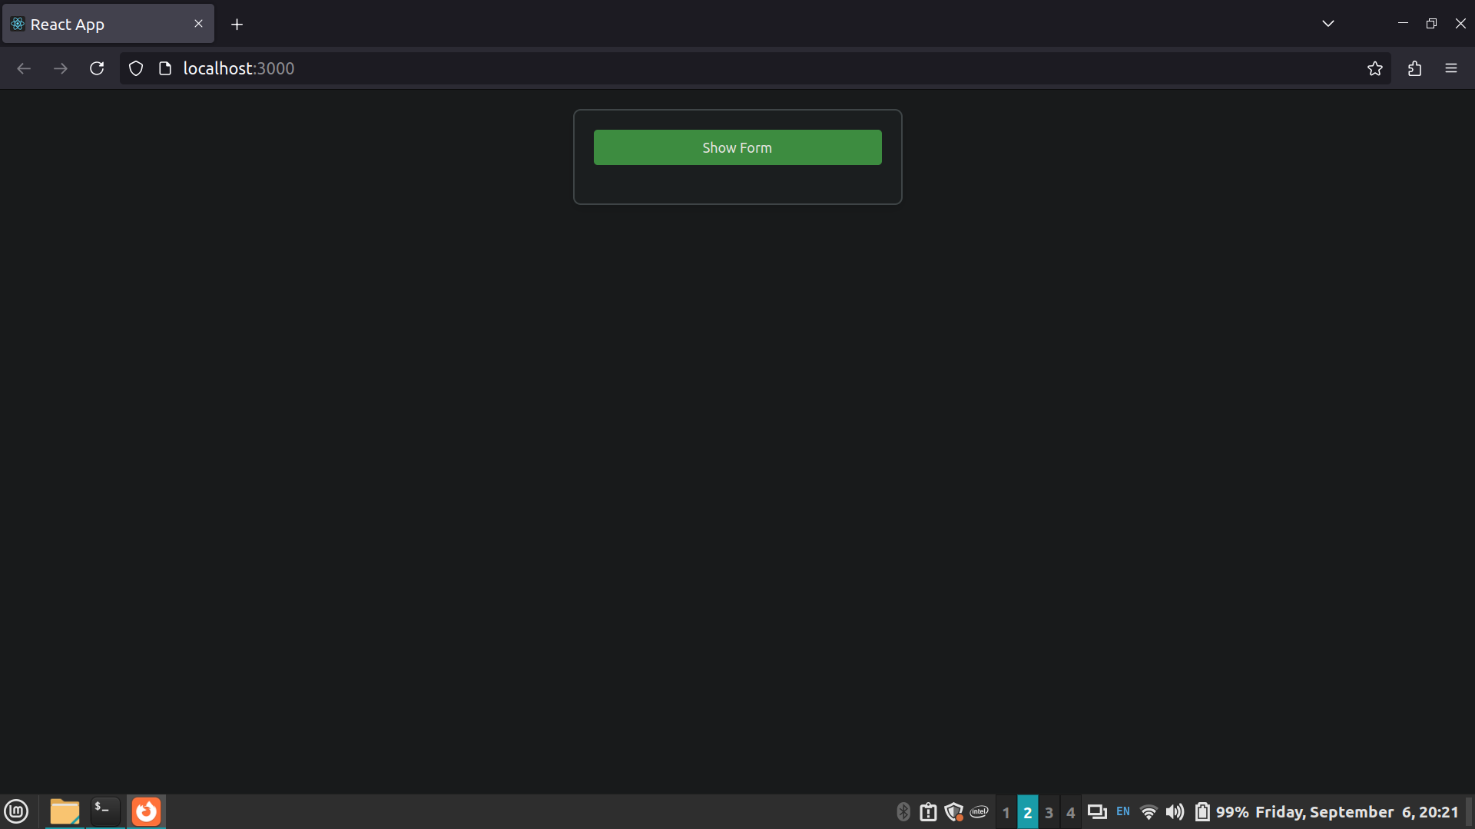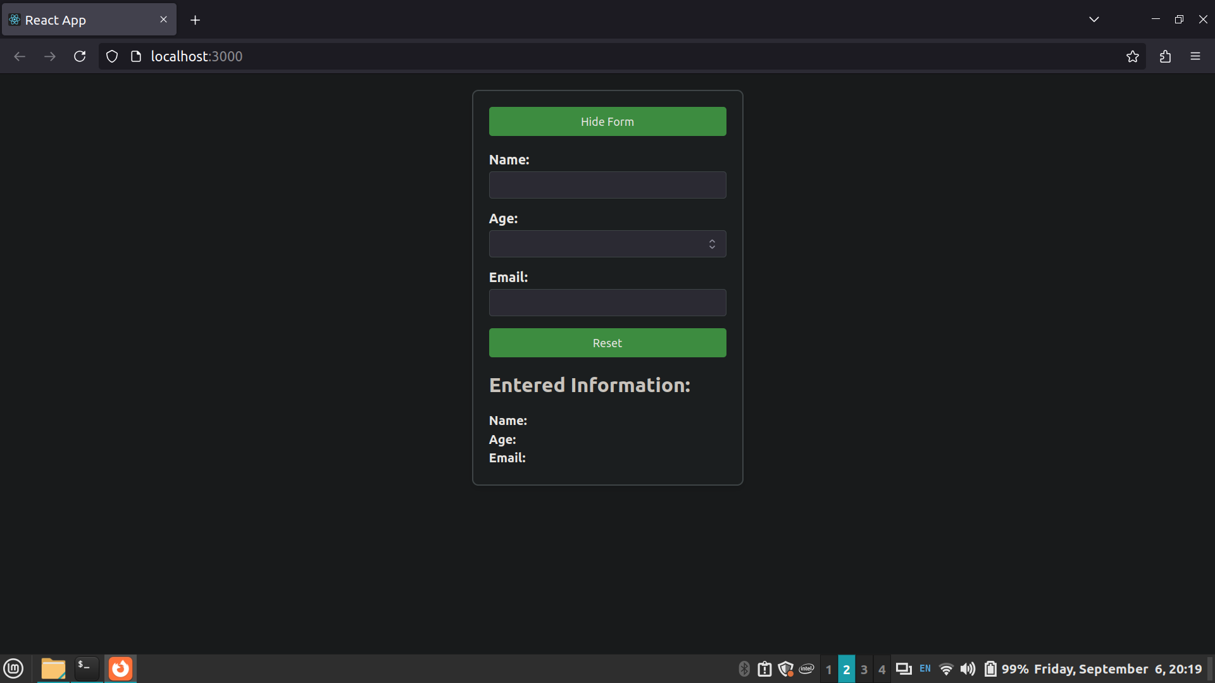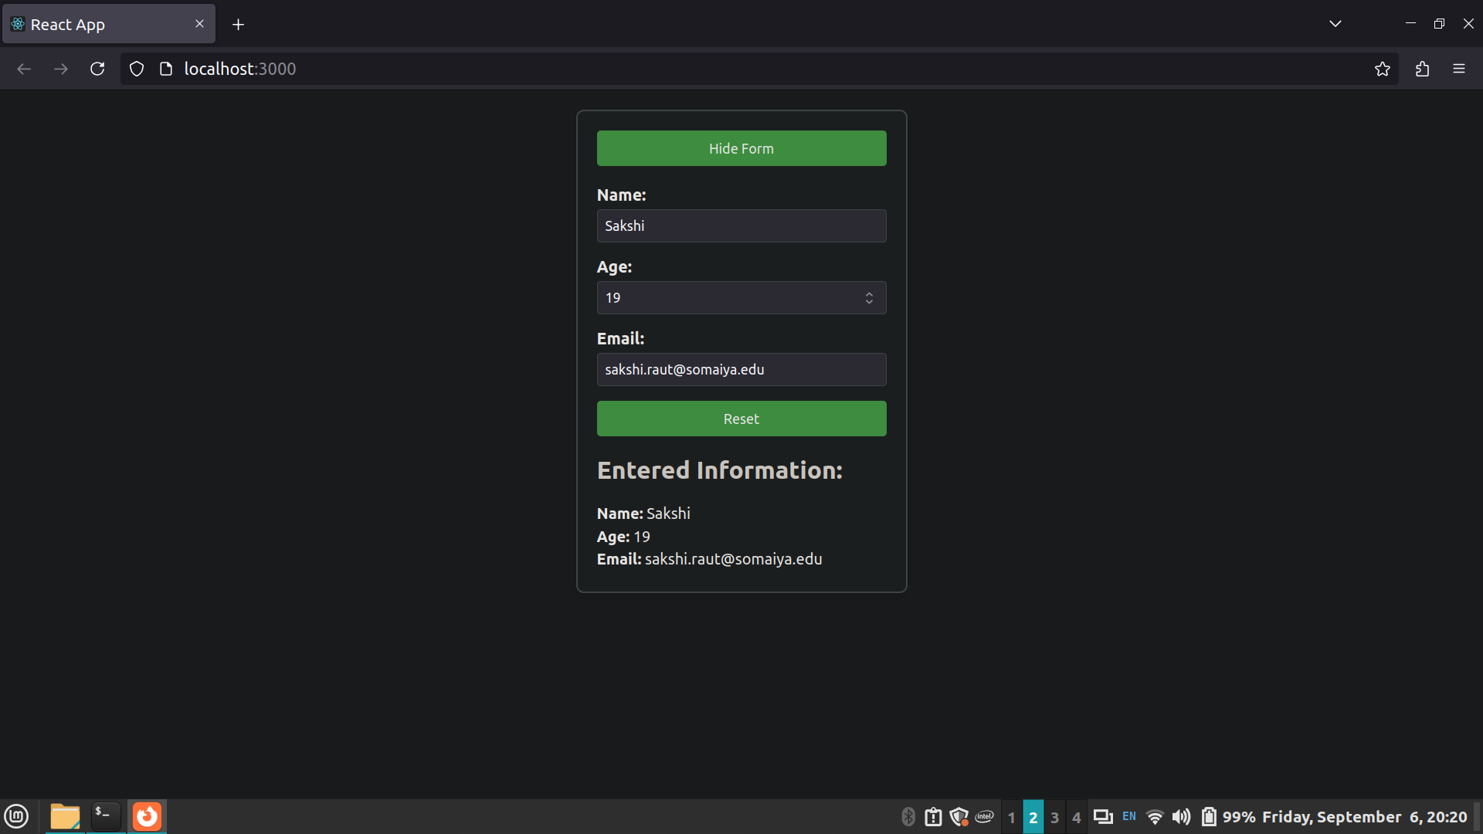

Task: Task Manager

// App.jsx

import React from 'react';
import TaskManager from './TaskManager';
const App = () => {
return (
<div>
<TaskManager />
</div>
);
};
export default App;

// TaskManager.js

import React, { useState } from 'react';
import './TaskManager.css'; // Import the CSS file for styling
const TaskManager = () => {
// State for tasks and task visibility
const [tasks, setTasks] = useState([]);
const [taskInput, setTaskInput] = useState('');
const [showCompleted, setShowCompleted] = useState(true);
// Add a new task
const addTask = () => {
if (taskInput.trim()) {
setTasks([...tasks, { text: taskInput.trim(), completed: false }]);
setTaskInput('');
}
};
// Mark a task as complete
const markAsComplete = (index) => {
const newTasks = tasks.map((task, i) =>
i === index ? { ...task, completed: !task.completed } : task
);
setTasks(newTasks);
};
// Toggle visibility of completed tasks
const toggleShowCompleted = () => {
setShowCompleted(!showCompleted);
};
// Reset the task list
const resetTasks = () => {
setTasks([]);
};
return (
<div className="task-manager">
<div className="task-input">
<input
type="text"
value={taskInput}
onChange={(e) => setTaskInput(e.target.value)}
placeholder="Add a new task..."
/>
<button onClick={addTask}>Add Task</button>
</div>
<button className="toggle-completed" onClick={toggleShowCompleted}>
{showCompleted ? 'Hide Completed Tasks' : 'Show Completed Tasks'}
</button>
<button className="reset-tasks" onClick={resetTasks}>
Reset Tasks
</button>
<ul className="task-list">
{tasks.map((task, index) => {
if (!showCompleted && task.completed) {
return null;
}
return (
<li key={index} className={task.completed ? 'completed' :
''}>
<span>{task.text}</span>
<button onClick={() => markAsComplete(index)}>
{task.completed ? 'Mark Incomplete' : 'Mark Complete'}
</button>
</li>
);
})}
</ul>
</div>
);
};
export default TaskManager;

/* TaskManager.css */

.task-manager {
width: 400px;
margin: 20px auto;
padding: 20px;
border: 2px solid #e0e0e0;
border-radius: 8px;
background-color: #f7f7f7;
box-shadow: 0 4px 10px rgba(0, 0, 0, 0.1);
}
.task-input {
display: flex;
justify-content: space-between;
margin-bottom: 20px;
}
.task-input input {
width: 75%;
padding: 10px;
border: 1px solid #ccc;
border-radius: 4px;
}
.task-input button {
width: 20%;
padding: 10px;
background-color: #4caf50;
color: white;
border: none;
border-radius: 4px;
cursor: pointer;
}
.task-input button:hover {
background-color: #45a049;
}
.toggle-completed, .reset-tasks {
width: 100%;
padding: 10px;
margin: 10px 0;
background-color: #2196f3;
color: white;
border: none;
border-radius: 4px;
cursor: pointer;
}
.reset-tasks {
background-color: #f44336;
}
.toggle-completed:hover, .reset-tasks:hover {
opacity: 0.9;
}
.task-list {
list-style-type: none;
padding: 0;
}
.task-list li {
display: flex;
justify-content: space-between;
padding: 10px;
border: 1px solid #ddd;
margin-bottom: 10px;
border-radius: 4px;
background-color: #fff;
transition: background-color 0.3s ease;
}
.task-list li.completed {
background-color: #e0ffe0;
text-decoration: line-through;
color: #888;
}
.task-list li button {
background-color: #2196f3;
color: white;
border: none;
padding: 6px 12px;
border-radius: 4px;
cursor: pointer;
}
.task-list li button:hover {
background-color: #1976d2;
}

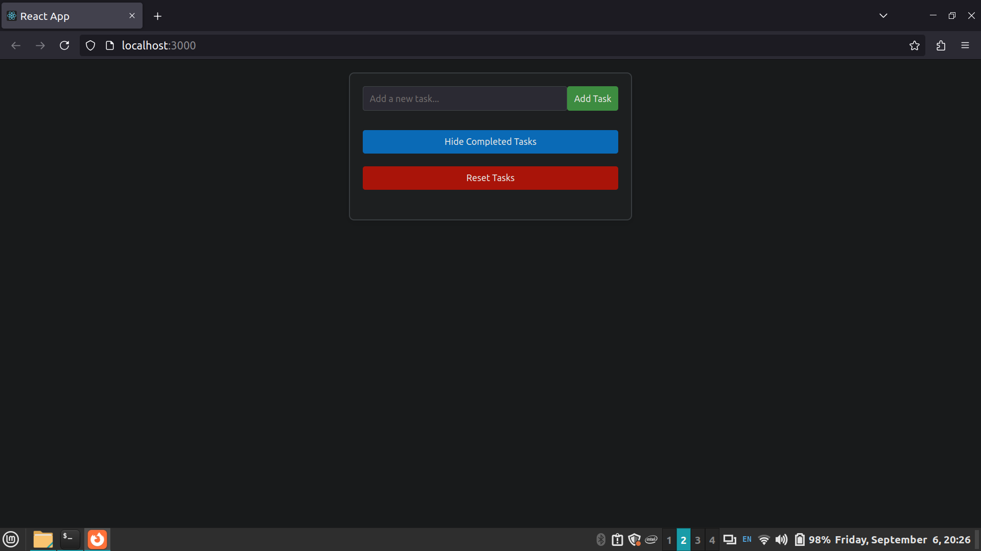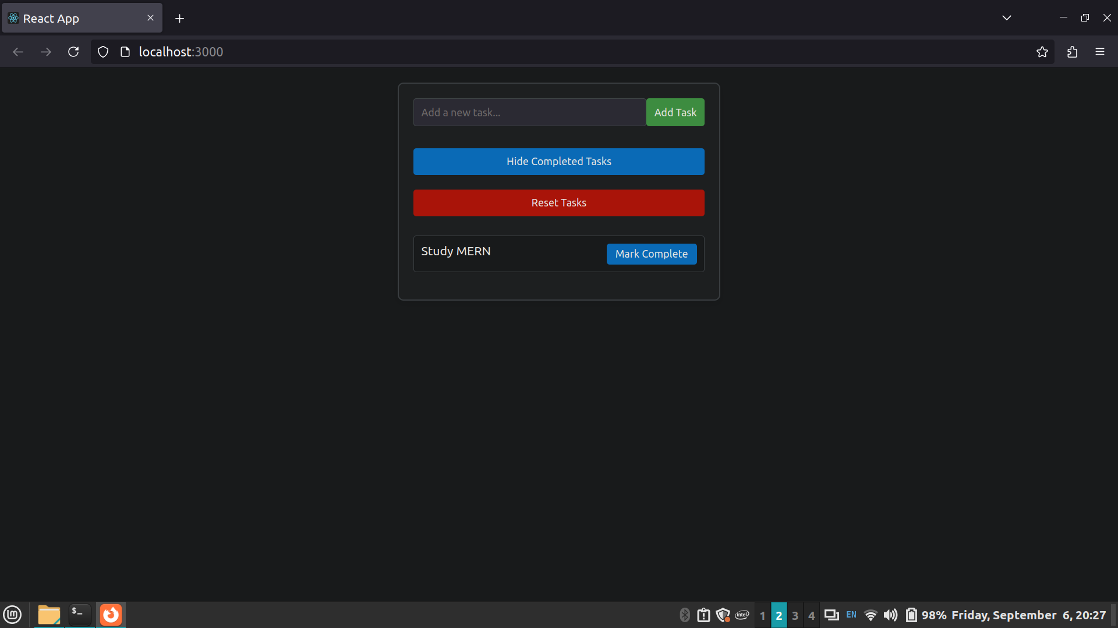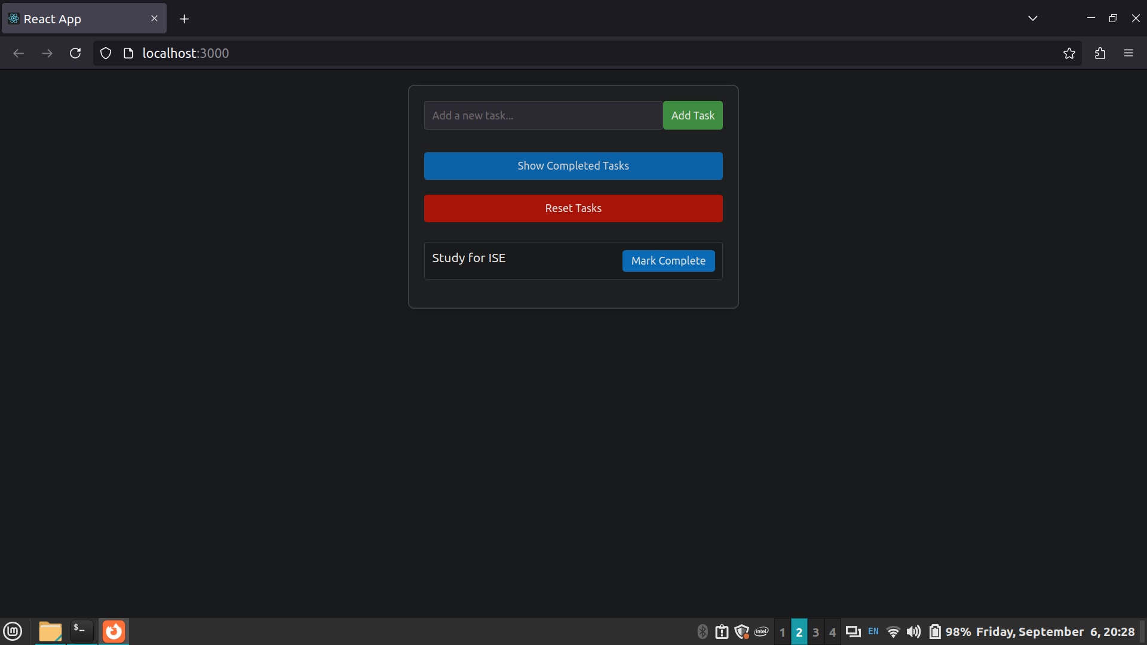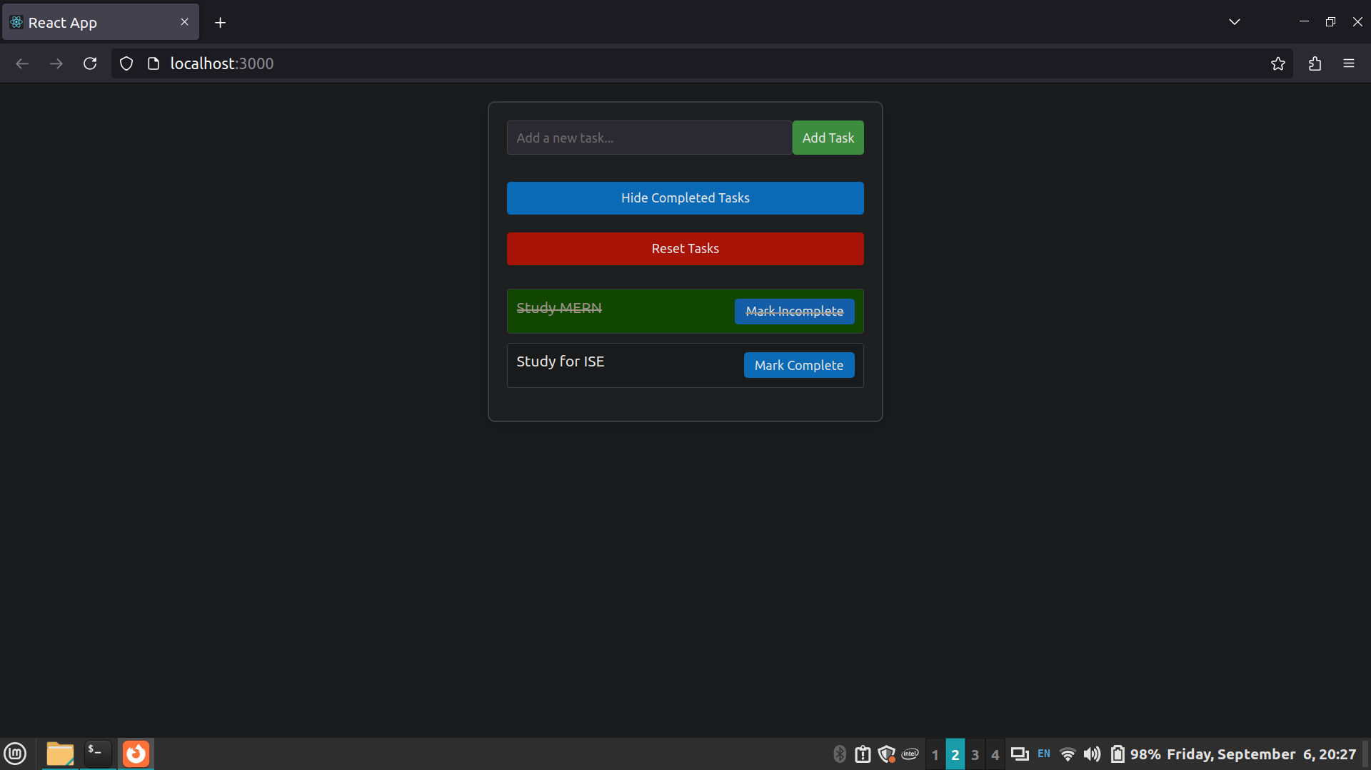

Task: User Profile Manager

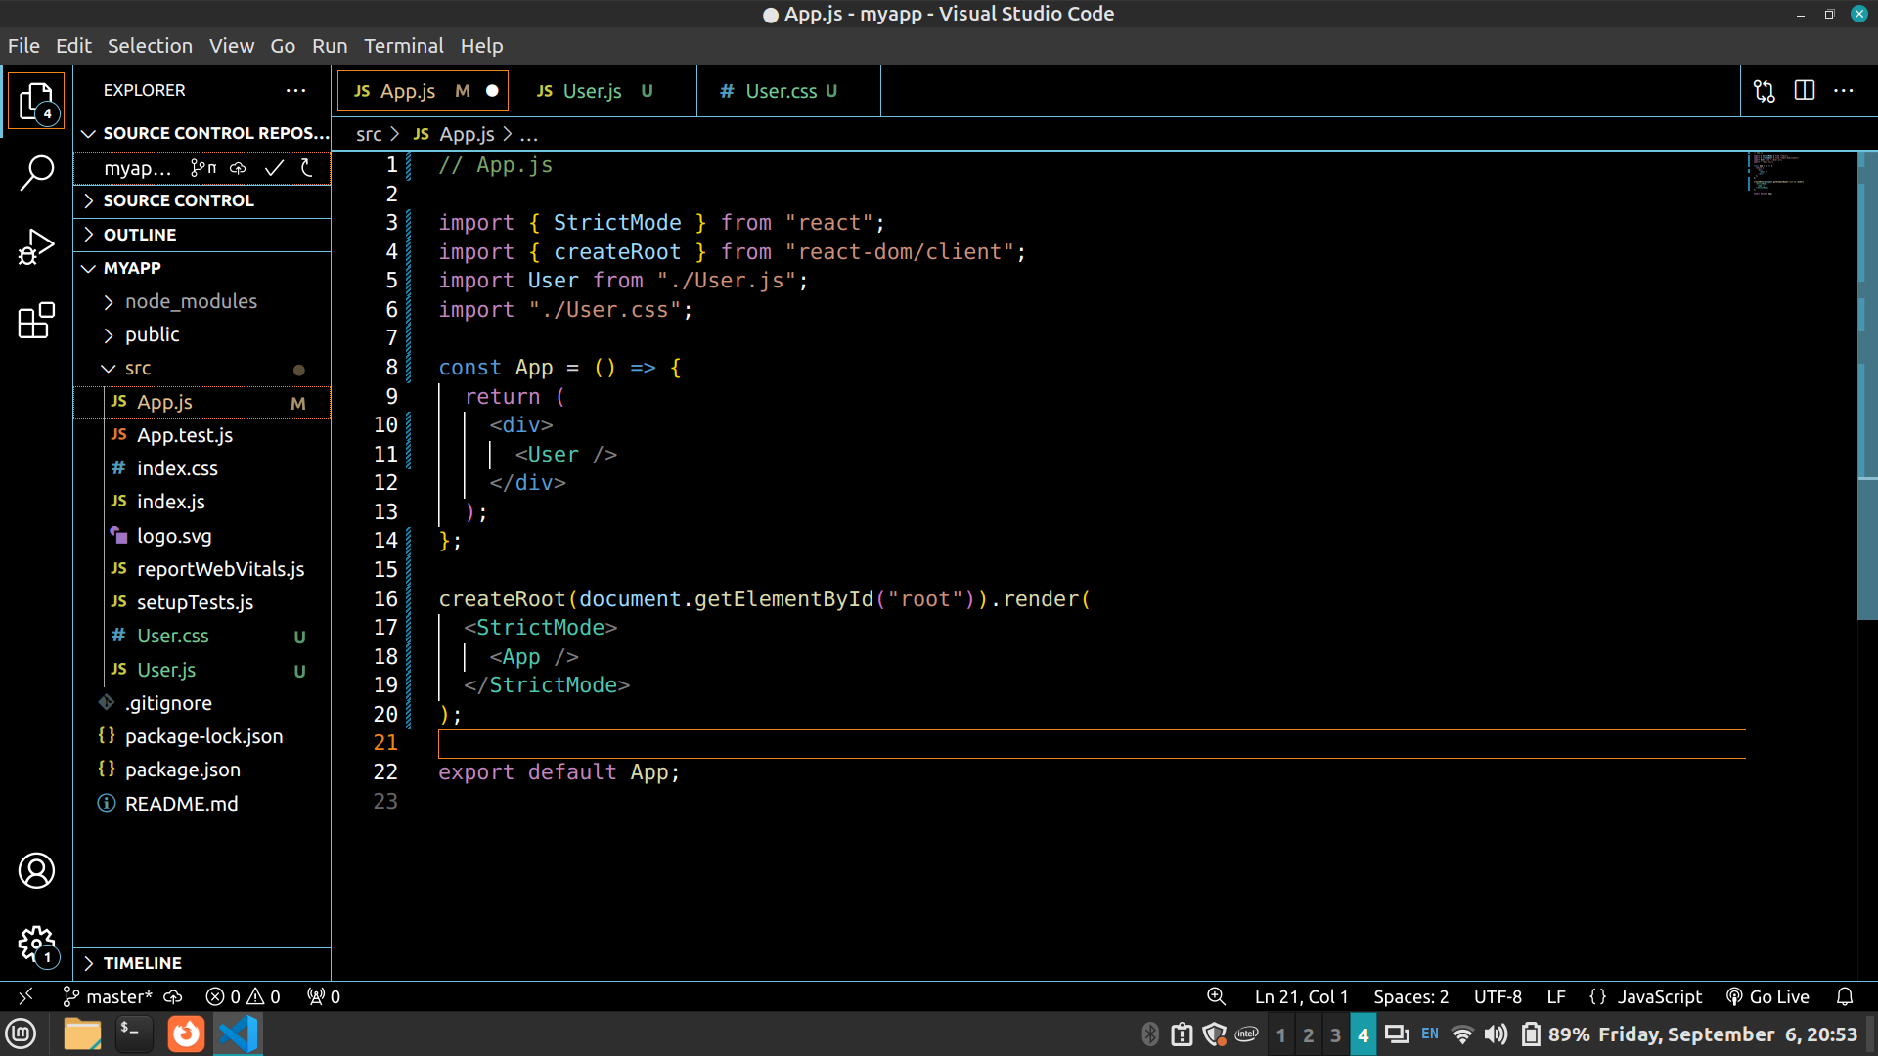

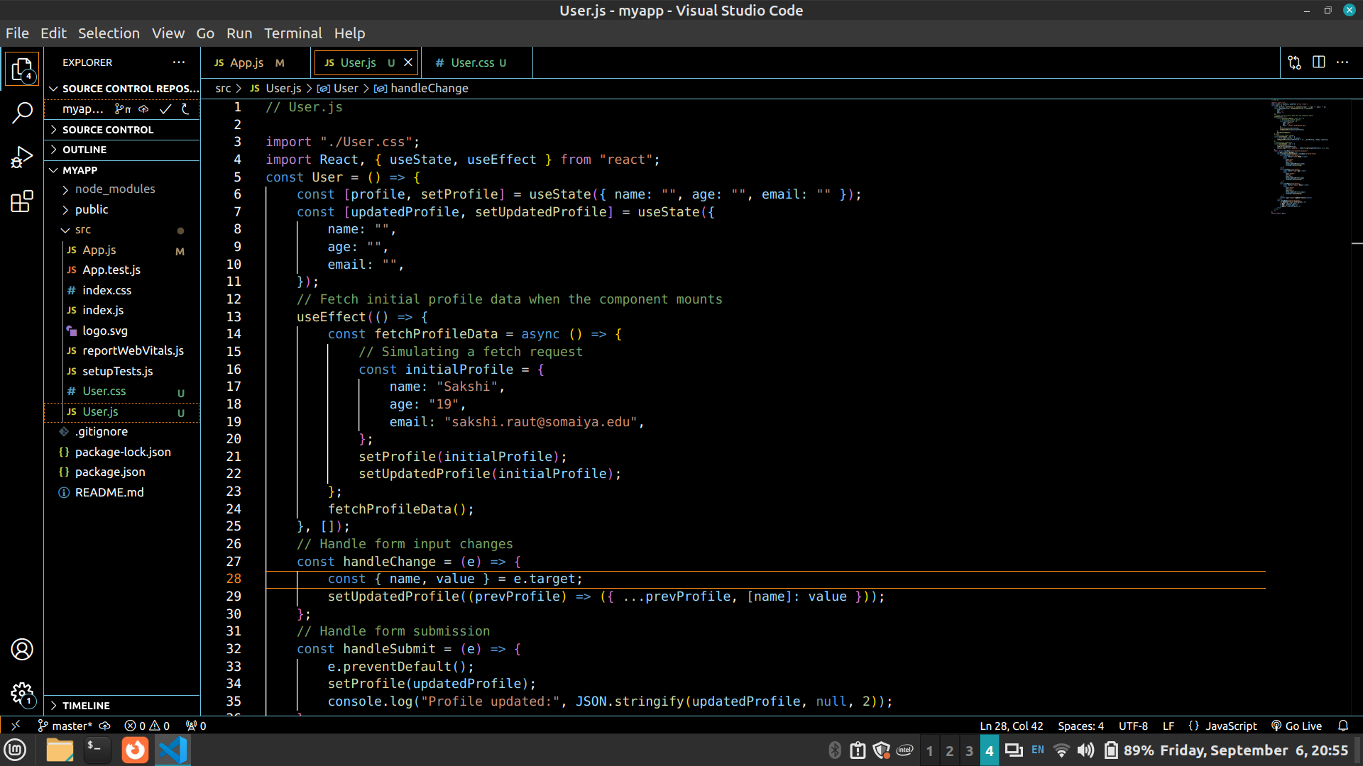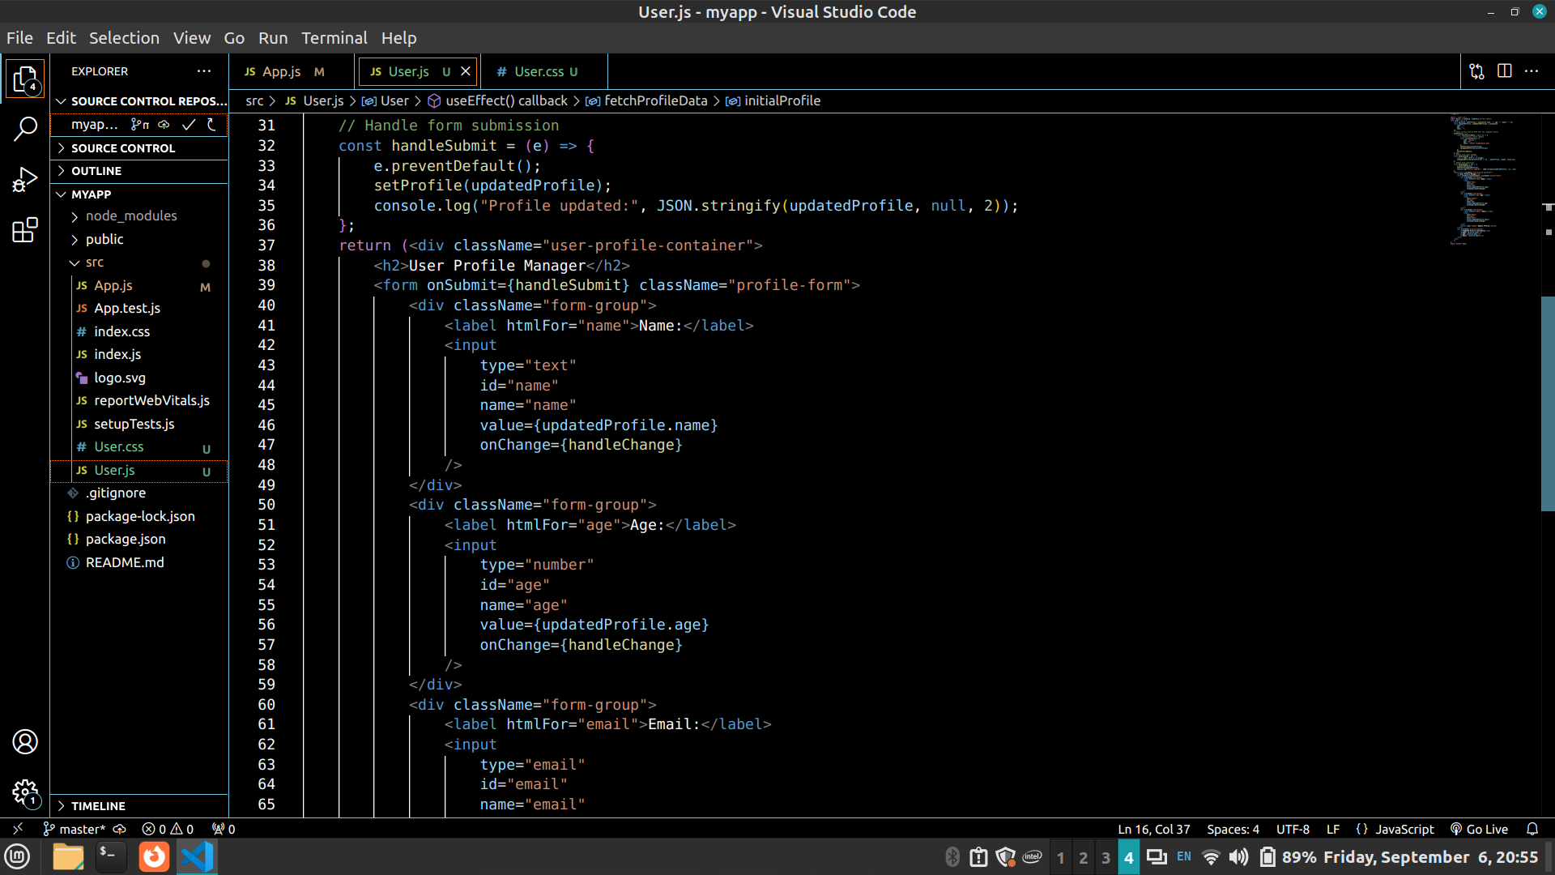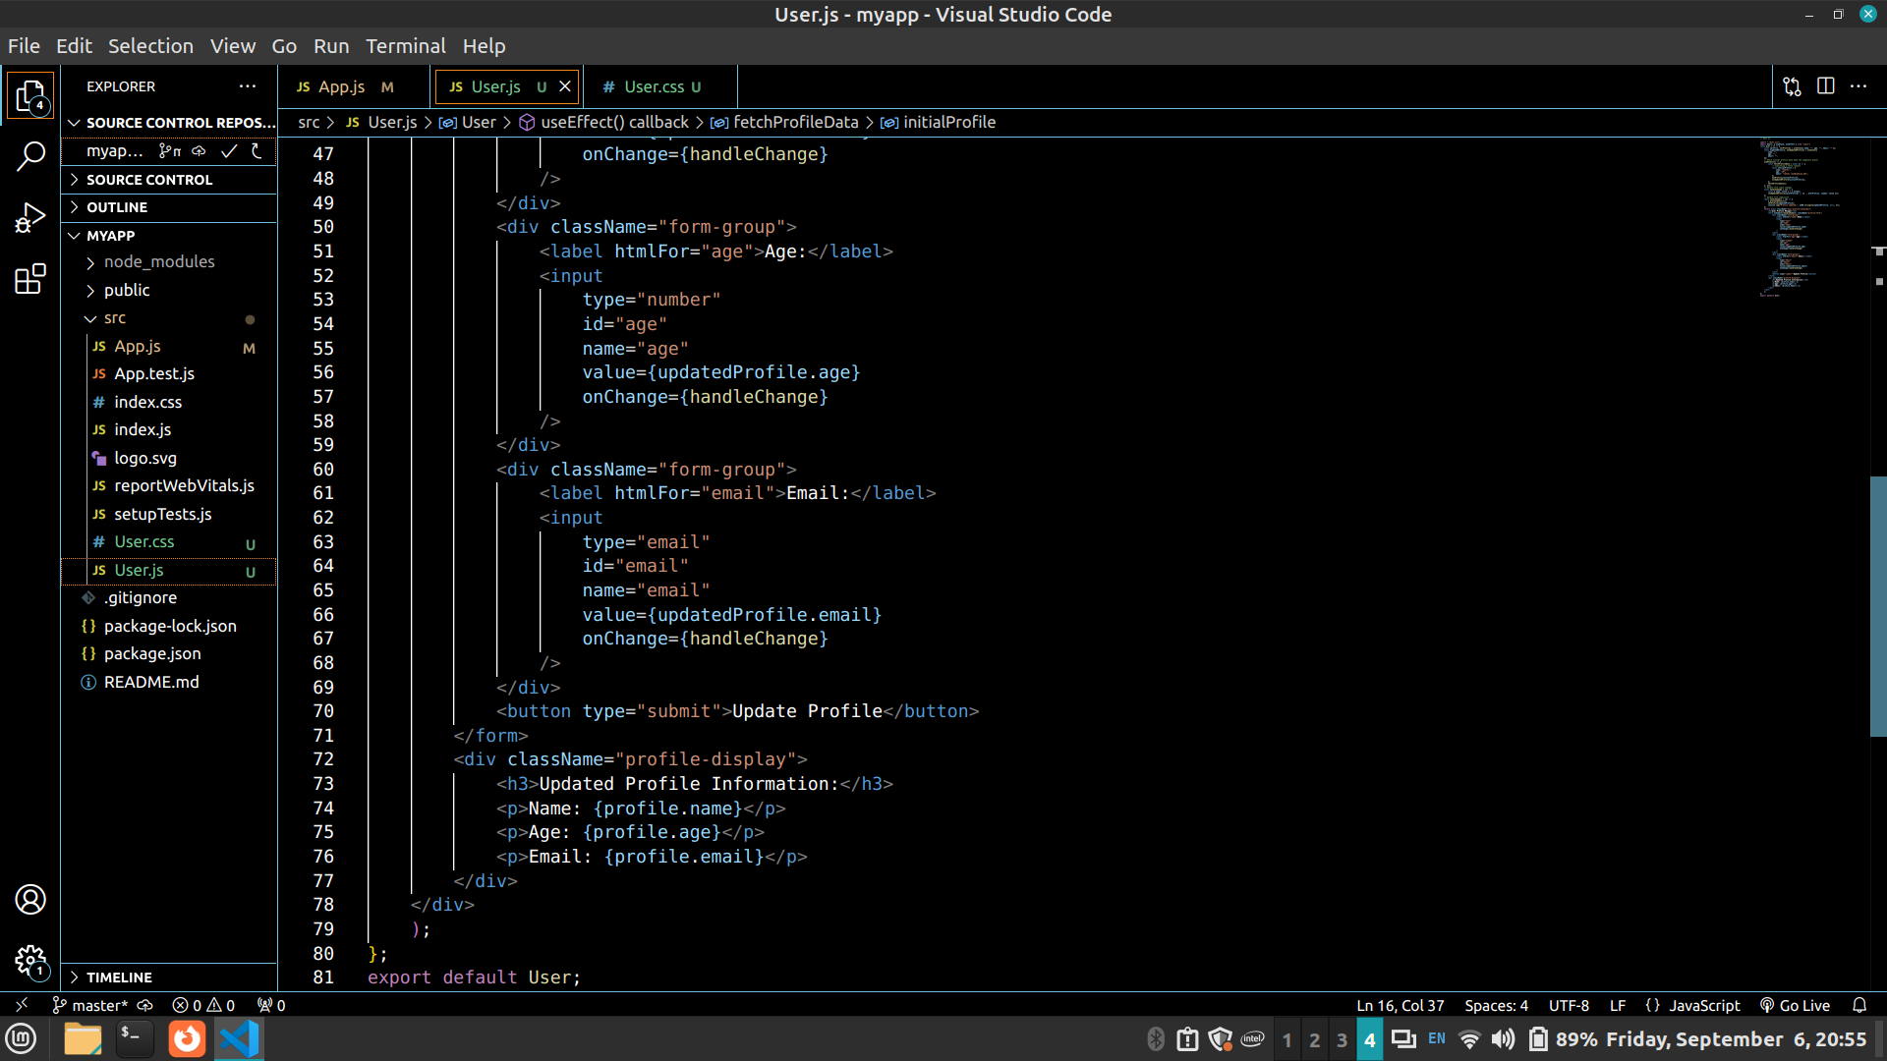
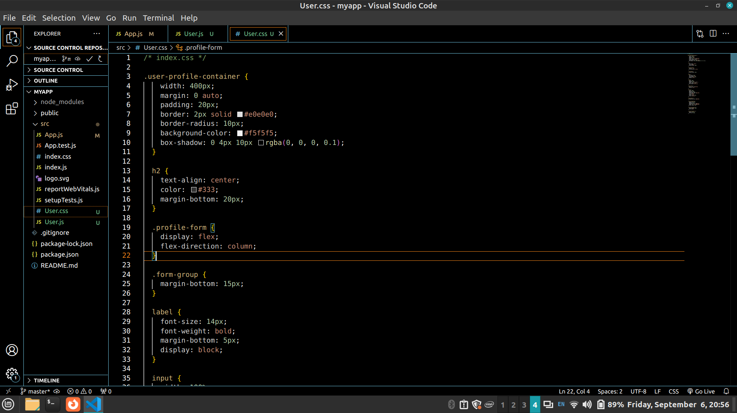
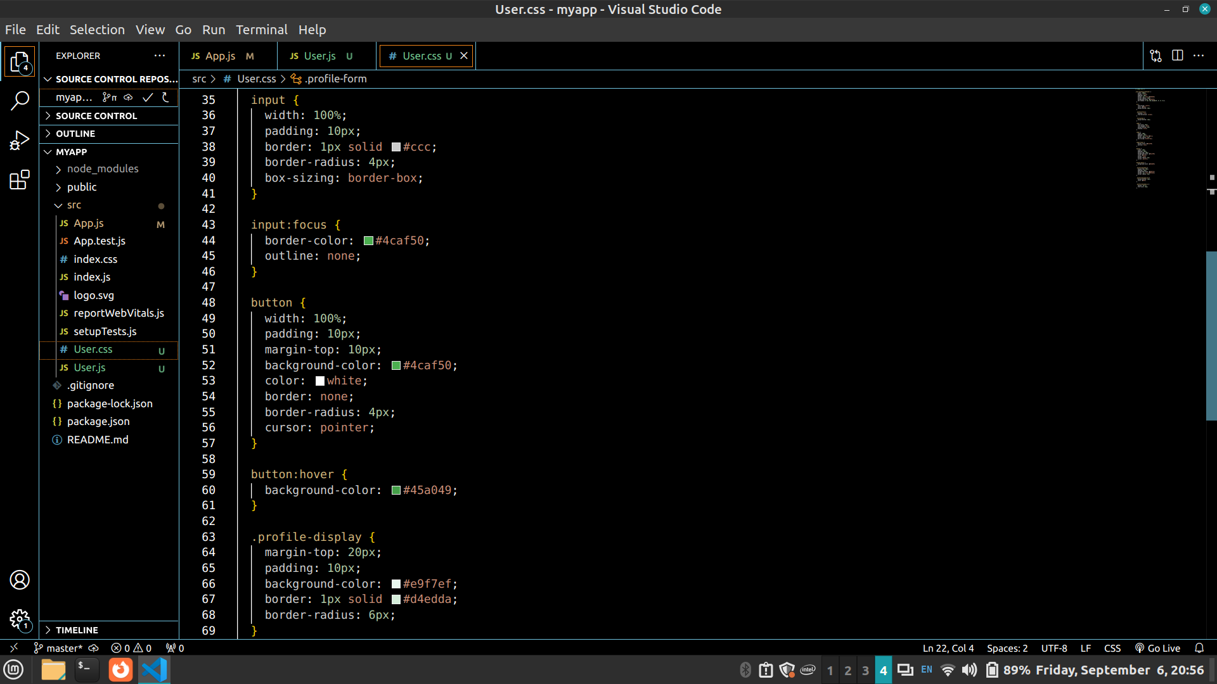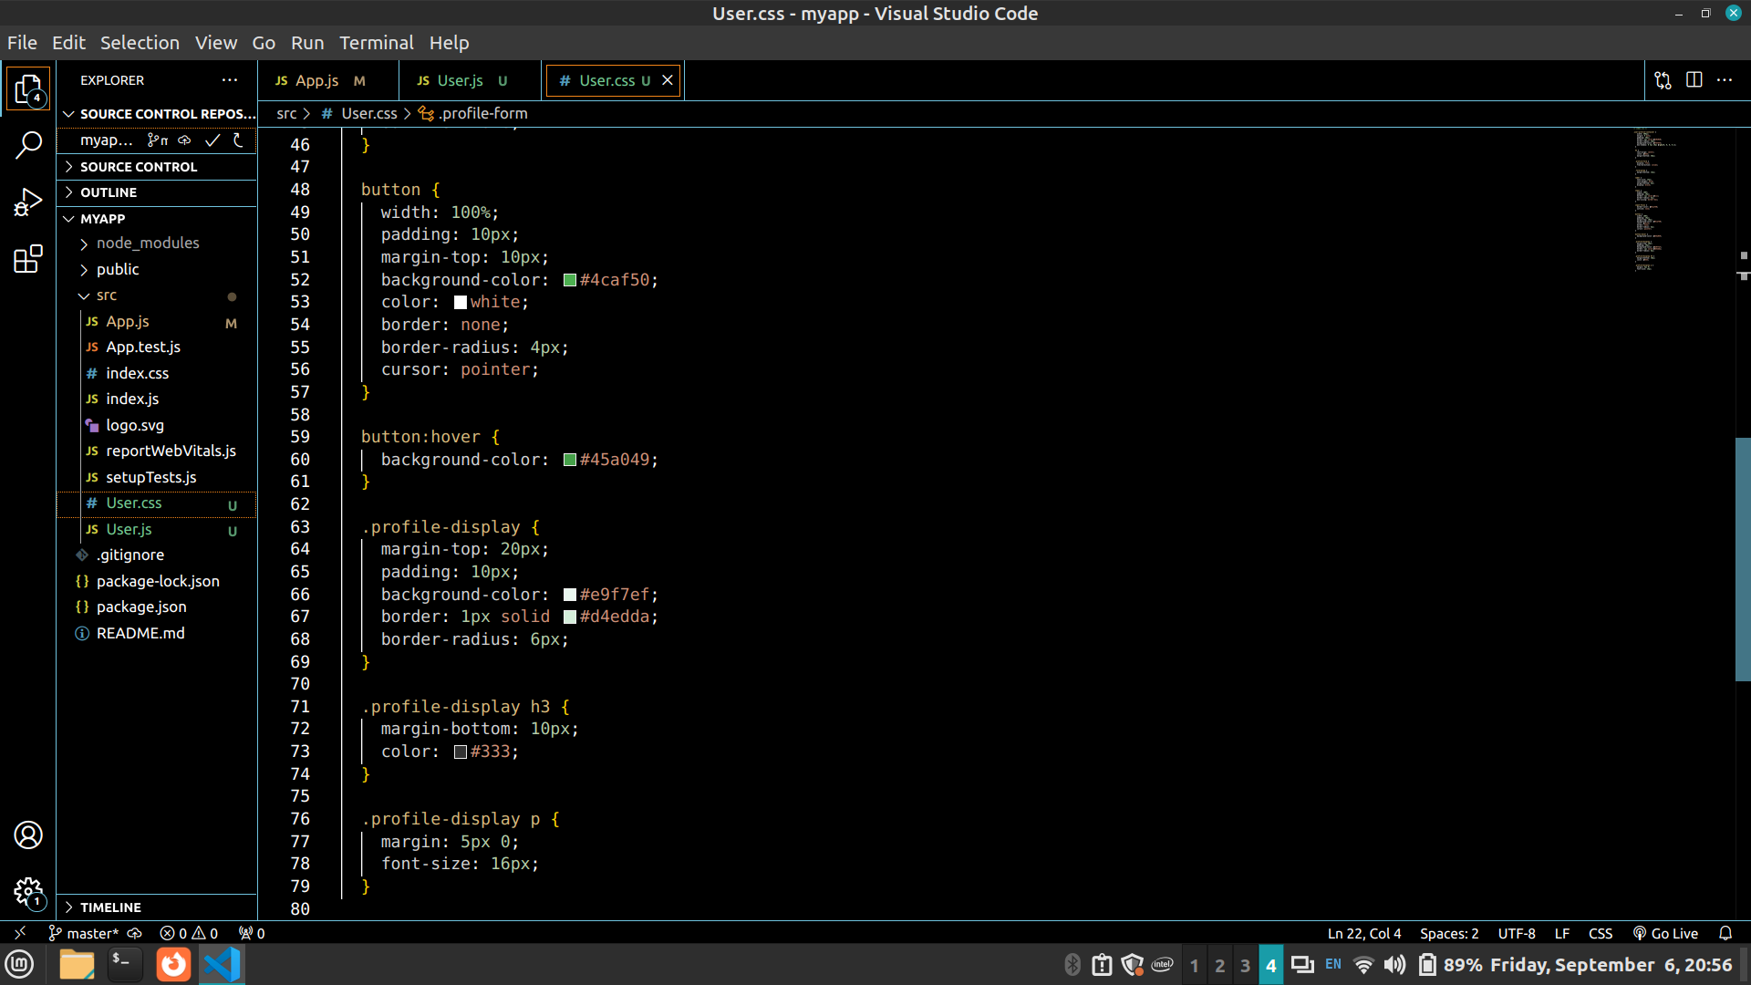
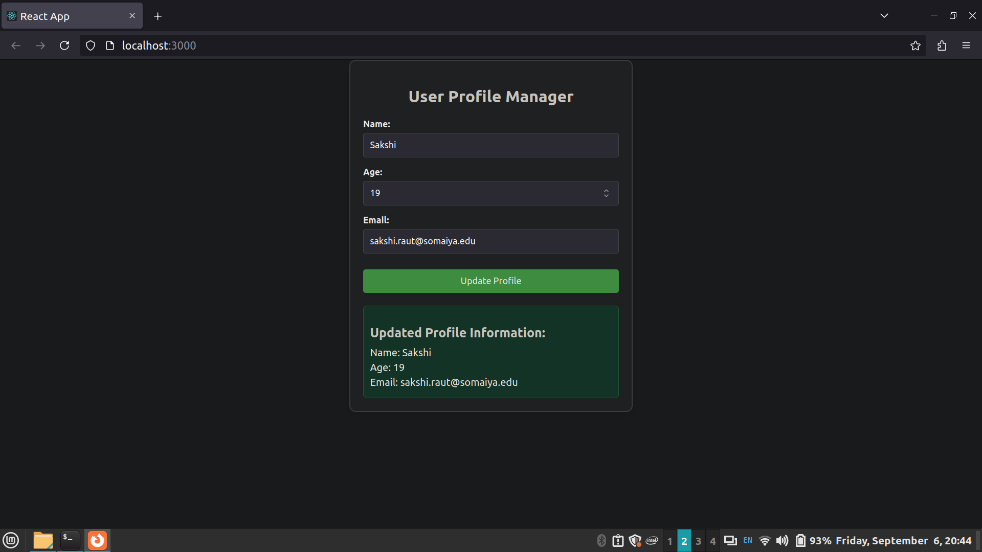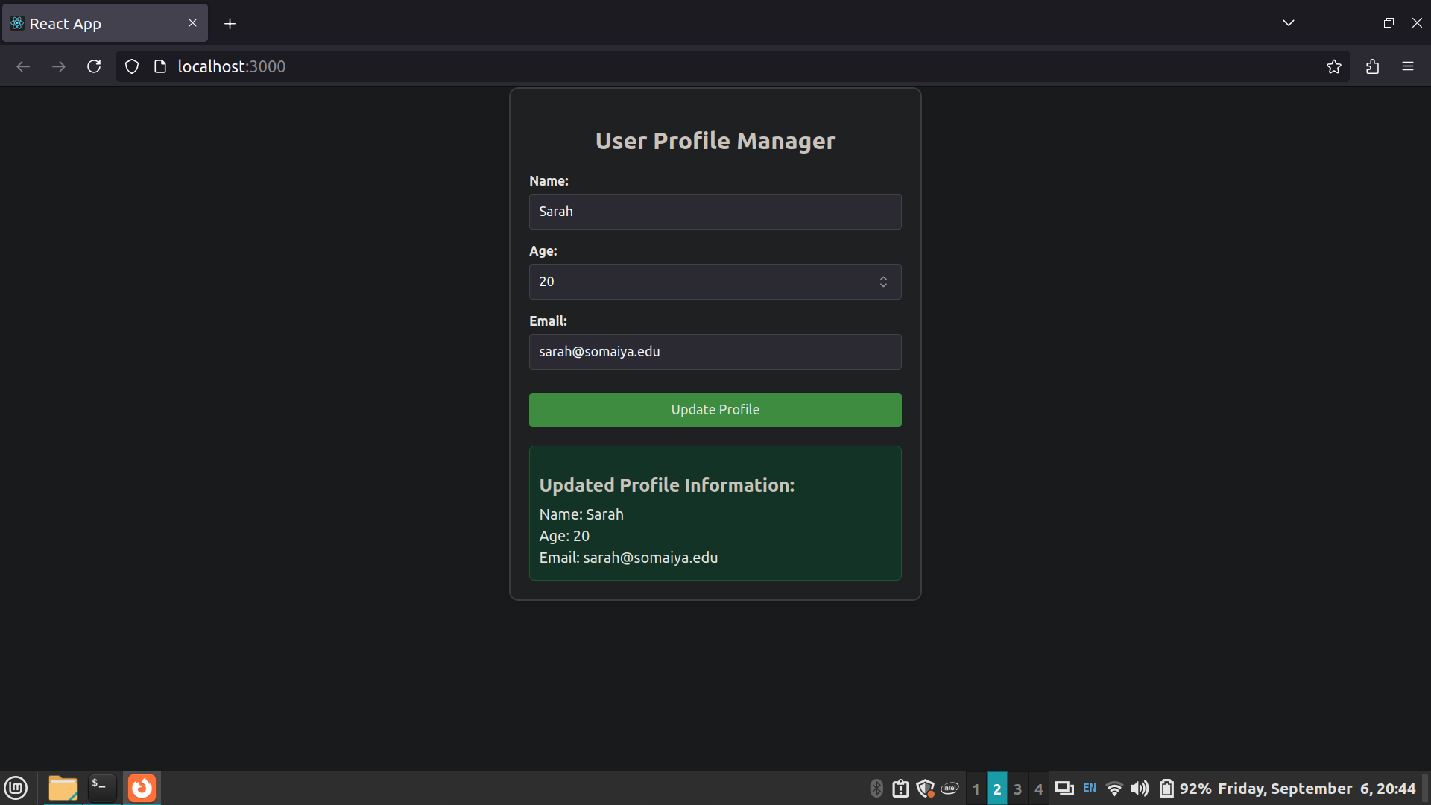

Steps for execution

1) Setup Environment:
• Ensure that your React development environment is properly set up.
• Install all required dependencies using npm install or yarn install.

2) Create and Implement Components:

• UserProfile Component:
1. Create a new file named UserProfile.jsx in the src directory.
2. Implement the form with fields for name, age, and email.
3. Add functionality to toggle form visibility and reset form data.
4. Display the entered information below the form.

• TaskManager Component:
1. Create a new file named TaskManager.jsx in the src directory.
2. Implement features to add tasks, mark tasks as complete, toggle visibility of completed tasks,
and reset the task list.
3. Display tasks with options to mark them as complete or incomplete.
• User Component:
1. Create a new file named User.jsx in the src directory.
2. Fetch initial profile data when the component mounts.
3. Implement form functionality to update and display profile information.
4. Log the updated profile information to the console upon form submission.

3) Integrate Components:
• Update App.jsx to include the UserProfile, TaskManager, and User components, as needed.

4) Styling:
• Create and apply CSS styles in corresponding CSS files (UserProfile.css, TaskManager.css, and
User.css) to style the components.

5) Testing:
• Run the React application and verify that each component functions as expected.
• Check for correct form operations, task management features, and console logs.

6) Capture Screenshots:
• Take screenshots of the application output and console logs to document the results.

7) Review and Finalize:
• Review the implemented features and ensure everything is working correctly.
• Make any necessary adjustments based on testing results.

Conclusion:
We built React components to handle user profiles and tasks. The UserProfile component lets users update their details and see them right away. The TaskManager helps keep track of tasks, showing which are done and which aren’t. The User component fetches and updates profile info, showing the changes in the console.

Post Lab questions:

1) What are the benefits of using state management in React components for handling form data?

Answer:
State management in React components ensures that form data is consistently tracked and updated in
real-time. It provides a dynamic way for components to react to user inputs, reflecting changes
immediately in the UI. This approach simplifies debugging by centralizing data handling and helps
maintain a single source of truth, reducing errors. Additionally, it enhances user experience by
providing instant feedback and keeping the interface synchronized with the current state of the
application.

2) How does toggling visibility of a form in a React component affect user experience and component
functionality?

Answer:
Toggling form visibility enhances user experience by allowing users to focus on specific tasks without
cluttering the interface. It makes the component more interactive and adaptable, showing or hiding the
form as needed. This approach also improves performance by rendering elements only when
necessary, which can reduce the load on the browser and make the application more responsive.

