Batch: B1 Roll No.: 16010122158

Experiment / Assignment / Tutorial No. 5

Grade: AA / AB / BB / BC / CC / CD / DD

Signature of the Staff In-charge with date

Title: Demonstrate the Use of node.js

AIM: To implement the node js Concepts based on the following topics.
Problem Definition:

Problem statement:
Consider the basic concepts, which are useful in the creation of an application.
Considering the following points, demonstrate the functionality of each with a simple script

1) Basic Routing:
1. Build First server application using http module
2. Basic routing: Demonstrate it using simple HTML/Json file
3. Demonstrate the callback in node.js

2) File operation
- Check Permissions of a File or Directory.
- Checking if a file or a directory exists.
- Determining the line count of a text file.
- Reading a file line by line.
- See the file content through the browser.

3) Building your custom modules
-To demonstrate this use some mathematics functions to create a custom module.

4) Blocking and Non Blocking
_____________________________________________________________________
Expected OUTCOME of Experiment:

CO 2:. Illustrate the concepts of various front-end, back-end web application development technologies & frameworks using different web development tools.
___________________________________________________________________
Books/ Journals/ Websites referred:
1. Shelly Powers Learning Node O’ Reilly 2 nd Edition, 2016.

Pre Lab/ Prior Concepts

Write details about the following content

- Node js.

Node.js is an open-source, cross-platform runtime environment that allows developers to execute JavaScript code on the server side. It is built on the V8 JavaScript engine, which is also used by Google Chrome, and enables the use of JavaScript outside of the browser. Node.js is known for its non-blocking, event-driven architecture, making it ideal for building fast and scalable network applications such as web servers, APIs, and microservices.
Key Features:
Event-Driven: Node.js operates on an event-driven model, where server operations (such as file reading, database queries, or HTTP requests) are handled asynchronously. This helps prevent the server from being blocked by time-consuming tasks.
Non-Blocking I/O: Instead of waiting for I/O operations (such as reading from a file or querying a database) to complete, Node.js moves on to the next task and handles the response asynchronously, improving performance for tasks that involve a large number of simultaneous connections.
Single-Threaded: Though single-threaded, Node.js can handle multiple requests concurrently due to its asynchronous architecture.
Package Ecosystem (npm): Node.js has a vast repository of modules and libraries called npm (Node Package Manager), making it easier for developers to find and integrate functionality like authentication, file handling, and more.
- Basic Routing

Routing in Node.js refers to the process of defining how a server responds to different client requests based on the URL path and the HTTP method (GET, POST, etc.). Routing allows servers to serve different content or execute different logic based on the requested route.
Key Concepts:
HTTP Module: You can use Node.js's built-in http module to create a server and define routes. A route consists of a URL path and an associated handler (callback) that gets executed when a request to that path is made.
Request and Response: When routing, you handle incoming requests (req) and respond to them (res). Based on the request URL, the server serves different responses (HTML, JSON, files, etc.).

- Custom module

In Node.js, you can create custom modules to encapsulate reusable code and organize your project structure more efficiently. A module in Node.js can export functions, objects, or variables that can be imported and reused in other files.
Key Concepts:
Modularization: Breaking down large applications into smaller, reusable components. This helps with code maintenance, testing, and reusability.
Exports and Requires: In Node.js, you define a module using module.exports to expose specific functionalities, and then use require to import it into other files.
- Asynchronous Programming

Asynchronous programming in Node.js is one of its core strengths. It allows the server to handle other tasks while waiting for operations (like reading a file or querying a database) to complete, without blocking the thread. This is achieved through mechanisms like callbacks, promises, and async/await.
Key Concepts:
Callbacks: A function that is passed as an argument to another function and is executed after the completion of the asynchronous operation. However, this can lead to "callback hell" if nested deeply.
Promises: A cleaner way to handle asynchronous operations than callbacks. A promise represents an operation that hasn't been completed yet but is expected to in the future. It can be in one of three states: pending, resolved (success), or rejected (failure).
Async/Await: A syntactical improvement over promises, allowing developers to write asynchronous code in a more synchronous (readable) manner. async functions return a promise, and await is used to wait for a promise to resolve before moving to the next line of code.

Methodology:

- Write the Node.js Script: Implement the required features such as file operations, routing, or custom modules in a Node.js script.
- Set Up HTTP Server: If server-based functionality is required, use Node’s built-in modules like http to create an HTTP server that can respond to browser requests.
- File Operations: Ensure any necessary files (e.g., text files, HTML) are created and ready for operations like reading or writing.
- Execute the Script: Run the Node.js script in your terminal to start the server or perform file operations.
- Access Output:
- View console-based outputs directly in the terminal (e.g., log messages, file read results).
- For server responses, access the output through a web browser or HTTP client using the specified URL (e.g., http://localhost:3000/).
Implementation Details:

1) Basic Routing

- Build First server application using http module

const http = require('http');

const server = http.createServer((req, res) => {
res.statusCode = 200;
res.setHeader('Content-Type', 'text/plain');
res.end('Hello, World! This is your first Node.js server.');
});

server.listen(3000, () => {
console.log('Server running at http://localhost:3000/');
});

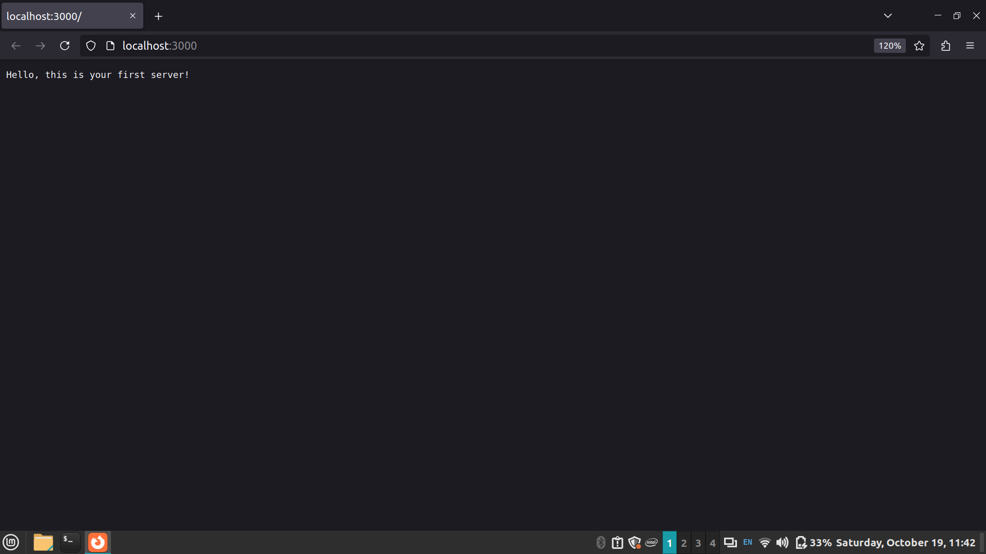

- Basic routing: Demonstrate it using simple HTML/Json file

const http = require('http');
const fs = require('fs');

const server = http.createServer((req, res) => {
if (req.url === '/') {
res.writeHead(200, { 'Content-Type': 'text/html' });
res.write('<h1>Welcome to the Homepage</h1>');
res.end();
} else if (req.url === '/data') {
res.writeHead(200, { 'Content-Type': 'application/json' });
res.write(JSON.stringify({ message: "Hello, this is JSON data" }));
res.end();
} else {
res.writeHead(404, { 'Content-Type': 'text/plain' });
res.write('404 Not Found');
res.end();
}
});

server.listen(3000, () => {
console.log('Server running at http://localhost:3000/');
});

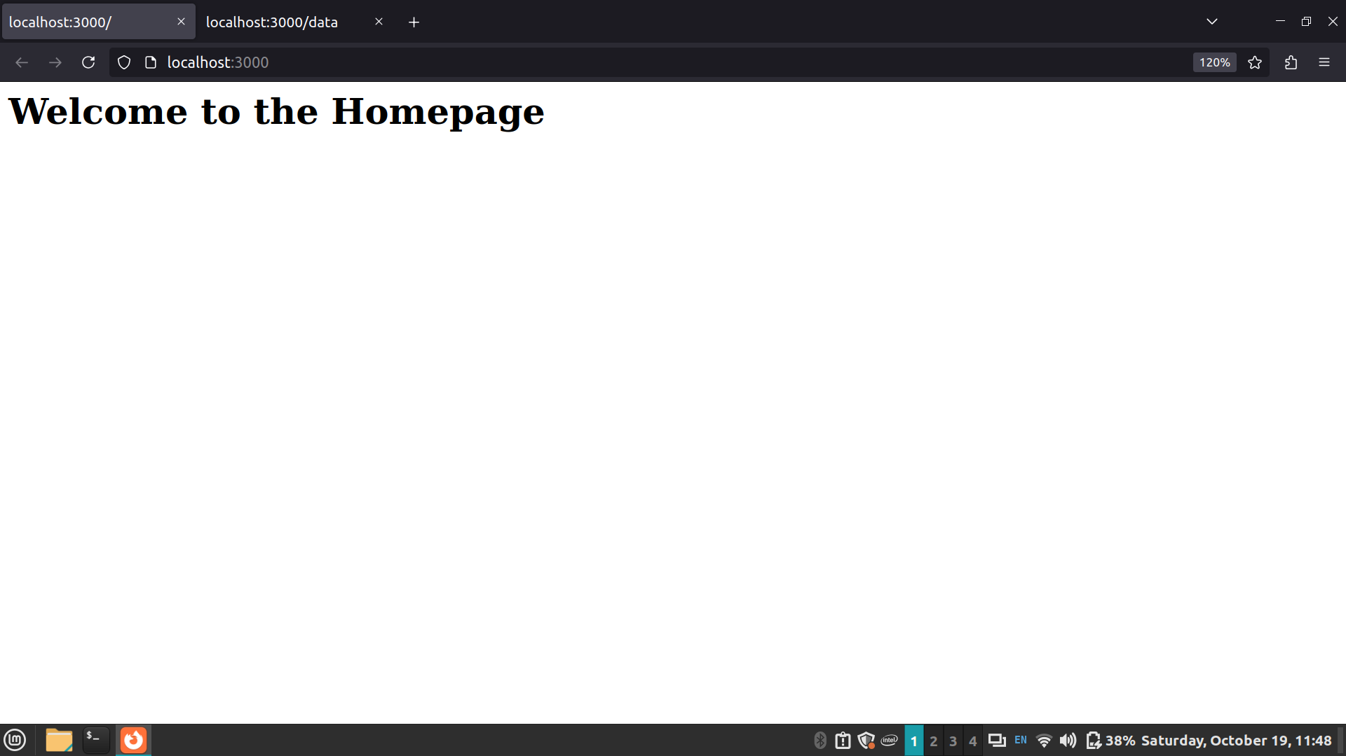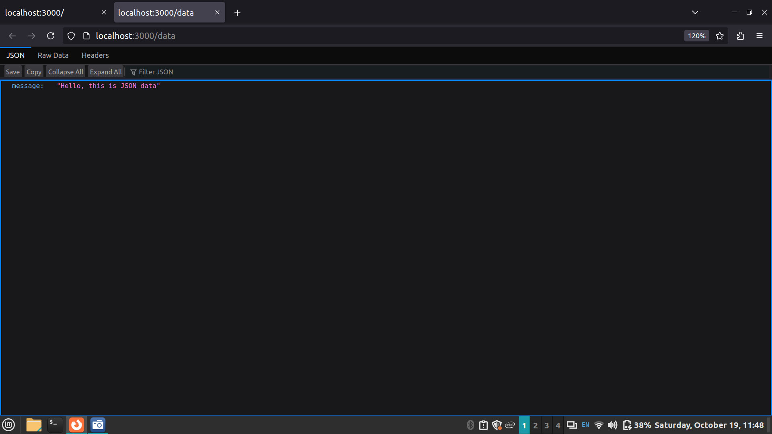
- Demonstrate the callback in node.js

const fs = require('fs');

function readFileCallback(err, data) {
if (err) {
console.error('Error reading file:', err);
} else {
console.log('File content:', data);
}
}

fs.readFile('example.txt', 'utf8', readFileCallback);

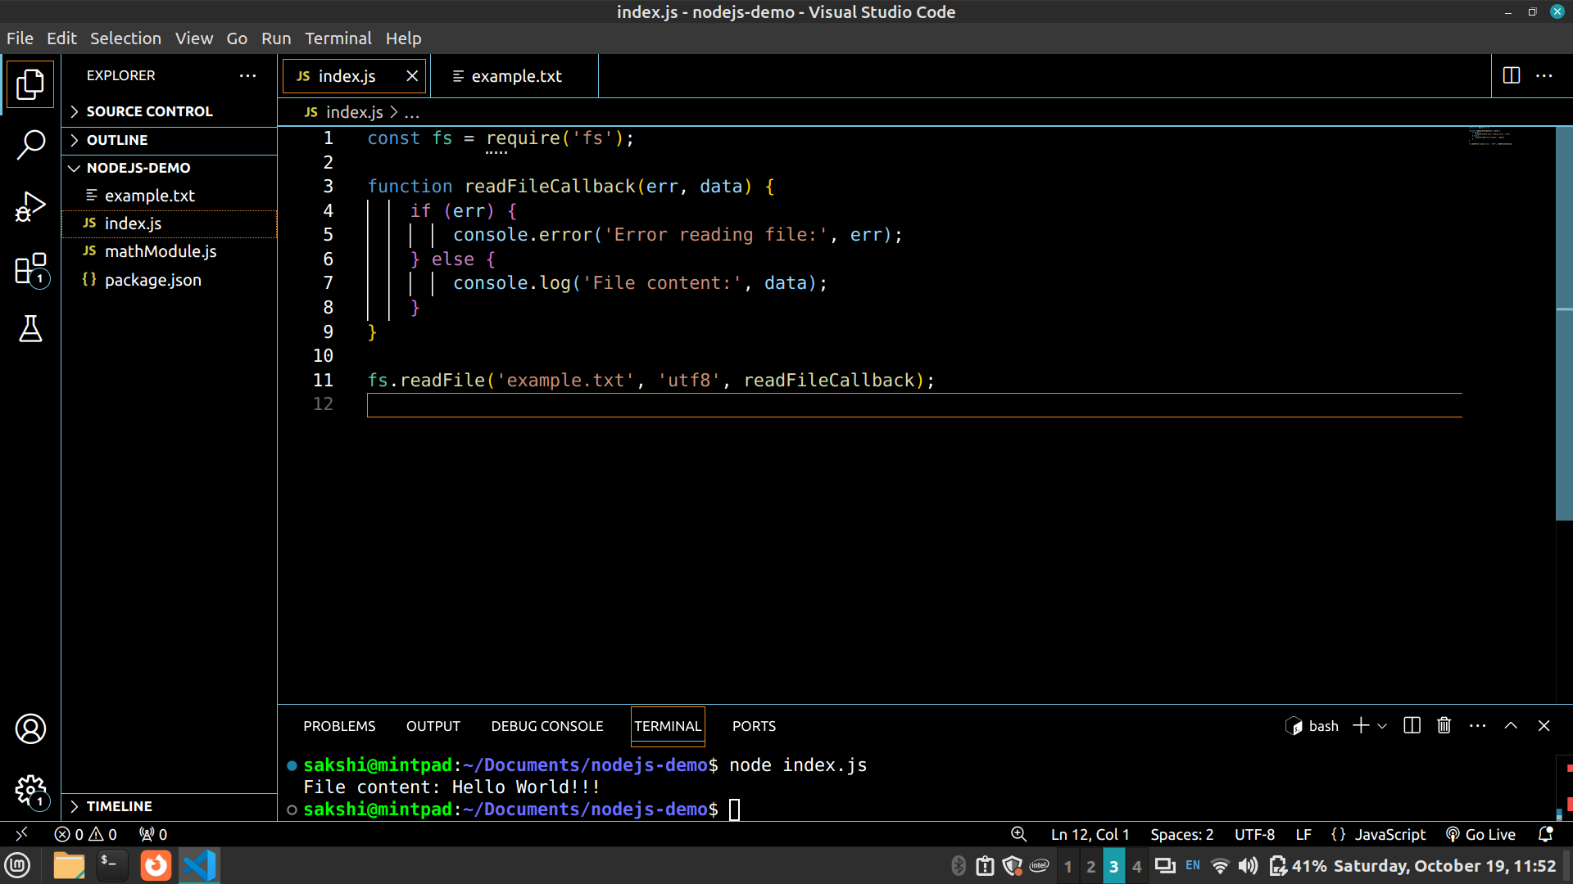

2) File operation

- Check Permissions of a File or Directory.

const fs = require('fs');

fs.access('example.txt', fs.constants.R_OK | fs.constants.W_OK, (err) => {
console.log(err ? 'No access!' : 'File is readable and writable');
});

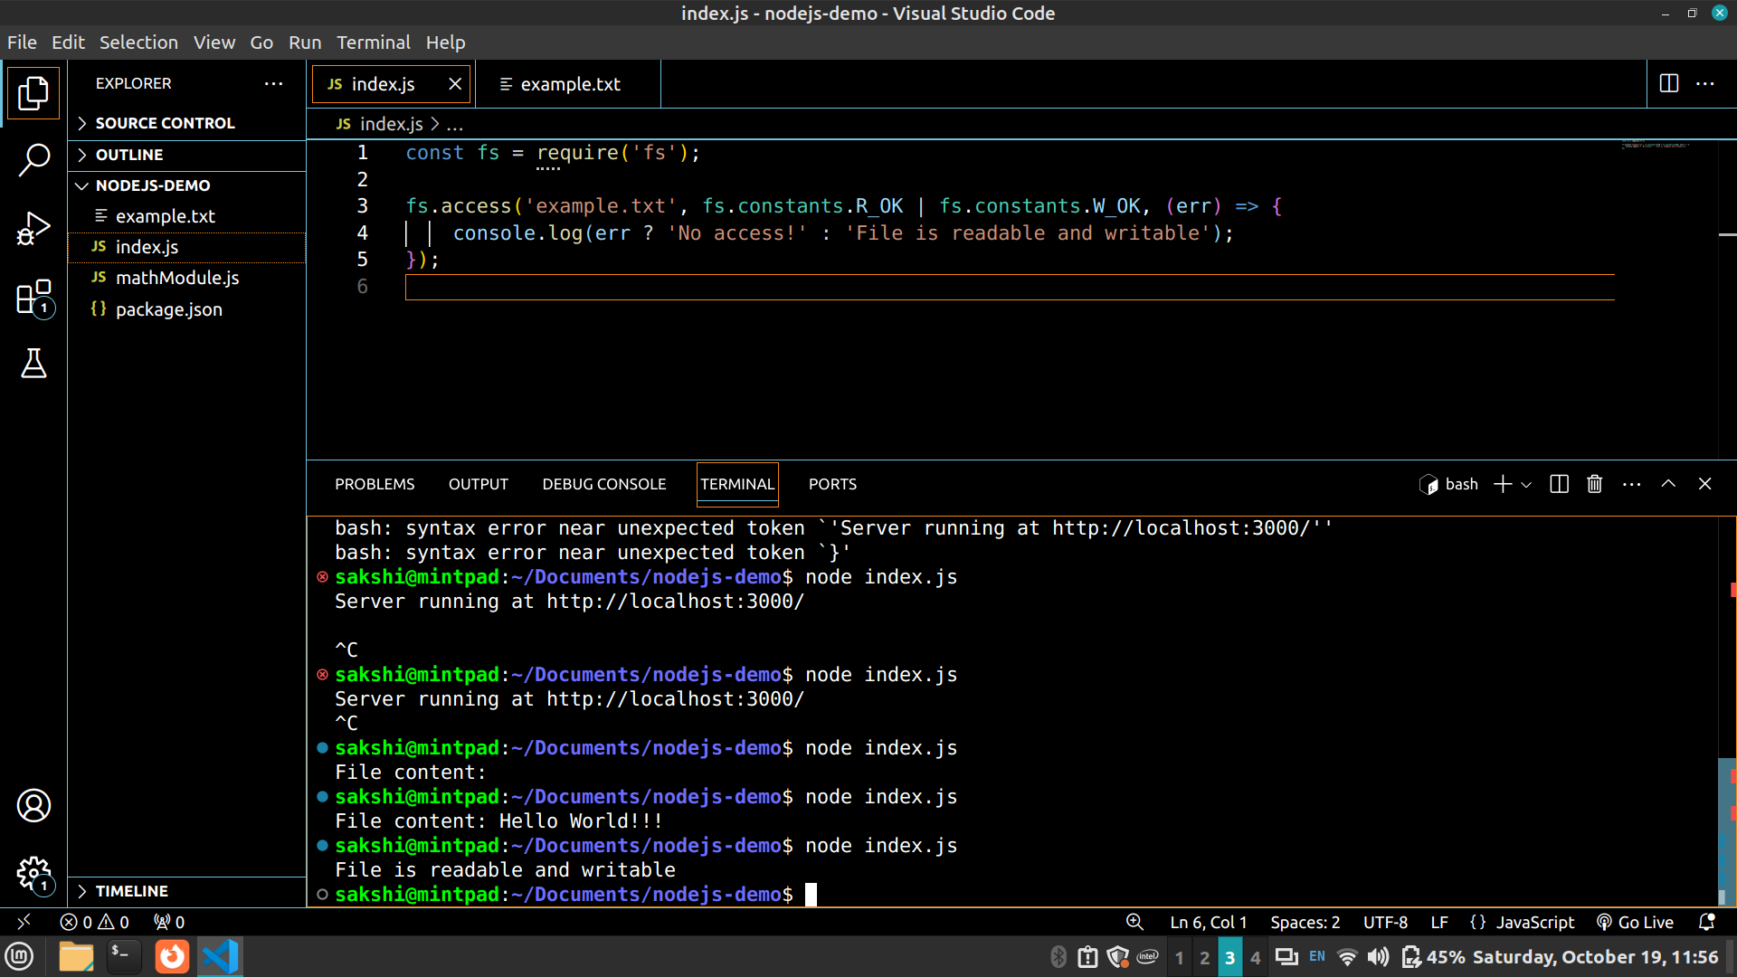

- Checking if a file or a directory exists.

const fs = require('fs');

fs.access('example.txt', fs.constants.F_OK, (err) => {
console.log(err ? 'File does not exist' : 'File exists');
});

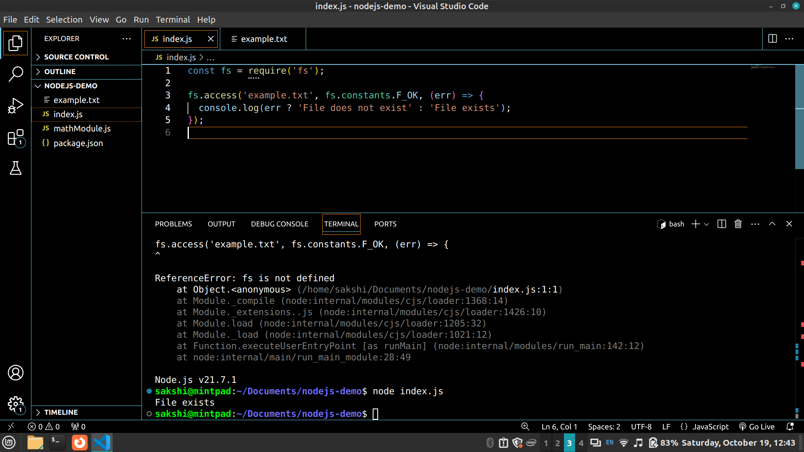

- Determining the line count of a text file.

const readline = require('readline');

const rl = readline.createInterface({
input: fs.createReadStream('example.txt'),
output: process.stdout,
terminal: false
});

let lineCount = 0;
rl.on('line', () => {
lineCount++;
});

rl.on('close', () => {
console.log(`Total lines: ${lineCount}`);
});

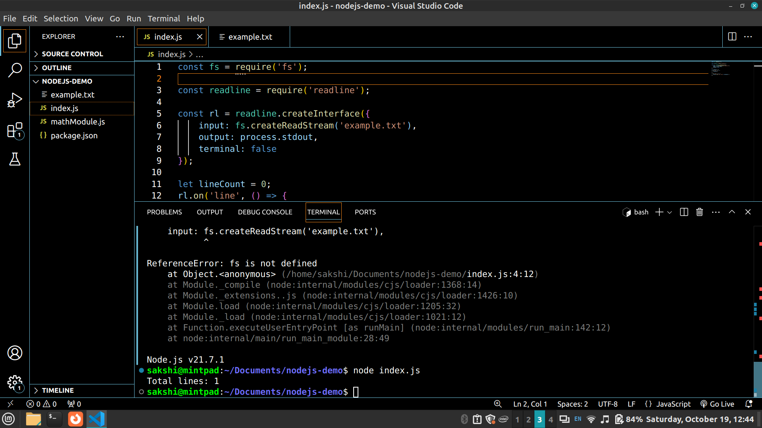
- Reading a file line by line.

const fs = require('fs');

const readline = require('readline');

const rl = readline.createInterface({
input: fs.createReadStream('example.txt'),
output: process.stdout,
terminal: false
});

rl.on('line', (line) => {
console.log(line);
});

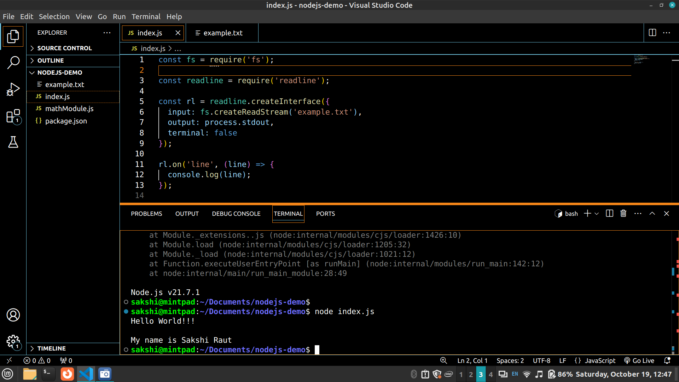
- See the file content through the browser.

const http = require('http');
const fs = require('fs');

const server = http.createServer((req, res) => {
if (req.url === '/file') {
fs.readFile('example.txt', (err, data) => {
if (err) {
res.writeHead(500, { 'Content-Type': 'text/plain' });
res.write('Error reading file');
} else {
res.writeHead(200, { 'Content-Type': 'text/plain' });
res.write(data);
}
res.end();
});
} else {
res.writeHead(404, { 'Content-Type': 'text/plain' });
res.write('404 Not Found');
res.end();
}
});

server.listen(3000, () => {
console.log('Server running at http://localhost:3000/');
});

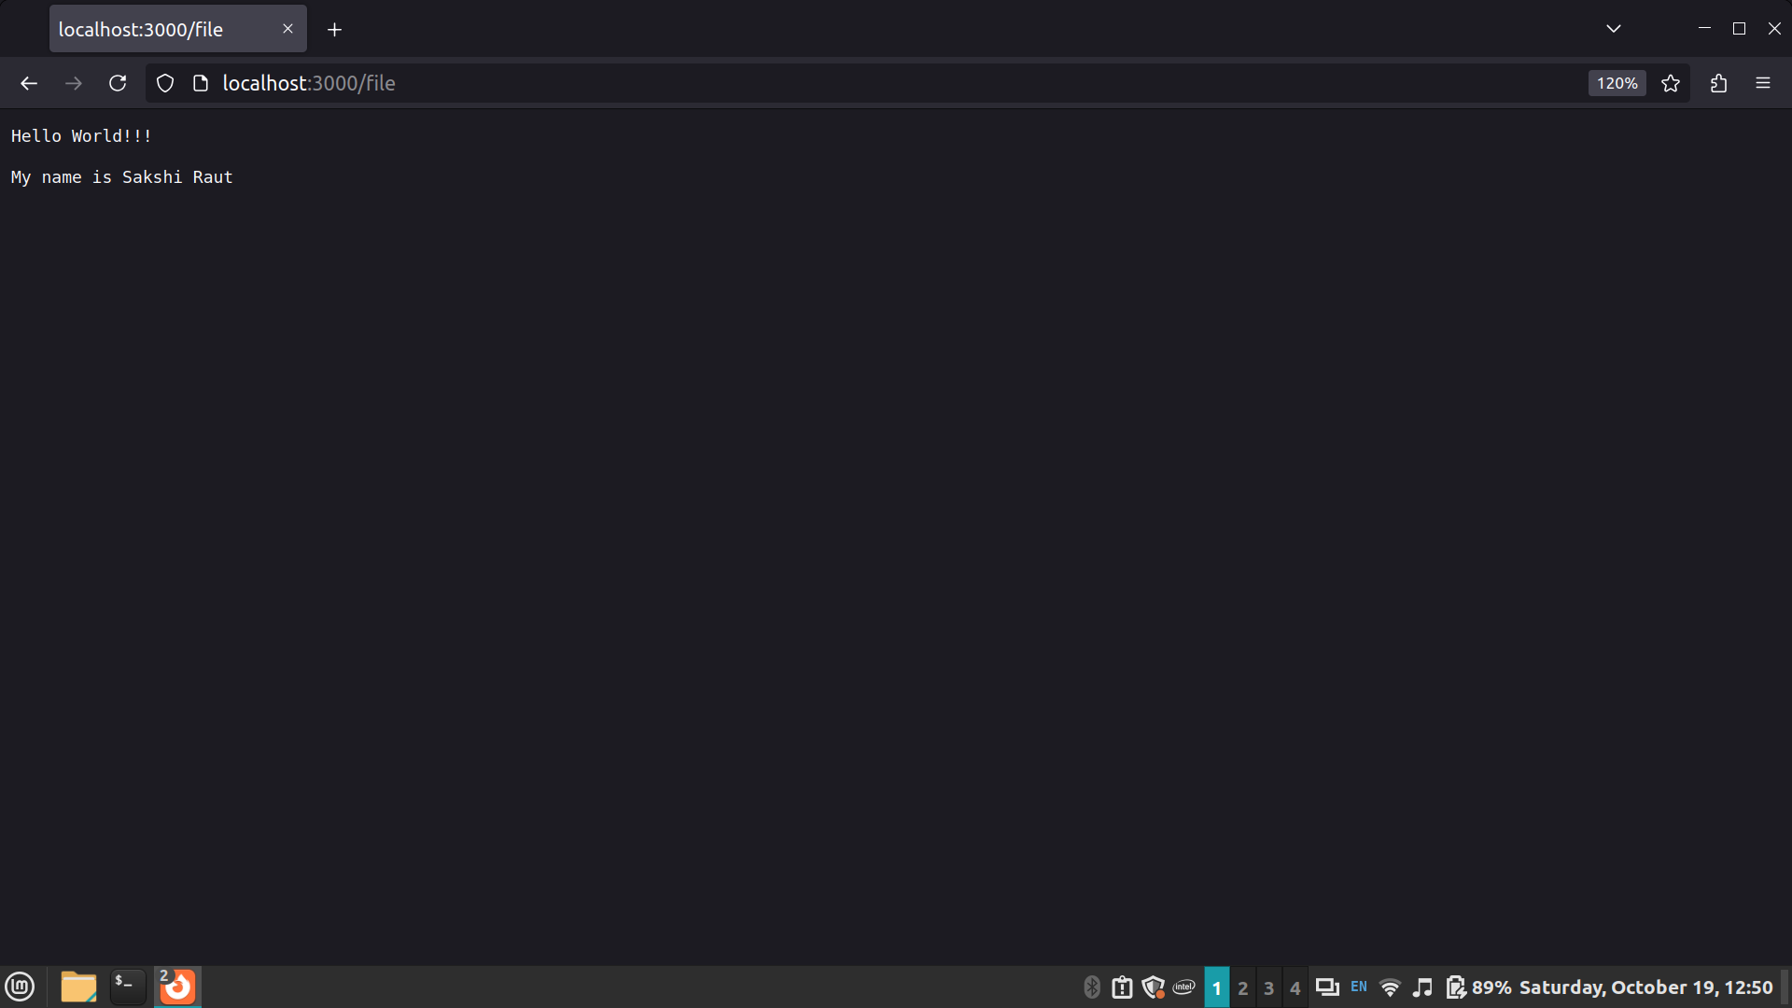

3) Building your custom modules
- To demonstrate this use some mathematics functions to create a custom module.

index.js

const math = require('./mathModule');

console.log('Add: ', math.add(10, 5));
console.log('Subtract: ', math.subtract(10, 5));
console.log('Multiply: ', math.multiply(10, 5));
console.log('Divide: ', math.divide(10, 5));

mathModule.js

exports.add = (a, b) => a + b;
exports.subtract = (a, b) => a - b;
exports.multiply = (a, b) => a * b;
exports.divide = (a, b) => a / b;

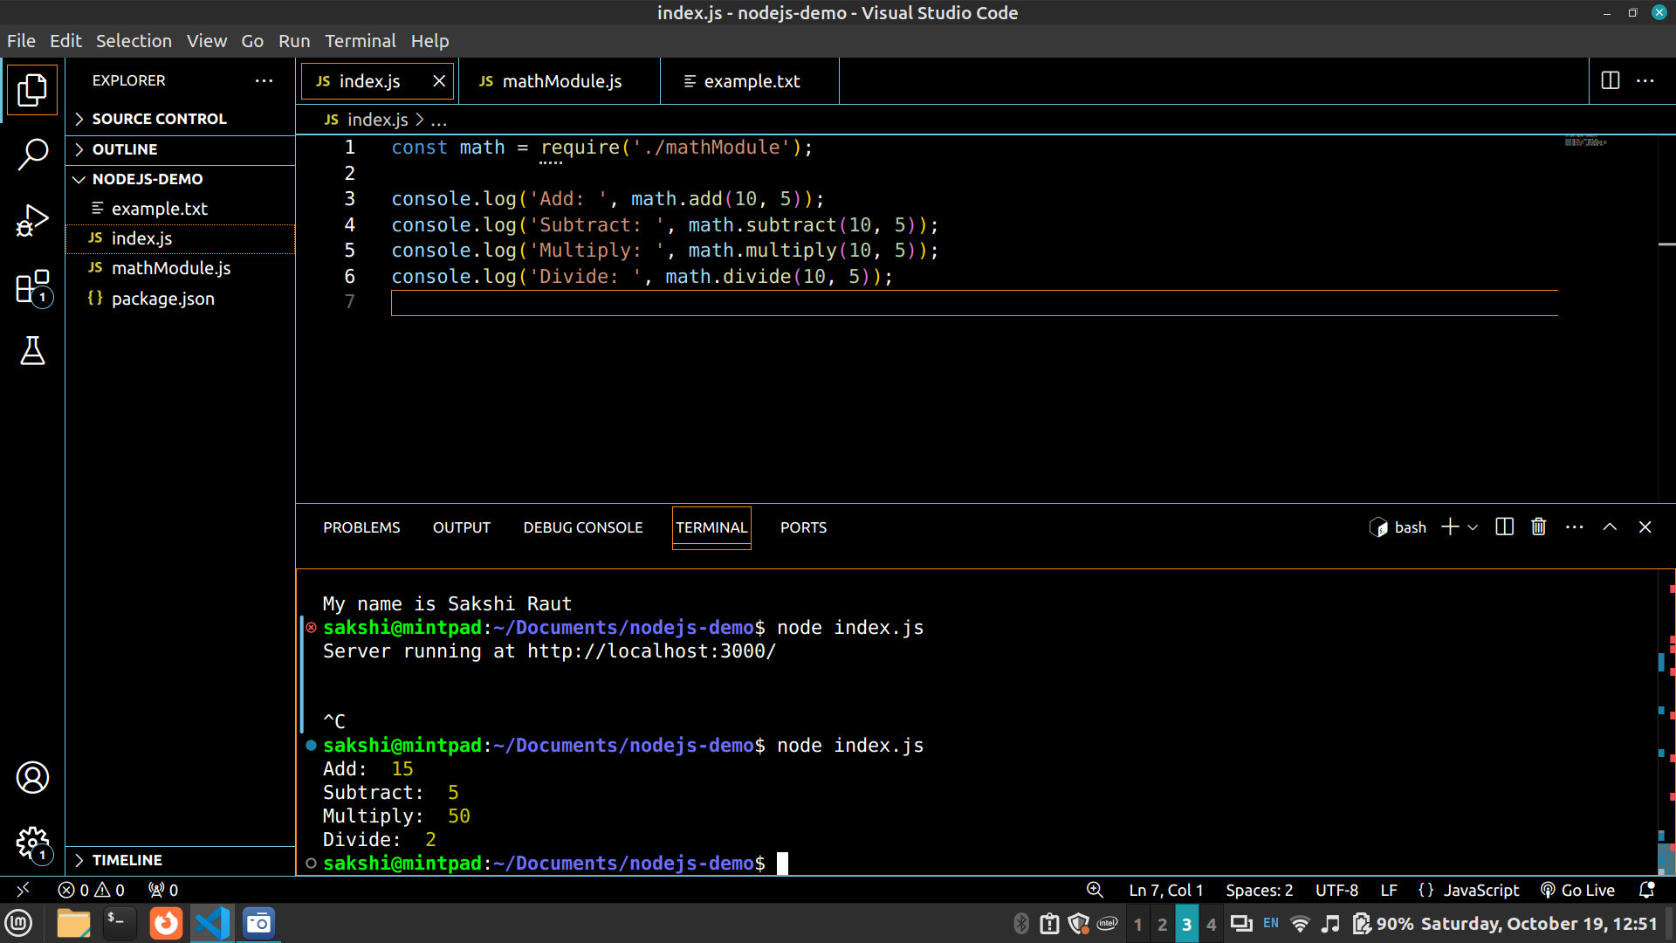

4) Blocking and Non Blocking

Blocking Example

const fs = require('fs');

const data = fs.readFileSync('example.txt', 'utf8');
console.log(data); // Blocking operation, code execution stops here until file is read.
console.log('This will run after reading the file.');

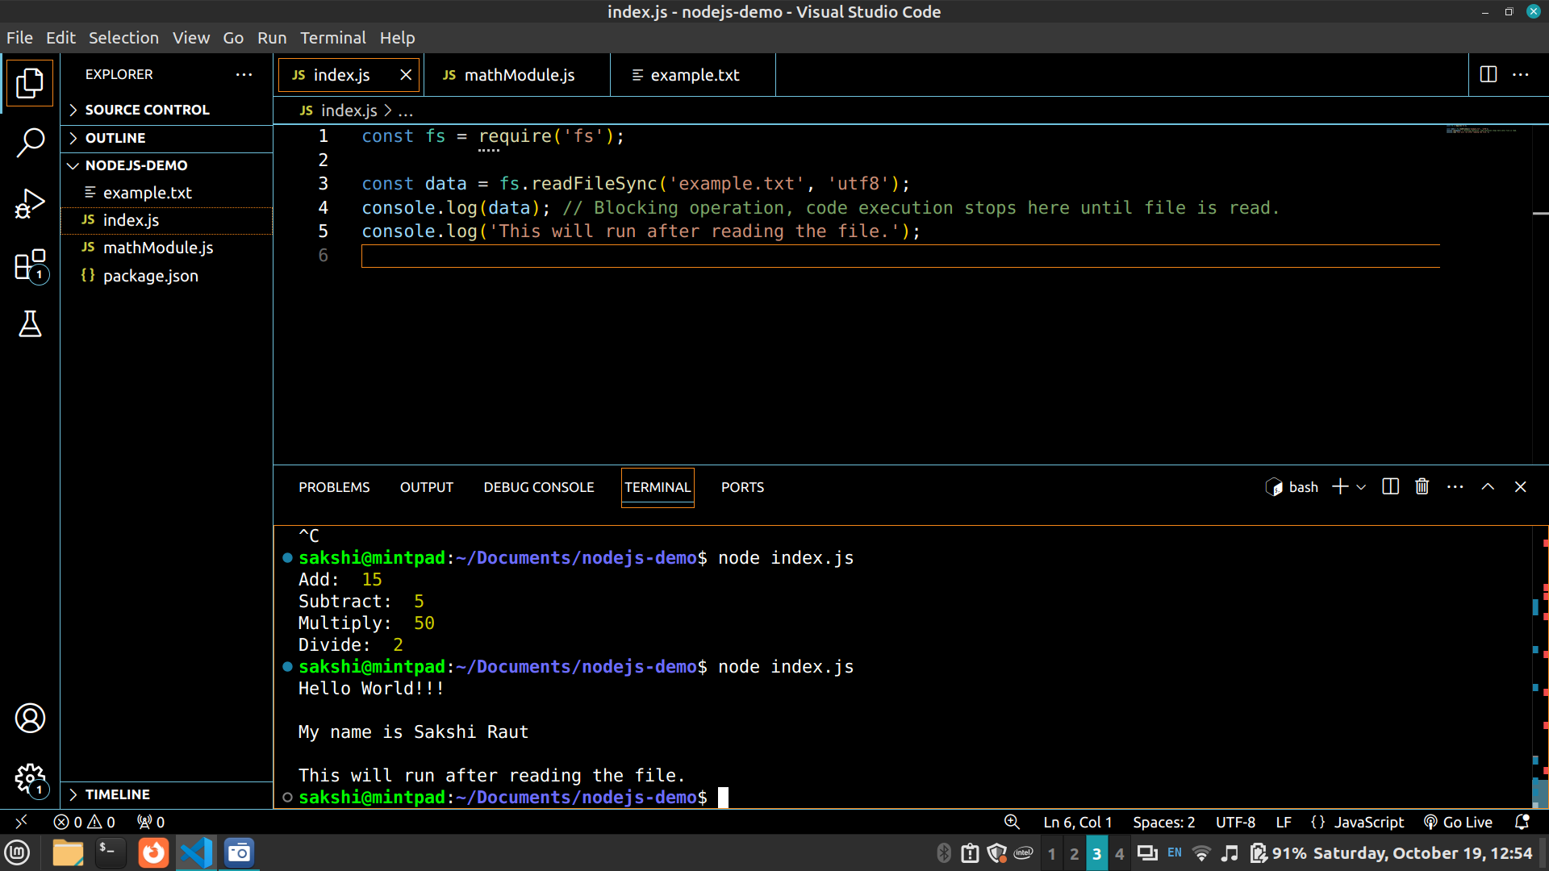

Non Blocking Example

const fs = require('fs');

fs.readFile('example.txt', 'utf8', (err, data) => {
if (err) throw err;
console.log(data); // Non-blocking operation, file is read asynchronously.
});
console.log('This will run before reading the file completes.');

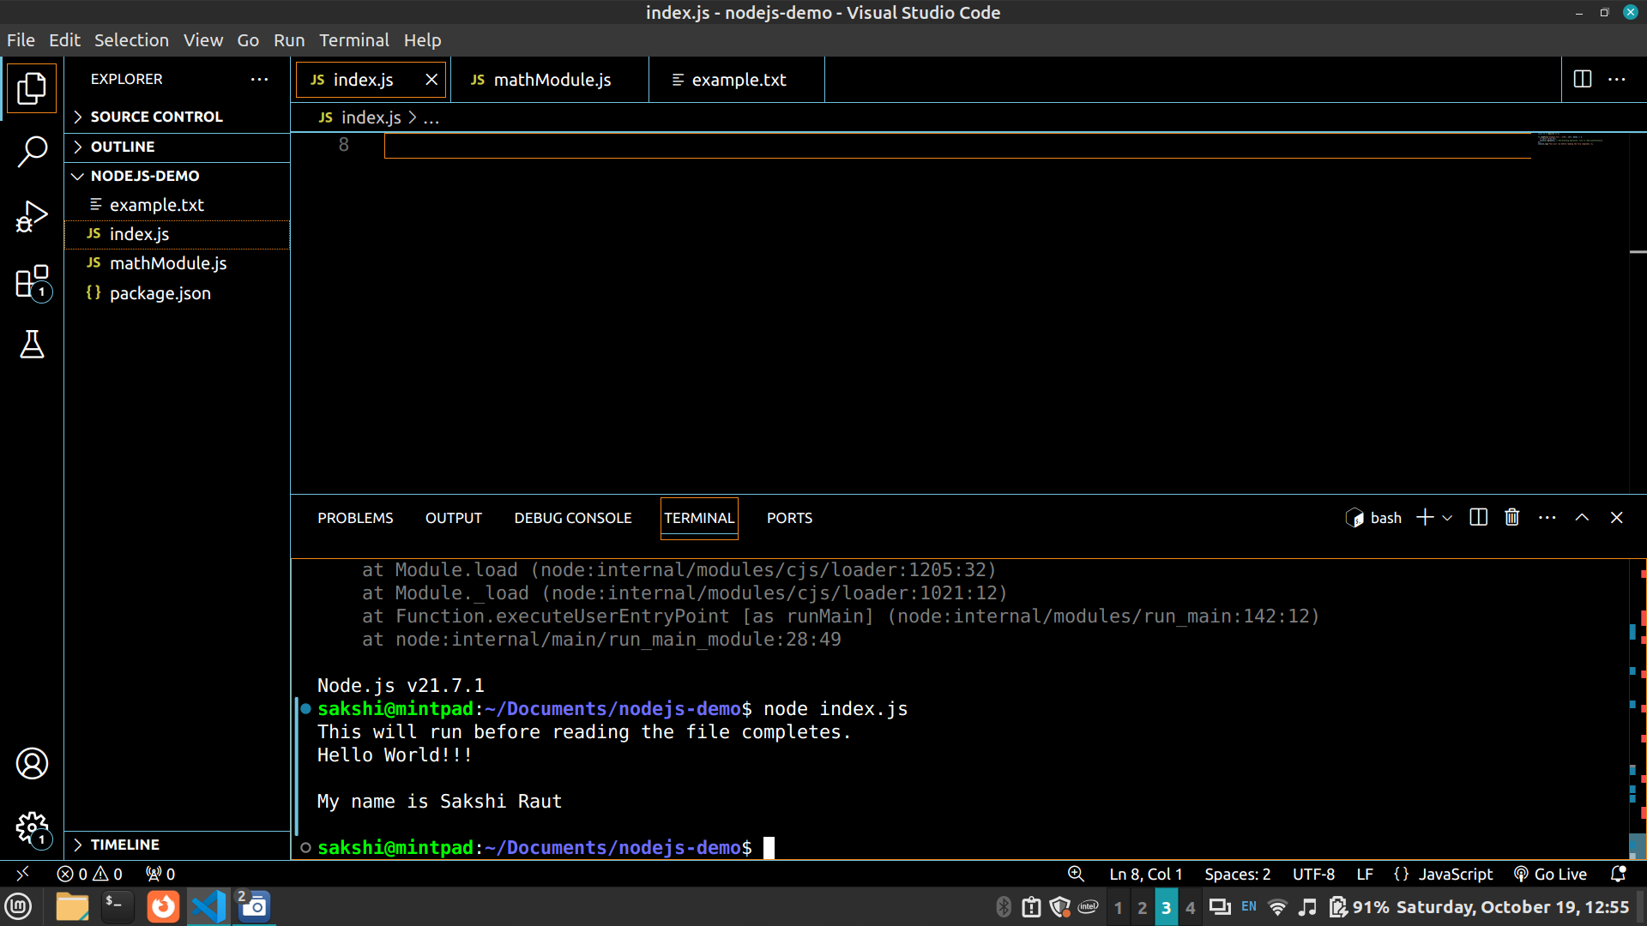

Steps for execution:

- Install Node.js if it’s not already installed on your machine.
- Create Your Script using a text editor or IDE, saving it in a .js file.
- Set Up the Directory: Place any necessary files (like text files or HTML) in the same directory as the script.
- Run the Script in your terminal by navigating to the directory and using the Node.js command.
- Access Results:
- For file operations and logs, check the terminal output.
- For HTTP server functionality, open a browser and navigate to the appropriate route to see the output.
Conclusion:

Explored key Node.js concepts such as basic routing, custom modules, and asynchronous programming to create a scalable and efficient server application.

