Literature Review: Analysis of Recent Trends and Issues in Memory Management
  - Paper Analyzed: An Evolutionary Study of Linux Memory Management for Fun and Profit
Authors: Jian Huang, Moinuddin K. Qureshi, Karsten Schwan
Conference: USENIX Annual Technical Conference, 2016

Abstract
This report synthesizes findings from the study of Linux memory management (mm), focusing on evolutionary changes through 4,587 patches from 2009 to 2015. By categorizing updates into bug fixes, optimizations, maintenance, and new features, the study exposes significant advancements as well as recurrent challenges in Linux memory management. Key topics covered include dynamic memory allocation, virtual memory management, memory protection, memory compression and deduplication, and garbage collection. The following report summarizes these findings, examines the study’s implications for scalability and performance, and discusses future directions for addressing persistent limitations.

Key Areas in Memory Management

1. Dynamic Memory Allocation
Techniques and Trends: Dynamic memory allocation in Linux memory management relies on allocation mechanisms like buddy systems, as well as the SLAB, SLUB, and SLOB allocators. The SLUB allocator, in particular, has been a focal point for optimizations due to its widespread use and central role in the system. In SLUB, fast-path optimizations, including lockless allocations and lock minimizations, have been repeatedly applied to reduce latency and improve throughput by handling memory allocation requests more efficiently. Such fast-path optimizations allow frequently executed paths to bypass more extensive processing, yielding improved performance, especially in high-demand scenarios.

Challenges: Even with these optimizations, Linux’s dynamic allocators face considerable challenges. The paper identifies concurrency issues, primarily lock contention and missing locks, as frequent sources of bugs in SLUB. The buddy system allocator also experiences performance limitations due to fragmentation. A significant portion of patch activity aims to mitigate such issues, especially as these components are crucial for ensuring effective memory management across various applications.

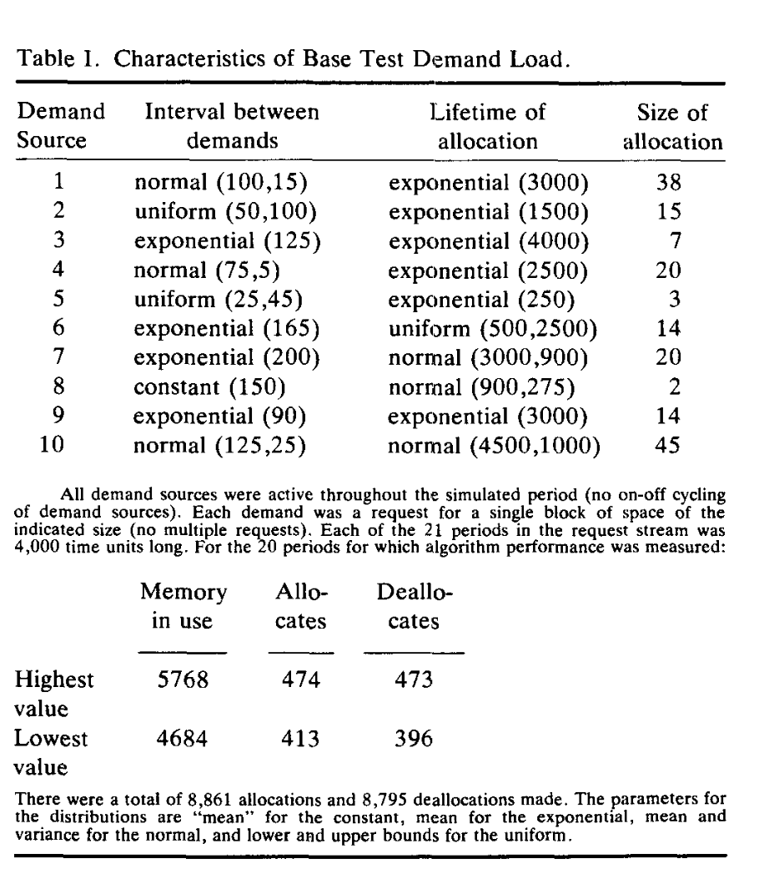
Implications: The improvements made in dynamic allocation illustrate the need for high-efficiency memory handling as systems continue to scale up. However, as SLUB and buddy systems gain complexity through optimizations, they remain prone to bugs and issues that require further oversight and patching. The intensive patching efforts observed in SLUB signify an ongoing need for balance between scalability, speed, and reliability in Linux memory management.

2. Virtual Memory Management (VMM)
Paging and Segmentation: Within Linux, virtual memory management is a core component, tasked with overseeing paging, segmentation, and TLB (Translation Lookaside Buffer) handling. Frequent updates to VMM aim to improve paging performance, especially for multi-core systems, by reducing latency in page allocation and retrieval. Support for huge pages and NUMA (Non-Uniform Memory Access) compatibility has also received significant attention, reflecting the demand for flexible memory solutions that cater to diverse hardware requirements. The study reports that paging mechanisms are continually refined to balance speed and storage efficiency within the VMM component.

TLB Optimizations: Lazy and asynchronous techniques are frequently employed for TLB operations, as they help to reduce the performance cost of high-frequency tasks such as TLB flushing. Lazy policies defer these tasks to reduce processing strain, whereas asynchronous policies prevent delays by managing tasks outside the main memory path. However, these policies introduce complexity, requiring additional error-handling mechanisms. The study points out that 30% of patches address missing state checks within policy definitions, an issue that hampers policy enforcement and affects memory integrity. This reliance on complex state management, combined with missing checks, represents a challenging aspect of Linux memory management’s development.

Challenges and Implications: Despite persistent optimizations, Linux’s VMM component remains error-prone. Missing state checks and policy definition errors continue to appear, suggesting that handling VMM efficiently and safely requires ongoing refinement. Moreover, the complexity added by lazy and asynchronous TLB optimizations points to a potential trade-off in performance versus stability, with new solutions potentially leading to higher error rates and debugging challenges.

3. Memory Protection
Security Enhancements: The memory protection system in Linux mm addresses security concerns, particularly through state management and locking mechanisms that safeguard memory against concurrent access issues. A significant focus within patches has been on synchronizing page states across different components to prevent unauthorized memory access or inadvertent memory corruption. Additionally, Linux mm has incorporated new concurrency and lock schemes within the memory protection framework to maintain memory integrity during multi-threaded operations.

Challenges: Concurrency remains a persistent challenge in memory protection. Lock contention and missing locks are recurring issues, which exacerbate the complexities of state tracking across memory pages. As concurrency levels grow with increasingly complex applications, memory protection mechanisms face significant difficulty in ensuring state consistency without performance sacrifices. Bugs linked to these issues, including unnecessary or missed locks, are prominent within the memory resource controller, which struggles to maintain synchronization without introducing bottlenecks.

Implications: The challenges faced in memory protection underline the importance of secure, reliable memory management, particularly as Linux mm continues to evolve. The frequency of lock-related errors indicates the need for improved synchronization mechanisms that minimize lock contention while maintaining efficient memory access and protection protocols.

4. Memory Compression and Deduplication
Trends and Advancements: Memory compression and deduplication have grown in importance as strategies to conserve physical memory in Linux mm. Compressed swap caching, introduced through zswap, allows memory pages to be compressed before they are swapped to disk, effectively reducing memory usage by lowering the physical storage requirements of data. Deduplication efforts similarly aim to reduce memory consumption by identifying and eliminating redundant data, thus enhancing overall memory efficiency.

Challenges: Although compression and deduplication optimize memory usage, they introduce new challenges related to latency and error handling. Asynchronous processing of compression tasks helps to maintain performance but also complicates error handling, as fault handlers need to address potential data inconsistencies without interrupting ongoing tasks. Patches frequently target these fault handlers, underscoring the difficulties of balancing effective compression and real-time fault management without impacting latency-sensitive applications.

Implications: The emphasis on memory compression reflects a growing need for efficient memory use in large-scale systems. However, achieving efficient and seamless compression within memory management systems still presents difficulties, especially in minimizing latency and ensuring reliability during compression-related tasks.

Figure 6: Bug distribution among Linux mm components

5. Garbage Collection (GC)
Strategies and Implementation: Garbage collection (GC) in Linux mm ensures that unused memory pages are reclaimed to support future allocations, thereby preventing out-of-memory (OOM) events. The kswapd daemon and shrinker functions form the core of GC in Linux mm, with each focusing on reclaiming memory and maintaining an adequate number of free pages for system stability. GC patches prioritize efficiency in page scanning and reclamation to keep memory usage balanced across components and zones.

Challenges: Garbage collection faces significant challenges in managing memory unpredictability, particularly during memory congestion events. The study notes that performance unpredictability within GC often stems from congestion-related delays that slow down page reclamation, impacting system performance as a whole. This unpredictability highlights the need for further scalability in GC to support effective memory usage without causing delays or resource bottlenecks during high-demand periods.

Implications: Improving GC efficiency is essential for maintaining predictable and high-performing memory management. The persistent challenges with GC scalability and congestion control indicate that garbage collection systems must evolve further to handle increasing memory requirements without hindering performance in complex workloads.

Table 6: Classification of approaches for fast path optimization in Linux mm.

Discussion and Implications
The comprehensive study by Huang, Qureshi, and Schwan reveals the strengths and limitations of Linux memory management as it has evolved over the years:

Scalability Needs
The need for scalable solutions is apparent from the focus on data structure optimization and concurrency management, such as the implementation of per-core and per-node variables. These updates are aimed at reducing lock contention and improving memory access times, demonstrating an ongoing shift towards scalable, high-efficiency memory management solutions that align with the growing memory demands of multi-core and large-scale systems.

Latency-Sensitive Optimizations
The use of lazy and asynchronous policies for tasks like TLB flushing and page migration shows that memory management systems must prioritize latency to accommodate high-performance, real-time applications. However, as evidenced by the frequency of patching in this area, these optimizations often complicate error handling and increase the potential for concurrency-related bugs.

Figure 4: Patch overview. It shows the patch distribution according to general types including bug, code maintenance, improvement and new feature.

Evaluation of Recent Solutions
The study’s findings indicate that while recent Linux memory management updates have introduced significant improvements, ongoing issues persist that require continued attention:

Concurrency and Lock Contention
Techniques like lockless optimization and per-core variable usage help to mitigate lock contention, yet concurrency issues remain challenging. Complex state management and tracking requirements increase the likelihood of bugs, making concurrency a primary focus of memory management optimizations.

High Bug Prevalence
A substantial number of patches address bugs within the memory manager, revealing that many components are error-prone despite their mature development. Memory-related errors like null pointer dereferences, page alignment issues, and concurrency problems frequently disrupt system performance and reliability.

Figure 3: The heat map of patch distribution in each component of Linux memory management. Each block represents the patches committed to the current version since the last stable version. The darker the color, the more patches applied. The number below the bar indicates the total number of committed patches applied to the given file.

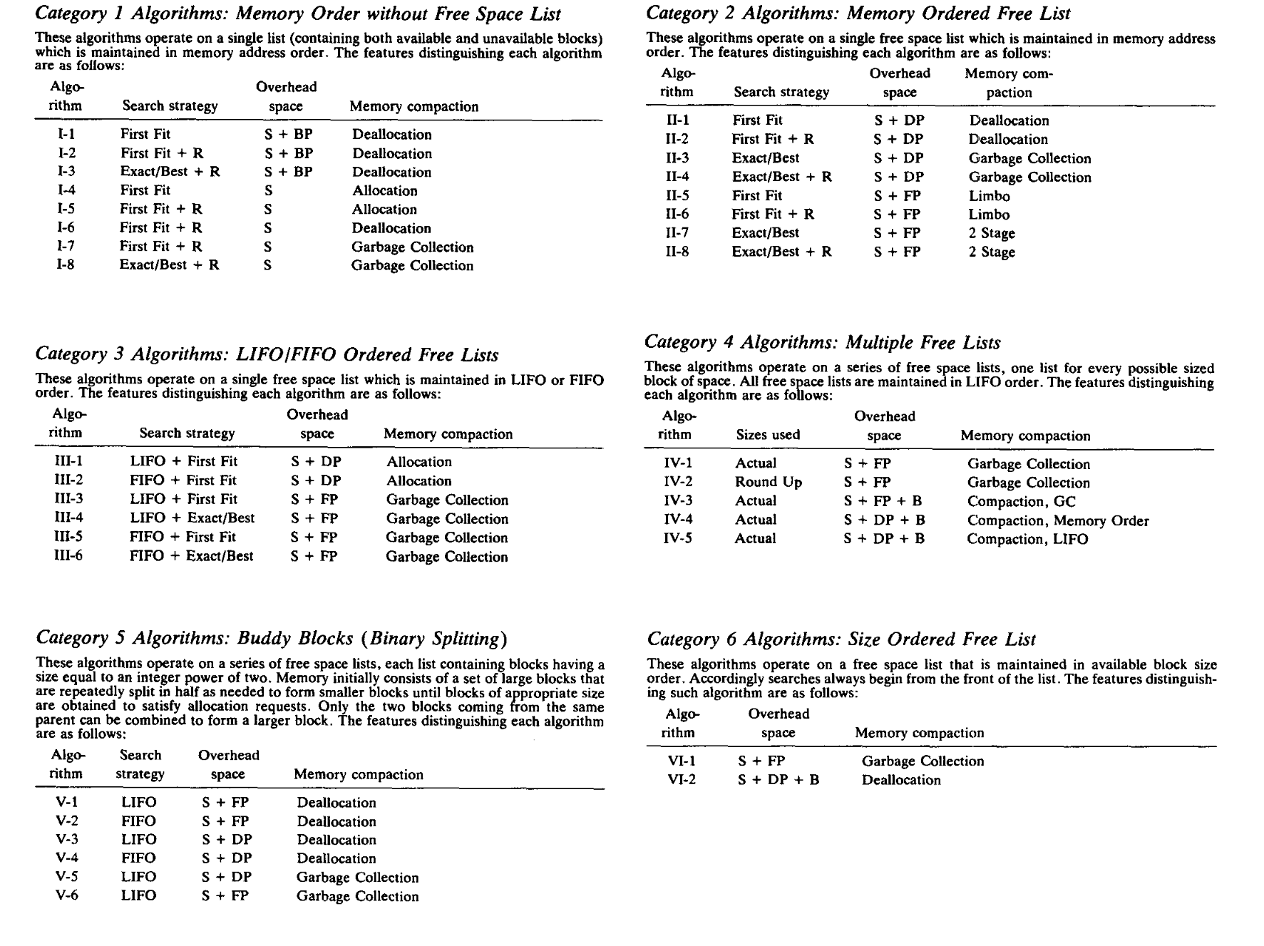

Future Research Directions
The authors propose several potential research avenues to address the limitations observed:

Formal Verification for Policies
Given the frequency of errors in policy definition and enforcement, formal verification frameworks for memory policies could reduce the prevalence of state tracking errors, helping to improve reliability in Linux memory management.

Enhanced Scalability Tools
The need for tools that can assess bottlenecks and scalability constraints in data structures and policy enforcement is highlighted in the study. Such tools would assist developers in identifying performance issues and ensuring that memory management scales efficiently across systems.

Improved Memory Profiling
Expanding memory profiling tools to detect latency-sensitive operations would enable memory management to better accommodate real-time, performance-critical tasks by identifying and optimizing processes that contribute most to latency.

Conclusion
The findings of this study underscore the progress made in Linux memory management and the challenges that remain. Through dedicated patches targeting optimizations, bug fixes, and scalability improvements, Linux mm continues to evolve to meet the demands of modern operating systems. However, issues related to concurrency, latency, and fault management reveal the need for continued refinement in memory management techniques. Addressing these challenges through future research and tool development will be crucial in building more efficient and reliable memory management systems.

