Batch: B1 Roll No.: 16010122158

Experiment No. 07

Grade: AA / AB / BB / BC / CC / CD / DD

Signature of the Staff In-charge with date

Batch:

Roll No.:

Experiment No. 06
Grade: AA / AB / BB / BC / CC / CD /DD

Signature of the Staff In-charge with date

TITLE: Implementation of dining philosopher problem using threads.
_____________________________________________________________________

AIM: Implementation of Process synchronization algorithms using threads – Dining Philosopher problem
______________________________________________________________________
Expected Outcome of Experiment:

CO 2. To understand the concept of process, thread and resource management.
CO 3. To understand the concepts of process synchronization and deadlock.
_____________________________________________________________________
Books/ Journals/ Websites referred:

- Silberschatz A., Galvin P., Gagne G. “Operating Systems Principles”, Willey Eight edition.
- Achyut S. Godbole , Atul Kahate “Operating Systems” McGraw Hill Third
Edition.
- William Stallings, “Operating System Internal & Design Principles”, Pearson.
- Andrew S. Tanenbaum, “Modern Operating System”, Prentice Hall.
_____________________________________________________________________
Pre Lab/ Prior Concepts:

Knowledge of Concurrency, Mutual Exclusion, Synchronization, Deadlock, Starvation,threads.
_____________________________________________________________________

The Dining Philosophers problem is a classic synchronization problem in computer science that illustrates issues related to resource allocation and deadlock in concurrent programming. It was formulated by Edsger Dijkstra in 1965 to model scenarios where several processes (or "philosophers") need access to a shared set of resources (or "chopsticks") without causing conflicts or resource starvation.
The problem is typically set up as follows: five philosophers sit around a circular table, each alternating between thinking and eating. Between each pair of philosophers lies a single chopstick (or fork). To eat, a philosopher needs both the left and the right chopstick. The challenge is that if every philosopher picks up their left chopstick simultaneously, they'll all end up waiting for the right chopstick to become available, causing a deadlock where no one can proceed.
Solving the Dining Philosophers problem requires a strategy that avoids deadlock, ensures mutual exclusion (only one philosopher can use a pair of chopsticks at any time), and prevents starvation (no philosopher should wait indefinitely to eat). Common solutions include imposing an ordering on resource acquisition (e.g., allowing one philosopher to pick up chopsticks in the reverse order), introducing a waiter to manage access to chopsticks, or setting conditions that allow philosophers to act only when both chopsticks are available. These approaches help in developing robust concurrent programs and managing shared resources without causing system-wide stalls or inefficiencies.
Description of the chosen process synchronization algorithm:
The code uses a concurrent locking algorithm with asymmetric, non-blocking acquisition to handle the Dining Philosophers problem, avoiding deadlock and reducing starvation risks. Here's how it works:
- Philosophers as Threads: Each philosopher is a thread that alternates between thinking and eating. Each requires two forks (locks) to eat.
- Forks as Locks: Each fork is a threading.Lock. A philosopher picks up the left fork first (blocking) and then tries to acquire the right fork (non-blocking).
- Non-Blocking Right Fork: If the right fork isn’t available, the philosopher releases the left fork and retries, breaking the circular wait condition and preventing deadlock.
- Eating and Releasing: Once both forks are acquired, the philosopher eats, then releases both forks, allowing others to use them.
This approach ensures deadlock is avoided through non-blocking attempts and fair access to resources.
Implementation details:
import threading
import random
import time
class Philosopher(threading.Thread):
running = True
def __init__(self, name, forkOnLeft, forkOnRight):
threading.Thread.__init__(self)
self.name = name
self.forkOnLeft = forkOnLeft
self.forkOnRight = forkOnRight
def run(self):
while(self.running):
time.sleep( random.uniform(3,13))
print(self.name, "is hungry.")
self.dine()
def dine(self):
fork1, fork2 = self.forkOnLeft, self.forkOnRight
while self.running:
fork1.acquire(True)
locked = fork2.acquire(False)
if locked: break
fork1.release()
else:
return
self.dining()
fork2.release()
fork1.release()
def dining(self):
print(self.name, 'starts eating ')
time.sleep(random.uniform(1,10))
print(self.name, 'finishes eating and leaves to think')
def DiningPhilosophers():
forks = [threading.Lock() for n in range(5)]
philosopherNames = ('Philosopher 1','Philosopher 2','Philosopher 3','Philosopher 4', 'Philosopher 5')
philosophers= [Philosopher(philosopherNames[i], forks[i%5], forks[(i+1)%5]) \
for i in range(5)]
random.seed(507129)
Philosopher.running = True
for p in philosophers: p.start()
time.sleep(100)
Philosopher.running = False
print ("Now we're finishing.")
if __name__ == "__main__":
DiningPhilosophers()

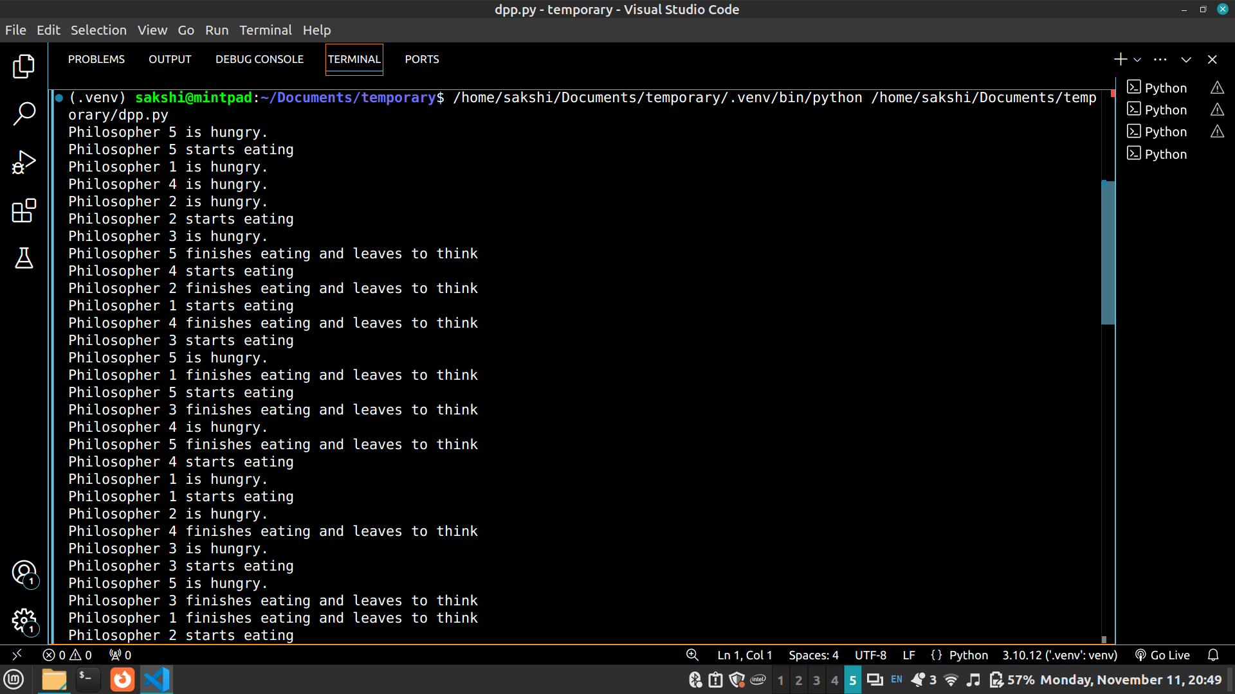
Conclusion:
Successfully implemented the dining philosopher problem.

Post Lab Descriptive Questions

1.Differentiate between a monitor, semaphore and a binary semaphore?

Monitor:
- A monitor is a high-level synchronization construct that provides a mechanism to ensure that only one process can execute in the critical section at a time.
- It encapsulates shared variables and operations (methods) that access the shared variables.
- Monitors use condition variables to allow processes to wait and signal each other.
- The key advantage of a monitor is that it simplifies synchronization by automating the locking and unlocking mechanisms.
Semaphore:
- A semaphore is a lower-level synchronization tool used to manage access to a shared resource by multiple processes in concurrent programming.
- It can be counting (allows a limited number of processes to access a resource) or binary (only allows one process at a time).
- Semaphores use two atomic operations: wait() (also called P) and signal() (also called V) to manage the resource access.
- Semaphores are prone to issues like deadlocks and require careful handling to prevent such issues.
Binary Semaphore:
- A binary semaphore is a special case of a semaphore where the value of the semaphore can only be 0 or 1.
- It functions similarly to a lock (mutex) by ensuring that only one process can access the shared resource at a time.
- In a binary semaphore:
  - wait() decreases the semaphore value to 0 (indicating the resource is occupied).
  - signal() increases the value back to 1 (indicating the resource is available).
- It is useful for mutual exclusion but requires careful management to avoid problems like priority inversion.

2. Define clearly the dining-philosophers problem?

The dining-philosophers problem is a classic synchronization and concurrency problem that illustrates the challenge of allocating limited resources among multiple processes without causing deadlock.
- There are five philosophers seated around a circular table.
- In front of each philosopher, there is a plate of food, and between each pair of philosophers, there is one fork (five philosophers, five forks).
- The philosophers either think or eat.
- To eat, a philosopher needs to pick up two forks (one from the left and one from the right).
- After eating, they put down both forks and resume thinking.
- The challenge is to ensure that no philosopher is starved or stuck in a deadlock, waiting for forks that are being used by others.

3. Identify the scenarios in the dining-philosophers problem that leads to the deadlock situations?

- Deadlock Condition:
  - Deadlock occurs when all philosophers pick up the fork on their left simultaneously and wait for the fork on their right.
  - Since no philosopher can pick up both forks, they remain in an infinite waiting state, leading to deadlock.
- Starvation:
  - Even if deadlock is avoided, one or more philosophers may be constantly waiting for forks because other philosophers take both forks frequently. This can lead to starvation (a philosopher never gets a chance to eat).
In essence, deadlock can occur if all philosophers try to pick up one fork at the same time, while starvation can happen if some philosophers always manage to eat before others.

Date: 6th November, 2024 Signature of faculty in-charge

