Batch: D-1 Roll No.: 16010122098

Experiment No. 01

Grade: AA / AB / BB / BC / CC / CD /DD

Signature of the Staff In-charge with date

TITLE: Exploring basic Commands of UNIX: Shell, Processes, Files
_____________________________________________________________________

AIM: To Explore basic commands for handling File system under Unix/Linux using shell scripts.(Creating groups, chown , chmod , directory name, tty , diff, umask).
______________________________________________________________________
Expected Outcome of Experiment:

CO 1. To introduce basic concepts and functions of operating systems.
_____________________________________________________________________
Books/ Journals/ Websites referred:

- Silberschatz A., Galvin P., Gagne G. “Operating Systems Principles”, Willey Eight edition.
- Achyut S. Godbole , Atul Kahate “Operating Systems”, McGraw Hill Third Edition.
- Sumitabha Das “ UNIX Concepts & Applications”, McGraw Hill Second
Edition.
_____________________________________________________________________
Pre Lab/ Prior Concepts:

An operating system (OS) is a resource manager. It takes the form of a set of software routines that allow users and application programs to access system resources (e.g. the CPU, memory, disks, modems, printers network cards etc.) in safe efficient and abstract way.
- The operating system kernel is in direct control of the underlying hardware. The kernel provides low-level device, memory and processor management functions (e.g. dealing with interrupts from hardware devices, sharing the processor among multiple programs, allocating memory for programs etc.)
- Basic hardware-independent kernel services are exposed to higher-level programs through a library of system calls (e.g. services to create a file, begin execution of a program, or open a logical network connection to another computer).
- Application programs (e.g. word processors, spreadsheets) and system utility programs (simple but useful application programs that come with the operating system, e.g. programs which find text inside a group of files) make use of system calls. Applications and system utilities are launched using a shell (a textual command line interface) or a graphical user interface that provides direct user interaction.
Operating systems can be distinguished from one another by the system calls, system utilities and user interface they provide, as well as by the resource scheduling policies implemented by the kernel.
UNIX has been a popular OS for more than two decades because of its multi-user, multi-tasking environment, stability, portability and powerful networking capabilities.
Linux is a free open source UNIX OS for PCs.
Linux has all of the components of a typical OS :
- Kernel
The Linux kernel includes device driver support for a large number of PC hardware devices (graphics cards, network cards, hard disks etc.), advanced processor and memory management features, and support for many different types of file systems. In terms of the services that it provides to application programs and system utilities, the kernel implements most BSD and SYSV system calls, as well as the system calls described in the POSIX.1 specification.
The kernel (in raw binary form that is loaded directly into memory at system startup time) is typically found in the file /boot/vmlinuz, while the source files can usually be found in /usr/src/linux.
- Shells and GUIs
Linux supports two forms of command input: through textual command line shells similar to those found on most UNIX systems (e.g. sh - the Bourne shell, bash - the Bourne again shell and csh - the C shell) and through graphical interfaces (GUIs) such as the KDE and GNOME window managers.
- System Utilities
Virtually every system utility that you would expect to find on standard implementations of UNIX has been ported to Linux. This includes commands such as ls, cp, grep, awk, sed, bc, wc, more, and so on. These system utilities are designed to be powerful tools that do a single task extremely well (e.g. grep finds text inside files while wc counts the number of words, lines and bytes inside a file). Users can often solve problems by interconnecting these tools instead of writing a large monolithic application program.
- Application programs
Linux distributions typically come with several useful application programs as standard. Examples include the emacseditor, xv (an image viewer), gcc (a C compiler), g++ (a C++ compiler), xfig (a drawing package), latex (a powerful typesetting language) and soffice (StarOffice, which is an MS-Office style clone that can read and write Word, Excel and PowerPoint files).
______________________________________________________________________
Description of Commands and options:

DOS commands: Attrib, dir, at, chkdsk, shutdown, tree, create a batch file, output and input redirection

Windows utilities: msconfig, defragmenter, performance monitor, task manager, registry editor, event viewer, process explorer

Unix Commands:

- Unix file operations: ls, cp, rm , mv, chmod, chown ,chgrp
- Text file operations in Unix : cat , more , less , head, tail , grep
- Unix directory management commands : cd, pwd , ln, mkdir, rmdir
- Unix system status commands: hostname, w, uname
- Process management: ps, top, kill
- Unix users commands: whoami , id, groups, passwd , who, last

Implementation details:
A. Basic and Important DOS (Windows Command Prompt) Commands:
1. dir - List contents of a directory.
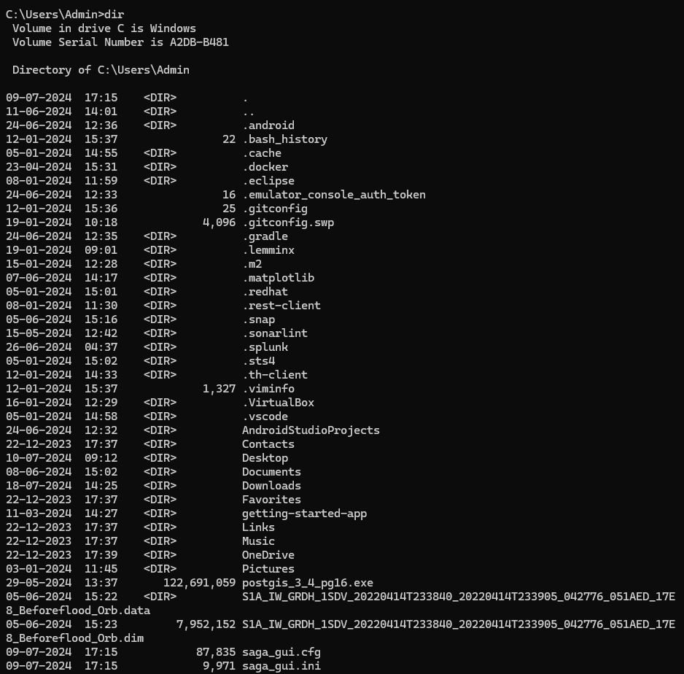
2. cd - Change directory.
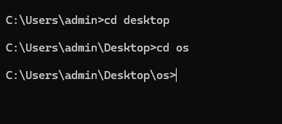
3. copy - Copy files.
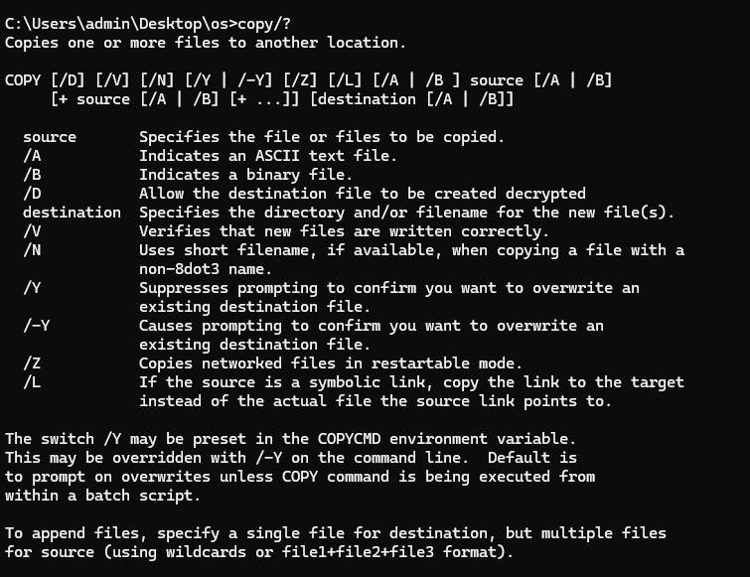
- move - Move files.
- del - Delete files.
- mkdir - Create a new directory.
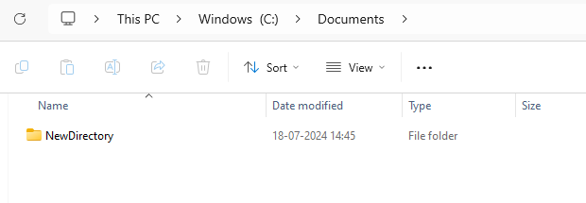
- rmdir - Remove a directory.
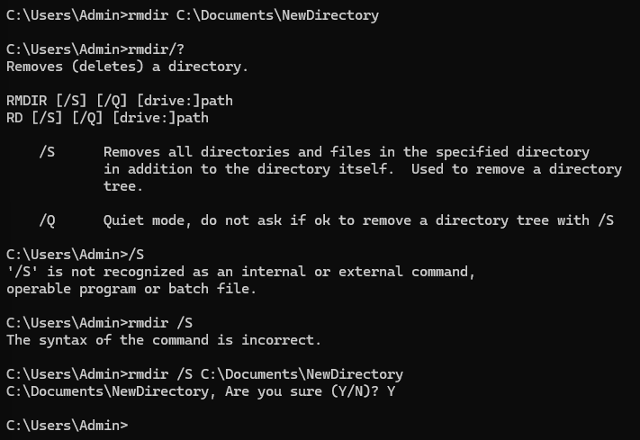
- type - Display the contents of a file.
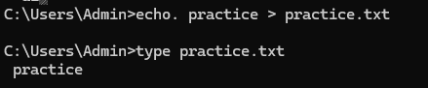
- ren - Rename files.
File rename
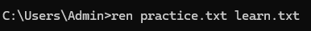

Folder rename
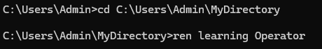

- cls - Clear the screen.
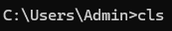
- echo - Display messages or turn command echoing on/off.
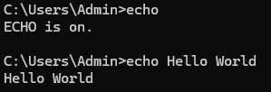
- exit - Exit the Command Prompt.
- attrib - Display or change file attributes.
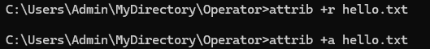
- tasklist - Display a list of currently running processes.
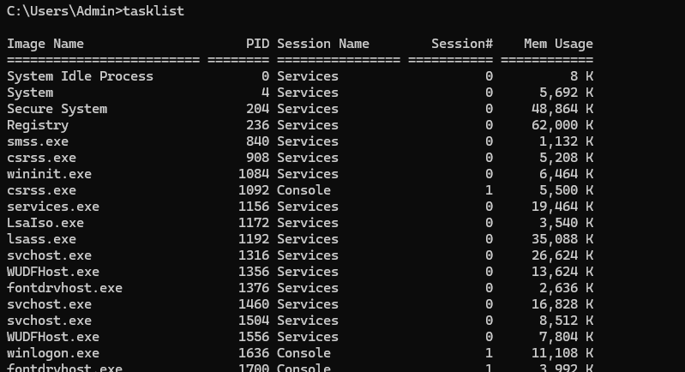
- ping - Test connectivity to another networked device using ICMP echo.
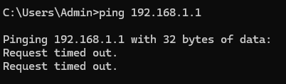
- Create a batch file and execute
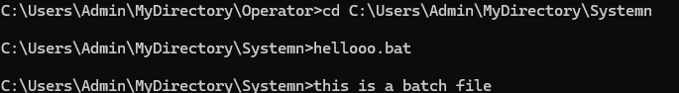

B. Basic and Important Unix (Linux/macOS) Commands:
1. ls - List directory contents.
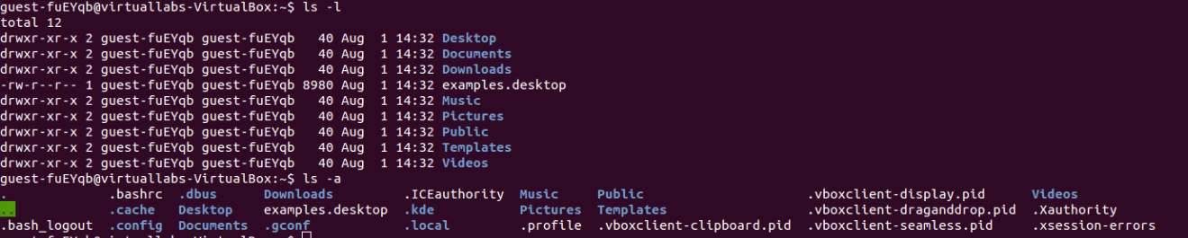
2. cd - Change directory.
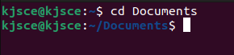
3. cp - Copy files and directories.
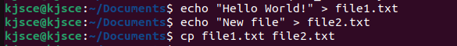
4. mv - Move/rename files and directories.
5. rm - Remove files and directories.
6. mkdir - Create directories.
7. rmdir - Remove empty directories.
8. cat - Concatenate and display files.
9. more or less - View file contents one screen at a time.
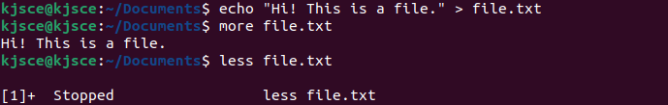
10. touch - Create an empty file or update file timestamps.
11. nano or vi (Linux) / TextEdit (macOS) - Text editors for creating and editing
files.
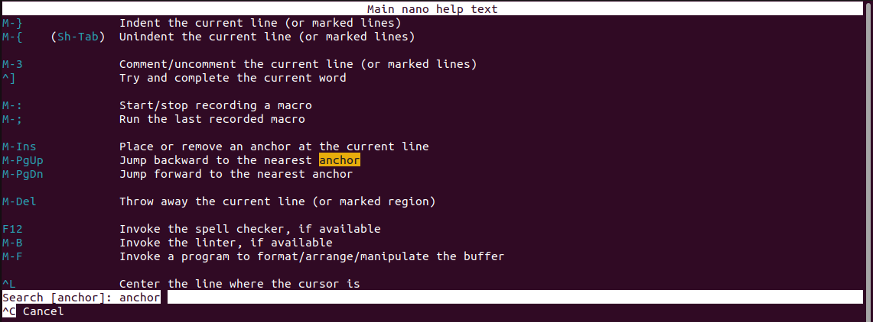
12. pwd - Print working directory.
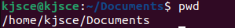
13. man - Display manual pages for commands.
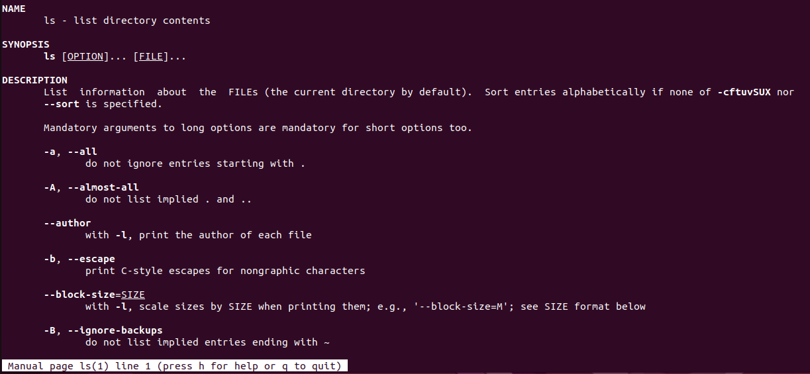
14. grep - Search for patterns in files.
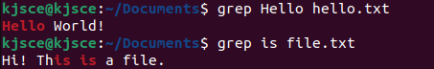
15. chmod - Change file permissions.
16. Run a command in background
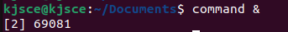

17. Suspend some commands and re-schedule them (Ctrl-z, ps, fg %sequence no of
suspended process)
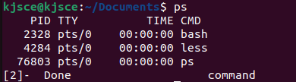
Important Unix Commands (Advanced):
1. sudo - Execute a command with superuser (root) privileges.
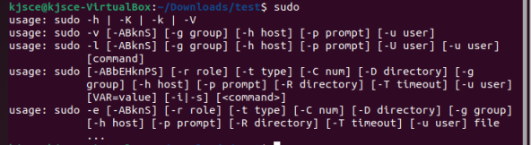
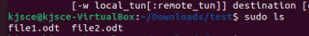
2. apt-get (Linux) / brew (macOS) - Package management commands for installing
and managing software packages.
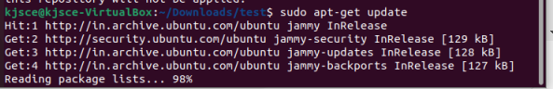
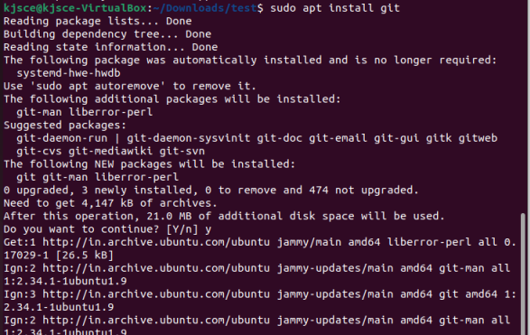
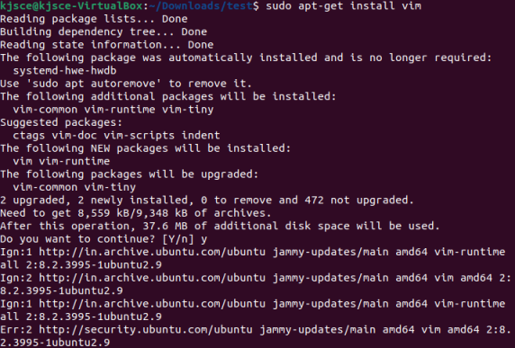
3. ssh - Secure Shell for remote login and command execution.
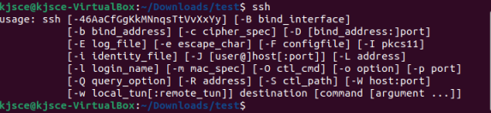
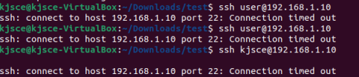
4. scp - Securely copy files between machines.
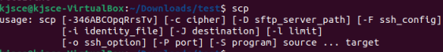
5. find - Search for files in a directory hierarchy.
6. awk - Pattern scanning and processing language.
7. sed - Stream editor for text transformations.
8. top - Display Linux tasks and system status in real-time.
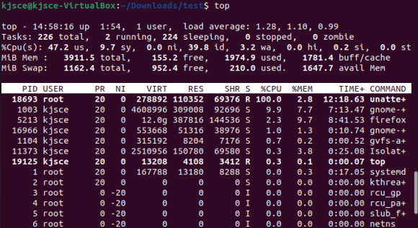
9. df - Report file system disk space usage.
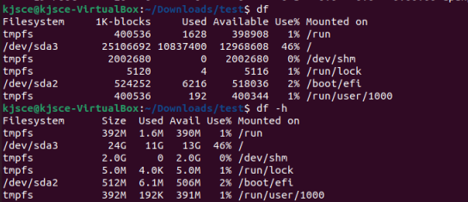
10. du - Estimate file space usage.
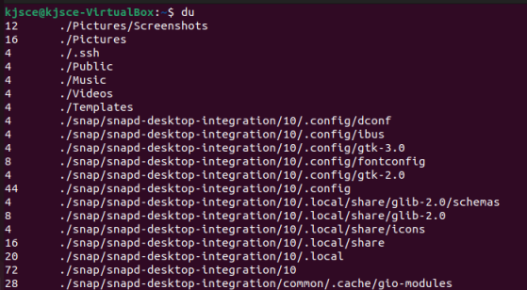
11. Edit .bash_profile file to print greeting based on time of the day. Execute the same.
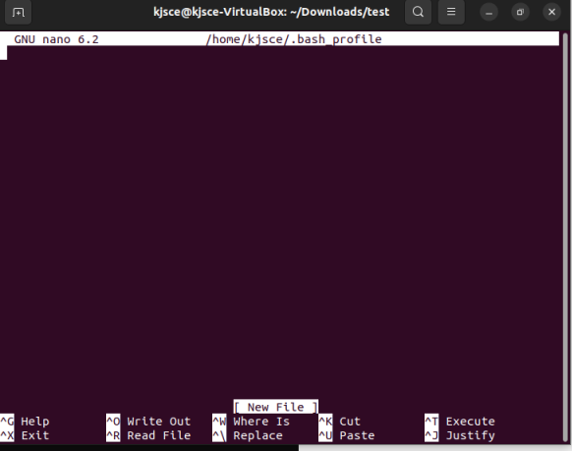
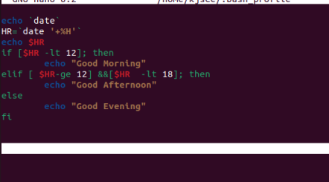
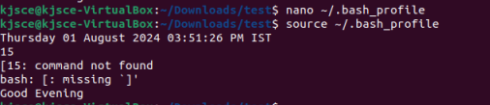
12. Run commands in multiple user profiles on same machine. (Hint: use hot keys)
Ctrl+Alt+F1 to Ctrl+Alt+F6 -Switch to different console
Ctrl+Alt+T- open new terminal
C. List of Windows OS Utilities for Exploration:
1. Task Manager :
- Purpose : Monitor system performance, view running processes, manage startup programs, and analyze resource usage (CPU, memory, disk, network).
- Usage : Identify resource-heavy processes, terminate unresponsive applications, and
monitor system health.
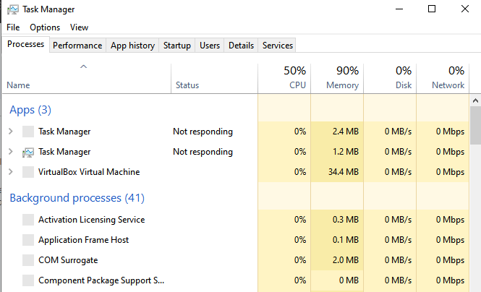
2. Resource Monitor :
- Purpose : Provides detailed real-time information about CPU, memory, disk, and network usage by processes and services.
- Usage : Monitor specific process performance, analyze disk activity, network usage, and identify resource bottlenecks.
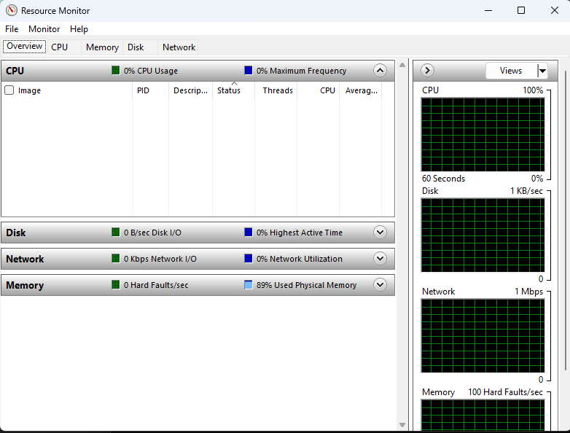
3. System Configuration (msconfig) :
- Purpose : Configure system startup, services, and startup programs.
- Usage : Enable/disable startup programs, manage boot options, and troubleshoot startup issues.
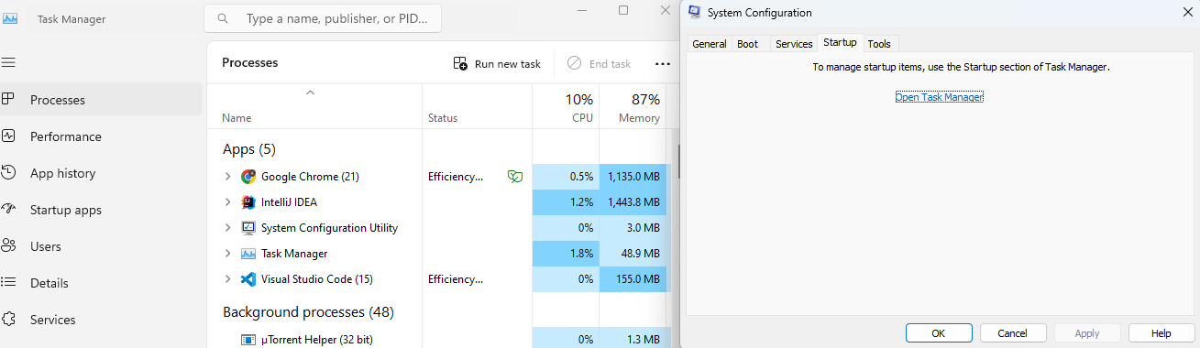
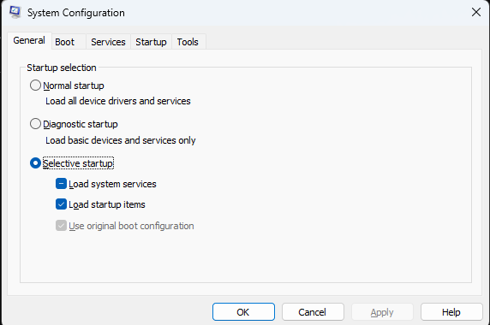
4. Disk Management :
- Purpose : Manage disk partitions, format disks, assign drive letters, and create/delete
volumes.
- Usage : Partition disks, extend/shrink volumes, convert disks between different formats, fragmentation/defragmentation(e.g., MBR to GPT).
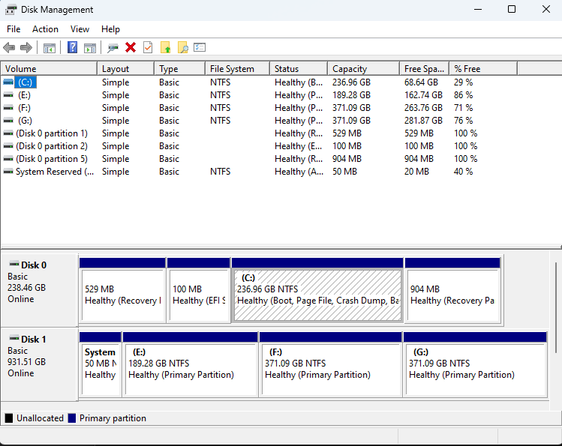
5. Event Viewer :
- Purpose : View system logs, application logs, and security logs to diagnose system and application issues.
- Usage : Investigate system errors, warnings, and information events to troubleshoot
problems and monitor system health.
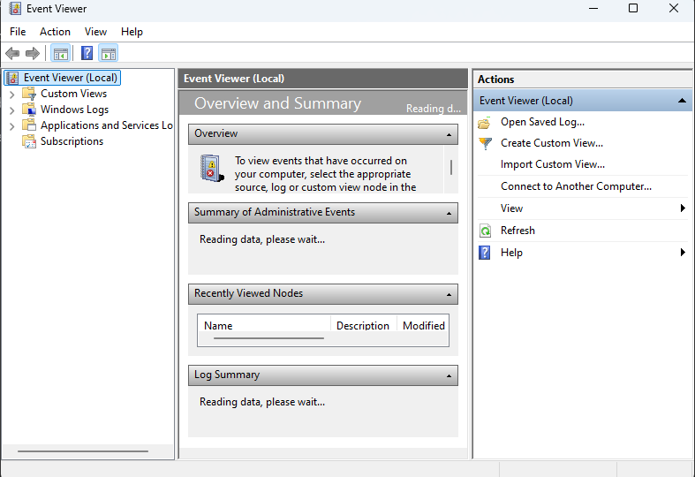
6. Performance Monitor :
- Purpose : Monitor and analyze system performance counters (CPU, memory, disk, network) over time.
- Usage : Create performance logs, set alerts based on performance thresholds, and analyze system performance trends.
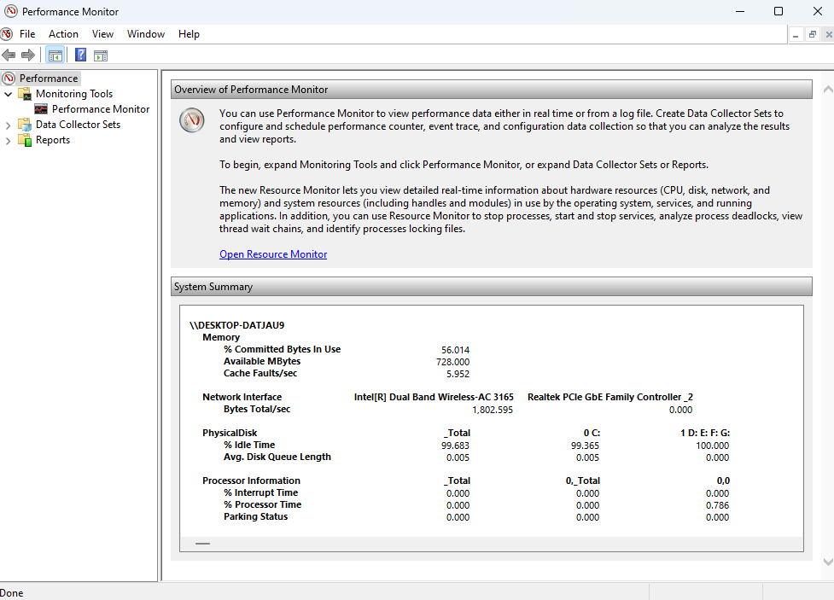
7. Task Scheduler :
- Purpose : Automate tasks and programs to run at specified times or events.
- Usage : Schedule disk cleanup, backups, maintenance tasks, and script executions.
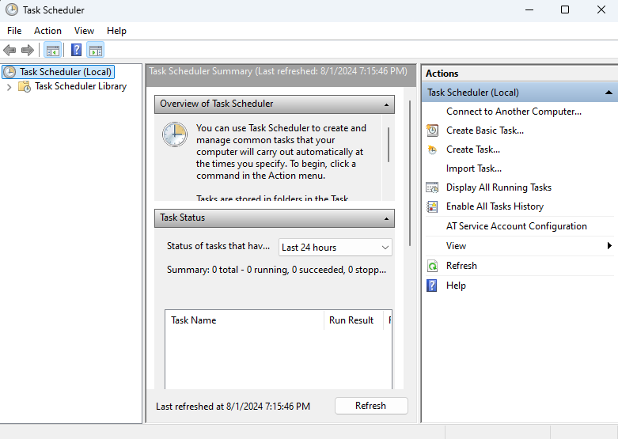
8. System Information (msinfo32) :
- Purpose : Provides detailed information about system hardware, components, software environment, and system settings.
- Usage : Retrieve system specifications, hardware details, installed software, and system configuration information.
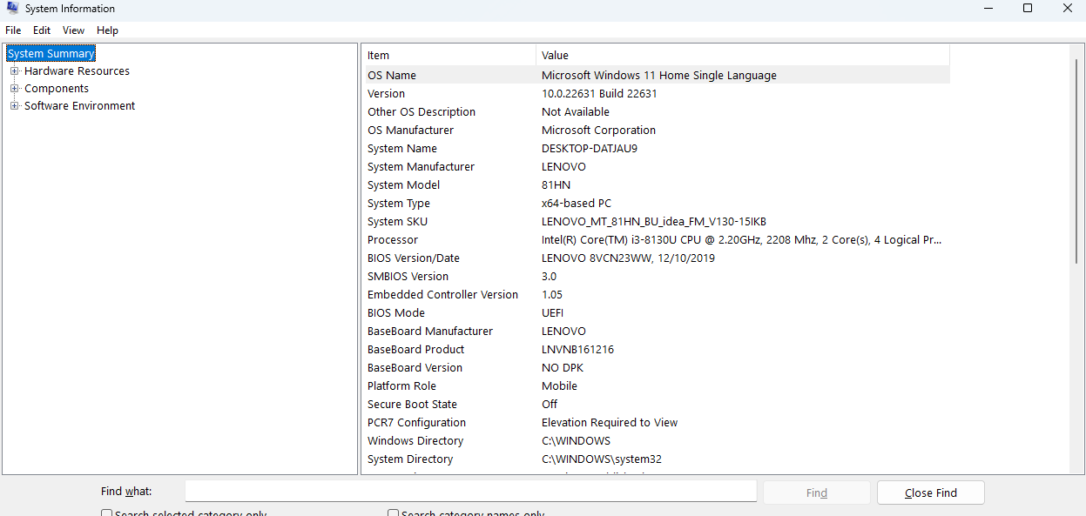
9. Registry Editor (Regedit) :
- Purpose : Edit and manage the Windows registry, which stores system configuration
settings and options.
- Usage : Modify registry keys and values, troubleshoot system settings, and configure
system behaviors.
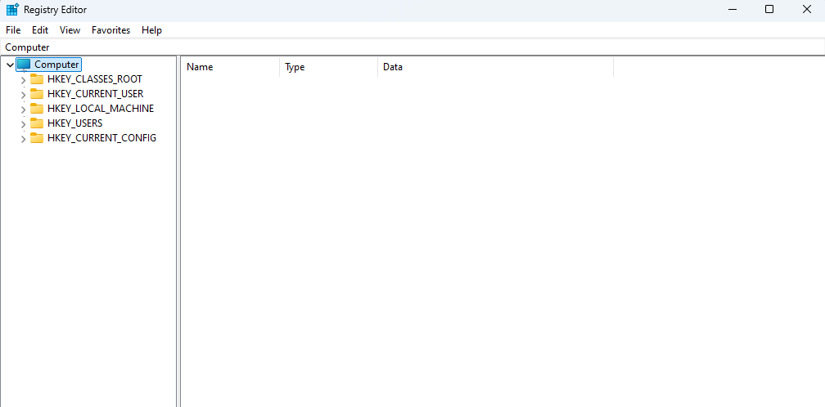

Task: check applications and programs those run on startup and enable/disable them as per personal preferences.

Conclusion:
Explored the basic as well as the basic and advanced features in the Windows and the Linux Operating System.

Post Lab Descriptive Questions

- Explain how do you read and interpret syntax of any OS command.

Reading and interpreting the syntax of an OS command involves understanding the command structure, which typically includes the command name, options/flags, and arguments. For example, consider the Unix command ls -l /home/user. Here's how to interpret it:

Command Name: ls is the command used to list directory contents.
Options/Flags: -l is an option that modifies the command's behavior to display detailed information (long format).
Arguments: /home/user is the argument specifying the target directory to list.
Understanding command syntax involves reading the command's manual or help page (e.g., using man ls or ls --help), which provides detailed descriptions of available options and arguments.

- Explain different functions of the operating systems.

Operating systems perform several key functions, including:

- Process Management: Handles creation, scheduling, and termination of processes.
- Memory Management: Manages memory allocation and deallocation, ensuring efficient use of RAM.
- File System Management: Provides a structure for data storage, retrieval, and organization in files and directories.
- Device Management: Manages hardware devices through drivers, facilitating communication between hardware and software.
- Security and Access Control: Protects system resources and data from unauthorized access and ensures user authentication.
- User Interface: Provides a user interface, such as a command-line interface (CLI) or graphical user interface (GUI), for interaction with the system.
- Networking: Facilitates communication between computers over a network, supporting protocols and services.

- What are the default permissions assigned by Unix for Directory.
In Unix-like systems, the default permissions for a newly created directory are typically 755 (rwxr-xr-x):

- Owner (User): rwx (read, write, and execute permissions)
- Group: r-x (read and execute permissions)
- Others: r-x (read and execute permissions)

These default permissions can be modified using the umask command, which sets the default file creation mode mask.

- Give the difference between DOS and WINDOWS.
• DOS (Disk Operating System):
- A command-line operating system without a graphical interface.
- Supports a single task and a single user at a time.
- Limited memory management capabilities.
- No native support for networking.
- Used primarily in early personal computers.

• Windows:
- A graphical operating system with a user-friendly interface.
- Supports multitasking and multiple users.
- Advanced memory management and virtual memory support.
- Built-in networking capabilities.
- Widely used in modern personal computers and supports a wide range of applications.

- Explain Booting Process.
The booting process is the sequence of events that occurs when a computer is powered on and starts up. It includes the following steps:
  - Power-On Self-Test (POST): The system's firmware checks the hardware components to ensure they are functioning properly.
  - Bootloader Execution: The system's firmware (BIOS or UEFI) loads the bootloader from the bootable storage device.
  - Operating System Kernel Loading: The bootloader loads the operating system kernel into memory.
  - Kernel Initialization: The kernel initializes system components, such as memory management and device drivers.
  - System Daemons and Services Start: System services and background processes are started.
  - User Interface Launch: The user interface (CLI or GUI) is launched, allowing user interaction.
The booting process is crucial for preparing the system to run applications and provide a usable environment for the user.

Date: 01/08/2024 Signature of faculty in-charge

