Batch: A2 Roll No.: 16010122034

Experiment No. 02

Grade: AA / AB / BB / BC / CC / CD /DD

Signature of the Staff In-charge with date

TITLE: Shell Programming
_____________________________________________________________________

AIM: To study the shell script and write the program using shell.
______________________________________________________________________
Expected Outcome of Experiment:

CO 1. To introduce basic concepts and functions of operating systems.
_____________________________________________________________________
Books/ Journals/ Websites referred:

- Silberschatz A., Galvin P., Gagne G. “Operating Systems Principles”, Willey Eighth edition.
- William Stallings “Operating Systems” Person, Seventh Edition
Edition.
- Sumitabha Das “ UNIX Concepts & Applications”, McGraw Hill Second
Edition.
_____________________________________________________________________
Pre Lab/ Prior Concepts:

The shell provides you with an interface to the UNIX system. It gathers input from you and executes programs based on that input. When a program finishes executing, it displays that program's output.

Shell Scripts
The basic concept of a shell script is a list of commands, which are listed in the order of execution. A good shell script will have comments, preceded by a pound sign, #, describing the steps.

Steps to create a Shell Script:
create a file using any text editor say vi, gedit, nano etc
1.$ vi filename

2.Insert the script/ commands in file and save the file to execute the file we need to give execute permission to the file
3.$ chmod 775 filename
4.Now execute the above file using any of following methods:
$ sh filename
OR
$ ./filename

NOTE: Before adding anything to your script, you need to alert the system that a shell script is being started. This is done using the shebang construct. For example −
#!/bin/sh.
______________________________________________________________________
Description of the application to be implemented:
- Write a shell Script that accepts two file names as command line arguments and compare two file contents and check whether contents are same or not. If they are the same, then delete the second file.

- Write a shell script that accepts integers and find the factorial of the number.

- Write a shell script for adding users.

- Write a shell script for counting no of logged in users.

- Write a shell script for counting no of processes running on system

Implementation details: (printout of code / screen shot)
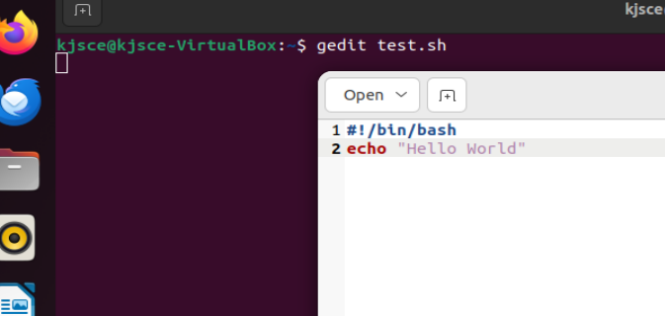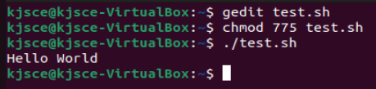
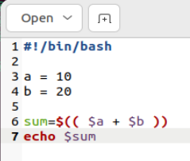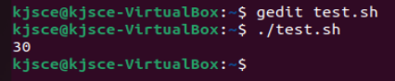

Write a shell Script that accepts two file names as command line arguments and compare two file contents and check whether contents are same or not. If they are the same, then delete the second file.
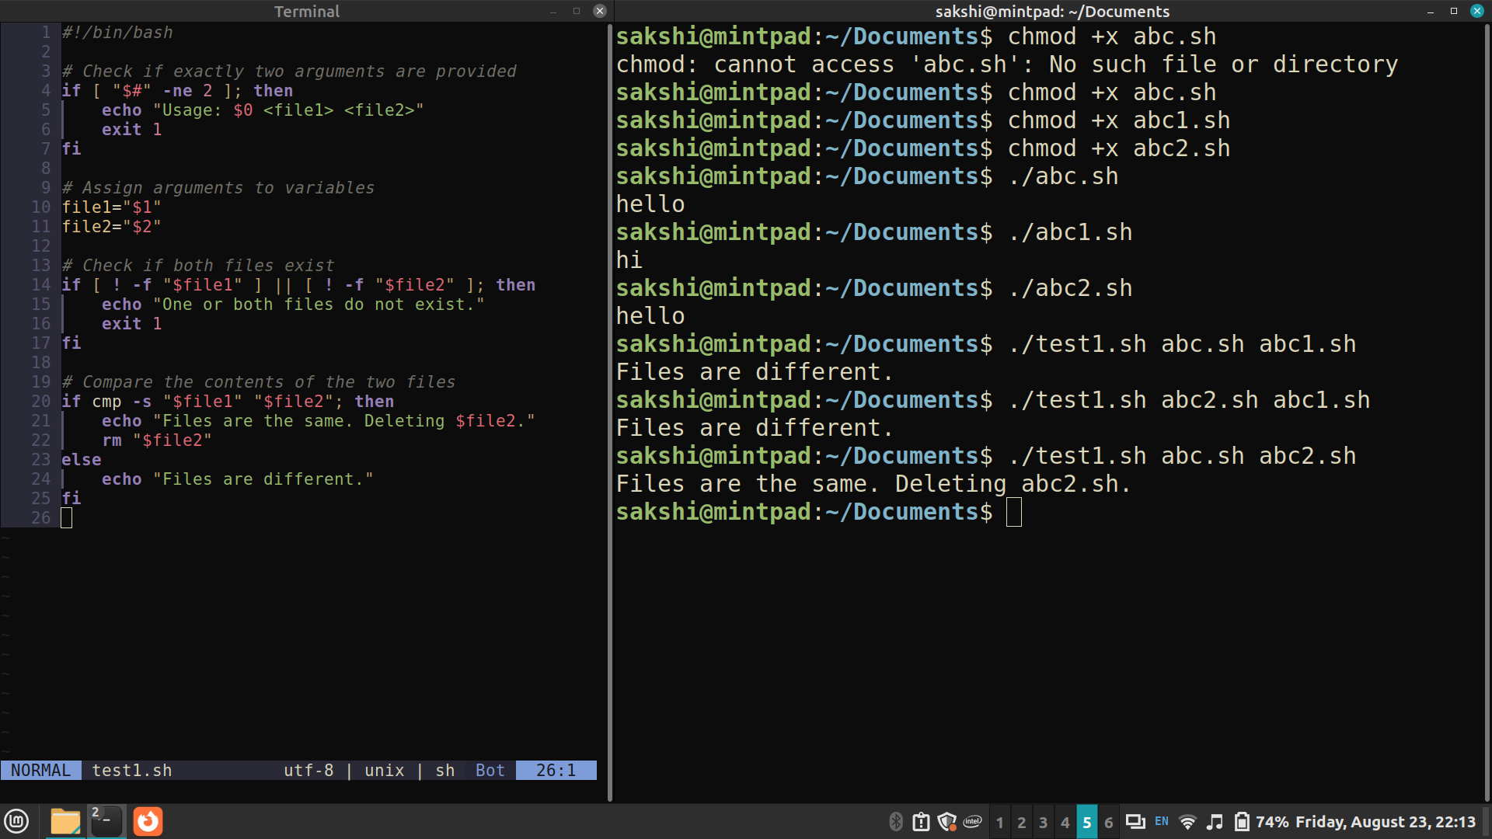

Write a shell script that accepts an integer and find the factorial of the number.

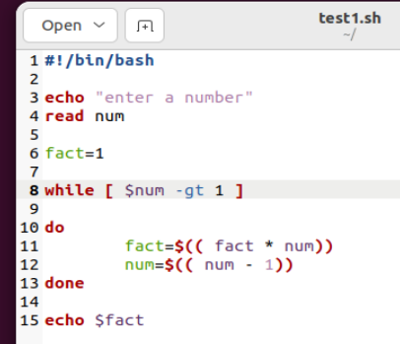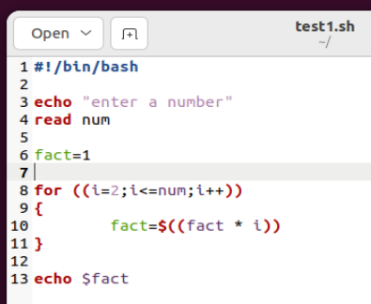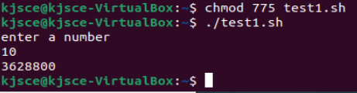

Write a shell script for adding users.

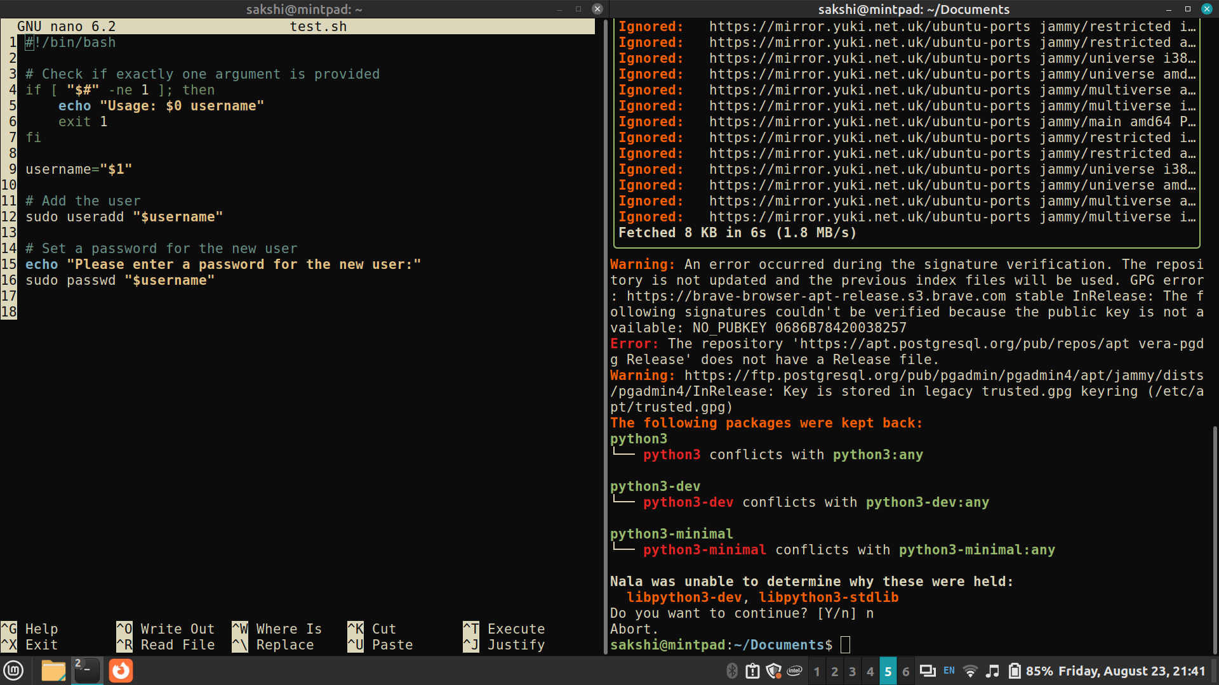
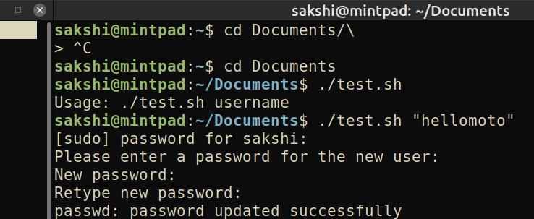

Write a shell script for counting no of logged in users.
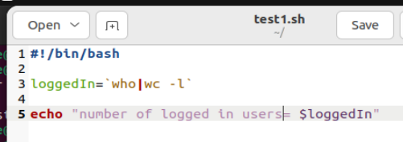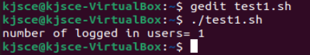
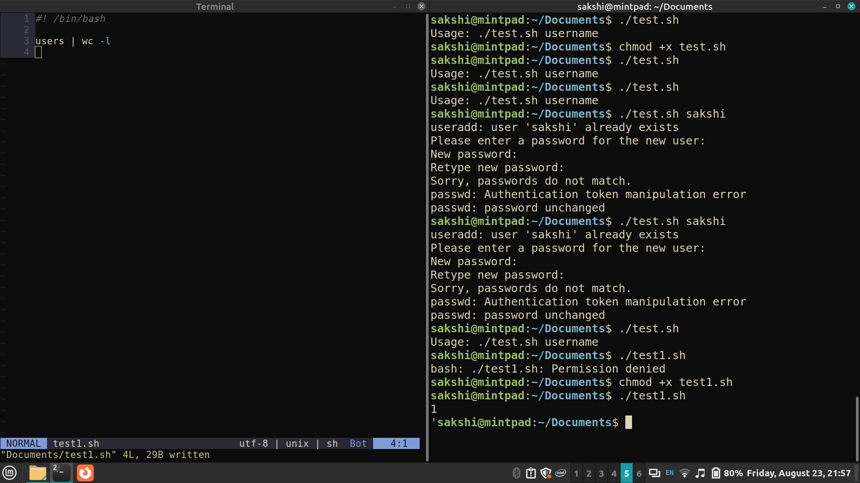

Write a shell script for counting no of processes running on system

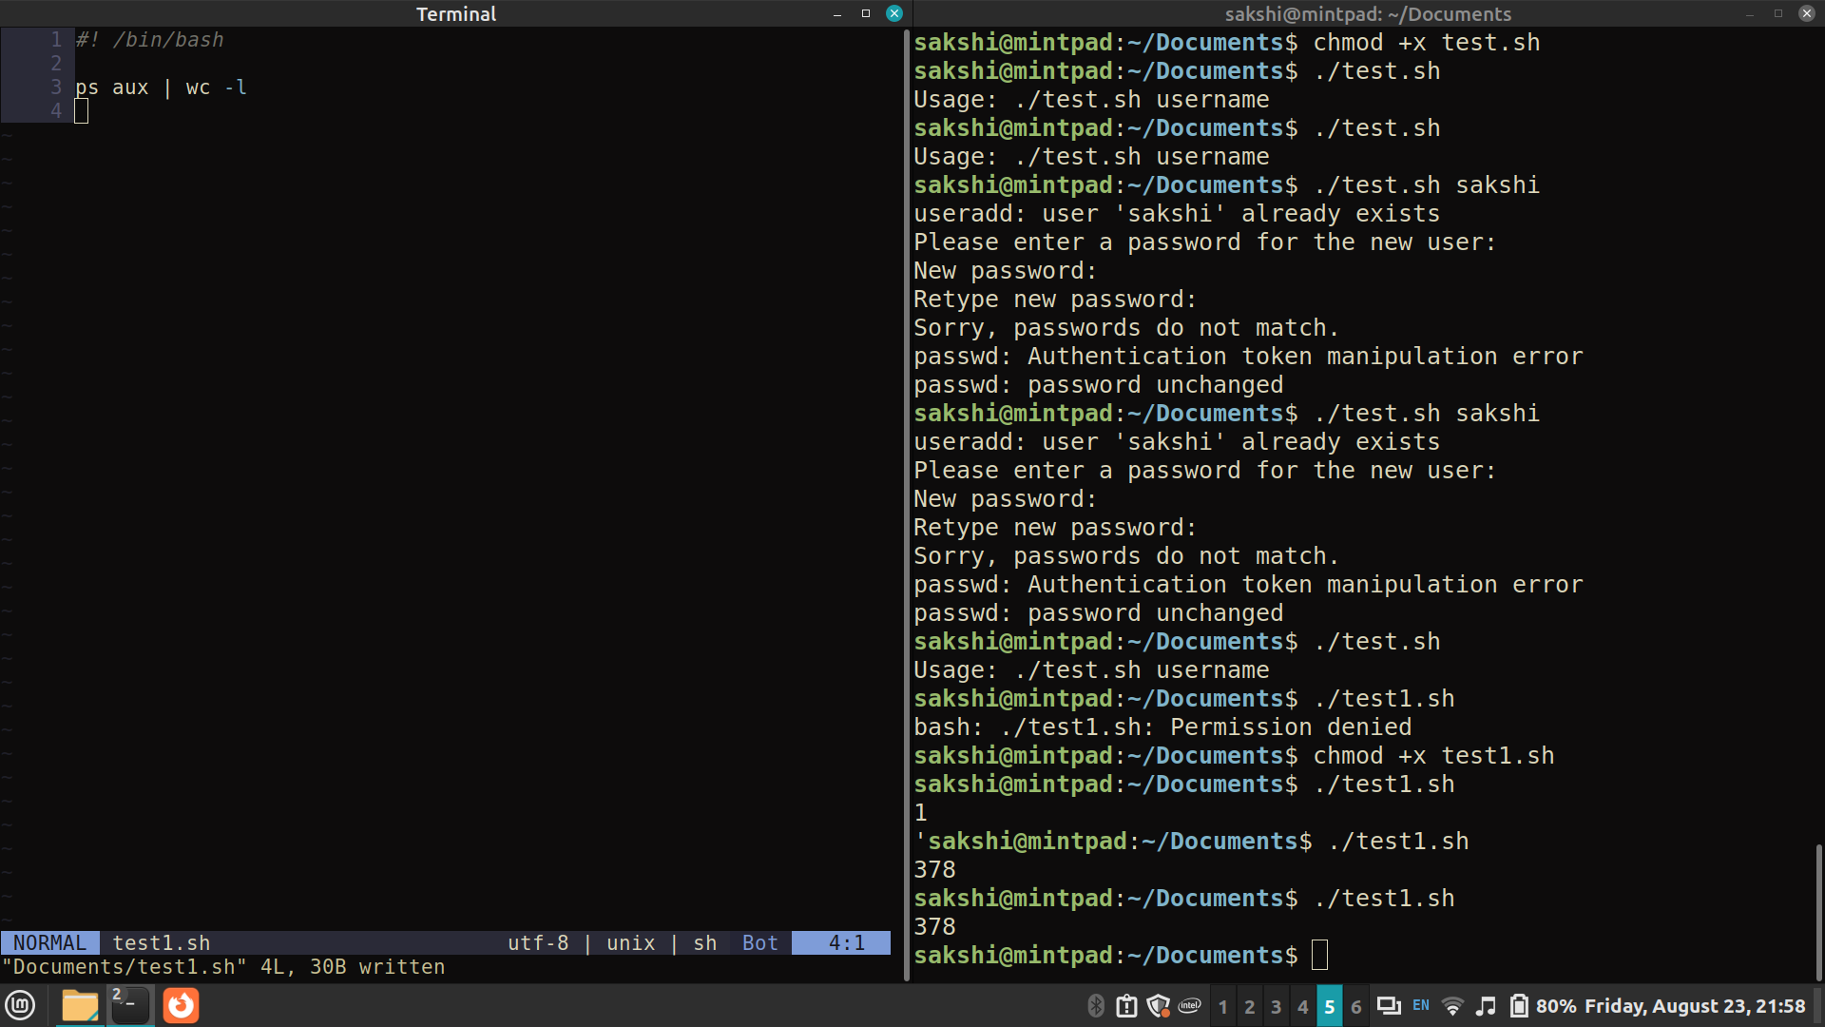
Conclusion :

Through this experiment, I gained a practical understanding of shell scripting and its applications in automating tasks and system management. The hands-on experience with writing and executing shell scripts enhanced my comprehension of various Linux shells and their scripting capabilities, while also familiarizing me with basic system call operations in UNIX-like environments.
Post Lab Descriptive Questions

- What are the different types of commonly used shells on a typical linux system?

Commonly Used Shells on a Typical Linux System
Bash (Bourne Again Shell):
Default: Most common shell and often the default on many Linux distributions.
Features: Scripting capabilities, command history, job control, and more.
Zsh (Z Shell):
Customization: Highly customizable with themes and plugins (e.g., Oh My Zsh).
Features: Advanced scripting features, better autocompletion, and shared history.
Fish (Friendly Interactive Shell):
User-friendly: Focuses on simplicity and user-friendliness.
Features: Built-in syntax highlighting, autosuggestions, and no need for scripting configuration.
Ksh (Korn Shell):
Compatibility: Backward-compatible with the Bourne shell (sh) and includes many features from the C shell (csh).
Features: Enhanced scripting capabilities, floating-point arithmetic, and associative arrays.
Tcsh (Tenex C Shell):
C-like syntax: An improved version of csh, with a C-like syntax.
Features: Command-line completion, history mechanism, and script programming features.
Dash (Debian Almquist Shell):
Performance: Designed to be lightweight and fast.
Use: Often used as /bin/sh in many systems due to its speed and simplicity.

- How do you find out what’s your shell?
To find out which shell you are using, you can use the following commands:
Check the $SHELL environment variable:
echo $SHELL
This will output the path of the shell binary, e.g., /bin/bash.

Check the current running shell with ps:
ps -p $$
This will display the name of the current shell process.

Use the echo command:
echo $0
This will print the name of the shell currently running.

- List the advantages and disadvantages of shell scripting.
Advantages:
- Automation: Shell scripts can automate repetitive tasks, reducing manual effort and error.
- Easy to Learn and Use: Shell scripting languages like Bash are relatively easy to learn, especially for those familiar with the command line.
- Integration: Shell scripts can easily interact with other command-line tools and utilities.
- Portability: Shell scripts can often run on any UNIX-like system with little or no modification.
- Rapid Prototyping: Scripts can be written and tested quickly for small to medium-sized tasks.
Disadvantages:
- Performance: Shell scripts can be slower than programs written in compiled languages, especially for complex tasks.
- Limited Functionality: Shell scripts are not suitable for large, complex applications or systems with significant performance requirements.
- Error Handling: Error handling in shell scripts can be more cumbersome compared to other programming languages.
- Maintenance: As shell scripts grow in size and complexity, they can become difficult to maintain and debug.
- Security Risks: Shell scripts can introduce security vulnerabilities if not written carefully, especially when dealing with user input or file permissions.

Date: 25/10/2024 Signature of faculty in-charge

