TITLE: Implementation of Basic Process management algorithms – Non Pre-emptive ( FCFS , SJF, priority)

AIM: To implement basic Non –Preemptive Process management algorithms ( FCFS , SJF , Priority)

Batch: A2
Roll No.: 16010122034
Signature of the Staff In-charge with date
Experiment No. 04

Grade: AA / AB / BB / BC / CC / CD / DD

Expected Outcome of Experiment:

CO 2. To understand the concept of process, thread and resource management.

Books/ Journals/ Websites referred:

- Silberschatz A., Galvin P., Gagne G. “Operating Systems Principles”, Willey Eight edition.
- Achyut S. Godbole , Atul Kahate “Operating Systems” McGraw Hill Third Edition.
- William Stallings, “Operating System Internal & Design Principles”, Pearson.
- Andrew S. Tanenbaum, “Modern Operating System”, Prentice Hall.

Pre Lab/ Prior Concepts:

Most systems have a large number of processes with short CPU bursts interspersed between I/O requests and a small number of processes with long CPU bursts. To provide good time-sharing performance, we may preempt a running process to let another one run. The ready list, also known as a run queue, in the operating system keeps a list of all

processes that are ready to run and not blocked on some I/O or other system request, such as a semaphore. Then entries in this list are pointers to the process control block, which stores all information and state about a process.

When an I/O request for a process is complete, the process moves from the waiting state to the ready state and gets placed on the run queue.

The process scheduler is the component of the operating system that is responsible for deciding whether the currently running process should continue running and, if not, which process should run next. There are four events that may occur where the scheduler needs to step in and make this decision:

- The current process goes from the running to the waiting state because it issues an I/O request or some operating system request that cannot be satisfied immediately.
- The current process terminates.

- A timer interrupt causes the scheduler to run and decide that a process has run for its allotted interval of time and it is time to move it from the running to the ready state.
- An I/O operation is complete for a process that requested it and the process now moves from the waiting to theready state. The scheduler may then decide to preempt the currently-running process and move this ready process into the running state.
The decisions that the scheduler makes concerning the sequence and length of time that processes may run is called the scheduling algorithm (or scheduling policy). These decisions are not easy ones, as the scheduler has only a limited amount of information about the processes that are ready to run. A good scheduling algorithm should:

  - Be fair – give each process a fair share of the CPU, allow each process to run in a reasonable amount of time.
  - Be efficient – keep the CPU busy all the time.
  - Maximize throughput – service the largest possible number of jobs in a given amount of time; minimize the amount of time users must wait for their results.

  - Minimize response time – interactive users should see good performance
  - Minimize overhead – don’t waste too many resources. Keep scheduling time and context switch time at a minimum.
  - Maximize resource use – favor processes that will use underutilized resources. There are two motives for this. Most devices are slow compared to CPU operations. We’ll achieve better system throughput by keeping devices busy as often as possible. The second reason is that a process may be holding a key resource and other, possibly more important, processes cannot use it until it is released. Giving the process more CPU time may free up the resource quicker.
  - Avoid indefinite postponement – every process should get a chance to run eventually.

Description of the application to be implemented:
- First-Come, First-Served Scheduling (FCFS):
Code:
#include <iostream>
#include <vector>
#include <algorithm>

using namespace std;

struct Process {
int pid;
int arrivalTime;
int burstTime;
};

void findWaitingTime(vector<Process>& processes, vector<int>& waitingTime) {
waitingTime[0] = 0;
for (int i = 1; i < processes.size(); i++) {
waitingTime[i] = processes[i - 1].burstTime + waitingTime[i - 1];
}
}
void findTurnaroundTime(vector<Process>& processes, vector<int>& waitingTime, vector<int>& turnaroundTime) {
for (int i = 0; i < processes.size(); i++) {
turnaroundTime[i] = processes[i].burstTime + waitingTime[i];
}
}

void findAvgTime(vector<Process>& processes) {
vector<int> waitingTime(processes.size()), turnaroundTime(processes.size());

findWaitingTime(processes, waitingTime);
findTurnaroundTime(processes, waitingTime, turnaroundTime);

cout << "Processes Arrival Time Burst Time Waiting Time Turn-Around Time\n";
int totalWaitingTime = 0, totalTurnaroundTime = 0;
for (int i = 0; i < processes.size(); i++) {
totalWaitingTime += waitingTime[i];
totalTurnaroundTime += turnaroundTime[i];
cout << " " << processes[i].pid << "\t\t"
<< processes[i].arrivalTime << "\t\t"
<< processes[i].burstTime << "\t\t"
<< waitingTime[i] << "\t\t"
<< turnaroundTime[i] << "\n";
}

cout << "Average waiting time = " << (float)totalWaitingTime / processes.size() << "\n";
cout << "Average turn-around time = " << (float)totalTurnaroundTime / processes.size() << "\n";
}

int main() {
vector<Process> processes = {{1, 0, 24}, {2, 1, 3}, {3, 2, 3}};

cout << "First-Come, First-Served Scheduling\n";
findAvgTime(processes);
return 0;
}

Output:
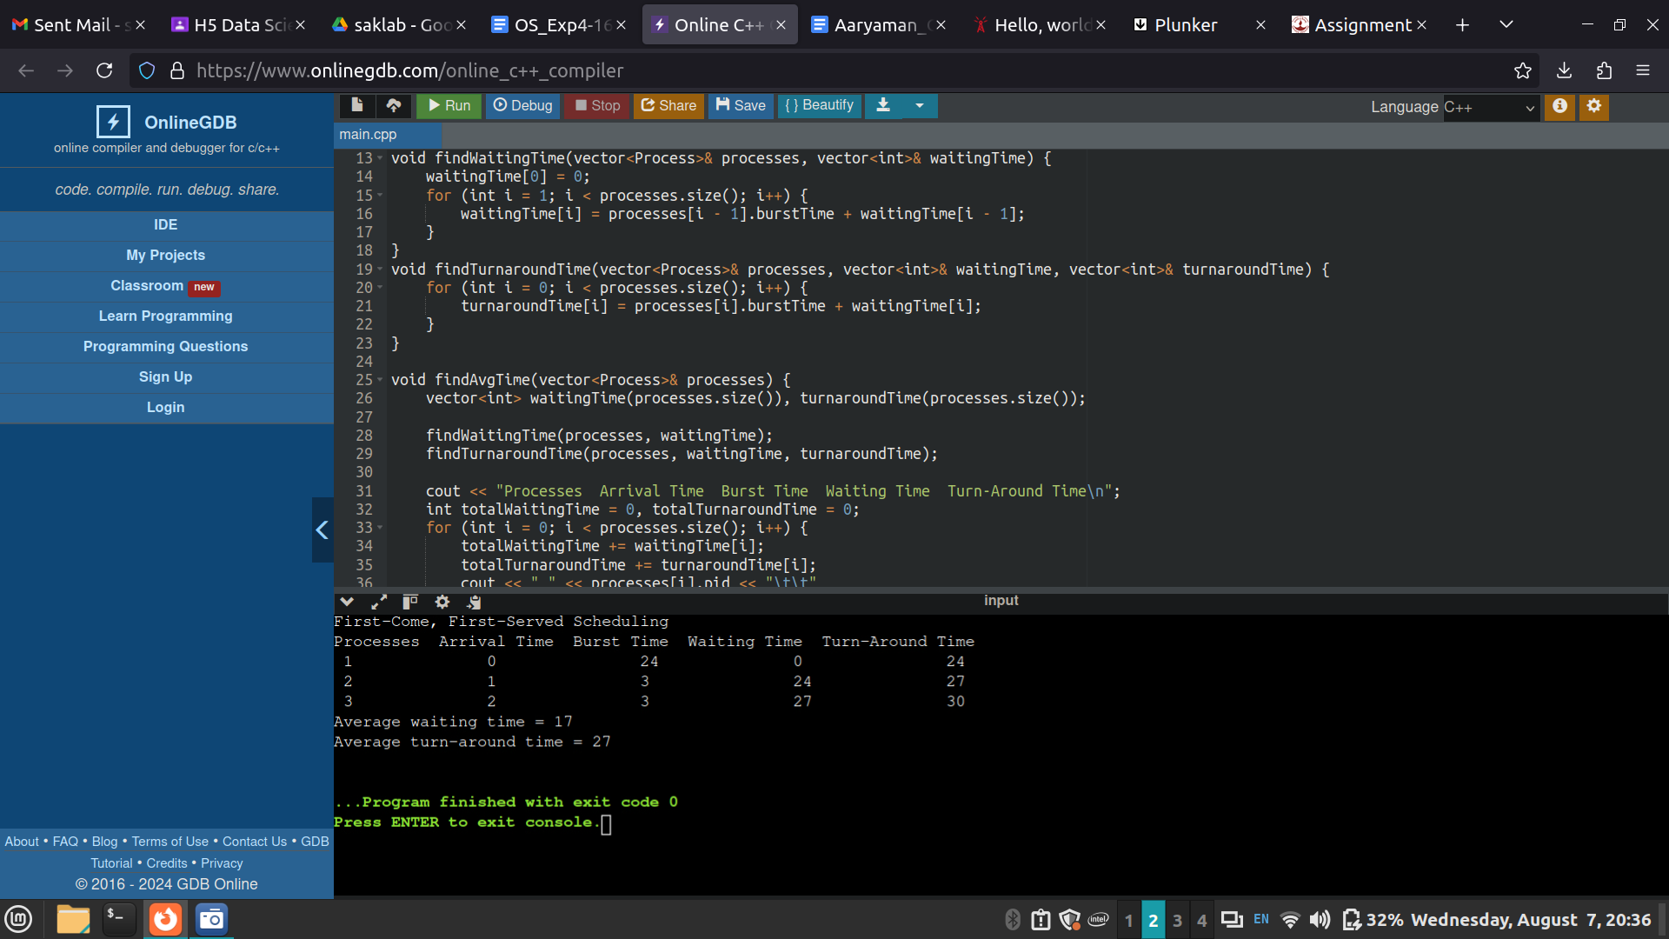

- Shortest job first (SJF):

Code:
#include <iostream>
#include <vector>
#include <algorithm>

struct Process {
int id;
int arrivalTime;
int burstTime;
int waitingTime;
int turnaroundTime;
};

bool compareArrival(Process a, Process b) {
return a.arrivalTime < b.arrivalTime;
}

bool compareBurst(Process a, Process b) {
return a.burstTime < b.burstTime;
}

int main() {
int n;
std::cout << "Enter the number of processes: ";
std::cin >> n;

std::vector<Process> processes(n);

for (int i = 0; i < n; i++) {
processes[i].id = i + 1;
std::cout << "Enter arrival time and burst time for process " << i + 1 << ": ";
std::cin >> processes[i].arrivalTime >> processes[i].burstTime;
}

std::sort(processes.begin(), processes.end(), compareArrival);

int currentTime = 0;
std::vector<Process> readyQueue;
std::vector<Process> completedProcesses;

while (!processes.empty() || !readyQueue.empty()) {
while (!processes.empty() && processes.front().arrivalTime <= currentTime) {
readyQueue.push_back(processes.front());
processes.erase(processes.begin());
}

if (!readyQueue.empty()) {
std::sort(readyQueue.begin(), readyQueue.end(), compareBurst);
Process currentProcess = readyQueue.front();
readyQueue.erase(readyQueue.begin());

currentProcess.waitingTime = currentTime - currentProcess.arrivalTime;
currentTime += currentProcess.burstTime;
currentProcess.turnaroundTime = currentTime - currentProcess.arrivalTime;
completedProcesses.push_back(currentProcess);
} else {
currentTime++;
}
}

std::cout << "\nProcess ID\tArrival Time\tBurst Time\tWaiting Time\tTurnaround Time\n";
for (auto& p : completedProcesses) {
std::cout << p.id << "\t\t" << p.arrivalTime << "\t\t" << p.burstTime
<< "\t\t" << p.waitingTime << "\t\t" << p.turnaroundTime << "\n";
}

return 0;
}

Output:
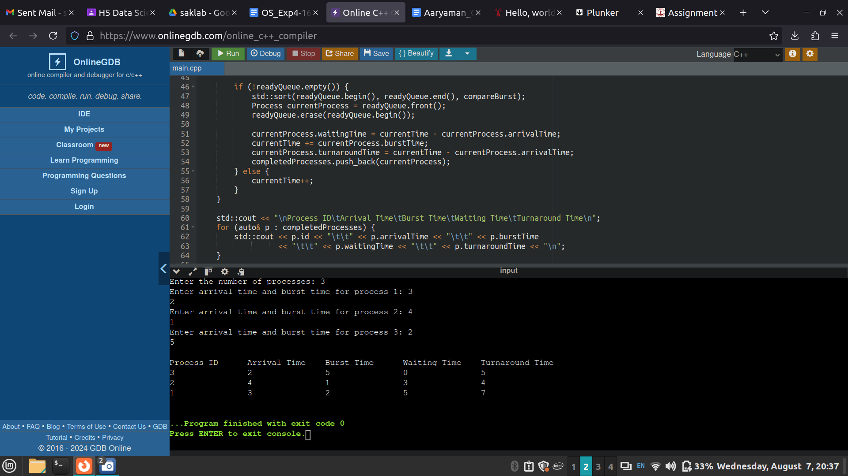

- Priority scheduling
Code:
#include <iostream>
#include <vector>
#include <algorithm>

struct Process {
int pid;
int arrival_time;
int burst_time;
int priority;
int start_time;
int completion_time;
int turnaround_time;
int waiting_time;
};

bool compareArrival(Process a, Process b) {
return a.arrival_time < b.arrival_time;
}

bool comparePriority(Process a, Process b) {
if (a.arrival_time == b.arrival_time)
return a.priority < b.priority;
return a.arrival_time < b.arrival_time;
}

int main() {
int n;
std::cout << "Enter number of processes: ";
std::cin >> n;

std::vector<Process> processes(n);

for (int i = 0; i < n; i++) {
processes[i].pid = i + 1;
std::cout << "Enter arrival time for process " << i + 1 << ": ";
std::cin >> processes[i].arrival_time;
std::cout << "Enter burst time for process " << i + 1 << ": ";
std::cin >> processes[i].burst_time;
std::cout << "Enter priority for process " << i + 1 << ": ";
std::cin >> processes[i].priority;
}

std::sort(processes.begin(), processes.end(), comparePriority);

int current_time = 0;
for (int i = 0; i < n; i++) {
if (current_time < processes[i].arrival_time)
current_time = processes[i].arrival_time;
processes[i].start_time = current_time;
processes[i].completion_time = current_time + processes[i].burst_time;
processes[i].turnaround_time = processes[i].completion_time - processes[i].arrival_time;
processes[i].waiting_time = processes[i].turnaround_time - processes[i].burst_time;
current_time += processes[i].burst_time;
}

std::cout << "\nProcess\tArrival\tBurst\tPriority\tStart\tCompletion\tTurnaround\tWaiting\n";
for (int i = 0; i < n; i++) {
std::cout << processes[i].pid << "\t" << processes[i].arrival_time << "\t" << processes[i].burst_time << "\t"
<< processes[i].priority << "\t\t" << processes[i].start_time << "\t" << processes[i].completion_time << "\t\t"
<< processes[i].turnaround_time << "\t\t" << processes[i].waiting_time << "\n";
}

return 0;
}

Output:

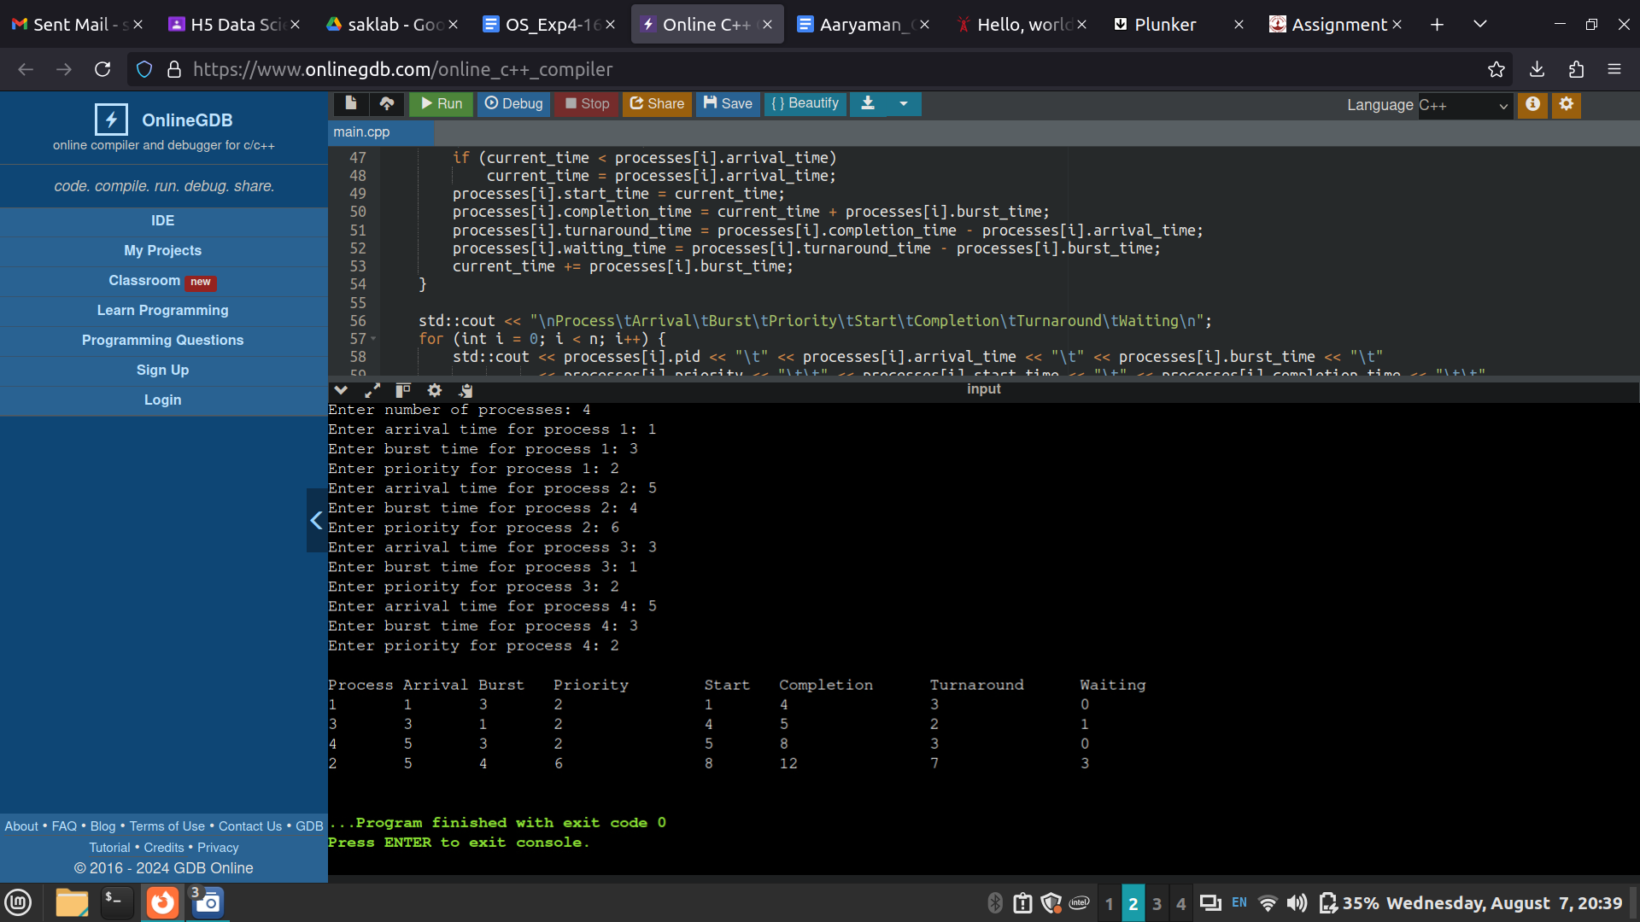

Post Lab Objective Questions

- What is the ready state of a process?
  - when process is scheduled to run after some execution
  - when process is unable to run until some task has been completed
  - when process is using the CPU
  - none of the mentioned
Ans:a)

- A process stack does not contain
  - function parameters
  - local variables
  - return addresses
  - PID of child process
Ans:d)

- A process can be terminated due to
  - normal exit
  - fatal error
  - killed by another process
  - all of the mentioned
Ans:d)

Date: 25/10/2024 Signature of faculty in-charge

