Batch: B1 Roll No.: 16010122158

Experiment No. 05

Grade: AA / AB / BB / BC / CC / CD / DD

Signature of the Staff In-charge with date

TITLE: Implementation of Basic Process management algorithms – Pre-emptive (SRTN, RR, priority)
_____________________________________________________________________

AIM: To implement basic Process management algorithms (Round Robin, SRTN, Priority)
______________________________________________________________________
Expected Outcome of Experiment:

CO 2. To understand the concept of process, thread and resource management.
_____________________________________________________________________
Books/ Journals/ Websites referred:

- Silberschatz A., Galvin P., Gagne G. “Operating Systems Principles”, Willey Eight edition.
- Achyut S. Godbole , Atul Kahate “Operating Systems” McGraw Hill Third
Edition.
- William Stallings, “Operating System Internal & Design Principles”, Pearson.
- Andrew S. Tanenbaum, “Modern Operating System”, Prentice Hall.
_____________________________________________________________________
Pre Lab/ Prior Concepts:

Most systems have a large number of processes with short CPU bursts interspersed between I/O requests and a small number of processes with long CPU bursts. To provide good time-sharing performance, we may pre-empt a running process to let another one run. The ready list, also known as a run queue, in the operating system keeps a list of all processes that are ready to run and not blocked on some I/O or other system request, such as a semaphore. Then entries in this list are pointers to the process control block, which stores all information and state about a process.
When an I/O request for a process is complete, the process moves from the waiting state to the ready state and gets placed on the run queue.
The process scheduler is the component of the operating system that is responsible for deciding whether the currently running process should continue running and, if not, which process should run next. There are four events that may occur where the scheduler needs to step in and make this decision:
- The current process goes from the running to the waiting state because it issues an I/O request or some operating system request that cannot be satisfied immediately.
- The current process terminates.
- A timer interrupt causes the scheduler to run and decide that a process has run for its allotted interval of time and it is time to move it from the running to the ready state.
- An I/O operation is complete for a process that requested it and the process now moves from the waiting to the ready state. The scheduler may then decide to pre-empt the currently-running process and move this ready process into the running state.
The decisions that the scheduler makes concerning the sequence and length of time that processes may run is called the scheduling algorithm (or scheduling policy). These decisions are not easy ones, as the scheduler has only a limited amount of information about the processes that are ready to run. A good scheduling algorithm should:
- Be fair – give each process a fair share of the CPU, allow each process to run in a reasonable amount of time.
- Be efficient – keep the CPU busy all the time.
- Maximize throughput – service the largest possible number of jobs in a given amount of time; minimize the amount of time users must wait for their results.
- Minimize response time – interactive users should see good performance
- Minimize overhead – don’t waste too many resources. Keep scheduling time and context switch time at a minimum.
- Maximize resource use – favor processes that will use underutilized resources. There are two motives for this. Most devices are slow compared to CPU operations. We’ll achieve better system throughput by keeping devices busy as often as possible. The second reason is that a process may be holding a key resource and other, possibly more important, processes cannot use it until it is released. Giving the process more CPU time may free up the resource quicker.
- Avoid indefinite postponement – every process should get a chance to run eventually.
_____________________________________________________________________
Description of the application to be implemented:
Round Robin Algorithm:
Round Robin is a CPU scheduling algorithm where each process is assigned a fixed time slot in a cyclic way. It is simple, easy to implement, and starvation-free as all processes get a fair share of CPU. It is pre-emptive as processes are assigned CPU only for a fixed slice of time at most. The disadvantage of the Round Robin Algorithm is that it has to bear the overhead due to context switching.

Shortest Remaining Time First Algorithm:
In the Shortest Remaining Time First (SRTF) scheduling algorithm, the process with the smallest amount of time remaining until completion is selected to execute. Since the currently executing process is the one with the shortest amount of time remaining by definition, and since that time should only reduce as execution progresses, processes will always run until they complete or a new process is added that requires a smaller amount of time.

Priority scheduling:
Each process is assigned first arrival time (less arrival time process first) if two processes have same arrival time, then compare to priorities (highest process first). Also, if two processes have the same priority then compare to process number (less process number first). This process is repeated while all processes get executed.

Implementation details: (printout of code)
Shortest Time Remaining First function:
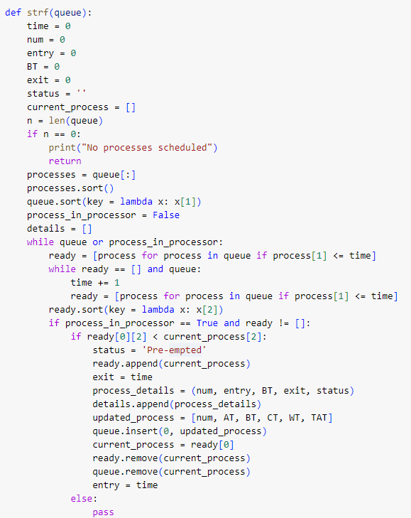
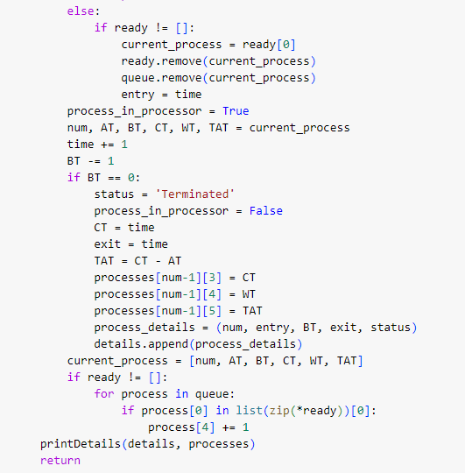
Function to accept all available processes as input:
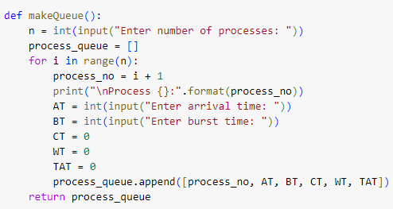
Function to print process details:
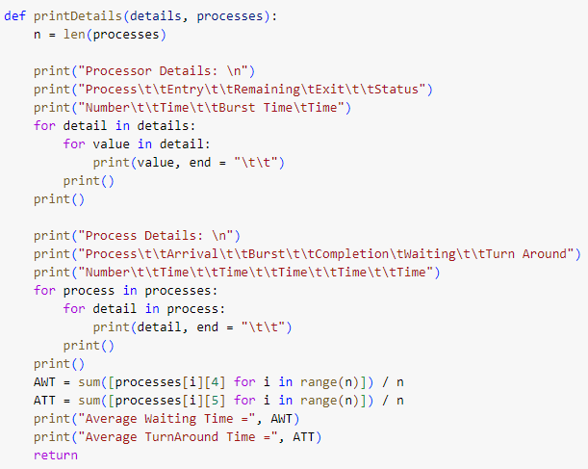
Driver code:
queue = makeQueue()
strf(queue)

Output:
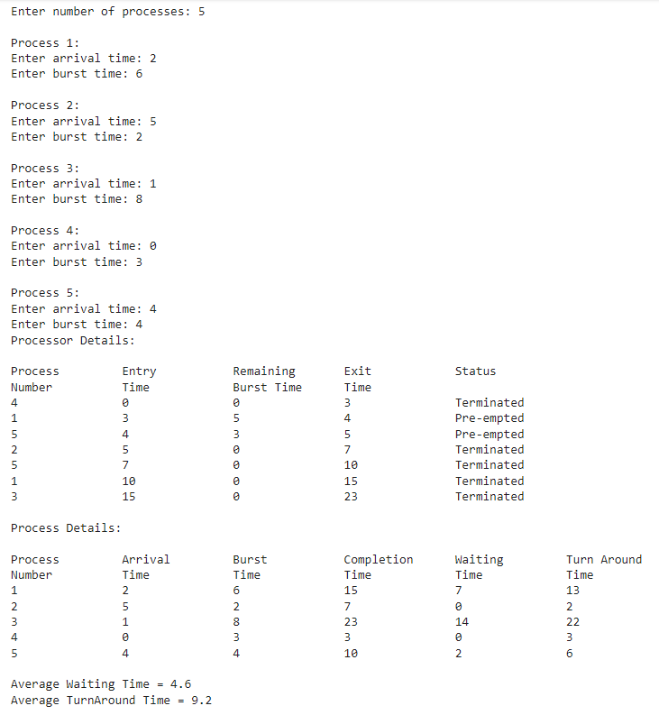

Priority Scheduling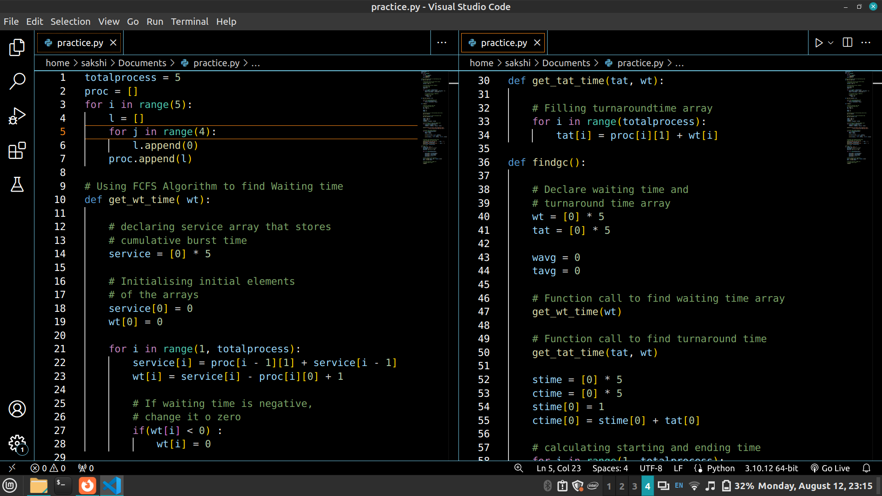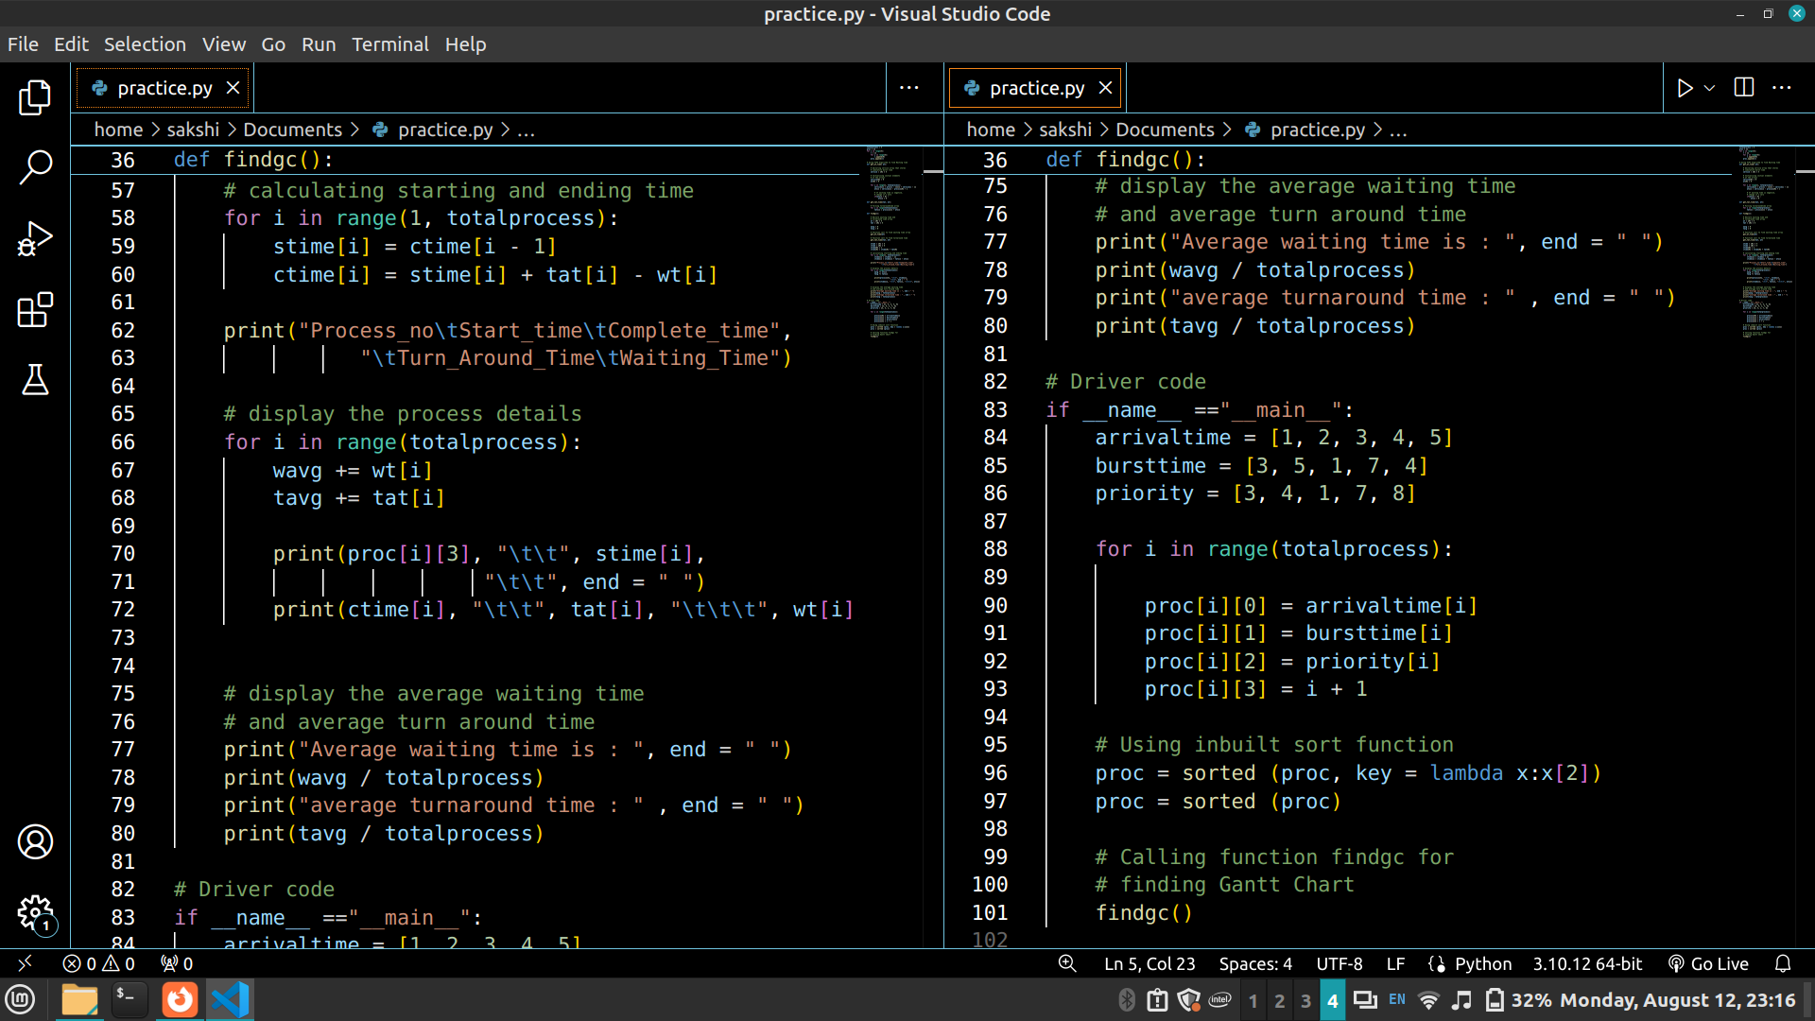

Output:
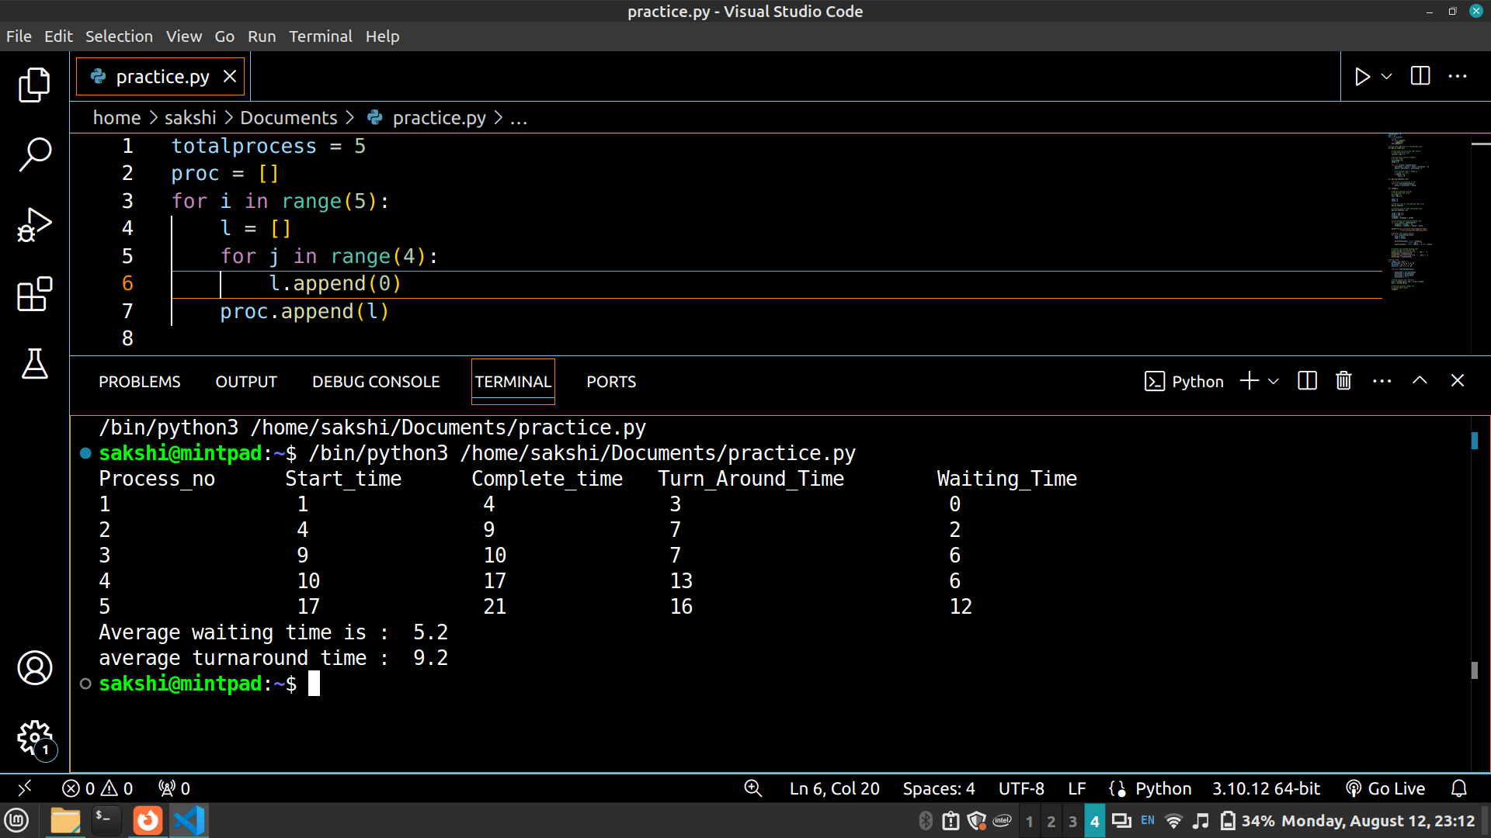

Round Robin
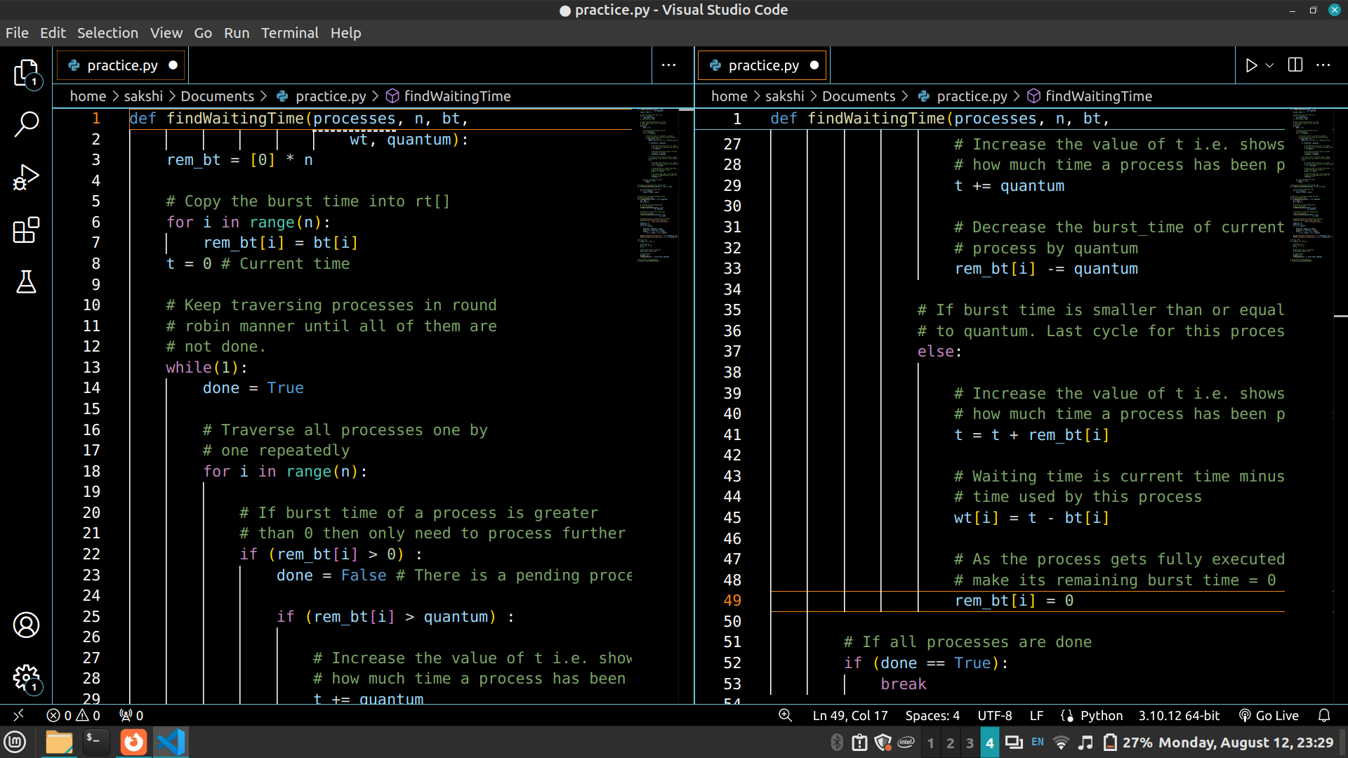

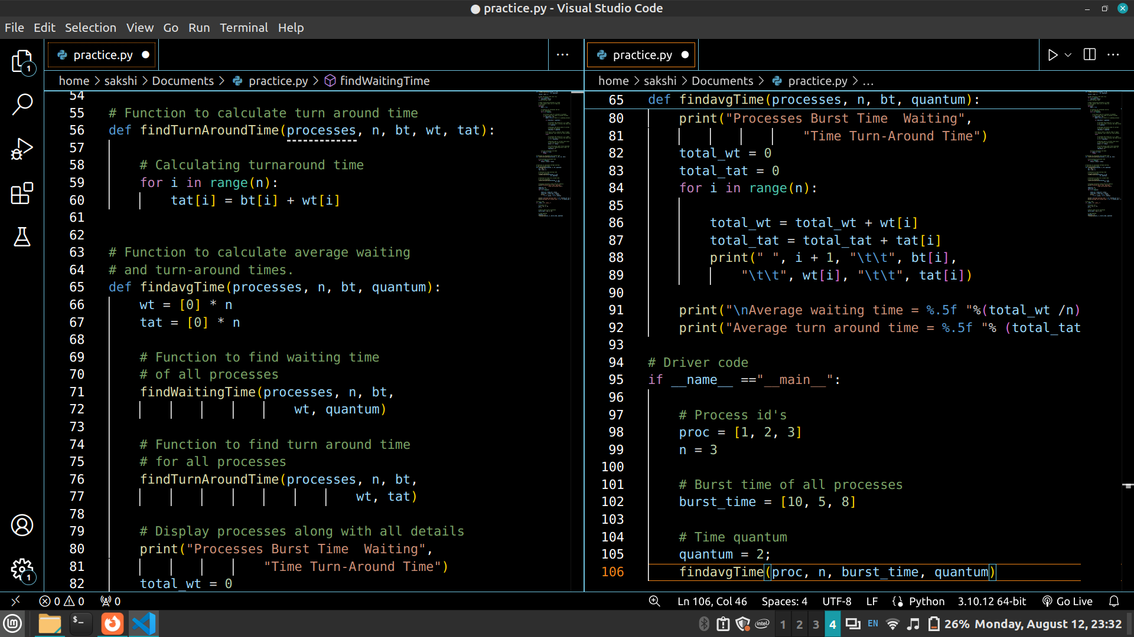


Output
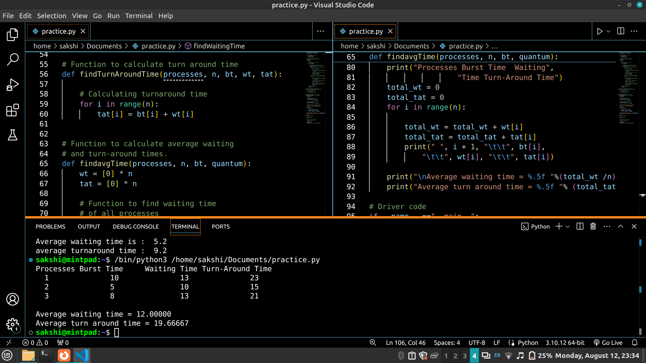
Conclusion:
Successfully implemented Round Robin, SRTN, Priority.

Post Lab Descriptive Questions

- Consider three processes, all arriving at time zero, with total execution time of 10, 20 and 30 units, respectively. Each process spends the first 20% of execution time doing I/O, the next 70% of time doing computation, and the last 10% of time doing I/O again. The operating system uses a shortest remaining compute time first scheduling algorithm and schedules a new process either when the running process gets blocked on I/O or when the running process finishes its compute burst. Assume that all I/O operations can be overlapped as much as possible. For what percentage of time does the CPU remain idle?
Total execution time:
Process 1 | Process 2 | Process 3
10 | 20 | 30

First 20% of time required for I/O:
Process 1 | Process 2 | Process 3
2 | 4 | 6

CPU will remain idle for first 2 units, when all three processes are blocked for I/O operations.

Last 10% of time required for I/O:
Process 1 | Process 2 | Process 3
1 | 2 | 3

CPU time required by processes:
Process 1 | Process 2 | Process 3
7 | 14 | 21

Thus, processes will exit CPU at following time:
Process 1 | Process 2 | Process 3
9 | 23 | 44

Neither process requires CPU time after the 44th unit. Process 3 needs 3 more units for its I/O operation, CPU will remain idle during that time.

Thus total CPU idle time = 2 + 3 = 5 units
Total time required = 47 units
CPU idle time % = $\frac{5}{47}×100$ = 10.638 %

- What is Starvation?
Starvation is a problem typically in priority scheduling algorithms, that occurs when lower priority processes cannot execute for indefinite time due to incoming higher priority processes.

Date: 25/10/2024 Signature of faculty in-charge

