Batch: A2 Roll No.: 16010122034

Experiment No. 02

Grade: AA / AB / BB / BC / CC / CD /DD

Signature of the Staff In-charge with date

Title: Implementation of ‘McCulloch Pitts Net for NAND and AND NOT function
___________________________________________________________________________________
Objective: To implement MP Neuron Model for the NAND and AND NOT logical function
___________________________________________________________________________________
Expected Outcome of Experiment:

CO1 : Identify and describe soft computing techniques and their roles ____________________________________________________________________________________
Books/ Journals/ Websites referred:

_________________________________________________________________________________
Pre Lab/ Prior Concepts:

McCulloch-Pitts Neuron

The first computational model of a neuron was proposed by Warren MuCulloch (neuroscientist) and Walter Pitts (logician) in 1943.

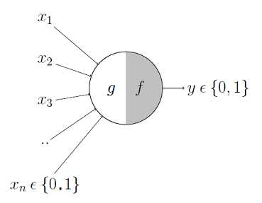

It may be divided into 2 parts. The first part, g takes an input (ahem dendrite ahem), performs an aggregation and based on the aggregated value the second part, f makes a decision.

These inputs can either be excitatory or inhibitory. Inhibitory inputs are those that have maximum effect on the decision making irrespective of other inputs i.e., if the inhibitory input is ON than the neuron will never fire. Excitatory inputs are NOT the ones that will make the neuron fire on their own but they might fire it when combined together. Formally, this is what is going on:
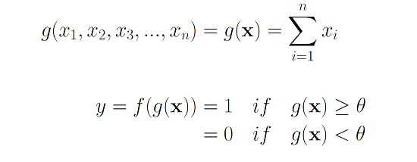
We can see that g(x) is just doing a sum of the inputs — a simple aggregation. And theta here is called thresholding parameter. For example, if I always watch the game when the sum turns out to be 2 or more, the theta is 2 here. This is called the Thresholding Logic.

Boolean Functions Using M-P Neuron

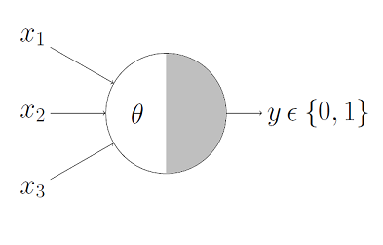

This representation just denotes that, for the boolean inputs x_1, x_2 and x_3 if the g(x) i.e., sum ≥ theta, the neuron will fire otherwise, it won’t.

AND Function
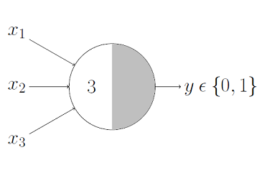
An AND function neuron would only fire when ALL the inputs are ON i.e., g(x) ≥ 3 here.
OR Function
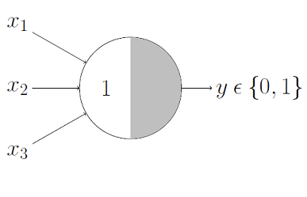
I believe this is self explanatory as we know that an OR function neuron would fire if ANY of the inputs is ON i.e., g(x) ≥ 1 here.

AND NOT function (write here)
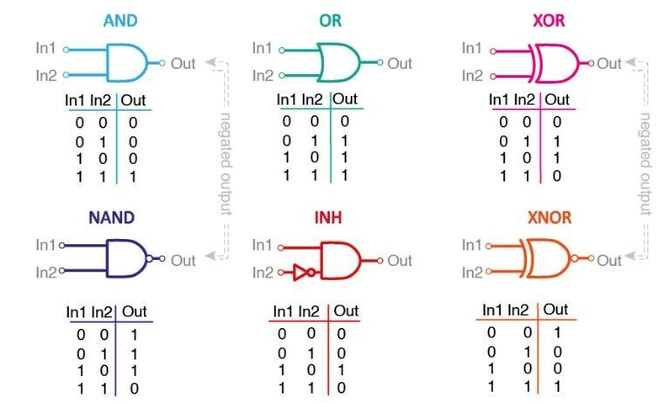
NAND function (write here)

____________________________________________________________________________________
Implementation Details:

Write the code for implementation of MP neuron model for NAND and AND NOT function

CODE: AND NOT

include <iostream>
include <vector>
include <numeric> // For std::accumulate

class McCullochPittsNeuron {
public:
McCullochPittsNeuron(const std::vector<int>& weights)
: weights(weights) {
// Calculate the threshold (θ) for AND NOT
threshold = -std::accumulate(weights.begin(), weights.end(), 0) + 1;
}

int activation(const std::vector<int>& inputs) {
int weighted_sum = 0;
for (size_t i = 0; i < weights.size(); ++i) {
weighted_sum += weights[i] * inputs[i];
}
return (weighted_sum);
}

int getThreshold() const {
return threshold;
}

private:
std::vector<int> weights;
int threshold;
};

int main() {
// Number of inputs
int num_inputs = 2; // AND NOT has 2 inputs (A, B)

// Input weights
std::vector<int> weights(num_inputs);
std::cout << "Enter the weights (for AND NOT, provide weights for A and B): ";
for (int i = 0; i < num_inputs; ++i) {
std::cin >> weights[i];
}

// Create the neuron
McCullochPittsNeuron neuron(weights);

// Display the calculated threshold
std::cout << "Calculated threshold (θ): " << neuron.getThreshold() << std::endl;

// Define the input combinations for the AND NOT function
std::vector<std::vector<int>> inputs = {
{0, 0},
{0, 1},
{1, 0},
{1, 1}
};

// Evaluate the neuron on each input
std::cout << "Evaluating AND NOT function:" << std::endl;
for (const auto& input : inputs) {
int output = neuron.activation(input);
std::cout << "Input: (" << input[0] << ", " << input[1] << "), Output: " << output << std::endl;
}

return 0;
}

Output

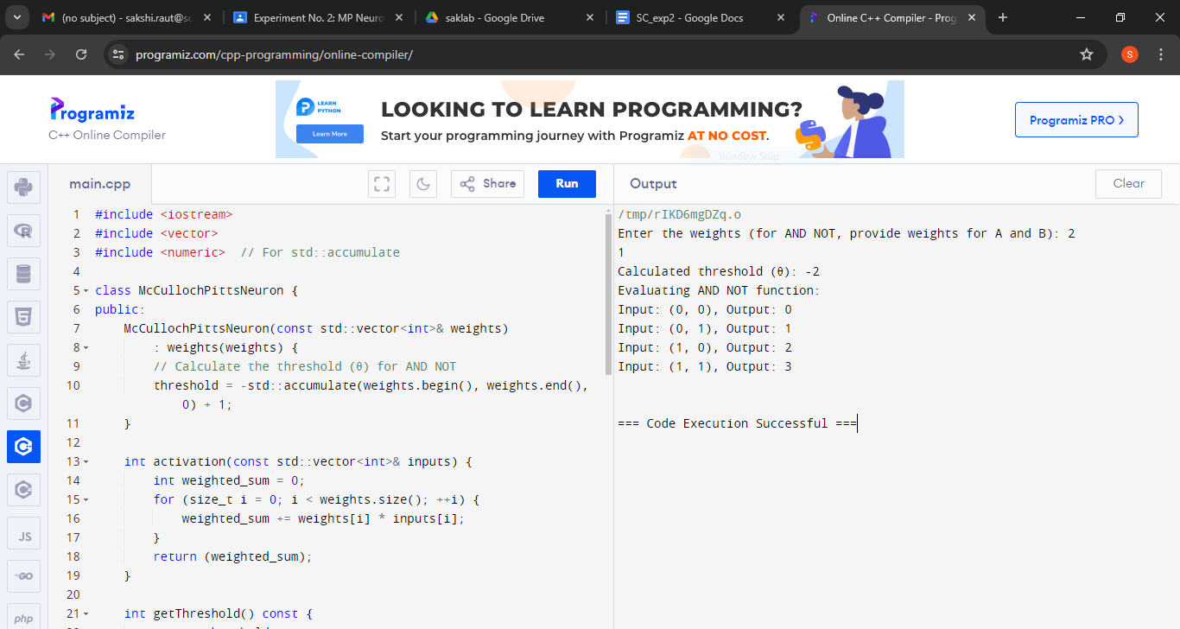

CODE: NAND

include <iostream>
include <vector>
include <numeric> // For std::accumulate

class McCullochPittsNeuron {
public:
McCullochPittsNeuron(const std::vector<int>& weights)
: weights(weights) {
// Calculate the threshold for NAND
threshold = -std::accumulate(weights.begin(), weights.end(), 0) + 1;
}

int activation(const std::vector<int>& inputs) {
int weighted_sum = 0;
for (size_t i = 0; i < weights.size(); ++i) {
weighted_sum += weights[i] * inputs[i];
}
return (weighted_sum);
}

int getThreshold() const {
return threshold;
}

private:
std::vector<int> weights;
int threshold;
};

int main() {
// Number of inputs
int num_inputs;
std::cout << "Enter the number of inputs: ";
std::cin >> num_inputs;

// Input weights
std::vector<int> weights(num_inputs);
std::cout << "Enter the weights: ";
for (int i = 0; i < num_inputs; ++i) {
std::cin >> weights[i];
}

// Create the neuron
McCullochPittsNeuron neuron(weights);

// Display the calculated threshold
std::cout << "Calculated threshold (θ): " << neuron.getThreshold() << std::endl;

// Define the input combinations for the NAND function
std::vector<std::vector<int>> inputs = {
{0, 0},
{0, 1},
{1, 0},
{1, 1}
};

// Evaluate the neuron on each input
for (const auto& input : inputs) {
int output = neuron.activation(input);
std::cout << "Input: (" << input[0] << ", " << input[1] << "), Output: " << output << std::endl;
}

return 0;
}

Output
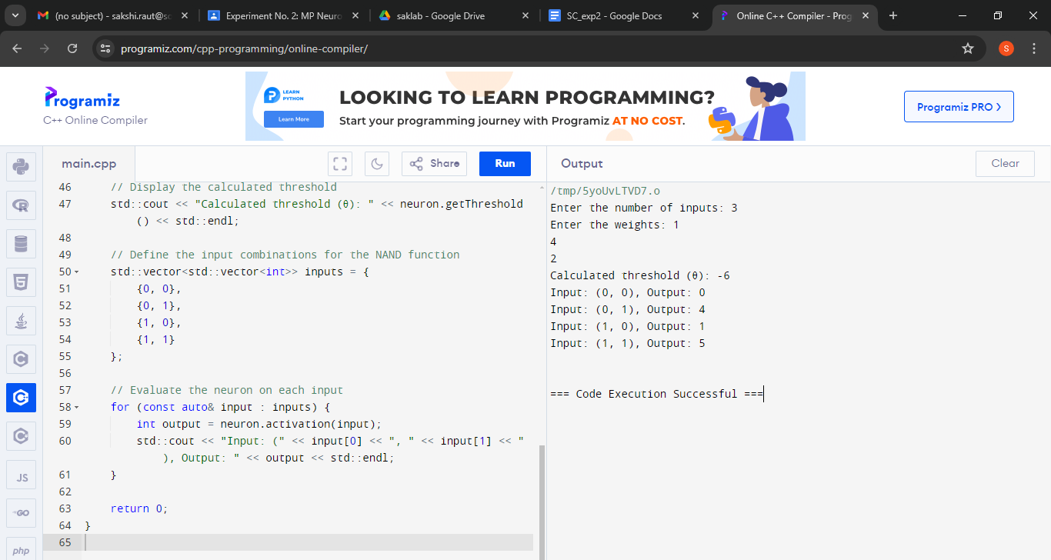

Conclusion: Thus, we have successfully implemented MP neuron model for NAND and AND NOT logical function

Post Lab Descriptive Questions :

- Discuss the limitations of MP neuron model

The McCulloch-Pitts (MP) neuron model is an early and fundamental model of artificial neurons, but it has several limitations:

1. Simplistic Activation Function: The MP neuron uses a binary step function (Heaviside step function) as its activation function, which outputs either 0 or 1 based on whether the weighted sum of inputs exceeds a certain threshold. This binary nature is too simplistic and doesn't capture the nuances of real biological neurons, which exhibit a range of responses.

2. No Learning Mechanism: The MP neuron does not include any mechanism for learning from experience or adjusting weights based on performance. It lacks the ability to adapt or improve over time, which limits its usefulness for practical applications.

3. Limited Complexity: The MP model can only solve problems that are linearly separable. It cannot handle more complex problems where the decision boundary is not a straight line. This makes it unsuitable for many real-world problems, which often require more sophisticated models.

4. No Temporal Dynamics: The MP neuron does not account for temporal aspects of input signals. Biological neurons have complex temporal dynamics and can integrate information over time, which the MP model does not consider.

5. No Representation of Biological Neurons: While inspired by biological neurons, the MP model does not accurately represent the complex behaviors of real neurons, such as varying firing rates, neurotransmitter effects, and network interactions.

- Explain with an example the concept of linear separability and Justify NOT XOR function is not linearly separable.

Linear Separability

A dataset or a problem is said to be linearly separable if it is possible to draw a straight line (or hyperplane in higher dimensions) that separates the different classes in the dataset without any errors.

Example of Linear Separability:
Imagine a 2D plane with two classes of points: red and blue. If you can draw a straight line on this plane such that all red points are on one side of the line and all blue points are on the other side, the dataset is linearly separable.

XOR Function and Linear Separability

The XOR function, where XOR stands for "exclusive OR," is a binary function defined as follows:

- XOR(0, 0) = 0
- XOR(0, 1) = 1
- XOR(1, 0) = 1
- XOR(1, 1) = 0

If we plot these points on a 2D plane, they form the following pattern:

- (0, 0) -> 0
- (0, 1) -> 1
- (1, 0) -> 1
- (1, 1) -> 0

To determine if the XOR function is linearly separable, consider the following plot:

- The points (0, 0) and (1, 1) belong to class 0.
- The points (0, 1) and (1, 0) belong to class 1.

You will notice that no straight line can separate the two classes without making some errors:

- A single line cannot simultaneously separate (0, 1) and (1, 0) from (0, 0) and (1, 1) because the XOR function's classes are interleaved.

This illustrates that the XOR function is not linearly separable. To solve XOR, a more complex model like a neural network with one hidden layer (a multi-layer perceptron) is needed. This model can create non-linear decision boundaries that can handle such patterns.

Date: 22/10/2024 Signature of faculty in-charge

