Batch: A2 Roll No.: 16010122034

Experiment No. 06

Grade: AA / AB / BB / BC / CC / CD / DD

Signature of the Staff In-charge with date

Title: To implement XOR LOGIC using perceptron network. .
___________________________________________________________________________________
Objective: Implement multilayer perceptron for XOR function with binary inputs and target.
___________________________________________________________________________________
Expected Outcome of Experiment:

CO2 : Analyze various neural network architectures ____________________________________________________________________________________
Books/ Journals/ Websites referred:

- Principles of Soft Computing by Sivanandan
- Introduction to Artificial Neural Systems by Zurada
____________________________________________________________________________________
Pre Lab/ Prior Concepts:

Perceptron Model

The Perceptron is the simplest type of artificial neural network, consisting of a single layer of neurons. It is mainly used for binary classification tasks and operates by classifying input data into one of two categories.
Working:
- Inputs: Each input has an associated weight, which determines the input's importance.
- Weighted Sum: The inputs are multiplied by their weights and summed up.
- Activation Function: The result is passed through a step activation function (such as the Heaviside function) to produce a binary output (0 or 1).
Key Concept:
- Learning: The perceptron adjusts the weights using a learning algorithm (e.g., Gradient Descent) to minimize classification errors.
The Perceptron can only classify data that is linearly separable, meaning the data can be perfectly divided by a straight line (in 2D) or hyperplane (in higher dimensions).

Linear separability

Linear separability refers to the ability to separate two classes of data points using a straight line, plane, or hyperplane.
Definition:
- A dataset is linearly separable if there exists a line (in 2D), plane (in 3D), or hyperplane (in higher dimensions) that divides the dataset into distinct classes.
Example:
- Linearly separable problem: AND logic gate, where you can separate the 0s and 1s with a straight line.
- Non-linearly separable problem: XOR logic gate, where a single line cannot separate the 0s and 1s.

Design of Classifier using Multi-layer Perceptron model for XOR logic of 2 inputs

An XOR logic gate problem is non-linearly separable, meaning a single-layer perceptron cannot solve it. Therefore, we need a Multi-layer Perceptron (MLP), which includes hidden layers to handle nonlinear problems.
Steps for Designing an MLP for XOR:
- Network Architecture:
  - Input Layer: 2 neurons (representing inputs A and B).
  - Hidden Layer: At least one hidden layer with 2 neurons. The hidden layer applies non-linearity using activation functions like sigmoid or ReLU.
  - Output Layer: 1 neuron (since XOR outputs a single value, 0 or 1).

- Forward Propagation:
  - The input is passed through the hidden layer, where non-linear activation functions are applied.
  - The result from the hidden layer is fed into the output neuron to give the final classification (0 or 1).

- Activation Functions:
  - Hidden Layer: Sigmoid or ReLU (Rectified Linear Unit) to introduce non-linearity.
  - Output Layer: Sigmoid or softmax for binary classification.

- Backpropagation:
  - The weights of the MLP are adjusted using backpropagation and an optimization algorithm (e.g., Gradient Descent) to minimize the error between predicted and actual XOR outputs.
Example:
For the XOR problem:
- Input (0, 0) should output 0.
- Input (0, 1) should output 1.
- Input (1, 0) should output 1.
- Input (1, 1) should output 0.
The MLP, with its hidden layers, learns to adjust the weights such that it can solve this non-linear problem. After training, the MLP will produce the correct XOR outputs.

Truth table for XOR logic

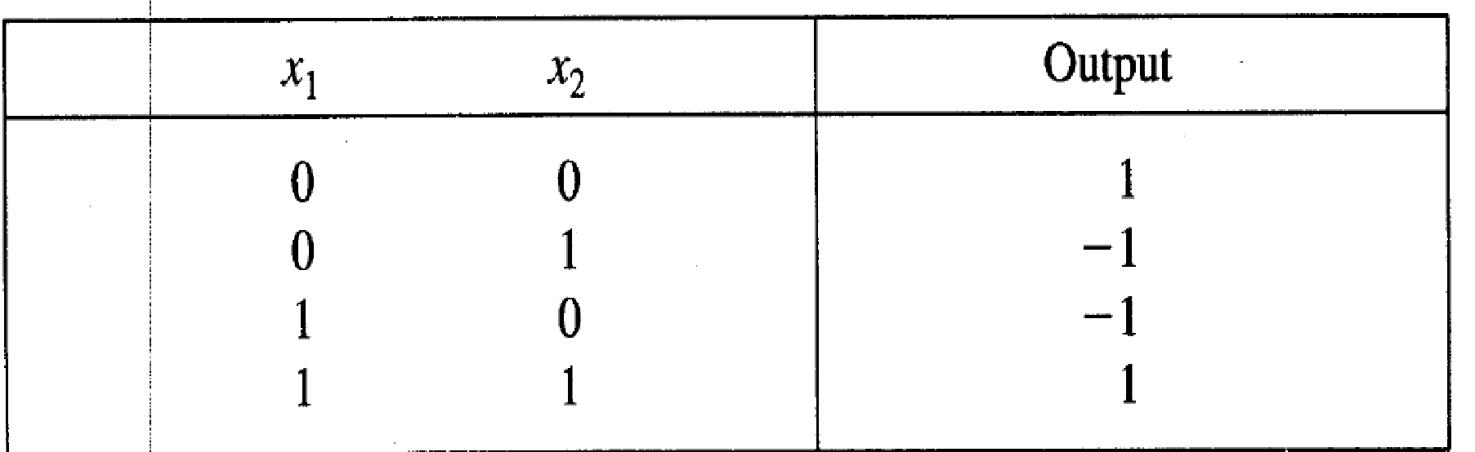

Classifier using Multi-layer Perception Network for implementing XOR logic for 2 inputs.

import numpy as np

input_vector = [(0,0), (0,1), (1,0), (1,1)]
bias = -1/2

# TLU 1
w1 = -2
w2 = 1
o1_vector = []
for input in input_vector:
x1, x2 = tuple(input)
net = x1*w1 + x2*w2 + bias
o1 = int(np.sign(net))
o1_vector.append(o1)

# TLU 2
w1 = 1
w2 = -1
o2_vector = []
for input in input_vector:
x1, x2 = tuple(input)
net = x1*w1 + x2*w2 + bias
o2 = int(np.sign(net))
o2_vector.append(o2)

# TLU 3
w1 = 1
w2 = 1
bias = 1
o3_vector = []
class_vector = []
for i in range(len(input_vector)):
o1 = o1_vector[i]
o2 = o2_vector[i]
net = o1*w1 + o2*w2 + bias
o3 = int(np.sign(net))
o3_vector.append(o3)
if o3 > 0:
class_vector.append(1)
else:
class_vector.append(2)

x1_vector = [i[0] for i in input_vector]
x2_vector = [i[1] for i in input_vector]
output = list(zip(x1_vector, x2_vector, o1_vector,o2_vector,o3_vector, class_vector))

print("------------------------------------------------------------------")
print("Pattern Space\t | Image Space\t | Output Space\t | Class\t |")
print("x1\t | x2 \t | o1\t | o2 \t | o3 \t\t | Number \t |")
print("------------------------------------------------------------------")

for record in output:
for value in record[:4]:
print(value, end = '\t | ')
for value in record[4:]:
print(value, end = '\t\t | ')
print()
print("------------------------------------------------------------------")

Output:
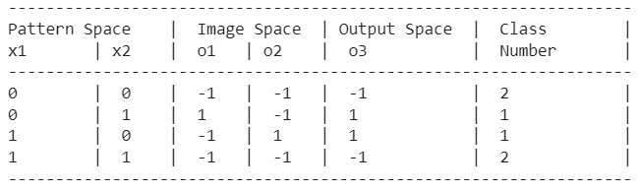

Conclusion: Thus, we have successfully implemented a classifier using MLP for linearly non-separable XOR functions of 2 inputs.

Post Lab Descriptive Questions:
- Why is the XOR-logic Gate function problem being Linearly non-separable?
Linear Separability refers to the data points in binary classification problems which can be separated using linear decision boundary. if the data points can be separated using a line, linear function, or flat hyperplane are considered linearly separable.

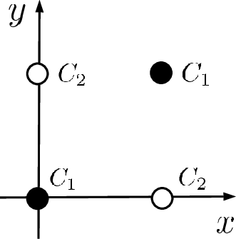
XOR is not linearly separable as the data points will overlap the data points of the linear line or different classes occur on a single side of the linear line.

There is no way to draw a single line to separate the classes C1 and C2.

- Design a classifier using MLP perceptron model for implementing NOT XOR logic.
import numpy as np

input_vector = [(0,0), (0,1), (1,0), (1,1)]
bias = -1/2

# TLU 1
w1 = -2
w2 = 1
o1_vector = []
for input in input_vector:
x1, x2 = tuple(input)
net = x1*w1 + x2*w2 + bias
o1 = int(np.sign(net))
o1_vector.append(o1)

# TLU 2
w1 = 1
w2 = -1
o2_vector = []
for input in input_vector:
x1, x2 = tuple(input)
net = x1*w1 + x2*w2 + bias
o2 = int(np.sign(net))
o2_vector.append(o2)

# TLU 3
w1 = -1
w2 = -1
bias = -1
o3_vector = []
class_vector = []
for i in range(len(input_vector)):
o1 = o1_vector[i]
o2 = o2_vector[i]
net = o1*w1 + o2*w2 + bias
o3 = int(np.sign(net))
o3_vector.append(o3)
if o3 > 0:
class_vector.append(1)
else:
class_vector.append(2)

x1_vector = [i[0] for i in input_vector]
x2_vector = [i[1] for i in input_vector]
output = list(zip(x1_vector, x2_vector, o1_vector,o2_vector,o3_vector, class_vector))

print("------------------------------------------------------------------")
print("Pattern Space\t | Image Space\t | Output Space\t | Class\t |")
print("x1\t | x2 \t | o1\t | o2 \t | o3 \t\t | Number \t |")
print("------------------------------------------------------------------")

for record in output:
for value in record[:4]:
print(value, end = '\t | ')
for value in record[4:]:
print(value, end = '\t\t | ')
print()
print("------------------------------------------------------------------")

Output:

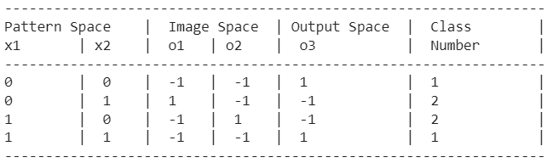

Date: 22/10/2024 Signature of faculty in-charge

