Batch: A2 Roll No.: 16010122034

Experiment No. : 08

Grade: AA / AB / BB / BC / CC / CD / DD

Signature of the Staff In-charge with date

Title: Implementation of fuzzy operations (COMPLEMENT, UNION ,INTERSECTION) on fuzzy sets.
____________________________________________________________________________________
Objective: To understand fuzzy operations
____________________________________________________________________________________
Expected Outcome of Experiment:

CO4 : Apply basics of Fuzzy logic and neural networks ____________________________________________________________________________________
Books/ Journals/ Websites referred:

____________________________________________________________________________________

Pre Lab/ Prior Concepts

Fuzzy logic

Fuzzy logic is a mathematical approach that allows for more flexible reasoning, resembling human logic by representing data with degrees of truth rather than binary true/false values. It is particularly useful in situations where information is imprecise or uncertain. Fuzzy logic uses linguistic variables, fuzzy sets, and rules to make decisions, and is commonly used to handle complex, real-world scenarios where crisp, binary logic falls short.

Definition of fuzzy set

A fuzzy set is a collection of elements with imprecise or gradual boundaries, allowing for the representation of uncertainty or vagueness in data. Membership functions determine the extent to which each element can be considered part of the fuzzy set, enabling a more flexible and nuanced representation of data in fuzzy logic applications.

Fuzzy set operations:

Fuzzy set operations are as follows
- Equality
- Complement
- Intersection
- Union
- Algebraic product
- Multiplication of fuzzy set with crisp number
- Power of fuzzy set
- Algebraic sum
- Algebraic difference
- Bounded sum
- Bounded difference
- Cartesian product
- Composition

Fuzzy inference system

A fuzzy inference system is a computational framework used in fuzzy logic that processes fuzzy input data through a set of predefined fuzzy rules and membership functions to produce a fuzzy output. It involves interpreting imprecise or uncertain information and making decisions or controlling systems based on this input. The system combines the fuzzy rules and input values to generate a fuzzy output, which may then be defuzzified to obtain a specific, actionable result. Fuzzy inference systems are valuable in situations where traditional crisp logic falls short, enabling more robust decision-making in complex, real-world scenarios.

____________________________________________________________________________________
Implementation Details:

- Implement the fuzzy operations- union, intersection, complement and visualize the same.

import numpy as np
import matplotlib.pyplot as plt

def fuzzy_complement(setA):
complement = []
for value in setA:
complement.append(round(1-value, 3))
return complement

def fuzzy_intersection(setA, setB):
intersection = []
for value in list(zip(setA, setB)):
intersection.append(min(value))
return intersection

def fuzzy_union(setA, setB):
union = []
for value in list(zip(setA, setB)):
union.append(max(value))
return union

def fuzzy_product(setA, setB):
product = []
for value1, value2 in list(zip(setA, setB)):
product.append(round(value1 * value2, 3))
return product

def fuzzy_crisp_multiplication(setA, crisp):
multiplication = []
for value in setA:
multiplication.append(round(value * crisp,3))
return multiplication

set_A = (0.7, 0.3, 0.9, 0.1)
set_B = (0.2, 0.5, 0.7, 0.4)
set_C = (0.1, 0.2, 0.3, 0.4)
set_D = (0.5, 0.7, 0.8, 0.9)

print("Set 1 =", set_A, sep = "\t")
print("set 2 =", set_B, sep = "\t")
print("Complement =", fuzzy_complement(set_A), sep = "\t")
print("Intersection =", fuzzy_intersection(set_A, set_B), sep = "\t")
print("Union =", fuzzy_union(set_A, set_B), sep = "\t\t")
print()
print("Set 3 =", set_C, sep = "\t")
print("set 4 =", set_D, sep = "\t")
print("Product =", fuzzy_product(set_C, set_D), sep = "\t")
print("Multiplication=", fuzzy_crisp_multiplication(set_C, 0.2))
Output
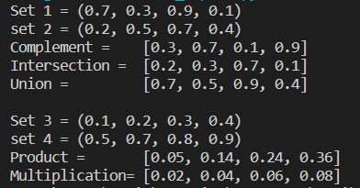

VISUALIZATIONS

Union:

# Plot the membership functions and their union
x_values = np.linspace(0, 10, 500)

# Function 1 (Triangular)
a, b, c = 3, 4, 5
y_values_triangular = [triangular_member(x, a, b, c) for x in x_values]
plt.plot(x_values, y_values_triangular, 'g', label=f'T({a}, {b}, {c})')

# Function 2 (Trapezoidal)
a, b, c, d = 4, 5, 8, 9
y_values_trapezoidal = [trapezoidal_member(x, a, b, c, d) for x in x_values]
plt.plot(x_values, y_values_trapezoidal, 'r', label=f'Tr({a}, {b}, {c}, {d})')

# Union
union_values = fuzzy_union(y_values_triangular, y_values_trapezoidal)
plt.plot(x_values, union_values, 'blue', label='Union')
plt.title('Union (OR) Operator')
plt.xlabel('X-axis')
plt.ylabel('Membership Value')
plt.legend()
plt.show()

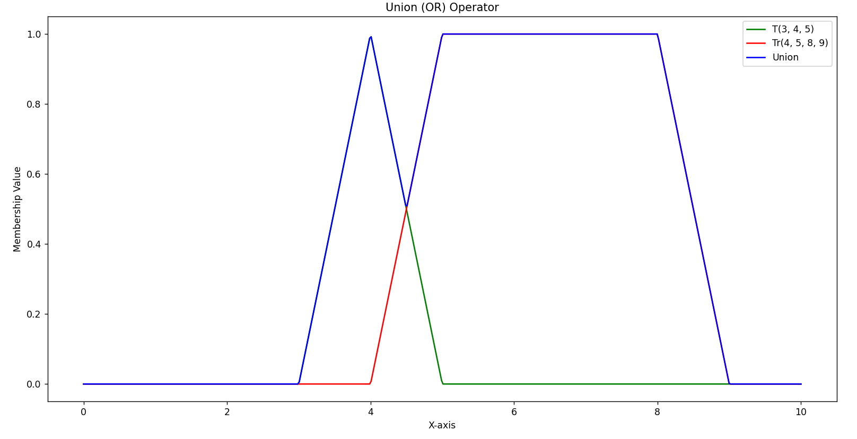

Intersection:
# Plot the membership functions and their intersection
x_values = np.linspace(0, 10, 500)

# Function 1 (Triangular)
a, b, c = 3, 4, 5
y_values_triangular = [triangular_member(x, a, b, c) for x in x_values]
plt.plot(x_values, y_values_triangular, 'g', label=f'T({a}, {b}, {c})')

# Function 2 (Trapezoidal)
a, b, c, d = 4, 5, 8, 9
y_values_trapezoidal = [trapezoidal_member(x, a, b, c, d) for x in x_values]
plt.plot(x_values, y_values_trapezoidal, 'r', label=f'Tr({a}, {b}, {c}, {d})')

# Intersection
intersection_values = fuzzy_intersection(y_values_triangular, y_values_trapezoidal)
plt.plot(x_values, intersection_values, 'yellow', label='Intersection')
plt.title('Intersection (AND) Operator')
plt.xlabel('X-axis')
plt.ylabel('Membership Value')
plt.legend()
plt.show()

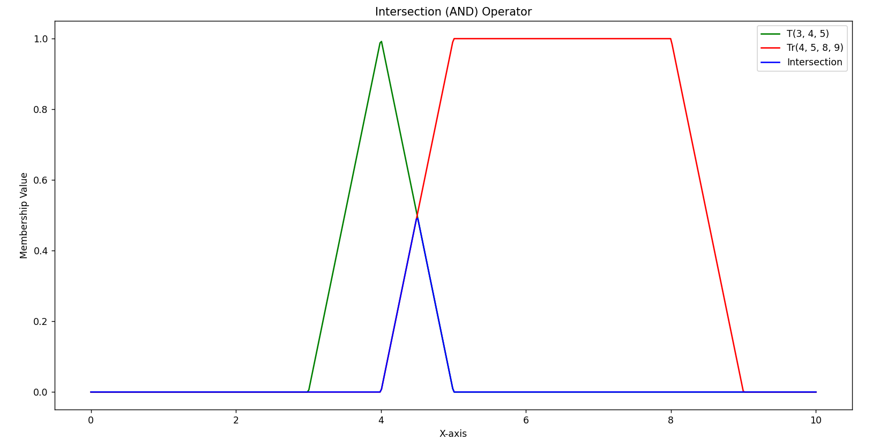

Complement:
# Plot the membership functions and their intersection
x_values = np.linspace(0, 10, 500)

# Function 1 (Triangular)
a, b, c = 3, 4, 5
y_values_triangular = [triangular_member(x, a, b, c) for x in x_values]
plt.plot(x_values, y_values_triangular, 'g', label=f'T({a}, {b}, {c})')

# Function 2 (Trapezoidal)
a, b, c, d = 4, 5, 8, 9
y_values_trapezoidal = [trapezoidal_member(x, a, b, c, d) for x in x_values]
plt.plot(x_values, y_values_trapezoidal, 'r', label=f'Tr({a}, {b}, {c}, {d})')

# Complement
complement_values = fuzzy_complement(y_values_trapezoidal)
plt.plot(x_values, complement_values, 'black', label='Complement')
plt.title('Complement (NOT) Operator')
plt.xlabel('X-axis')
plt.ylabel('Membership Value')
plt.legend()
plt.show()
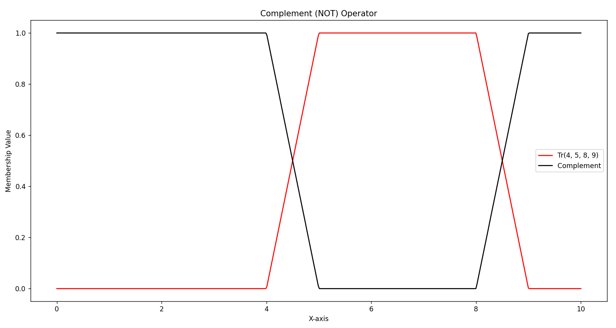
Post Lab Descriptive Questions :

Q1 Two fuzzy sets A and B are given with membership functions μA(x) = {0.2, 0.4, 0.8, 0.5, 0.1} μB(x) = {0.1, 0.3, 0.6, 0.3, 0.2} Then the value of μ ––– will be A∩B
(A) {0.9, 0.7, 0.4, 0.8, 0.9}
(B) {0.2, 0.4, 0.8, 0.5, 0.2}
(C) {0.1, 0.3, 0.6, 0.3, 0.1}
(D) {0.7, 0.3, 0.4, 0.2, 0.7}

Q2 The height h(A) of a fuzzy set A is defined as h(A) =sup A(x) where x belongs to A. Then the fuzzy set A is called normal when
(A)h(A)=0
(B)h(A)<0
(C)h(A)=1
(D)h(A)<1

Q3 If A and B are two fuzzy sets with membership functions μA(x) = {0.6, 0.5, 0.1, 0.7, 0.8} μB(x) = {0.9, 0.2, 0.6, 0.8, 0.5}
Then the value of μ Complement A∪B(x) will be
(A) {0.9, 0.5, 0.6, 0.8, 0.8}
(B) {0.6, 0.2, 0.1, 0.7, 0.5}
(C) {0.1, 0.5, 0.4, 0.2, 0.2}
(D){0.1,0.5,0.4,0.2,0.3}

Date: 22/ 10/ 2024 Signature of faculty in-charge

