Batch: B1 Roll No.: 16010122158

Experiment No. 10

Grade: AA / AB / BB / BC / CC / CD / DD

Signature of the Staff In-charge with date

Title: : Study experiment on Bi-directional Associative Memory, example
____________________________________________________________________________________
Aim : To understand the Bi-Directional Associative Memory
____________________________________________________________________________________
Expected Outcome of Experiment:

CO3 : Understand perceptron’s and counter propagation networks ____________________________________________________________________________________
Books/ Journals/ Websites referred:

____________________________________________________________________________________
Theory:

Bi-Directional Associative Memory (BAM) is a type of recurrent neural network that is designed to store and retrieve pairs of patterns. Unlike traditional feedforward networks, BAM allows information to flow in both directions, facilitating the association of patterns in a more dynamic way. It consists of two layers of neurons: the input layer (X) and the output layer (Y). Each layer is fully interconnected with weights that allow for the mutual reinforcement of patterns.
The fundamental concept of BAM is based on the following principles:
- Associative Memory: BAM can retrieve one pattern when provided with a related pattern.
- Bidirectionality: This characteristic enables BAM to function as both an input and output model.
- Energy Minimization: BAM operates by minimizing an energy function, leading to stable states corresponding to the stored patterns.

Architecture of BAM:

The architecture of a BAM consists of two layers:
- Input Layer (X): Receives the input patterns and passes them to the output layer.
- Output Layer (Y): Produces the output patterns based on the inputs received from the input layer.
Key Components:
- Neuron Nodes: Represent the individual processing units in each layer.
- Weights: Each connection between neurons has a weight that signifies the strength of the association.
- Activation Function: Typically, a binary or bipolar activation function is used to determine the output of each neuron based on the weighted sum of its inputs.
Structure:
- Neurons in layer X are connected to neurons in layer Y through weighted connections.
- The two layers can activate each other, enabling the memory retrieval process.
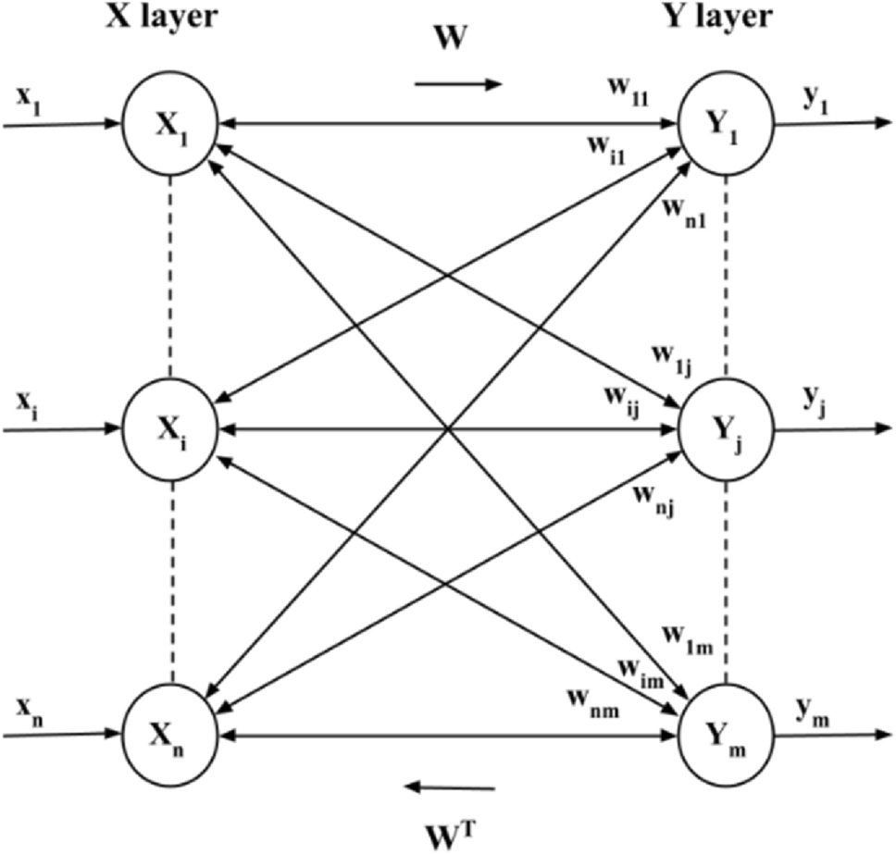

Training and Testing of Discrete BAM

Test the noisy patterns entering into the network. Testing algorithm for the net is as follows:

- Step 0: Initialize the weights to store ρ vectors. Also initialize all the
activations to zero.

- Step 1: Perform steps 2-6 for each testing input.

- Step 2: Set the Activation of X layer to current input patterns, presenting the
input x to X layer and presenting the input pattern y to Y layer. It is
bidirectional memory.

- Step 3: Perform steps 4-6 when the activations are not converged.

- Step 4: Update the activation of units in Y layer. Calculate the net input.
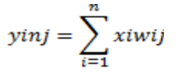

- Applying the Activation, we get yj=f(yinj).

- Send this signal to X layer.

- Step 5: Update the activation of units in X layer. Calculate the net input.
Applying the activation over the net input: xi=f(xini)
Send this signal to Y layer.

- Step 6: Test for convergence of the net. The convergence occurs if the activation vectors x and y reach equilibrium. If this occurs, then stop, else continue.

Training and Testing of Continuous BAM

Testing Continuous BAM with Noisy Patterns

Understanding Continuous BAM

Unlike Discrete BAM, Continuous BAM operates with continuous-valued activations. This allows for a more nuanced representation of patterns and relationships.

Testing Algorithm:

- Initialization:
  - Initialize the weights to store ρ vectors.
  - Initialize all activations to zero.
- Input Presentation:
  - For each testing input:
    - Set the activation of the X layer to the current input pattern.
    - Set the activation of the Y layer to the corresponding target pattern.
- Iterative Activation Update:
  - Repeat steps 4-6 until convergence:
    - Update Y layer activations:
      - Calculate net inputs for Y layer units using the formula:
      - y_inj = sum(w_ji * x_i)
      - Update activations using a differential equation:
      - dy_j/dt = f(y_inj) - y_j
where f is the activation function (e.g., sigmoid, tanh).
      - Integrate this equation to obtain the new y_j values.
    - Update X layer activations:
      - Follow the same process as for the Y layer.
    - Test for convergence:
      - Check if the change in activations for both layers is sufficiently small.
Testing Procedure:

- Prepare Noisy Patterns:
  - Generate noisy versions of your input patterns as described for Discrete BAM.
- Run the Algorithm:
  - Apply the algorithm to each noisy pattern.
  - Observe the resulting output patterns from the Y layer.
- Evaluate Performance:
  - Use the same metrics (accuracy, recall, precision, F1-score) as for Discrete BAM to evaluate the network's performance.

Additional Considerations:

- Integration Method: Choose a suitable numerical integration method (e.g., Euler's method, Runge-Kutta) to solve the differential equations.
- Learning Rate: If training the weights, adjust the learning rate to optimize convergence.
- Convergence Criteria: Carefully define the convergence criteria to ensure accurate results.
Key Differences from Discrete BAM:

- Continuous Activations: Continuous BAM operates with real-valued activations, allowing for finer-grained representations.
- Differential Equations: The activation updates are governed by differential equations, requiring numerical integration.
- Convergence Criteria: Convergence is typically assessed based on the change in activations rather than discrete equilibrium.
By following these steps and considering the specific characteristics of Continuous BAM, you can effectively test its performance on noisy patterns and evaluate its suitability for your application.

Code Implementation

import numpy as np

input1 = np.array([[1], [1], [1],
[-1], [1], [-1],
[-1], [1], [-1],
[-1], [1], [-1]])

input2 = np.array([[1], [1], [1],
[1], [-1], [1],
[1], [-1], [1],
[1], [1], [1]])

target1 = np.array([[1, -1]])
target2 = np.array([[1, 1]])

w1 = np.dot(input1, target1)
w2 = np.dot(input2, target2)

w = w1 + w2

y_in = np.dot(input1.T, w)
print("y_in:", y_in)

def signum(y_in):
y = []
for i in y_in[0]:
if i == 0:
y.append(0)
elif i < 0:
y.append(-1)
else:
y.append(1)
return np.array(y)

y = signum(y_in)
print("y:", y)

def tester1(y, target1):
if np.array_equal(y, target1.flatten()):
print("test passed")
else:
print("test failed")

tester1(y, target1)

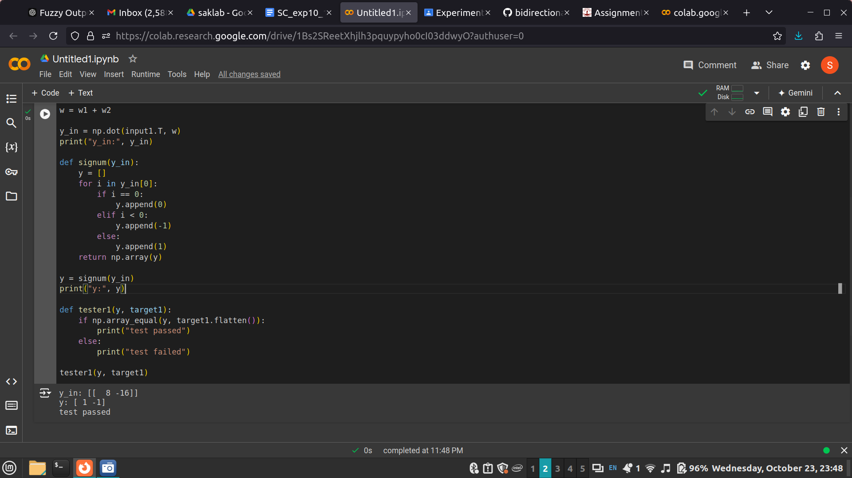

Numerical to solve (handwritten solution) :
Question 1:

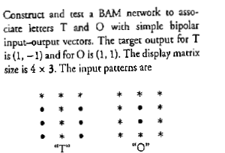

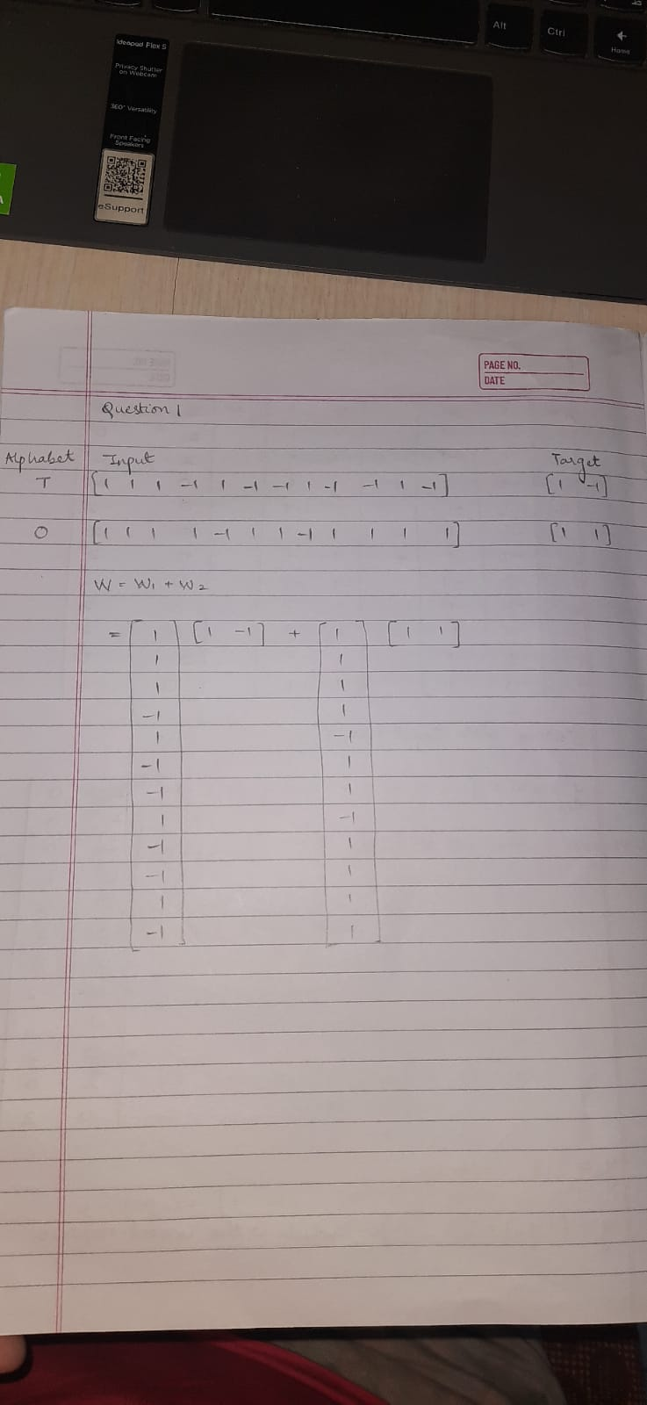
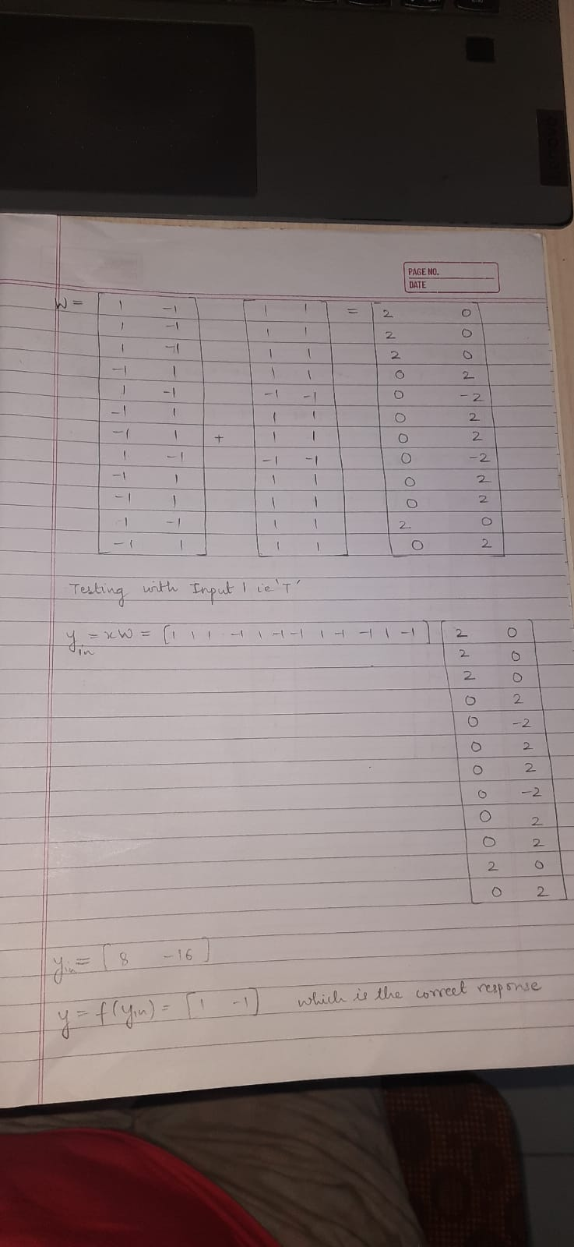
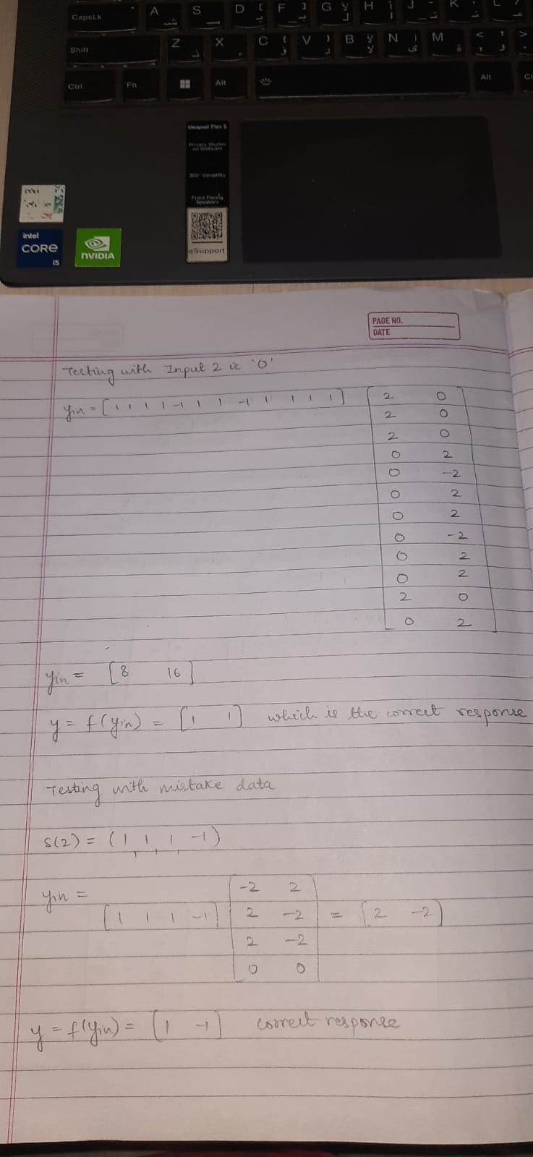

Question 2:

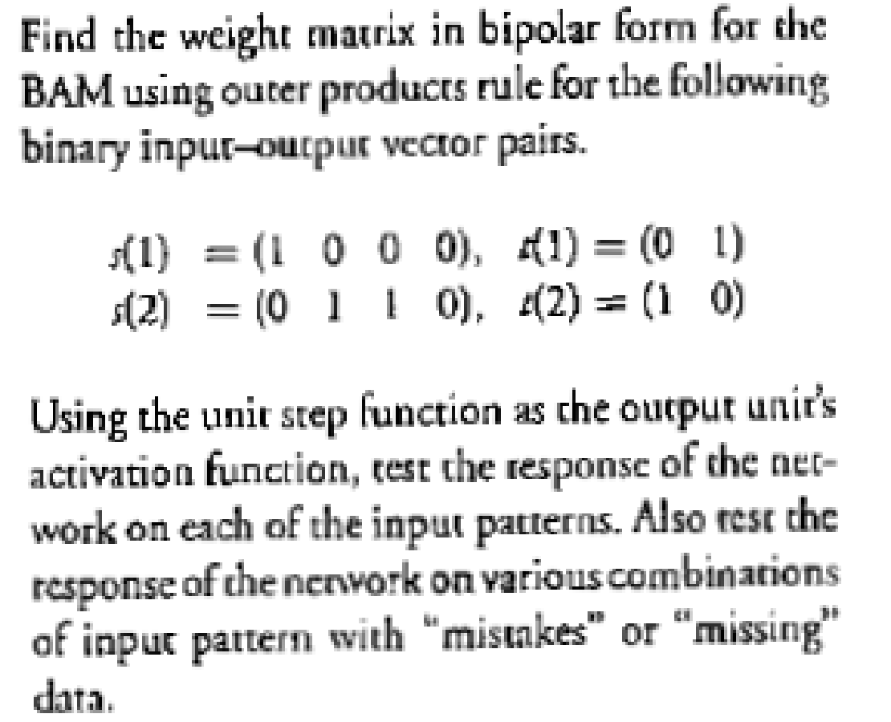

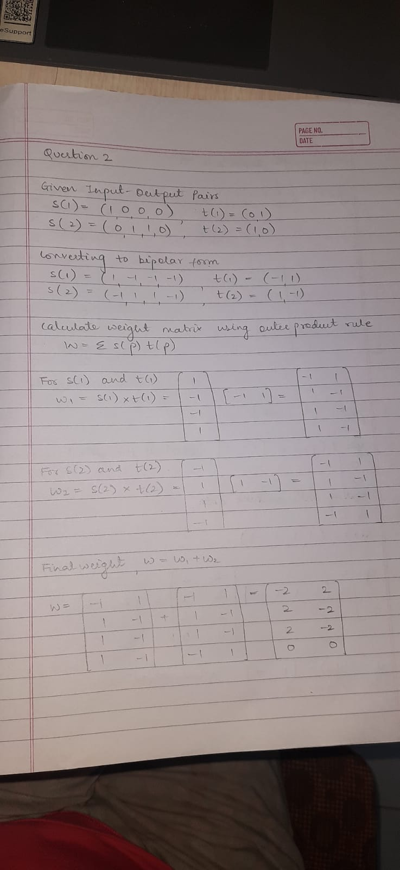

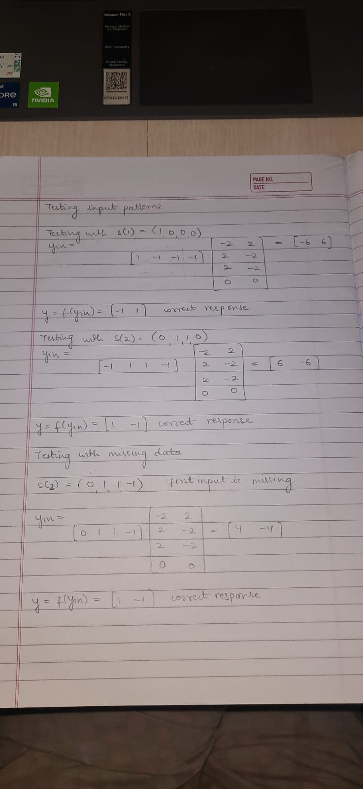


Date: 5/ 11/ 2024 Signature of faculty in-charge

