Batch: B1 Roll No.: 16010122158

Experiment No. 03

Grade: AA / AB / BB / BC / CC / CD / DD

Signature of the Staff In-charge with date

Title: Implement Hebbian learning Rule
___________________________________________________________________________________
Objective: To implement Hebbian learning with binary bipolar activation functions..
___________________________________________________________________________________
Expected Outcome of Experiment:

CO3: Understand perceptron and counter-propagation networks
____________________________________________________________________________________
Books/ Journals/ Websites referred:

____________________________________________________________________________________
Pre Lab/ Prior Concepts:
Hebbian learning rule and algorithm
The Hebbian rule was the first learning rule. In 1949 Donald Hebb developed it as learning
algorithm of the unsupervised neural network. We can use it to identify how to improve the weights of nodes of a network. The Hebb learning rule assumes that – If two neighbour neurons activated and deactivated at the same time. Then the weight connecting these neurons should increase. For neurons operating in the opposite phase, the weight between them should decrease If there is no signal correlation, the weight should not change. When inputs of both the nodes are either positive or negative, then a strong positive weight exists between the nodes. If the input of a node is positive and negative for other, a strong negative weight exists between the nodes. At the start, values of all weights are set to zero. This learning rule can be used0 for both soft and hard-activation functions. Since desired responses of neurons are not used in the learning procedure, this is the unsupervised learning rule. The absolute values of the weights are usually proportional to the learning time, which is undesired.
The Hebbian learning rule describes the formula as follows:



____________________________________________________________________________________
Implementation Details:

# Implement Hebbian learning for the given network
#Compare the learning using Binary and Bipolar activation functions.
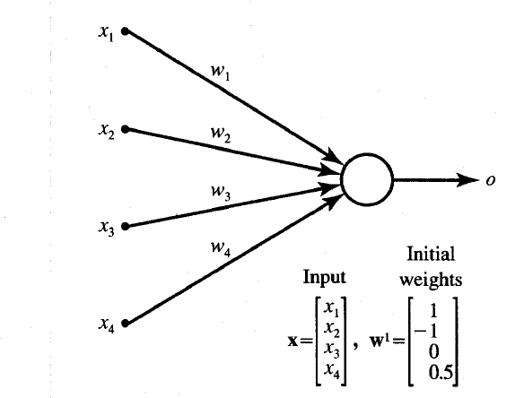

Network for implementation

Input vector:
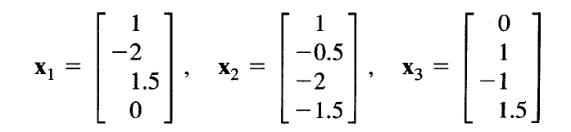

Conclusion: #write the conclusion w.r.t the comparison between the Hebbian learning using Binary and Bipolar activation function

Code:
#include <iostream>
#include <vector>

using namespace std;

void printVector(const vector<double>& vec) {
for (double v : vec) {
cout << v << " ";
}
cout << endl;
}

void printWeights(const vector<double>& weights) {
cout << "Weights: ";
printVector(weights);
}

int sign(double value) {
return (value >= 0) ? 1 : -1;
}

int binaryActivation(double value) {
return (value > 0) ? 1 : 0;
}

int bipolarActivation(double value) {
return (value > 0) ? 1 : -1;
}

void updateWeights(vector<double>& weights, const vector<double>& input, int activation) {
for (size_t i = 0; i < weights.size(); ++i) {
weights[i] += activation * input[i];
}
}

void trainStepByStep(vector<double>& weights, const vector<vector<double>>& inputs) {
// Step 1
cout << "Step 1:" << endl;
vector<double> x1 = inputs[0];
double net1 = weights[0] * x1[0] + weights[1] * x1[1] + weights[2] * x1[2] + weights[3] * x1[3];
int signNet1 = sign(net1);
cout << "net^1 = " << net1 << ", sign(net^1) = " << signNet1 << endl;
updateWeights(weights, x1, signNet1);
printWeights(weights);

// Step 2
cout << "Step 2:" << endl;
vector<double> x2 = inputs[1];
double net2 = weights[0] * x2[0] + weights[1] * x2[1] + weights[2] * x2[2] + weights[3] * x2[3];
int signNet2 = sign(net2);
cout << "net^2 = " << net2 << ", sign(net^2) = " << signNet2 << endl;
updateWeights(weights, x2, signNet2);
printWeights(weights);

// Step 3
cout << "Step 3:" << endl;
vector<double> x3 = inputs[2];
double net3 = weights[0] * x3[0] + weights[1] * x3[1] + weights[2] * x3[2] + weights[3] * x3[3];
int signNet3 = sign(net3);
cout << "net^3 = " << net3 << ", sign(net^3) = " << signNet3 << endl;
updateWeights(weights, x3, signNet3);
printWeights(weights);
}

void trainWithActivation(vector<double>& weights, const vector<vector<double>>& inputs, bool useBipolar) {
for (const auto& input : inputs) {
double net = weights[0] * input[0] + weights[1] * input[1] + weights[2] * input[2] + weights[3] * input[3];
int activation = useBipolar ? bipolarActivation(net) : binaryActivation(net);
updateWeights(weights, input, activation);
}
}

int main() {
vector<double> initialWeights = {1, -1, 0, 0.5};
vector<vector<double>> inputVectors = {
{1, -2, 1.5, 0},
{1, -0.5, -2, -1.5},
{0, 1, -1, 1.5}
};

cout << "Initial Weights: ";
printVector(initialWeights);

cout << "Step-by-Step Hebbian Learning:" << endl;
vector<double> weightsStepByStep = initialWeights;
trainStepByStep(weightsStepByStep, inputVectors);

cout << "Training with Binary Activation Function:" << endl;
vector<double> weightsBinary = initialWeights;
trainWithActivation(weightsBinary, inputVectors, false);
printWeights(weightsBinary);

cout << "Training with Bipolar Activation Function:" << endl;
vector<double> weightsBipolar = initialWeights;
trainWithActivation(weightsBipolar, inputVectors, true);
printWeights(weightsBipolar);

return 0;
}

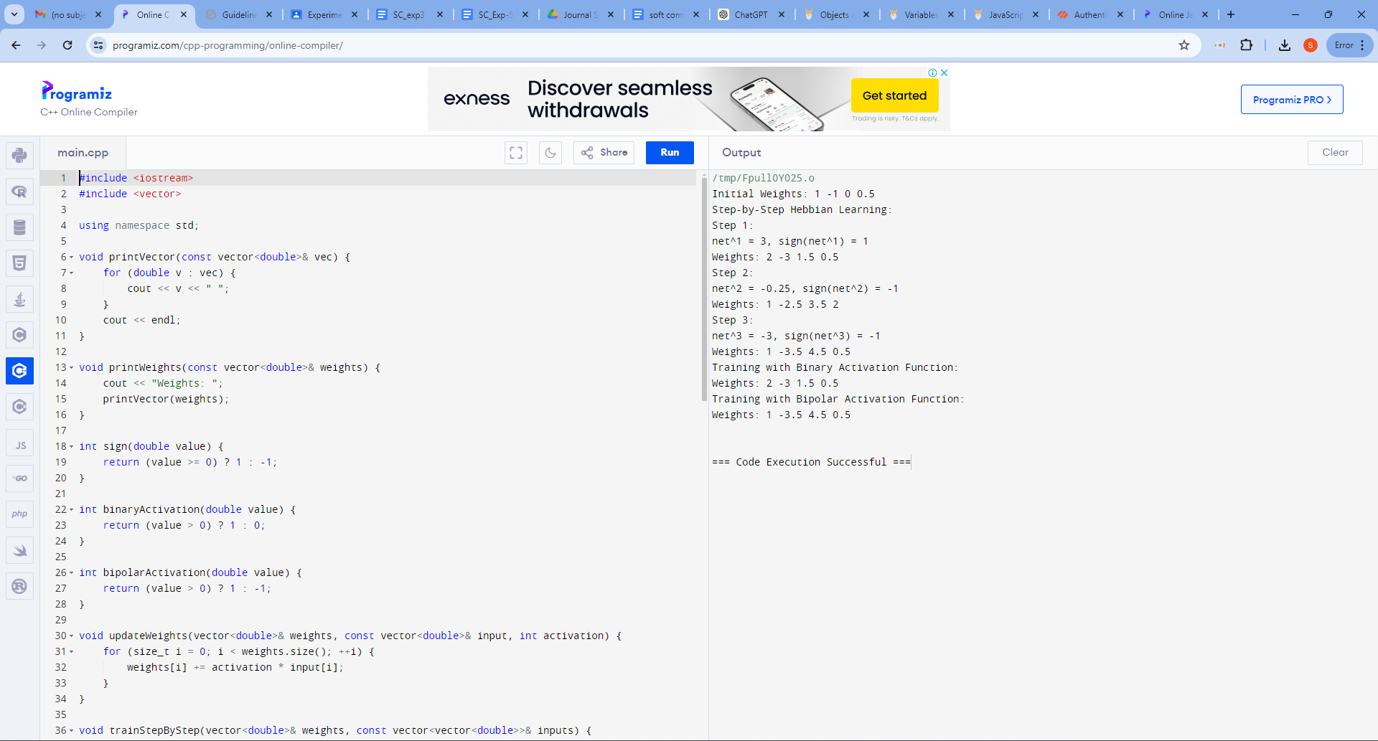

Post Lab Descriptive Questions :

- Compare the Hebbian learning and competitive learning.
Hebbian learning and competitive learning are two types of unsupervised learning algorithms used in neural networks and artificial intelligence. Both are inspired by biological neural processes, but they function differently and are used for different purposes.
Hebbian Learning
Key Principle: "Cells that fire together, wire together."
1. Mechanism:
- Hebbian learning strengthens the connection between two neurons that are activated simultaneously.
- If neuron A consistently helps to activate neuron B, the synaptic connection between them is reinforced.

2. Usage:
- Hebbian learning is often used to model associative memory, where associations between different inputs are formed.
- It can be seen as a way to learn correlation patterns in data.

3. Limitations:
- It can lead to unbounded growth of synaptic weights unless some form of normalization or decay is applied.
- It doesn't typically lead to the development of distinct, specialized neurons (e.g., different neurons representing different features).
Competitive Learning
Key Principle: Neurons compete to become the most active and "win," leading to specialization.
1. Mechanism:
- In competitive learning, neurons in a network compete to be the one that fires in response to a given input.
- The "winning" neuron has its weights updated to become more like the input vector.
- The competition can be implemented through mechanisms like lateral inhibition, where active neurons suppress the activity of their neighbors.

2. Usage:
- Competitive learning is often used in clustering tasks, such as in the Self-Organizing Map (SOM) algorithm.
- It leads to the emergence of neurons that specialize in different features or patterns within the data.
3. Limitations:
- It requires careful tuning of the learning rate and the competition mechanism.
- The process can be slow, as it requires many iterations to achieve well-separated clusters or feature maps.
Comparison

- Learning Process:
- Hebbian learning is more about building associations through correlation, while competitive learning focuses on specialization through competition.

- Outcome:
- Hebbian learning tends to create distributed representations, where many neurons might respond to similar stimuli. Competitive learning, on the other hand, often results in a more sparse, specialized representation where different neurons are tuned to different inputs.

- Application:
- Hebbian learning is often used in scenarios where associating inputs or identifying correlations is crucial, such as in associative memory models.
- Competitive learning is suitable for tasks requiring clustering or feature extraction, like in SOMs.

Both learning methods are foundational in understanding how artificial and biological neural networks adapt and process information, each offering unique strengths for different types of tasks.

- Find the weights after one iteration for hebbian learning of a single neuron network. Start with initial weights W=[1,-1] and Inputs as X1=[1,-2] X2=[2,3], x3[1,-1] and C=1.

Using Bipolar Binary Activation Function

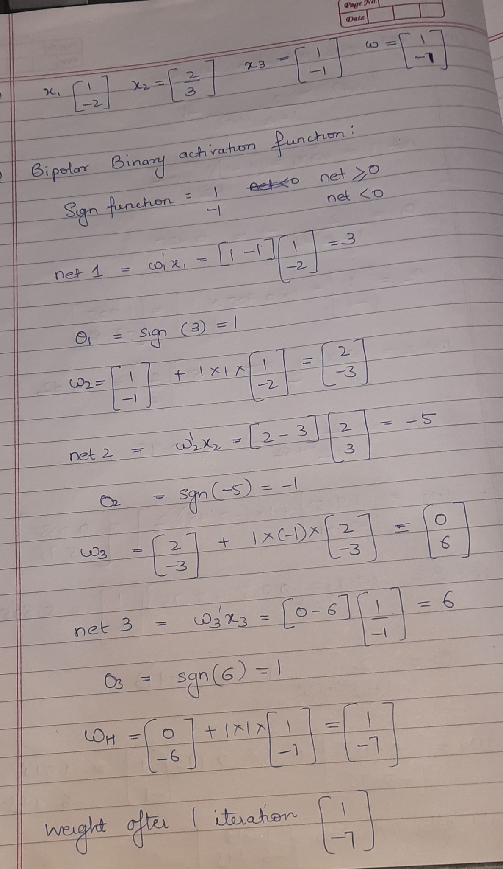
Using Continuous Activation Function

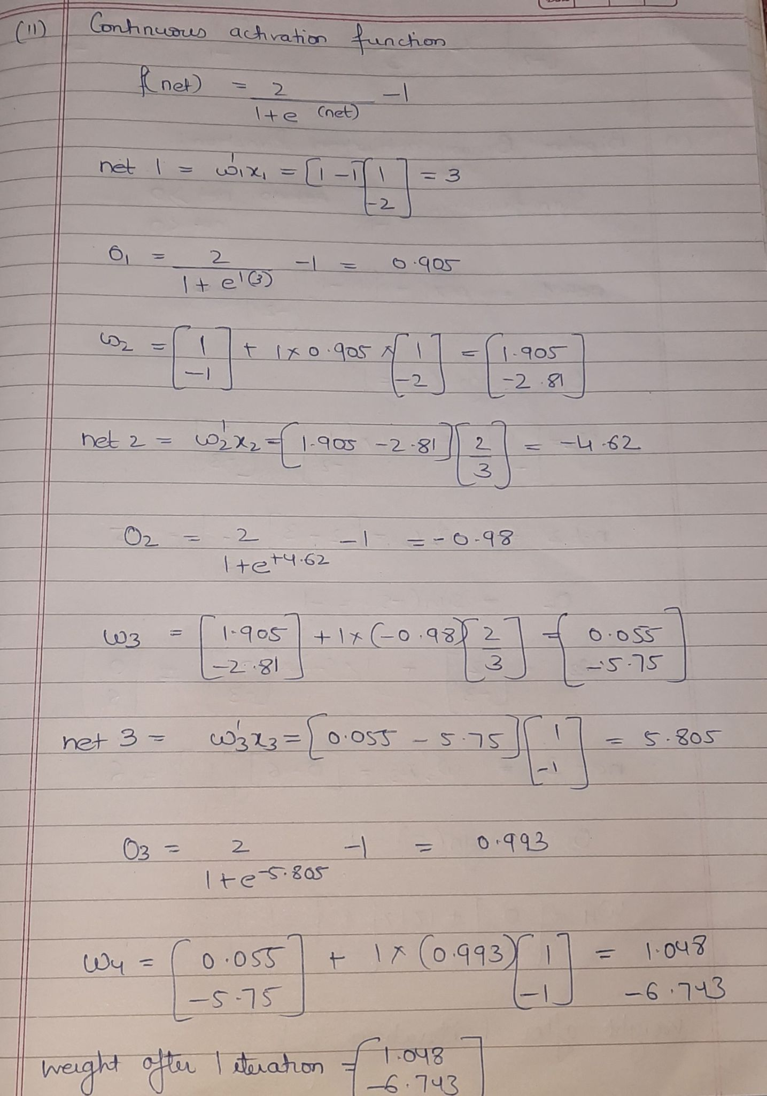

Date: 14/08/2024 Signature of faculty in-charge

