Batch: B 2 Roll No.: 16010122181

Experiment No. : 04

Grade: AA / AB / BB / BC / CC / CD / DD

Signature of the Staff In-charge with date

Title: Perceptron net for an AND function with bipolar inputs and targets.
____________________________________________________________________________________
Objective: To write a program to implement the perceptron learning rule
____________________________________________________________________________________
Expected Outcome of Experiment:

CO2 : Understand perceptron’s and counter propagation networks ____________________________________________________________________________________
Books/ Journals/ Websites referred:

__________________________________________________________________________________
Pre Lab/ Prior Concepts:

Learning
In the context of machine learning, refers to the process where a model enhances its ability to perform a task based on the data it is exposed to. The model improves its performance as it gains more experience through interaction with data. There are various types of learning in machine learning:

Types of learning
□ Supervised Learning:
In supervised learning, the algorithm is trained using labeled data, where each input is associated with a known output. The objective is for the model to learn a mapping that accurately predicts outputs based on new inputs.

□ Unsupervised Learning:
Unsupervised learning involves training the model on data without labeled outcomes. The algorithm attempts to discover hidden structures or patterns in the data without any explicit output values.

□ Reinforcement Learning:
In reinforcement learning, an agent learns to make decisions by interacting with an environment, aiming to maximize cumulative rewards. The agent explores different actions and adjusts its behavior based on feedback from those actions.

Perceptron learning rule.

The Perceptron Learning Rule is an algorithm used to train a single-layer perceptron, which is a basic neural network used for binary classification tasks. The goal of this rule is to adjust the weights associated with the inputs so that the perceptron correctly classifies the input data into one of two categories.

Steps of Perceptron learning algorithm/approach for binary classification

1. Initialization: Begin by initializing the weights and bias with small random values.

2. Input Processing: For each input vector, append a bias term (usually set to 1) to the input vector.

3. Calculate Weighted Sum: Compute the weighted sum of the inputs and weights using the formula: Weighted Sum = (Weight 1 * Input 1) + (Weight 2 * Input 2) + ... + (Bias * Bias Weight)

4. Activation Function: Apply an activation function (typically a step function). If the weighted sum is greater than or equal to a threshold (often 0), the output is 1; otherwise, the output is 0.

5. Error Calculation: Compute the error by subtracting the perceptron's predicted output from the actual target value.

6. Weight Update Rule: Adjust the weights and bias using the following update rules: New Weight = Old Weight + (Learning Rate * Error * Input) New Bias Weight = Old Bias Weight + (Learning Rate * Error * Bias)

7. Iteration: Repeat the steps for calculating the weighted sum, applying the activation function, and adjusting weights until the error is minimized or the specified number of training iterations (epochs) is completed.

8. Termination: Stop the training process when either the error is sufficiently reduced or the algorithm has gone through the maximum number of epochs

Single layer perceptron network for

AND Logic Function:
• Activation Function: Step function (returns 1 if the weighted sum ≥ 0, otherwise returns 0)
• Explanation: In the AND logic function, the perceptron applies a step function as its activation function. It computes the weighted sum of the inputs. If this sum meets or exceeds a threshold (typically 0), the perceptron produces an output of 1; otherwise, the output is 0.
OR Logic Function:
• Activation Function: Step function (returns 1 if the weighted sum ≥ 0, otherwise returns 0)
• Explanation: Similar to the AND logic function, the OR logic uses a step function. The perceptron computes the weighted sum, and if this value is greater than or equal to 0, it returns 1; otherwise, it returns 0.
NOT Logic Function:
• Activation Function: Step function (returns 1 if the weighted sum ≥ 0, otherwise returns 0)
• Explanation: In the NOT logic function, the perceptron again uses a step function for classification. Based on the weighted sum of the input, the perceptron will output 1 if the sum is greater than or equal to 0, and it will output 0 otherwise.
____________________________________________________________________________________
Implementation Details:

Task to be done:

Write a program to implement a Perceptron network for the AND logic function using bipolar inputs and targets. Test the Perceptron with different learning rates and initial weights. Additionally, explore multiple epochs until the weights converge

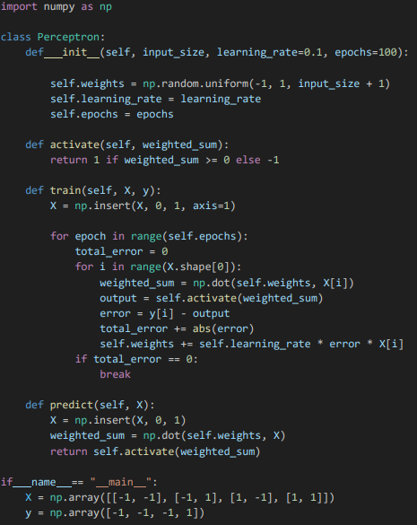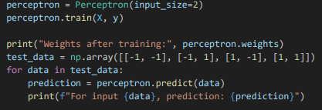
Conclusion:

The Perceptron network successfully models the AND function with bipolar inputs and targets, adjusting its weights through iterative learning using the Perceptron learning rule. By applying a numerical approach, the network converges to the correct solution, accurately classifying the inputs after training. This demonstrates the effectiveness of the Perceptron in solving simple linearly separable problems such as the AND logic function.

Post Lab Descriptive Questions :

- How is _the linear separability concept implemented using perceptron network

Linear separability refers to the property of a dataset where two or more classes can be completely separated by a linear decision boundary (a straight line in 2D, a plane in 3D, or a hyperplane in higher dimensions).

Perceptron Network: A perceptron is the simplest form of an artificial neural network. It consists of a single neuron with adjustable weights and a bias term.
a) Input: The perceptron takes a set of input features (x₁, x₂, ..., xₙ) and their corresponding weights (w₁, w₂, ..., wₙ).

b) Weighted Sum: It calculates the weighted sum of inputs plus a bias term: z = w₁x₁ + w₂x₂ + ... + wₙxₙ + b

c) Activation Function: The result is then passed through a step activation function: y = 1 if z > 0 y = 0 if z ≤ 0

d) Decision Boundary: The equation w₁x₁ + w₂x₂ + ... + wₙxₙ + b = 0 represents the decision boundary.

e) Training: The perceptron learns by adjusting its weights and bias to minimize classification errors. This is typically done using the perceptron learning rule: w_new = w_old + η(y_true - y_pred)x b_new = b_old + η(y_true - y_pred) Where η is the learning rate, y_true is the correct label, and y_pred is the perceptron's prediction.

Linear Separability and Perceptron:

• If the data is linearly separable, the perceptron is guaranteed to find a solution (converge) in a finite number of steps.
• The final weights and bias will define a hyperplane that correctly separates the classes.
• If the data is not linearly separable, the perceptron will not converge, and more complex models (like multi-layer perceptrons) are needed.

- Mention the application of the perceptron network.

• Teaching Tool: Perceptrons are often used as an educational tool to introduce concepts of neural networks and machine learning. They help in understanding fundamental concepts like weights, biases, and the learning process.

• Binary Classification: The most straightforward application of perceptrons is in binary classification tasks, where data needs to be categorized into two distinct classes. Examples include spam detection in emails (spam vs. not spam) or simple medical diagnoses (disease present vs. absent).

• Logical Operations: Perceptrons can model basic logical operations like AND, OR (though not XOR, which requires a multi-layer network). This makes them useful in simple rule-based systems or as components in more complex logical circuits.

• Text Classification: For simple text classification tasks, such as categorizing short text snippets into predefined categories, perceptrons can be effective, especially when dealing with linearly separable data.

• Decision Making: In scenarios where decisions are based on weighted criteria, perceptrons can model the decisionmaking process. For instance, in a simple loan approval system, where decisions are based on a few key factors.

• Pattern Recognition: Perceptrons can be used for basic pattern recognition tasks, especially when the patterns are linearly separable. This could include recognizing simple shapes or distinguishing between different types of objects in images.

• Feature Selection: The weights learned by a perceptron can indicate the importance of different features in making a classification. This can be useful in identifying which input variables are most crucial for a particular decision.

• Simple Control Systems: In some basic control systems, perceptrons can be used to make binary decisions based on input from sensors.

• Preprocessing for Complex Networks: Perceptrons can serve as building blocks or preprocessing units in more complex neural network architectures. They might be used to perform initial feature extraction before passing data to more sophisticated layers.

• Prototype for More Complex Models: While not used extensively in complex real-world applications, perceptrons often serve as prototypes or proofs of concept for more advanced neural network models.

- The following is a training set for a 2-class (as 0 and 1) classification problem. Iterate the perception using the perceptron learning algorithm through the training set and obtain the weights. You may make a reasonable assumption if any.

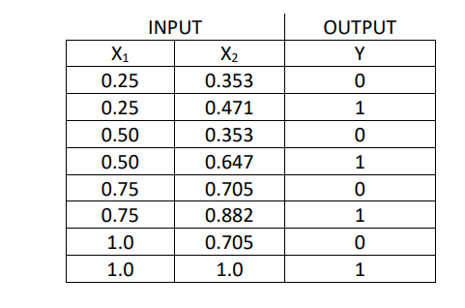
1. Initialization: Randomly initialize the weights and bias.

2. Weighted Sum Calculation: For each training example, calculate the weighted sum z=w1⋅X1+w2⋅X2+b

3. Activation Function: Use a step function (0 or 1) to get the output.

4. Error Calculation: Compute the error=Y−Y^.

5. Weight Update Rule: Adjust the weights and bias using the formula: wi=wi+learning_rate×error×Xi b=b+learning_rate×error

6. Iteration: Repeat the process for each example for a specified number of epochs or until the weights converge.

Assumptions:

1. Learning Rate: Let's assume a small learning rate, e.g., 0.1.
2. Initial Weights and Bias: We initialize the weights and bias randomly between -1 and 1. The final weights after training the Perceptron on the given dataset are: • Bias weight: -0.334 • Weight for X1: -0.649 • Weight for X2: 1.072

Date: 29/ 08/ 2024 Signature of faculty in-charge

