Batch: B1 Roll No.: 16010122158

Experiment No. 05

Grade: AA / AB / BB / BC / CC / CD /DD

Signature of the Staff In-charge with date

Title: Implementation of OR function with bipolar inputs and targets using Adaline network. Assume the required parameters for training of the network.
___________________________________________________________________________________
Objective: To learn Adaline network.
___________________________________________________________________________________
Expected Outcome of Experiment:

CO2: To understand the features of neural networks and different learning methods.
____________________________________________________________________________________
Books/ Journals/ Websites referred:

____________________________________________________________________________________
Pre Lab/ Prior Concepts:

Adaptive Linear Neuron (Adaline):
Adaline which stands for Adaptive Linear Neuron, is a network having a single linear unit.
It was developed by Widrow and Hoff in 1960.
Some important points about Adaline are as follows −
- It uses bipolar activation function.
- It tries to minimize the Mean-Squared Error (MSE) between the actual output and the desired/target output.
The weights and the bias are adjustable

Architecture:

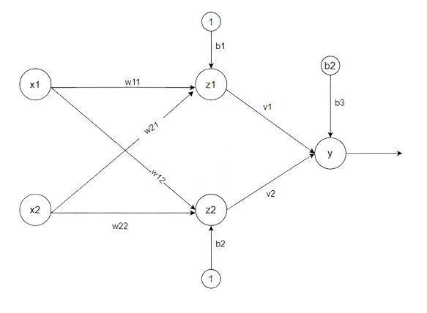

Algorithm:
Step 1: Initialize the following to start the training −Weights, Bias, Learning rate α
Step 2: While the stopping condition is False do steps 3 to 7.
Step 3: for each training set perform steps 4 to 6.
Step 4: Set activation of input unit xi = si for (i=1 to n).
Step 5: compute net input to output unit
Here, b is the bias and n is the total number of neurons.
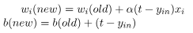
Step 6: Update the weights and bias for i=1 to n

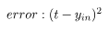
and calculate
Step 7: Test the stopping condition. The stopping condition may be when the weight changes at a low rate or no change.

____________________________________________________________________________________
Implementation Details:

Implementation of OR function with bipolar inputs and targets using Adaline network.

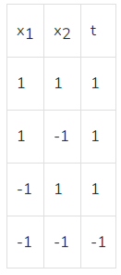

import numpy as np

x = np.array([[-1, -1], [-1, 1], [1, -1], [1, 1]])
t = np.array([-1, 1, 1, 1])
weight = np.array([0.1, 0.1])
bias = 0.1
learning_rate = 0.1
min_squared_error = 2
epoch = 0

while True:
epoch += 1
print("\n=== Epoch:", epoch, "===")
total_squared_error = 0

for j in range(len(x)):
desired_y = t[j]
x1, x2 = x[j]
actual_y = np.dot(np.array([x1, x2]), weight) + bias
error = desired_y - actual_y
print("Error: ", error)
total_squared_error += error ** 2
weight[0] += learning_rate * error * x1
weight[1] += learning_rate * error * x2
bias += learning_rate * error

print("Total Squared Error:", total_squared_error)
if total_squared_error < min_squared_error:
print("\n\n==================\n\n")
print("Total Squared Error < Minimum Total Squared Error")
print("Total Number of Epochs:", epoch)
print("Weights Achieved:", weight, "\nBias Achieved:", bias)
break

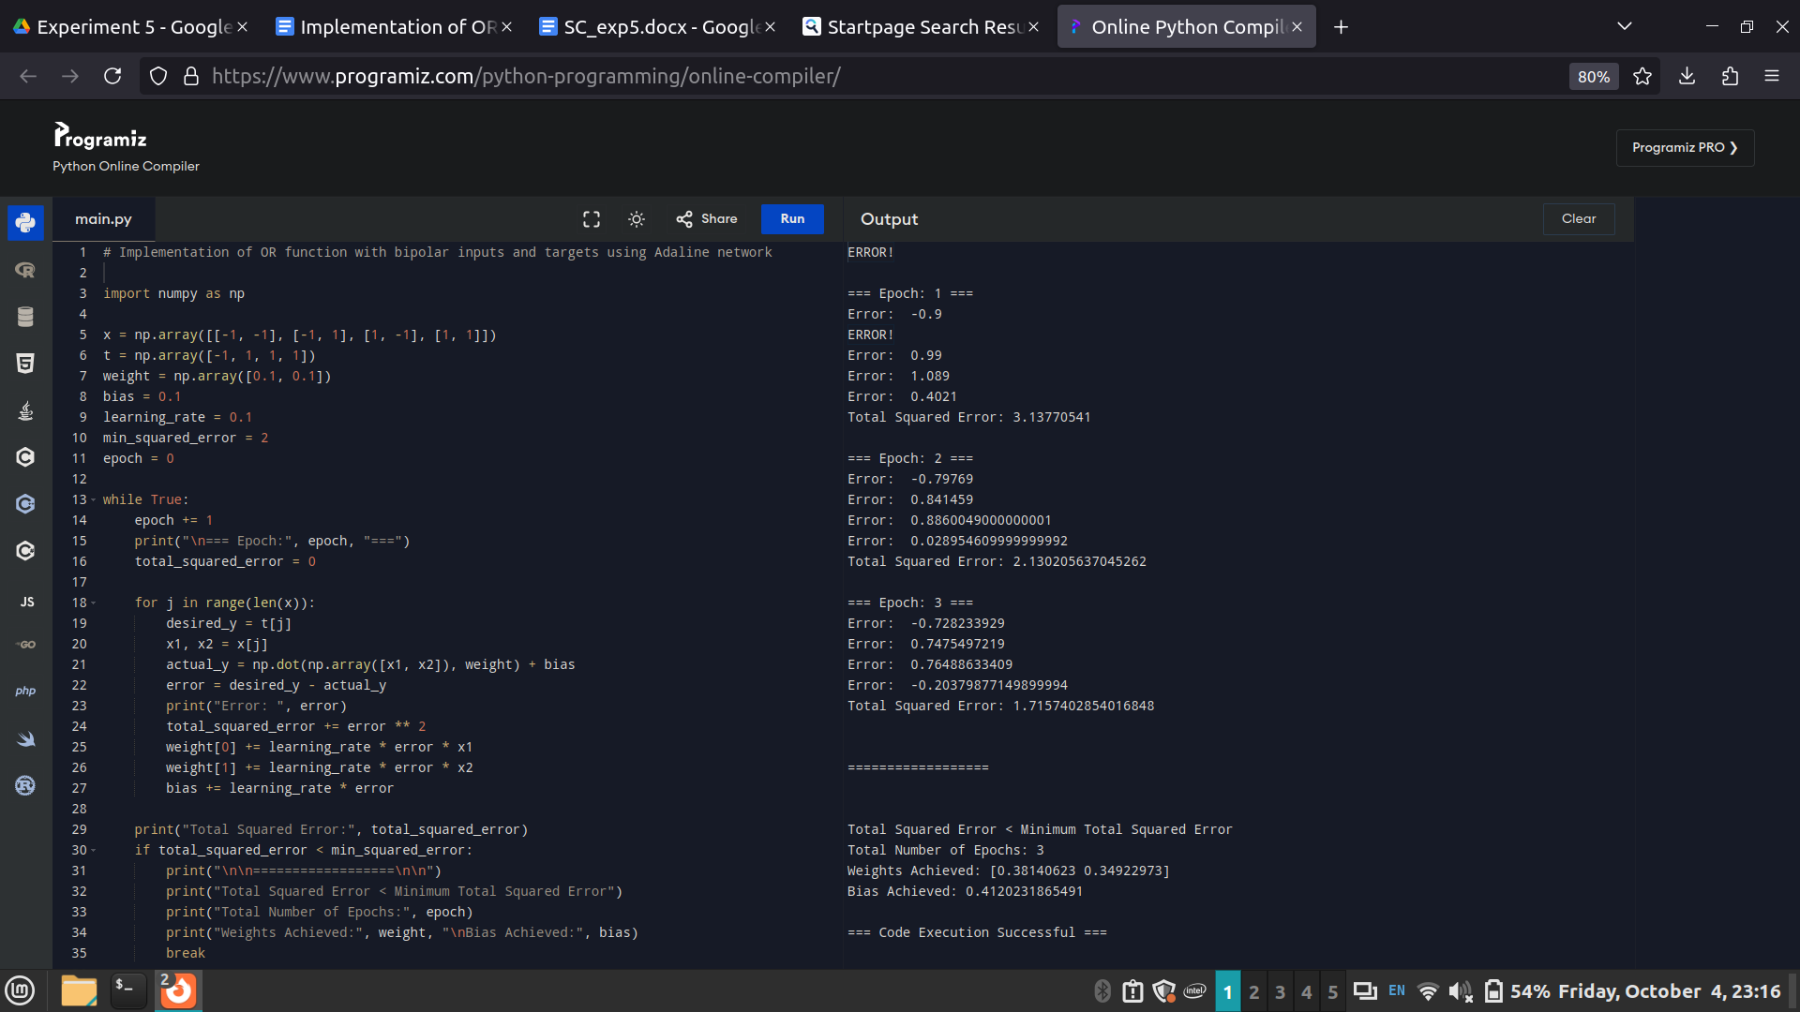

Conclusion:

The Adaline network successfully implemented the OR function with bipolar inputs, adjusting weights and bias to minimize the mean-squared error. The network converged after several epochs, demonstrating the learning process of an adaptive linear neuron.

Post Lab Descriptive Questions:

Use an Adaline network to train AND NOT function with bipolar inputs and targets. Perform 1 epoch of training

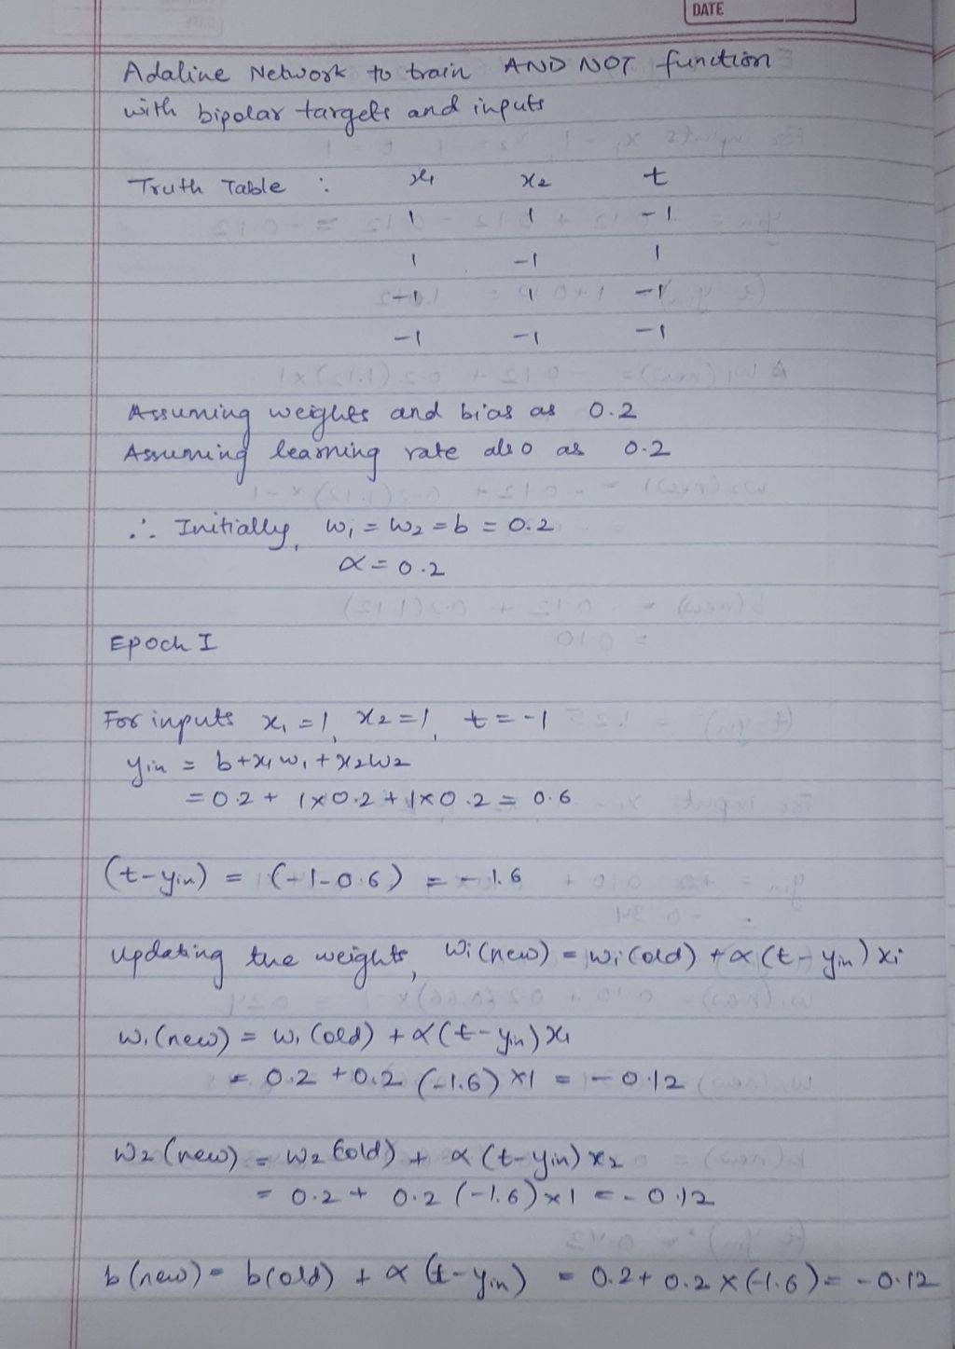
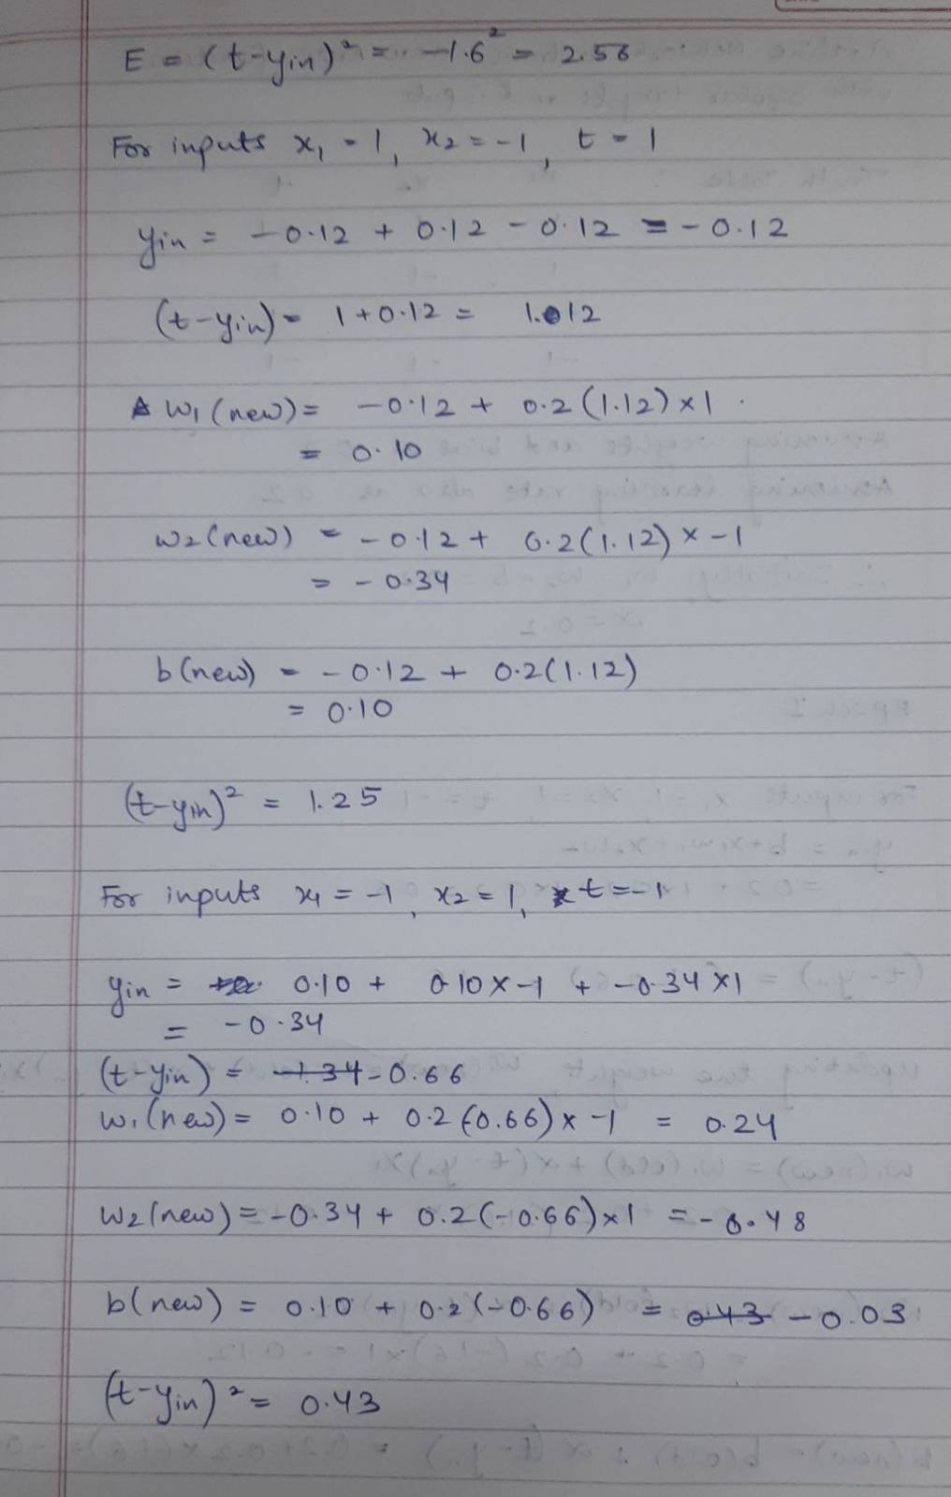
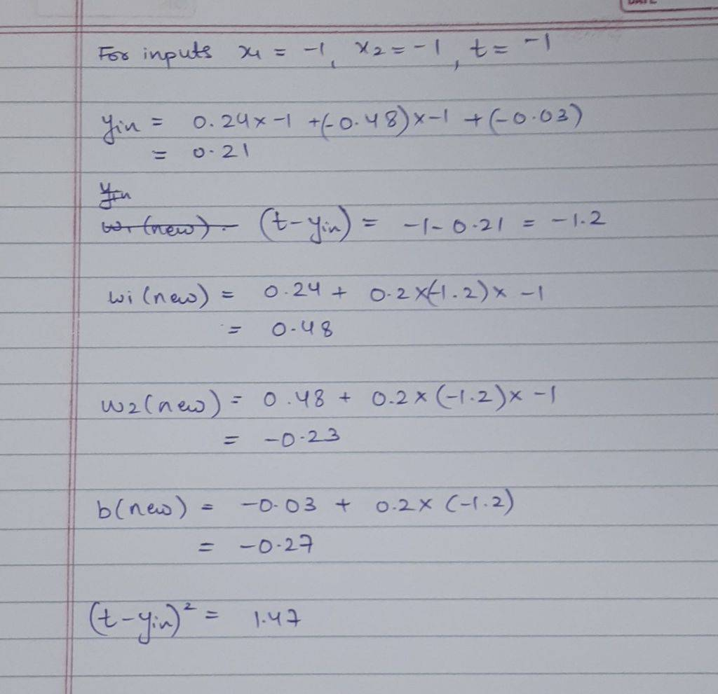

Date: 3/10/2024 Signature of faculty in-charge

