Batch: B1 Roll No.: 16010122158

Experiment No. : 09

Grade: AA / AB / BB / BC / CC / CD / DD

Signature of the Staff In-charge with date

Title: Implementation of de-fuzzification methods (Center of Sum, Centre of
Gravity, Mean of Maximum).
____________________________________________________________________________________
Objective: To understand de-fuzzification methods
____________________________________________________________________________________
Expected Outcome of Experiment:

CO4 : Apply basics of Fuzzy logic and neural networks ____________________________________________________________________________________
Books/ Journals/ Websites referred:

____________________________________________________________________________________
Pre Lab/ Prior Concepts:
____________________________________________________________________________________

Defuzzification :
Defuzzification is the process of producing a quantifiable result in Crisp logic, given fuzzy sets and corresponding membership degrees. It is the process that maps a fuzzy set to a crisp set. It is typically needed in fuzzy control systems. These will have a number of rules that transform a number of variables into a fuzzy result, that is, the result is described in terms of membership in fuzzy sets. Defuzzification is the conversion of a fuzzy quantity to a precise quantity, just as fuzzification is the conversion of a precise quantity to a fuzzy quantity. µ
For example, Fig (a) shows the first part of the Fuzzy output and Fig (b) shows the second part of the Fuzzy output.
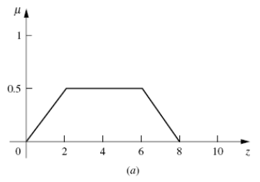
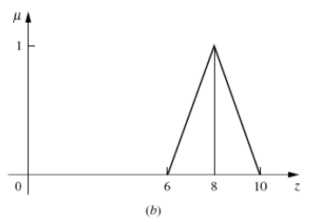
Then Fig (c) shows the union of the two parts (a) and (b).
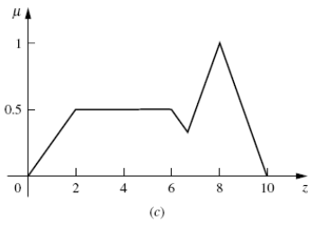

Different Defuzzification methods
- Max membership method

This method is also known as height method and is limited to peak output functions. This method is given by the algebraic expression:
µ(z*) >= µ(z) for all z ∊ Z.

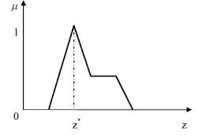
- Center of gravity or centroid
This method is also known as the centre of mass, centre of area or centre of gravity. It is the most commonly used defuzzification method. The defuzzified output z* is given by:
z* = ∫µ(z).zdz / ∫µ(z)dz

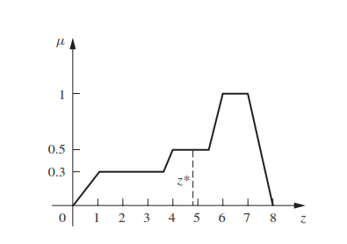

- Centre of sums

This method employs the algebraic sum of the individual fuzzy subsets instead of their union. The calculations here are very fast, but the main drawback is that the intersecting areas are added twice. The defuzzified value z* is given by
z* = ∫ z*∑µ(z).zdz / ∫ ∑µ(z)dz
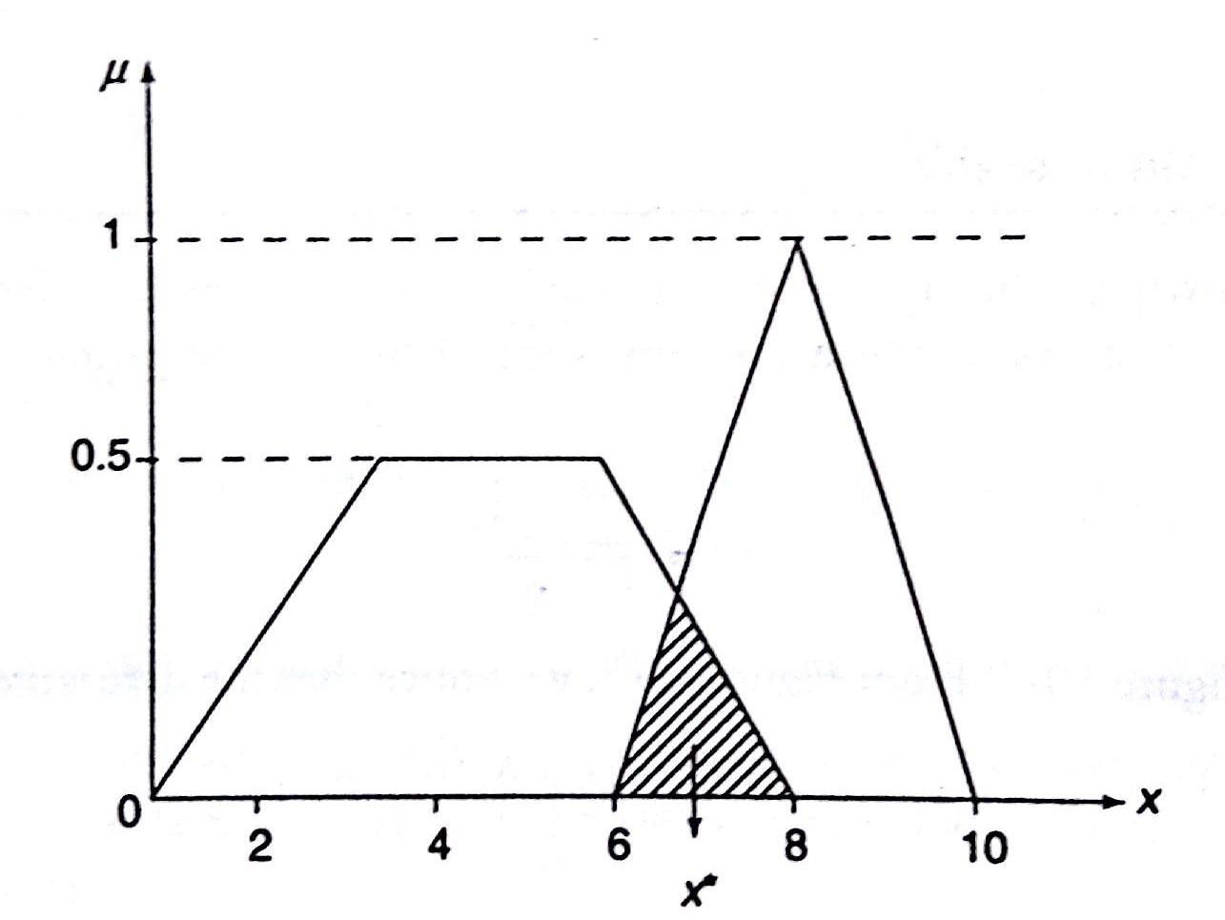

- Mean of maximum method
This method is also known as the middle of the maxima. This is closely related to the max-membership method, except that the locations of the maximum membership can be nonunique. The output here is given by:
z* = ∑z' / n ; where z' is the maximum value of the membership function.
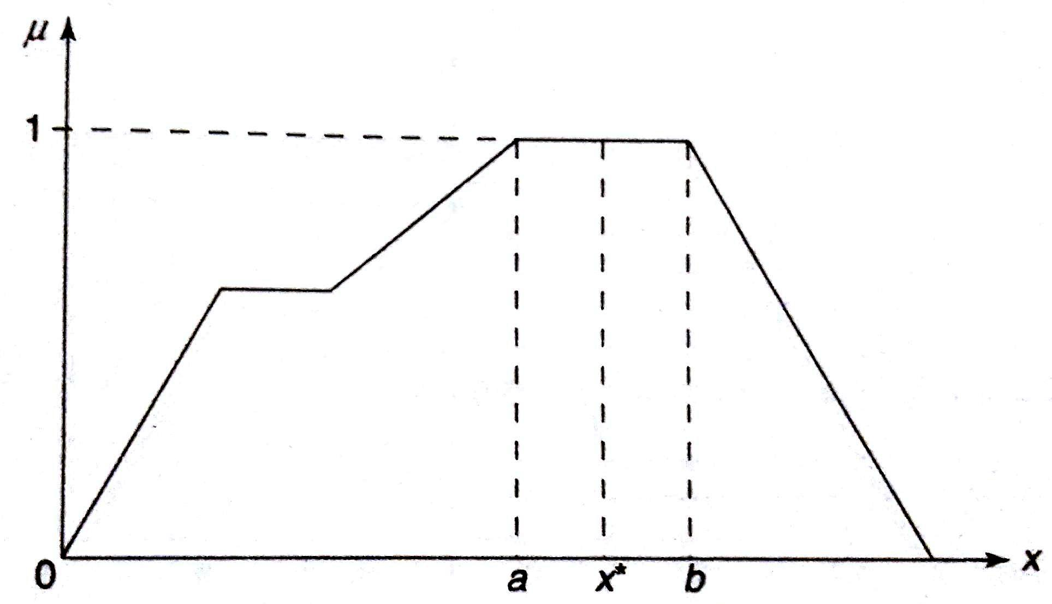

____________________________________________________________________________________
- Weighted average method
This method is valid for symmetrical output membership functions only. Each membership function is weighted by its maximum membership value. The output in the case is given by
z* = ∑µ(z').z' / ∑µ(z') ; where z' is the maximum value of the membership function.

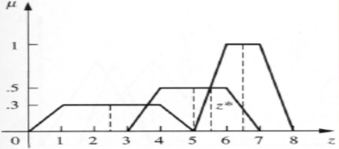

- Centre of Largest Area
This method can be adopted when the output of at least two convex fuzzy subsets which are not overlapping. The output, in this case, is biased towards a side of one membership function. When output fuzzy st has at least two convex regions, then the centre of gravity of the convex fuzzy subregion having the largest are is used to obtain the defuzzified value z*. The value is given by

z* = ∫ µc(z).zdz / ∫ ∑µc(z)dz

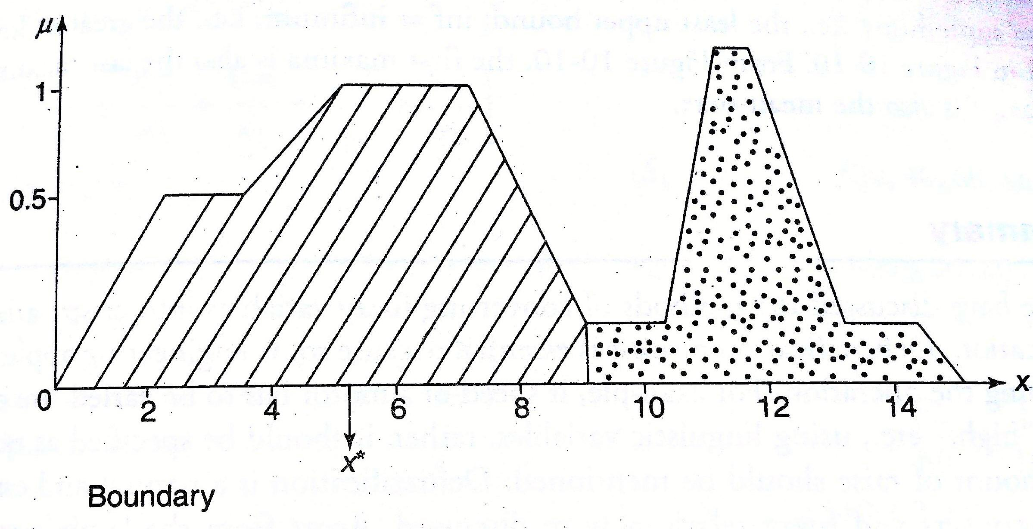

Implementation Details: Code and Snap shot of graph

- Max membership method:
Code:
import numpy as np
import matplotlib.pyplot as plt

# TRIANGULAR membership function
def triangular_member(x, a, b, c):
"""Triangular membership function"""
if x <= a:
return 0.0
elif a < x <= b:
return (x - a) / (b - a)
elif b < x <= c:
return (c - x) / (c - b)
else:
return 0.0

# TRAPEZOIDAL membership function
def trapezoidal_member(x, a, b, c, d, height):
"""Trapezoidal membership function"""
if x <= a:
return 0.0
elif a < x < b:
return ((x - a) / (b - a)) * height
elif b <= x <= c:
return height
elif c < x < d:
return ((d - x) / (d - c)) * height
else:
return 0.0

def fuzzy_union(setA, setB):
union = []
for value in list(zip(setA, setB)):
union.append(max(value))
return union

# Plot the membership functions and operations
x_values = np.linspace(0, 10, 500)

# Function 1 (Triangular)
a, b, c = 2, 4, 6
y_values_triangular = [triangular_member(x, a, b, c) for x in x_values]

# Function 2 (Trapezoidal)
a, b, c, d, h = 4, 5, 6, 7, 0.5
y_values_trapezoidal = [trapezoidal_member(x, a, b, c, d, h) for x in x_values]

# Fuzzy set (obtained by taking union of functions defined above)
fuzzy_values = fuzzy_union(y_values_triangular, y_values_trapezoidal)
plt.plot(x_values, fuzzy_values, 'blue', label='Fuzzy Set')
plt.title('Max Membership Method')
plt.xlabel('X-axis')
plt.ylabel('Membership Value')

def max_membership(x_values, fuzzy_values):
# values = zip(x_values, fuzzy_values)
index = fuzzy_values.index(max(fuzzy_values))
crisp_value = int(x_values[index])
plt.axvline(x=crisp_value, color='r', linestyle='--', label=f'x = {crisp_value}')
plt.legend()
plt.show()

max_membership(x_values, fuzzy_values)

Output:
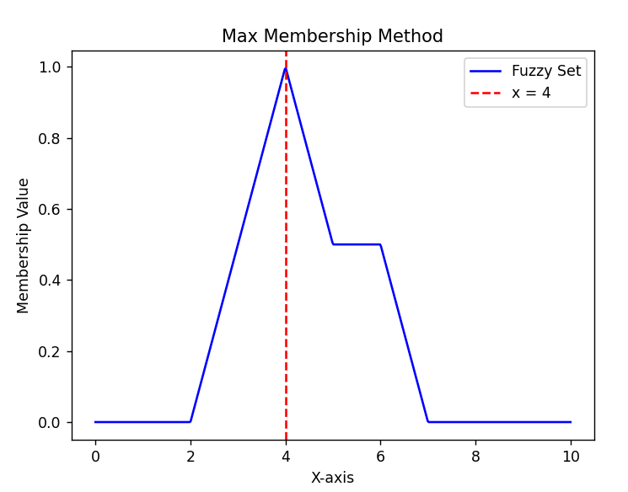
- Center of gravity / Centroid method:
Code:
import numpy as np
import matplotlib.pyplot as plt

# TRAPEZOIDAL membership function
def trapezoidal_member(x, a, b, c, d, height):
"""Trapezoidal membership function"""
if x <= a:
return 0.0
elif a < x < b:
return ((x - a) / (b - a)) * height
elif b <= x <= c:
return height
elif c < x < d:
return ((d - x) / (d - c)) * height
else:
return 0.0

def fuzzy_union(setA, setB, setC):
union = []
for value in list(zip(setA, setB, setC)):
union.append(max(value))
return union

def fuzzy_product(setA, setB):
product = []
for value1, value2 in list(zip(setA, setB)):
product.append(round(value1 * value2, 3))
return product

# Plot the membership functions and operations
x_values = np.linspace(0, 8, 500)

# Function 1
a, b, c, d, h = 0, 1, 4, 5, 0.3
y_values_func1 = [trapezoidal_member(x, a, b, c, d, h) for x in x_values]

# Function 2
a, b, c, d, h = 3, 4, 6, 7, 0.5
y_values_func2 = [trapezoidal_member(x, a, b, c, d, h) for x in x_values]

# Function 3
a, b, c, d, h = 5, 6, 7, 8, 1
y_values_func3 = [trapezoidal_member(x, a, b, c, d, h) for x in x_values]

# Fuzzy set (obtained by taking union of functions defined above)
fuzzy_values = fuzzy_union(y_values_func1, y_values_func2, y_values_func3)
plt.plot(x_values, fuzzy_values, 'blue', label='Fuzzy Set')
plt.title('Centroid Method')
plt.xlabel('X-axis')
plt.ylabel('Membership Value')

def centroid(x_values, fuzzy_values):
crisp_value = np.trapz(fuzzy_product(fuzzy_values, x_values), x_values) / np.trapz(fuzzy_values, x_values)
crisp_value = round(crisp_value, 3)
plt.axvline(x=crisp_value, color='r', linestyle='--', label=f'x = {crisp_value}')
plt.legend()
plt.show()

centroid(x_values, fuzzy_values)

Output:
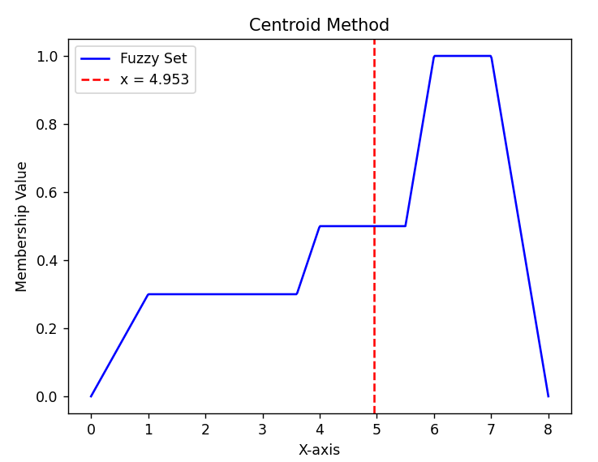
- Center of Sums Method:
Code:
import numpy as np
import matplotlib.pyplot as plt

# TRIANGULAR membership function
def triangular_member(x, a, b, c):
"""Triangular membership function"""
if x <= a:
return 0.0
elif a < x <= b:
return (x - a) / (b - a)
elif b < x <= c:
return (c - x) / (c - b)
else:
return 0.0

# TRAPEZOIDAL membership function
def trapezoidal_member(x, a, b, c, d, height):
"""Trapezoidal membership function"""
if x <= a:
return 0.0
elif a < x < b:
return ((x - a) / (b - a)) * height
elif b <= x <= c:
return height
elif c < x < d:
return ((d - x) / (d - c)) * height
else:
return 0.0

def fuzzy_union(setA, setB, setC):
union = []
for value in list(zip(setA, setB, setC)):
union.append(max(value))
return union

def fuzzy_product(setA, setB):
product = []
for value1, value2 in list(zip(setA, setB)):
product.append(round(value1 * value2, 3))
return product

# Plot the membership functions and operations
x_values = np.linspace(0, 10, 500)

# Function 1
a, b, c, d, h = 0, 3, 6, 8, 0.5
y_values_func1 = [trapezoidal_member(x, a, b, c, d, h) for x in x_values]

# Function 2
a, b, c = 6, 8, 10
y_values_func2 = [triangular_member(x, a, b, c) for x in x_values]

# Fuzzy set (obtained by taking union of functions defined above)
plt.plot(x_values, y_values_func1, 'blue')
plt.plot(x_values, y_values_func2, 'blue')
plt.title('Center of Sums Method')
plt.xlabel('X-axis')
plt.ylabel('Membership Value')

def centerOfSums(x_values, func1, func2):
A1 = np.trapz(func1, x_values)
X1 = np.trapz(fuzzy_product(func1, x_values), x_values) / np.trapz(func1, x_values)
A2 = np.trapz(func2, x_values)
X2 = np.trapz(fuzzy_product(func2, x_values), x_values) / np.trapz(func2, x_values)
crisp_value = (A1 * X1 + A2 * X2) / (A1 + A2)
crisp_value = round(crisp_value, 3)
plt.axvline(x=crisp_value, color='r', linestyle='--', label=f'x = {crisp_value}')
plt.axhline(y=0, color='black')
plt.legend()
plt.show()

centerOfSums(x_values, y_values_func1, y_values_func2)

Output:
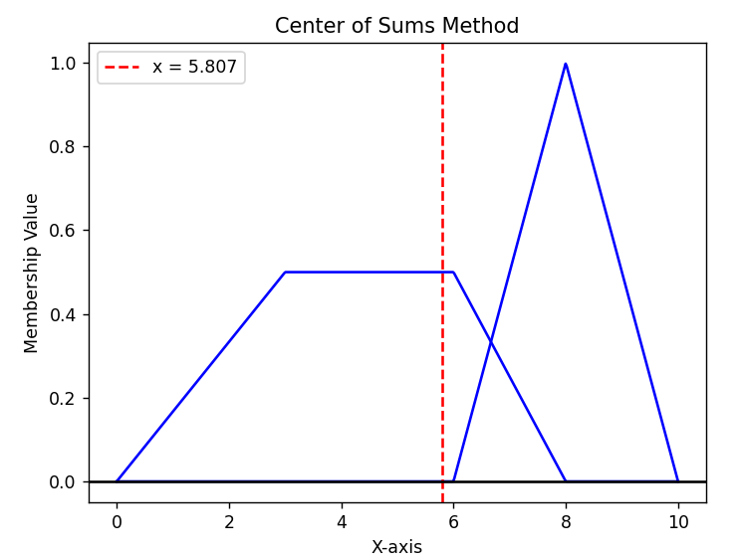

- Mean of Maxima Method:
Code:
import numpy as np
import matplotlib.pyplot as plt

# TRAPEZOIDAL membership function
def trapezoidal_member(x, a, b, c, d, height):
"""Trapezoidal membership function"""
if x <= a:
return 0.0
elif a < x < b:
return ((x - a) / (b - a)) * height
elif b <= x <= c:
return height
elif c < x < d:
return ((d - x) / (d - c)) * height
else:
return 0.0

def fuzzy_union(setA, setB):
union = []
for value in list(zip(setA, setB)):
union.append(max(value))
return union

# Plot the membership functions and operations
x_values = np.linspace(0, 10, 500)

# Function 1
a, b, c, d, h = 0, 2, 4, 6, 0.7
y_values_func1 = [trapezoidal_member(x, a, b, c, d, h) for x in x_values]

# Function 2
a, b, c, d, h = 2, 5, 8, 10, 1
y_values_func2 = [trapezoidal_member(x, a, b, c, d, h) for x in x_values]

# Fuzzy set (obtained by taking union of functions defined above)
fuzzy_values = fuzzy_union(y_values_func1, y_values_func2)
plt.plot(x_values, fuzzy_values, 'blue', label='Fuzzy Set')
plt.title('Mean of Maxima Method')
plt.xlabel('X-axis')
plt.ylabel('Membership Value')

def meanOfMaxima(x_values, fuzzy_values):
maxima = max(fuzzy_values)
maxima_index = [i for i, x in enumerate(fuzzy_values) if x == maxima]
maxima_values = [x_values[x] for x in maxima_index]
crisp_value = np.mean(maxima_values)
crisp_value = round(crisp_value, 3)
plt.axvline(x=crisp_value, color='r', linestyle='--', label=f'x = {crisp_value}')
plt.legend()
plt.show()

meanOfMaxima(x_values, fuzzy_values)

Output:
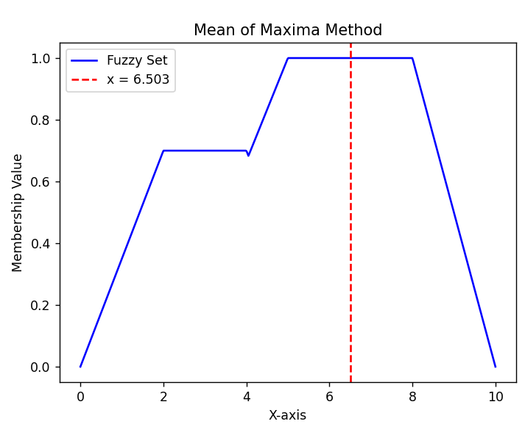

- Weighted Average Method:
Code:
import numpy as np
import matplotlib.pyplot as plt

# TRAPEZOIDAL membership function
def trapezoidal_member(x, a, b, c, d, height):
"""Trapezoidal membership function"""
if x <= a:
return 0.0
elif a < x < b:
return ((x - a) / (b - a)) * height
elif b <= x <= c:
return height
elif c < x < d:
return ((d - x) / (d - c)) * height
else:
return 0.0

# Plot the membership functions and operations
x_values = np.linspace(0, 8, 500)

# Function 1
a, b, c, d, h = 0, 1, 4, 5, 0.3
y_values_func1 = [trapezoidal_member(x, a, b, c, d, h) for x in x_values]
plt.plot(x_values, y_values_func1, 'blue')

# Function 2
a, b, c, d, h = 3, 4, 6, 7, 0.5
y_values_func2 = [trapezoidal_member(x, a, b, c, d, h) for x in x_values]
plt.plot(x_values, y_values_func2, 'blue')

# Function 3
a, b, c, d, h = 5, 6, 7, 8, 1
y_values_func3 = [trapezoidal_member(x, a, b, c, d, h) for x in x_values]
plt.plot(x_values, y_values_func3, 'blue')

# Fuzzy set (obtained by taking union of functions defined above)
plt.title('Weighted Average Method')
plt.xlabel('X-axis')
plt.ylabel('Membership Value')

def weightedAverage(x_values, y_values_func1, y_values_func2, y_values_func3):
maxima1 = max(y_values_func1)
maxima_index = [i for i, x in enumerate(y_values_func1) if x == maxima1]
maxima_values = [x_values[x] for x in maxima_index]
crisp1 = round(np.mean(maxima_values), 3)
WA1 = crisp1 * maxima1
plt.axvline(x=crisp1, color='g', linestyle='--', label=f'x = {crisp1}')

maxima2 = max(y_values_func2)
maxima_index = [i for i, x in enumerate(y_values_func2) if x == maxima2]
maxima_values = [x_values[x] for x in maxima_index]
crisp2 = round(np.mean(maxima_values), 3)
WA2 = crisp2 * maxima2
plt.axvline(x=crisp2, color='g', linestyle='--', label=f'x = {crisp2}')

maxima3 = max(y_values_func3)
maxima_index = [i for i, x in enumerate(y_values_func3) if x == maxima3]
maxima_values = [x_values[x] for x in maxima_index]
crisp3 = round(np.mean(maxima_values), 3)
WA3 = crisp3 * maxima3
plt.axvline(x=crisp3, color='g', linestyle='--', label=f'x = {crisp3}')

crisp_value = (WA1 + WA2 + WA3) / (maxima1 + maxima2 + maxima3)
crisp_value = round(crisp_value, 3)
plt.axvline(x=crisp_value, color='r', linestyle='--', label=f'x = {crisp_value}')
plt.legend()
plt.show()

weightedAverage(x_values, y_values_func1, y_values_func2, y_values_func3)

Output:
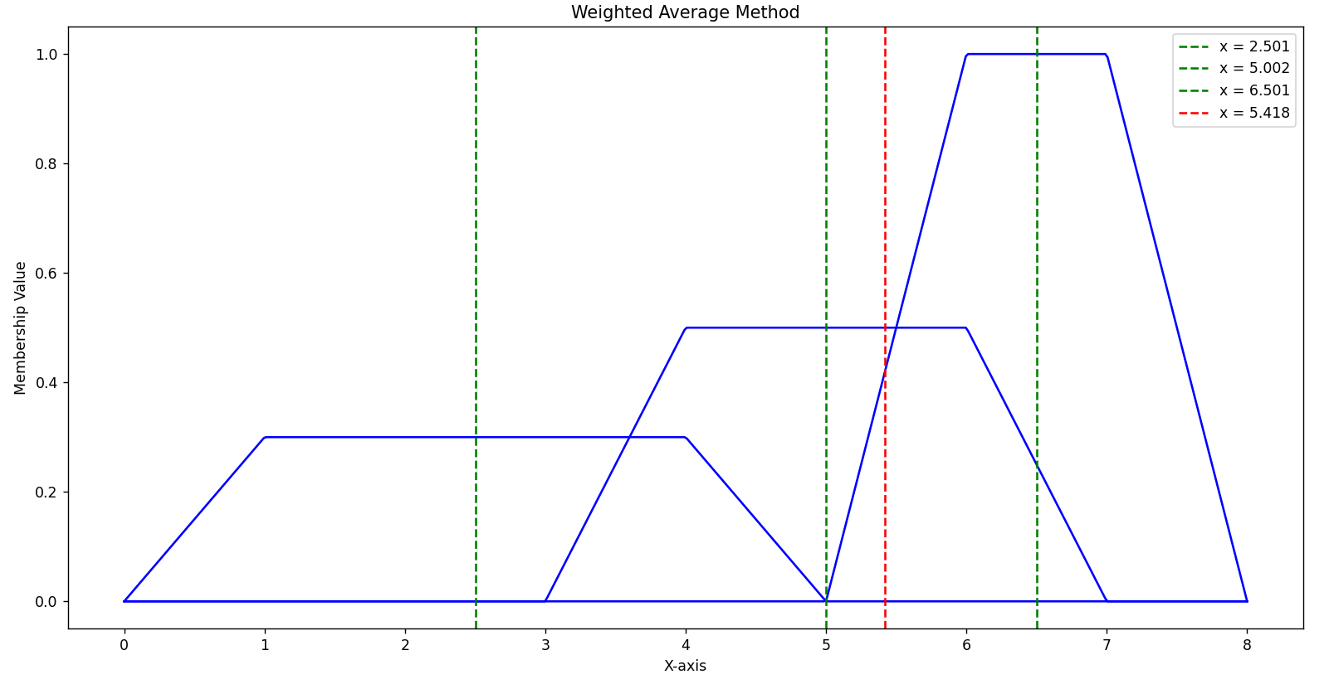
Conclusion:
Implementation of defuzzification methods was done successfully.

Post Lab Descriptive Questions
Find crisp values corresponding to the following fuzzy output sets using various de-fuzzification methods.
