B1

Batch: B1 Roll No.: 16010122160

Experiment No. 3

Grade: AA / AB / BB / BC / CC / CD /DD

Signature of the Staff In-charge with date

Title: To develop UML diagrams for selected project
______________________________________________________________________
Aim: To learn and understand the way of creating various UML diagrams for requirement analysis
______________________________________________________________________
CO: Analyse the software requirements and Model the defined problem with the help of UML diagram
______________________________________________________________________

Books/ Journals/ Websites referred:
- Roger Pressman, “Software Engineering”, sixth edition, Tata McGraw Hill.
- System Analysis & Design by Satzinger, Jackson and Burd, Cengage Learning, 2007
- System Analysis and Design Methods by Jeffery l. Whitten, Lonnie D Bentley,McGraw Hill, 7th edition.
- System Analysis and Design by Alan Dennis, Barbara H. Wixom, Roberta M. Roth,Wiley India 4th edition
- http://en.wikipedia.org/wiki/Software_requirements_specification
- http://en.wikipedia.org/wiki/Use_case

__________________________________________________________________
Pre Lab/ Prior Concepts:
Use Case Diagram:
- A use case diagram shows the interaction between users (actors) and the system. It highlights the different functionalities (use cases) the system provides and who interacts with them.
- In your project, the use case diagram helps identify the key features of the system and the primary actors involved. It provides a high-level view of what the system will do, allowing stakeholders to understand the system's capabilities and how users will interact with it.
Activity Diagram:
- An activity diagram represents the workflow or the sequence of activities in a system. It illustrates the dynamic aspects of the system, showing how different activities are connected and the flow of control from one activity to another.
- For your project, the activity diagram helps map out the processes or workflows within the system. It allows you to visualize how the system behaves during different operations, such as how a user might navigate through the system or how different components interact during a process.
Sequence Diagram:
- A sequence diagram focuses on the time-ordering of messages or interactions between objects or components in the system. It shows how objects interact with each other over time to carry out a particular functionality.
- In your project, the sequence diagram is used to detail the interactions between objects for specific use cases. It helps in understanding the flow of messages between objects, the order of operations, and how the system's components work together to achieve a particular outcome.
Class Diagram:
- A class diagram describes the static structure of the system by showing the system's classes, their attributes, operations, and the relationships between them.
- For your project, the class diagram serves as the blueprint for the system's code. It defines the system's data structure and the relationships between different entities (classes). This diagram is essential for understanding how the system's data is organized and how different classes interact to perform the system's functionalities.
Developing these UML diagrams for your project provides a comprehensive view of both the static and dynamic aspects of the system. They are crucial for the design phase, ensuring that all stakeholders have a clear understanding of the system's architecture and behavior. By creating these diagrams, you lay the foundation for a well-structured, maintainable, and scalable software system.

Diagram for your system:
Use case:
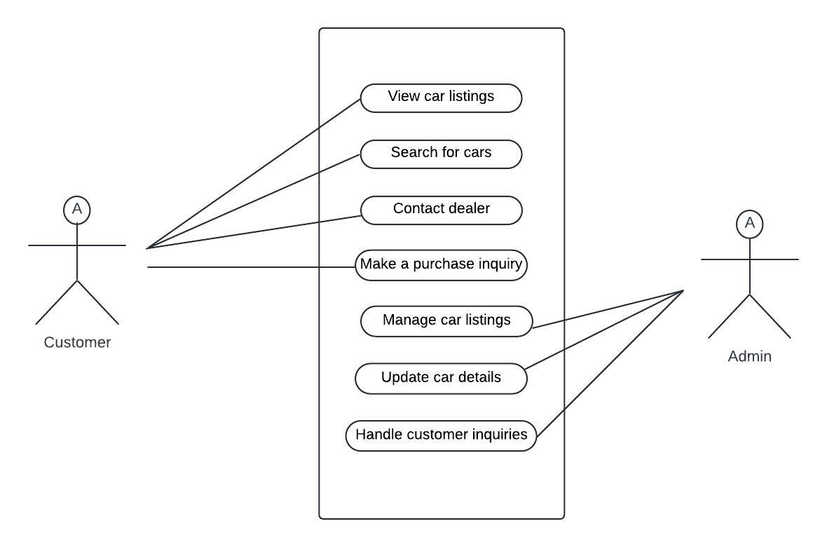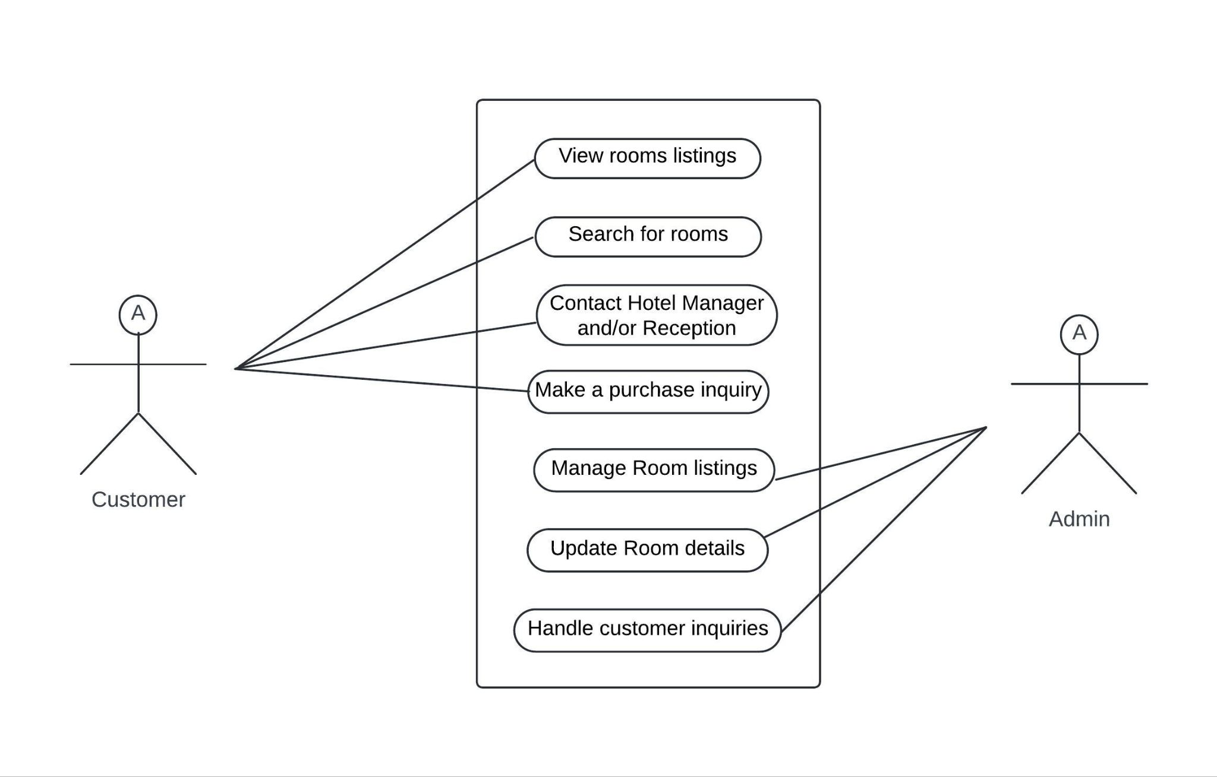
Activity diagram:
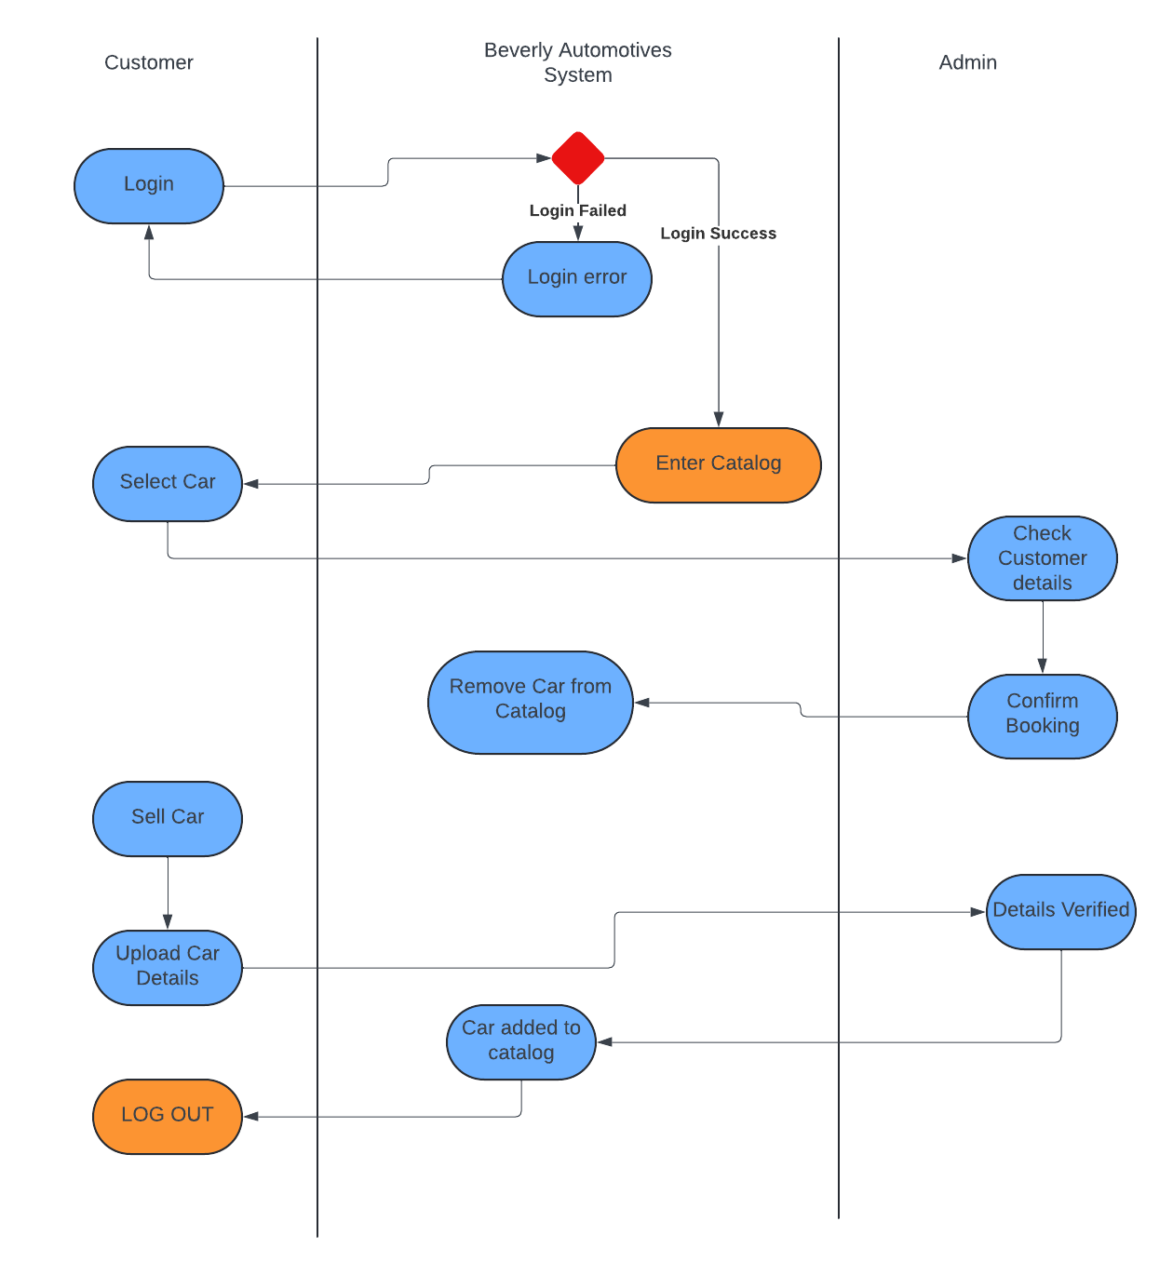
Sequence diagram: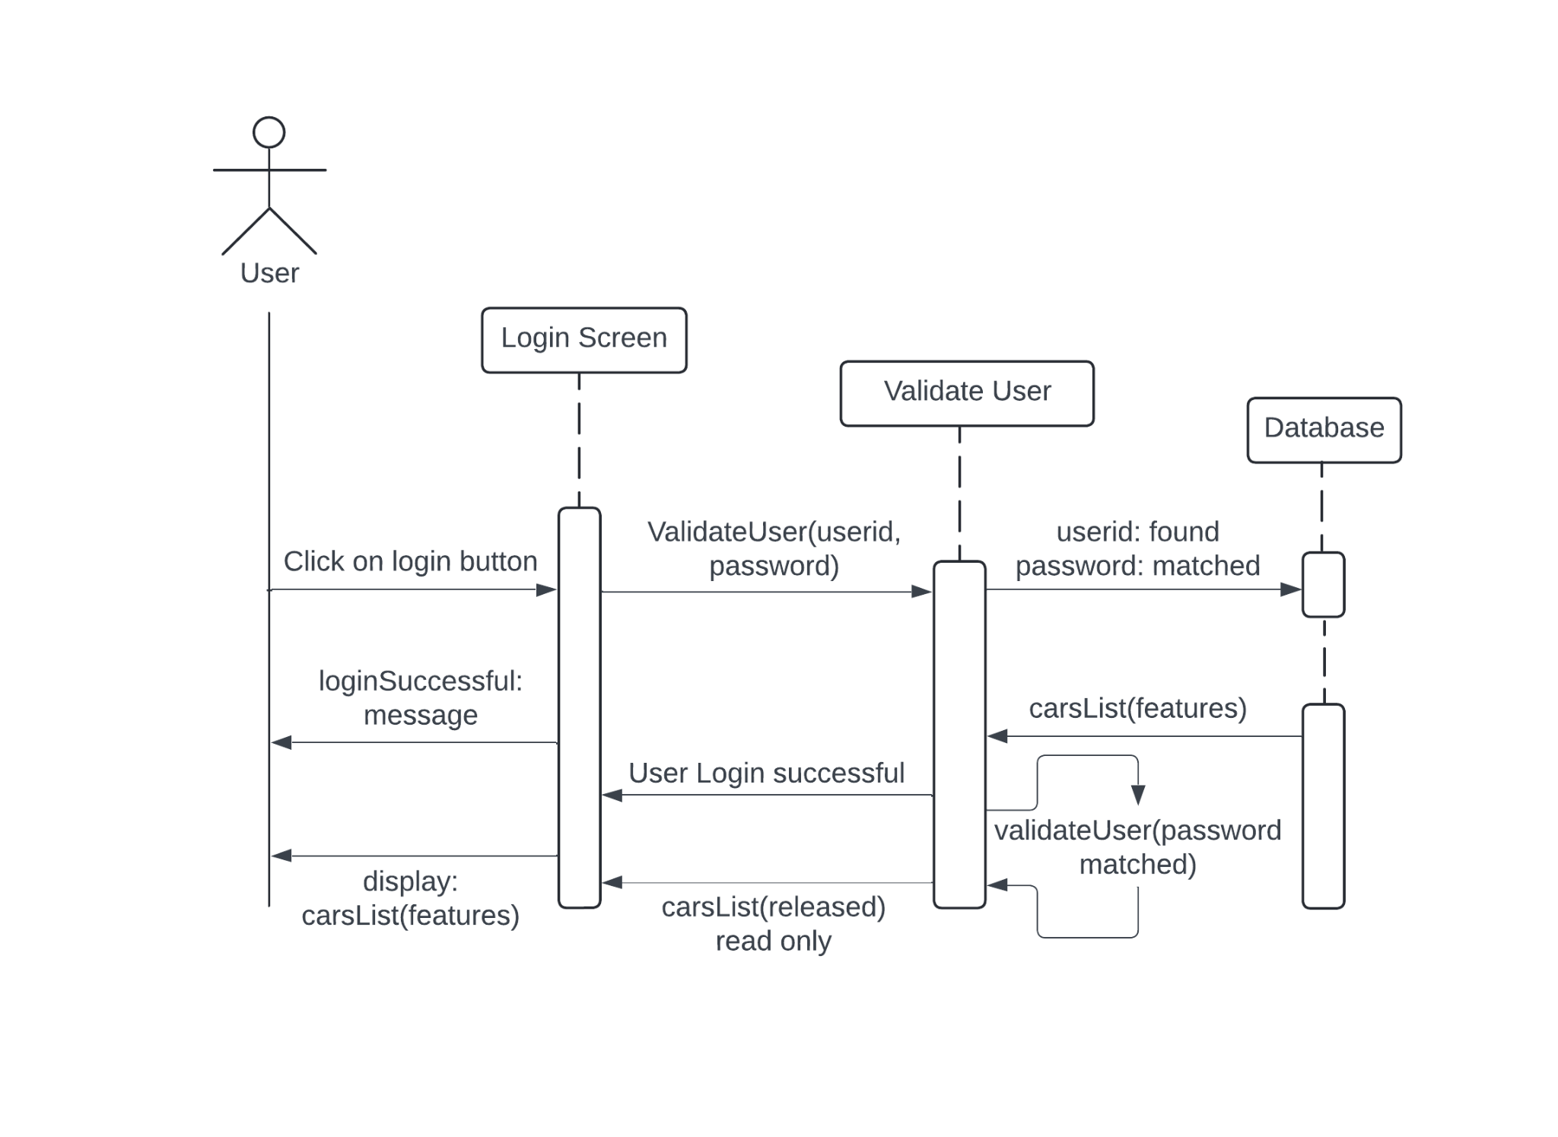

Class diagram:
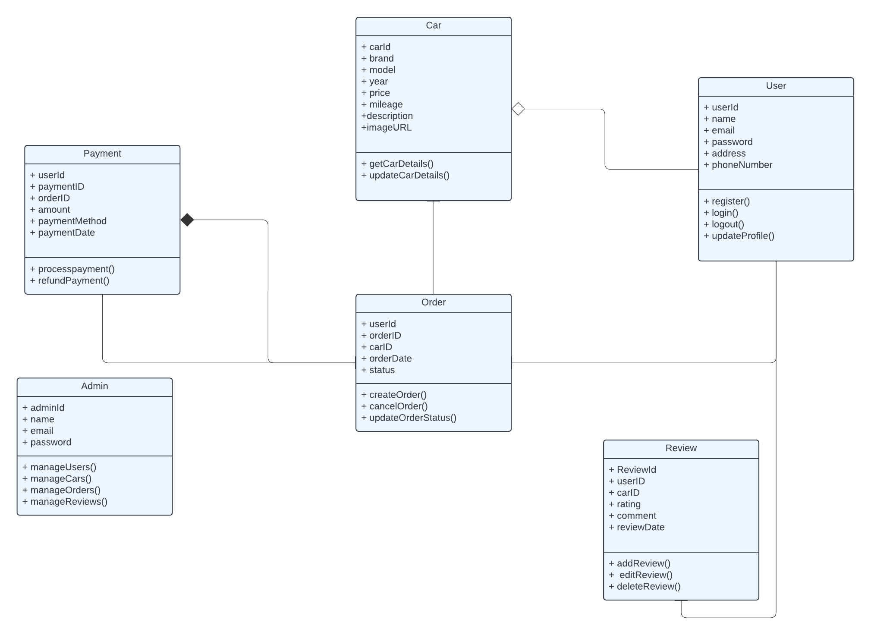
Collaboration diagram:
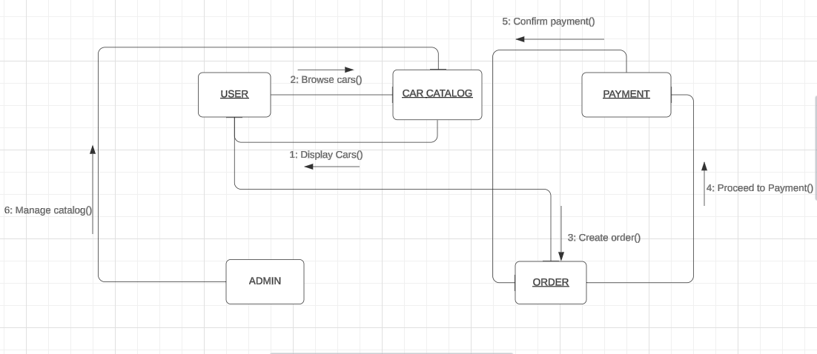

State chart diagram:
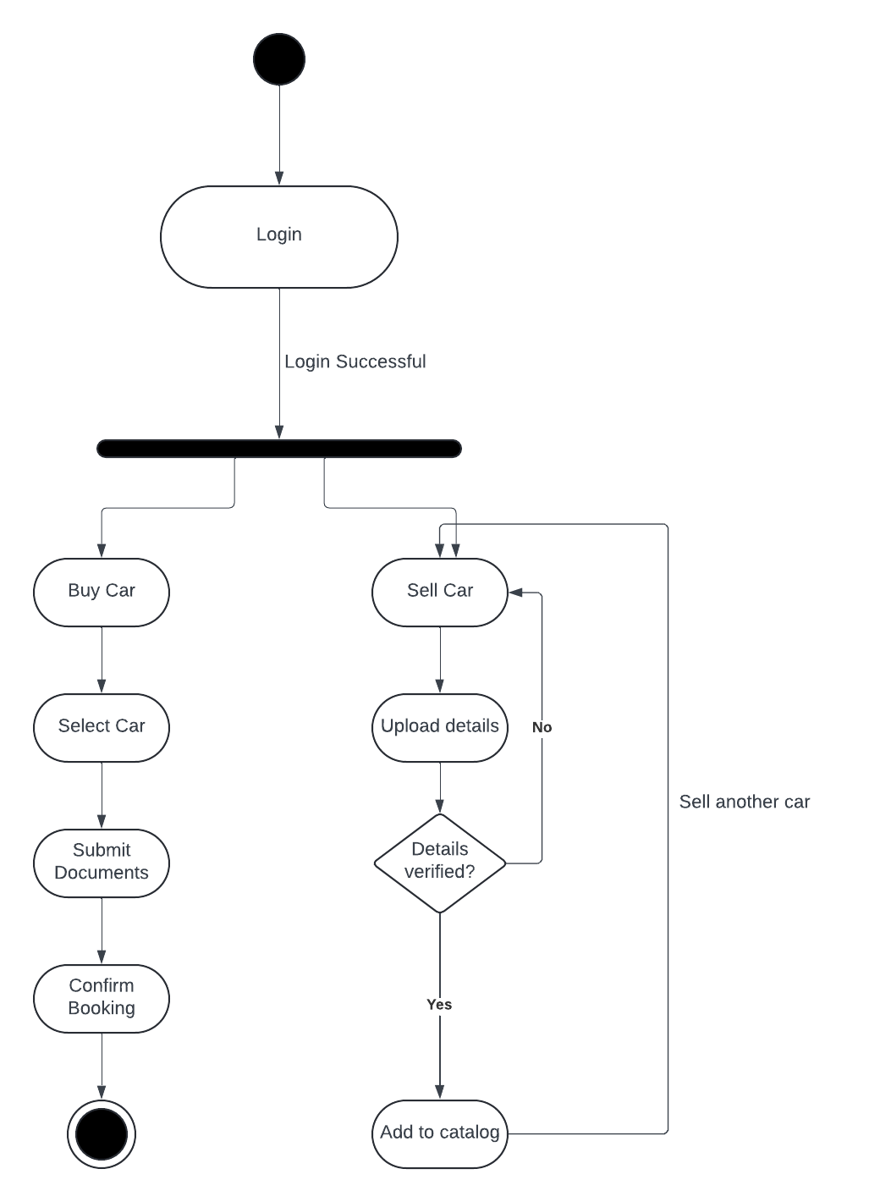
Conclusion:
Developing UML diagrams is essential for understanding the software's architecture and behavior during requirement analysis. By creating diagrams such as use case, activity, class, sequence diagrams, collaboration and state chart diagrams we can effectively communicate the system's functionality and interactions, laying a solid foundation for implementation and testing.

Post Lab Descriptive Questions:

- Where do use cases fit in the software development life cycle?
A use case is a written description of how users will perform tasks on your website. It outlines, from a user’s point of view, a system’s behavior as it responds to a request. Each use-case is represented as a sequence of simple steps, beginning with a user’s goal and ending when that goal is reached.
- Compare sequence diagram with collaboration diagram. Explain pros and cons of each.
Sequence Diagram | Collaboration Diagram
Used to visualize the sequence of calls in a system. | Used to visualize the organization of objects.
Time sequence is the main focus. | Object organization is the main focus.
Better suited for ananysis of activities. | Better suited for depicting simpler interaction of objects.
Shows the sequence of messages that flow from one object to another. | Shows the structured organization of the system and the messages sent.

- List different notations used in Class diagram with example
Different Notations used in class diagram are:
Class:
Classes represent the central objects in a system. It is represented by a rectangle with up to 3 compartments.
The first one shows the class’s name, while the middle one shows the class’s attributes which are the characteristics of the objects. The bottom one lists the class’s operations, which represents the behaviour of the class.
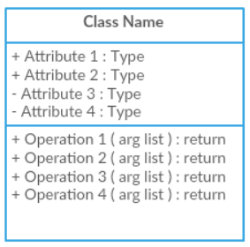
Interface:
The interface symbol in class diagrams indicates a set of operations that would detail the responsibility of a class.
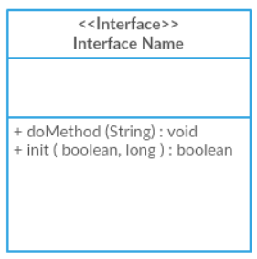

Package:
The package symbol is used to group classes or interfaces that are either similar in nature or related. Grouping these design elements using the package symbols improves the readability of the diagram.
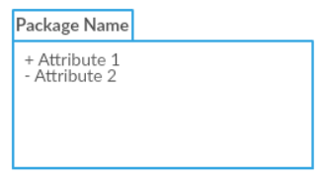

Relationships:
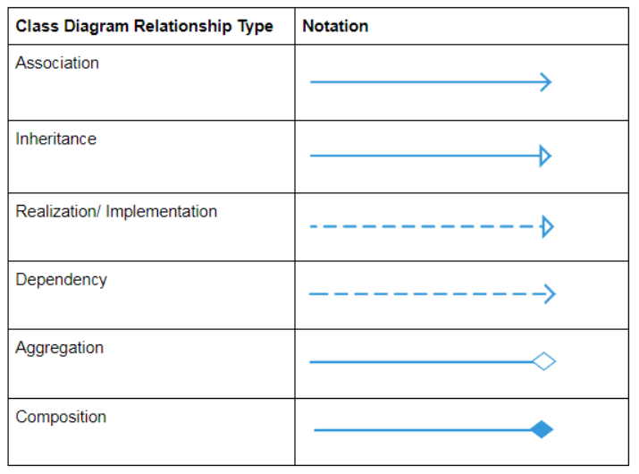
- Modeling UML Use Case, Class diagram, Sequence Diagram.
- Virtual Lab Link: http://vlabs.iitkgp.ernet.in/se/3/exercise/
- Virtual Lab Link: http://vlabs.iitkgp.ernet.in/se/5/exercise/
- Virtual Lab Link: http://vlabs.iitkgp.ernet.in/se/6/
- Virtual Lab Link: http://vlabs.iitkgp.ernet.in/se/7/
