Batch: B1 Roll No.: 16010122160

Experiment No. 6

Grade: AA / AB / BB / BC / CC / CD / DD

Signature of the Staff In-charge with date

Title: User interface design using UI tools for mini project
______________________________________________________________________
Aim: To enable the students learn different user interface design tools and their aspects
______________________________________________________________________

CO: Prepare the System Design and Model ______________________________________________________________________

Books/ Journals/ Websites referred:
- Roger Pressman, “Software Engineering”, sixth edition, Tata McGraw Hill.
__________________________________________________________________
Pre Lab/ Prior Concepts:
The user interface Need:
System users often judge a system by its interface rather than its functionality. A poorly designed interface can cause a user to make catastrophic errors. Poor user interface design is the reason why so many software systems are never used. Most users of business systems interact with these systems through graphical interfaces although.
GUI characteristics
Windows Multiple windows allow different information to be displayed simultaneously on the user’s screen. Icons different types of information. On some systems, icons represent files; on others, icons represent processes. Menus Commands are selected from a menu rather than typed in a command language. A pointing device such as a mouse is used for selecting choices from a menu or indicating items of interest in a window.
GUI advantages
They are easy to learn and use.
• Users without experience can learn to use the system quickly
The user may switch quickly from one task to another and can interact with several different applications.
Information remains visible in its own window when attention is switched.
Fast, full-screen interaction is possible with immediate access to anywhere on the
User Interface Design Models
User model — a profile of all end users of the system
Design model — a design realization of the user model
Mental model (system perception) — the user’s mental image of what the interface is
Implementation model — the interface “look and feel” coupled with supporting information that describe interface syntax and semantics
User interface design analysis:
The overall process for analysing and designing a user interface begins with the creation of different models of system function (as perceived from the outside). You begin by delineating the human- and computer-oriented tasks that are required to achieve system function and then considering the design issues that apply to all interface designs. Tools are used to prototype and ultimately implement the design model, and the result is evaluated by end users for quality.
Study and describe any one user interface tool.
Figma is a popular web-based UI/UX design tool that allows designers to create, prototype, and collaborate on user interface designs in real time. Here are some key features and aspects of Figma:

Key Features
- Real-Time Collaboration: Multiple users can work on the same design file simultaneously, making it easy for teams to collaborate and provide feedback in real time.
- Cloud-Based: Being web-based means that designs are accessible from anywhere with an internet connection, and there’s no need to worry about software updates or file management.
- Prototyping: Figma allows designers to create interactive prototypes that simulate user interactions, helping to visualize how an application will function.
- Design Systems: It supports the creation of design systems, enabling teams to maintain consistency across projects with reusable components, styles, and assets.
- Plugins and Integrations: Figma has a wide array of plugins that extend its functionality, from accessibility tools to design handoff features.
- Cross-Platform Compatibility: Works on any operating system (Windows, macOS, Linux) since it's browser-based.
- Version Control: Figma tracks changes and allows users to view and restore previous versions of their designs.

Use Cases
- Web and Mobile App Design: Ideal for designing interfaces for websites and mobile applications.
- User Testing: Prototypes can be shared with stakeholders or users for feedback before development.
- Marketing Assets: Useful for creating graphics for marketing materials, presentations, and social media.

Community and Resources
Figma has a robust community where users can share resources, templates, and plugins. There are also numerous tutorials and documentation available to help both beginners and experienced designers.

Pricing
Figma offers a free tier with limited features, as well as paid plans for individuals and teams with additional features like more storage, advanced collaboration tools, and enhanced security options.
Overall, Figma is highly regarded for its user-friendly interface and collaborative capabilities, making it a top choice among UI/UX designers.
Figma link- https://www.figma.com/design/WjRprIUw2IdD1go2PviYcf/Untitled?node-id=0-1&t=hDIG3jvDbRjNQdKZ-1

UI Screenshots:





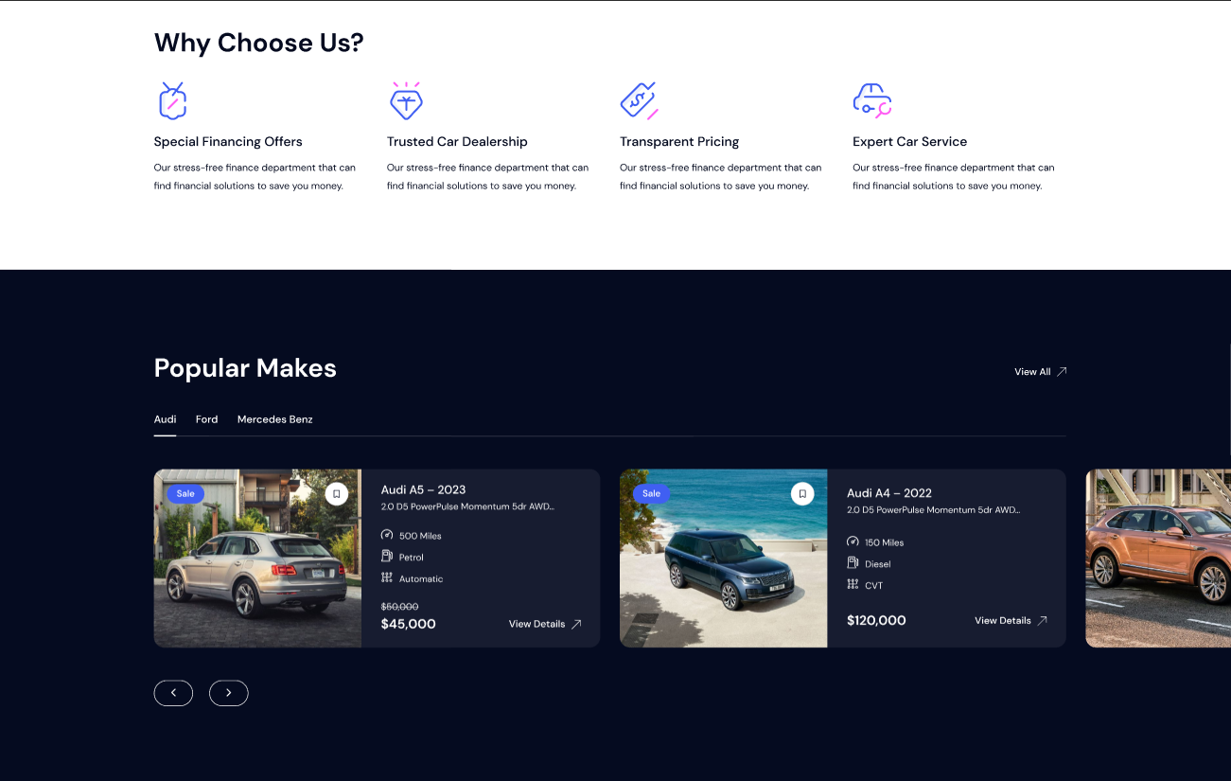
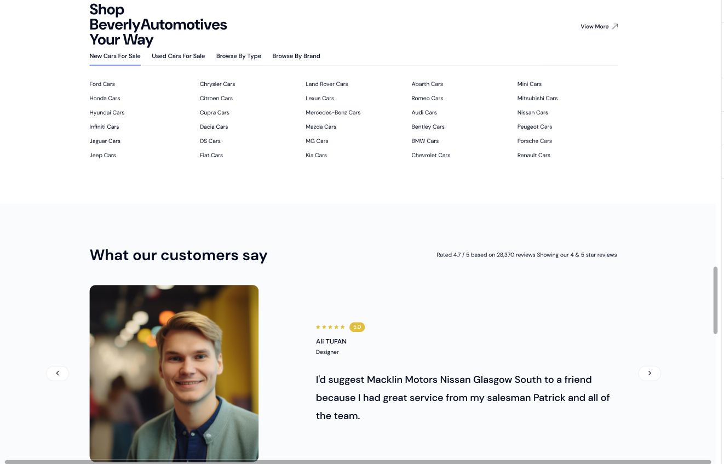
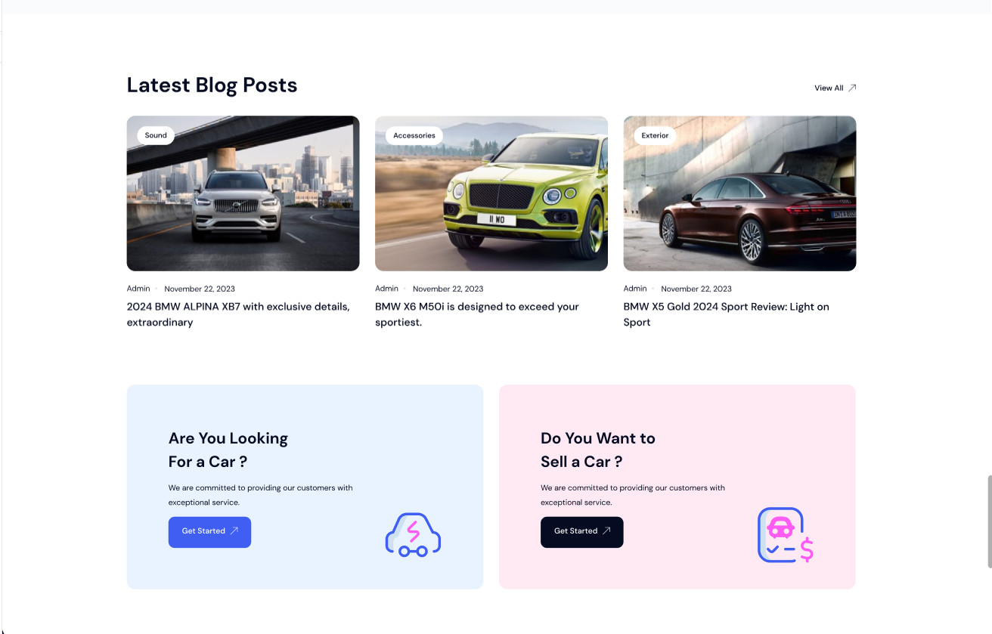
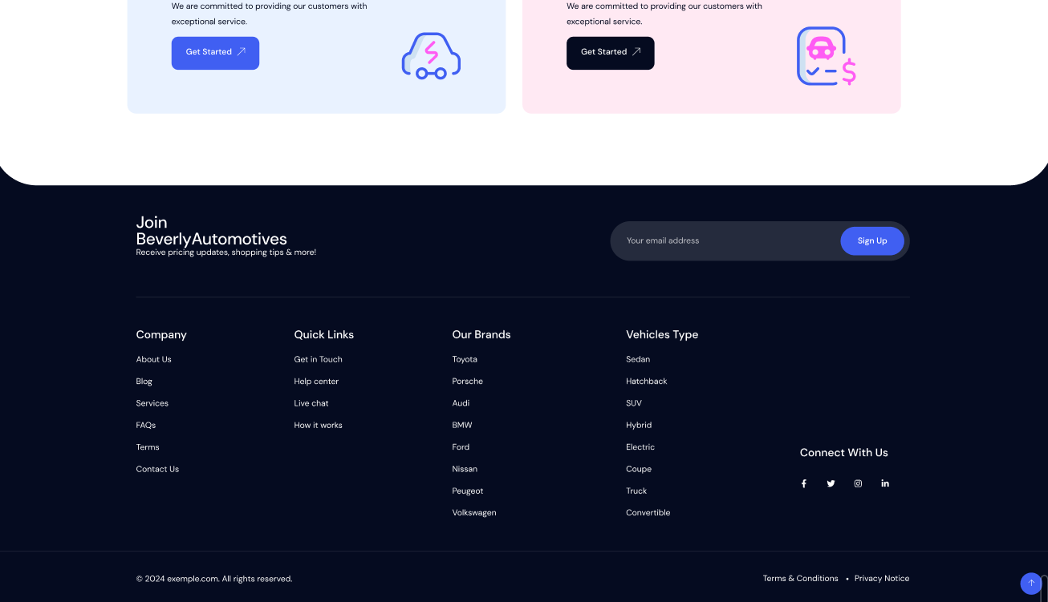

CONCLUSION:
User interface (UI) design is essential in software engineering, significantly impacting user experience. Exploring various UI design tools—such as Figma, Adobe XD, and InVision—highlights their unique capabilities for creating intuitive and visually appealing interfaces. A well-designed UI serves as the first point of interaction, influencing usability and success. By mastering these tools, students gain crucial skills in crafting user-friendly applications that enhance satisfaction and productivity.
Post Lab Descriptive Questions

- State various types of UI design tools.

The tools used for the User Interface (UI) design of a software application i.e. it is part of software engineering to help UI designers to develop display screen design, design of important features, prototyping or blueprint for the software application user interface. It provides a replica or model of software application view screen design, prototype, or exchange of application features with the developer and tracking the product design workflow.

1. Sketch
It is a Photoshop-like tool, which is mostly preferred by the designer to design a User Interface (UI) for the software application. It is used to design UI for Mac Operating System (macOS) and provides the standard features like, art boards, symbols and mirroring effect, etc. It is a vector based drawing tool, allowing editing and manipulating photos, changing in style, layout, and size, reusable of elements using copy & paste inside the application UI.
2. Invision
It is a web based prototyping tool mainly used for UI design and is used in mac Operating System (macOS). It provides advanced prototypes, workflow status, drag and drop design components, adding of static images, adding animation pictures and uploading files. It makes a workflow bridge between designer and developer to design a better, faster and real time user interface (UI). It is also known as InVision Studio.
3. Adobe Xd
It is also known as Adobe Experience Design. It is a vector-based designing and prototyping tool used for user interface design. It supports macOS as well as Windows Operating systems. Adobe Xd provides screen designing and reusing, prototyping, developing wireframes, view designs in real-time, importing files and also integrating some Adobe based products/tools like Photoshop.
4. Figma
It is the first UI design tool that denotes design functionality, real-time collaboration, screen designing, real time mirroring of UI, prototyping, screen size change, gathering feedback, advanced animations, and reuse of design elements. It will support Web, macOS, Linux, Windows operating systems.
5. Flinto
It is an interactive prototyping tool used for user interface design of software applications. It offers some advanced features like, micro interactions between design, screen switching transitions, adding of video files by dragging video files or other video files like, GIF files into our user interface design, adding of sound effects and scrolling page effect, etc. It will be a suitable Mac Operating system only.
6. Balsamiq
It is the best Wireframing (Structural Level Design of Websites) tool, which makes links between designers, product owners, project managers, and developers. Here the different user interface elements are present in the UI library and as per our requirement; we choose the element and drag & drop it in the wireframe. So this is the easy way for the designer to ready the prototype of the UI. We can test it before handing it over to developers for a usability test. It is suitable for macOS as well as Windows operating system.
7. Origami Studio
It is a user interface design tool used by Facebook having multiple features like adding different rules and logics to the interactions, dynamic animation, screen visibility criteria, real time view, etc. It supports all types of operating systems like mac OS, Windows, Linux, and Web.
8. Principle
When we design a multi screen application or new animations then this tool is best for the UI design. It supports mac OS with extra features like, screen connections, art board creation, alignment, real time preview of UI and mirroring of screen and it does not support collaboration or teamwork.
9. Zeplin
It is not a UI design and prototyping tool but, it is used in the post design environment of the UI design prototype. It is an intermediate between the designer and developer to convert the UI into a developed application i.e. if we add the designed user interface to Zeplin then it converts into developer environment to develop the project. It will support the Mac OS, Windows, Web.

