Batch: A2 Roll No.: 16010122034

Experiment No. 8

Grade: AA / AB / BB / BC / CC / CD / DD

Signature of the Staff In-charge with date

Title: Study of Project Management tool.
______________________________________________________________________
Aim: To enable the students learn different tools and their aspects
______________________________________________________________________

CO4: Prepare the System Design and Model ______________________________________________________________________

Books/ Journals/ Websites referred:
- Roger Pressman, “Software Engineering”, sixth edition, Tata McGraw Hill.
__________________________________________________________________
Pre Lab/ Prior Concepts:

1. Wrike
Wrike is an award-winning work management platform, used by more than 20,000 companies and 2.4m people in over 140 countries. With a suite of tools for everyone from project managers to marketing heads, Wrike is the first choice for teams, departments, and organizations in every industry and field.
Pros and cons
Wrike is packed with an unrivaled range of features, including built-in resource planning, time-tracking, and budgeting features that help modern teams do more with less. It has long pioneered the benefits of automation and AI, helping customers save time and resources as well as predict project risks, generate expansive reports, and prioritize automatically.
There can be a learning curve to get the most out of the platform’s higher layers of features and capabilities. However, most customers feel that it’s worth the investment in terms of time, as these more nuanced and complex features allow companies to scale and grow exponentially, from within the same platform.
Key features
Kanban board task management: Access a real-time task management dashboard for quick and easy collaboration. The Kanban board will illuminate your pipeline and make all progress transparent. You can also plug in real-time updates for each individual card.
Customizable Gantt charts: One of Wrike’s most popular features, the Gantt chart helps you visualize your due dates and monitor project progress in real time. Zoom out to get a broad overview of your projects’ progress, or zoom in so you can better manage team workloads.
Real-time analytics: It’s more important than ever for organizations to analyze their health on an ongoing basis, allowing them to pivot fast when needed. Wrike’s powerful analytics provide valuable insights into company-wide performance. Issue real-time reports in seconds.
Integrations
Wrike has more than 400 app integrations so customers can seamlessly move between the platform and their other favorite apps such as Google Drive, Google Calendar, Slack, and more. It also offers built-in Adobe CC and DAM integrations, so users can create, edit, and publish directly from Wrike.
Pricing plans
- Free - $0
- Team - $10 per user/month (billed annually)
- Business - $24.80 per user/month (billed annually)
- Enterprise - Custom pricing for large teams (billed annually)
- Pinnacle - Custom pricing for teams with complex needs
Customer ratings and reviews
Customers feel that Wrike’s interface is intuitive, with natural workflows that allow them to visualize and manage their projects effectively. One of the biggest mentioned benefits is the ability to update in real time, which allows for easy and enjoyable collaboration between teams.
It has a Capterra rating of 4.3/5 (2,400+ customers).
Support
Wrike offers an exceptional level of support, with award-winning assistance that scales with your business. Help is available 24/7 with upgradeable support packages to cater for organizations of varied needs. There is also a large library of in-depth guides, articles, and eBooks on how to maximize Wrike’s wide range of features to deliver productivity, efficiency, and increased revenue for all.
Implementation SS: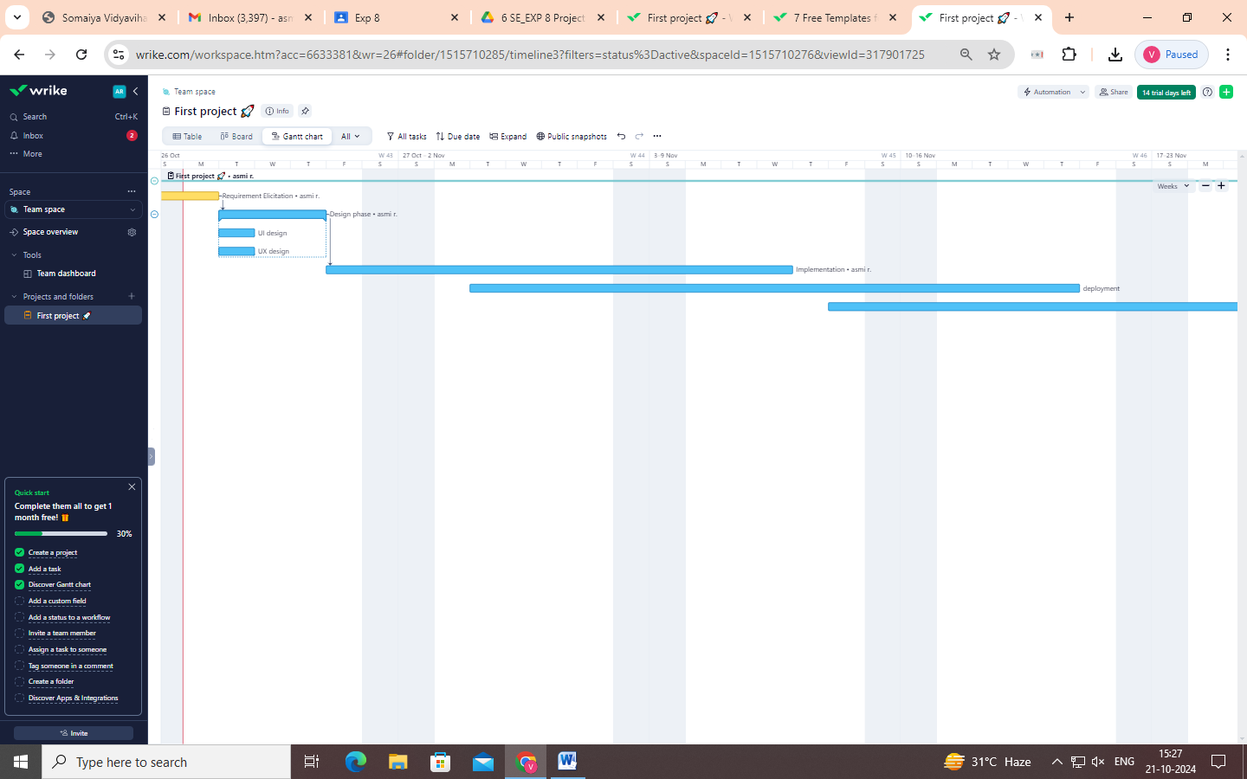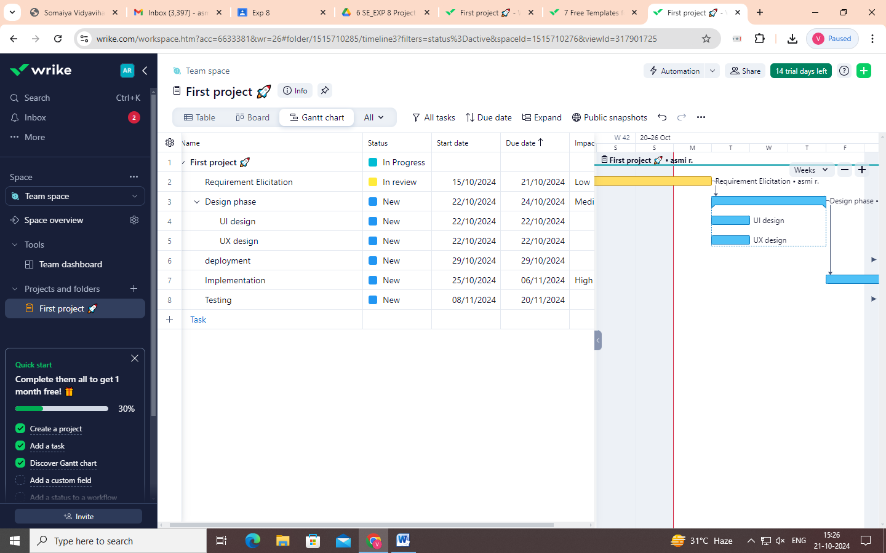
For the StayZen project, we have utilized the Wrike project management tool to streamline and organize our tasks. Here's an overview of what we accomplished using Wrike:
- Task Breakdown:
  - We structured the project into different phases, including Requirement Elicitation, Design Phase, Implementation, Deployment, and Testing.
  - Each phase was further broken down into specific tasks such as UI Design, UX Design, etc., ensuring all aspects of the project were well-planned.
- Task Management:
  - Each task was assigned a status: New, In Progress, Completed, or Planned, reflecting the current state of the task.
  - Specific start and due dates were allocated for each task to maintain a well-defined timeline. For example, Requirement Elicitation was marked as in progress from 15/10/2024, and UI/UX Design was scheduled from 22/10/2024.
- Gantt Chart Overview:
  - We utilized Wrike's Gantt Chart feature to visualize the project timeline, showing dependencies between tasks and phases.
  - This allowed us to see how tasks are interconnected, such as the link between the Design Phase and subsequent implementation steps.
- Resource Allocation:
  - Team members were assigned to specific tasks. For example, Peeth Chowdhary was responsible for multiple tasks, ensuring accountability for each deliverable.
- Budget and Impact:
  - We monitored the budget for each phase (e.g., $5,000 for Requirement Elicitation and $1,000 for Testing).
  - The impact of each task was categorized as low, medium, or high to help prioritize efforts. High-impact tasks were given more attention during execution.
In conclusion, Wrike helped us keep track of the project’s progress, deadlines, team responsibilities, and resource allocation, ensuring smooth coordination and visibility across the StayZen project.

