Batch: B1 Roll No.: 16010122160

Experiment / Assignment / Tutorial No. 1

TITLE: Requirement Specification Document

AIM: To learn and understand the way of analysing the gathered information in the previous phase for the development process and prepare requirement specification document. A concept of software engineering. ______________________________________________________________________
Expected Course outcome of Experiment:

Process of gathering requirements and converting them into specifications.
Document created will be used by both, the customer and the developer, to understand WHAT is going to be developed.
_____________________________________________________________________
Books/ Journals/ Websites referred:

1. Roger Pressman, Software Engineering: A practitioners Approach, McGraw Hill, 2010 ,6th edition
2. Ian Somerville, Software Engineering , Addison Wesley,2011,9th edition
- http://en.wikipedia.org/wiki/Software_requirements_specification
_____________________________________________________________________
Pre Lab/ Prior Concepts:

Requirements analysis in systems engineering and software engineering, encompasses those tasks that go into determining the needs or conditions to meet for a new or altered product, taking account of the possibly conflicting requirements of the various stakeholders, such as beneficiaries or users. It is an early stage in the more general activity of requirements engineering which encompasses all activities concerned with eliciting, analyzing, documenting, validating and managing software or system requirements.
Requirements analysis is critical to the success of a systems or software project. The requirements should be documented, actionable, measurable, testable, traceable, related to identified business needs or opportunities, and defined to a level of detail sufficient for system design.
Conceptually, requirements analysis includes three types of activities:
- Eliciting requirements: the task of identifying the various types of requirements from various sources including project documentation, (e.g. the project charter or definition), business process documentation, and stakeholder interviews. This is sometimes also called requirements gathering.
- Analysing requirements: determining whether the stated requirements are clear, complete, consistent and unambiguous, and resolving any apparent conflicts.
- Recording requirements: Requirements may be documented in various forms, usually including a summary list and may include natural-language documents, use cases or process specifications.
New systems change the environment and relationships between people, so it is important to identify all the stakeholders, taken into account all their needs and ensure they understand the implications of the new systems. Analysts can employ several techniques to elicit the requirements from the customer. These may include the development of scenarios, the identification of use cases, the use of workplace observation or ethnography, holding interviews, or focus groups (more aptly named in this context as requirements workshops, or requirements review sessions) and creating requirements lists. Prototyping may be used to develop an example system that can be demonstrated to stakeholders. Where necessary, the analyst will employ a combination of these methods to establish the exact requirements of the stakeholders, so that a system that meets the business needs is produced
Different types of Requirements
- Functional requirements
- Usability requirements
- Reliability requirements
- Performance requirements
- Security requirements
A typical SRS document template is shared subsequently. This document acts as a reference and will be used by both, the customer (for whom the software system is to be developed), and the organization which develops the solution. Typically, prepared by the development organization at the early stage of development by the professionals after interacting with the customer.
Software Requirements Specification for:
Beverly Automotives: A car dealership website
Version 1.0
Prepared by Sakshi Raut, Asmi Rode , Aakanksh Sen
1st August,2024.

Table of Contents
Table of Contents ii
1. Introduction 1
1.1 Purpose 1
1.2 Product Scope 1
1.3 References 1
2. Overall Description 2
2.1 Product Perspective 2
2.2 Product Functions 2
2.3 User Classes and Characteristics 2
2.4 Operating Environment 2
2.5 Design and Implementation Constraints 2
2.6 User Documentation 2
2.7 Assumptions and Dependencies 3
3. External Interface Requirements 3
3.1 User Interfaces 3
3.2 Hardware Interfaces 3
3.3 Software Interfaces 3
3.4 Communications Interfaces 3
4. System Features 4
4.1 System Feature 1 4
4.2 System Feature 2 4
5. Other Nonfunctional Requirements 4
5.1 Performance Requirements 4
5.2 Safety Requirements 5
5.3 Security Requirements 5
5.4 Software Quality Attributes 5
5.5 Business Rules 5
6. Other Requirements 5
Appendix A: Glossary 5
Appendix B: Analysis Models 5
Appendix C: To Be Determined List 6

Introduction
Purpose
The purpose of the Beverly Automotives website is to showcase their range of luxury vehicles, provide detailed information about each model, offer subscription plans that include concierge services, 24/7 roadside assistance, accidental insurance coverage, and access to exclusive customer events and discounts, facilitate service scheduling, and enhance customer engagement through virtual tours and special promotions.
Product Scope
The software for Beverly Automotives is a comprehensive platform designed to manage luxury vehicle offerings and customer subscription services. Its purpose is to streamline operations, enhance customer experiences, and foster long-term loyalty through personalized services like concierge support and exclusive events. By aligning with Beverly Automotives' strategy to differentiate in the luxury market, the platform supports the dealership's goals of increasing efficiency and strengthening customer relationships.

References

References and Inspirations for Beverly Automotives Project
User Interface Design: To create an attractive, seamless, and simple frontend, we took inspiration from the following websites:
- Amazon.com
- Amazon Prime Video
- Netflix India
- CarWale
- Big Boy Toyz
Graphic Design:
- Canva: Used for designing graphic illustrative images for backgrounds.
Frontend Development: We used a combination of HTML, CSS, JavaScript, React, and Bootstrap to build the frontend.
Backend Development: For the backend, we utilized SQL and PHP. When encountering challenges, we referred to:
- Tech with Tim
- Ecommerce Website - Course
These resources collectively helped shape the development and design of Beverly Automotives.

Overall Description
Product Perspective
The product specified in this SRS is a new, self-contained system developed exclusively for Beverly Automotives. It is designed to unify various luxury automotive services into a single platform, offering an enhanced customer experience. This product is not part of an existing product family nor a replacement for older systems.
While the system operates independently, it integrates with external services such as third-party providers for roadside assistance, insurance claims, and event management, as well as payment gateways for handling transactions. These integrations ensure a seamless and comprehensive service offering.

Subsystem Overview
The product includes the following key subsystems:
- Vehicle Management: Manages the inventory and status of luxury vehicles.
- Subscription Management: Handles customer subscriptions, billing, and payments.
- Customer Service Interface: Provides personalized support and service scheduling.
- Roadside Assistance: Interfaces with third-party providers for real-time assistance.
- Insurance Management: Manages insurance details and claims processing.
- Event and Discount Management: Organizes customer events and exclusive offers.

Product Functions
The product provided by Beverly Automotives performs the following major functions:
- Luxury Vehicle Management:
  - Manages inventory of luxury vehicles.
  - Displays detailed information about each vehicle.
- Subscription Plan Management:
  - Offers various subscription plans with customizable options.
  - Handles customer enrollment and plan modifications.
  - Manages billing and payment processing.
- Customer Service and Support:
  - Provide a user interface for personalized concierge services.
- Roadside Assistance:
  - Provide real-time roadside assistance requests and tracking.
  - Integrate with third-party service providers for dispatch.
  - Record and manage assistance requests and resolutions.
- Insurance Management:
  - Manage accidental insurance coverage details.
  - Process insurance claims.
  - Provide customers with insurance documentation and updates.
- Customer Portal:
  - Provide a centralized dashboard for customers to manage their accounts.
  - Enable vehicle selection and booking.
  - Allow access to subscription details, billing history, and service records.
- Administrative Functions:
  - Provide an interface for administrators to manage the system.
  - Generate reports and analytics on system usage and performance.
  - Manage user roles and permissions.

Operating Environment
Hardware Platform:
- Servers: High-performance servers with multi-core processors, ample RAM, and SSD storage to handle high traffic and provide fast load times.
- Client Devices: Desktops, laptops, tablets, and smartphones.
Operating System:
- Server Side: Linux-based servers (e.g., Ubuntu 20.04 LTS) for stability and security.
- Client Side: Compatibility with Windows, macOS, iOS, and Android operating systems.
Software Components:
- Database: PostgreSQL for managing vehicle and user data.
- Backend: Node.js for server-side scripting and API management.
- Frontend: HTML, CSS, and JavaScript for the user interface..
Design and Implementation Constraints
- Compliance with data protection laws (e.g., GDPR) and e-commerce regulations.
- Adherence to corporate branding guidelines
- Server performance must handle peak traffic loads.
- Ensuring client-side performance across a range of devices and browsers.
- Use of Node.js for backend and PostgreSQL for the database.
- Dependency on cloud services for hosting and storage.
- Supporting multiple users and transactions simultaneously.
- Primary development in JavaScript

User Documentation
No user manual or online help tutorials are delivered along with the software. The software aims to be self-explanatory to the users.

Assumptions and Dependencies
External Interface Requirements
Third-Party Components:Reliable and continuous service from third-party APIs (e.g., payment gateway, analytics).
1.Development Environment:

Stable and up-to-date development tools and libraries.
  - Access to necessary development environments (local, staging, production).
- Operating Environment:
  - Consistent performance of hosting servers.
  - High availability and uptime of server infrastructure.
- User Environment:
  - Users will have modern browsers and devices capable of running the website efficiently.
  - Internet connectivity and bandwidth will be sufficient for a smooth user experience.
Dependencies:
- External Software Components:
  - Use of reusable code or modules from previous projects for user authentication, vehicle catalog, and search functionality.
- Infrastructure Services:
  - Dependence on cloud services (AWS)for hosting and data storage.
If any of these assumptions are incorrect or if dependencies are not met, the project requirements and timeline could be significantly affected.

User Interfaces
1.Landing page
Hero Section:
- Eye-catching images of luxury cars.
- Brief tagline emphasizing sophistication and performance.
Navigation Bar:
- Links to Home, Catalog, FAQ, Login, and Pricing pages.
Car Listings:
- Highlighted models with brief descriptions and high-quality images.
- "View More" option for detailed specifications.
Celebrity Endorsements:
- Testimonials from celebrities like Yuvraj Singh, Shilpa Shetty, and Honey Singh.
Subscription Plans:
- Overview of Basic, Standard, and Premium plans with exclusive perks.
Footer:
- Contact information, social media links, and additional resources.
image
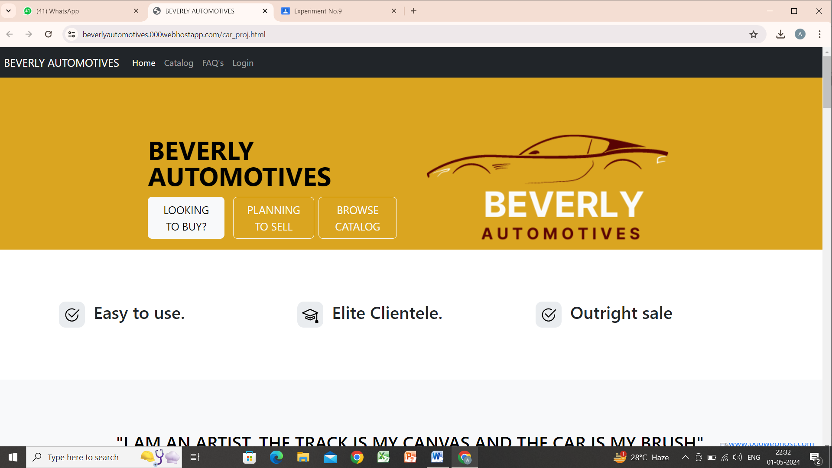


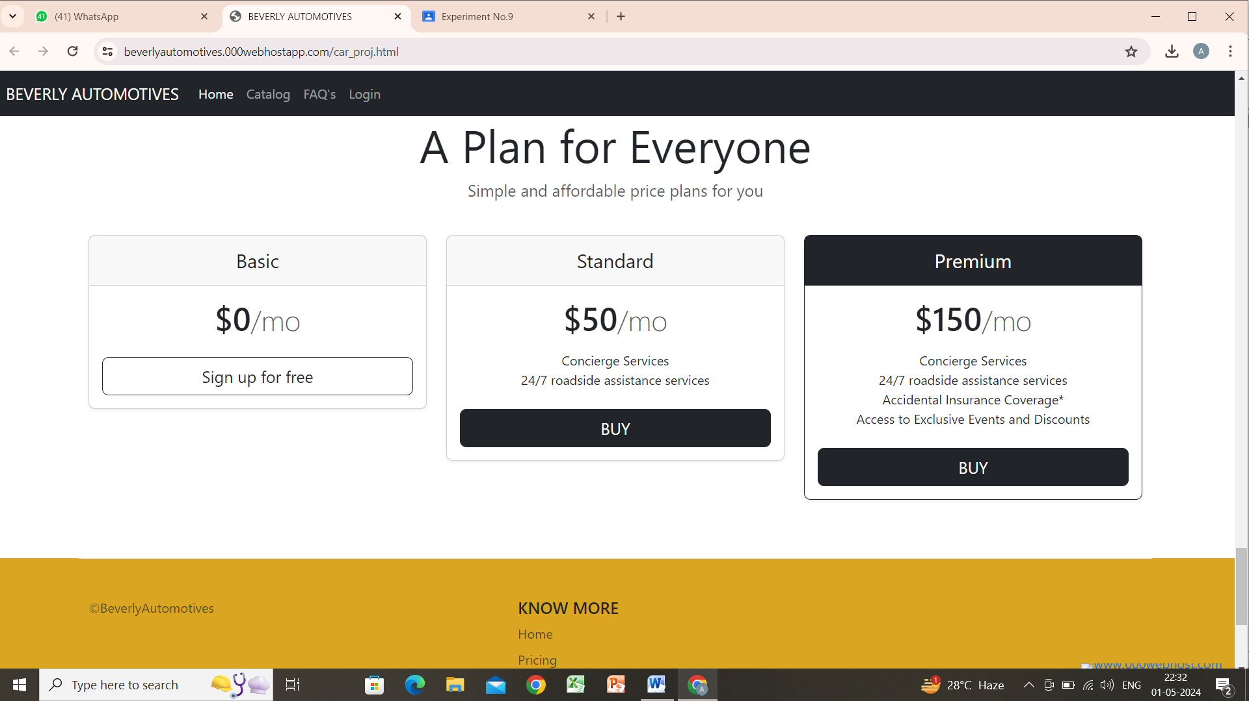

2.Sell Page
Introduction Section:
- Overview of the benefits of selling your car through Beverly Automotives.
Step-by-Step Selling Process:
- Vehicle Details: Enter your car's information and upload photos.
- Inspection: Schedule a professional inspection.
- Offer: Receive and accept an offer from Beverly Automotives.
- Payment: Secure and quick payment process.
Why Sell with Us:
- Highlights the advantages like hassle-free process, competitive offers, and secure transactions.
Contact Information:
- Details for reaching out for further assistance or inquiries.
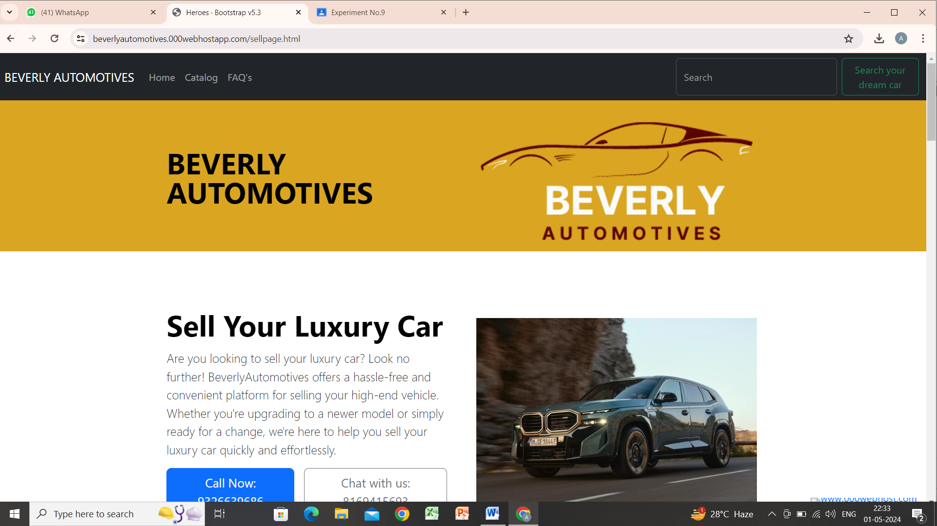
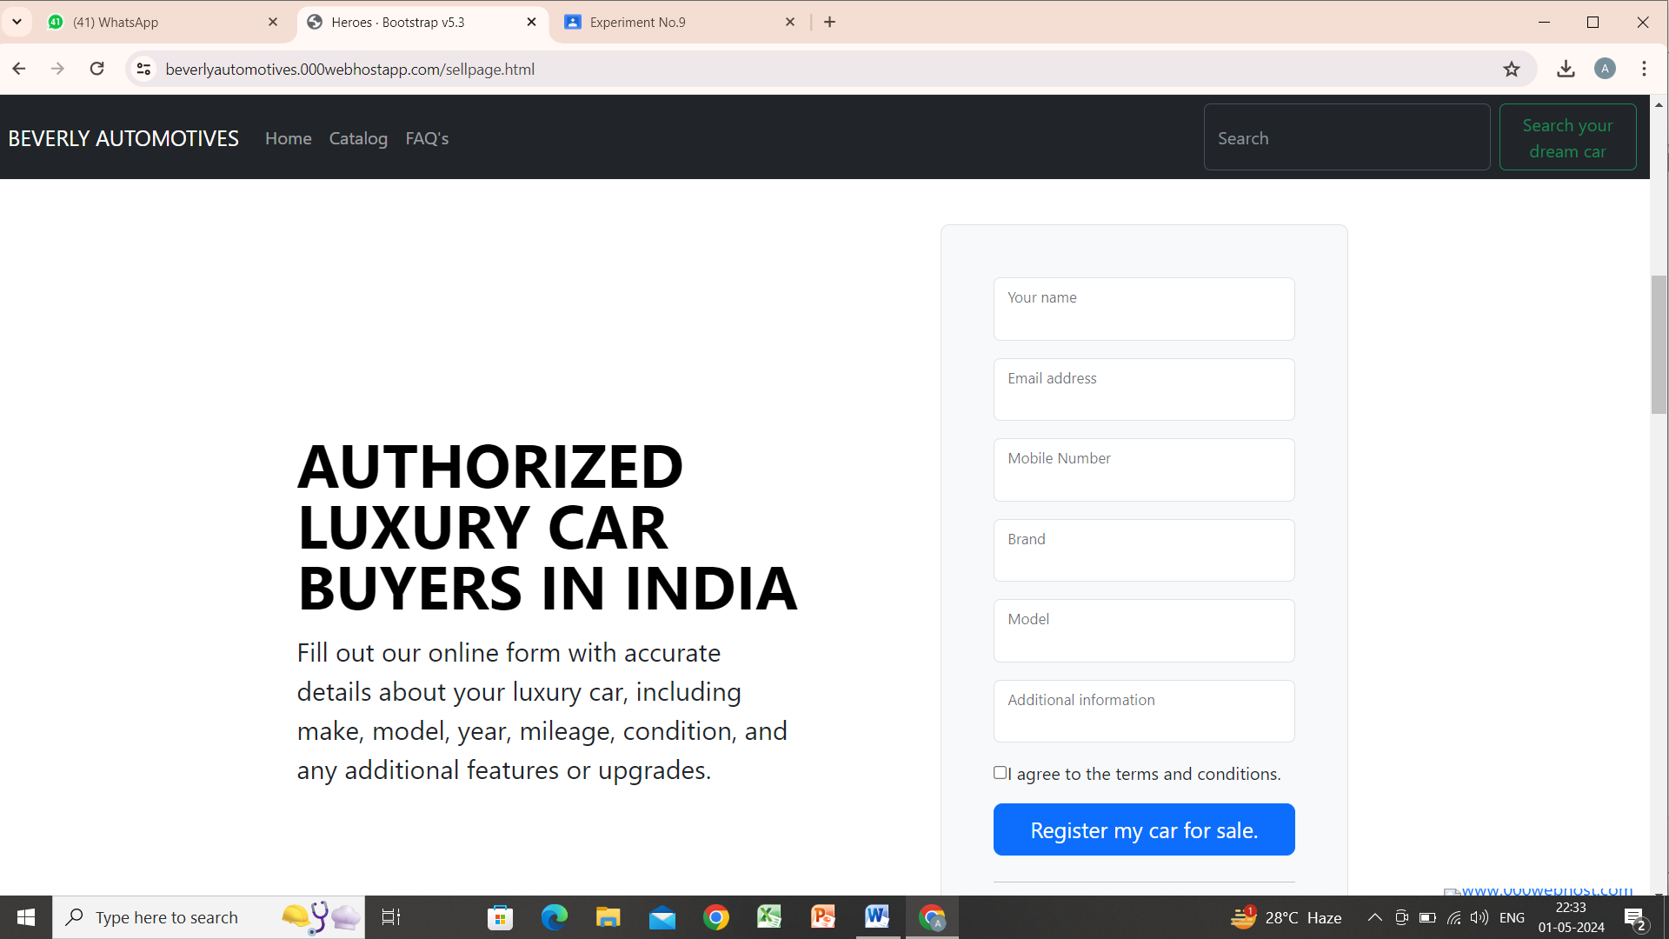
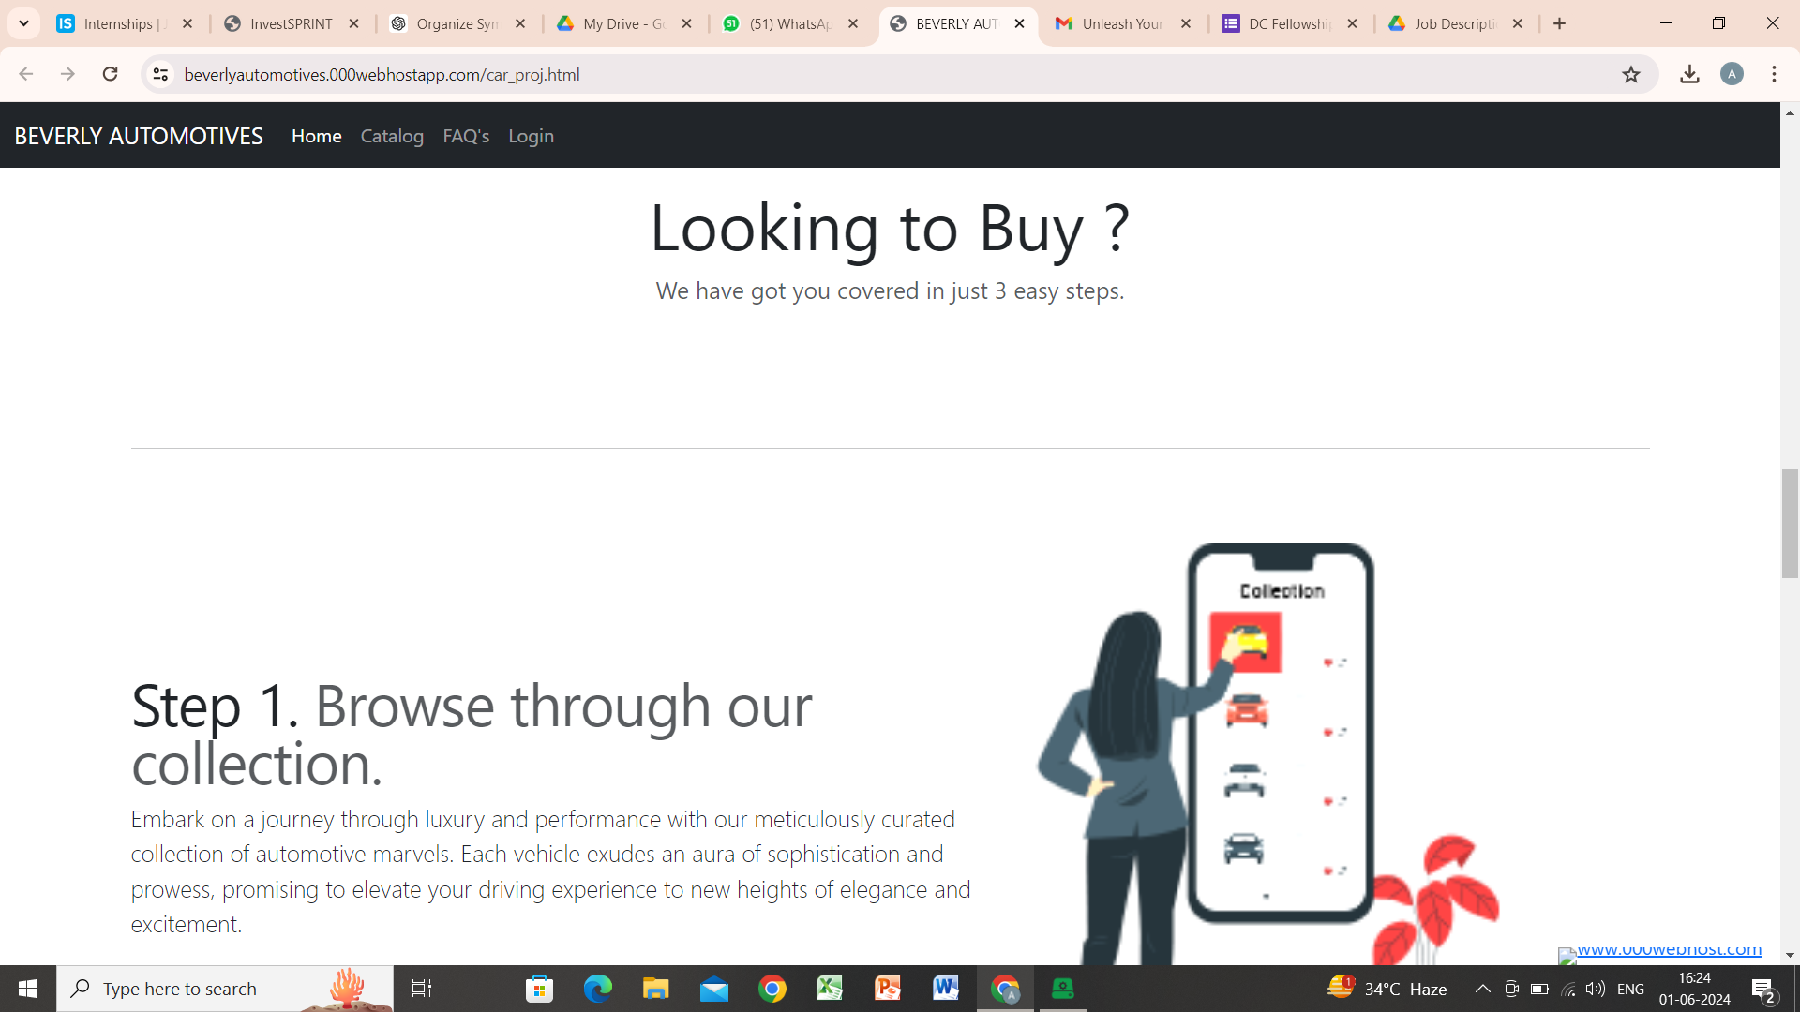

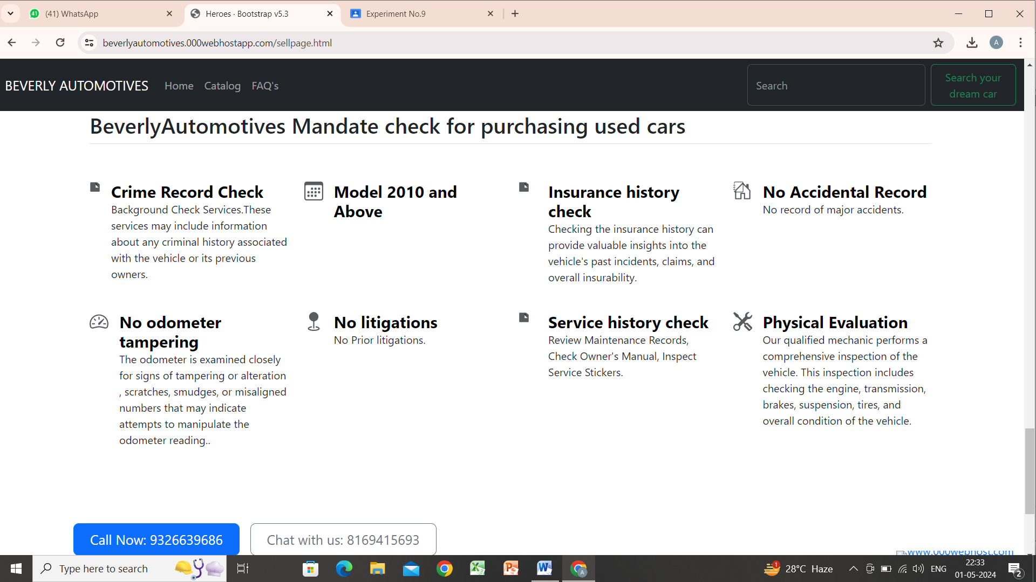
3.Checkout Page
Order Summary:
- Displays selected car details, pricing, and any additional services or warranties.
Customer Information:
- Form to enter personal details such as name, address, and contact information.
Payment Options:
- Various secure payment methods (credit card, PayPal, etc.).
- Option to apply discount codes or promotional offers.
Review and Confirm:
- Summary of the order for final review.
- Button to confirm and complete the purchase.
Customer Support:
- Contact details for assistance during the checkout process.

4.Car Description Page
Vehicle Overview:
- High-resolution images and a brief introduction to the car.
Detailed Specifications:
- Engine type, horsepower, torque, transmission, and fuel economy.
- Dimensions, weight, and cargo capacity.
Pricing and Financing Options:
- Base price and available financing plans.
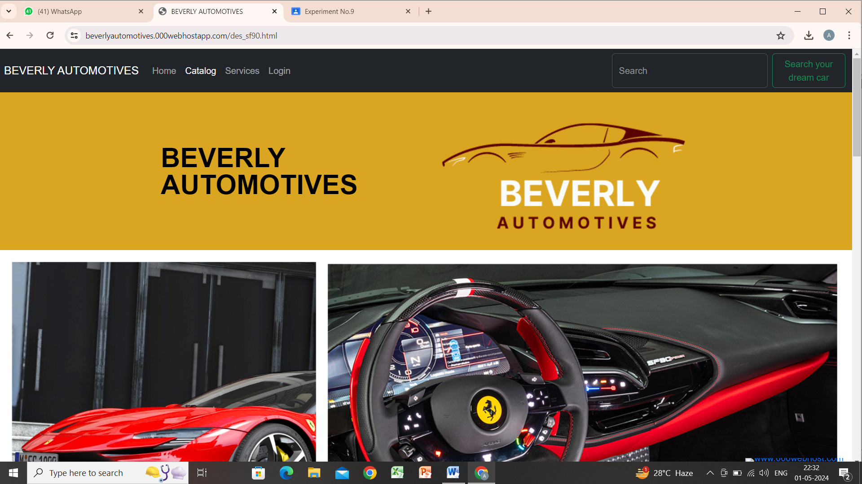
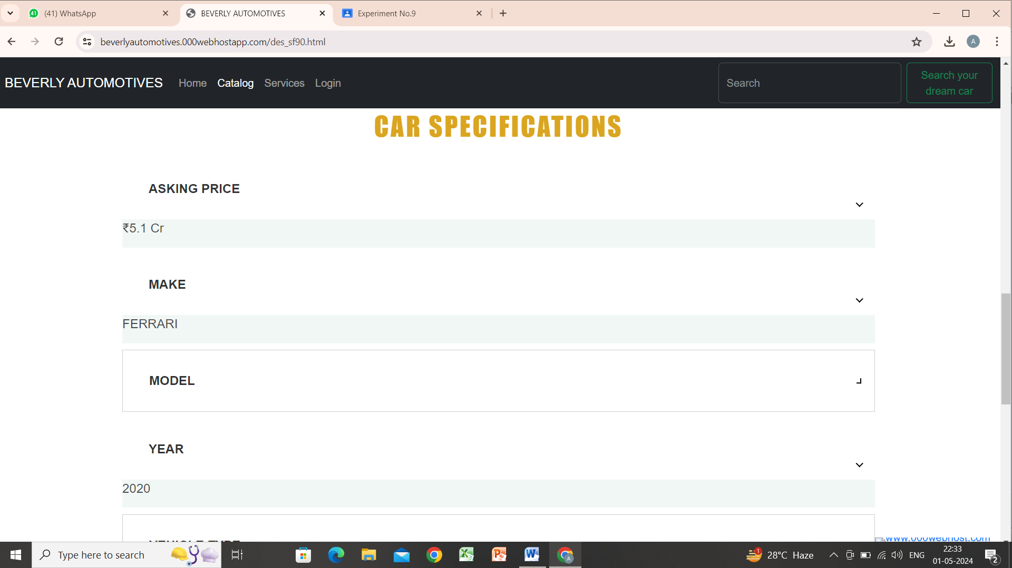
5.Car Catalog
Brand Filters:
- Filter options to select cars by brand (e.g., Audi, Aston Martin, Maserati).
Car Listings:
- Display of cars with images, brief descriptions, and price.
- "View More" button for detailed specifications.
Sort and Search:
- Sorting options (e.g., price, popularity).
- Search bar to find specific models.
Featured Vehicles:
- Highlighting popular or special offers.
Navigation and User Experience:
- Clean layout with easy navigation through different car brands and models.
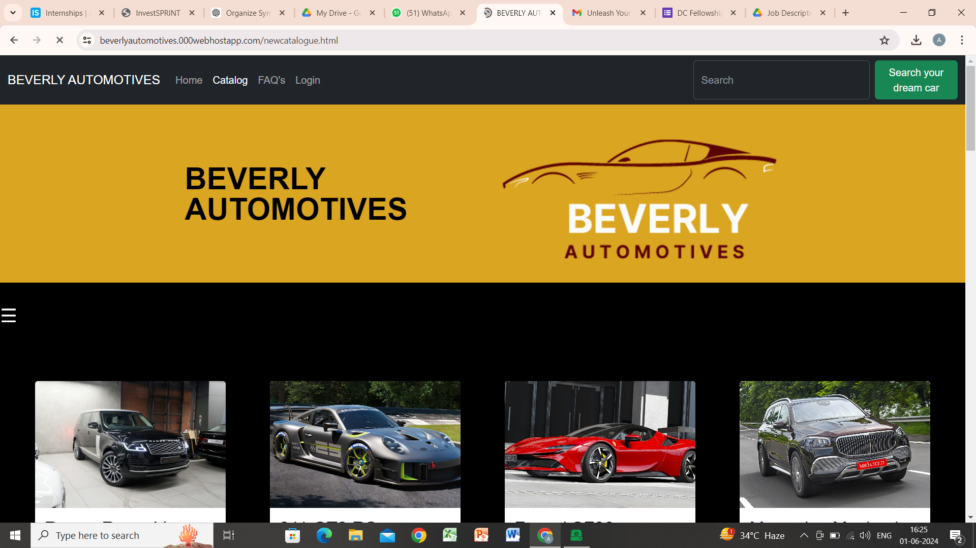

Hardware Interfaces
Interface Characteristics for Beverly Automotives Website

Supported Device Types
- Desktops and Laptops: The website should be fully functional on Windows, macOS, and Linux operating systems, compatible with popular browsers like Chrome, Firefox, Safari, and Edge.
- Mobile Devices: Fully responsive design supporting iOS and Android devices, compatible with mobile browsers.

Data and Control Interactions
- User Inputs: Data from forms (registration, login, booking, membership management) sent via HTTPS to the server.
- Outputs: Dynamic web content delivered to users based on their interactions, ensuring real-time updates for inventory and bookings.

Communication Protocols
- HTTP/HTTPS: Secure data transfer using HTTPS to ensure encryption and protection of user data.
- API Integration: RESTful APIs for communication between the website and external services (e.g., payment gateways).

Logical Characteristics
- Data Processing: Real-time data validation and processing for user interactions.
- Session Management: Secure session handling for authenticated users, including timeout and re-authentication protocols.

Physical Characteristics
- Server Infrastructure: Cloud-based hosting with scalable resources to handle varying loads and ensure high availability.
- Database Servers: Secure, encrypted storage for user and transaction data, with regular backups and disaster recovery plans.
Software Interfaces
Software Components and Connections for Beverly Automotives Website

Databases
- PostgreSQL 8.0: Used for storing user data, car listings, bookings, and membership information.
- Incoming Data: User registration details, car listings, booking requests, membership plans.
- Outgoing Data: User authentication data, car catalog details, booking confirmations, membership statuses.

Operating Systems
- Web Servers: Linux-based servers (e.g., Ubuntu 20.04) for hosting the website.

Tools and Libraries
- Frontend:
- React.js 18.0: For building dynamic user interfaces.
- Bootstrap 5: For responsive design and styling.
- Axios 0.24: For making HTTP requests to APIs.
- Backend:
- Node.js 16: For server-side scripting.
- Express 4.17: For creating the web server and handling routing.

Communication Protocols
- RESTful APIs: For communication between the frontend and backend, and with external services.
- Incoming Messages: API requests for user actions (e.g., booking a test drive, updating membership).
- Outgoing Messages: API responses with data requested by the frontend or confirmations from external services.

Data Sharing
- User Data: Shared between the backend and the PostgreSQL database for authentication and user actions.
- Car Listings and Bookings: Shared between the backend and the PostgreSQL database for displaying up-to-date information to users.

Communications Interfaces
Communications Requirements for Beverly Automotives Website

Email Communications
- Functionality: Automated emails for user registration confirmation, booking confirmations, membership updates, and promotional content.
- Protocols: SMTP for sending emails, IMAP/POP3 for receiving emails.
- Message Formatting: HTML emails with a plain text alternative, ensuring responsiveness and compatibility with various email clients.

Web Browser Communications
- Protocols: HTTP/HTTPS for all web communications.
- Standards: Follow W3C standards for HTML5, CSS3, and JavaScript.

Network Server Communications
- Protocols: RESTful APIs for backend/frontend communication.
- Data Transfer Rates: Optimized to handle high volumes of traffic, ensuring fast response times

These communication functions and standards ensure secure, efficient, and reliable interactions between the website, users, and external systems.
System Features

Car Catalog Browsing

4.1.1 Description and Priority

This feature allows users to browse the car catalog, view car details, and filter cars based on various criteria such as make, model, price, and features.
- Priority: High
- Benefit: 8
- Penalty: 7
- Cost: 4
- Risk: 3

4.1.2 Stimulus/Response Sequences
- Stimulus: User navigates to the car catalog page.
- Response: Display the list of available cars.
- Stimulus: User applies filters (e.g., make, model, price).
- Response: Display the filtered list of cars.
- Stimulus: User clicks on a car listing.
- Response: Display detailed information about the selected car.

4.1.3 Functional Requirements
- REQ-1: The system shall display a list of available cars with basic information (make, model, price).
- REQ-2: The system shall allow users to filter cars based on criteria such as make, model, price, and features.
- REQ-3: The system shall display detailed information about a selected car, including specifications, images, and availability.
- REQ-4: The system shall handle errors gracefully if no cars match the filter criteria, displaying an appropriate message to the user.

Test Drive Booking
4.2.1 Description and Priority
This feature allows registered users to book a test drive for any car listed in the catalog.
- Priority: Medium
- Benefit: 7
- Penalty: 6
- Cost: 5
- Risk: 4

4.2.2 Stimulus/Response Sequences
- Stimulus: Registered user logs in.
- Response: Display user dashboard.
- Stimulus: User navigates to the car details page and clicks "Book Test Drive."
- Response: Display booking form.
- Stimulus: User submits the booking form with preferred date and time.
- Response: Confirm booking and send email confirmation.

4.2.3 Functional Requirements
- REQ-1: The system shall require users to log in before booking a test drive.
- REQ-2: The system shall display a booking form with fields for date, time, and contact information.
- REQ-3: The system shall validate the booking form input and provide error messages for invalid inputs.
- REQ-4: The system shall send a booking confirmation email to the user upon successful booking.
- REQ-5: The system shall update the booking data store with the new booking information.
Performance Requirements
Performance Requirements for Beverly Automotives Website

Loading Times
- Homepage and Car Catalog: Must load within 3 seconds on a standard broadband connection. This ensures a smooth user experience and reduces bounce rates.
- Images and Media: Optimize images and media to load within 2 seconds to enhance visual appeal without compromising performance.

Responsiveness
- Mobile Devices: The site should be fully responsive, loading within 3 seconds on 4G connections and adapting to various screen sizes without layout issues.
- Desktop Browsing: Should maintain functionality and load times consistent with the mobile experience.

Interactive Elements
- Booking Process: Ensure form submission and confirmation steps complete within 1-2 seconds to avoid user frustration.
- Membership Sign-Up: The process should be smooth, with each step taking no more than 2 seconds to load and process.

Real-Time Updates
- Inventory Management: If integrated, real-time updates to car availability should be reflected within 1 second to provide accurate information to users.

Rationale
These performance requirements ensure that the website remains user-friendly, retains visitors, and provides a seamless experience, which is crucial for high-end automotive clientele. Fast loading times and responsiveness also contribute to better search engine rankings, potentially increasing visibility and customer engagement.
Safety Requirements
Safety Requirements for Beverly Automotives Website

Data Security
- User Data Protection: Implement SSL/TLS encryption for all data exchanges to protect user information from interception.
- Data Storage: Store sensitive data (e.g., personal and payment information) securely using encryption and comply with GDPR, CCPA, and other relevant data protection regulations.

Transaction Security
- Payment Processing: Use secure, PCI-DSS compliant payment gateways to handle transactions, preventing financial data breaches.
- Booking Confirmation: Ensure booking confirmations are securely transmitted to avoid fraud and unauthorized bookings.

System Integrity
- Backup and Recovery: Implement regular data backups and disaster recovery plans to prevent data loss.
- Access Control: Restrict administrative access to the website backend to authorized personnel only to prevent unauthorized changes or data breaches.

Compliance and Certification
- Compliance: Adhere to relevant e-commerce regulations and standards, including data protection and consumer rights.
- Certification: Obtain necessary security certifications, such as ISO/IEC 27001, to demonstrate commitment to data security and management best practices.

By addressing these safety requirements, the website can ensure the protection of user data, secure transactions, and overall system integrity, thereby fostering trust and reliability.
Security Requirements
Security Requirements for Beverly Automotives Website

Data Protection
- Encryption: Use SSL/TLS for encrypting all data transfers to safeguard user information.
- Data Storage: Encrypt sensitive data at rest and in transit, following GDPR and CCPA regulations.

Authentication
- User Authentication: Implement strong password policies, multi-factor authentication (MFA), and session management to verify user identities.

These measures ensure the website remains secure, protecting user data and maintaining compliance with relevant regulations.

Software Quality Attributes
Software Quality Attributes for Beverly Automotives Website

Adaptability
- Requirement: The site should easily accommodate new features or updates without major overhauls.
- Measurement: Ability to integrate new car models or user features within 2 weeks.

Availability
- Requirement: Ensure 99.9% uptime to provide continuous service to users.
- Measurement: Monitor uptime using web hosting tools and services.

Correctness
- Requirement: Display accurate information regarding car models, prices, and availability.
- Measurement: Regular audits and automated tests to verify data integrity.

Flexibility
- Requirement: Support a wide range of browsers and devices.
- Measurement: Compatibility testing across different platforms.

Interoperability
- Requirement: Seamless integration with third-party services such as payment gateways.
- Measurement: Successful API integrations and data exchanges.

Maintainability
- Requirement: Codebase should be clean, well-documented, and modular to facilitate updates and bug fixes.
- Measurement: Code reviews and adherence to coding standards.

Portability
- Requirement: The website should function correctly across various operating systems.
- Measurement: Cross-platform testing.

Reliability
- Requirement: The site should handle expected loads without crashing or significant slowdowns.
- Measurement: Load testing to ensure performance under peak traffic conditions.

Reusability
- Requirement: Common components should be reusable across different parts of the site.
- Measurement: Use of modular design and libraries.

Robustness
- Requirement: The site should handle unexpected inputs or conditions gracefully without crashing.
- Measurement: Comprehensive error handling and testing for edge cases.

Testability
- Requirement: The site should be easy to test for functionality and performance.
- Measurement: Use of automated testing tools and continuous integration pipelines.

Usability
- Requirement: The site should be intuitive and easy to navigate for users.
- Measurement: User testing and feedback, aiming for a satisfaction rating of 4.5/5.

These attributes ensure a high-quality, user-friendly, and maintainable website that meets customer and developer expectations.
Business Rules
Business Rules for Beverly Automotives Website

1. User Roles:
- Visitors: Can browse car catalogs and view details.
- Registered Users: Can book test drives, sign up for memberships, and access exclusive content.
- Administrators: Manage inventory, update content, and oversee user activities.

2. Booking Test Drives:
- Only registered users can book test drives.
- Users must confirm their email before a test drive is scheduled.

3. Membership Plans:
- Only logged-in users can purchase or manage membership plans.
- Membership benefits are only available to active members.

4. Content Management:
- Only administrators can add, edit, or remove car listings.
- Regular audits to ensure data accuracy.

5. User Data:
- All personal information must be securely stored and handled according to GDPR and CCPA regulations.

These rules guide the development of functional requirements, ensuring the website operates smoothly and securely.

Other Requirements

Other Requirements for Beverly Automotives Website

Database Requirements
- Scalability: The database must handle increasing volumes of user data, car listings, and transactions.
- Security: Implement encryption for sensitive data and regular backups.

Internationalization
- Multi-Language Support: The website should support multiple languages to cater to a global audience.
- Currency Conversion: Display prices in local currencies based on user location.

Reuse Objectives
- Component Reusability: Design modular components for reuse across different sections of the site.
- Code Reusability: Encourage use of shared libraries and frameworks to streamline development.

These requirements ensure the website is robust, user-friendly, and compliant with global standards.

Appendix A: Glossary

API (Application Programming Interface): A set of protocols and tools for building and interacting with software applications.

Backend: The server-side part of an application that handles business logic, database interactions, and server configuration.

CSS (Cascading Style Sheets): A style sheet language used for describing the presentation of a document written in HTML.

HTTPS (Hypertext Transfer Protocol Secure): An extension of HTTP for secure communication over a computer network.

JavaScript: A programming language used primarily for creating and controlling dynamic website content.

Node.js: A JavaScript runtime built on Chrome's V8 JavaScript engine, used for building scalable network applications.

React: A JavaScript library for building user interfaces.

SRS (Software Requirements Specification): A document that describes the functionalities a software system must provide and the constraints under which it must operate.

UI (User Interface): The space where interactions between humans and machines occur.This glossary includes terms specific to the Beverly Automotives project, ensuring clear and consistent communication among stakeholders.

Appendix B: Analysis Models
DATA FLOW DIAGRAM

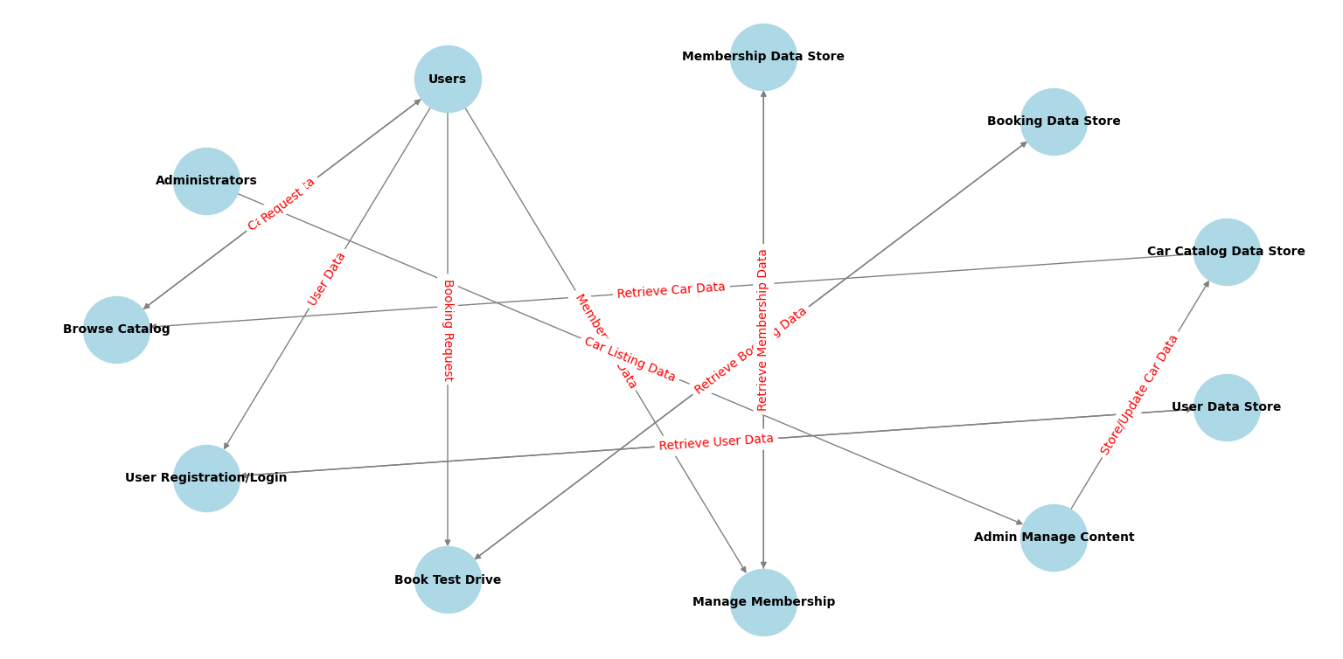

ER DIAGRAM:
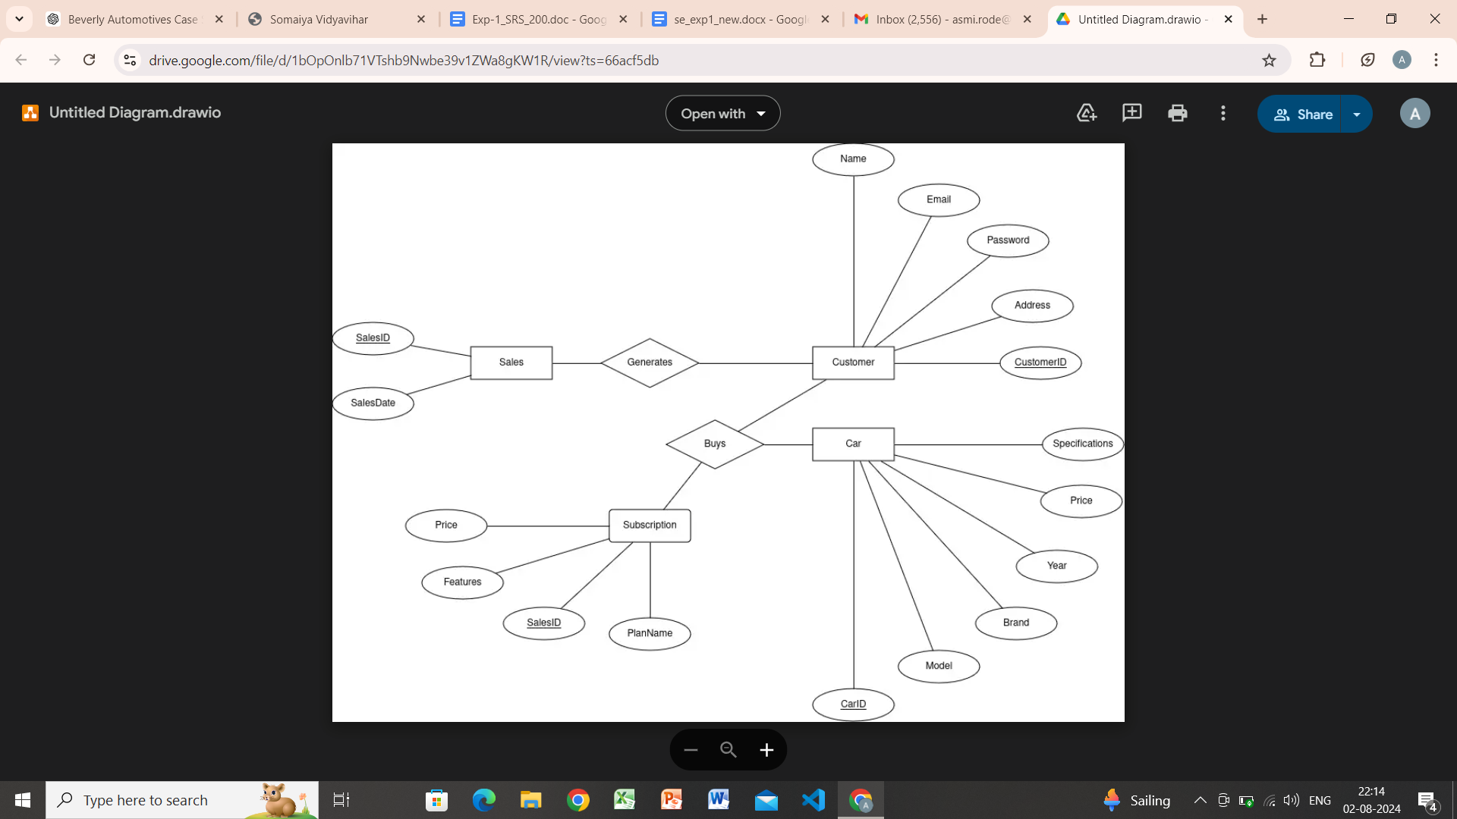

Post Laboratory Activity:

- You are required to prepare an SRS document for any project. ( It could be the mini project you have completed in semester IV
- Prepare a questionnaire for the allotted project considering your lab instructor is the client for requirement gathering.
- Consider the following scenario: An institute is interested in developing a Library Information System (LIS) for the benefit of students and employees of the institute. LIS will enable the members to borrow a book (or return it) with ease while sitting at his desk/chamber. The system also enables a member to extend the date of his borrowing if no other booking for that particular book has been made. For the library staff, this system aids them to easily handle day-to-day book transactions. The librarian, who has administrative privileges and complete control over the system, can enter a new record into the system when a new book has been purchased, or remove a record in case any book is taken off the shelf. Any non-member is free to use this system to browse/search books online. However, issuing or returning books is restricted to valid users (members) of LIS only.

The final deliverable would be a web application (using the recent HTML 5), which should run only within the institute LAN. Although this reduces security risk of the software to a large extent, care should be taken no confidential information (e.g. passwords) is stored in plain text.

Prepare an SRS document for the same in the format discussed in the write-up.

Post Lab Descriptive Questions answers must be handwritten and to be submitted BEFORE the next turn.

  - What are different techniques to gather information for software development?

The following are some of the well-known requirements gathering techniques −
- Brainstorming: Brainstorming is used in requirement gathering to get as many ideas as possible from a group of people. Generally used to identify possible solutions to problems, and clarify details of opportunities.

- Document Analysis: Reviewing the documentation of an existing system can help when creating AS–IS process documents, as well as driving gap analysis for scoping of migration projects. In an ideal world, we would even be reviewing the requirements that drove creation of the existing system – a starting point for documenting current requirements. Nuggets of information are often buried in existing documents that help us ask questions as part of validating requirement completeness.

- Focus Group: A focus group is a gathering of people who are representative of the users or customers of a product to get feedback. The feedback can be gathered about needs/opportunities/ problems to identify requirements, or can be gathered to validate and refine already elicited requirements. This form of market research is distinct from brainstorming in that it is a managed process with specific participants.

- Interface analysis: Interfaces for a software product can be human or machine. Integration with external systems and devices is just another interface. User centric design approaches are very effective at making sure that we create usable software. Interface analysis – reviewing the touch points with other external systems is important to make sure we don’t overlook requirements that aren’t immediately visible to users.

- Interview: Interviews of stakeholders and users are critical to creating the great software. Without understanding the goals and expectations of the users and stakeholders, we are very unlikely to satisfy them. We also have to recognize the perspective of each interviewee, so that we can properly weigh and address their inputs. Listening is the skill that helps a great analyst to get more value from an interview than an average analyst.

- Observation: By observing users, an analyst can identify a process flow, steps, pain points and opportunities for improvement. Observations can be passive or active (asking questions while observing). Passive observation is better for getting feedback on a prototype (to refine requirements), where active observation is more effective at getting an understanding of an existing business process. Either approach can be used.

- Prototyping: Prototyping is a relatively modern technique for gathering requirements. In this approach, you gather preliminary requirements that you use to build an initial version of the solution - a prototype. You show this to the client, who then gives you additional requirements. You change the application and cycle around with the client again. This repetitive process continues until the product meets the critical mass of business needs or for an agreed number of iterations.

- Requirement Workshops: Workshops can be very effective for gathering requirements. More structured than a brainstorming session, involved parties collaborate to document requirements. One way to capture the collaboration is with creation of domain-model artifacts (like static diagrams, activity diagrams). A workshop will be more effective with two analysts than with one.

- Reverse Engineering: When a migration project does not have access to sufficient documentation of the existing system, reverse engineering will identify what the system does. It will not identify what the system should do, and will not identify when the system does the wrong thing.

- Survey/Questionnaire: When collecting information from many people – too many to interview with budget and time constraints – a survey or questionnaire can be used. The survey can force users to select from choices, rate something (“Agree Strongly, agree…”), or have open ended questions allowing free-form responses. Survey design is hard – questions can bias the respondents.

  - List verification and validation techniques for requirements.

Requirement validation is the process of checking that requirements defined for development, and defining the system that the customer really wants. To check issues related to requirements, we perform requirements validation. We usually use requirements validation to check errors at the initial phase of development as the error may increase excessive rework when detected later in the development process. In the requirements validation process, we perform a different type of test to check the requirements mentioned in the Software Requirements Specification (SRS), these checks include:

- Completeness checks
- Consistency checks
- Validity checks
- Realism checks
- Ambiguity checks
- Verifiability

There are several techniques which are used either individually or in conjunction with other techniques to check to check entire or part of the system:

Test case generation: Requirement mentioned in SRS document should be testable, the conducted tests reveal the error present in the requirement. It is generally believed that if the test is difficult or impossible to design then, this usually means that requirement will be difficult to implement and it should be reconsidered.
Prototyping: In these validation techniques the prototype of the system is presented before the end-user or customer, they experiment with the presented model and check if it meets their needs. This type of model is generally used to collect feedback about the requirement of the user.
Requirements Reviews: In this approach, the SRS is carefully reviewed by a group of people including people from both the contractor organizations and the client side, the reviewer systematically analyzes the document to check error and ambiguity.
Automated Consistency Analysis: This approach is used for automatic detection of an error, such as nondeterminism, missing cases, a type error, and circular definitions, in requirements specifications.

Validation:
- Identification of unstable components/functionalities
- Validation focused on error-handling: complementary (not concurrent) validation regarding the one performed by the development team
- Compliance with software and system requirements
- Black box testing and White box testing techniques
- Experience based techniques

