Name- Sakshi

Exam Roll No- 20020570029

College Roll no- 20201439

Set-1

OUTPUT 1:

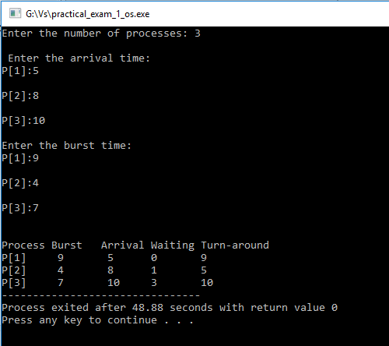

OUTPUT 2

