**NATIONAL INSTITUTE OF TECHNOLOGY, TIRUCHIRAPPALLI-15**



***Department of Computer Applications***

**HOSTEL MANAGEMENT SYSTEM**

**PROJECT REPORT**

*Under the guidance of : Submitted By :*

**Dr. P.Chitra Sakshi Jain**

**205119089**

**Abhishek Kumar Pandey**

**205119003**

**NATIONAL INSTITUTE OF TECHNOLOGY, TIRUCHIRAPPALLI-15**



**CERTIFICATE**

This is to certify that Sakshi Jain and Abhishek kumar pandey, student of 2nd semester MCA (batch 2019-2022) of National Institute of Technology, Tiruchirappalli has successfully completed the project Hostel Management System in CPP under the guidance of Dr. P. Chitra.

**(signature)**

**Dr. P.Chitra**

**ACKNOWLEDGMENT**

I take this occasion to thank God, almighty for blessing us with his

grace and taking our endeavor to a successful culmination. I extend my sincere and heartfelt thanks to our esteemed guide, Dr. P. Chitra

for providing me with the right guidance and advice at the crucial junctures and for showing me the right way.

I would like to thank the other faculty members also, at this occasion. Last but not the least, I would like to thank my friends and family for the support and encouragement they have given me during the course of our work.

**1. Sakshi Jain**

**2. Abhishek Kumar Pandey**

**INDEX**

|  |  |  |  |
| --- | --- | --- | --- |
| S_NO | NAME OF THE CONTENT | PAGE | REMARKS |
| 1 | Overview | 5 |  |
| 2 | Details of The Project | 5-6 |  |
| 3 | Student details | 6-7 |  |
| 4 | Room Allotment | 7-8 |  |
| 5 | Describing Procedure | 8-10 |  |
| 6 | Editing Student Details | 10-12 |  |
| 7 | Glimpses of Project | 12-13 |  |
| 8 | Bibliography | 14 |  |

**Overview**

This project “HOSTEL MANAGEMENT SYSTEM” is developed in the cpp.This is a simple project that fullfill the requirement of any college for hostel administration to maintain the record of students for a particular hostel.This uses basically all the features of cpp.

C++ is a statically typed, compiled, general-purpose, case-sensitive, free-form programming language that supports procedural, object-oriented, and generic programming.

C++ is regarded as a middle-level language, as it comprises a combination of both high-level and low-level language features.

C++ was developed by Bjarne Stroustrup starting in 1979 at Bell Labs in Murray Hill, New Jersey, as an enhancement to the C language and originally named C with Classes but later it was renamed C++ in 1983.

C++ is a superset of C, and that virtually any legal C program is a legal C++ program.

C++ fully supports object-oriented programming, including the four pillars of object-oriented development −

* Encapsulation
* Data hiding
* Inheritance
* Polymorphism

Standard Libraries

Standard C++ consists of three important parts −

* The core language giving all the building blocks including variables, data types and literals, etc.
* The C++ Standard Library giving a rich set of functions manipulating files, strings, etc.
* The Standard Template Library (STL) giving a rich set of methods manipulating data structures, etc.

**DETAILS OF THE PROJECT**

**Header Files Used**

**Iostream.h**

iostream is the basic input and output component of the C++ standard library, equivalent to stdio.h in C. It can be used to read from and write to standard output (the terminal) as well as writing to files (or block devices), as well as any other streams you create or are found in libraries you use. For instance, with the Boost.Asio library, you can write to streams that send data over a network connection.

**stdlib.h**

stdlib.h is the header of the general purpose standard library of C programming language which includes functions involving memory allocation, process control, conversions and others. It is compatible with C++ and is known as cstdlib in C++. The name "stdlib" stands for "standard library".

**conio.h**

The conio.h header file used in C programming language containsfunctions for console input/output. Some of its most commonly used functions are clrscr, getch, getche, kbhit etc. They can be used to clear screen, change color of text and background, move text, check whether a key is pressed or not and to perform other tasks.

THIS PROJECT CONTAIN LOGIN FORM FOR ADMINISTRATION, CHOICE MENU FOR STUDENT,

HOSTEL DETAILS, RECORD FOR ALLOTED ROOMS, MODIFICATION OPTIONS,DELETION OF DATA,STUDENT RECORD.

**STUDENT DETAILS**

THIS CONTAIN STUDENT DETAILS LIKE NAME,ROLL,EMAIL ID,PHONE NUMBER.

**ROOM ALLOTMENT**

THIS IS FOR SHOWING THE ALLOTMENT OF ROOMS FOR REGARDING HOSTELS.IT FIRST ASK TO ENTER THE HOSTEL NAME AFTER THAT IT WILL ASK TO ENTER THE ROLL NUMBER IF THE STUDENT, IF STUDENT RECORD IS FOUND IN THAT HOSTEL, IT WILL SHOW THE ALLOTED ROOM NUMBER, IF NOT FOUND THEN IT WILL SHOW A MESSAGE “RECORD NOT FOUND”.

**DESCRIBING PROCEDURE**

THIS PROJECT USES THE CONCEPT OF INHERITANCE,FUNCTION,TEMPLATE.WE HAVE USES MULTIPLE FUNCTION OF DIFFERENT TYPE OF PURPOSES LIKE MENU, STUDENT DETAILS, HOSTEL ALLOTMENT ETC.

1.int add();

2. int display();

3. int rooms();

4. int edit();

5. int check(int);

6. int modify(int);

7. int delete_rec(int);

**EDITING STUDENT DETAIL**

THIS PROCEDURE HELP ADMISTRATION TO EDIT THE STUDENT RECORD IF STUDENT IS WILLING TO CHANGE THE HOSTEL OR HE/SHE LEFT THE COLLEGE.

**Glimpses of Project:-**

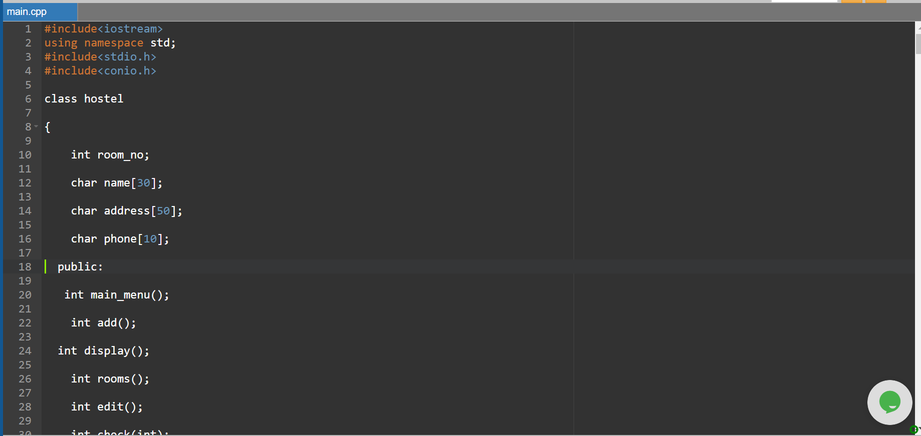

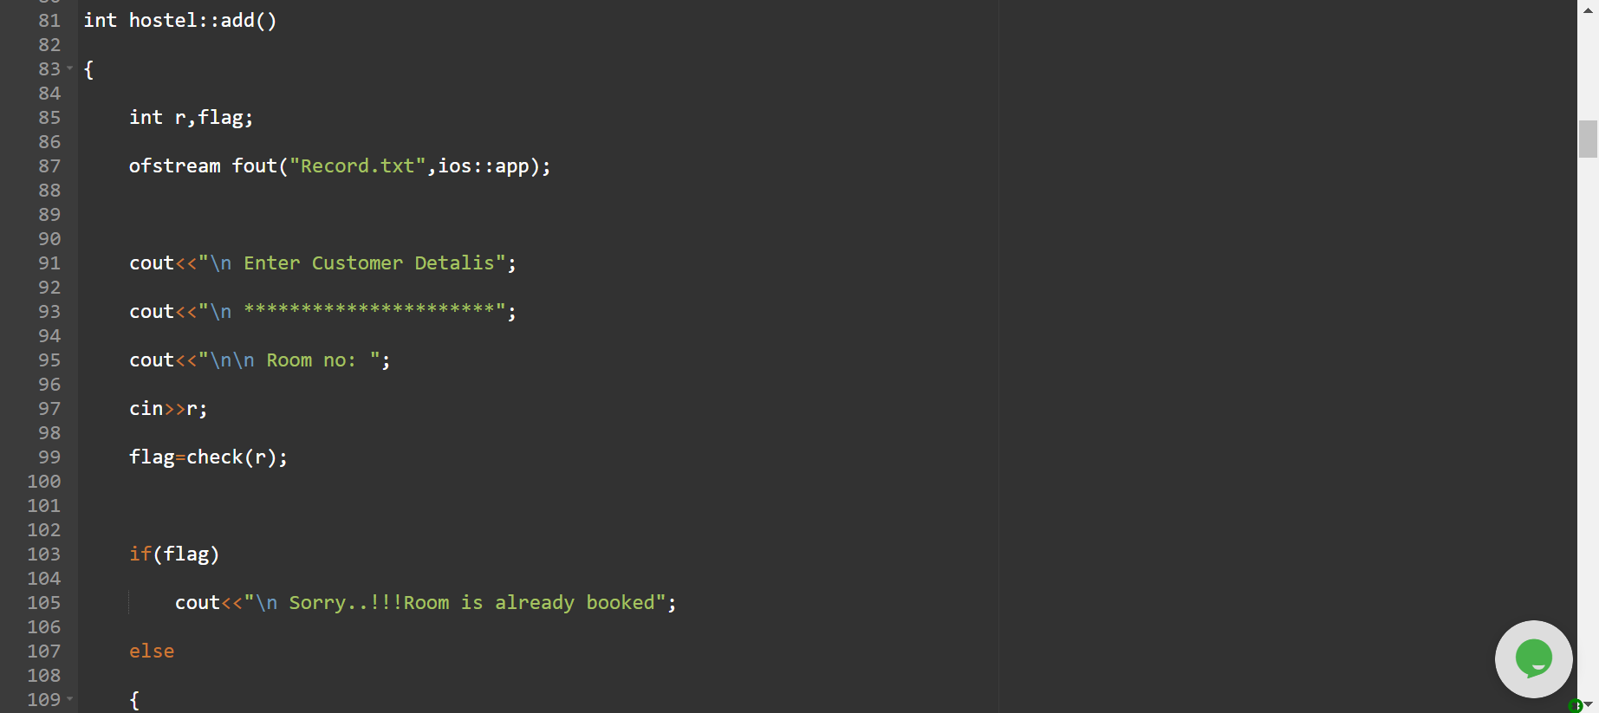

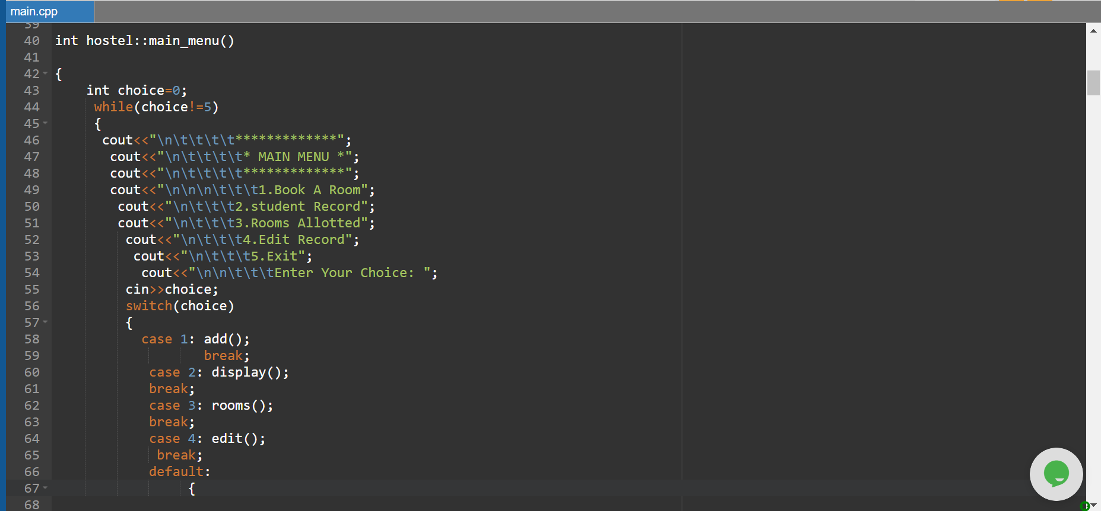

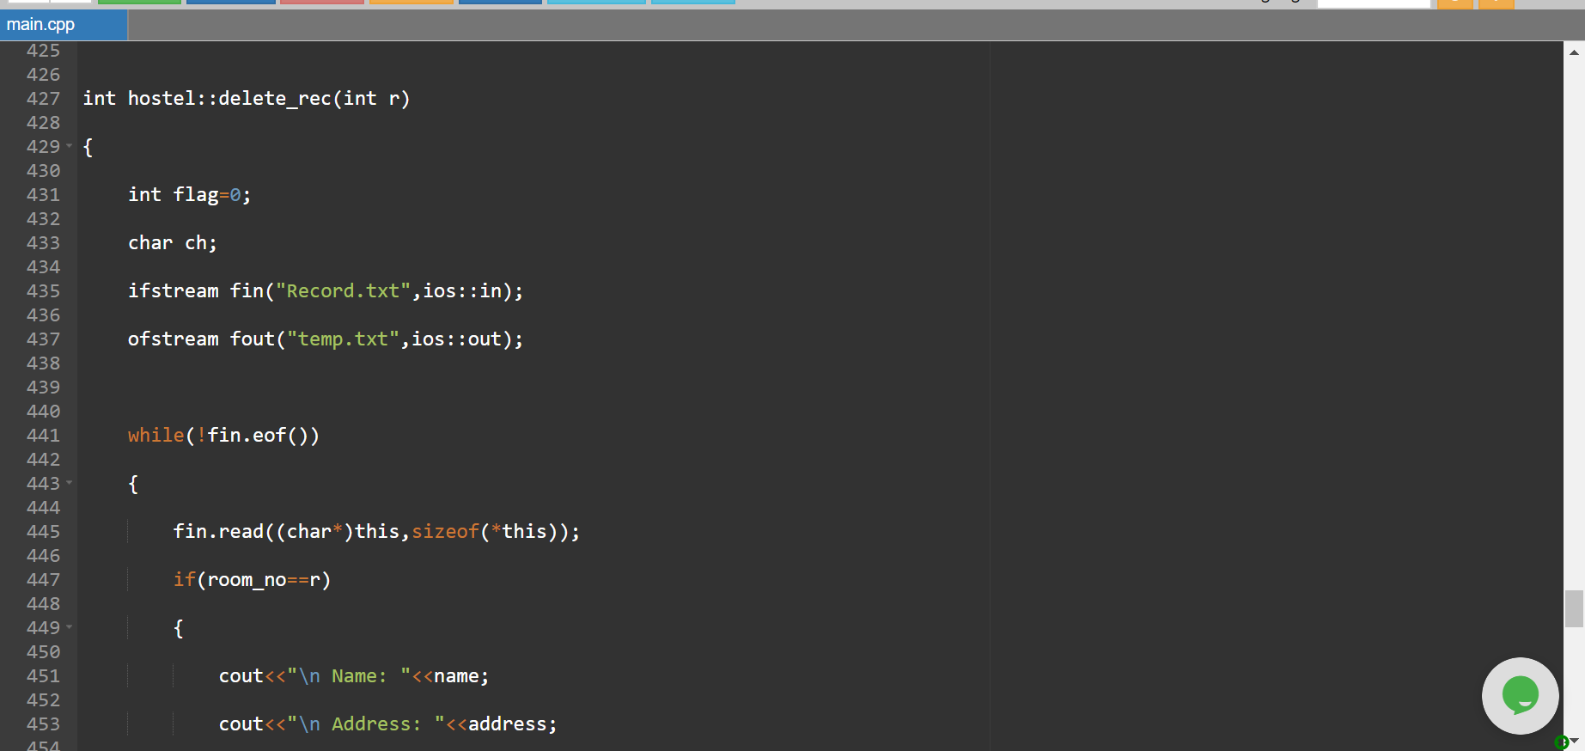

**BIBLIOGRAPHY**

FOR THE PROJECT WE TOOK THE HELP OF CONCEPT WHICH WAS GIVEN BY FACULTY DURING THE CLASS, INTERNET FOR SOME PROCEDURE, AND ONE BOOK OF CPP I.E “MODERN C++ DESIGN BY JOHN VILSSIDES”.