AGRIBUSINESS DATA CLEANING AND PREPROCESSING STRATEGY
Week 2 Task | Junior Data Scientist Internship
Prepared by: Sakshi Prabhakar Bhusawale
Study context: A hypothetical (synthetic) Indian mandi price dataset, structured like AGMARKNET data

1. Introduction
Decisions in agribusiness, such as when a farmer should sell, where a trader should send produce, or how much a cold store should hold, depend on data collected from hundreds of markets, farms, weather stations and government agencies. That data is rarely ready for analysis. Different people enter it in different ways, feeds are merged together, and gaps appear whenever a market is closed or an officer skips a field. Analysis run on uncleaned data can look convincing and still be wrong.
This document sets out a strategy for cleaning and preprocessing agribusiness data. It follows on from the Week 1 plan, which proposed studying daily market prices and arrivals from AGMARKNET and crop statistics from the Directorate of Economics and Statistics. Rather than only describing the strategy in general terms, the document demonstrates it on a hypothetical dataset and reports what each step actually changed.
About the hypothetical dataset
The data are synthetic. A script (seed 42) generated 609 clean daily records for 3 crops (soybean, onion, wheat) in 4 Maharashtra markets (Pune, Lasalgaon, Latur, Nagpur) from 1 October to 30 November 2025, with about 18% of market-days unreported. Realistic problems were then injected at known rates, producing a 630-row raw file.
Because the clean answer key is known, we can measure how close the cleaning gets to the truth. This is not possible with real data, where the truth is unknown. Real data will be messier and will need more domain checks, as discussed in Section 7.

How the document is organised. Section 2 introduces the common data quality issues. Section 3 gives the step-by-step cleaning plan with worked examples. Section 4 presents the preprocessing framework and workflow diagram. Section 5 shows evidence that the methods work. Section 6 discusses reproducibility. Sections 7 and 8 cover limitations and conclusions.

2. Common Data Quality Issues in Agribusiness Datasets

2.1 Why agribusiness data is especially messy
- Many independent data sources. Hundreds of mandis report separately, often through manual entry, so spelling, units and formats vary between reporters.
- Merged feeds. Prices, arrivals, weather and crop statistics come from different agencies with different time scales (daily prices versus annual production), codes and units.
- Seasonality and real shocks. A genuine price spike from a festival, unseasonal rain or a transport strike looks like an error to a simple filter, so cleaning must not remove real events.
- Irregular reporting. Markets close on holidays and during strikes, and reporting is patchy, so gaps are the norm, not the exception.

2.2 Catalogue of issues
Issue | Typical cause | Example in our dataset | Risk if ignored
Missing values | Market closed, field skipped, entries stored as NA, -, blank or nan | 139 missing cells; arrivals missing in 89 of 630 rows (14.1%) | Biased averages, dropped rows, broken time series
Inconsistent date formats | Different reporters or feeds | 3 formats mixed (2025-11-23, 23/11/2025, 23-Nov-2025); 277 rows not ISO | Parsing failures; day and month silently swapped
Inconsistent category names | Free-text entry, typos, suffixes | 14 spellings for 3 crops; 12 for 4 markets (e.g. Soyabean, SOYBEAN, Lasalgoan) | One crop split into groups; filters miss rows
Unit inconsistency | Rs/Quintal vs Rs/Kg across feeds | 36 rows reported in Rs/Kg | Prices 100 times too low
Duplicate records | Re-downloaded batches, overlapping pulls | 21 exact duplicates (3.3%) | Inflated counts; double weighting
Outliers | Data-entry typos (extra zero) or genuine shocks | 7 typos (10x or 0.1x) and 6 plausible spikes | Distorted mean, spread and correlation; or real events deleted
Logical inconsistencies | Swapped columns, impossible values | 9 rows with min > max; 4 negative arrivals | Impossible values enter models
Coverage gaps | Holidays, strikes, irregular reporting | About 18% of market-days unreported | Biased trends if gaps are not random
Granularity mismatch | Daily prices vs annual production | Not simulated here; relevant when combining the Week 1 sources | Invalid joins and comparisons

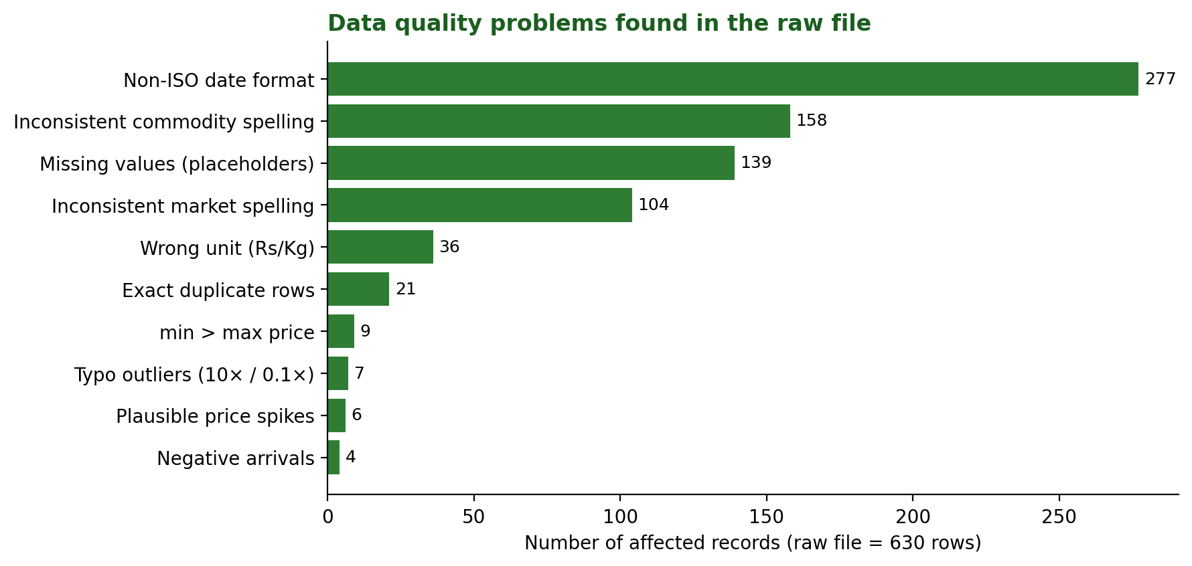
Figure 1: Problems found in the raw file (counts from the cleaning log; some are counted before and some after duplicate removal).

2.3 The hypothetical dataset
Column | Meaning | Unit / type | Known problems injected
record_id | Unique row identifier | integer | Duplicates
date | Reporting date | text (3 formats) | Mixed formats
state, district, market | Location of the mandi | text | Spelling variants in market
commodity, variety | Crop and variety | text | Spelling, case, trailing spaces
min_price, max_price, modal_price | Wholesale price range and most frequent price | Rs per quintal | Missing, wrong unit, typos, min > max
arrivals_tonnes | Quantity arriving at the market | tonnes | Missing (14%), negative values
price_unit | Declared unit of the price columns | text | Rs/Quintal, Rs./Quintal, Rs/Kg, Rs/kg

3. Step-by-Step Data Cleaning Plan
The plan has nine steps. Each follows the same pattern: a goal, a method, a worked example from the hypothetical dataset, and the reason the method was chosen over alternatives. The order is deliberate and is explained in Section 4.3.

Step 1: Preserve the raw data and fingerprint it
Goal. Make sure the original file can never be altered by cleaning.
Method.
- Store the raw file in a read-only folder and never edit it; every correction happens in code on a copy.
- Read every column as text first, so nothing is silently converted (for example, NA becoming a number or a date flipping day and month).
- Compute a SHA-256 hash of the file and record it in the log.
Worked example. The raw file has hash 78e41b5e3b7a35c4 (first 16 characters). If this value changes, the input has changed.
Why this choice. Cleaning decisions can only be audited if the starting point is fixed.

Step 2: Profile the data before changing anything
Goal. Measure how bad the problems are, so cleaning effort goes where it matters.
Method.
- Count rows and columns, data types, unique values per categorical column, and date range.
- Count missing values per column, including hidden placeholders (NA, N/A, -, blank, nan).
- Count duplicate rows and list the distinct spellings of each category.
Worked example. Profiling the raw file shows 630 rows, 139 missing cells hidden behind 5 different placeholder styles (arrivals 89, modal price 26, min price 12, max price 12), 21 duplicate rows, 14 commodity spellings and 12 market spellings.
Why this choice. Profiling shows, for instance, that arrivals needs far more attention than min price, and that spelling problems are common enough to need systematic handling.

Step 3: Structural fixes: placeholders, types and duplicates
Goal. Make every column the right type and remove records that are literally repeated.
Method.
- Convert all placeholder strings to a true missing value (NaN) and convert price and arrival columns to numbers.
- Parse dates by trying explicit formats in order (%Y-%m-%d, %d/%m/%Y, %d-%b-%Y). Avoid automatic guessing, because 04/11/2025 can mean 4 November or 11 April.
- Drop exact duplicate rows (all columns identical) and keep the first occurrence. After standardisation, run a second check on the business key (date + market + commodity).
Worked example. 139 placeholder cells became NaN; 21 duplicate rows were removed (630 to 609 rows); all dates parsed (range 2025-10-01 to 2025-11-30, 0 unparsed).
Why this choice. Explicit formats fail loudly on an unexpected format, whereas guessing fails silently.

Step 4: Standardise categories and units
Goal. Make equal things look equal.
Method.
- Normalise text: trim spaces, lower-case for comparison, collapse repeated spaces.
- Map known aliases through a dictionary (for example soyabean to Soybean, Lasalgaon(Niphad) to Lasalgaon), then use fuzzy matching (similarity cutoff 0.8) as a fallback for unseen typos. Anything unmatched is reported, not guessed.
- Convert all prices to one unit (Rs per quintal; 1 quintal = 100 kg), using the declared price_unit column.
Worked example. Commodity spellings fell from 14 to 3, and market spellings from 12 to 4, with 0 unmatched. 36 Rs/Kg rows were multiplied by 100. For example, record 409 (Wheat, Pune) had a modal price of 25.29 Rs/kg, which became 2,529 Rs/quintal.
Why this choice. A dictionary is transparent and auditable, and fuzzy matching only catches near-misses. Unit conversion must come before outlier detection, otherwise Rs/Kg values would be flagged as extreme outliers.

Step 5: Apply rule-based validation
Goal. Catch values that are impossible regardless of statistics.
Method.
- Arrivals cannot be negative: set to missing (to be imputed) and flag.
- Minimum price must not exceed maximum price. If reversed, swap the two values, since a swapped column pair is the most likely cause.
- Modal price should lie between minimum and maximum: flag violations for review instead of altering them.
Worked example. 4 negative arrivals set to missing; 9 min/max pairs swapped; 6 modal prices outside their range were flagged (these turned out to be the plausible spikes in Step 6).
Why this choice. Rules based on domain knowledge are cheap, certain and explainable. They should run before statistical methods.

Step 6: Detect and treat outliers
Goal. Remove data-entry errors while preserving genuine market events.
Method.
- Detect with a robust z-score computed within each crop and market series: z = 0.6745 x (x - median) / MAD, where MAD is the median absolute deviation. Flag |z| > 3.5.
- Classify each flagged value: if it is about 10 times or 0.1 times the series median (ratio above 5 or below 0.2), treat it as a typing error; otherwise treat it as a plausible price spike.
- Treat: set typos to missing (to be imputed in Step 7). Keep plausible spikes but flag them with flag_price_spike_kept, and verify against neighbouring markets or news before analysis.
Worked example. The rule flagged 13 values. Seven were typos: for instance, record 217 (onion, Pune, 21 Oct 2025) reported Rs 19,445 per quintal against a series median of Rs 1,895 (ratio 10.3x), so it was set to missing. Six were spikes of roughly 1.3 to 1.5 times the median, which were kept and flagged.
Why this choice. The median and MAD are not distorted by the very outliers being sought, unlike the mean and standard deviation. Running the rule within each crop-market series stops a normal soybean price from being judged against onion prices.
Treatment options at a glance.
Option | What it does | Use when | Risk
Remove row | Deletes the record | Clearly corrupt row with no usable fields | Loses information; can bias sample
Set to missing, then impute | Treats value as unknown | Typing error in one field (used for typos here) | Imputed value is an estimate
Cap / winsorise | Pulls extremes to a percentile limit | Values are real but too influential for a model | Alters genuine data
Flag and keep | Retains the value with a marker | Plausible real event (used for spikes here) | Spikes still influence summaries

Step 7: Handle missing values (imputation)
Goal. Fill gaps in a way that respects how each variable behaves, and record every fill.
Method.
- Add a flag column (modal_price_was_imputed, arrivals_was_imputed) before filling, so imputed values can always be separated out.
- Prices: time-based linear interpolation within each crop-market series, limited to gaps of 5 days. Daily prices change gradually, so neighbouring days are good evidence.
- Min and max prices: modal price multiplied by that series' median min/modal (or max/modal) ratio.
- Arrivals: median of the same crop-market series. Arrivals are right-skewed, so the median is more representative than the mean.
- Do not impute when most of a series is missing, or when a whole market is absent for a period. Instead, report the gap and exclude that period.
Worked example. 31 modal prices, 24 min or max prices, and 89 arrival values were imputed. Record 58 (Soybean, Lasalgaon) had arrivals of "N/A", which became 179.8 tonnes (the series median) with the flag set.
Why this choice. Section 5 compares the methods against the known true values.
Imputation options compared.
Method | Strength | Weakness | Suited to
Drop rows with gaps | Simple; no invented values | Loses data; breaks daily series | Very few gaps, random
Overall mean / median | Trivial | Ignores crop and market differences | Rarely appropriate here
Group mean / median | Respects crop and market | Ignores time pattern | Skewed, non-trending variables (arrivals)
Time interpolation | Uses neighbouring days | Poor across long gaps or sudden shocks | Smooth daily series (prices)
Model-based (KNN, regression) | Can use many predictors | More complex; needs validation | Larger datasets, many correlated columns

Step 8: Transform and normalise
Goal. Create analysis-ready features and put variables on comparable scales.
Method.
- Derived feature: price_spread = max_price - min_price as a rough measure of market uncertainty.
- Log transform: log_arrivals = ln(1 + arrivals) to reduce right skew before correlation or regression.
- Scaling within each crop: min-max (x - min)/(max - min) for a 0 to 1 scale, or z-score (x - mean)/sd for comparing price movement across crops with different price levels. Scaling is only applied for modelling or cross-crop comparison; original rupee values are kept for reporting.
- Further steps for later work: calendar features (month, week), weekly resampling, and one-hot encoding of markets for machine-learning models.
Worked example. For a soybean record with a modal price of Rs 4,394: min-max scaling gives 0.23 (series range 3,971 to 5,851), z-score gives -0.27, and arrivals of 139.5 tonnes become a log value of 4.95. Note that the upper end of the range (5,851) is a kept spike, which shows how min-max scaling is sensitive to extremes.
Why this choice. Scaling comes last so it is calculated on clean values. Z-scores are more robust to a single extreme value than min-max scaling, but a robust (median/MAD) scaler is an option when spikes are common.

Step 9: Validate and export
Goal. Prove the cleaned data meet the rules before anyone uses them.
Method.
- Run automated assertions (a failed check stops the pipeline).
- Write the cleaned file, the cleaning log and a short data-quality report.
- Never overwrite the raw file; save the clean file as a new, versioned file.
Worked example. All six checks below passed on the hypothetical dataset.
Validation check | Result
No duplicate records on (date, market, commodity) | Pass
No missing values in core columns | Pass
min_price <= max_price in every row | Pass
All prices positive | Pass
Exactly 3 commodities and 4 markets | Pass
Single price unit (Rs/Quintal) | Pass

Before and after: five records
Problem | Raw value | Cleaned value | Step
Date format | "23/11/2025" | 2025-11-23 | 3
Crop spelling | "SOYBEAN" | Soybean | 4
Wrong unit | 25.29 (Rs/kg) | 2,529 Rs/Quintal | 4
Typing error (10x) | 19,445 (series median 1,895) | 1,981 (interpolated, flagged) | 6, 7
Missing arrivals | "N/A" | 179.8 t (group median, flagged) | 7

4. Proposed Preprocessing Framework

4.1 A three-zone data structure
The framework separates data into three zones, so that each stage has a single purpose and earlier stages are never overwritten.
Zone | Contents | Allowed changes | File in this project
1. Raw | Exactly as downloaded | None (read-only) | raw_mandi_prices.csv
2. Cleaned | Correct types, standard names and units, errors fixed, every change flagged | Only through the pipeline script | clean_mandi_prices.csv
3. Analysis-ready | Cleaned data plus derived and scaled features, filtered to the study scope | Feature engineering only | Columns added at Step 8

Suggested project layout:
agribusiness-data-cleaning/
data/raw/ # Zone 1: never edited
data/clean/ # Zone 2 and 3 outputs
src/clean_pipeline.py # the single source of truth
logs/cleaning_log.json # counts per step + file hashes
docs/data_dictionary.md # meaning and units of each column
requirements.txt # pinned package versions
README.md # how to reproduce the results

4.2 Workflow diagram
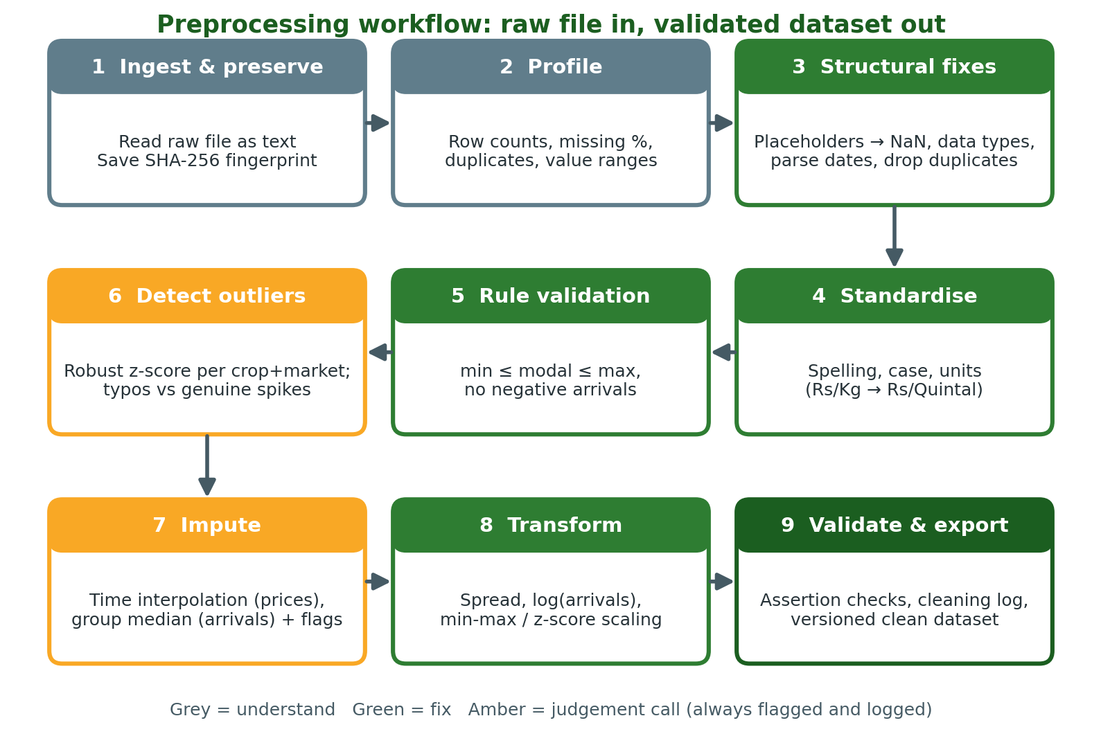
Figure 2: Nine-stage preprocessing workflow. Amber stages involve judgement and must be logged.
Stage | Input | Process | Output and check
1 Ingest | Raw file | Read as text; hash | Hash recorded
2 Profile | Raw text table | Counts, missing, duplicates, spellings | Issue inventory
3 Structural | Raw text table | Placeholders, types, dates, duplicates | Typed table; row count logged
4 Standardise | Typed table | Alias map, fuzzy match, unit conversion | One spelling per entity; one unit
5 Rules | Standardised table | min <= max, no negatives, modal in range | Violations fixed or flagged
6 Outliers | Rule-checked table | Robust z within crop-market; classify | Typos to missing; spikes flagged
7 Impute | Table with gaps | Interpolation, ratios, group median; flags | No gaps in core columns; flags set
8 Transform | Complete table | Spread, log, scaling | Analysis-ready features
9 Validate | Final table | Assertions; write log and file | All checks pass; versioned export

4.3 Why the order matters
- Duplicates before statistics. Medians and interpolations should be calculated once per real observation, not once per copy.
- Spelling before grouping. The outlier rule works within each crop-market group. If "Soyabean" and "Soybean" were still separate groups, each would have thinner and less reliable statistics.
- Units before outliers. If outlier detection ran first, all 36 Rs/Kg rows (values about 100 times too small) would be flagged as extreme, burying the real errors.
- Outliers before imputation. A 10x typo left in place would distort the interpolation of its neighbours.
- Scaling last. Scaling parameters (min, max, mean, standard deviation) should be computed on clean values only.

4.4 Audit flags
Instead of silently changing values, the cleaned file carries seven audit columns: modal_price_was_imputed, min_price_was_imputed, max_price_was_imputed, arrivals_was_imputed, flag_outlier, flag_price_spike_kept and flag_modal_out_of_range. Anyone analysing the data can then run results with and without imputed or flagged values to see how much they matter (a sensitivity check).

5. Evidence: Does the Cleaning Strategy Work?
Because the true values are known for this hypothetical dataset, three versions of the same analysis can be compared: a naive version (convert text to numbers, drop blanks, filter on exact crop names), the cleaned version, and the true values.

5.1 Summary statistics
Crop | Rows used (naive / clean / true) | Mean modal price, Rs/quintal (naive / clean / true) | Maximum modal price (naive / clean / true)
Soybean | 155 / 200 / 200 | 4,226 / 4,463 / 4,444 | 42,929 / 5,851 / 4,919
Onion | 158 / 208 / 208 | 1,837 / 1,826 / 1,817 | 19,445 / 2,745 / 2,033
Wheat | 155 / 201 / 201 | 2,359 / 2,533 / 2,530 | 3,407 / 3,407 / 2,785

- Lost records. The naive analysis used only 155 of 200 soybean records (23% lost), because inconsistent spelling and blanks meant exact-name filtering missed rows.
- Biased average. Naive mean soybean price was Rs 4,226, which is 4.9% below the true Rs 4,444. The cleaned mean (Rs 4,463) is within 0.4%. For wheat, the naive mean was 6.8% too low because Rs/Kg rows dragged it down.
- Absurd maximums. The naive maximum soybean price was Rs 42,929 and onion Rs 19,445, both caused by typing errors. After cleaning they fall to Rs 5,851 and Rs 2,745.
- A remaining discrepancy. Wheat's maximum stays at Rs 3,407 against a true Rs 2,785, because a 1.35x spike was deliberately kept and flagged. Whether to keep it requires checking neighbouring markets and news. This is the cost of the "flag and keep" policy.

5.2 Effect on a relationship: arrivals versus price
A typical research question, from the Week 1 plan, is whether higher market arrivals coincide with lower prices. The Pearson correlation between modal price and arrivals gives:
Crop | Naive | Cleaned | True
Soybean | -0.07 | -0.50 | -0.64
Onion | -0.03 | -0.41 | -0.50
Wheat | -0.08 | -0.44 | -0.54

Without cleaning, the relationship is almost invisible (soybean -0.07), and an analyst could wrongly conclude that arrivals and prices are unrelated. After cleaning, a clear negative relationship emerges (-0.50), close to the true -0.64. It does not match exactly because kept spikes and imputed values still add some noise. This shows that cleaning changes the conclusion, not just the tidiness of the table.

5.3 Which imputation method recovers the truth best?
The 31 imputed modal prices and 89 imputed arrival values were compared with their true values using mean absolute percentage error (MAPE, lower is better).
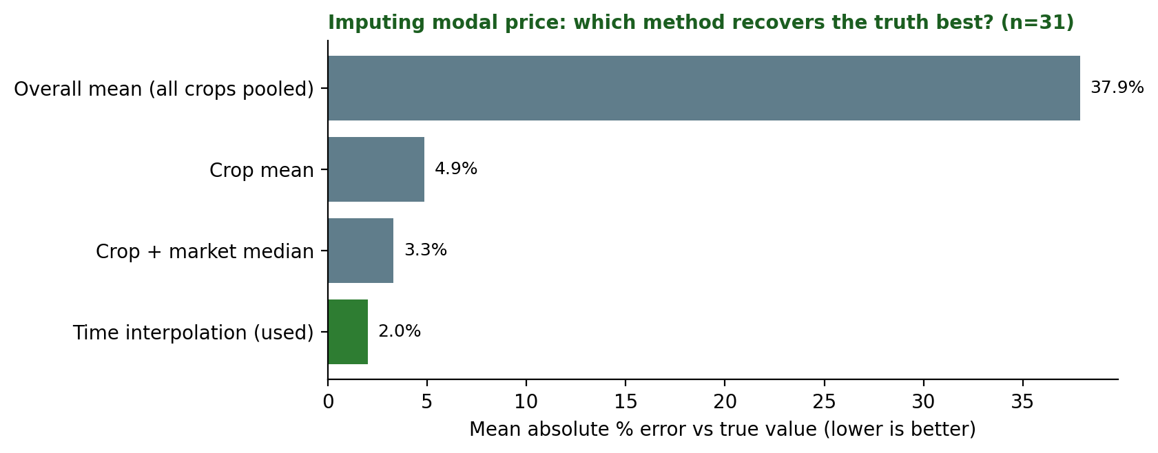
Figure 3: Error of four imputation methods for modal price. Time interpolation is clearly best.
Variable | Overall mean (pooled) | Crop mean | Crop + market median | Time interpolation
Modal price (n = 31) | 37.9% | 4.9% | 3.3% | 2.0%
Arrivals (n = 89) | 40.2% | 13.2% | 13.5% | not applicable

- Prices: time interpolation (2.0% error) beats group medians (3.3%) and crop means (4.9%), while pooling all crops together is badly wrong (37.9%). Using neighbouring days makes sense because prices are strongly autocorrelated.
- Arrivals: crop mean and crop-plus-market median perform about the same (13.2% vs 13.5%), and both are far better than pooling all crops (40.2%). The median was chosen because arrivals are skewed, and the small difference between the two is not meaningful. The residual 13% error is expected, since daily arrivals fluctuate randomly.

5.4 Before and after for one series
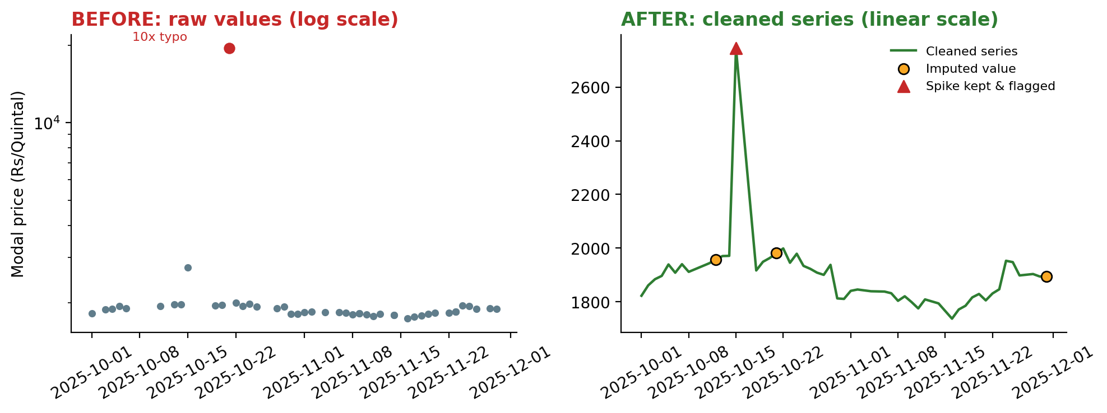
Figure 4: Onion at Pune. Left: raw values on a log scale, where a 10x typing error dominates. Right: cleaned series with imputed values and the kept spike marked.

6. Importance of Reproducibility in Data Cleaning
Reproducibility means that another person (or the same person six months later) can start from the same raw file, run the same code, and get exactly the same cleaned data. It matters for several practical reasons.
- Trust and verification. A conclusion such as "arrivals and prices are negatively related" is only credible if the path from raw data to result can be checked.
- Updating. Mandi data arrives daily. A scripted pipeline can be re-run on new data in minutes, with identical rules, instead of repeating hand edits.
- Auditability of judgement calls. Cleaning involves decisions (thresholds, imputation choices). Recording them lets reviewers challenge or change them and see the effect.
- Error detection. Manual spreadsheet edits leave no trace. A mistake in a script can be found and fixed everywhere at once.
- Collaboration. Teammates can reuse and extend the same pipeline rather than each creating their own version of the truth.

6.1 Practices and how they were applied here
Practice | Applied in this project
Keep raw data immutable | Raw file is never edited; its SHA-256 fingerprint (78e41b5e3b7a35c4) is stored in the log
Script every step | All changes are in one script (clean_pipeline.py); no manual spreadsheet edits
Fix random seeds | Seed 42 in the data generator, so the raw file is identical on every run
Log every change | cleaning_log.json records the number of records changed by each step
Flag instead of silently overwrite | Seven audit columns identify imputed and flagged values
Use version control | Scripts, log and data dictionary go into the project's Git repository, with one commit per rule change
Pin the environment | Python 3.12.3, pandas 3.0.2, numpy 2.4.4 recorded in requirements.txt
Validate automatically | Six assertion checks run at the end of each run
Document decisions | Thresholds (z > 3.5, ratio 5 and 0.2, 5-day interpolation limit) and their reasons are written in the README.md

Reproducibility test (actually performed)
The data generator and the cleaning pipeline were each run twice from scratch. Both runs produced byte-identical files: the raw file had fingerprint 78e41b5e3b7a35c4 both times and the cleaned file had fingerprint 5ebb0d948bbc3f0b both times.

Excerpt of the cleaning log. Each run writes counts like these, so a reviewer can see exactly what the pipeline did.
Pipeline step | Records affected
Placeholder values converted to missing | 139
Exact duplicate rows removed | 21
Commodity names standardised | 158
Market names standardised | 104
Rs/Kg converted to Rs/Quintal | 36
Min/max prices swapped | 9
Negative arrivals set to missing | 4
Outliers flagged (typos / spikes) | 13 (7 / 6)
Modal prices imputed | 31
Min/max prices imputed | 24
Arrivals imputed | 89

7. Limitations and Next Steps
- Synthetic data. The problems were injected by design and are cleaner and more predictable than real data. Real mandi data will have additional issues such as market-specific codes, revised figures and reporting gaps that are not random.
- Thresholds need tuning. The z-score cutoff of 3.5 and the typo ratios are reasonable defaults, but they should be reviewed on real series and with agricultural domain knowledge (for example, genuine onion price surges in lean seasons).
- Imputation reduces variability. Filled values are estimates and make data look smoother than reality. Imputed rows should be excluded in a sensitivity check, and no more than a small share of a series should be imputed.
- Small sample. The dataset has 609 true records, so the correlation figures are illustrative, not statistically conclusive.
- Next steps. Apply the pipeline to the real AGMARKNET and DES files selected in Week 1, add a data dictionary for each source, and extend the plan to join daily prices with annual production at a common time scale.

8. Conclusion
Agribusiness data needs deliberate cleaning before it can support reliable conclusions. This strategy handles the common problems (missing values, inconsistent formats, duplicates, wrong units and outliers) through a nine-step, ordered workflow in which every change is logged and flagged. On the hypothetical dataset, the approach recovered the average soybean price to within 0.4% of the truth, removed impossible maximum prices, and restored an arrivals-price relationship that the uncleaned data had hidden (correlation -0.07 naive versus -0.50 cleaned, true value -0.64). Equally important, the whole process is reproducible: the same raw file and the same code give the same output every time.

Appendix A: Key Code Excerpts
The full scripts (make_raw_data.py, clean_pipeline.py, impact_analysis.py, make_figs.py) are provided with this submission. Two core excerpts follow.
Outlier rule (Step 6):
g = df.groupby(["commodity", "market"])["modal_price"]
med = g.transform("median")
mad = g.transform(lambda s: (s - s.median()).abs().median())
df["robust_z"] = 0.6745 * (df.modal_price - med) / mad
df["ratio_to_median"] = df.modal_price / med
df["flag_outlier"] = df.robust_z.abs() > 3.5
typo = df.flag_outlier & ((df.ratio_to_median > 5) | (df.ratio_to_median < 0.2))
df["flag_price_spike_kept"] = df.flag_outlier & ~typo # real but extreme: keep and flag
df.loc[typo, "modal_price"] = np.nan # entry errors: impute later

Imputation with audit flags (Step 7):
df["modal_price_was_imputed"] = df.modal_price.isna() # flag BEFORE filling
df["arrivals_was_imputed"] = df.arrivals_tonnes.isna()
df = df.set_index("date")
df["modal_price"] = df.groupby(["commodity", "market"])["modal_price"].transform(
lambda s: s.interpolate(method="time", limit=5, limit_direction="both"))
df["arrivals_tonnes"] = df["arrivals_tonnes"].fillna(
df.groupby(["commodity", "market"])["arrivals_tonnes"].transform("median"))

Appendix B: Files Delivered
File | Purpose
make_raw_data.py | Generates the hypothetical raw dataset and the hidden answer key (seed 42)
clean_pipeline.py | The nine-step cleaning and preprocessing pipeline with logging and validation
impact_analysis.py | Compares naive, cleaned and true results; evaluates imputation methods
make_figs.py | Creates the workflow diagram and charts used in this document
raw_mandi_prices.csv / clean_mandi_prices.csv | Raw and cleaned datasets
cleaning_log.json | Machine-readable log of every change and validation result
README.md / requirements.txt | How to reproduce the results; pinned package versions

References
- Open Government Data Platform India. "Current Daily Price of Various Commodities from Various Markets (Mandi)." https://www.data.gov.in/catalog/current-daily-price-various-commodities-various-markets-mandi
- Directorate of Economics and Statistics, Department of Agriculture and Farmers Welfare. "Area, Production & Yield Reports." https://data.desagri.gov.in/website/crops-apy-report-web
- Iglewicz, B. and Hoaglin, D. C. (1993). How to Detect and Handle Outliers. ASQC Quality Press. (Modified z-score with a 3.5 threshold.)
- Leys, C., Ley, C., Klein, O., Bernard, P. and Licata, L. (2013). Detecting outliers: Do not use standard deviation around the mean, use absolute deviation around the median. Journal of Experimental Social Psychology, 49(4), 764-766.
- Little, R. J. A. and Rubin, D. B. (2019). Statistical Analysis with Missing Data, 3rd edition. Wiley.
- Wilkinson, M. D. et al. (2016). The FAIR Guiding Principles for scientific data management and stewardship. Scientific Data, 3, 160018.

