**Project Report**

(CSC-20002 Database Systems)

**1. Functional Requirements**

IDEA Home Furniture Company operates a network of stores that offer a variety of home furnishing products, including furniture, carpets, lamps, rugs, and other similar items. Given the diversity in product types and delivery methods, the company requires a robust database system to manage information related to its products, customers, stores, employees, and suppliers.

The company's key functional requirements for the database include:

1. **Product Information:** Comprehensive information on products, such as product ID, description, price, and whether the product is for delivery or collection. If a product is for delivery, its dimensions are stored for calculating shipping costs. If it is for collection, its weight is stored for handling and transportation within the store.
2. **Store Management:** The company operates multiple stores across the country. Each store has a unique ID and location, and the database must track these details. Additionally, the stores have multiple employees, each with designated roles related to product handling, either for delivery or collection.
3. **Customer Data:** Customers can create unique accounts with the company, allowing them to track their purchases and order history. This information is valuable for customer relationship management and marketing efforts.
4. **Supplier Information:** The company has several suppliers providing products for sale in the stores. The database must record supplier details, including supplier ID, name, and contact information.
5. **Order Management:** The database must track orders, capturing details like order ID, product ID, customer name, store ID, supplier ID, price, and supply date. This information is crucial for managing order fulfillment and monitoring business performance.

**2. Database Design and Implementation:**

To meet the functional requirements, a relational database design was implemented using Oracle SQL. The database consists of multiple interconnected tables, each serving a specific purpose. Here is an overview of the database structure:

1. **Product Table:** This table holds information about the company's products, including product ID, description, price, and type (delivery or collection). If a product is for delivery, its dimensions are stored; if it is for collection, its weight is stored.
2. **Store Table:** This table represents the company's stores, each with a unique ID and location.
3. **Employee Table:** Employees are linked to specific stores, with their roles indicating whether they deal with deliveries or collections.
4. **Customer Table:** This table records customer details, including customer ID, name, and email. It helps manage customer accounts and purchase histories.
5. **Supplier Table:** This table contains information about the suppliers who deliver products to the stores.
6. **Orders Table:** The orders table tracks individual orders, including the product purchased, the customer who made the purchase, the associated store, and the supplier.

The relationships between the tables are as follows:

* **Product to Orders:** A one-to-many relationship, indicating that each product can be linked to multiple orders.
* **Store to Employee:** A one-to-many relationship, showing that each store can have multiple employees.
* **Store to Orders:** Another one-to-many relationship, indicating that each store can be associated with multiple orders.
* **Supplier to Orders:** This one-to-many relationship represents that each supplier can deliver products for multiple orders.

The database design ensures data integrity and supports complex business operations, allowing for efficient tracking of products, customers, orders, stores, and suppliers.

The database design can be comprehensively shown through the following ER Diagram:

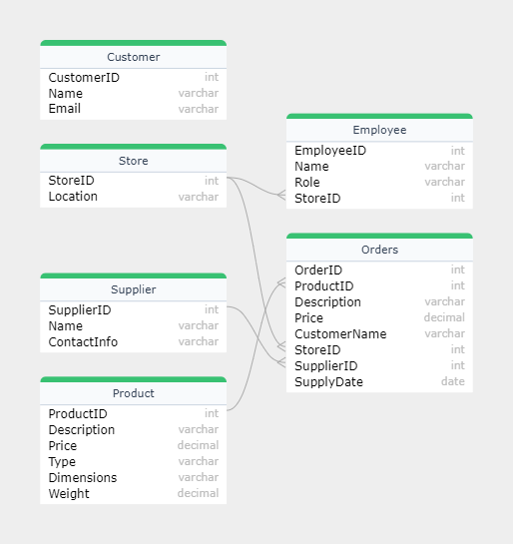

**3. Application Features**

The web-based application interacts with the Oracle SQL database through PHP, using HTML and CSS for the client-side interface. The Oracle Call Interface Functions facilitate the connection between PHP and the Oracle database, allowing for dynamic interaction with the data.

The key features of the application include:

**Data Visualization:** Users can view all database tables through dedicated web pages. This feature provides an intuitive way to access information about products, stores, employees, customers, suppliers, and orders. Each table is displayed on a separate page, making it easy to navigate and retrieve information.

**Data Insertion:** The application provides forms that allow users to add new data to the tables. This capability enables the company to update the database dynamically as new products are introduced, new orders are placed, or new customers are added.

**Query and Search Functionality:** Users can query and search data within the database tables. This feature is essential for retrieving specific information, such as orders by customer, products by type, or employee details by store. It enhances the application's usability and facilitates quick data retrieval.

**4. Appraisal of Application Features**

The application effectively meets the needs of IDEA Home Furniture Company. Its ability to display, insert, and query data offers a comprehensive solution for managing the company's operations. The use of Oracle SQL ensures robust data management and high performance, while the PHP-based server-side code provides flexibility for future development and feature enhancements.

Overall, the application is well-structured and user-friendly. The interface allows users to interact with the database seamlessly, providing an efficient workflow for managing business operations.

**5. Application Access**

The Application can be accessed at the following URL: