NETWORKING

Networking :

A network is a way or means of transmission or exchange of information from one or more sources.

Computer networks form the backbone of most enterprises big or small around the world. Computer network allows people to access information available across the globe. Computer networks are being used to provide resources sharing between systems separated from a few feet to thousands ok kilometers.

The entire network can be classified into two categories
1. LAN, 2. WAN 3. MAN

A local-area network (LAN) is a computer network that spans a relatively small area. Most LANs are confined to a single building or group of buildings, however, one LAN can be connected to other LANs over any distance via telephone lines and radio waves. A system of LANs connected in this way is called a wide-area network (WAN).
Most LANs connect workstations and personal computers. Each node (individual computer ) in a LAN has its own CPU with which it executes programs, but it also is able to access data and devices anywhere on the LAN. This means that many users can share expensive devices, such as laser printers, as well as data. Users can also use the LAN to communicate with each other, by sending e-mail or engaging in chat sessions.
LANs are capable of transmitting data at very fast rates, much faster than data can be transmitted over a telephone line; but the distances are limited, and there is also a limit on the number of computers that can be attached to a single LAN.

A WAN spans a large geographic area, such as a state, province or country. WANs often connect multiple smaller networks, such as local area networks (LANs) or metro area networks (MANs).
Computers connected to a wide-area network are often connected through public networks, such as the telephone system. They can also be connected through leased lines or satellites. The largest WAN in existence is the Internet.

A metropolitan area network (MAN) is a network that interconnects users with computer resources in a geographic area or region larger than that covered by even a large local area network (LAN) but smaller than the area covered by a wide area network (WAN). The term is applied to the interconnection of networks in a city into a single larger network (which may then also offer efficient connection to a wide area network). It is also used to mean the interconnection of several local area networks by bridging them with backbone lines. The latter usage is also sometimes referred to as a campus network.

Building a Small Office Network:
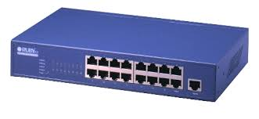
When building a small office network, the two most essential pieces of equipment you will need are switches and routers. Though they look similar, the two devices perform different functions in a network.
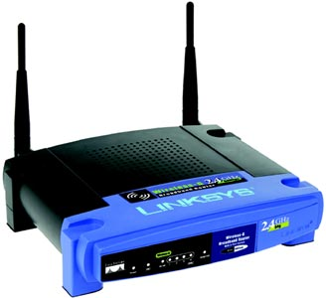
- Switches connect multiple devices (computers, printers, servers) on the same network within a building or campus. A switch enables connected devices to share information and talk to each other. Building a small office network isn’t possible without switches to tie devices together.

- Routers tie multiple networks together. A router connects the networked computers to the Internet. This enables all connected computers to share one single Internet connection. A router acts as a dispatcher, choosing the best route for your information to travel. It connects your business to the world, protects information from security threats, and can even decide which computers get priority over others.
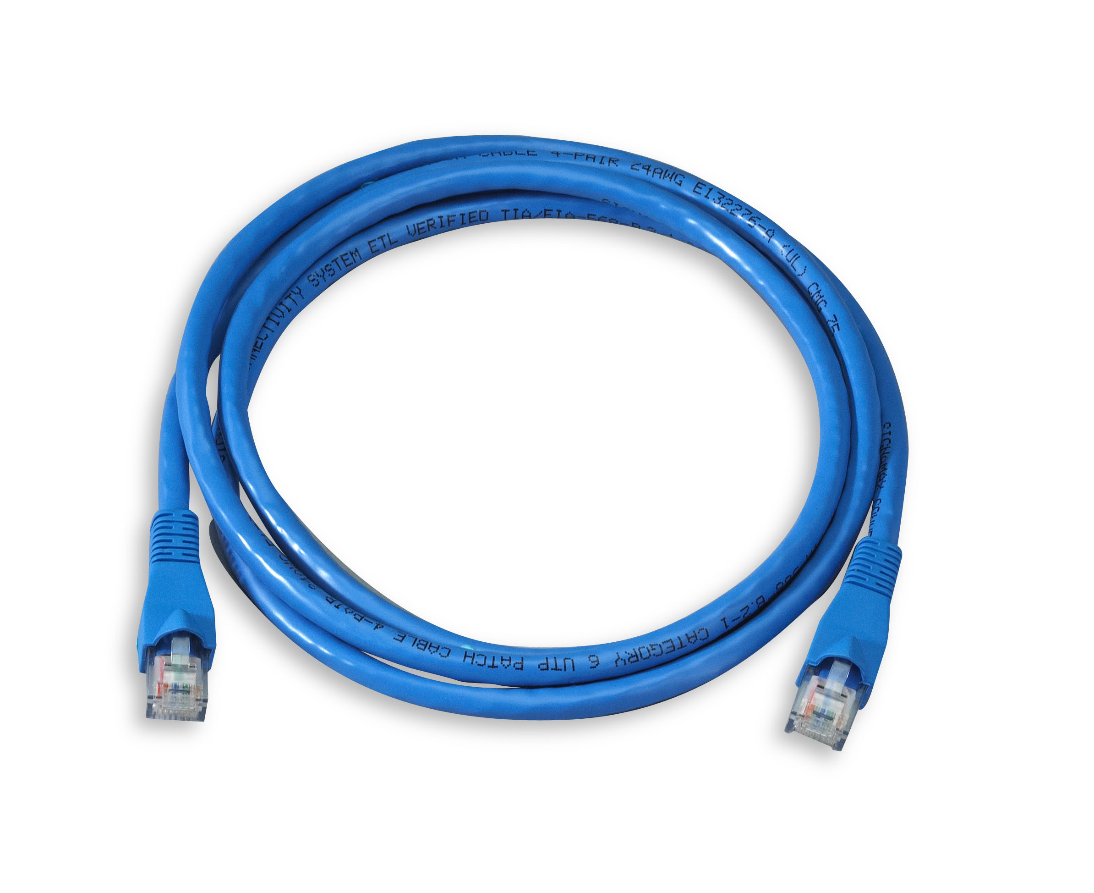
- A patch cable is the network cable that fits between a device and a socket either a wall socket or another device. They are made up from a pair of plastic RJ45 plugs joined together with CAT5e patch cable.

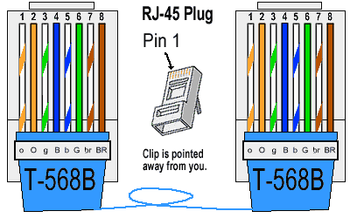
COLOUR CODING FOR PATCH CORD WITH THE RJ45 CONNECTORS

STRAIGHT THROUGH CONNECTION
A straight through cable is used to connect a computer to a router a switch or hub.
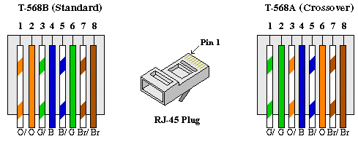

CROSS OVER CONNECTION
A crossover cable is used to connect two computers, two hubs , two switches, two routers ect.

Configuration
Once the network has been physically connected the devices need to know where each other are and the language they need to speak to communicate with each other, The network standard language uses a protocol called TCP/IP. This allows the computers to convert the data into a form that can be transferred easily and quickly by slicing the data into bite sized chunks called Packets. Also within this protocol there is an address this is called the IPAddress. Its format would look like below

192.168.1.1

This number will identify the device on the network, all devices has to have its own address on the network, this would be like the houses on a street each having a post code relating them to an area and a house number for individuality within the street so that the post man knows the location and address in which to deliver post. Each part of the address has a function, the first parts of the address allow you to identify the network uniquely, 192.168.1 is the post code of the network and the .1 relates to the address of the device. Each device must have a unique number.

TCP/IP
One of the most common ways used by computers to send information across the internet is by using two protocols (called TCP and IP) together.
IP (Internet Protocol) works by giving each machine on the internet a unique 12 digit IP address (like 142.109.265.155). When a computer wants to send information across the internet, the information is broken into small segments called packets, and each packet is stamped with a "to" and "from" IP address. The packets are then sent across the internet to their destination.
TCP (Transmission Control Protocol) adds extra information to each packet to make sure that when they are received at the destination computer (by using IP) they have not been damaged, none of them are missing, and they are all put back together in the right order. If any packets are missing or damaged, a request is sent back to re-send those packets before the information is reassembled.

Subnet Mask
A subnet mask is a number that defines a range of IP addresses that can be used in a network. Subnet masks are used to designate subnetworks, or subnets, which are typically local networks LANs that are connected to the Internet. Systems within the same subnet can communicate directly with each other, while systems on different subnets must communicate through a router. Therefore, subnetworks can be used to partition multiple networks and limit the traffic between them.
A subnet mask hides, or "masks," the network part of a system's IP address and leaves only the host part as the machine identifier. A common subnet mask for a Class C IP address is 255.255.255.0. Each section of the subnet mask can contain a number from 0 to 256, just like an IP address. Therefore, in the example above, the first three sections are full, meaning the IP addresses of computers within the subnet mask must be identical in the first three sections. The last section of each computer's IP address can be anything from 0 to 255. For example, the IP addresses 10.0.1.201 and 10.0.1.202 would be in the same subnet, while 10.0.2.201 would not. Therefore, a subnet mask of 255.255.255.0 allows for close to 256 unique hosts within the network (since not all 256 IP addresses can be used).
GATEWAY:
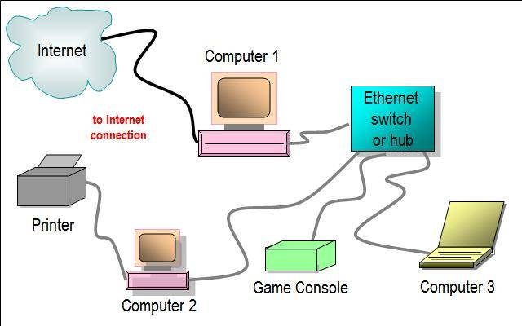
A gateway is a node on a network that serves as an entrance to another network. A gateway provides communication to a remote network or an autonomous system that is out of bounds for the host network nodes. Gateways serve as the entry and exit point of a network; all data routed inward or outward must first pass through and communicate with the gateway in order to use routing paths. Generally, a router is configured to work as a gateway device in computer networks.

LAYOUT OF A NETWORK

