/*********************** **FILE REGARDING THE DATABASE TABLES** ***********************/

* **Database Name: attendance**

1. Table Name: **teacher**

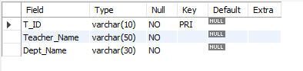

1. Table Name: **login**

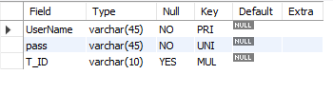

1. Table Name: **coursename**

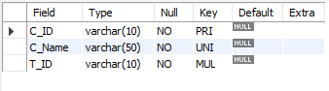

1. Table Name: **course**

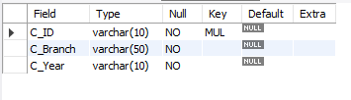

1. Table Name: **student**

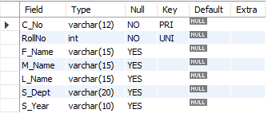

1. Table Name: **attendance**

