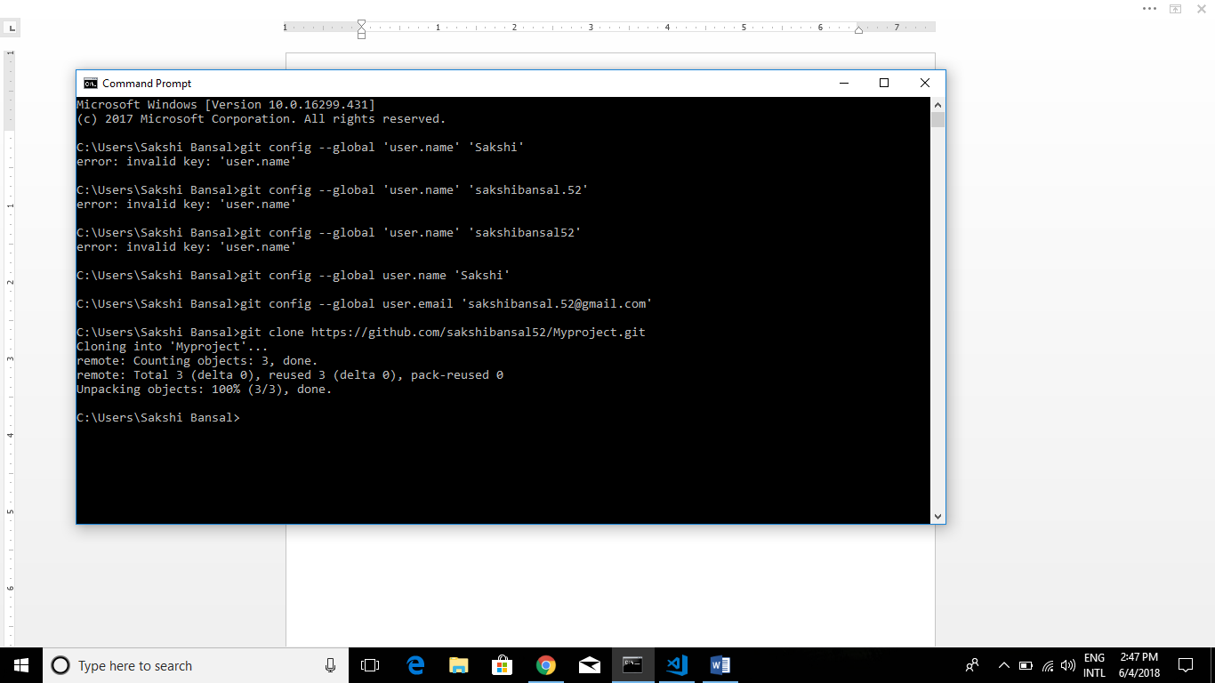

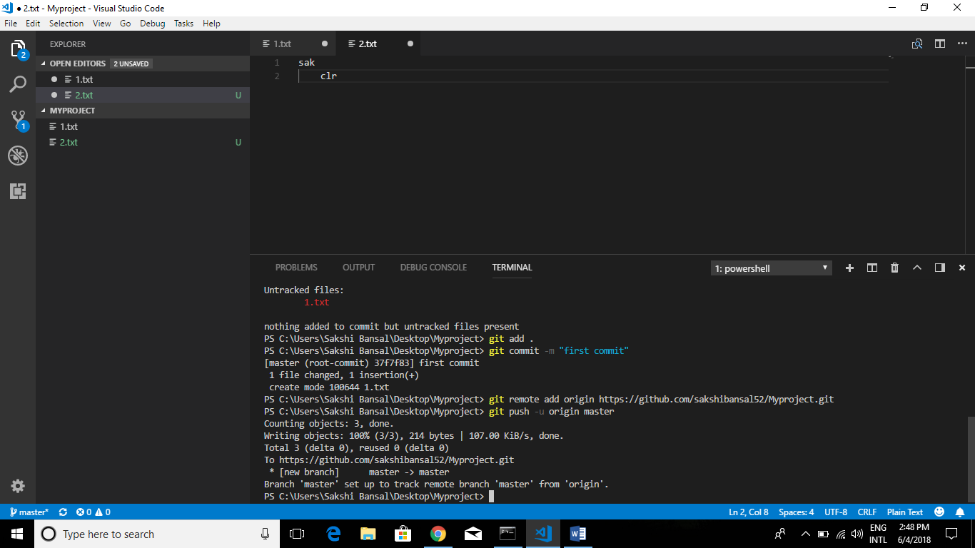

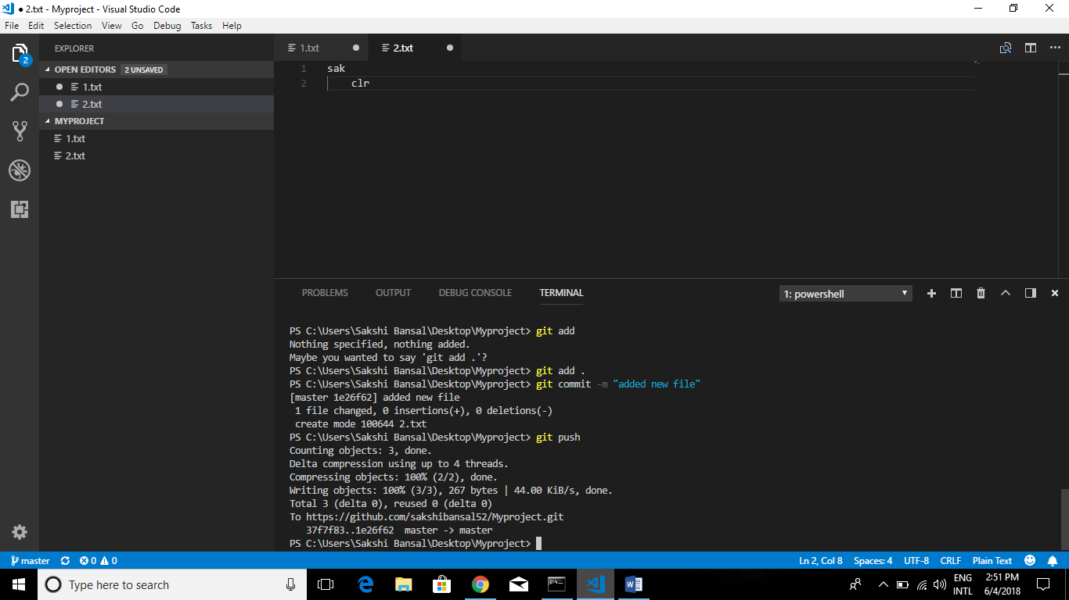

Update repo:- (update mode by us)

* git add .
* git command –m “Ok”
* git push
* update folder in local pc for changes made by other 🡺 git pull

To add a collaborator 🡺 settings 🡺 collaborator 🡺 username with whom u want to collaborate