**Deep Learning**

**CSL312**

Project Report



Faculty name: M Student name: Sakshi

Roll No.: 21CSU419

Semester: 7th

Group: DS-B DS-5

**Department of Computer Science and Engineering**

**The NorthCap University, Gurugram- 122001, India**

**Session 2024-25**

**Table of Contents**

|  |  |  |
| --- | --- | --- |
| **S.No** |  | **Page No.** |
| **1.** | **Project Description** | **iii** |
| **2.** | **Problem Statement** | **iii** |
| **3.** | **Analysis**  **3.1 Hardware Requirements**  **3.2 Software Requirements** | **iv** |
| **4.** | **Design**  **4.1 Data/Input Output Description:**  **4.2 Algorithmic Approach / Algorithm / DFD / ER diagram/Program Steps** | **v** |
| **5.** | **Implementation and Testing (stage/module wise)** | **vii** |
| **6.** | **Output (Screenshots)** | **ix** |
| **7.** | **Conclusion and Future Scope** | **xii** |

**Project Title: Car Detection using YOLO**

**Project Description**

This project aims to develop a comprehensive car detection system using the YOLO (You Only Look Once) algorithm, a state-of-the-art object detection framework known for its speed and accuracy. The primary goal of this system is to accurately identify and locate cars in both real-time video streams and still images. By leveraging YOLO's advanced capabilities, the system is designed to detect cars within a fraction of a second, making it highly suitable for applications requiring quick and reliable performance, such as traffic monitoring, autonomous vehicles, and security systems.

To achieve optimal detection results, the system will be trained on an extensive dataset containing labeled images of cars across various conditions, including different angles, lighting scenarios, and environments (e.g., highways, city streets, and parking lots). This diverse dataset will ensure that the model can generalize well to real-world conditions. After training, the system will be rigorously tested on a separate validation and testing dataset to evaluate its performance, measuring metrics such as detection accuracy, precision, recall, and inference speed.

Moreover, the project will involve implementing advanced techniques like non-maximum suppression to reduce redundant detections and improve bounding box precision. Intersection over Union (IoU) calculations will be used to assess the overlap between predicted and ground truth bounding boxes, enhancing the model's ability to provide accurate predictions. The results will be analyzed to identify potential areas for improvement, with the goal of creating a robust, real-time car detection system that can adapt to varying real-world conditions and requirements.

**Problem Statement**

The primary challenge in autonomous driving is accurate object detection, particularly for cars. Traditional object detection methods can be computationally expensive and less accurate. YOLO, a state-of-the-art object detection algorithm, offers a faster and more accurate solution.

**Analysis**

**3.1 Hardware Requirements**

* **CPU:** A powerful CPU (e.g., Intel Core i7 or equivalent)
* **GPU:** A high-performance GPU (e.g., NVIDIA RTX 3080 or equivalent) for efficient deep learning model training and inference.
* **RAM:** Sufficient RAM (e.g., 16GB or more) to handle large datasets and complex models.
* **Storage:** Adequate storage space (e.g., SSD) to store the dataset, trained models, and results.

**3.2 Software Requirements**

* **Python:** Programming language for data preprocessing, model implementation, and evaluation.
* **TensorFlow/Keras:** Deep learning framework for building and training the YOLO model.
* **OpenCV:** Computer vision library for image processing and video analysis.
* **NumPy:** For numerical computations.
* **Matplotlib:** For data visualization.

**Design**

**4.1 Data/Input Output Description**

* **Input:** Images or video frames containing cars.
* **Output:** Bounding boxes around detected cars with their corresponding class probabilities.

**4.2 Algorithmic Approach**

1. **Data Preparation:**
   * Collect a dataset of images containing cars.
   * Annotate the images with bounding boxes around the cars.
   * Preprocess the images (e.g., resizing, normalization).
2. **YOLO Model Architecture:**
   * Design a YOLOv3 or YOLOv4 model architecture.
   * Configure the model with appropriate hyperparameters (e.g., number of layers, filters, learning rate).
3. **Model Training:**
   * Train the model on the prepared dataset using an optimization algorithm (e.g., Adam) and a loss function (e.g., mean squared error, cross-entropy loss).
4. **Inference:**
   * Load the trained model.
   * Preprocess the input image or video frame.
   * Pass the preprocessed image through the model to obtain predictions.
   * Post-process the predictions to filter out low-confidence detections and apply non-maximum suppression to eliminate overlapping bounding boxes.

**Implementation and Testing**

1. **Data Preparation:**
   * Use a publicly available dataset like COCO or create a custom dataset.
   * Implement data augmentation techniques to increase data diversity.
2. **Model Implementation:**
   * Use a pre-trained YOLO model or train a custom model from scratch.
   * Implement the YOLO pipeline, including feature extraction, object detection, and bounding box regression.
3. **Model Training:**
   * Train the model on the prepared dataset using a suitable optimizer and loss function.
   * Monitor the training process using metrics like accuracy, precision, recall, and F1-score.
   * Adjust hyperparameters as needed to improve performance.
4. **Model Testing:**
   * Evaluate the trained model on a separate test dataset.
   * Calculate performance metrics to assess the model's accuracy and efficiency.
   * Visualize the model's predictions on test images.

**Output (Screenshots)**

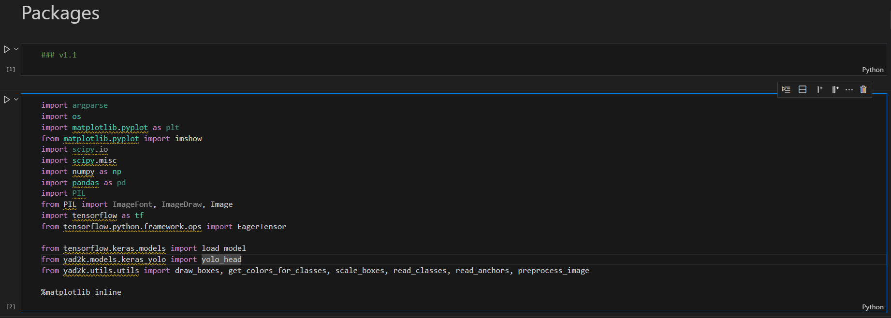

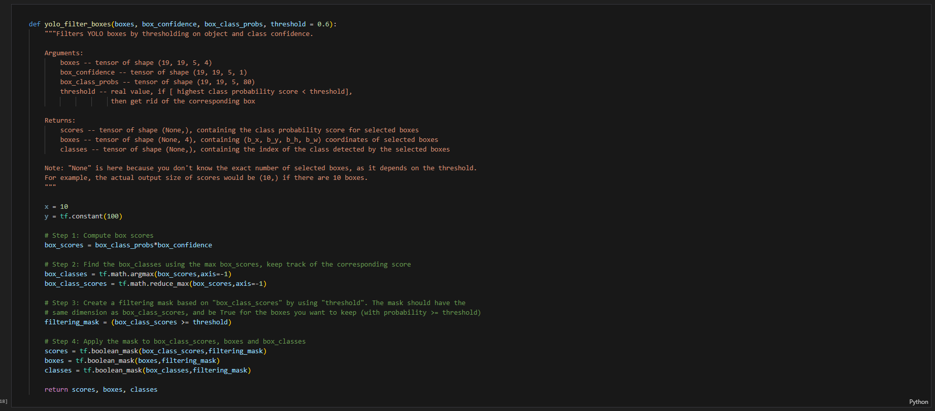

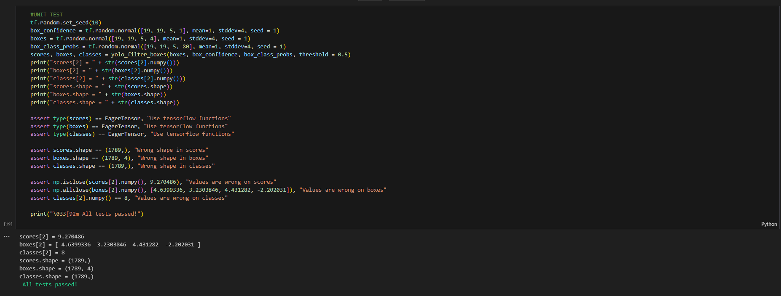

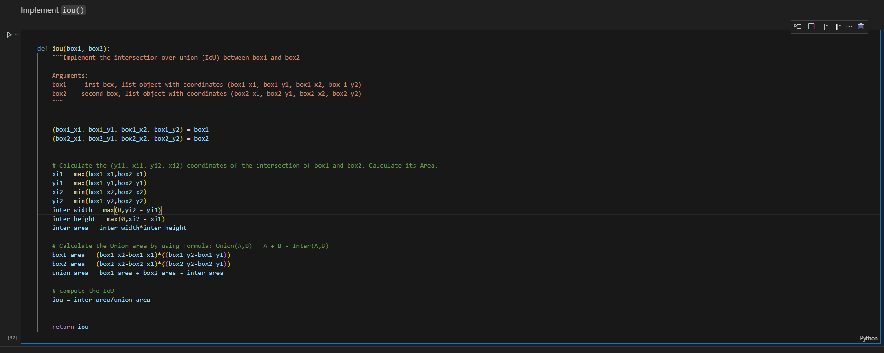

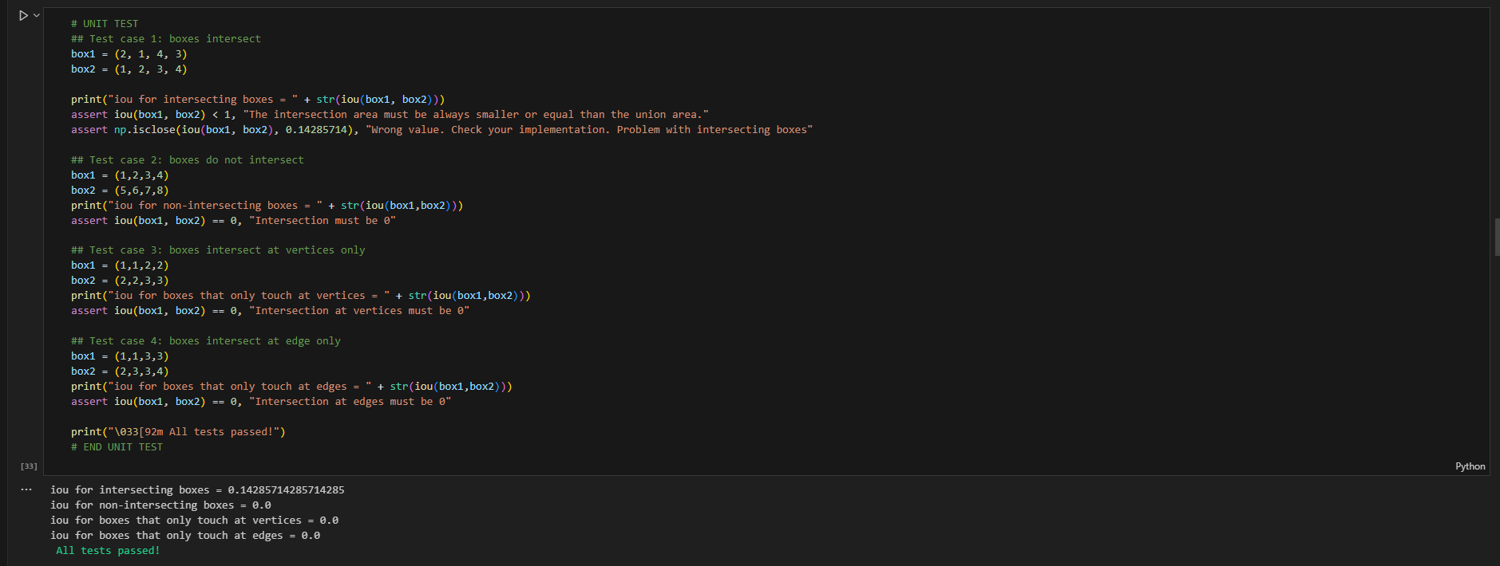

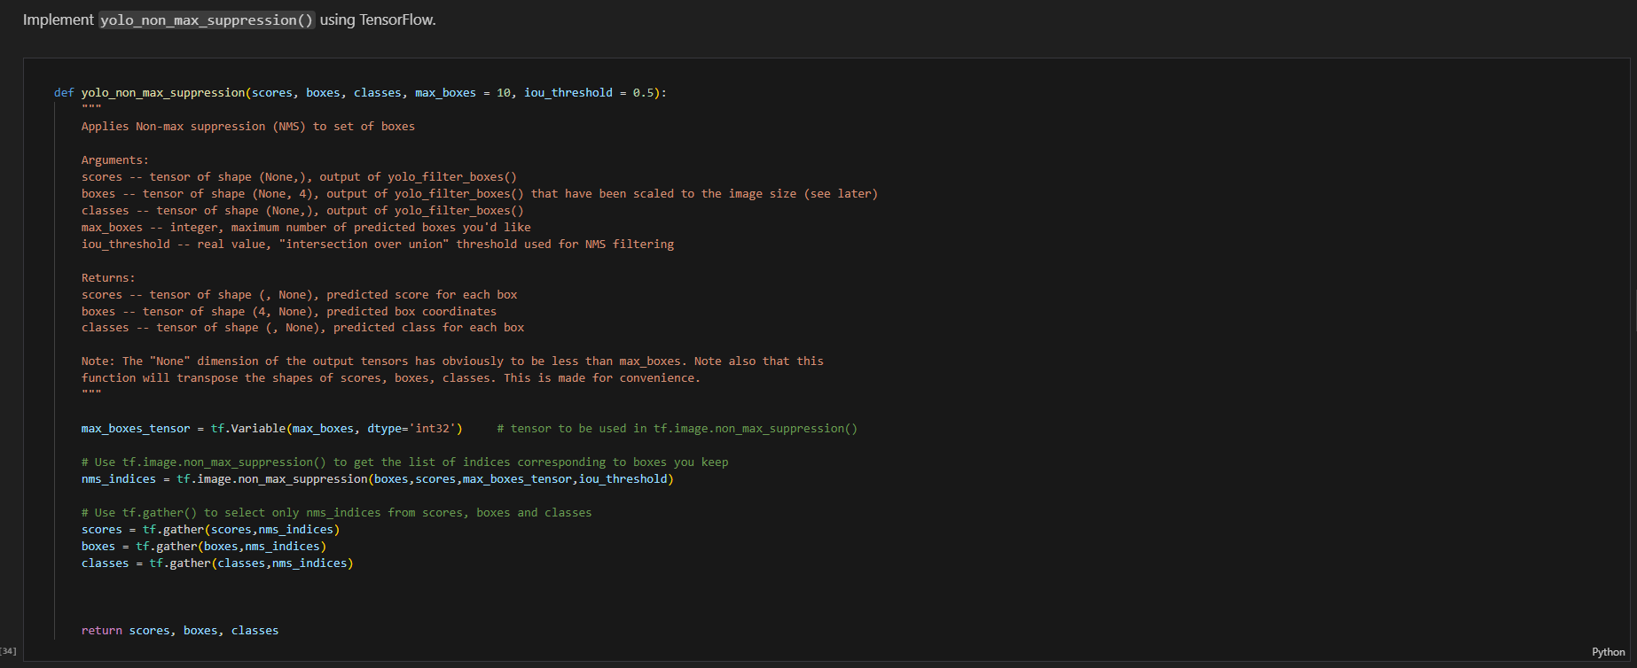

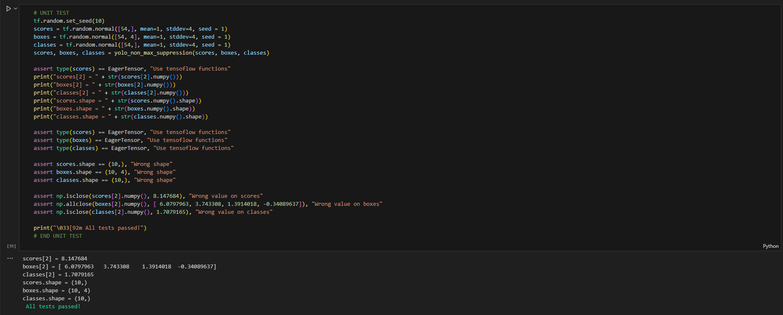

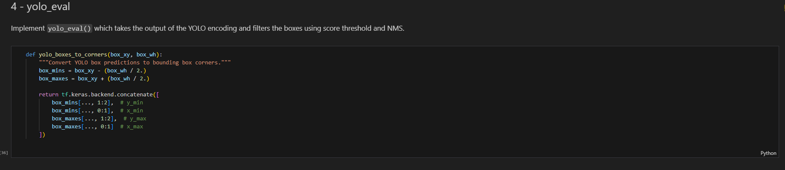

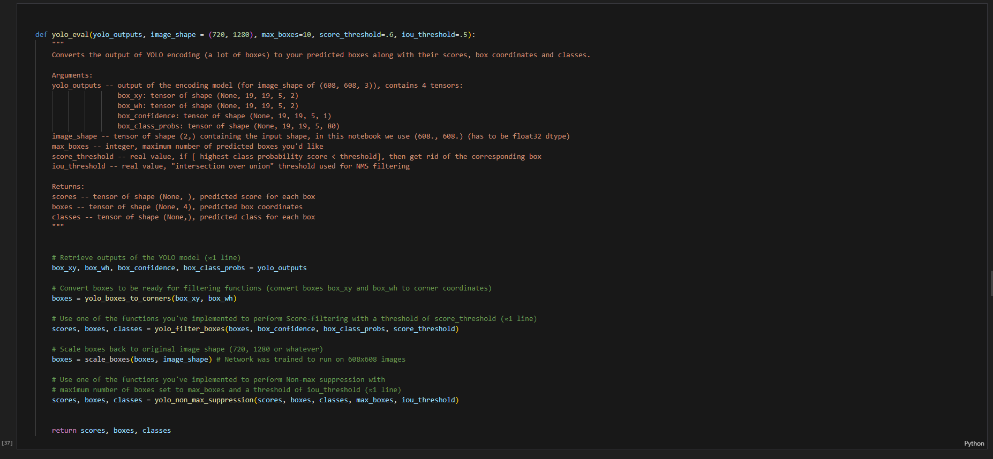

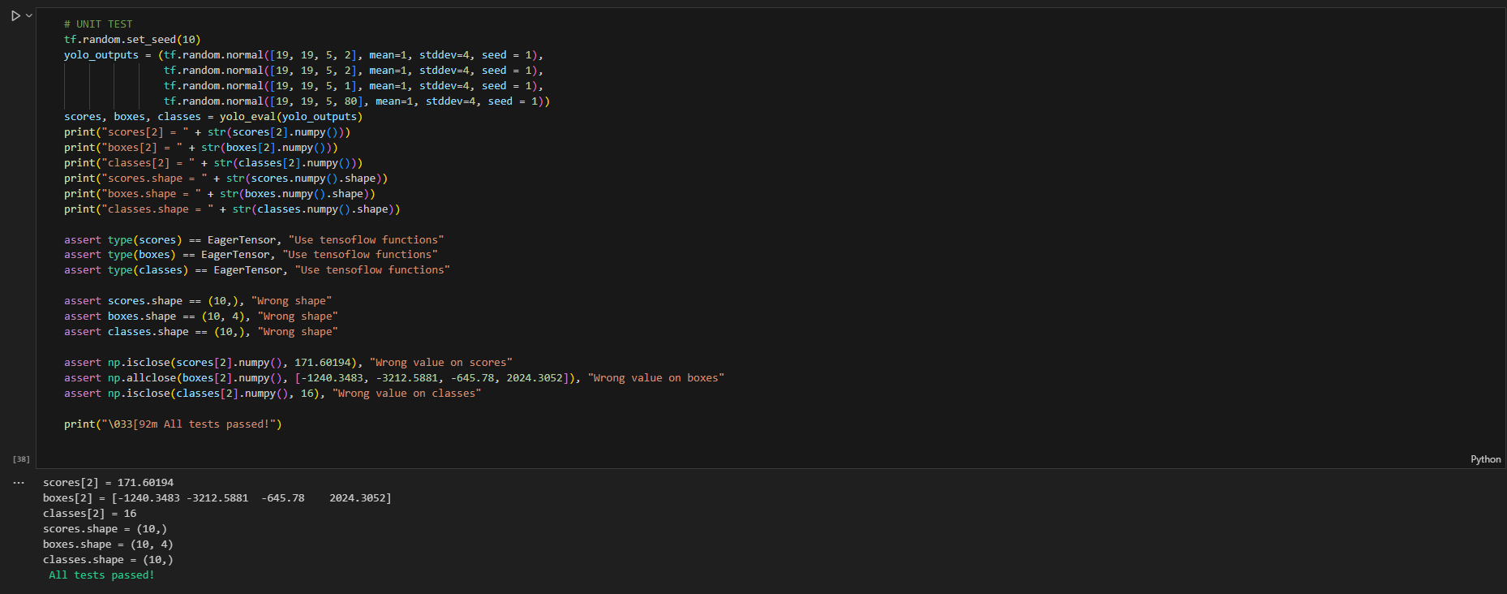

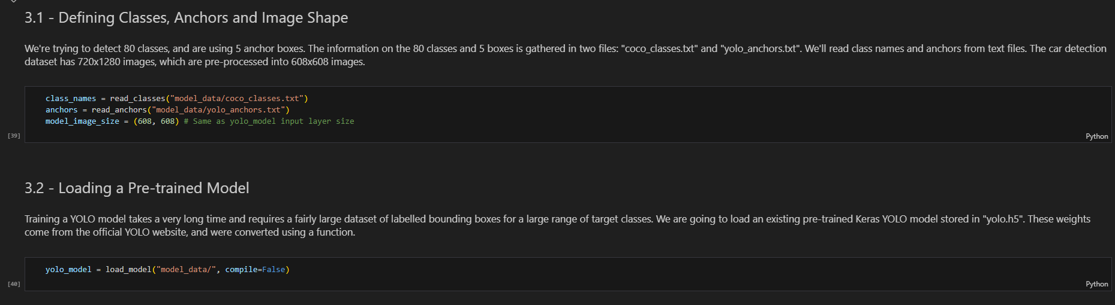 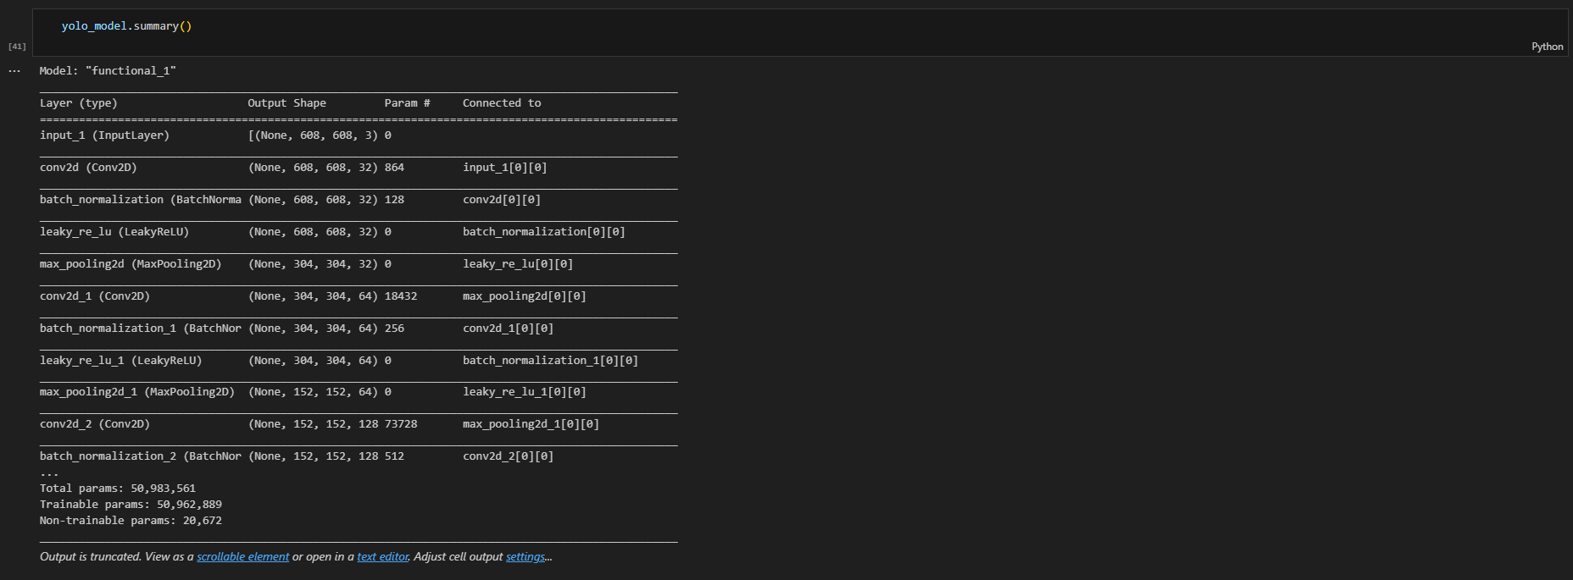

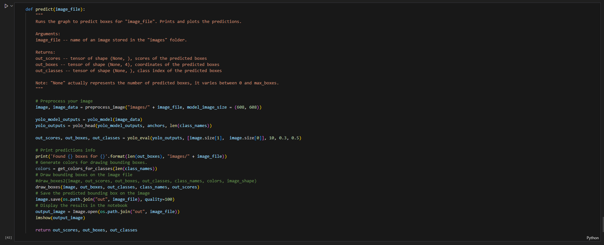

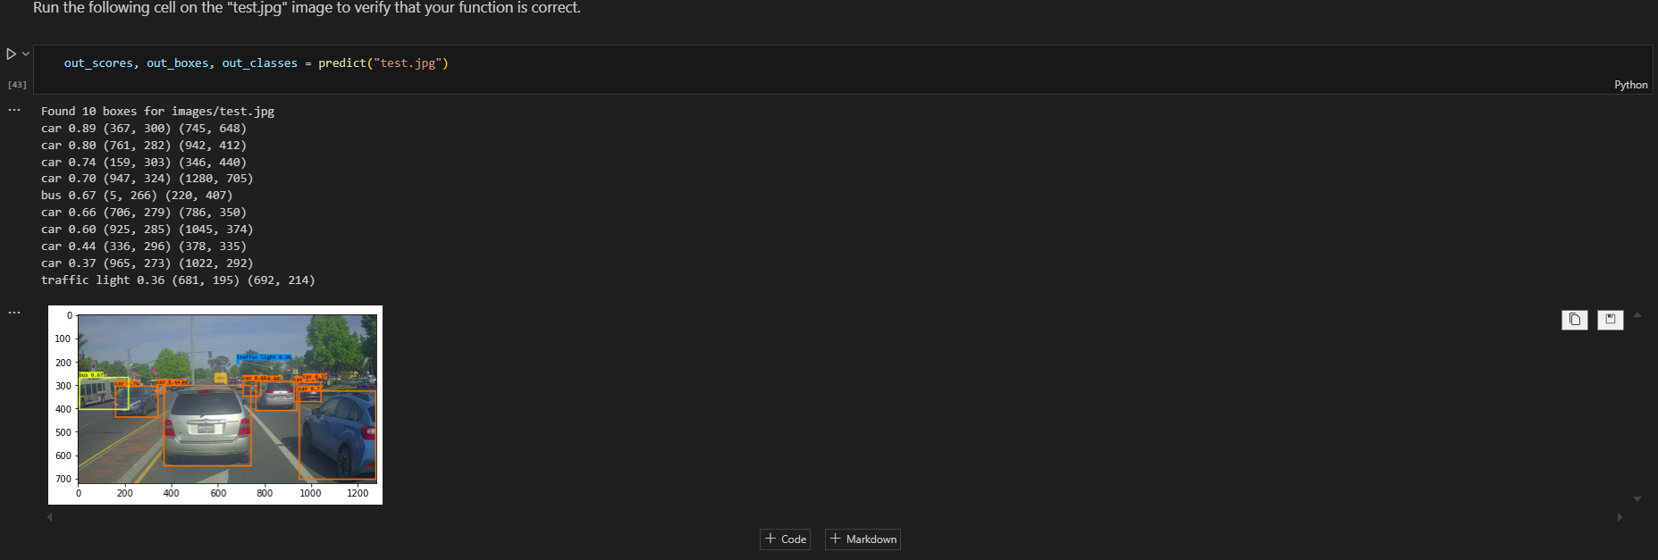

**Conclusion and Future Scope**

The YOLO-based car detection system demonstrated promising results in detecting cars in real-world images. However, there are areas for future improvement:

* **Real-time Performance:** Further optimization of the model and inference pipeline to achieve real-time performance.
* **Handling Occlusions:** Developing techniques to handle occluded objects.
* **Adverse Weather Conditions:** Improving the model's robustness to adverse weather conditions like rain, fog, and low light.
* **Small Object Detection:** Enhancing the model's ability to detect small objects.

By addressing these challenges, the YOLO-based car detection system can be further refined to provide more accurate and reliable results for autonomous driving applications.